Description of Data
i. Population Density
Subzone E265 with 69.5% of urbanized area, housed the highest proportion of population (3.36%) in Singapore. (Figure S1) In terms of population density, W112 (46,805 persons per sq.km) was the most densely populated subzone, while W109 (0.27 persons per sq.km) was the least. The distribution of subzones according to density is as follows –very highly dense (6); highly dense (30); moderately dense (44) and 243 were low dense/non-populated subzones.

ii. Urbanization trends
Many subzones in Singapore were found in the highly urbanised category as per the urbanization cut-off of 50%. (Figure S2) A total of 13 subzones had very high levels of urbanization, 136 with high, 66 with moderate, 108 subzones with low percentage of urbanized area.

iii. Average Building Age
The average building age in most subzones in Singapore falls within the category of 30-40 years, followed by 10-20 years and 40-50 years. (Figure S3) Around 170 subzones had an average building age <10 years, 21 subzones between 10-20 years, 49 subzones between 20-30 years, 62 subzones between 30-40 years, and 13 subzones between 40-50 years. C281 had the oldest buildings; the only subzone with average building age>50 years (53.34), while N232 had the lowest average building age (0.1 years).

iv. Flood vulnerability
Singapore experiences occasional floods in certain low-lying regions in the presence of excessive rainfall. Subzones of Singapore had varied levels of flood vulnerable zones. (Figure S4) A total of 82 subzones had flood vulnerable area of >10%. About 20 subzones had 5-10% of flood vulnerable areas, 37 subzones had 1-5% of flood vulnerable areas, and 186 subzones had <1% flood vulnerable areas. E81 had the highest percentage of flood vulnerable area (15.9%), followed by N173 (9.82%), C169 (6.8%), W47 (6.3%), C133 (5.2%), C185 (4.2%) and E44 (4.2%). The remaining 49 subzones had less flood vulnerable area, varying between 0.01% and <4%.

v. Temperature
Between 2013 and 2020, the lowest monthly average temperature recorded was 25.81ºC in N88 (January 2014), while highest monthly average temperature was 29.96ºC in C157 (April 2016).

vi. Rainfall
In terms of rainfall distribution between 2013 and 2020, N127 recorded both the highest (210.7mm; November 2017) as well as lowest amount of rainfall (0.40mm; February 2014). The highest and lowest monthly rainfall from 2013 to 2019 were recorded in the following subzones respectively – 2013 [C310 (157mm;December) & W236 (119mm; July)], 2014 [C119 (195.2cm; December] & N127 (0.40mm, February)], 2015 [C310 (128mm; December &3.2mm, June)], 2016 [W198(132.4cm; July) & E187 (3.3mm, March)], 2017 [N127 (153.8cm; December) & C310 (11.4cm; June)], 2018 [W286 (190.4mm; June) & W291(18.8mm; August)], 2019 [(E191 (135mm; December) & C271 (1.3mm; September)]. In the first three months of 2020, W289 recorded the highest rainfall (88.6mm in January), while C271 recorded the lowest (3.2mm in March).

vii. Dengue incidence rate
(Figure S5)
Figures
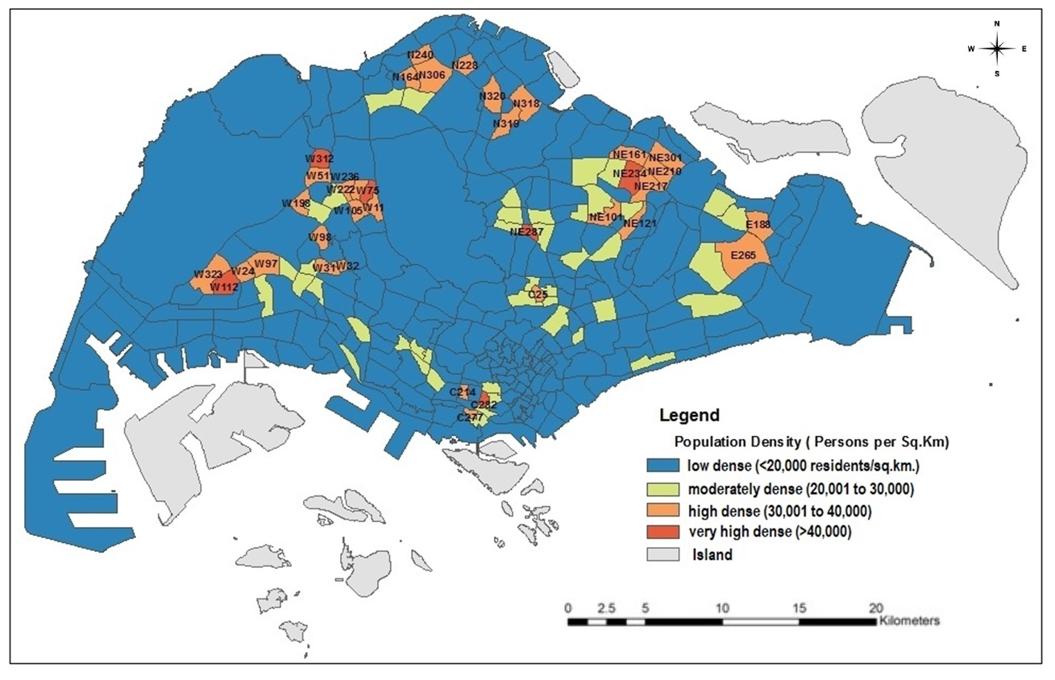
Figure S1. Population Density

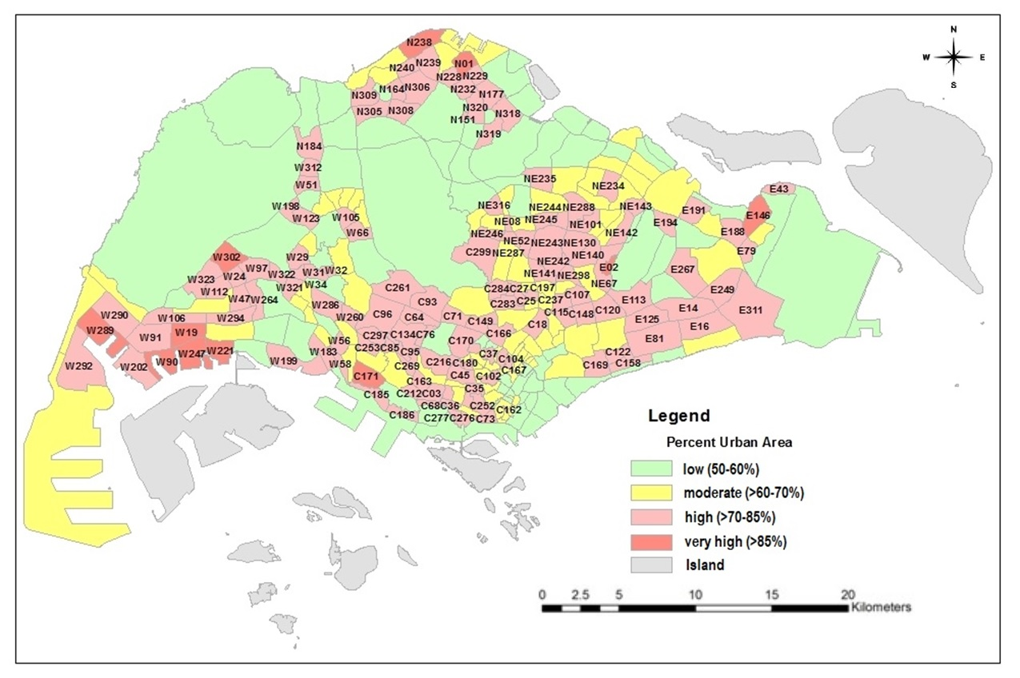
Figure S2. Urbanisation level

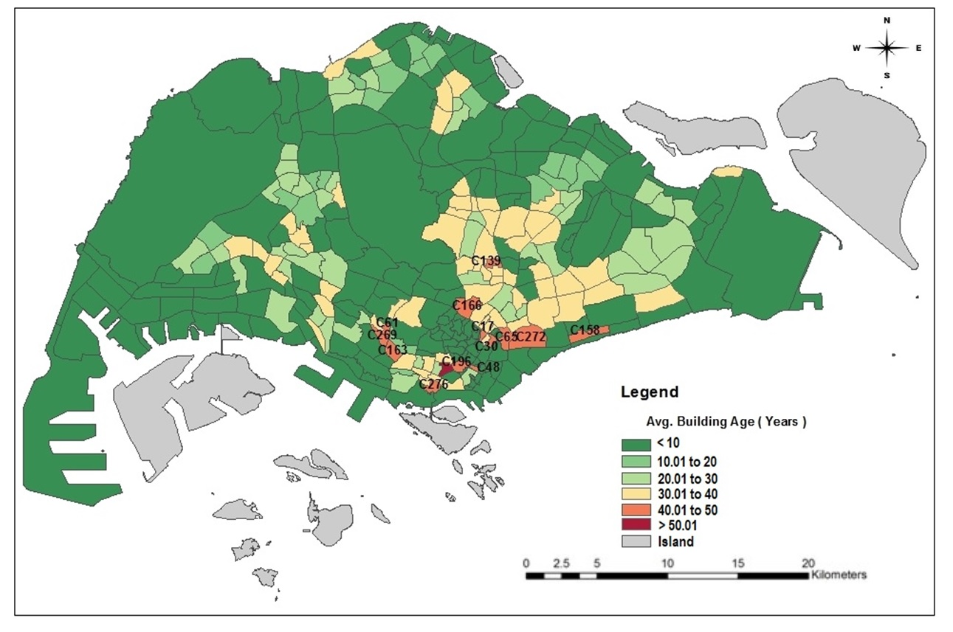
Figure S3. Building Age

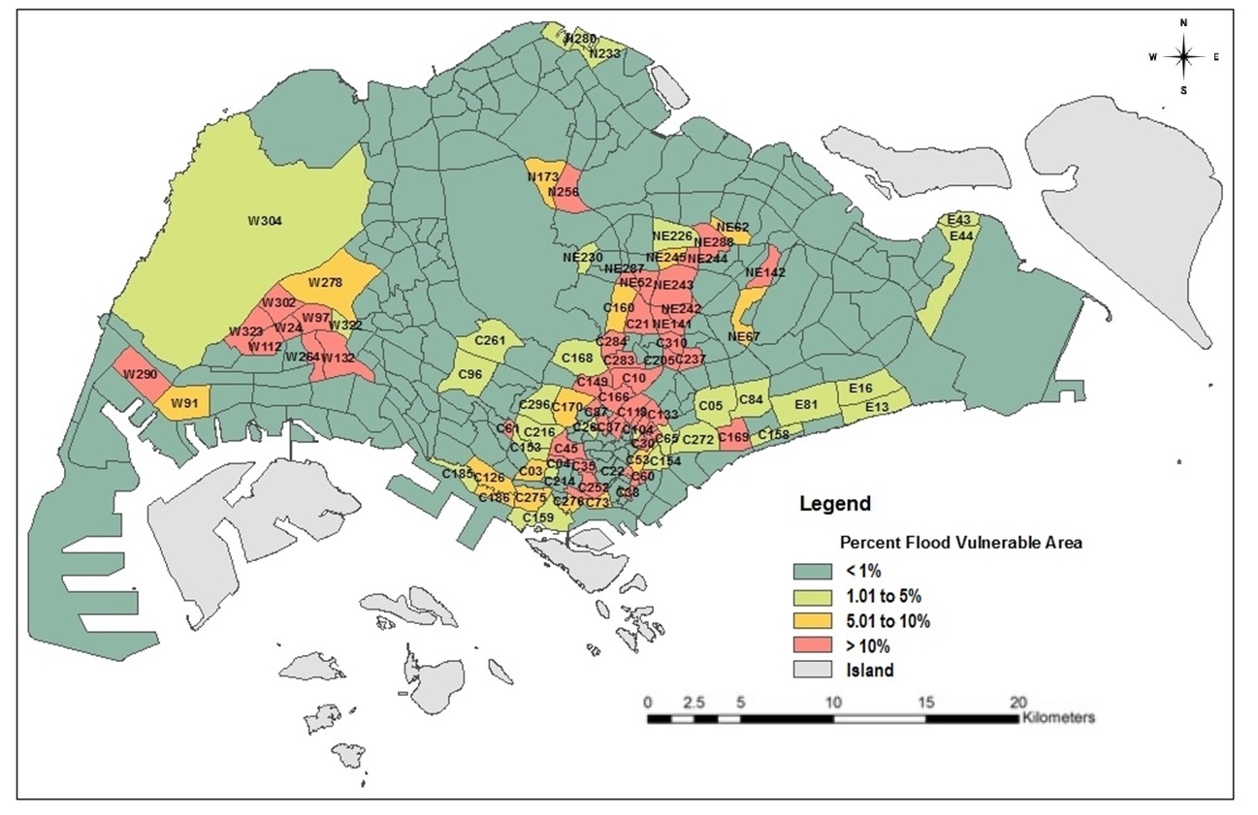
Figure S4. Flood Vulnerability

January  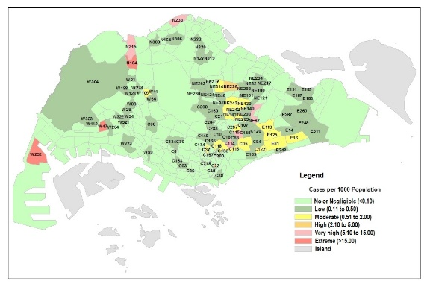 | February  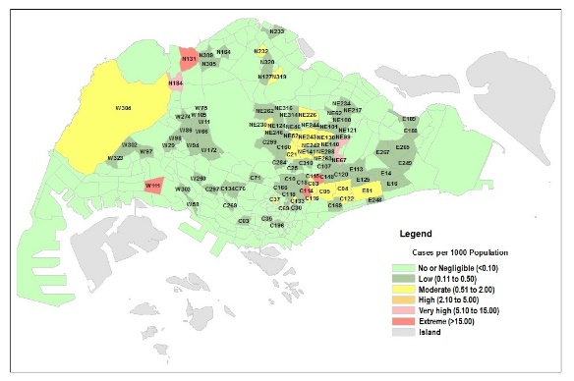 | March  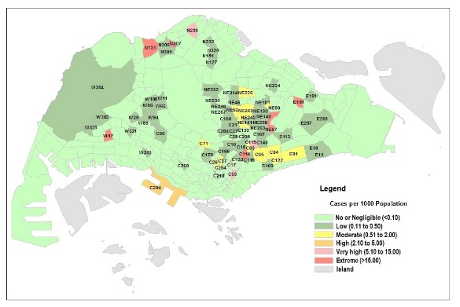 | April  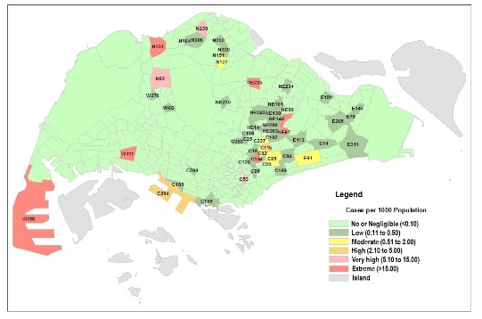
May  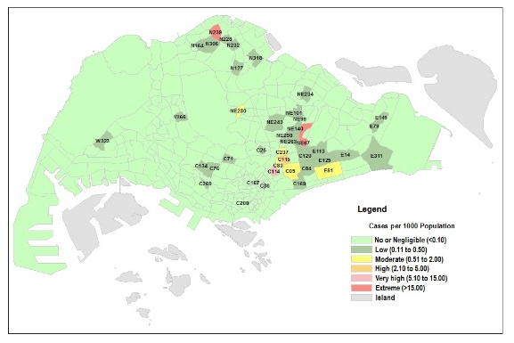 | June  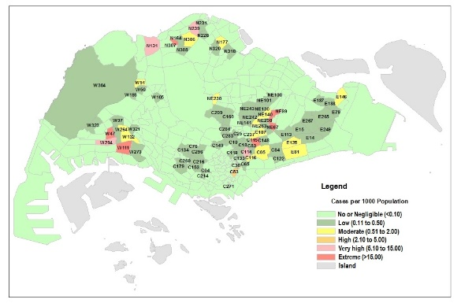 | July  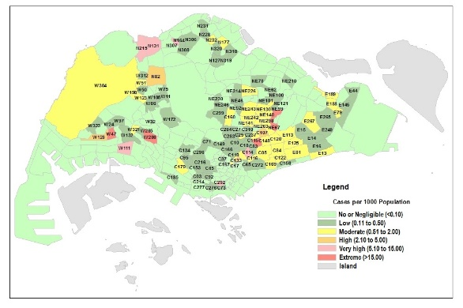 | August  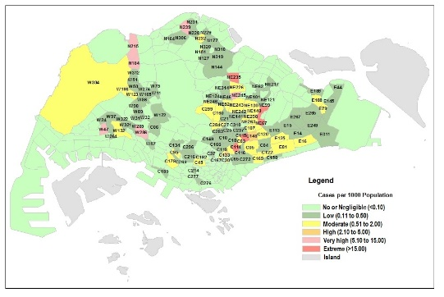
September  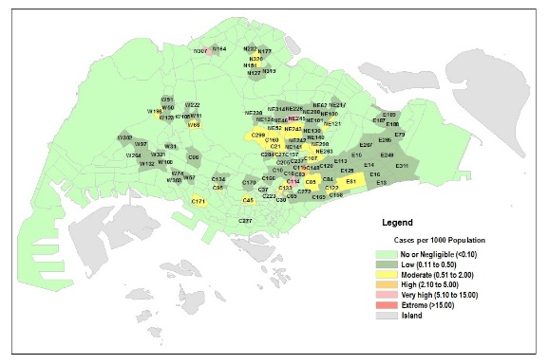 | October  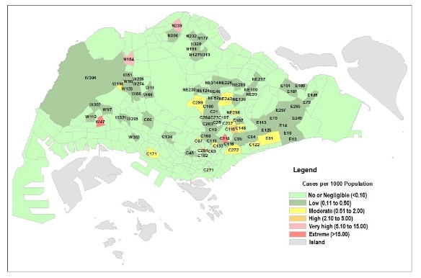 | November  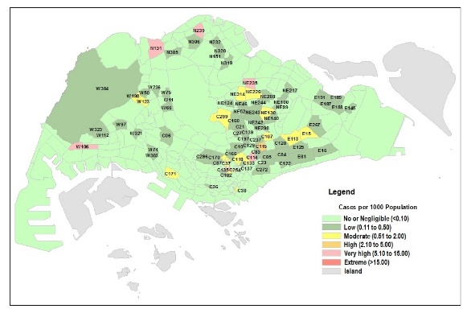 | December  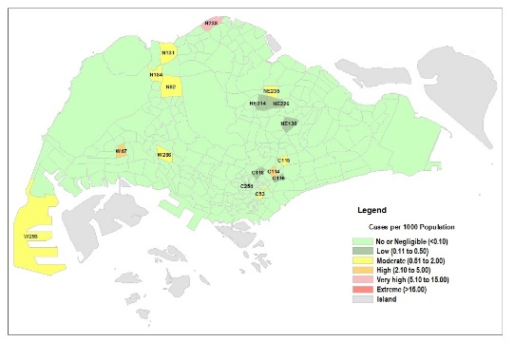

Figure S5. Dengue Incidence Rate (IR) by Months
 | 2013 |  | 2014 | 2015 | 2016
Jan |  |  | 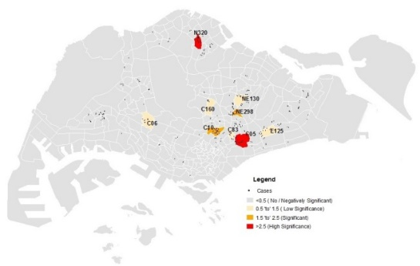 | 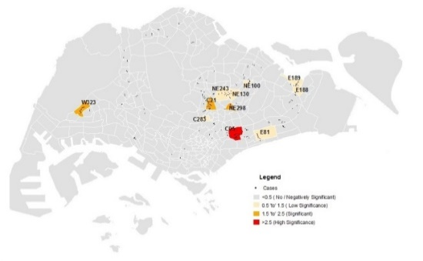 | 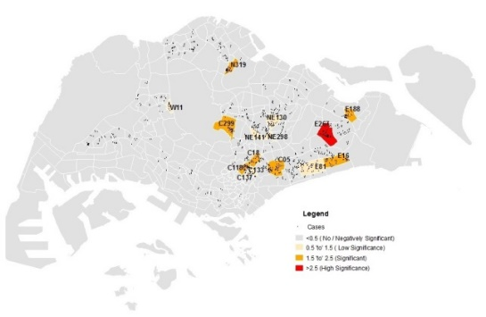
Feb |  |  | 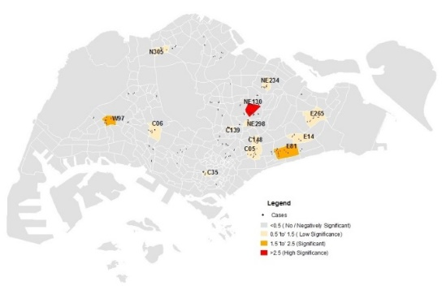 | 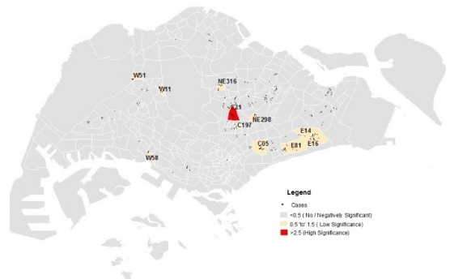 | 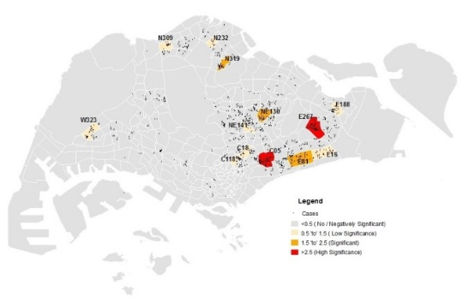
Mar |  |  | 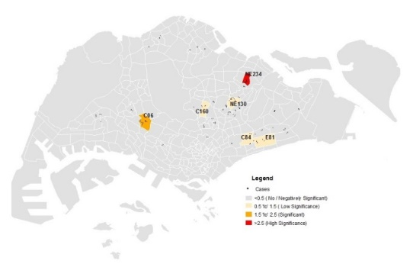 | 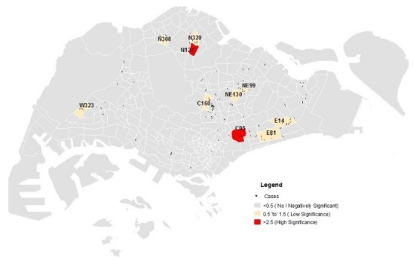 | 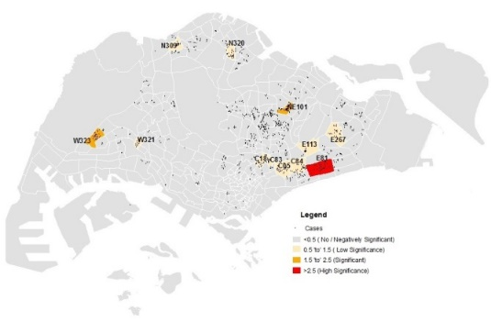
Apr |  |  | 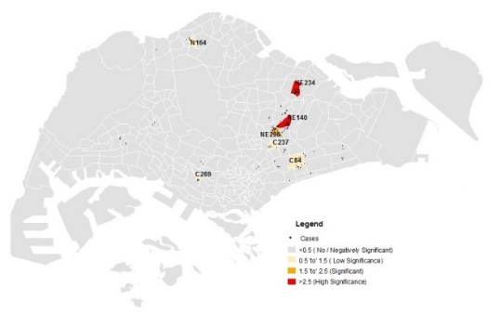 | 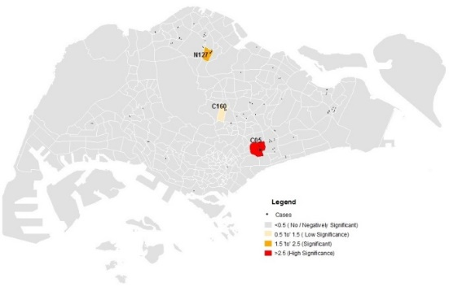 | 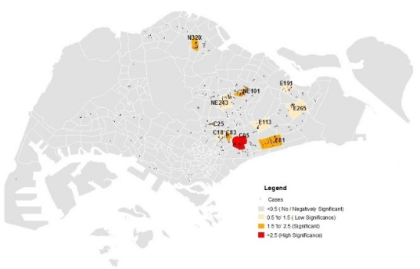
May | 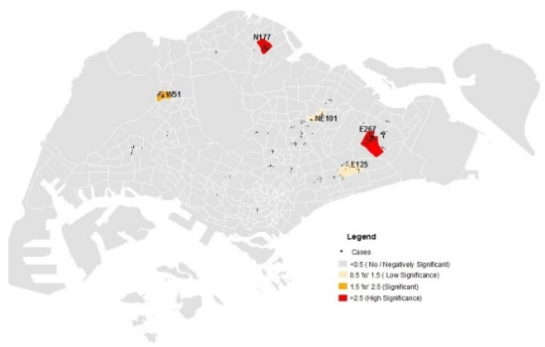 |  | 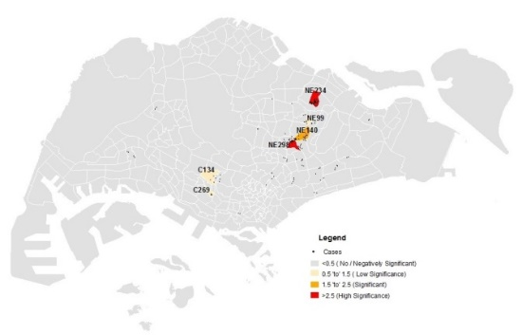 | 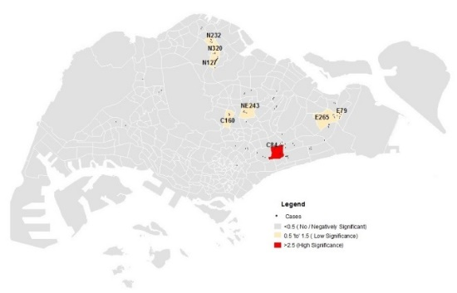 | 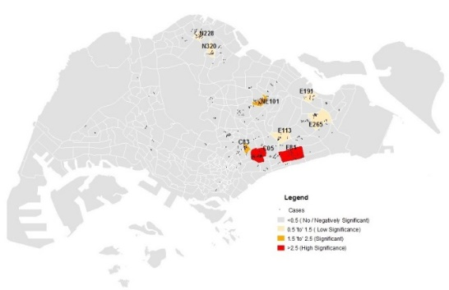
Jun | 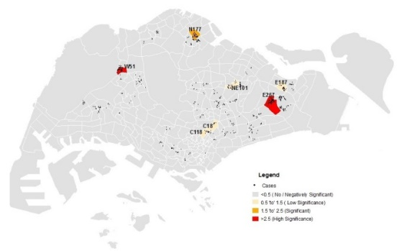 |  | 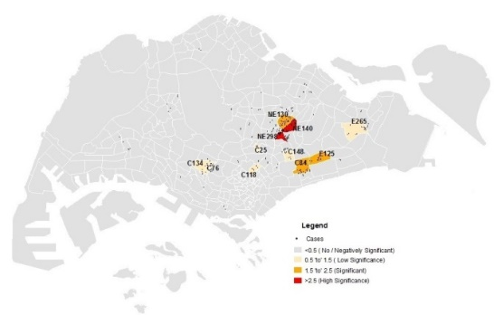 | 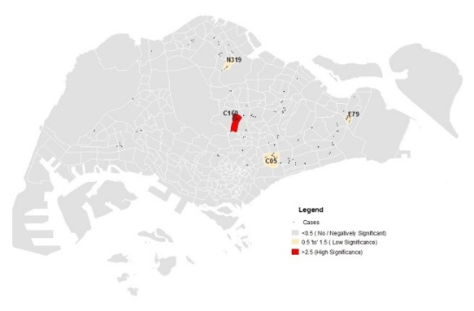 | 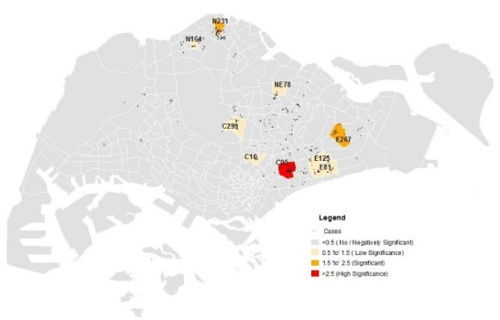
Jul | 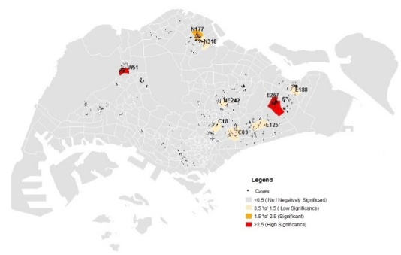 |  | 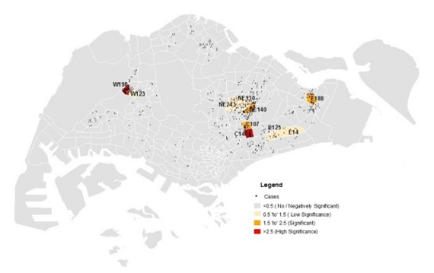 | 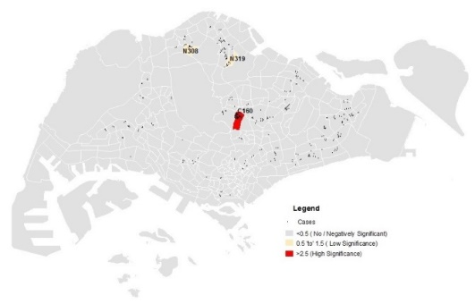 | 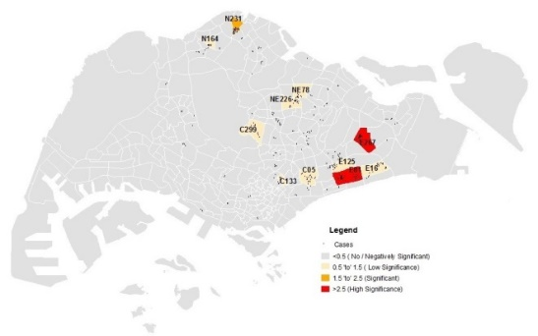
Aug | 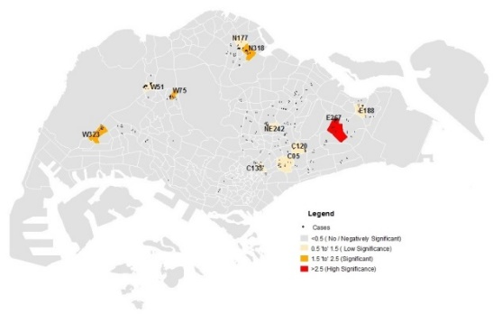 |  | 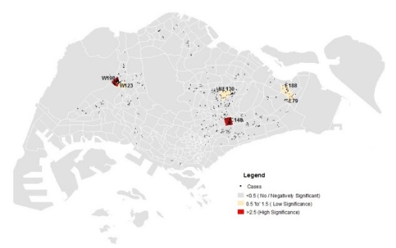 | 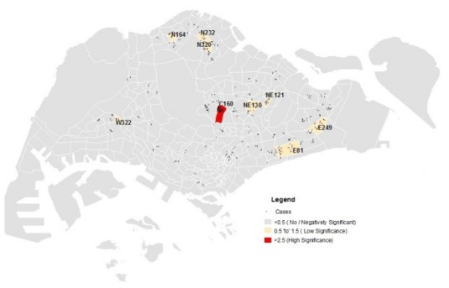 | 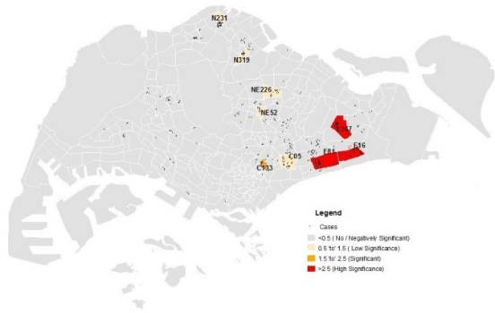
Sep | 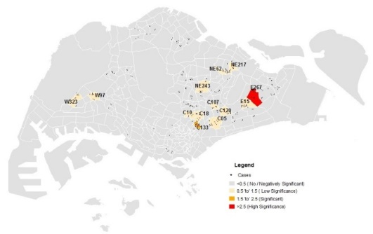 |  | 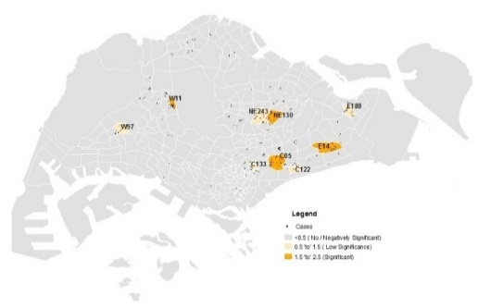 | 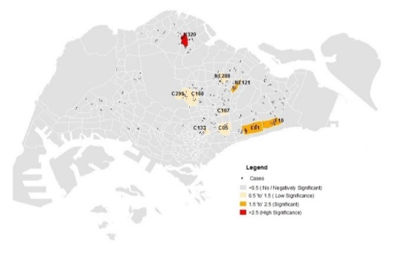 | 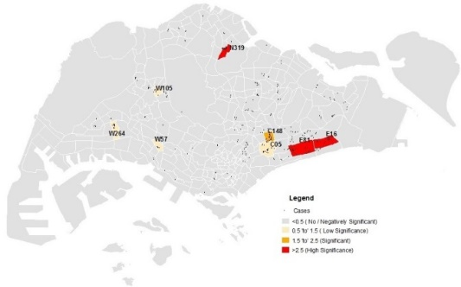
Oct | 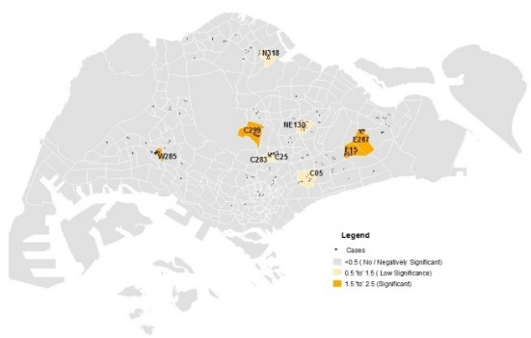 |  | 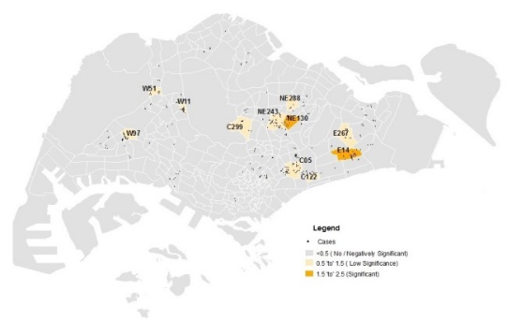 | 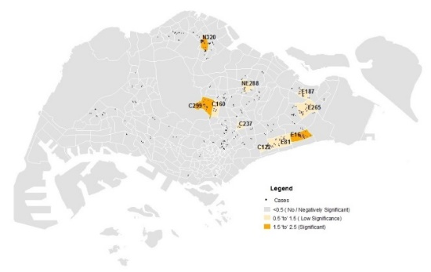 | 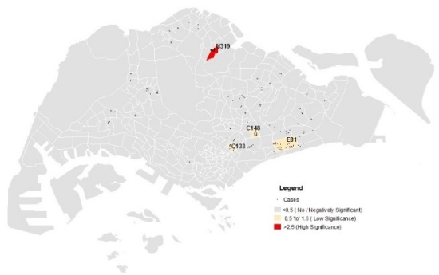
Nov | 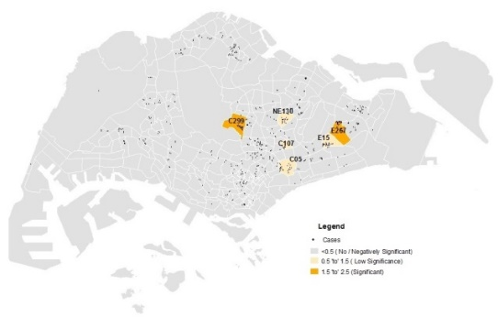 |  | 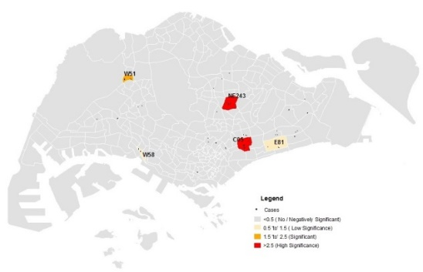 | 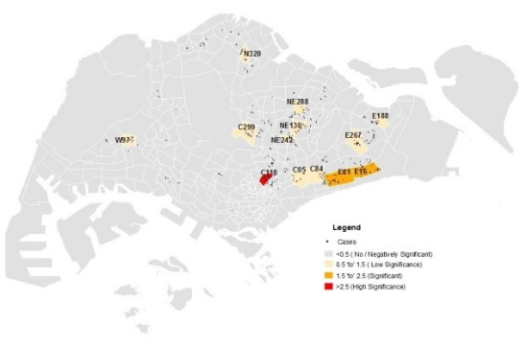 | 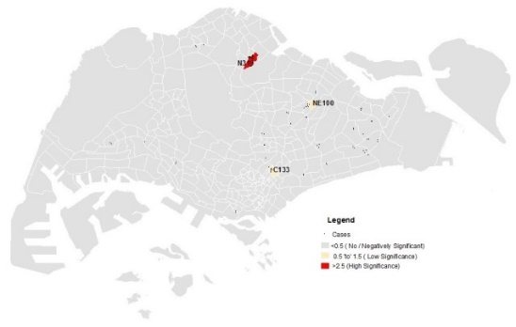
Dec | 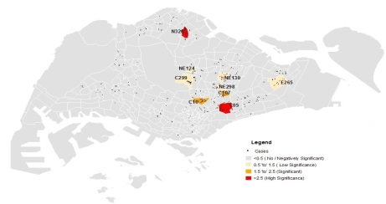 |  | 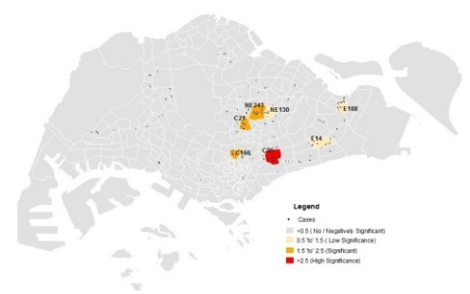 | 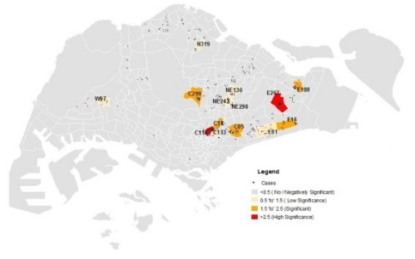 | 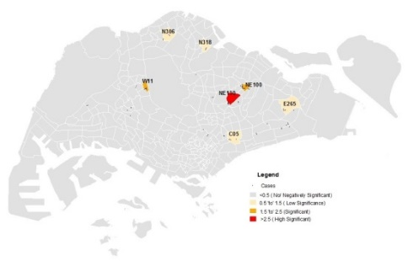
 | 2017 | 2018 |  | 2019 | 2020
Jan | 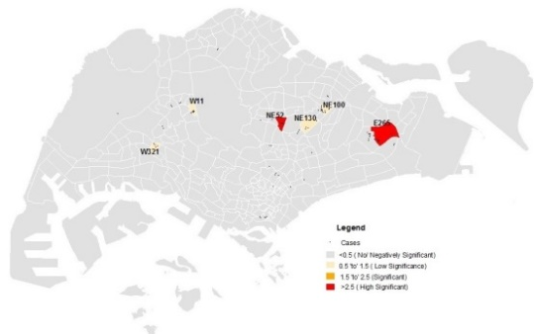 | 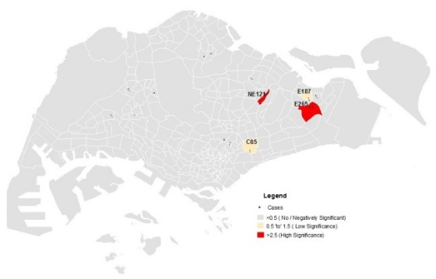 |  | 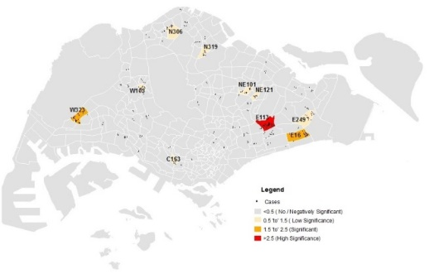 | 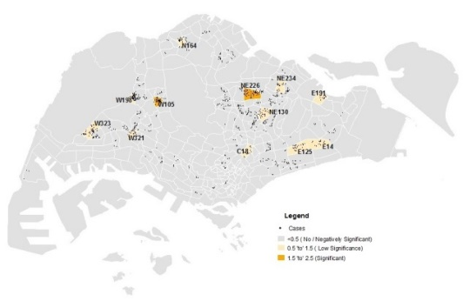
Feb | 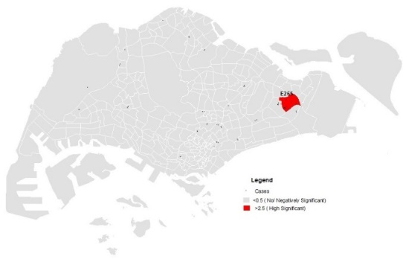 | 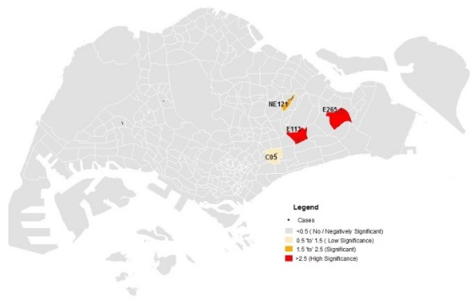 |  |  | 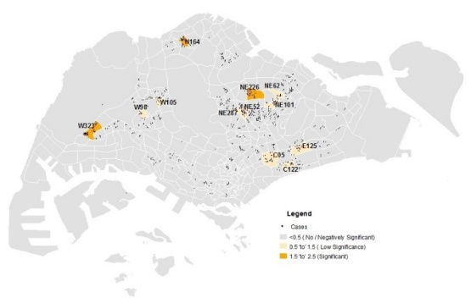
Mar | 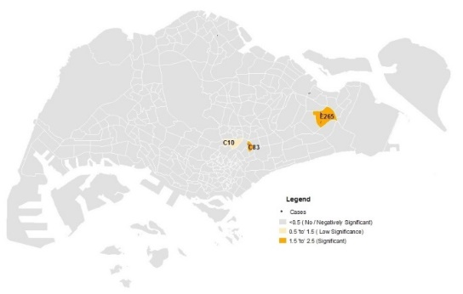 | 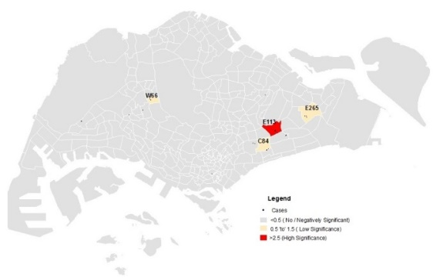 |  |  | 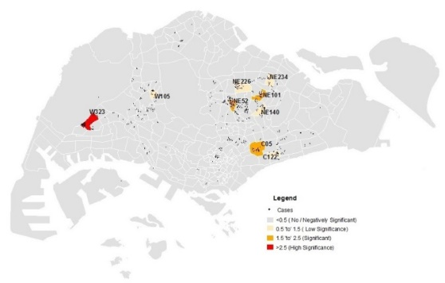
Apr | 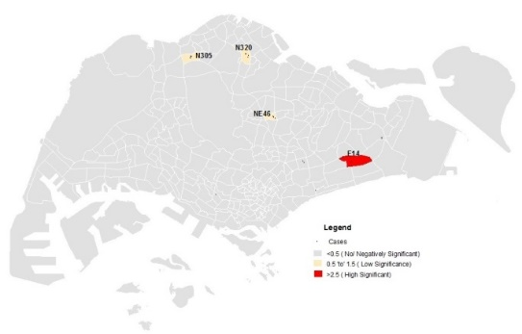 | 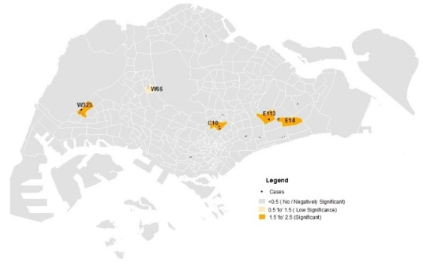 |  | 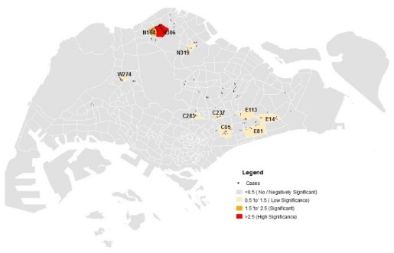
May | 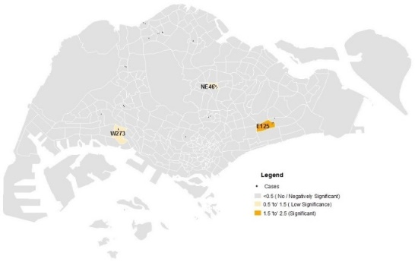 | 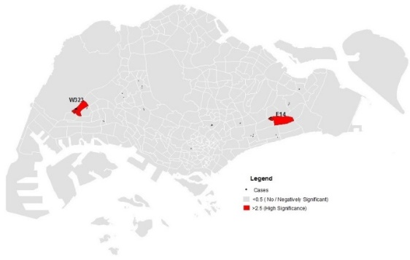 |  | 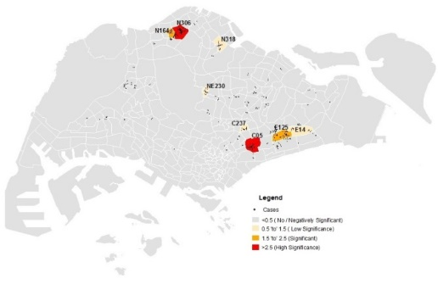
Jun | 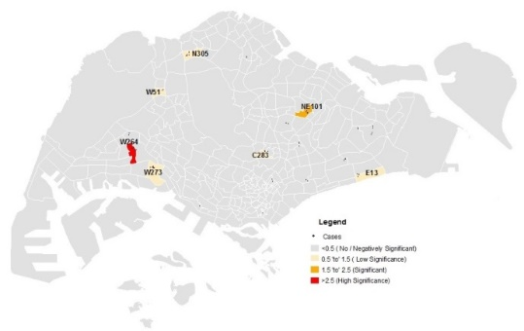 | 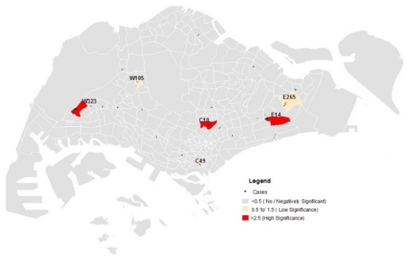 |  | 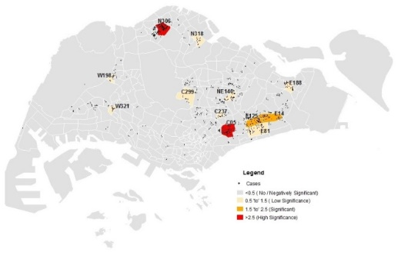
Jul | 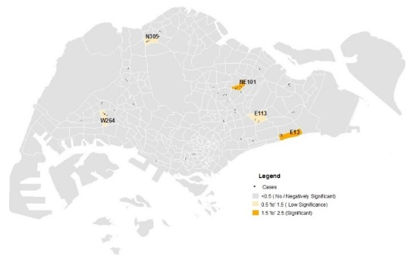 | 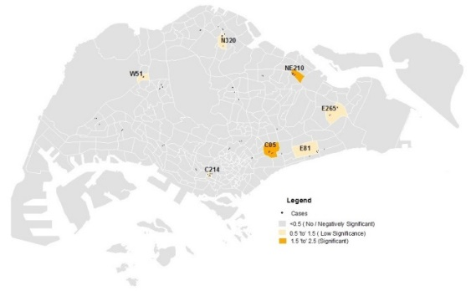 |  | 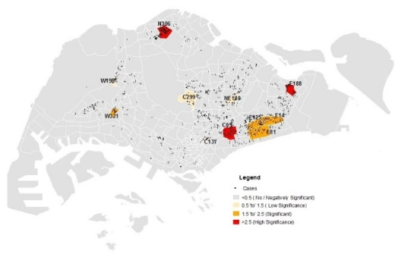
Aug | 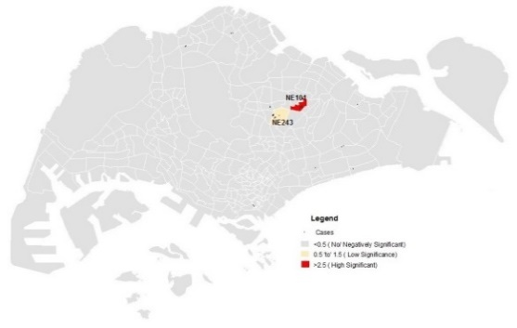 | 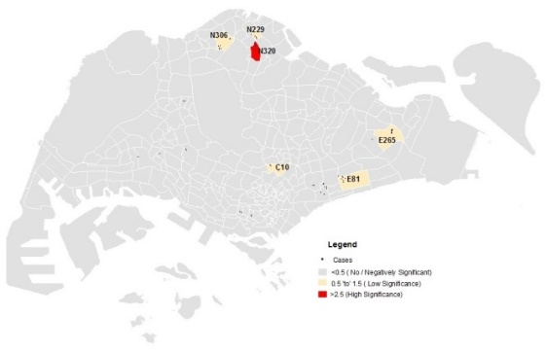 |  | 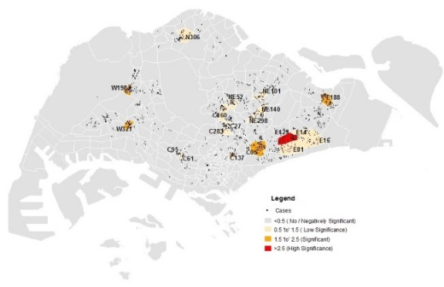
Sep | 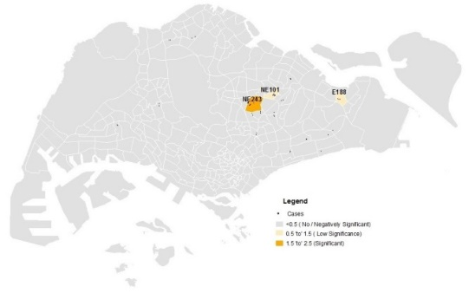 | 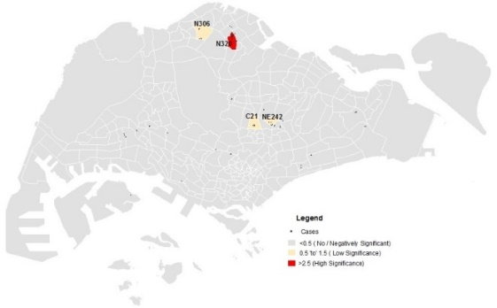 |  | 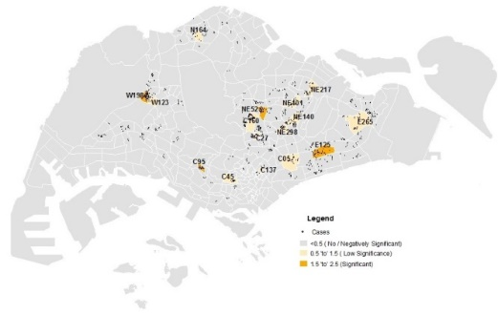
Oct | 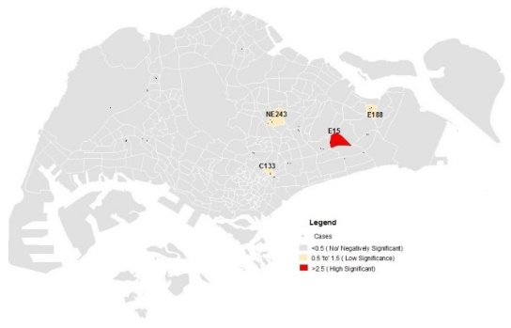 | 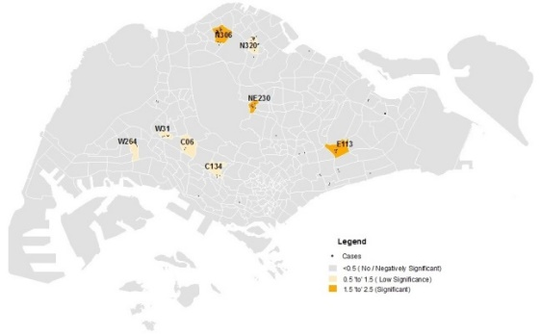 |  | 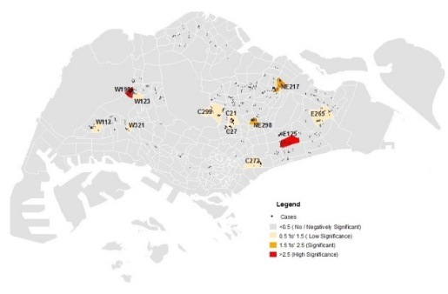
Nov | 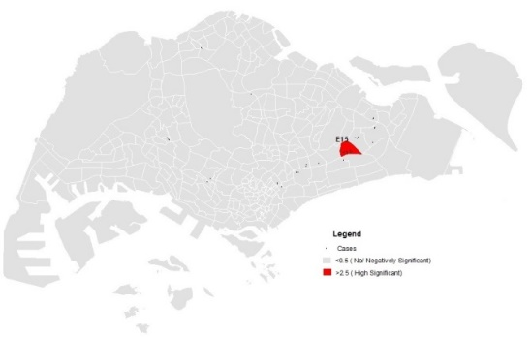 | 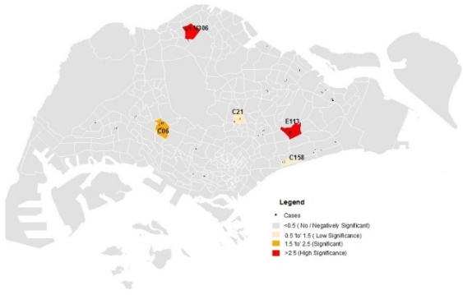 |  | 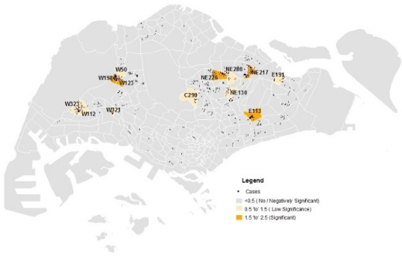
Dec | 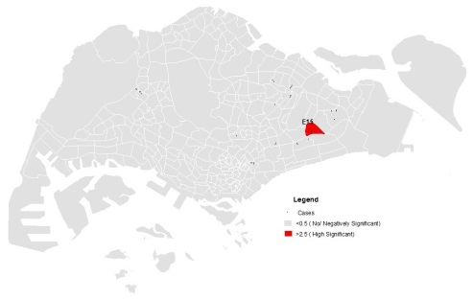 | 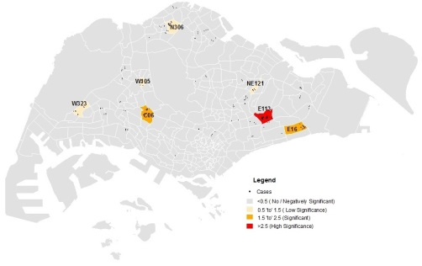 |  | 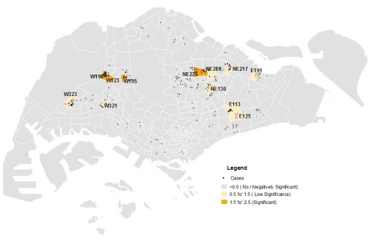
Figure S6: Significant Subzones by Months and Years

