Supplemental Figure

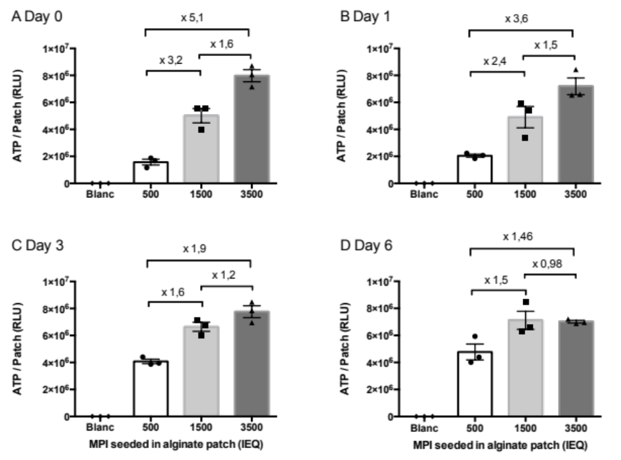

Supplemental Figure 1. MIN6 cell proliferation within encapsulated MPIs were encapsulated at 500, 1500, and 3500 IEQ/cm² in alginate sheets and cultured in the normoxic environment for 0, 1, 3, and 6 days (A to D). ATP content measurement allowed monitoring of MIN6 cell proliferation within the encapsulated MPIs over time. Linearity between fold increase in ATP content (mentioned in plots) and fold increase in islet density was maintained only on day 0 and 1 of culture, suggesting different proliferation rates according to islet seeding density during longer culture periods. Results are presented as the mean ± SEM.

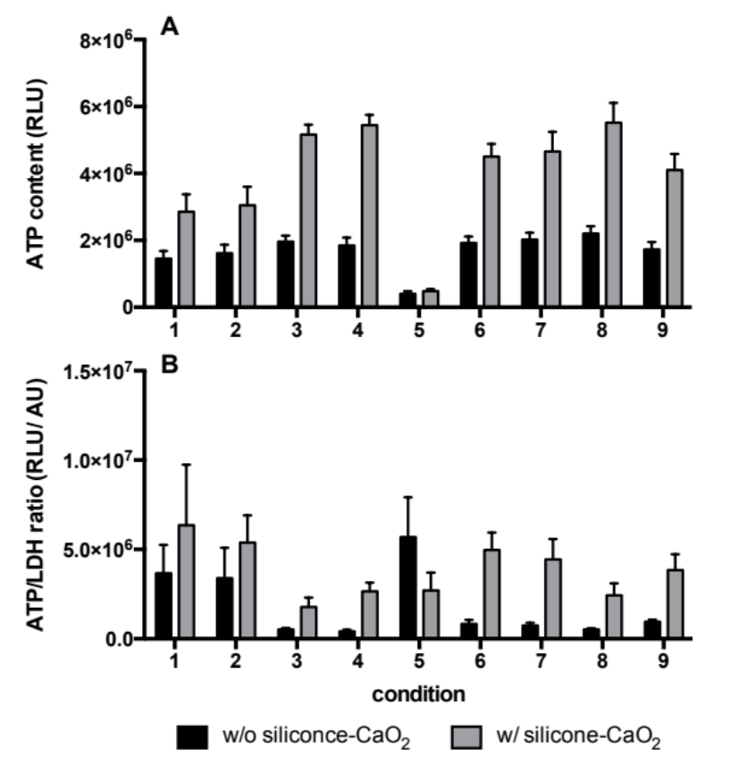

Supplemental Figure 2. Raw data from the optimization DoE Raw data of ATP content (A) and ATP/LDH ratio (B) are represented according to the conditions tested in the optimization experimental plan without (black bars) and with (grey bars) the silicone-CaO₂ disk of MIN6 pseudo-islets cultured under hypoxia (1% O₂) for 24 h. Data are expressed as mean ± SEM of independent experiments (n=5–6).

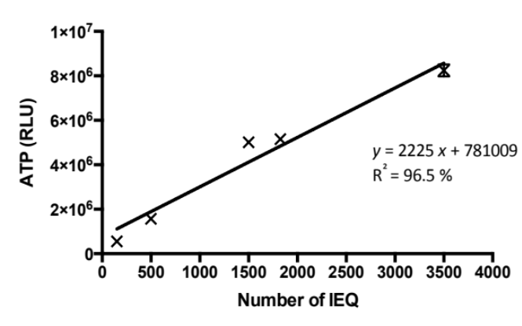

Supplemental Figure 3. Standard curve of ATP content according to the MIN6 pseudo-islets seeding density in alginate sheets. ATP content was measured on day 0 after encapsulation of MPIs in alginate sheets at densities ranging from 150 to 3,500 IEQ per sheet. Linear regression allowed the estimation of the quantity of viable islets in the BAP composed of two alginate sheets.

Supplemental Figure 4. PDX-1 expression in neonate pig islets (NPIs) within BAPs. Staining was performed on NPIs before encapsulation (day 1) and on NPIs recovered from the BAP through a de-encapsulation process after 8 days of culture under both positive and negative controls, respectively. Normoxia (20% O₂) and hypoxia (1% O₂) and under the hypoxic condition with the O₂ strategy. The nuclei are counterstained blue with hematoxylin. In each column, the three captions correspond to three different neonate pigs. Scale bars are 20 μm.

Supplemental Tables

Supplemental Table 1. Analysis of variance for ATP content from the screening DoE.
Factors | Sum of squares  (× 10¹¹) | Degrees of freedom | Mean square  (× 10¹¹) | F ratio | p-value
A Hemoxcell | 145.81 | 1 | 145.81 | 8.80 | 0.0109
B Silicone-CaO₂ | 439.51 | 1 | 439.51 | 26.53 | 0.0002
C O₂ tension | 226.73 | 1 | 226.73 | 13.69 | 0.0027
AB interaction | 150.30 | 1 | 150.30 | 9.07 | 0.0100
AC interaction | 21.16 | 1 | 21.16 | 1.28 | 0.2788
BC interaction | 1526.42 | 1 | 1526.42 | 92.15 | 0.0000
Block | 168.28 | 2 | 84.14 | 5.08 | 0.0234
Residual error | 215.33 | 13 | 16.56
Total error | 3134.30 | 21
Determination coefficient R² | 0.93

Supplemental Table 2. Analysis of variance for LDH release from the screening DoE.
Factors | Sum of squares | Degrees of freedom | Mean square  (× 10¹¹) | F ratio | p-value
A Hemoxcell | 118.75 | 1 | 118.75 | 1.20 | 0.2928
B Silicone-CaO₂ | 4137.73 | 1 | 4137.73 | 41.88 | 0.0000
C O₂ tension | 911.37 | 1 | 911.37 | 9.22 | 0.0095
AB interaction | 333.71 | 1 | 333.71 | 3.38 | 0.0890
AC interaction | 44.22 | 1 | 44.22 | 0.45 | 0.5152
BC interaction | 9.37 | 1 | 9.37 | 0.09 | 0.7630
Block | 1504.12 | 2 | 752.06 | 7.61 | 0.0065
Residual error | 1284.39 | 13 | 98.80
Total error | 9010.97 | 21
Determination coefficient R² | 0.86

Supplemental Table 3. Analysis of variance for insulin stimulation index from the screening DoE.
Factors | Sum of squares | Degrees of freedom | Mean square | F ratio | p-value
A Hemoxcell | 0.66 | 1 | 0.66 | 1.11 | 0.3160
B Silicone-CaO₂ | 2.60 | 1 | 2.60 | 4.36 | 0.0633
C O₂ tension | 11.65 | 1 | 11.65 | 19.56 | 0.0013
AB interaction | 0.93 | 1 | 0.93 | 1.56 | 0.2404
AC interaction | 0.94 | 1 | 0.94 | 1.58 | 0.2380
BC interaction | 0.11 | 1 | 0.11 | 0.18 | 0.6838
Block | 7.08 | 2 | 3.54 | 5.94 | 0.0199
Residual error | 5.96 | 13 | 0.60
Total error | 30.53 | 21
Determination coefficient R² | 0.81

Supplemental Table 4. Analysis of variance for ATP content from the optimization DoE with the silicone-CaO₂ disk.
Factors | Sum of squares  (× 10¹¹) | Degrees of freedom | Mean square  (× 10¹¹) | F ratio | p-value
A Hemoxcell concentration | 37.95 | 1 | 37.95 | 0.87 | 0.3686
B Islet seeding density | 3440.50 | 1 | 3440.50 | 79.11 | 0.0000
AA | 144.06 | 1 | 144.06 | 3.31 | 0.0938
BB | 160.23 | 1 | 160.23 | 3.68 | 0.0790
AB interaction | 13.73 | 1 | 13.73 | 0.32 | 0.5841
Block | 1300.14 | 3 | 433.38 | 9.97 | 0.0014
Lack-of-fit test | 708.58 | 27 | 26.24 | 0.60 | 0.8660
Residual error | 521.88 | 12 | 43.49
Total error | 6392.18 | 47
Determination coefficient R² | 0.81

Supplemental Table 5. Analysis of variance for ATP/LDH ratio from the optimization DoE with the silicone-CaO₂ disk.
Factors | Sum of squares  (× 10¹¹) | Degrees of freedom | Mean square  (× 10¹¹) | F ratio | p-value
A Hemoxcell concentration | 89.30 | 1 | 89.30 | 0.12 | 0.7367
B Islet seeding density | 430.71 | 1 | 430.71 | 0.58 | 0.4658
AA | 16.24 | 1 | 16.24 | 0.02 | 0.8857
BB | 1269.91 | 1 | 1269.91 | 1.71 | 0.2234
AB interaction | 311.01 | 1 | 311.01 | 0.02 | 0.5337
Block | 3064.12 | 2 | 1532.06 | 2.06 | 0.1830
Lack-of-fit test | 2842.79 | 19 | 149.62 | 0.20 | 0.9984
Residual error | 6682.54 | 9 | 742.51
Total error | 14827.60 | 35
Determination coefficient R² | 0.36

Supplemental Table 6. Regression coefficients from optimization DoE with the silicone-CaO₂ disk.
Regression coefficients | ATP content  (RLU) | ATP/LDH ratio  (RLU/AU)
β₀ | 3.02 × 10⁶ | 12.38 × 10⁶
β_{A} | -1.69 × 10⁴ | -2.56 × 10⁴
β_{B} | 2197.14 | 1609.90
β_{AB} | 0.77 | 4.23
β_{AA} | 29.54 | 11.45
β_{BB} | -0.14 | -0.46

