Supporting Information

A Mitochondria-targeted Fluoropolymer Nanoparticle with Inherent Mitophagy Inducing and Red Fluorescence Properties for Treatment of Atherosclerosis
Mengxiao Liang^{1#}, Shengzhe Ruan^{2#}, Qian Wang^{3#}, Yuxue Cheng¹, Jiaqi Li¹, Changping Wang^{2*}, Yiyun Cheng^{4*}, Hui Wang^{1*}
¹South China Advanced Institute for Soft Matter Science and Technology, School of Emergent Soft Matter, South China University of Technology, Guangzhou, 510640, China.
²Department of Orthopedics, Shanghai General Hospital, Shanghai Jiao Tong University School of Medicine, Shanghai, 200080, China.
³Department of Oncology, Shanghai Ninth People's Hospital, Shanghai Jiao Tong University School of Medicine, Shanghai, 201999, China.
⁴Shanghai Key Laboratory of Regulatory Biology, School of Life Sciences, East China Normal University, Shanghai, 200241, China.
# Mengxiao Liang, Shengzhe Ruan and Qian Wang contributed equally to this work.
*Corresponding author. E-mail: wangchp@sjtu.edu.cn, yycheng@mail.ustc.edu.cn, wangh@scut.edu.cn.

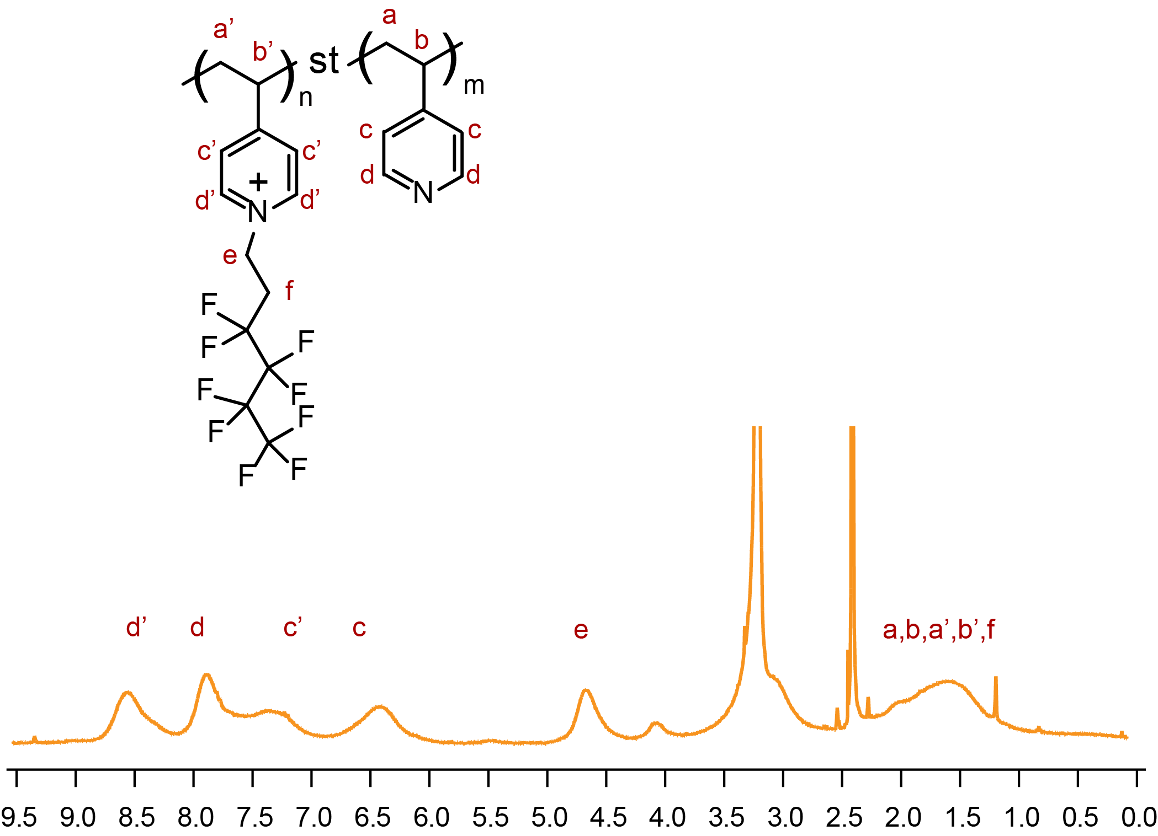
Figure S1. ¹H NMR spectrum of PF in d6-DMSO.

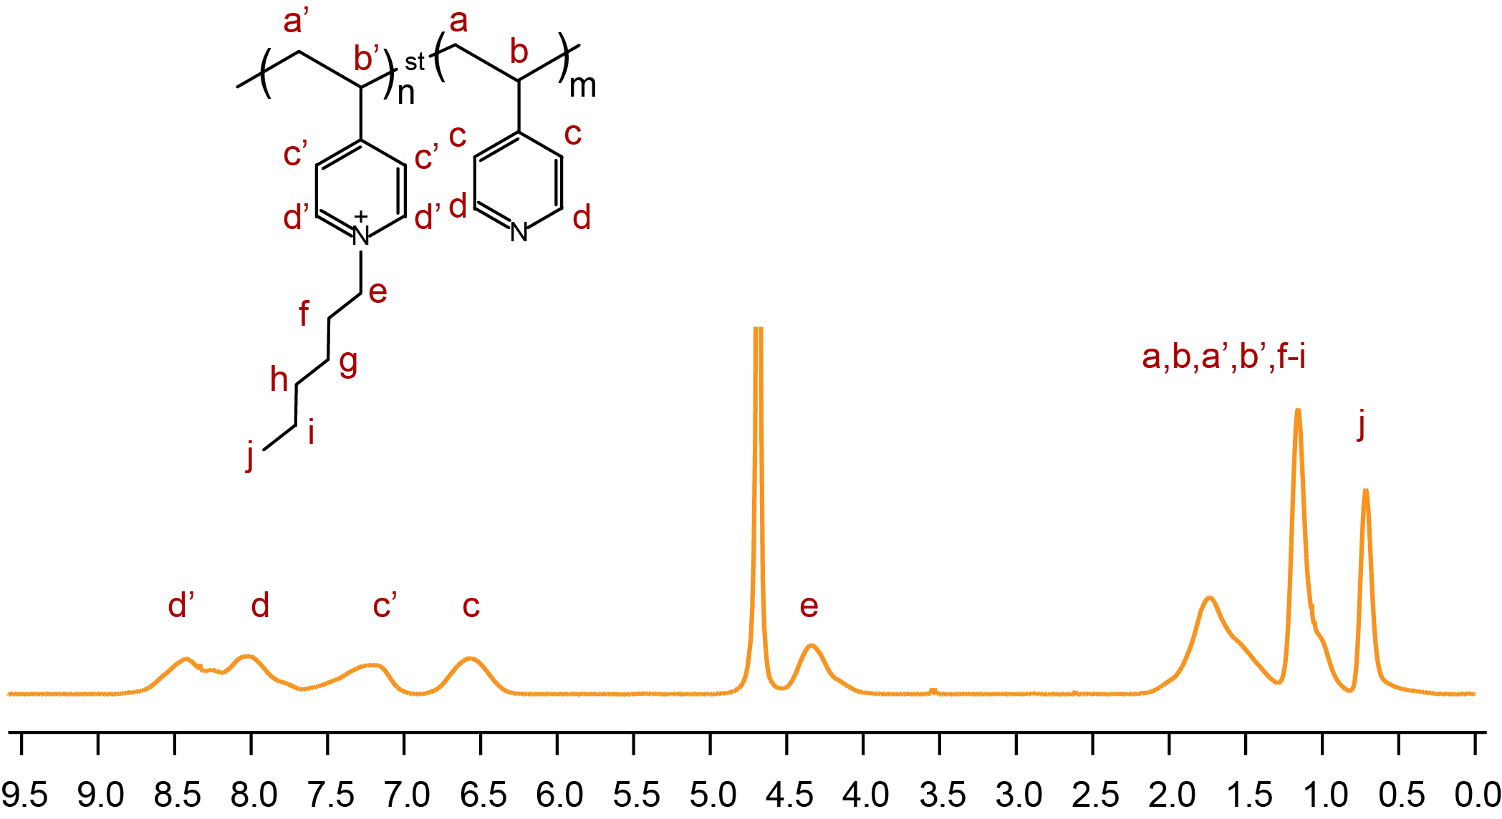
Figure S2. ¹H NMR spectrum of PC in D₂O.

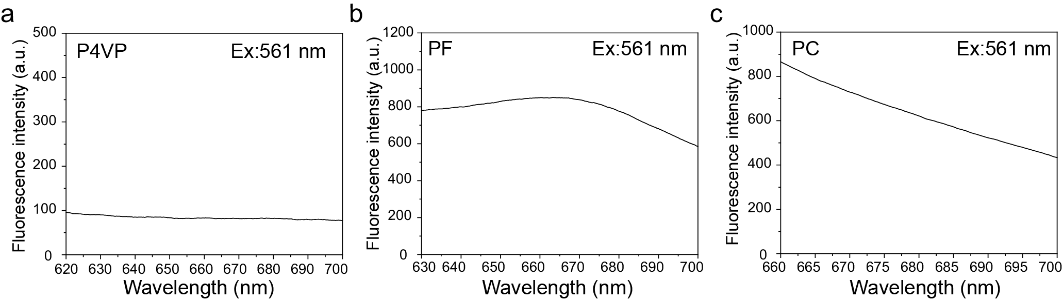
Figure S3. The fluorescence spectra of P4VP, PF, and PC in 20:80 (v/v) DMSO/DCM at excitation wavelength of 561 nm.

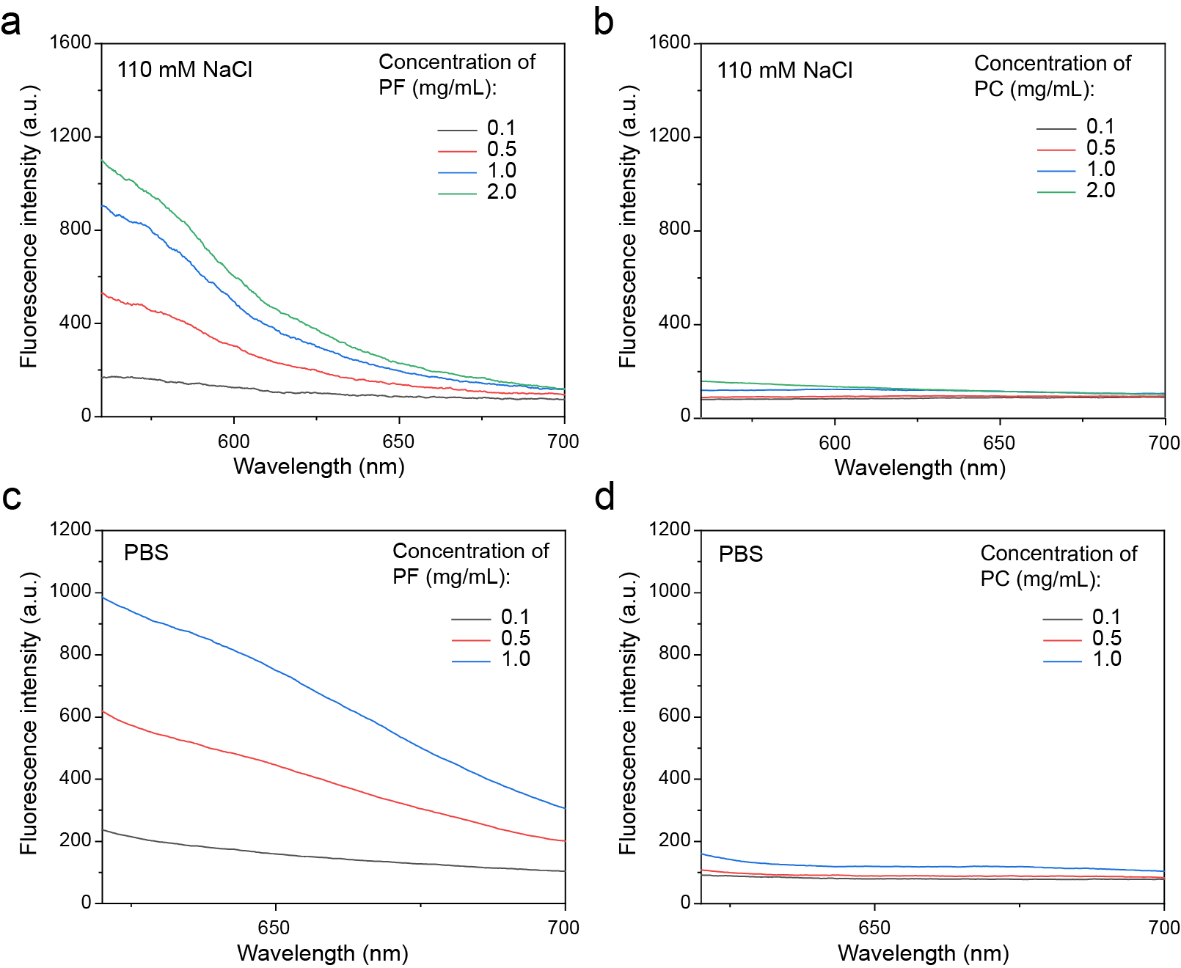
Figure S4. The fluorescence spectra of various concentrations of PF (a, c) and PC (b, d) in 110 mM NaCl solution (a, b) and PBS buffer (c, d). λ_{ex} = 561 nm.

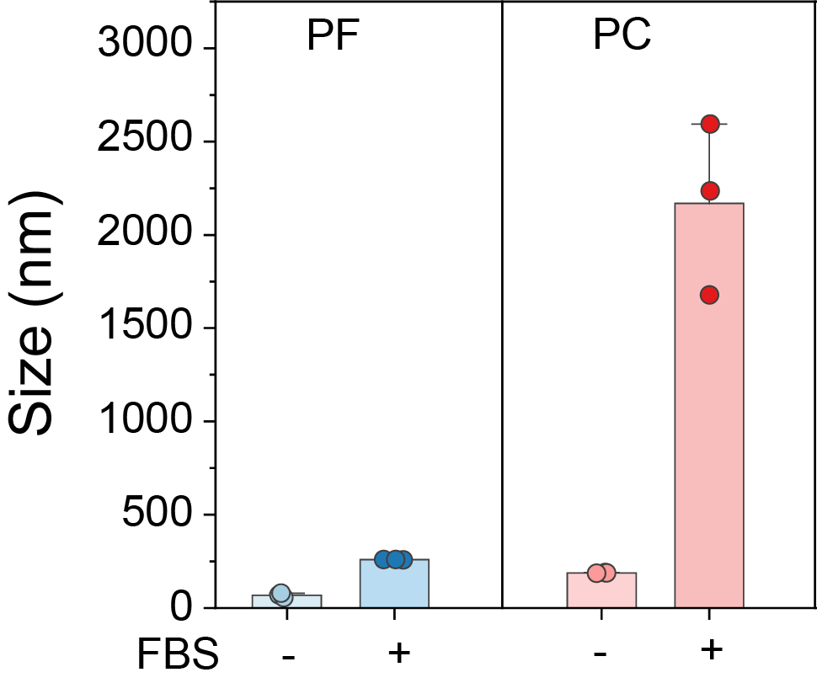
Figure S5. Average size of PF and PC in aqueous solution with and without 20% FBS (v/v). The concentrations of PF and PC were both 0.2 mg/mL.

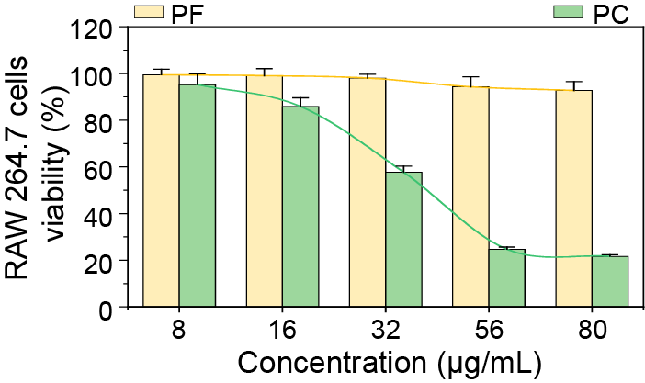
Figure S6. The cytotoxicity of PF and PC in RAW264.7 cells at various concentrations assessed by the CCK-8 assay. Data are presented as mean ± standard deviation (n=5).

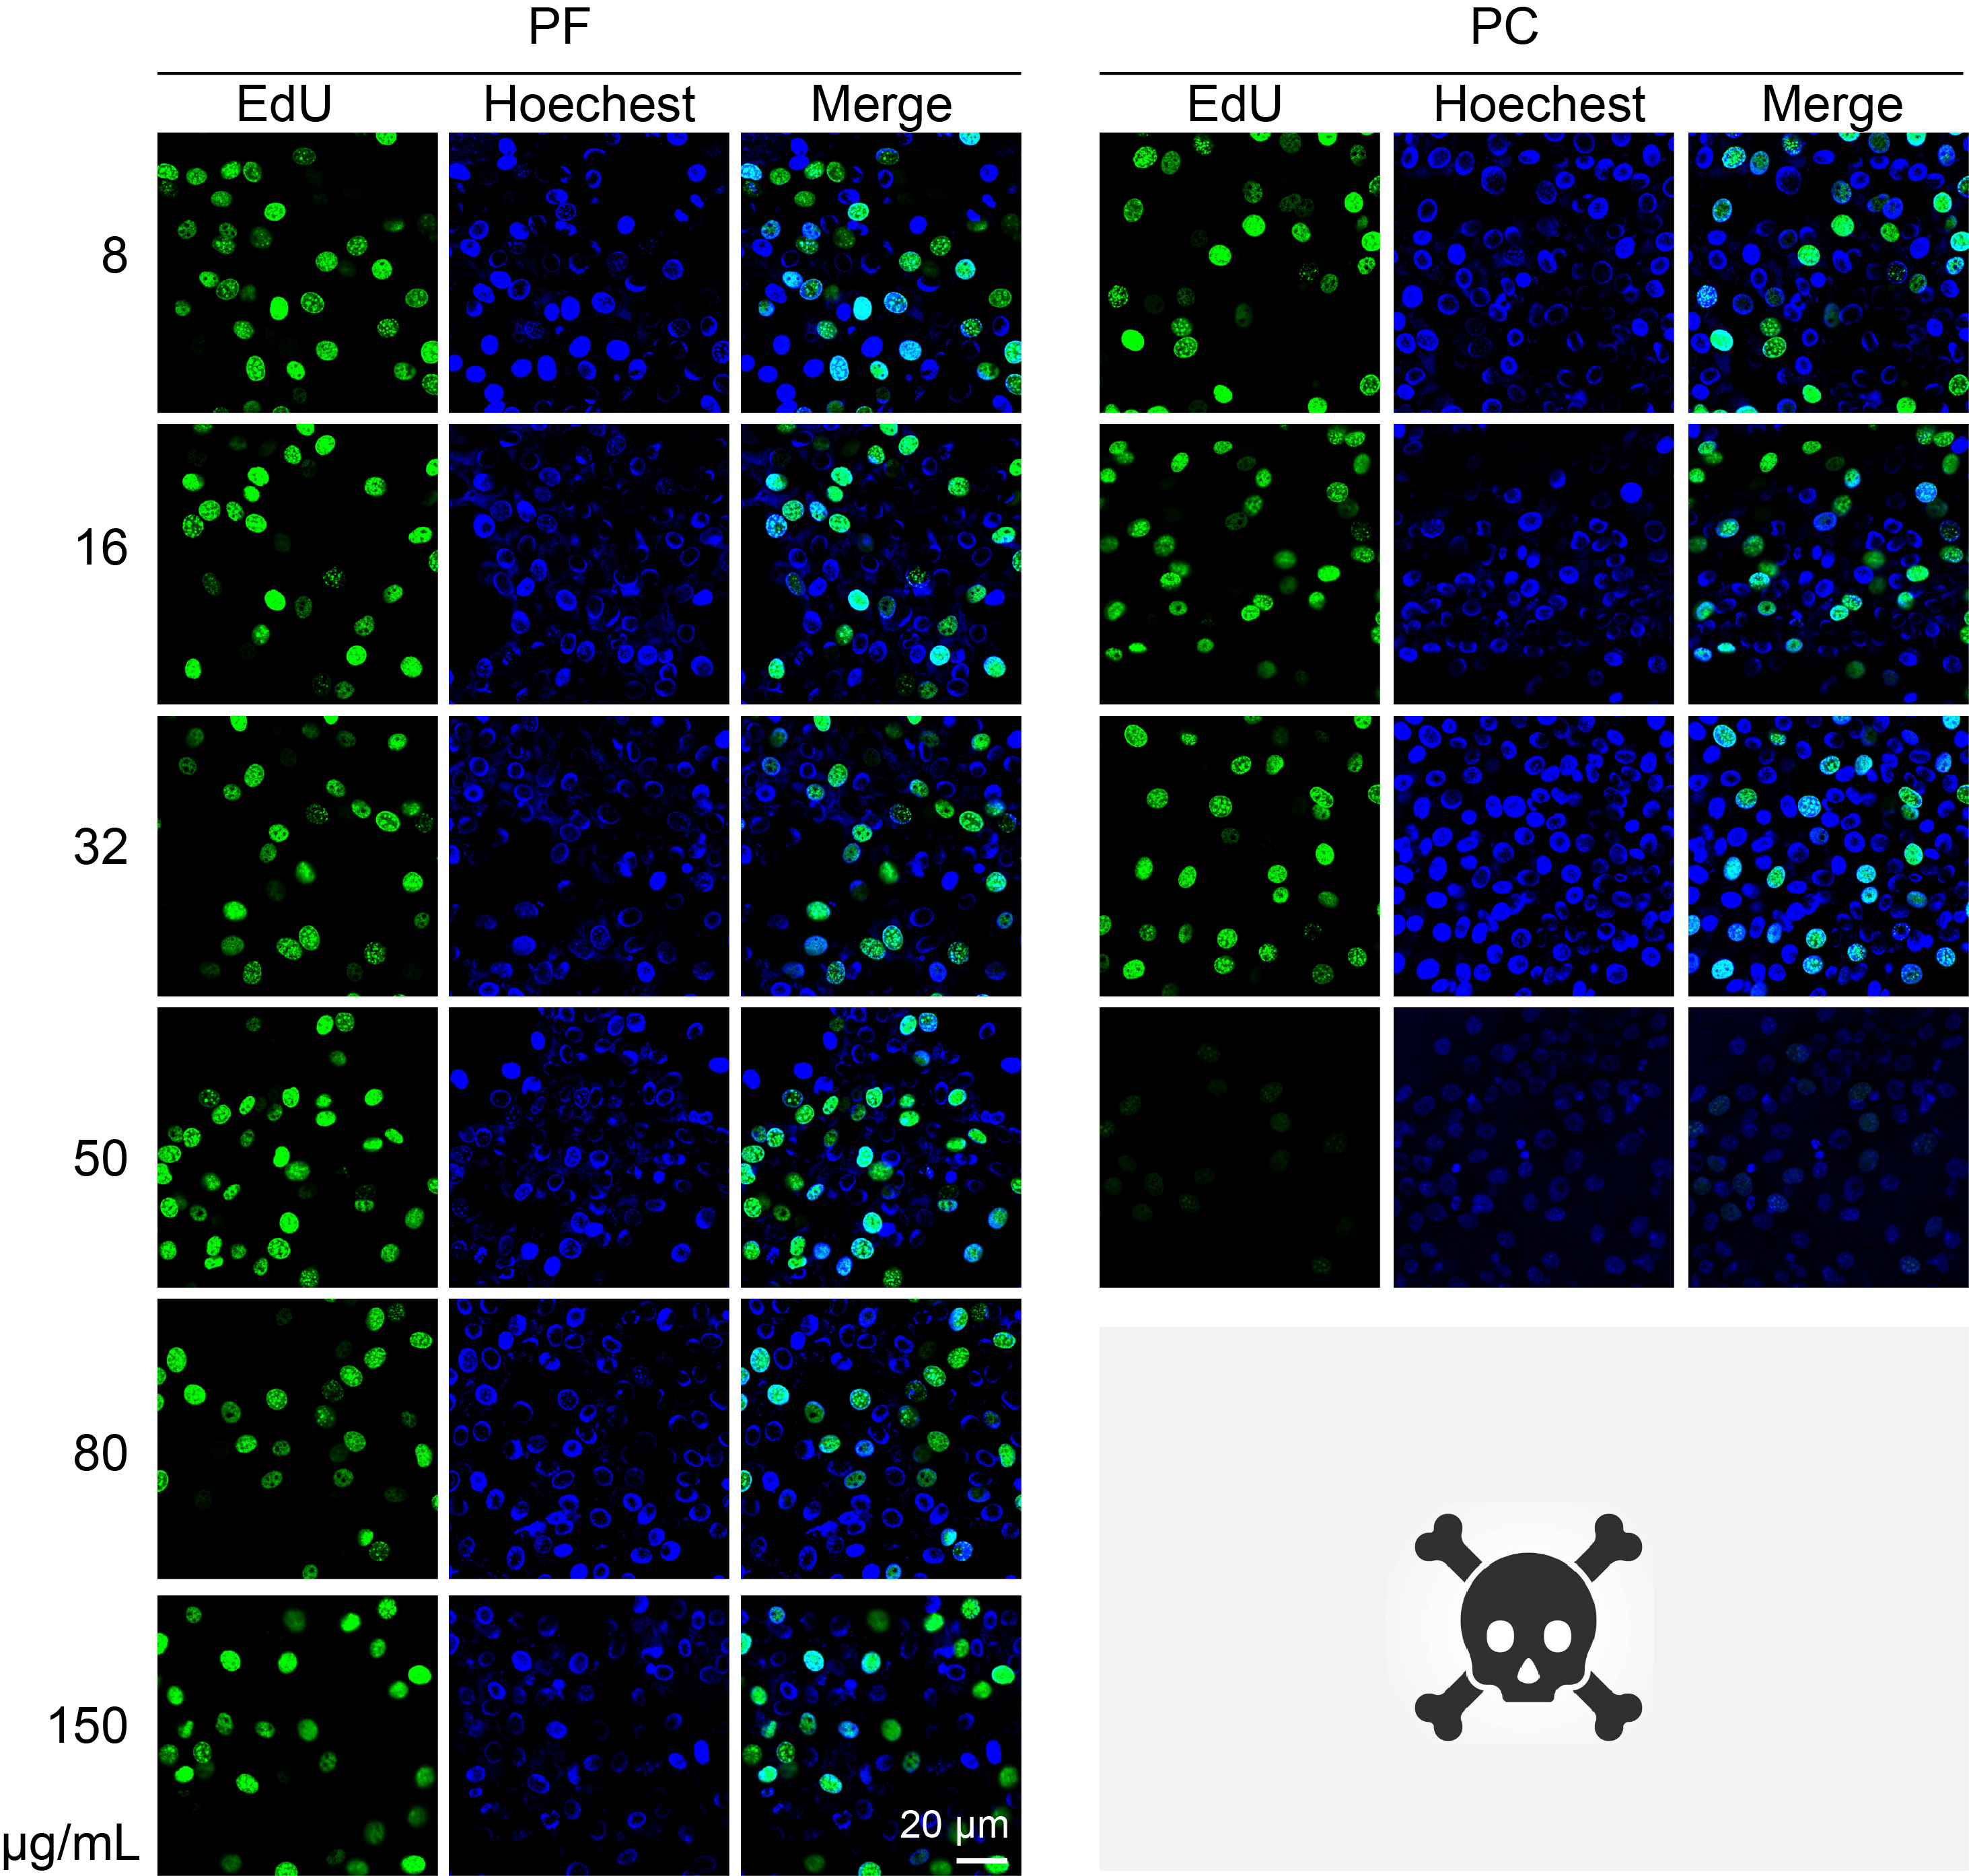
Figure S7. Confocal images of EdU-positive cells to evaluate cell proliferation in NIH 3T3 cells treated with various concentrations of PF and PC.

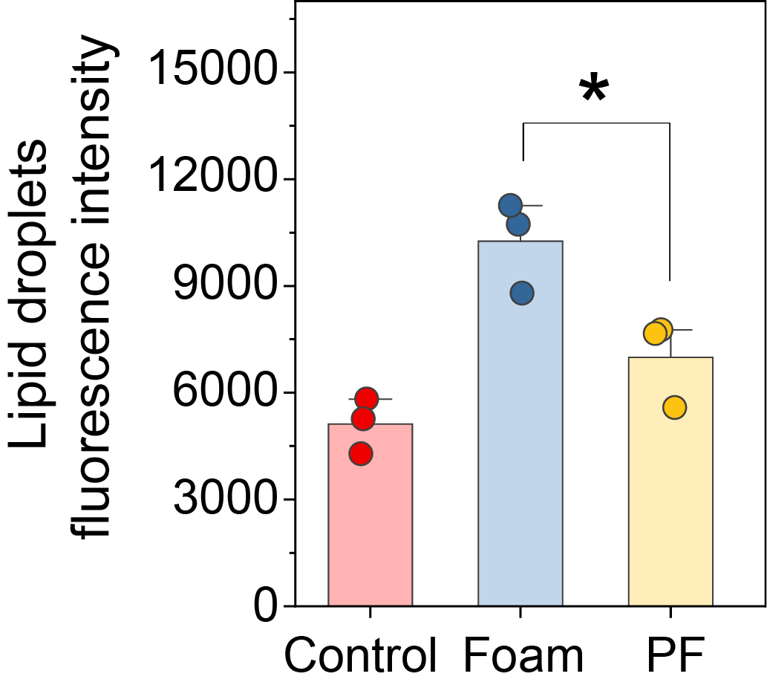
Figure S8. Quantitative analysis of lipid droplets in foam cells after a 6-hour incubation with PF. Lipid droplets were stained with BODIPY 493/503. The concentration of PF was 32 μg/mL. Data are presented as mean ± standard deviation (n=3). *p < 0.05.

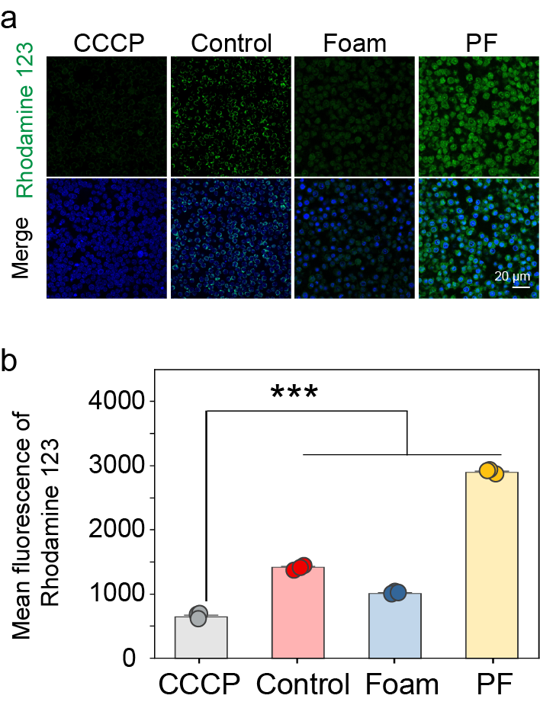
Figure S9. Confocal images and quantitative analysis of mitochondrial membrane potential (MMP) in foam cells treated with PF for 6 hours. MMP was measured using a mitochondrial membrane potential assay kit with Rhodamine 123. The CCCP treatment group was used as a negative control. The concentration of PF was 32 μg/mL. Data are presented as mean ± standard deviation (n=3). ***p < 0.001.

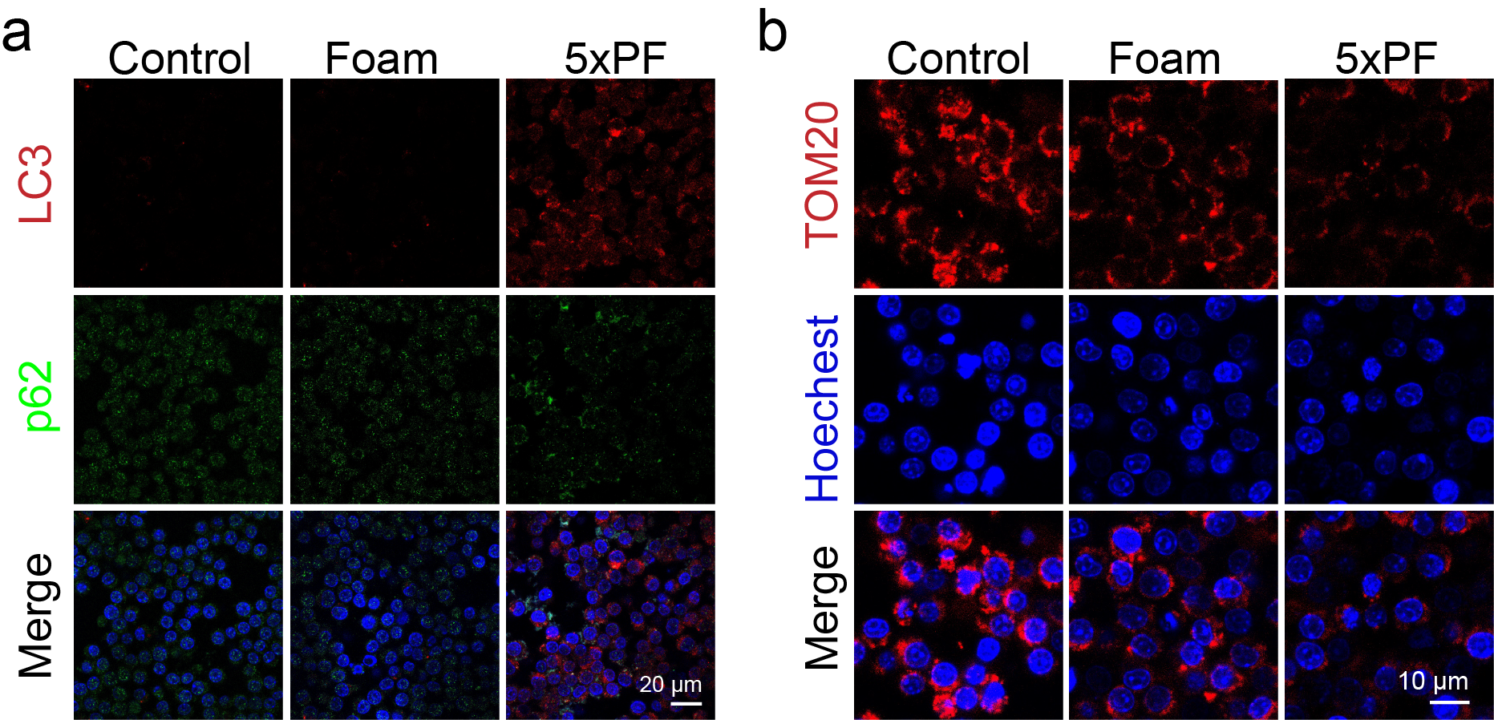
Figure S10. (a) Immunofluorescence images of LC3 and p62 in foam cells treated with 5xPF for 6 hours. Red, LC3; green, p62; blue, nucleus stained with Hoechst. (b) Immunofluorescence images of TOM20 in foam cells treated with 5xPF for 6 hours. Red, TOM20; blue, nucleus stained with Hoechst. The concentration of 5xPF was 160 μg/mL.

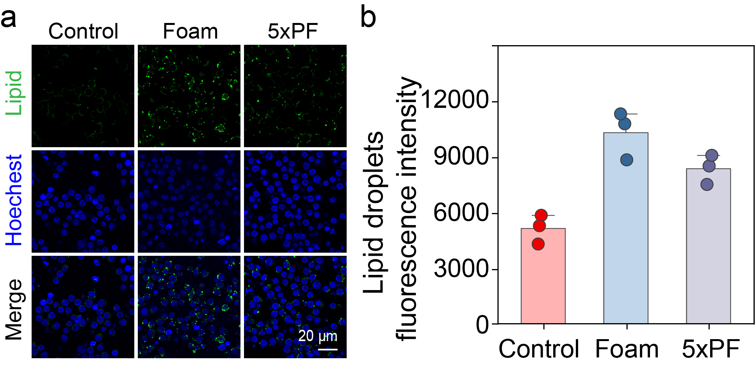
Figure S11. Confocal images (a) and quantitative analysis (b) of lipid droplets in foam cells after treatment with 5xPF for 6 hours. Lipid droplets were stained with BODIPY 493/503 (green). The concentration of 5xPF was 160 μg/mL.

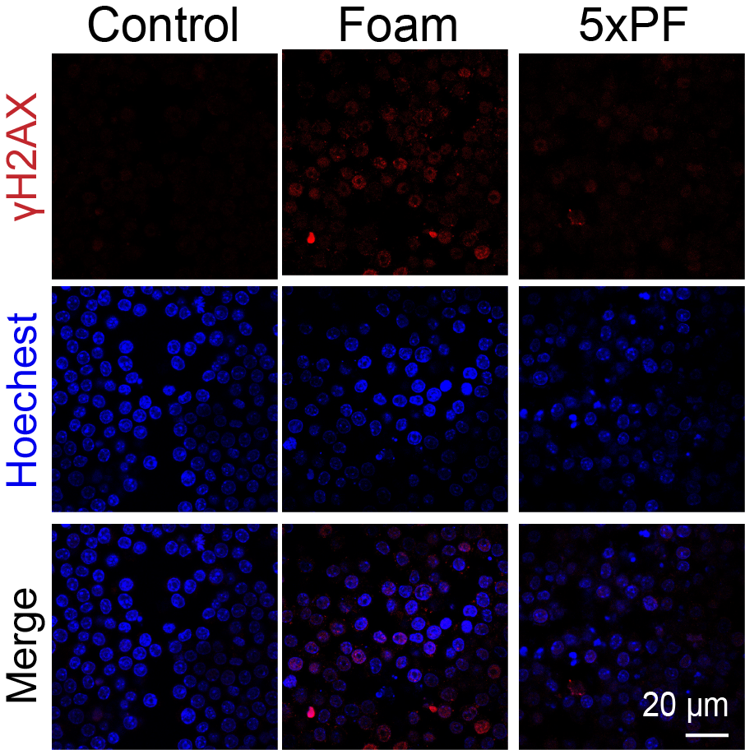
Figure S12. Immunofluorescence images of γH2AX in the foam cells after treatment with 5xPF for 6 hours. The concentration of 5xPF was 160 μg/mL. λ_{ex} = 647 nm.

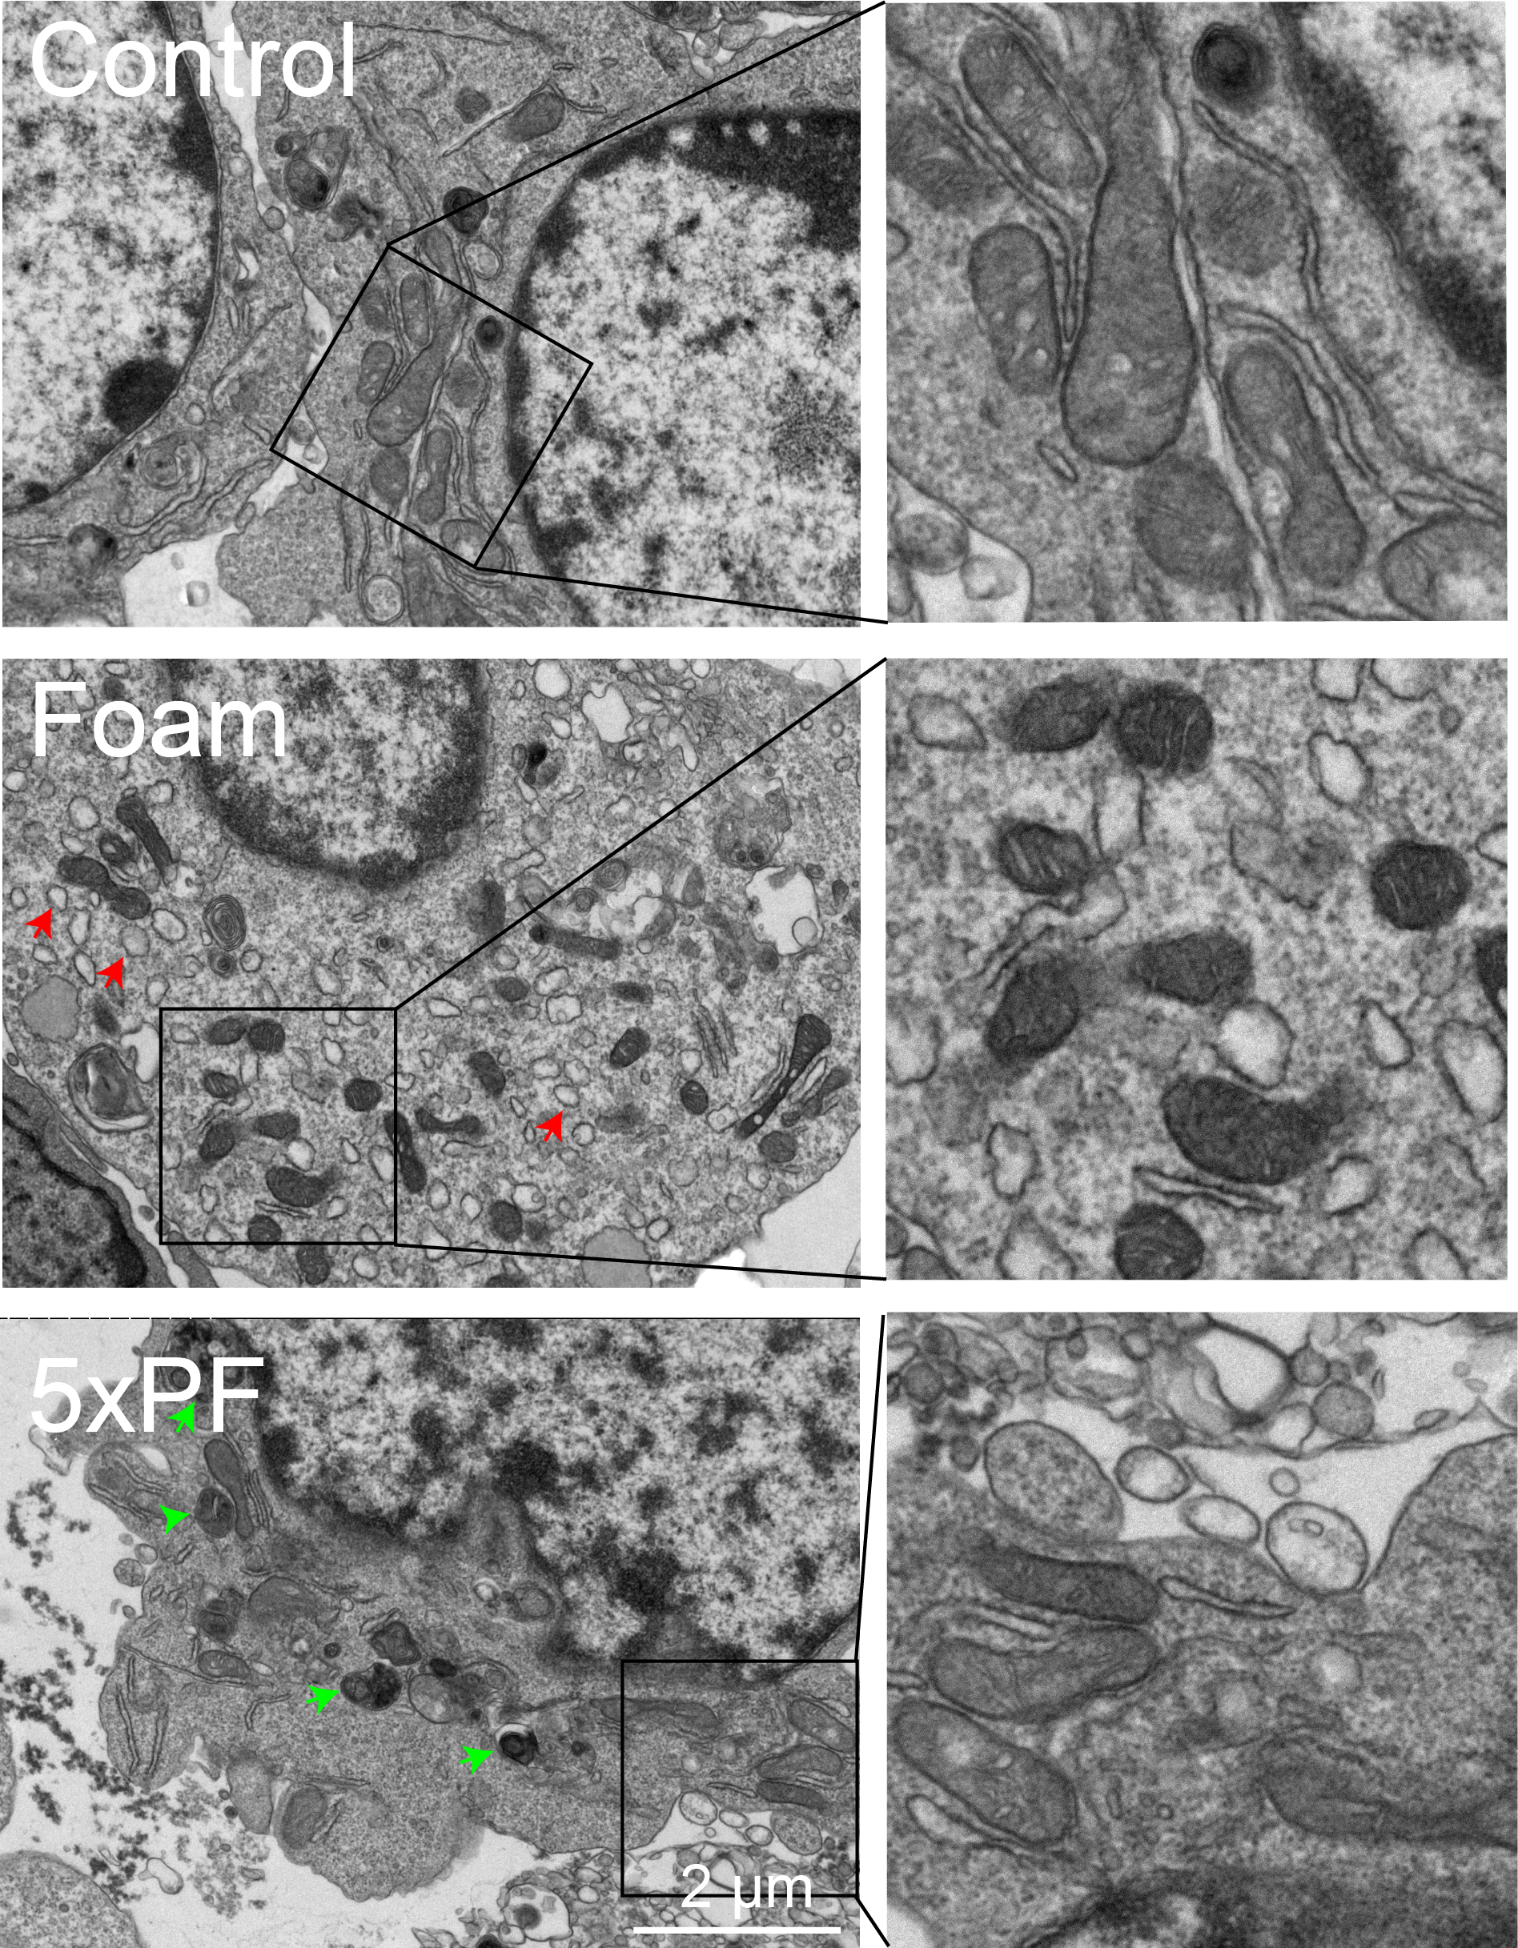
Figure S13. TEM images of mitochondria in RAW264.7 cells (control), foam cells (Foam) and 5xPF-treated foam cells (5xPF). The red arrow marks lipid droplets, and the green arrow marks autophagosomes encapsulating mitochondria. The concentration of 5xPF was 160 μg/mL. Scale bar: 2 μm.

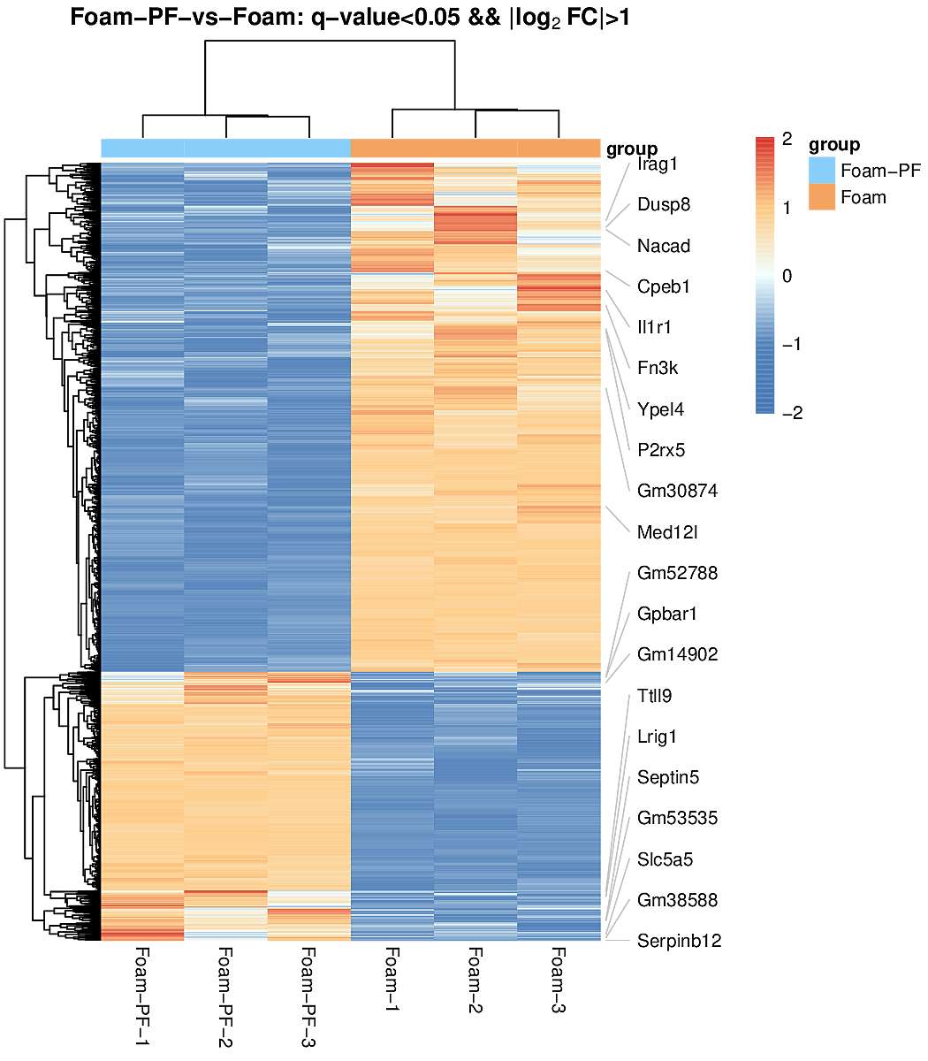
Figure S14. Heatmaps showing differentially expressed genes between foam cells with and without PF treatment.

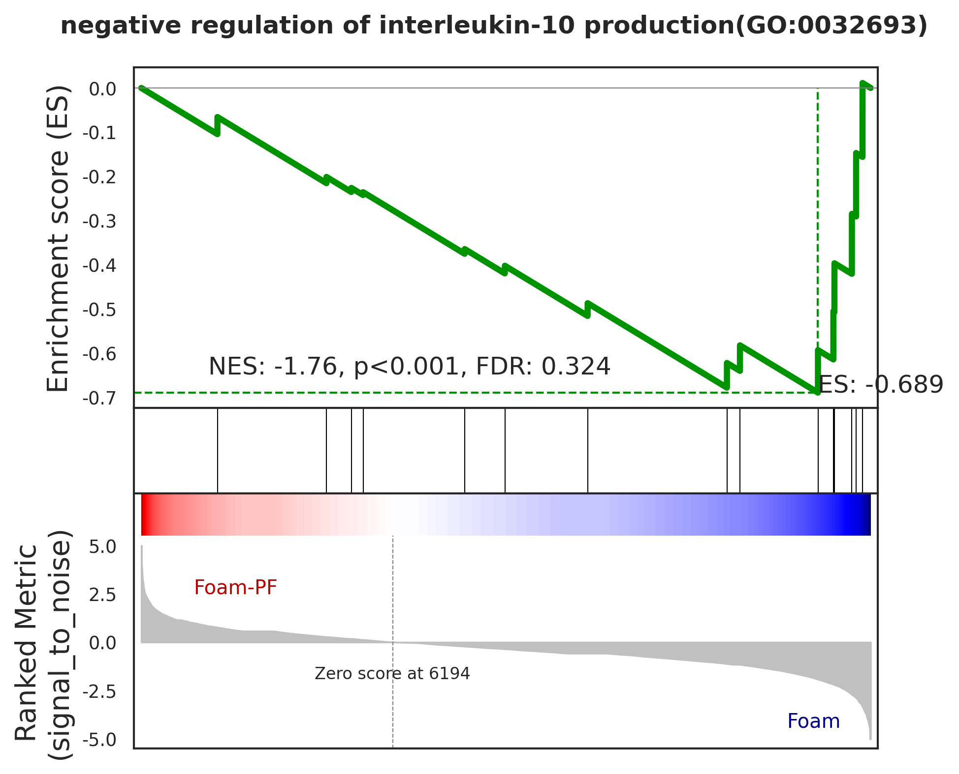
Figure S15. GSEA enrichment analysis of negative regulation of interleukin-10 production between foam cells with and without PF treatment.

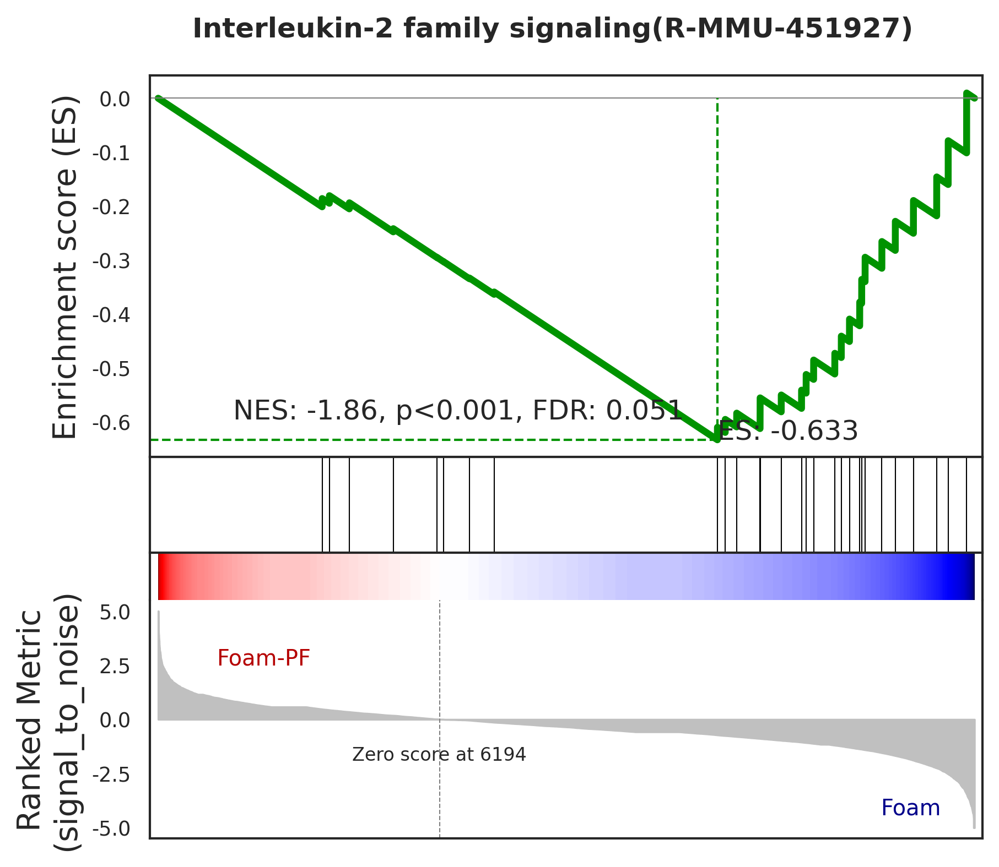
Figure S16. GSEA enrichment analysis of interleukin-2 family signaling between foam cells with and without PF treatment.

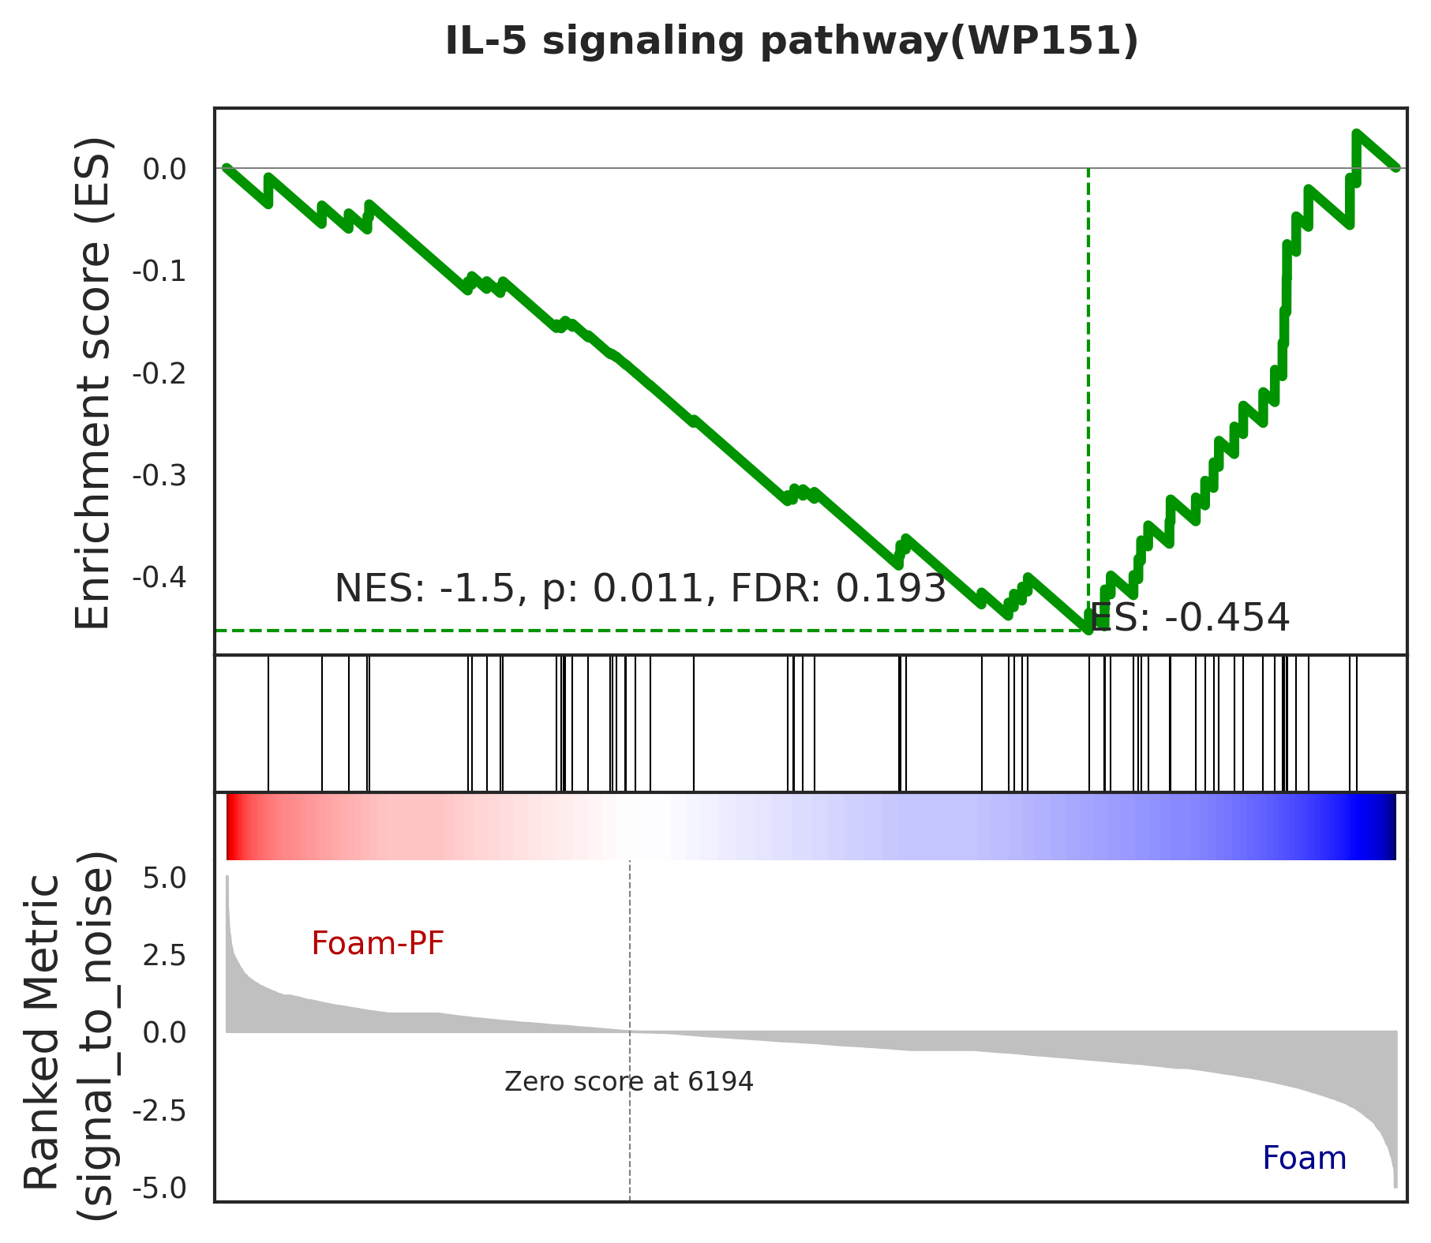
Figure S17. GSEA enrichment analysis of IL-5 signaling pathway between foam cells with and without PF treatment.

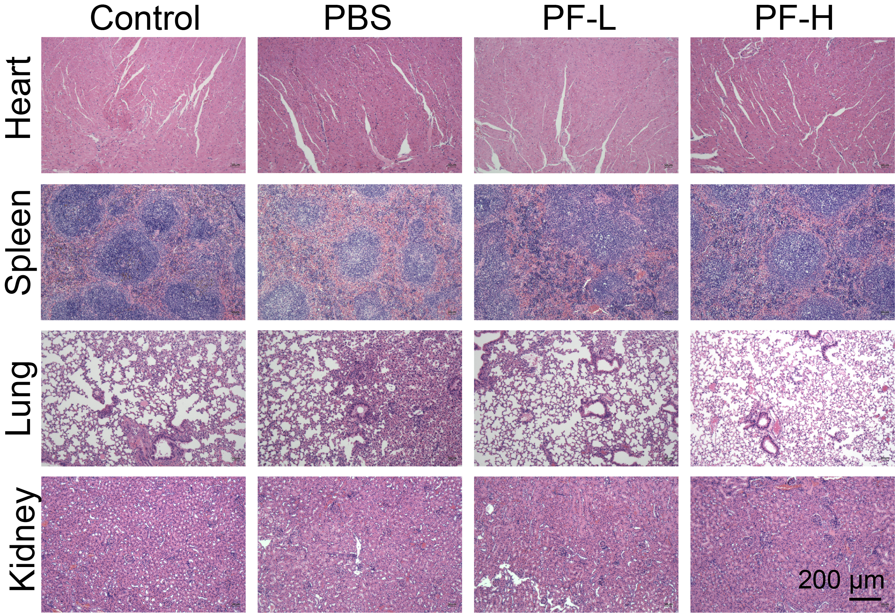
Figure S18. H&E staining images of major tissues in the mice after treatment.

