Supplementary information 1 – The study design

Study area
The Kgalagadi Transfrontier Park is a large (ca. 38,000 km²) wildlife preserve and conservation area within the southern Kalahari Desert, encompassing both the Northern region of South Africa and South-Western region of Botswana. The terrain consists of sparse vegetation within an undulating red sand dune environment [1]. Two fossilised riverbeds (Nossob and Auob rivers) intercept this environment [1]. Artificial water holes are located along both riverbeds. As of 2005, this wildlife reserve is considered both a lion conservation unit and stronghold in Southern Africa [2]. Dirt roads used by tourists and park rangers follow close to the fossilised riverbeds.

Collar design and set up
Fifteen LiteTrack GPS collar systems (six iridium and nine store-on-board) from Lotek Wireless Inc. [3] were deployed. Twelve of these were fitted with Gypsy_5 Techno-smart GPS units (see later) and data from eleven analysed for this study. LiteTrack GPS units were pre-programmed to record one fix every 30 minutes. Iridium collars transmitted stored fixes every six hours. A magnet activated timed drop-off mechanism was fitted to each collar. There were two different collar sizes; five ‘large’ collars (two iridium, three store-on board), with an internal circumference range of 81-87 cm and ten ‘small’ collars (four iridium and six store-on-board), with an internal circumference range of 64-71 cm.
Daily diary (DD) logging units [cf. 4] recording at 40 Hz, enclosed in a water-tight aluminium housing were fitted to one side of the collar. DD units were coated with electro-lube clear protective lacquer and the inside of the housings were coated with insulating tape to prevent short-circuiting. Orthogonal acceleration measurements were logged as acceleration with respect to gravity (1 g = 9.81 m/s⁻², measuring within the range of ± 16 g) and orthogonal magnetometry measurements were recorded in Gauss (G) (magnetic intensity recorded within the range of ± 0.88 G at 0.73 mG/LSB resolution). DD’s were powered by 3 parallel circuited A-cell batteries. The combined weight of a fully equipped DD housing was 239 g. Data were stored on a 2 GB removable microSD card.
Gypsy_5 Techno-smart GPS units (attached the opposite side to DD units) were programmed to record at 1 Hz, requiring a minimum of ≥ 3 satellites before registering a fix. Gypsy_5 loggers were powered by 2 parallel circuited A-cell batteries and encased in a thick 3D-printed ABS plastic oval housing. This was to ensure signal propagation was not obstructed and to maintain robustness. Acetone was painted onto the housings to reduce porosity of plastic layers, reducing the risk of water seepage. GPS units were turned on via magnet activation and synced to GMT time zone from a personal computer. Once units were activated, GPS housings were coated with layers of black water-proof Tessa-tape to reduce conspicuousness (since lions are mostly nocturnal) and as an additional barrier to water ingress. The combined weight of a fully equipped Gypsy_5 Techno-smart GPS housing, was 128 g.
Male lions weighed between 165 and 215 (x̅ ± SD (n) = 184.3 ± 18.1 (6)) kg and female lions weighed between 99 and 136 (x̅ ± SD (n) = 121.5 ± 12.3 (10)) kg. Small collars weighed 1.24 kg and large collars weighed 1.33 kg (including attached DD and Gypsy_5 Techno-smart GPS units). Collars attached with all devices (cf. Fig. 1) constituted < 2 % and < 1% of the body mass of the lightest equipped female and male, respectively. Based on morphological measurements, experienced veterinary personal estimated the age of collared individuals to be between 4 and 12+ years of age.
Capture protocol
Lions were tracked and darted from vehicles during the evening and night, when weather conditions were coolest, and lions were most active. Areas of potential capture were pre-determined based on two critical parameters.
(1) Reports from trackers sent to locate prides earlier in the day prior to capture and reported sightings from tourists on game drives.
(2) Open sites close to the riverbed (where terrain is flattest) with clear 360º views.
Once in position, audio playback of a buffalo calf in distress were played from the vehicle in which darting took place. Occasionally carcasses were used for bait. Darts contained Zoletil® (tiletamine and zolazepam) and medetomidine, the latter reversed with atipamezole at the end of the procedure. Once all individuals of a pride (or those in visible vicinity) were anaesthetized, all required veterinary procedures, measurements and collar fitting were carried out according to the Standard Operating Procedures of SANParks Veterinary Services [cf. 5]. The collars were adjusted on the lion to allow three fingers to pass through, whilst ensuring that the collar size did not exceed the lion’s head circumference. Animals were monitored until ambulatory. To exclude periods of data acquisition where behaviour may have been altered due to human disturbance or drug administration, only data ≥ 6 hours after the lion’s anaesthesia had been reversed were included for analysis. Full details regarding the SANParks operational procedures as detailed in SANParks’ ‘Standard Operating Procedures for the Capture, Transportation and Maintenance in Holding Facilities of Wildlife’. The data were retrieved after approximately two weeks using a similar capture protocol. No females were with cubs or pregnant. At least one member of each pride wore an Iridium collar which remotely supplied the location of the individual (and thus the pride) twice daily. During the recapture, high-res GPS housings were detached, and the DD SD cards were replaced. The collars remained on the lions for an additional 8 months (as part of a longer-term study), releasing automatically via the on-board timed drop-off mechanism - later found via the VHF beacon.
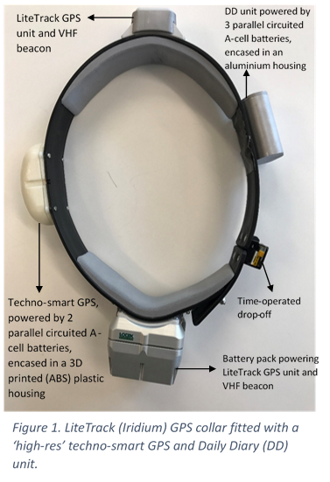
Figure 1. LiteTrack (Iridium) GPS collar, fitted with a ‘high-res’ techno-smart GPS and Daily Diary (DD) unit.

Supplementary information 2 – Relationship between VeDBA and GPS speed

We used the vectorial dynamic body acceleration (VeDBA) as our DBA metric;
VeDBA = $\sqrt{(x^{2} + y^{2} + z^{2})}$ , (1)
where x, y & z are the derived dynamic acceleration values from each axis [6]. For this, a 2-second running mean was applied to each axis to derive the static component of acceleration, which was subsequently subtracted from the raw acceleration before the dynamic component from each axis was summed (eqn 1). VeDBA values used in this analysis were post-smoothed using a rolling window of 2 seconds to ensure that both acceleration and deceleration components of a lion’s stride cycle were incorporated together within any particular time period [7].
The shortest distance (d) between two GPS fixes via;
$d={2•R•sin}^{-1}\left(\sqrt{\sin^{2}\left(\frac{φ_{2}-φ_{1}}{2}\right) +\cos\left(φ_{1}\right)•cos\left(φ_{2}\right)•\sin^{2}\left(\frac{{λ_{2} λ}_{1}}{2} \right)}\right)$ (2)
where R is the radius of earth (approx. 6378137 km), $φ$₁, $φ$₂ are the latitude coordinates between point 1 and point 2 (in radians) and λ₁, λ₂ are the longitude coordinates between point 1 and point 2 (in radians), respectively [cf. 8].

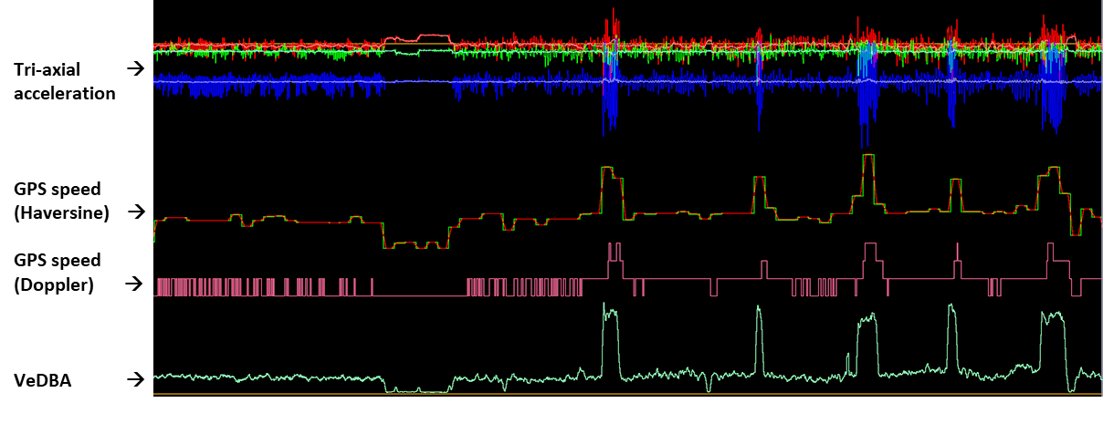
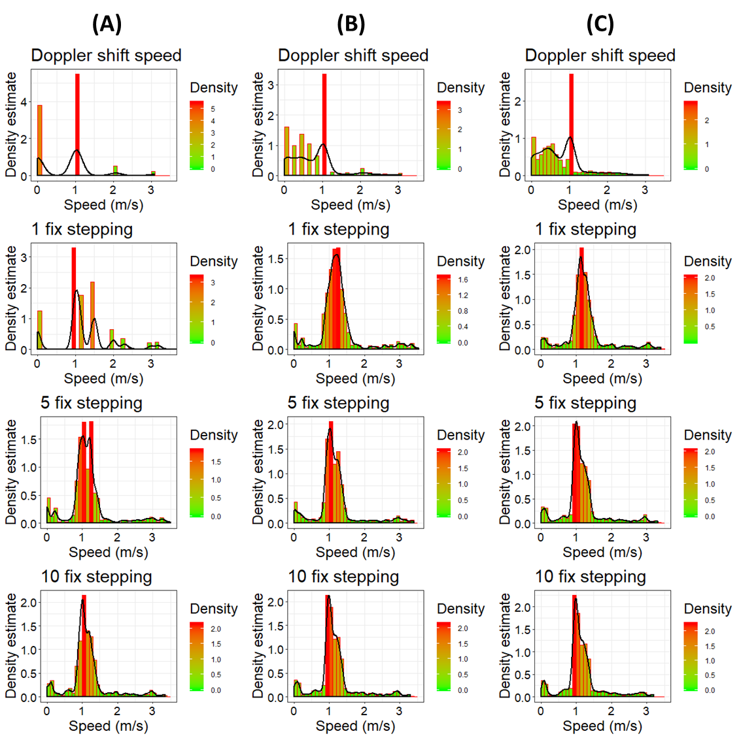
Figure 1. (Top plot) the magnitude of acceleration and GPS speed plotted against time for a given lion during a fifteen-minute bout of mostly translocation behaviour (top plot). GPS speed (Doppler) refers to the raw speed recorded by the GPS device itself calculated using the doppler shift from orbiting satellites. GPS speed (Haversine) refers to speed calculated from distance between fixes (using a stepping range of 5 fixes and post-smoothing window of 5 seconds). (Bottom plot) density plots of GPS-derived speed (m/s) from this period. The first row shows speed calculated from the doppler shift method and the second, third and fourth rows shows speed calculated using the Haversine method at 1, 5 and 10 fix stepping ranges, respectively. The first column (A) reflects no post-smoothing filter (raw data), with column (B) and (C) reflecting 5 and 10 second post-smoothing rolling mean windows, respectively.
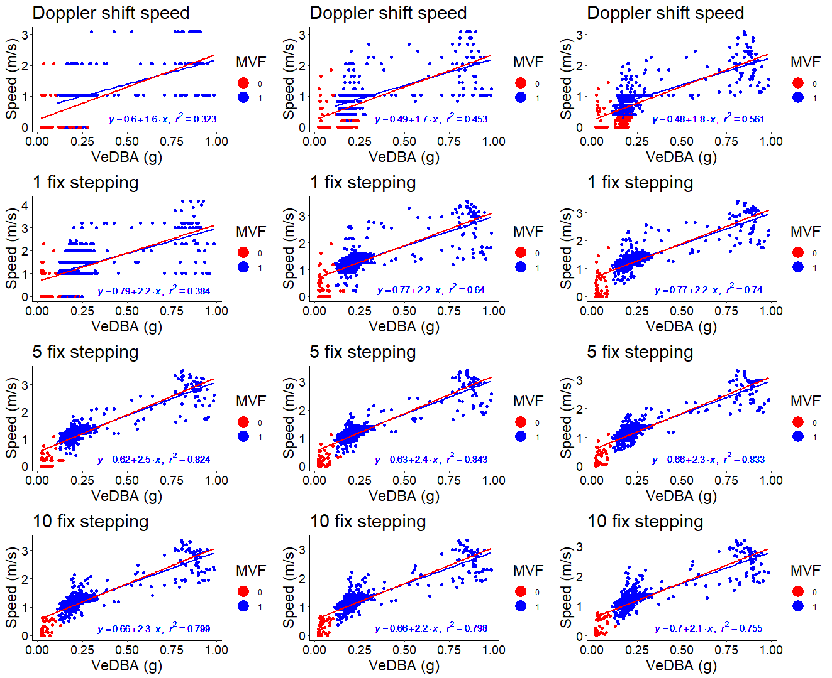

Figure 2. Relationship between VeDBA and GPS speed, with the data and order of plots following on from the same bout of activity as illustrated in Fig. 1. Data points coloured red represent values that did not meet the MVF thresholds (0), with blue data points reflecting values that met the criteria (1). Each plot consists of two linear regressions, with red lines representing a linear regression constructed from all values and the blue lines, from only values that met the MVF protocol. Regression estimates and R² values are given for the regression constructed from only values that met the MVF protocol.

The precision of calculated speed from both the doppler shift method and Haversine method is limited according to the number of decimal places given per GPS fix. Resampling at less frequent intervals can reduce the spurious noise associated with location error, especially when rates of moving are less than the limited spatial resolution of the GPS between fixes.
Whilst we do not know the exact means in which speed is calculated from doppler shift, it is clear that the Haversine method applied over a suitable stepping range produces more detailed estimates of speed and a tighter relationship with VeDBA (as reflected in the more Gaussian-shaped distribution and higher R² values in Fig. 1 & 2, respectively). The bimodal clumping of points in Fig. 2 is resultant from a change in stride gait (from walking to running) (as demonstrated in the disproportionate peaks in VeDBA (top plot, Fig.1)) relative to the magnitude imparted at other times. We propose that a five-fix stepping range and 5 second post-smoothing rolling mean window was suitable for this study species, providing a creditable compromise between maintaining a level of comparability to acceleration estimates whilst interpolating speed estimates at a greater than 1 m resolution, per unit time.

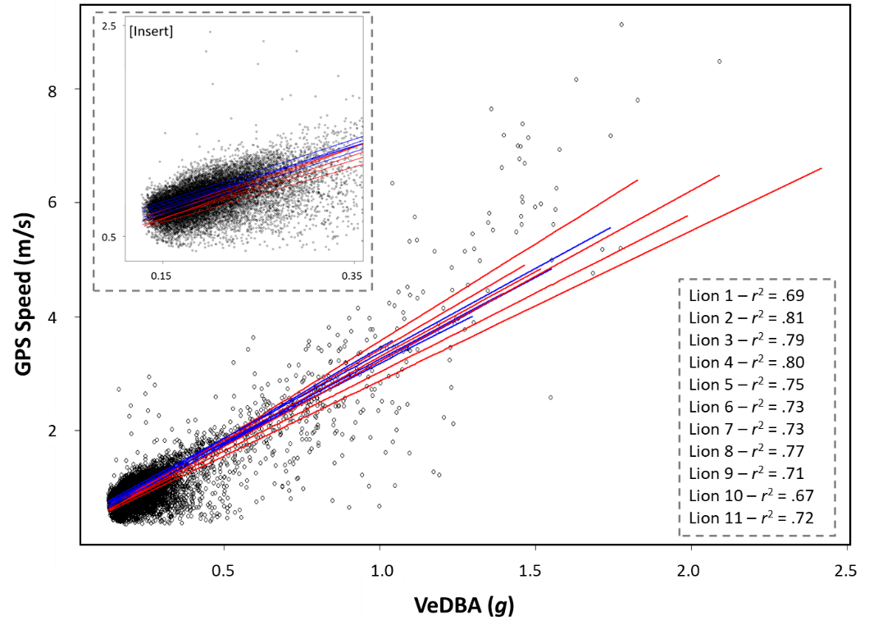
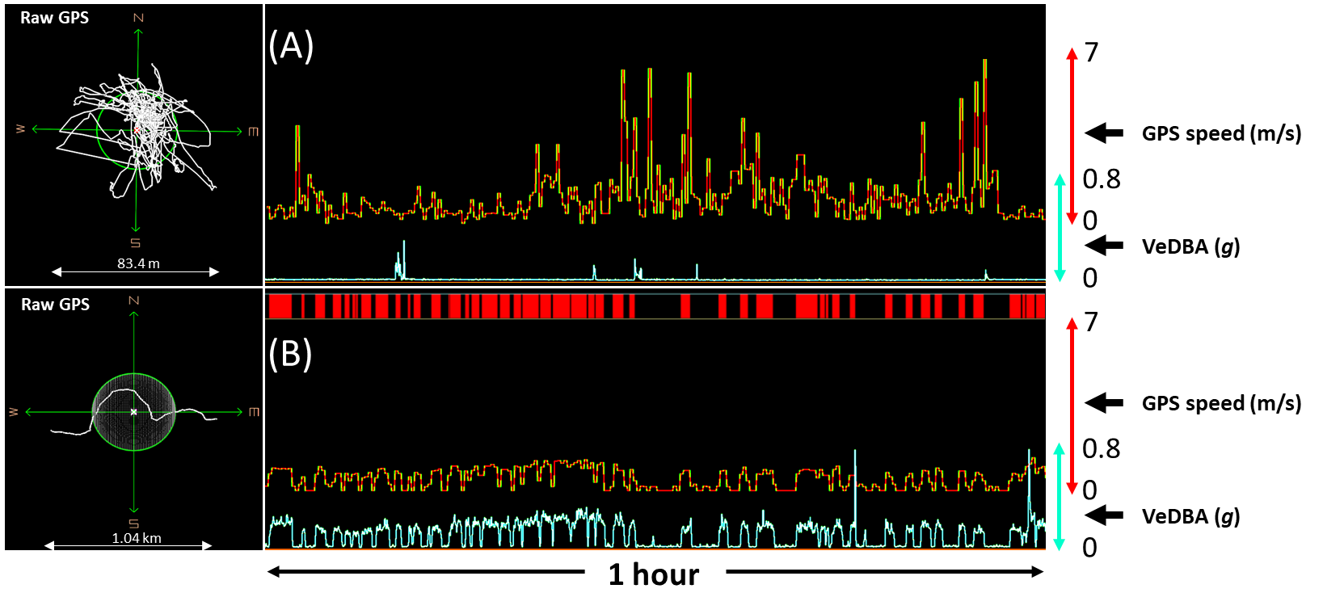
Figure 1. GPS speed ~ VeDBA relationships for all lions with linear regression (y = a + bx and zoomed in the inset). Blue = males, red = females. Data taken only from marked moving periods following the MVF method. Each data point represents the mean value per period.
Figure 3. DD- and GPS-derived data showing two different movement scenarios, each over 1 hour. In the upper panel, the animal was considered to be at rest (due to minimal DBA), while in the lower panel, it was considered to be moving extensively (due to the succinctness between the patterns of magnitude between DBA and GPS speed). Note large locational errors prevalent during rest as manifest by inflated estimates of GPS speed and high levels of GPS jitter.
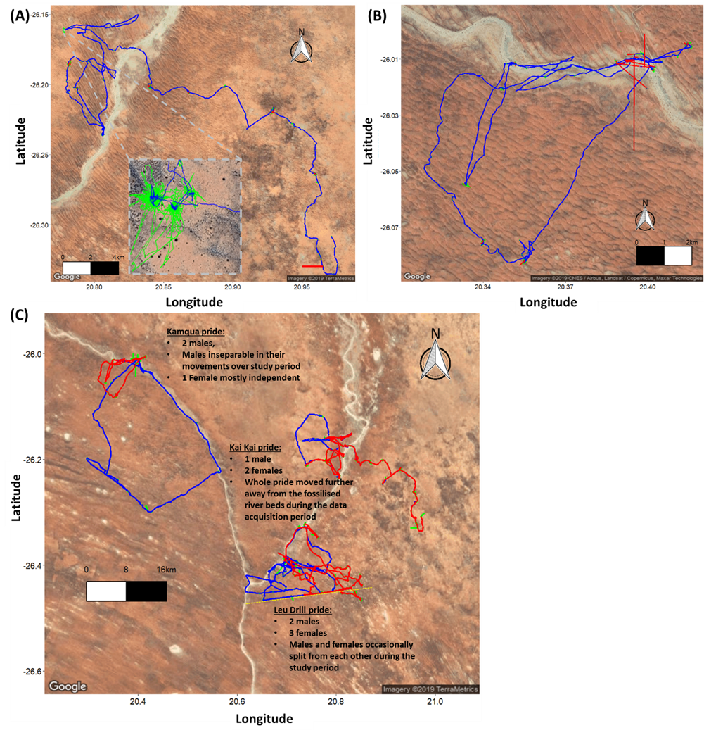
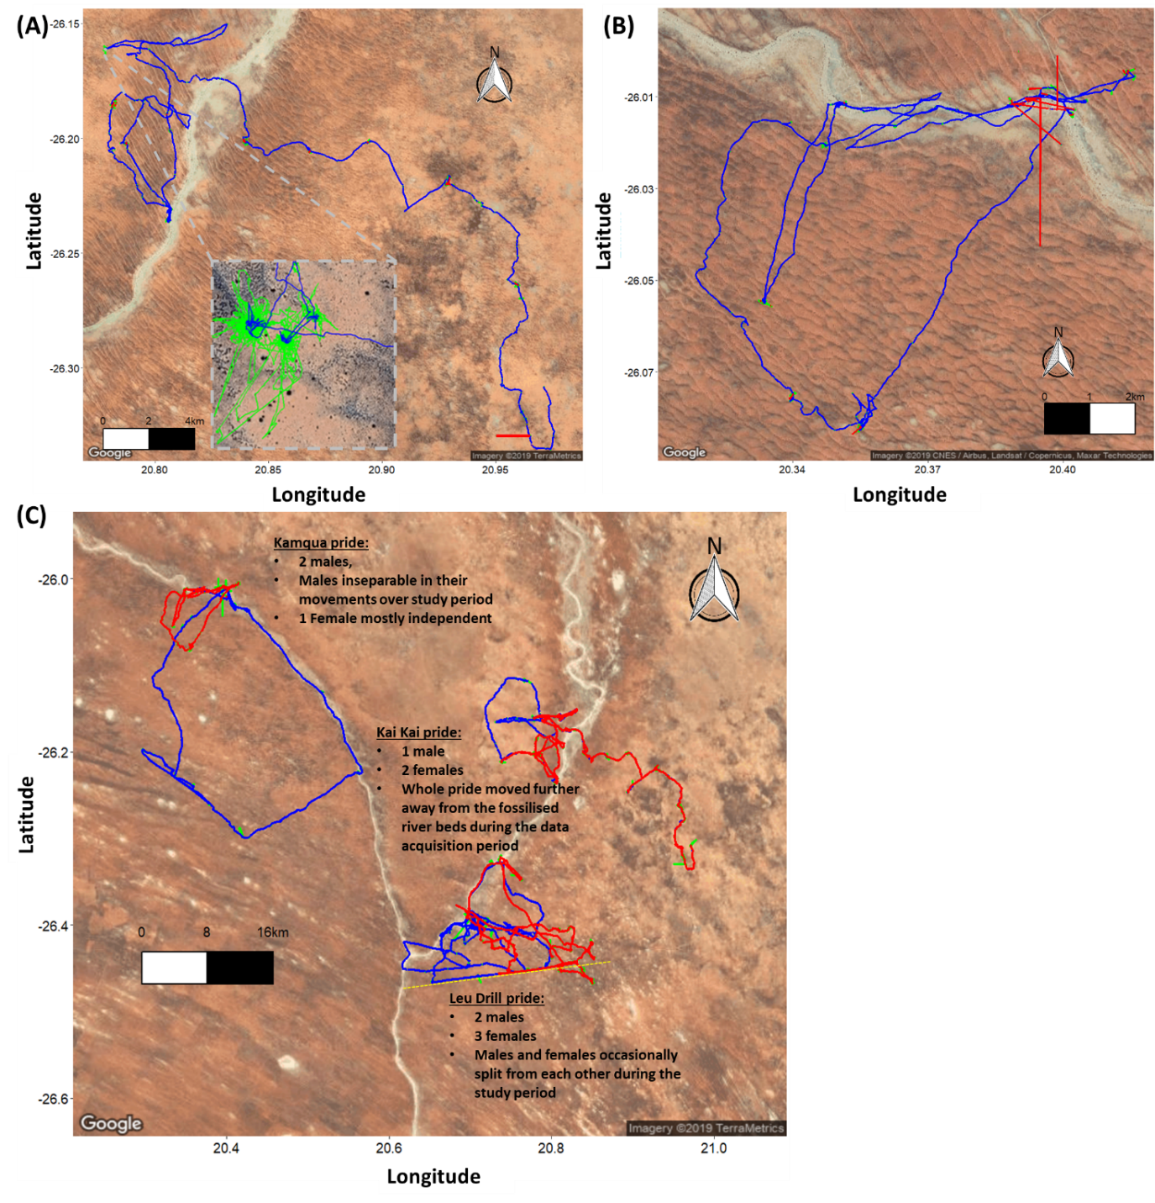
Figure 5. GPS tracks for the entire data acquisition period of 14 days, plotted according to MVF value. (A) and (B) show two individual lions from different prides; Data discerned as non-moving (MVF = 0 = green) and moving (MVF = 1 = blue). Missing locational data and data that failed the z threshold = red. Insert of (A) shows zoomed section of track with high rates of GPS jitter. (C) Each individual from the three prides plotted; Male (MVF = 1) = blue, female (MVF value = 1) = red. MVF values of 0 (including missing locational data and data that failed the z threshold) = green. Brief pride dynamics of the individuals analysed given. Dotted yellow line depicts the electric fence bordering Botswana (which the Leeu Drill pride females crossed).

Supplementary information 3 – Descriptive statistics comparing the MVF results

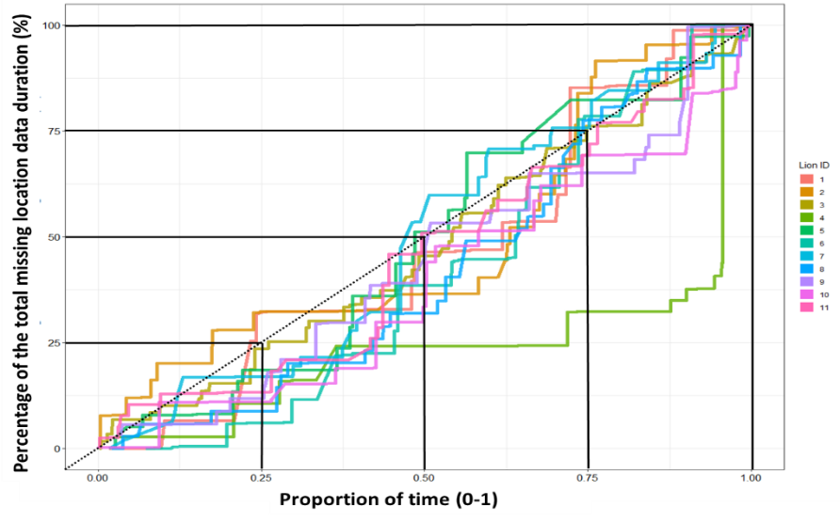
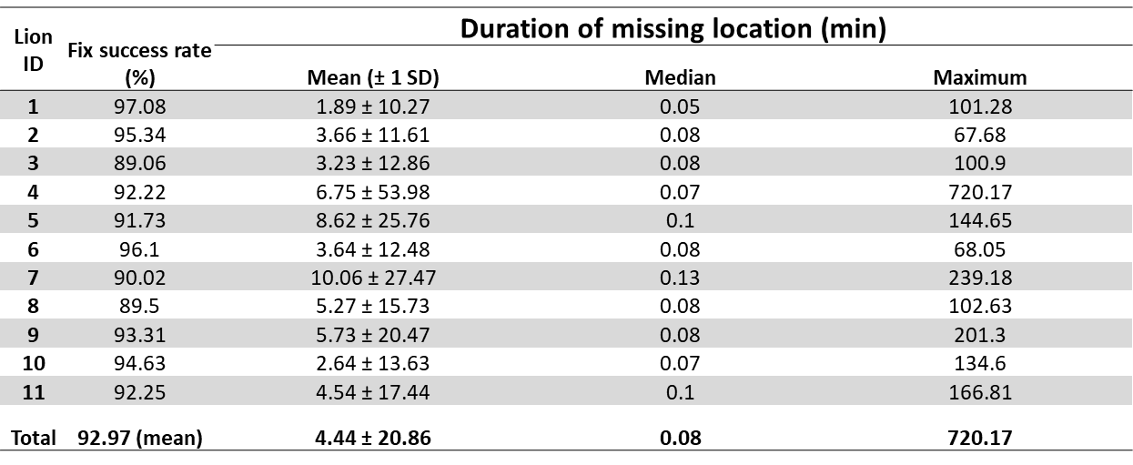
For the majority of lions, battery longevity was just enough, with the GPS units having either run out of battery on the day of retrieval (after approx. 2 weeks) or still functioning, but at low voltage capacity. Only 1 lion (lion 4) had a significantly large portion of data (approx. 12 hours) missing at the end of the data acquisition period (Fig. 1). In general, though, fix success rate did not seem to vary significantly according to the length of accumulated time being switched on, whilst the duration of the GPS not registering a fix varied considerably, indicating that missing locational data was not directly attributable to battery life (and associated voltage level).
Figure 1. Relative cumulative frequency of missing locational data duration (%) per lion over their respective data acquisition periods. Black solid lines reflect y~x 25 % quantiles and the black dotted line reflects an equal distribution of missing location data over time.
Table 1. Summary parameters of fix success rate during period of data acquisition per lion.
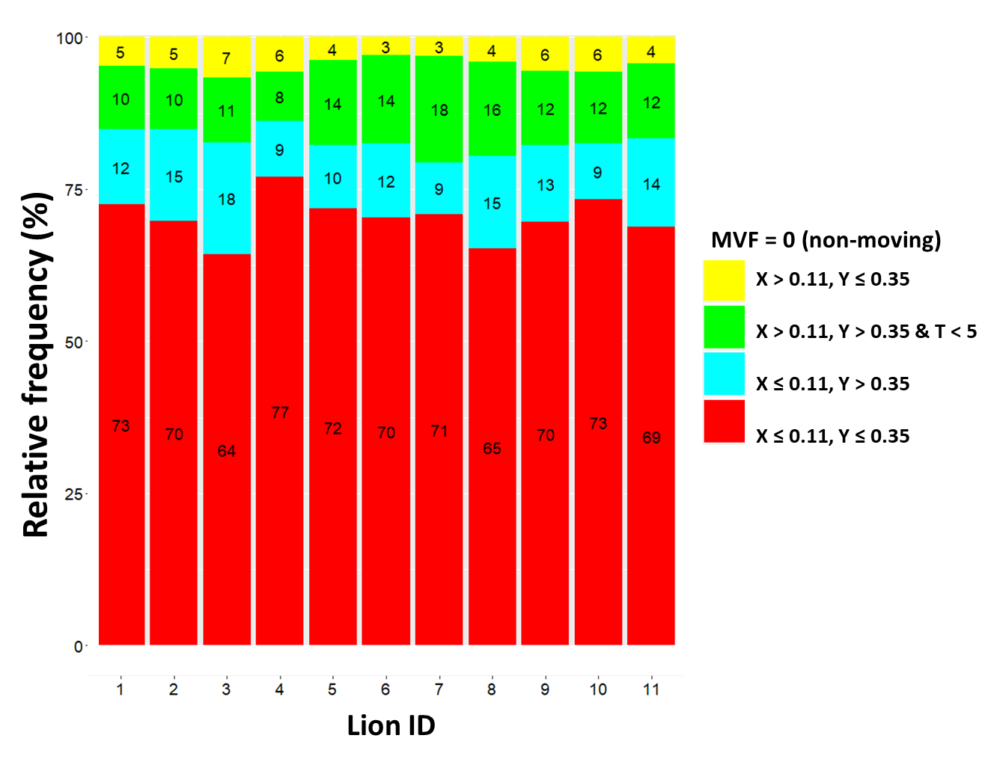
Figure 2. Relative frequency of the four possible combinations of movement and time thresholds (VeDBA (X), GPS speed (Y) and time (T)) that resulted in an MVF value of zero (condition classified as non-moving). Red = non traveling behaviour with little or no GPS jitter, bue = non traveling behaviour with an appreciable degree of GPS jitter, green = either transitionary movements, e.g., rolling over/feeding when GPS jitter is apparent or temporally short travelling periods, not long enough to warrant a considerable movement bout, yellow = non-travelling movement. Missing locational and extreme outliers are not included.

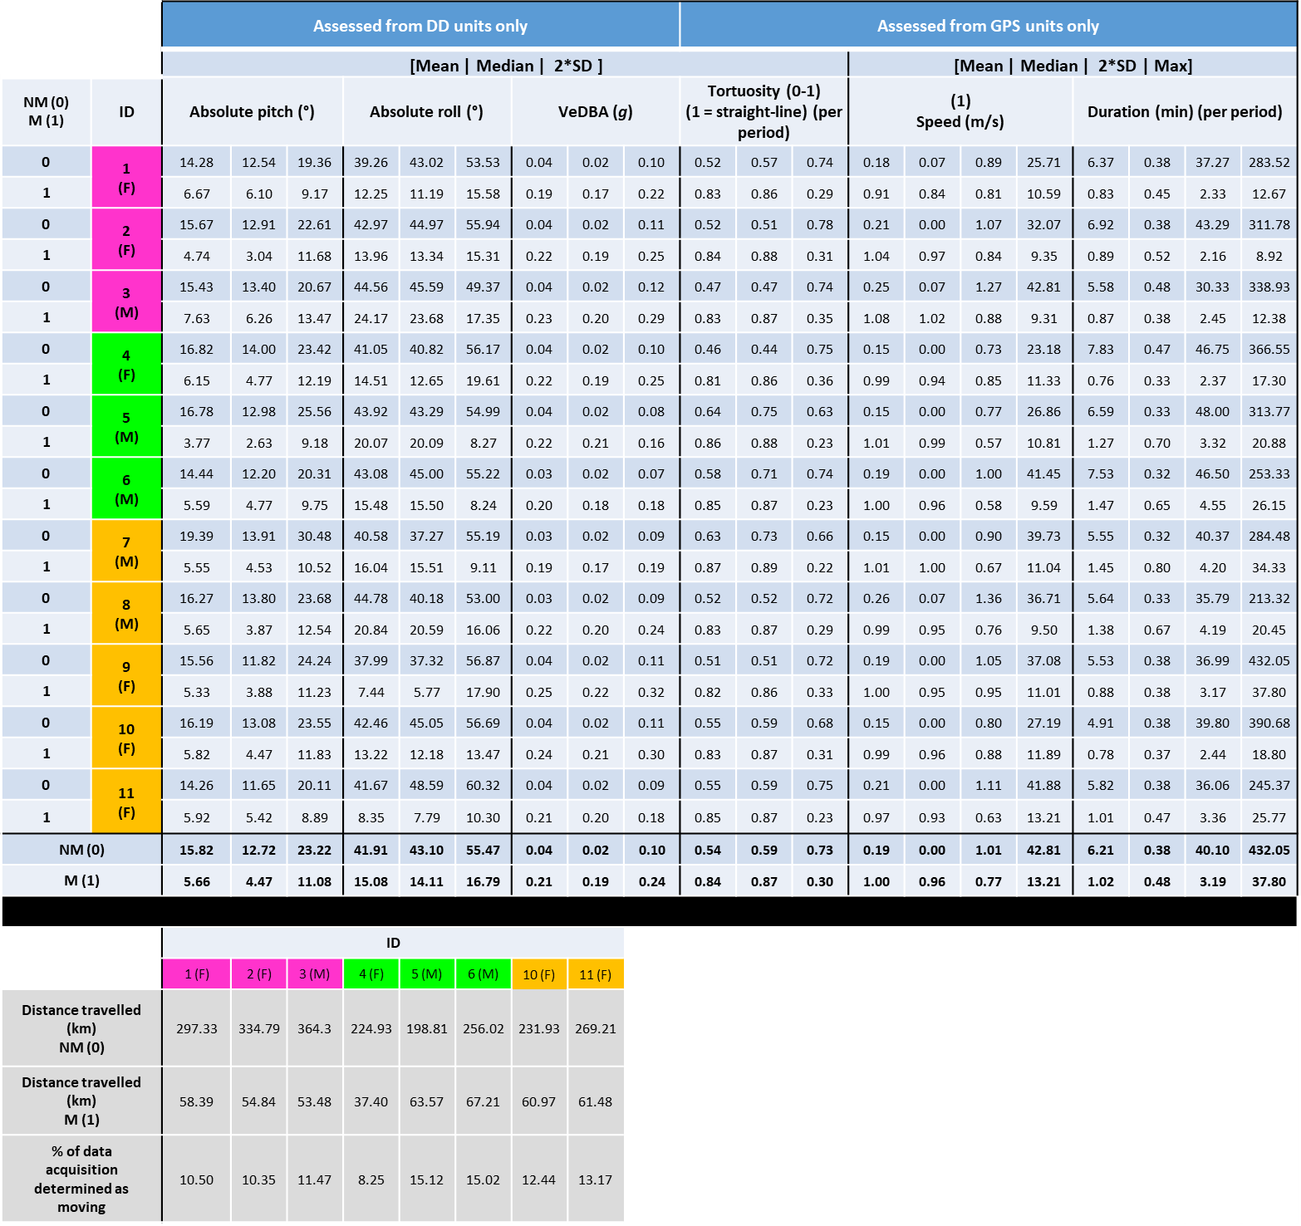
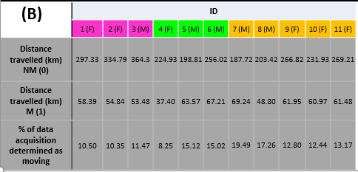
Table 2. DD- and GPS derived summary metrics associated with data ascribed as non-moving (MVF = 0) and moving (MVF = 1) (A). Note, distance travelled estimates are used as a comparator between moving and non-moving, however these are likely highly underestimated given that times of missing location data were excluded. Such missing locational data was also excluded prior to calculating the percentage of data acquisition determined as moving. The cells filled with colour shading (ID and gender) denotes which individuals belonged to the same pride.
(A)

Supplementary information 4 - mathematical procedures for various DD- and GPS-derived metrics used to compare MVF results

Derivation of pitch, roll and heading
Prior to collars being fitted, magnetic calibrations were performed [cf. 9] and, following data retrieval, compass heading was computed using methods outlined by Bidder et al. [10] and Walker et al. [11] and . Compass heading (H) with respect to magnetic North, was given via:
$H=mod\left(360+(atan2({-m}_{y}, m_{x} ) • \frac{180}{π} ) , 360\right)$(1)
where m_{x,y,z} refer to the normalised, ellipse-fitted and co-ordinate frame-adjusted x, y and z channels of the magnetometer, respectively [10, 12, 13].
A common practice to derive animal posture (in terms of pitch and roll; required in the tilt correction procedure prior to calculating heading) is to use the static component of acceleration. This was achieved by passing a two-second rolling mean to each of the three orthogonal acceleration channels.
Pitch and roll were then computed via;
$Pitch \left(β\right)= (atan2(S_{x},\sqrt{S_{y }{ •S}_{y}+S_{z} { •S}_{z}}) • \frac{180}{π}$ (2) $Roll \left(Y\right)= (atan2(S_{y},\sqrt{S_{x }{ •S}_{x}+S_{z} { •S}_{z}}) • \frac{180}{π}$ (3)
where S_{x,y,z} refer to the static components of acceleration from the x (anterior-posterior), y (medio-lateral) and z (dorsal-ventral) channels of the accelerometer [13].
Pitch, roll and heading values were post-smoothed using a rolling window of 1 second, which represented a trade-off between reducing some of the signal-to-noise ratio of collar roll and maintaining sensitivity to the animal’s movements.
For this study site, magnetic declination (the angle on the horizontal plane between magnetic north and true north) was estimated at -16.5º so this value was added to each derived-heading value to acquire a true bearing.
The pre- and post-smoothing windows used in the derivation of the DD’s static acceleration, heading, pitch and roll was carried out in DDMT at the frequency of 40 Hz, prior to sub-sampling the data.
GPS heading
Heading (bearing) ($θ$) from the GPS data was calculated between consecutive fixes using;
$ψ=atan2\left(sin\left({Δλ}_{1}\right)•\cos\left(φ_{2}\right), cos\left(φ_{1}\right)•\left(sin\left(φ_{2}\right)-sin\left(φ_{1}\right)\right)•cos\left(φ_{2}\right)•cos\left({Δλ}_{1}\right)\right)$ (4)
The formula [cf. 14] output is in radians, so values were multiplied by 180/π to get degrees. Lastly, the range is -180° to +180°, so to convert to the same range as DD heading (0° to 360°), we applied the logical expression;
H = (ψ+360) $mod 360$ (5)
where mod refers to the modulo operator.
The difference between DD heading and GPS heading was calculated per second, and a logical expression applied to ensure the difference between the two never exceeded 180° [cf. 15]. Lastly, the resultant values were made absolute, since the degree of turn was of more importance than the direction for analytical purposes.
We applied a circular mean to raw values of DD-derived and GPS-derived headings per unique moving/non-moving period [cf. 13].
The mean resultant length ($\overline{R}$) was calculated via:
$\overline{R}=\sqrt{\left(X^{2}+ Y^{2}\right)} /n$ (6)
Here X and Y are the sum of the sines and cosines of H, respectively (units in radians) and $n$, the length of X and Y input. Note that $\overline{R}$ varies between 0 and 1, with values closer to 1, implying less variation in angular variance between observations.
A non-parametric circular kernel regression estimation (using von Mises kernel) was used to construct a circular covariate (DD heading) to the circular response (GPS heading) regression. This was achieved using the NPCirc package in R [16]. The bw.reg.circ.circ function was used to estimate the ideal bandwidth (to provide the least squares cross-validation smoothing parameter for the local linear estimators) and the kern.reg.circ.circ function (using the local linear estimator method) was used to construct a circular ~ circular regression.
Tortuosity
The tortuosity (T) was calculated by dividing the straight-line distance (SLD), that is the two-dimensional Euclidean distance between the initial fix and the end fix of the path, by the sum of the consecutive individual distance steps (SDS) between fix₁, fix₂,..., fix_{n} that constituted the total path length [cf. 17] (the duration of each unique moving/non-moving period) using;
$SLD=\sqrt{({{λ_{n}-λ}_{1})}^{2}+({φ_{n}-φ_{1})}^{2}}$ (7)
$SDS=\sum_{i=1}^{n}{\left(\sqrt{({{λ_{2}-λ}_{1})}^{2}+({φ_{2}-φ_{1})}^{2}}\right)}$ (8)
$T=\frac{SLD}{SDS}$ (9)
$φ$and λ are the latitude and longitude coordinates (decimal format), respectively. Here, a T of 1 represents straight-line movement while values below this indicate increasing deviations.
Distance and speed estimates
Following the MVF protocol, distance and speed estimates were recalculated separately for both moving and non-moving periods. Distance was computed using a stepping range of five seconds, (same as MVF, except that the stepping range reset with each new MVF period). This meant periods of non-moving ≤ 4 s were excluded from distance estimates (moving periods were always ≥ 5 s and so this stepping range provided at least one value per period). For speed estimates, distance values were divided by the time between the rolling stepping range (in this case, always 5 s) and values were then smoothed using a rolling mean window of three seconds, which consequently excluded speed estimates from both non-moving and moving ≤ 6 s.

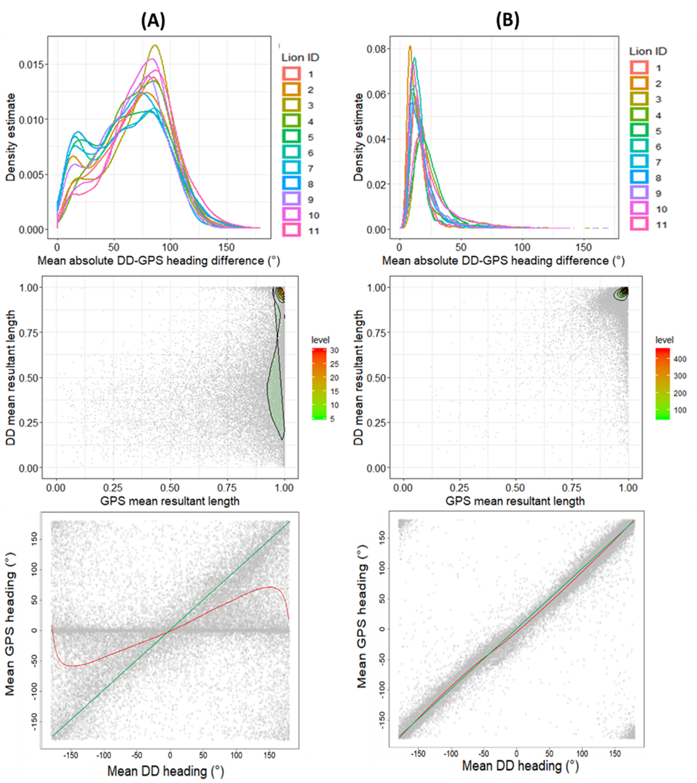
Figure 1. Relationship between DD- and GPS-derived heading for both non-moving (A) and moving (B) filtered datasets (all lions). Each value reflects the circular mean calculated per unique period. A non-parametric circular kernel regression estimation (using von Mises kernel) was used to construct a circular covariate (DD heading) to circular response (GPS heading) regression (red line). A linear relationship (intercept = -180) shown for reference (green). Note the banding of GPS heading values reading 0 are a consequence of identical consecutive longitude and latitude coordinates. Also note the range of heading given between -180 to +180º (both of which represent south).

References SI. 1:4

1. Mills G, Mills M: Hyena Nights & Kalahari Days: Jacana Media; 2010.
2. IUCN S: Regional conservation strategy for the lion Panthera leo in Eastern and Southern Africa. IUCN SSC Cat Specialist Group 2006.
3. Lotek products. Available at https://www.lotek.com/. Accessed 07 March 2021
4. Wilson RP, Shepard E, Liebsch N: Prying into the intimate details of animal lives: use of a daily diary on animals. Endangered Species Research 2008, 4(1-2):123-137.
5. South African National Parks. Game capture and translocation - Lion. Available at https://www.sanparks.org/conservation/veterinary/about/animals/lion.php. Accessed 07 March 2021
6. Wilson RP, Börger L, Holton MD, Scantlebury DM, Gómez-Laich A, Quintana F, Rosell F, Graf PM, Williams H, Gunner R, Hopkins L, Marks N, Geraldi NR, Duarte CM, Scott R, Strano MS, Robotka H, Eizaguirre C, Fahlman A, Shepard ELC: Estimates for energy expenditure in free-living animals using acceleration proxies: A reappraisal. Journal of Animal Ecology 2020, 89(1):161-172.
7. Gleiss AC, Wilson RP, Shepard EL: Making overall dynamic body acceleration work: on the theory of acceleration as a proxy for energy expenditure. Methods in Ecology and Evolution 2011, 2(1):23-33.
8. Chopde NR, Nichat MK: Landmark based shortest path detection by using A* and Haversine formula. International Journal of Innovative Research in Computer and Communication Engineering 2013, 1(2):298-302.
9. Williams HJ, Holton MD, Shepard EL, Largey N, Norman B, Ryan PG, Duriez O, Scantlebury M, Quintana F, Magowan EA, Marks N, Alagaili AN, Bennett NC, Wilson RP: Identification of animal movement patterns using tri-axial magnetometry. Movement ecology 2017, 5(1):6.
10. Bidder O, Walker J, Jones M, Holton M, Urge P, Scantlebury D, Marks N, Magowan E, Maguire I, Wilson R: Step by step: reconstruction of terrestrial animal movement paths by dead-reckoning. Movement ecology 2015, 3(1):1-16.
11. Walker JS, Jones MW, Laramee RS, Holton MD, Shepard ELC, Williams HJ, Scantlebury DM, Marks NJ, Magowan EA, Maguire IE, Bidder OR, Di Virgilio A, Wilson RP: Prying into the intimate secrets of animal lives; software beyond hardware for comprehensive annotation in ‘Daily Diary’ tags. Movement Ecology 2015, 3(1):29.
12. Pedley M: eCompass-Build and Calibrate a Tilt-Compensating Electronic Compass. Circuit Cellar-The Magazine For Computer Applications 2012(265):1−6.
13. Gunner RM, Wilson RP, Holton MD, Scott R, Hopkins P, Duarte CM: A new direction for differentiating animal activity based on measuring angular velocity about the yaw axis. Ecology and evolution 2020, 10(14):7872-7886.
14. Robusto CC: The cosine-haversine formula. The American Mathematical Monthly 1957, 64(1):38-40.
15. Pewsey A, Neuhäuser M, Ruxton GD: Circular Statistics in R: OUP Oxford; 2013.
16. Oliveira Pérez M, Crujeiras Casais RM, Rodríguez Casal A: NPCirc: An R package for nonparametric circular methods. Journal of Statistical Software 2014, 61(i09).
17. Benhamou S: How to reliably estimate the tortuosity of an animal's path:: straightness, sinuosity, or fractal dimension? Journal of theoretical biology 2004, 229(2):209-220.

