Single-cell atlas reveals the resistance of cortex cells to bacterial wilt in peanut roots

Kai Zhao^{1,5}, Yanzhe Li^{1,5}, Zhuo Chen^{2,5}, Zenghui Cao¹, Xingli Ma¹, Fangping Gong¹, Yue Tu¹, Zhongfeng Li¹, Zhanmin Sun³, Xuemin Zhang³, Lin Zhang¹, Ding Qiu¹, Xingguo Zhang¹, Rui Ren¹, Kunkun Zhao¹, Rajeev K. Varshney⁴, Xinyou Zhang¹, Zhe Liang³ & Dongmei Yin¹

¹College of Agronomy & Peanut Functional Genome and Molecular Breeding Engineering, Henan Agricultural University, Zhengzhou 450046, China
²School of Management and Economics, North China University of Water Resources and Electric Power, Zhengzhou 450046, China
³Biotechnology Research Institute, Chinese Academy of Agricultural Sciences, Beijing 100081, China
⁴Food Futures Institute, Murdoch University, Murdoch, Australia
⁵These authors contributed equally: Kai Zhao, Yanzhe Li, Zhuo Chen.
e-mail: yindm@henau.edu.cn; liangzhe@caas.cn

Supplementary Figures and legends
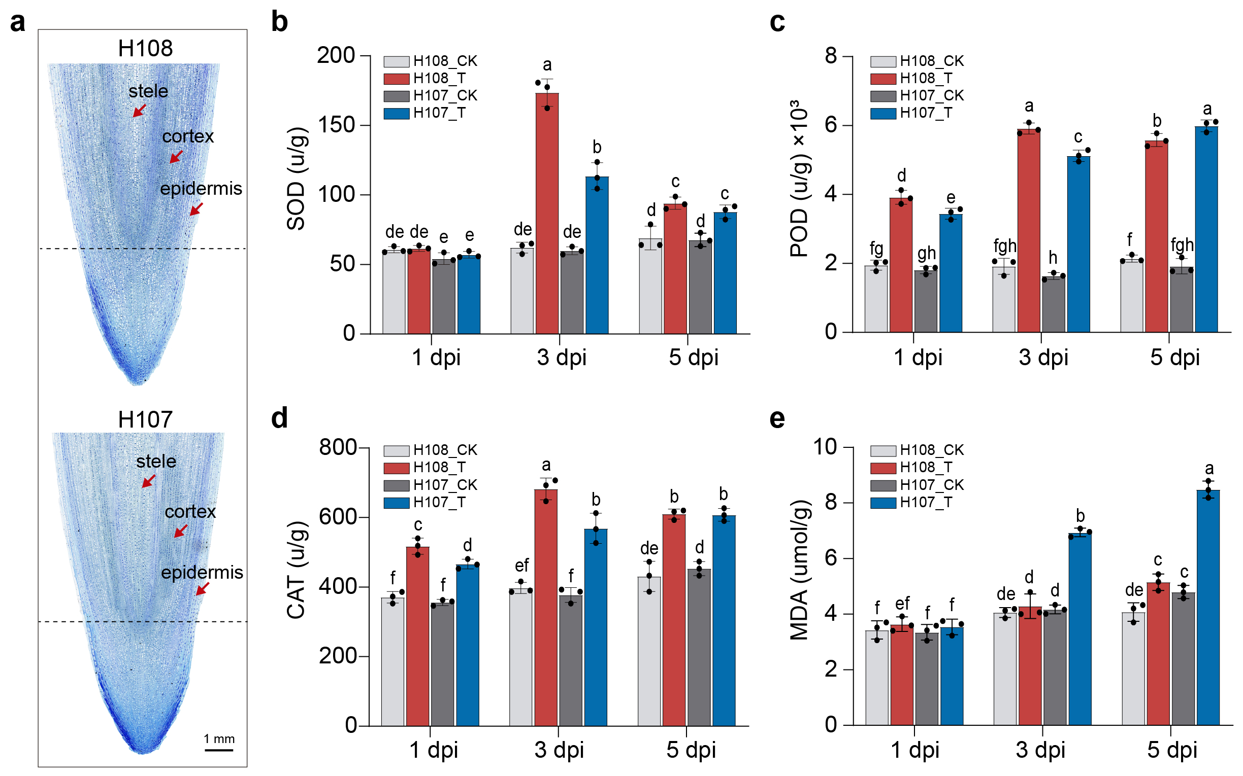
Supplementary Fig. 1〡Comparison of morphology and physiological differences between peanut H108 and H107. a Longitudinal microscopic comparison of root tips between H108 and H107. The roots were stained with toluidine blue. Red arrows point to the epidermis, cortex, and stele of the root tips respectively. b-e Changes in the contents of SOD (b), POD (c), CAT (d) and MDA (e) in the root tips of H108 and H107 after inoculation with R. solanacearum. Multiple methods are Fisher's Least Significant Difference (LSD), different letters represent significant differences between different groups (P < 0.05).

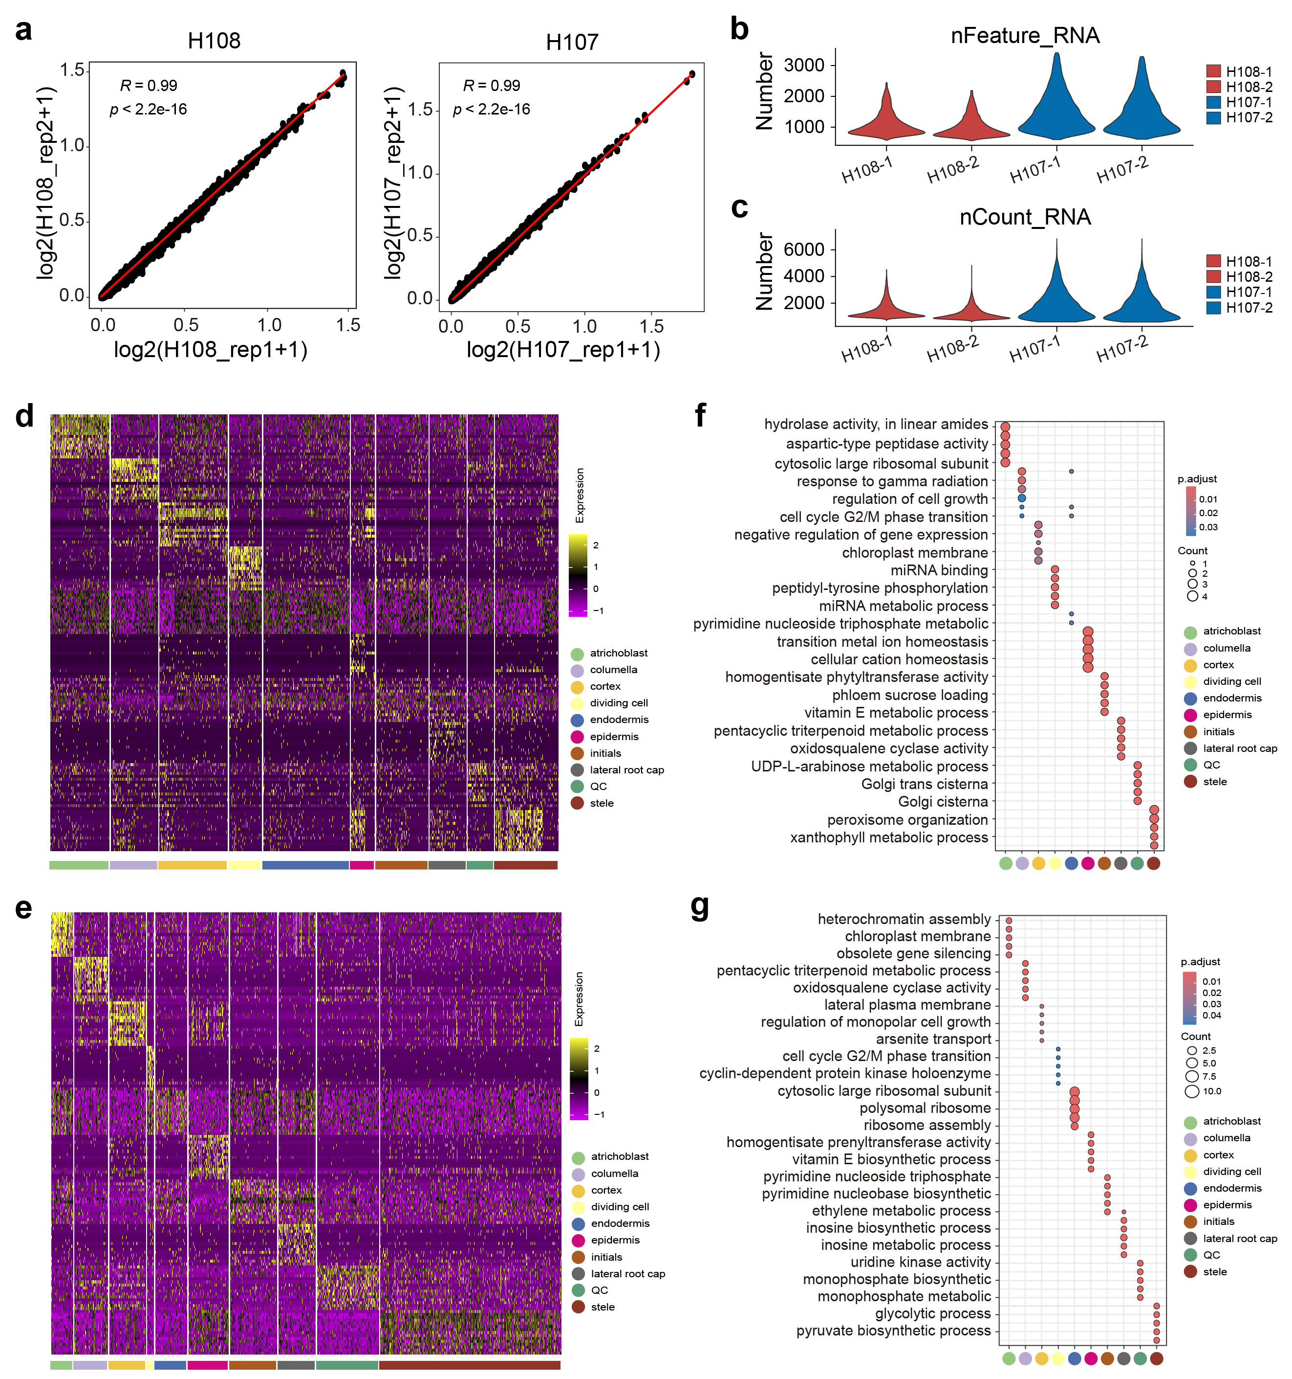
Supplementary Fig. 2〡Single-cell RNA-seq of root tips of H107 and H108. a Correlation analysis of two replicates indicates the high reproducible of scRNA-seq data for H107 and H108. R, Pearson correlation coefficient. b The number of genes detected in each cell (nFeature RNA). c, The number of gene copies detected in each cell (nCount_RNA). d,e Heatmap showing the expression levels of top 15 maker genes in H108 (d, f) and H107 (e, g) in different cell types. f,g GO enrichment analysis of genes enriched for each cell types, and the top 5 GO terms for each cell type were shown.

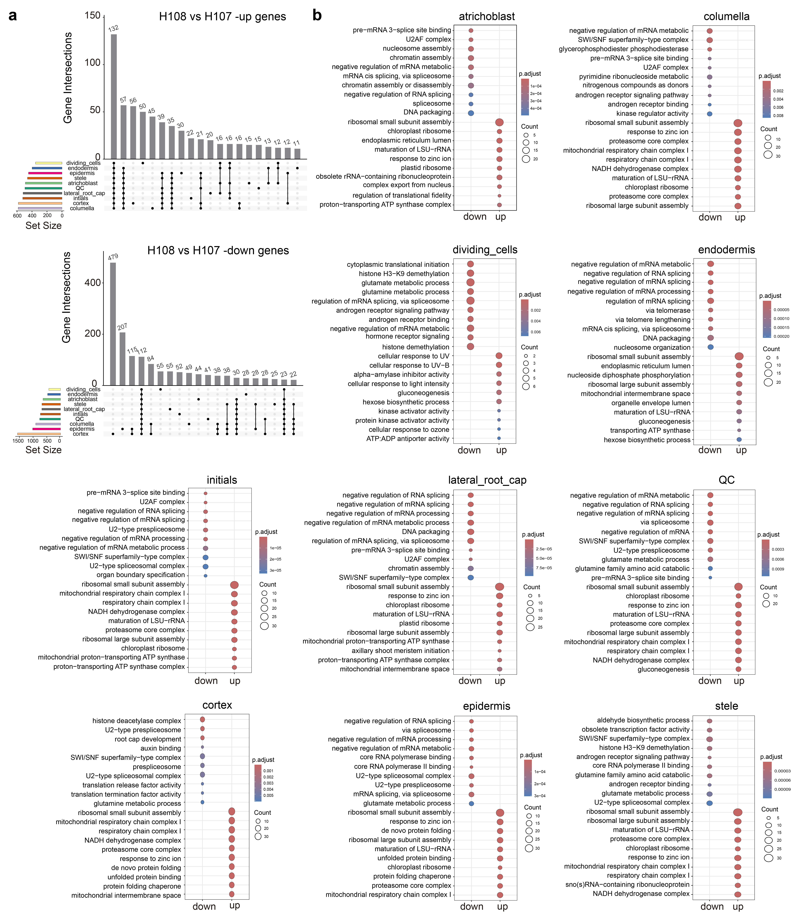
Supplementary Fig. 3〡Analysis of up- and down- regulation of maker genes in different cell types of H108 and H107. a The Venn diagram shows the up- and down- regulation of differentially expressed genes in different cell types. b GO enrichment analysis was performed on different types of cells, and the top 20 annotation results are shown.
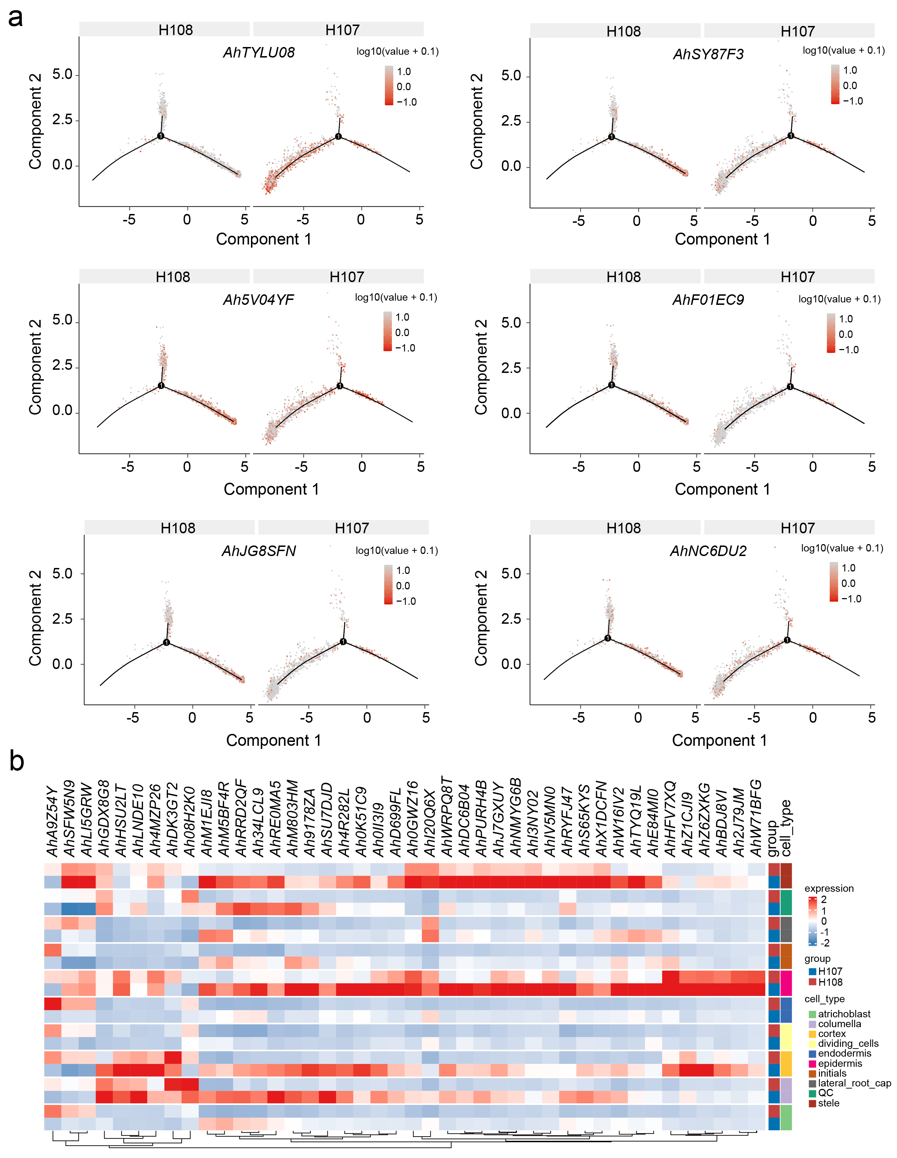
Supplementary Fig. 4〡Differential analysis of genes between H108 and H107. a Pseudo-time series analysis of six genes in the cortex of H108 and H107 respectively. b Heatmap displays the expression levels of 42 significantly differentially expressed genes in different cell types.
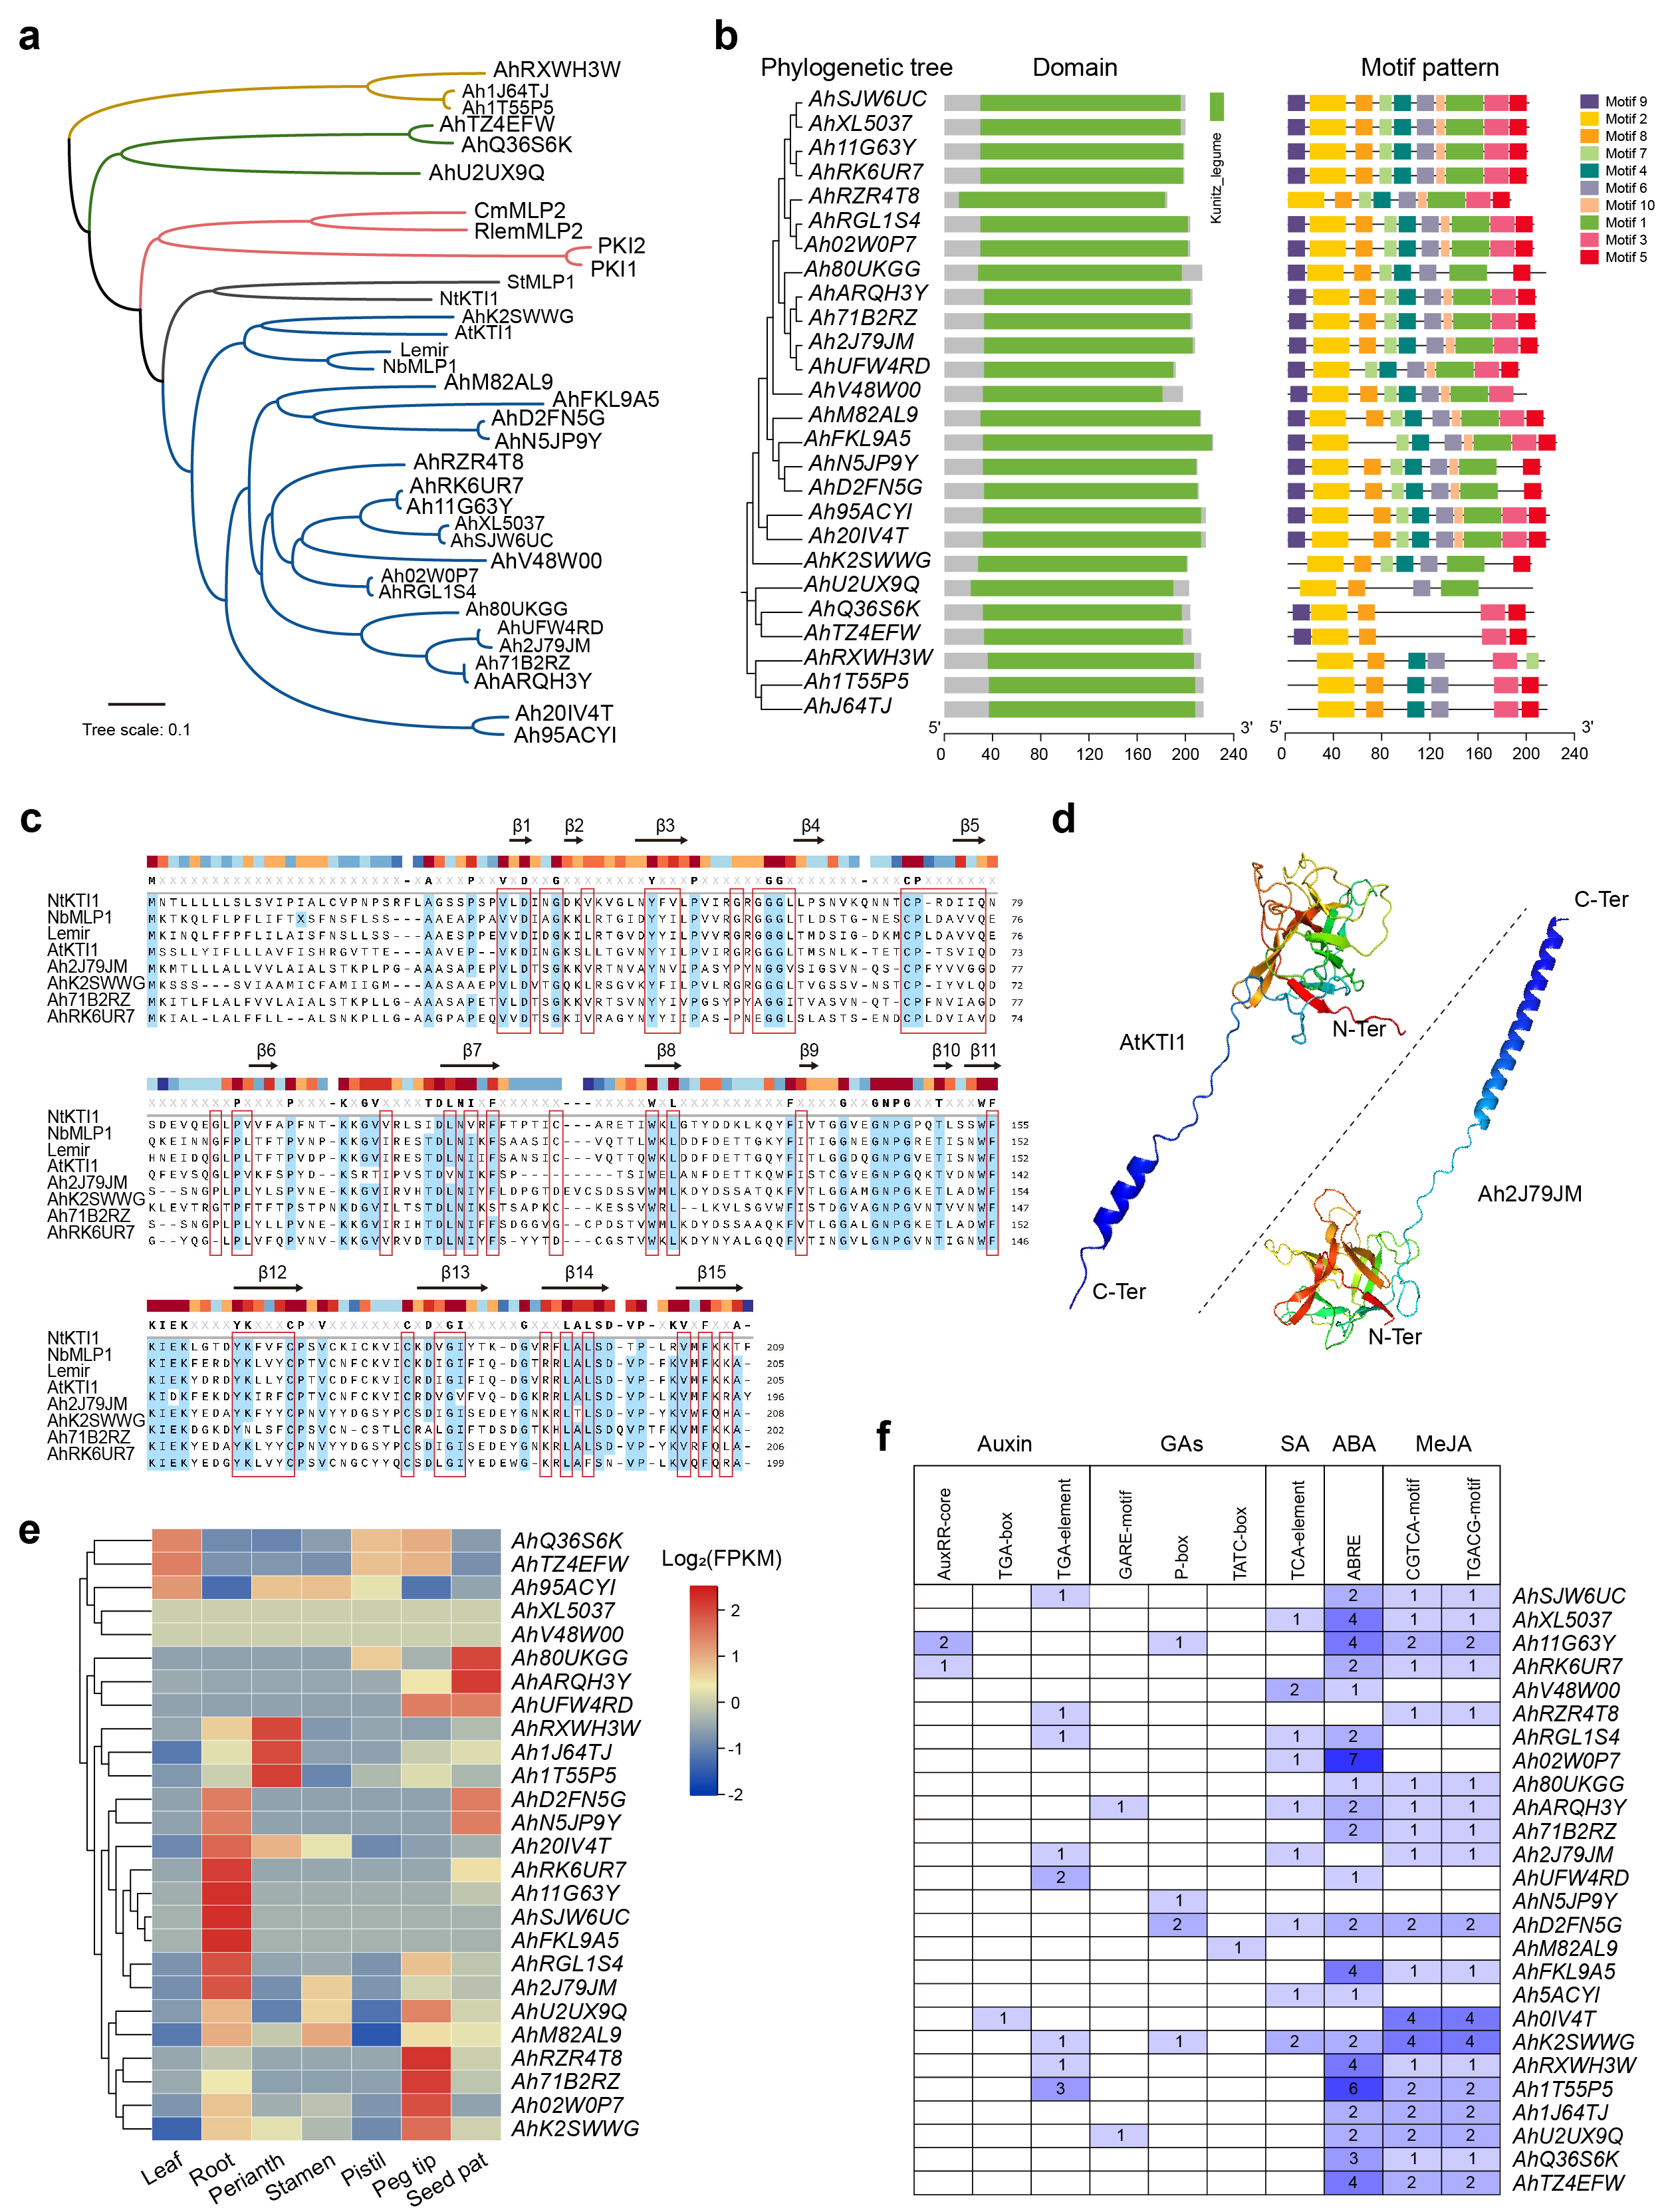
Supplementary Fig. 5〡Bioinformatics analysis of peanut KTI family. a Phylogenetic analysis of 26 KTIs in peanut and other plant species. b All the peanut KTI family member have a conserved Kunitz 1egume domain, with Motif2 shared by 26 members and 13 family members having all 10 Motifs. c Multiple sequence alignment between four KTIs of peanuts and AtKTI1, NtKTI1 and NbMLP1. The protein secondary structures were conserved. d Ah2J79JM, and AtKTI1 have similar protein tertiary structures. e Heatmap showing the expression levels of 26 KTIs in different tissues of peanut. The transcriptomic data of eight tissues (leaf, root, perianth, stamen, pistil, peg tip, and seed pat) of cultivated peanuts were obtained from the peanut database. f The hormone regulation- and defense responses-related cis-regulatory elements in promoter regions of peanut KTI genes. The numbers represent the response elements in the promoter regions (~2000 bp) of the peanut KTI genes.

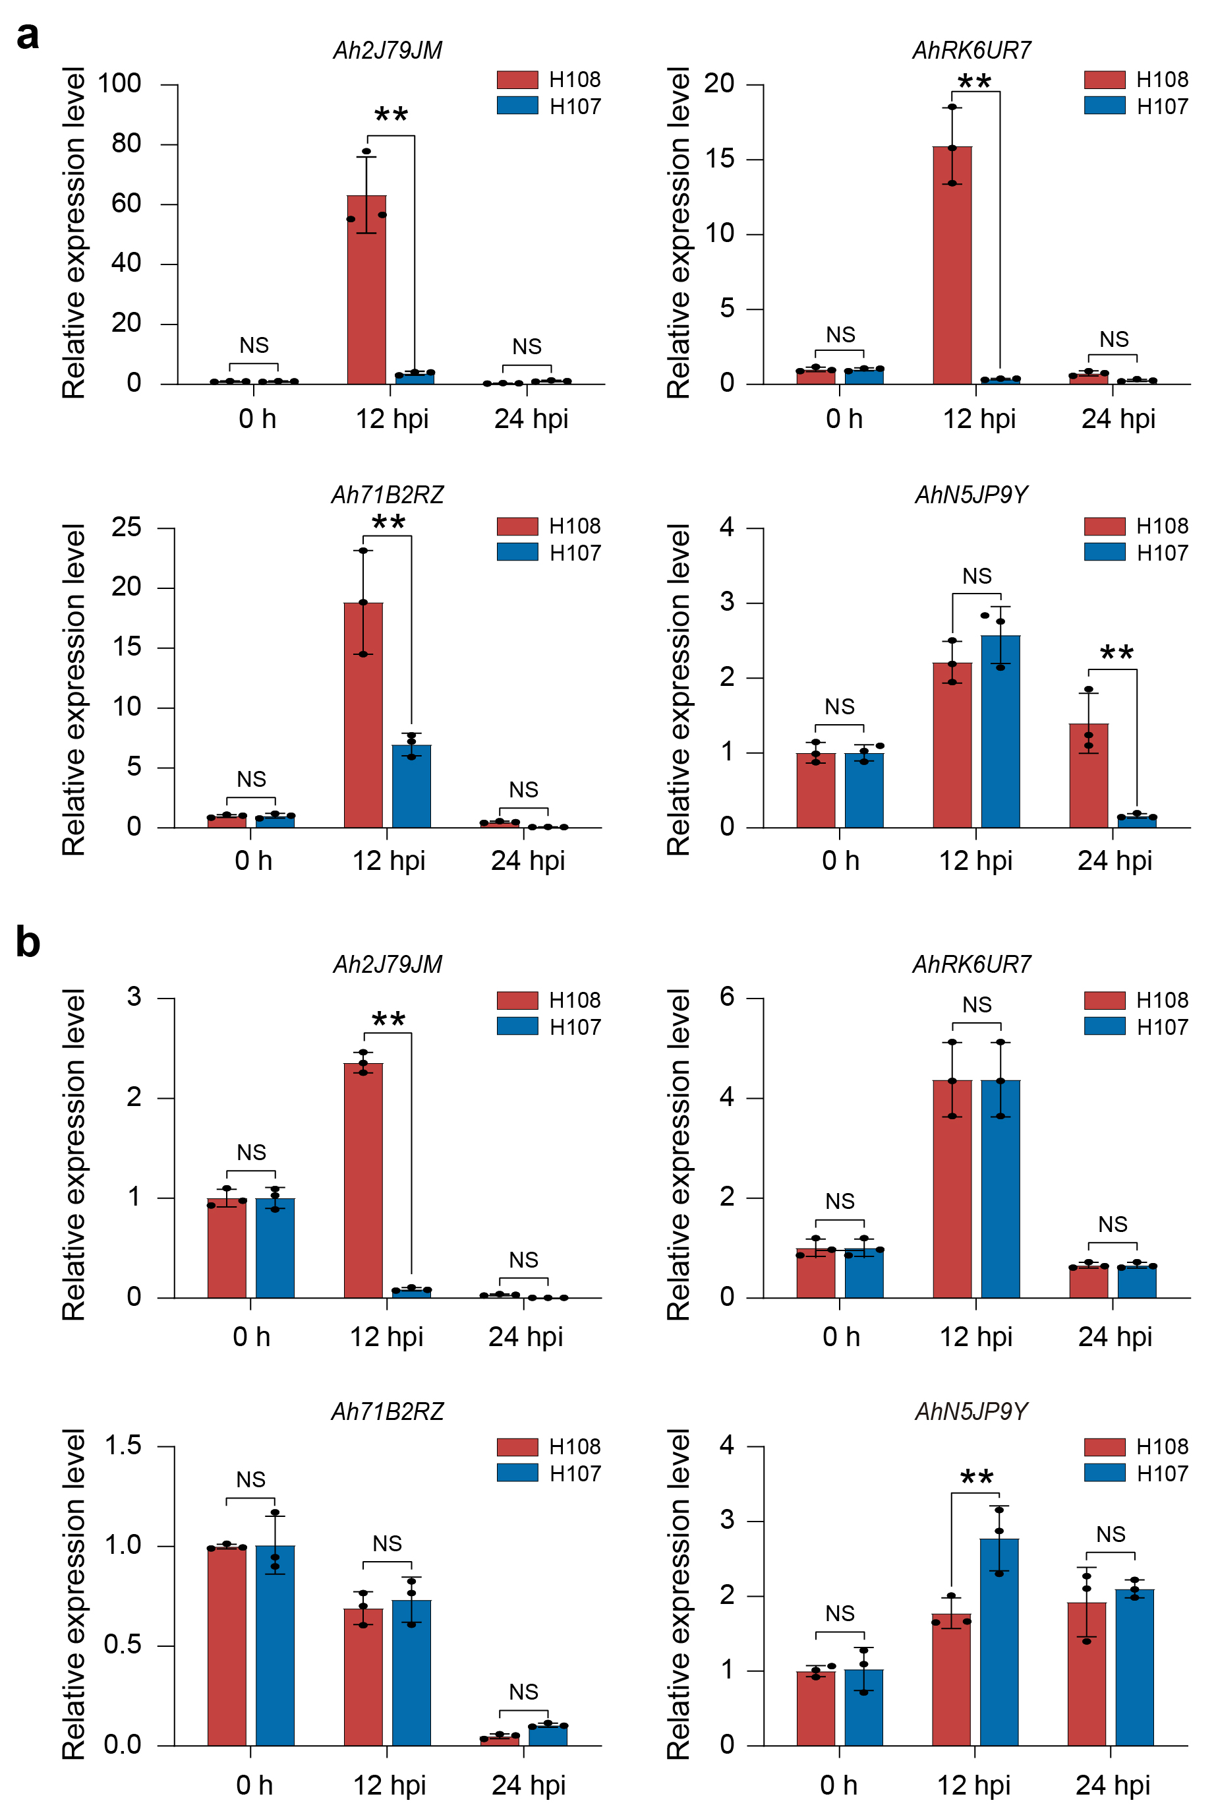
Supplementary Fig. 6〡Expression analysis of AhKTI genes by qRT-PCR. Expression analysis of peanut genes under 100 mmol/L JA (a) and 10 μg/mL ABA (b) treatment. Y-axis represents relative expression. Significance was assessed by the Mann-Whitney U test and indicated with asterisks. * P < 0.05, ** P < 0.01. n = 3, Error bars, SD.
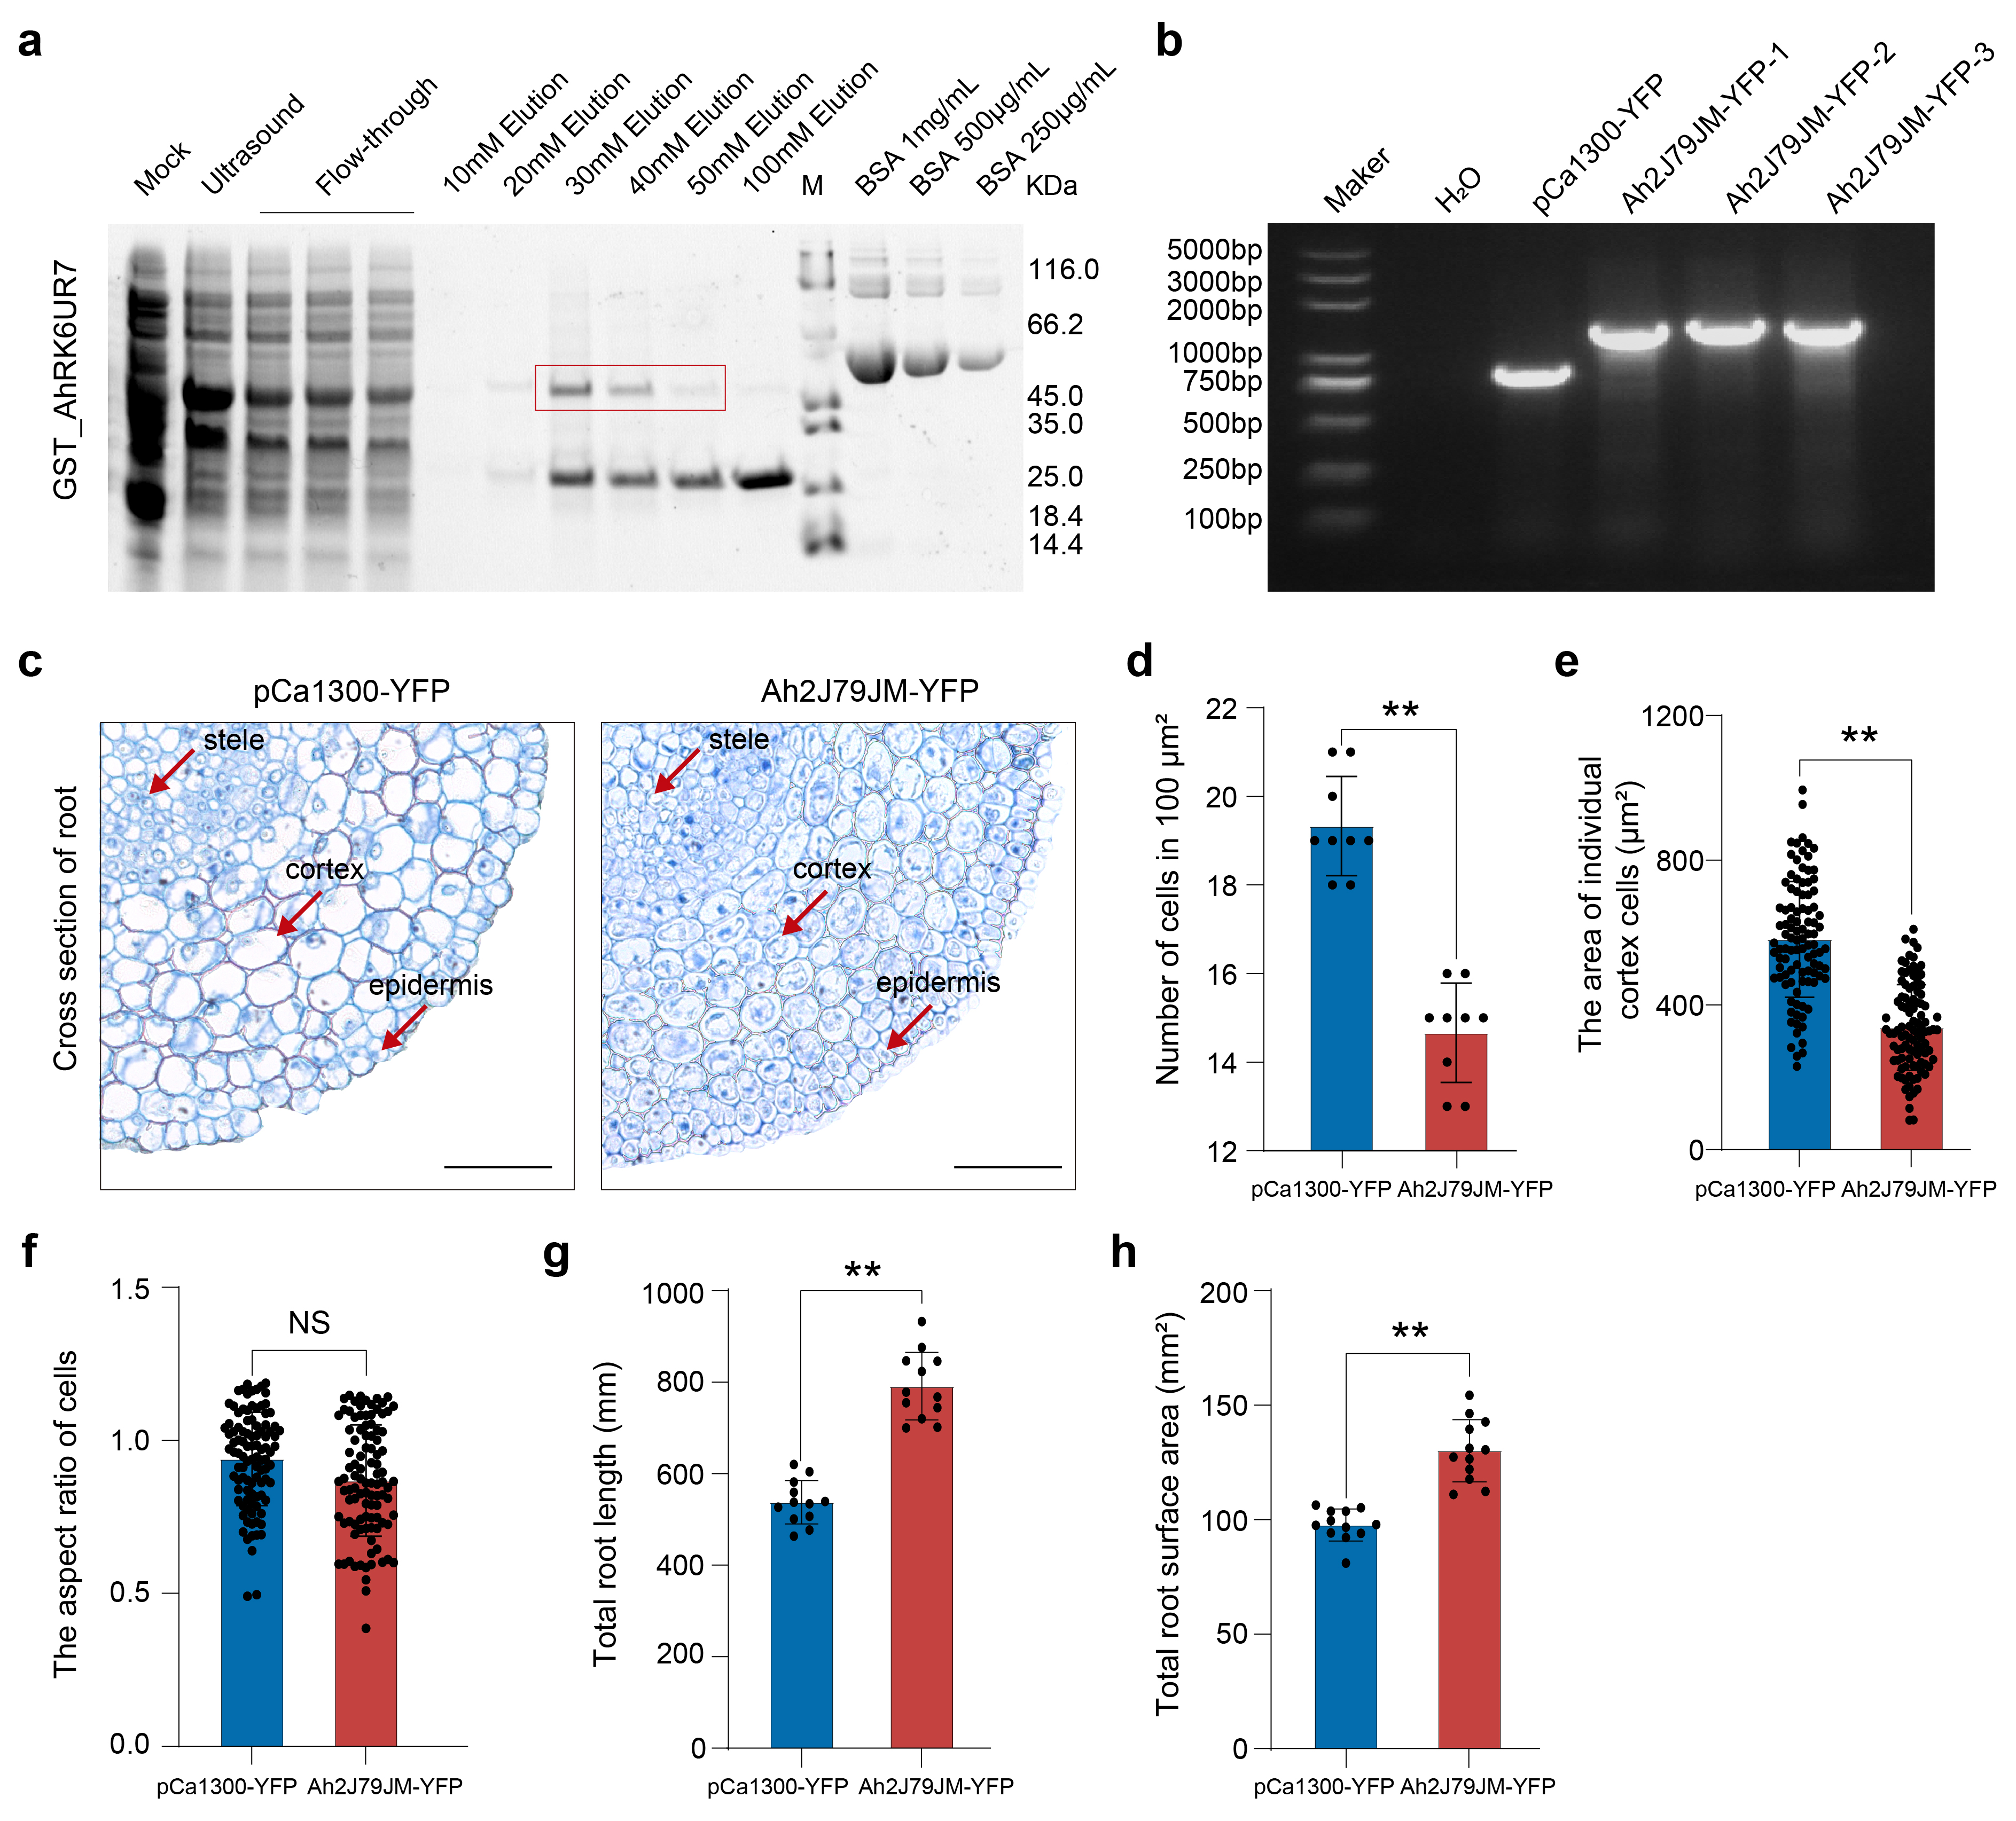
Supplementary Fig. 7〡Protein purification of and physiological effect of overexpression of Ah2J79JM in peanut. a Purification of GST-tagged AhRK6UR7 protein, with the target band shown in the red box. , PCR validation of of Ah2J79JM-YFP positive transgenic peanut. c Cross section comparison between Ah2J79JM overexpression and control. d Comparison of the number of cells within a range of 100 μm² in the cortex between Ah2J79JM overexpression and control peanut. Error bars, mean ± SD, n = 9, P < 0.01. e Comparison of individual cell area of cortex cells between Ah2J79JM overexpression and control peanut. Error bars, mean± SD, n = 100, P < 0.01. f Comparison of cortex cell aspect ratio between Ah2J79JM overexpression and control peanut. Error bars, mean ±SD, n = 100, P < 0.01. g-h Comparison of total root length (g) and total root surface area (h) between Ah2J79JM overexpression and control peanut. The peanuts were inoculated with R. solanacearum for 5 days. Error bars, mean ± SD, student's t-test *, P < 0.05, **, P < 0.01, NS: no significant difference.

