Supplementary file for the study titled: " England's Lockdown vs. Sweden's Herd Immunity: A Comparison of the Daily New COVID-19 Cases and Related Deaths Using Comparative Interrupted Time Series Analysis."

Moaath K. Mustafa Ali, MD, MPH^{1Ϯ}; Yazan Samhouri, MD^{2Ϯ}; Marwa Sabha, MD³; Lynna Alnimer, MD⁴
¹ Marlene and Stewart Greenebaum Comprehensive Cancer Center, University of Maryland Medical Center, Baltimore, Maryland.
² Department of Hematology and Medical Oncology, Allegheny Health Network, Pittsburgh, Pennsylvania.
³ Division of Rheumatology and Clinical Immunology, Department of Medicine, University of Maryland Medical Center, Baltimore, Maryland.
⁴ Department of Internal Medicine, Ascension Providence Hospital, Michigan State University, College of Human Medicine, Southfield, Michigan.

Contents:
- Statistical analysis
- Results
- eTables (number: 2)
- eFigures (number: 2 )

Statistical analysis
Both linear and nonlinear polynomial models were fit for time series. We used comparative interrupted time series (ITS) regression models, as described by Linden et al[1] :

Y_{t} = β₀ + β₁.T + β₂.X_{t} + β₃.X_{t}.T + β₄.Z + β₅.Z.T + β₆.Z.X_{t}+ β₇.Z.X_{t}.T + ϵ_{t}
Y_{t}= daily new cases or deaths counts
Z= treatment and control indicator (dummy variable)
X_{t} = intervention indicator (dummy variable)
T = time since the start of the study (continuous variable)
β₀ = Intercept
β₁ = slope in control before intervention
β₂ = difference in daily new cases or deaths in control before and after the intervention
β₃ = difference in the slope in control before and after the intervention
β₄ = difference in daily new cases or deaths between treatment and control before intervention
β₅ = difference in the slope between treatment and control before the intervention
β₆ = difference in daily new cases or deaths between treatment and control in the period immediately after the intervention
β₇ = difference in the slope between treatment and control after the intervention
ϵ_{t} = error

In this regression model, a significant β6 or β7 indicates the intervention effect. β7 indicates the change in rate after intervention implementation and is the primary outcome of the interest of this study.

Results
eTables 1 shows the results of ITS regression models to estimate the effect of lockdown implemented in England compared to Sweden. Coefficient β7 represents the intervention effect, which is the change in rates of COVID-19 daily cases or deaths per 10,000,000 person in Sweden compared to England. In this table, we used both linear and polynomial models to estimate the intervention effects. Both models resulted in similar estimates of coefficient β7.

eTable 1 Generalized least square regression models to estimate the effect of lockdown order on daily confirmed cases and deaths related to COVID-19 in England compared to Sweden using controlled interrupted time series analysis
Variable | Value | Standard Error | T-value | P-value
Linear model: Daily confirmed cases interrupted time series model ^{µ}
Intercept (β0) | -220.46 | 57.44 | -3.84 | < 0.001
Time (β1) | 22.54 | 2.92 | 7.72 | < 0.001
Intervention (Post-lock down) (β2) | 1187.81 | 90.03 | 13.19 | < 0.001
Time: Intervention (β3) | -29.30 | 3.13 | -9.36 | < 0.001
Control (Sweden) (β4) | 23.22 | 64.87 | 0.36 | 0.72
Time: Control (β5) | -7.24 | 2.94 | -2.46 | 0.01
Intervention: Control (β6) | -790.22 | 103.37 | -7.64 | < 0.001
Time: Intervention: Control (β7) | 19.38 | 3.08 | 6.30 | < 0.001
Non-linear (polynomial) model: Daily confirmed cases interrupted time series model ^{µ}
Intercept (β0) | 126.48 | 104.24 | 1.21 | 0.23
Time (β1) | -0.75 | 7.39 | -0.10 | 0.92
Time squared | 0.33 | 0.18 | 1.80 | 0.07
Time cubic | 0.00 | 0.00 | -2.42 | 0.02
Intervention (Post-lock down) (β2) | 762.22 | 408.30 | 1.87 | 0.06
Time: Intervention (β3) | -18.63 | 11.79 | -1.58 | 0.12
Control (Sweden) (β4) | -10.20 | 60.72 | -0.17 | 0.87
Time: Control (β5) | -7.93 | 2.91 | -2.72 | 0.01
Intervention: Control (β6) | -693.75 | 116.34 | -5.96 | < 0.001
Time: Intervention: Control (β7) | 19.39 | 3.38 | 5.73 | < 0.001
Linear model: Daily deaths interrupted time series model ¥
Intercept (β0) | -44.32 | 7.71 | -5.75 | < 0.001
Time (β1) | 5.66 | 0.37 | 15.23 | < 0.001
Intervention (Post-lock down) (β2) | 223.04 | 12.77 | 17.46 | < 0.001
Time: Intervention (β3) | -7.19 | 0.41 | -17.33 | < 0.001
Control (Sweden) (β4) | 5.25 | 8.21 | 0.64 | 0.52
Time: Control (β5) | -1.74 | 0.41 | -4.20 | < 0.001
Intervention: Control (β6) | -53.85 | 15.66 | -3.44 | < 0.001
Time: Intervention: Control (β7) | 2.20 | 0.47 | 4.63 | < 0.001
Nonlinear (polynomial model): Daily deaths interrupted time series model ¥
Intercept (β0) | -27.81 | 7.05 | -3.94 | < 0.001
Time (β1) | 2.13 | 0.86 | 2.49 | 0.01
Time squared | 0.12 | 0.03 | 4.61 | < 0.001
Time cubic | 0.00 | 0.00 | -4.33 | < 0.001
Intervention (Post-lock down) (β2) | 436.10 | 42.26 | 10.32 | < 0.001
Time: Intervention (β3) | -13.26 | 1.23 | -10.82 | < 0.001
Control (Sweden) (β4) | 0.91 | 7.61 | 0.12 | 0.91
Time: Control (β5) | -1.55 | 0.35 | -4.43 | < 0.001
Intervention: Control (β6) | -50.19 | 10.86 | -4.62 | < 0.001
Time: Intervention: Control (β7) | 2.02 | 0.35 | 5.74 | < 0.001
^{µ} In daily confirmed cases model, the intervention was delayed for five days, equal to the median COVID-19 incubation period. ¥ In the death related to the COVID-19 model, the intervention was delayed for eighteen days, equal to the sum of the COVID-19 incubation period and the median time from symptom onset to death. NB: lockdown order was implemented in England on March 23, 2020. The numbers represented in the table are adjusted for the difference in population size. In these models, both England and Sweden's population sizes were adjusted to ten billion.

To understand the relation of COVID-19 daily cases and related deaths with phases one and two of lifting restrictions in England compared to Sweden, we estimated coefficients using segmented ITS regression models (eTable 2). Coefficient β7b represents the effect of phase one of loosening restrictions, which is the change in rates of COVID-19 daily cases or deaths per 10,000,000 person in Sweden compared to England. After phase one, Sweden experienced an acceleration of new COVID-19 cases compared to England (49 cases/ 10⁷ person, 95% CI: 30-67, P<0.001). There was no difference in the daily new COVID-19 cases rate after phase two (Coefficient β7c).
Regarding mortality, there was no difference in daily deaths related to COVID-19 between England and Sweden after phase one or two of loosening restrictions (coefficient β7b and coefficient β7c, respectively).
Both daily COVID-19 cases and related deaths models are presented in eFigure1 and 2, respectively.

eTable 2 Generalized least square regression models to estimate the effect of lockdown order and its reversal on daily confirmed cases and deaths related to COVID-19 in England compared to Sweden using controlled interrupted time series analysis
Variable | Value | Standard Error | T-value | P-value
Daily confirmed cases interrupted time series model ^{µ}
Intercept (β0) | -219.37 | 49.27 | -4.45 | < 0.001
Time (β1) | 21.06 | 2.61 | 8.06 | < 0.001
Intervention (Post-lock down) (β2a) | 898.39 | 120.89 | 7.43 | < 0.001
Intervention (Post-reversal phase 1) (β2b) | 3005.91 | 595.91 | 5.04 | < 0.001
Intervention (Post-reversal phase 2) (β2c) | -141.67 | 781.68 | -0.18 | 0.86
Time: Intervention (Post-lock down) (β3a) | -22.47 | 3.40 | -6.61 | < 0.001
Time: Intervention (Post-reversal phase 1) (β3b) | -47.20 | 6.53 | -7.23 | < 0.001
Time: Intervention (Post-reversal phase 1) (β3c) | -17.34 | 7.51 | -2.31 | 0.02
Control (Sweden) (β4) | 1.46 | 64.54 | 0.02 | 0.98
Time: Control (β5) | -3.24 | 2.92 | -1.11 | 0.27
Intervention: Control (β6a) | -224.27 | 160.36 | -1.40 | 0.16
Intervention: Control (β6b) | -3928.16 | 838.24 | -4.69 | < 0.001
Intervention: Control (β6c) | 1569.70 | 1091.42 | 1.44 | 0.15
Time: Intervention (Post-lock down): Control (β7a) | 5.36 | 3.88 | 1.38 | 0.17
Time: Intervention (Post-reversal phase 1): Control (β7b) | 48.69 | 9.21 | 5.29 | < 0.001
Time: Intervention (Post-reversal phase 2): Control (β7c) | -2.74 | 10.05 | -0.27 | 0.79
Daily deaths interrupted time series model ¥
Intercept (β0) | -47.50 | 7.00 | -6.78 | < 0.001
Time (β1) | 5.86 | 0.34 | 17.18 | < 0.001
Intervention (Post-lock down) (β2a) | 242.94 | 15.96 | 15.22 | < 0.001
Intervention (Post-reversal phase 1) (β2b) | 112.61 | 80.30 | 1.40 | 0.16
Intervention (Post-reversal phase 2) (β2c) | 129.14 | 158.18 | 0.82 | 0.42
Time: Intervention (Post-lock down) (β3a) | -7.68 | 0.46 | -16.79 | < 0.001
Time: Intervention (Post-reversal phase 1) (β3b) | -6.24 | 0.89 | -7.00 | < 0.001
Time: Intervention (Post-reversal phase 1) (β3c) | -6.40 | 1.48 | -4.31 | < 0.001
Control (Sweden) (β4) | 5.80 | 7.24 | 0.80 | 0.42
Time: Control (β5) | -1.76 | 0.37 | -4.68 | < 0.001
Intervention: Control (β6a) | -7.68 | 0.46 | -16.79 | < 0.001
Intervention: Control (β6b) | -6.24 | 0.89 | -7.00 | < 0.001
Intervention: Control (β6c) | -6.40 | 1.48 | -4.31 | < 0.001
Time: Intervention (Post-lock down): Control (β7a) | 2.13 | 0.54 | 3.94 | < 0.001
Time: Intervention (Post-reversal phase 1): Control (β7b) | 0.19 | 1.24 | 0.15 | 0.88
Time: Intervention (Post-reversal phase 2): Control (β7c) | 0.45 | 2.07 | 0.22 | 0.83
^{µ} In daily confirmed cases model, the intervention was delayed for five days, equal to the median COVID-19 incubation period. ¥ In the death related to the COVID-19 model, the intervention was delayed for eighteen days, equal to the sum of the COVID-19 incubation period and the median time from symptom onset to death. NB: lockdown order was implemented in England on March 23, 2020. Phase one of restriction loosening was implemented in England on May 13, 2020. Phase two of restriction loosening was implemented in England on June 1, 2020. The numbers represented in the table are adjusted for the difference in population size. In these models, both England and Sweden's population sizes were adjusted to ten billion.

eFigure 1 Comparative time series analysis to assess the impact of England's lockdown order, and phase one and two loosenings of restrictions on daily new cases of COVID-19 compared to Sweden, adjusted for population size.
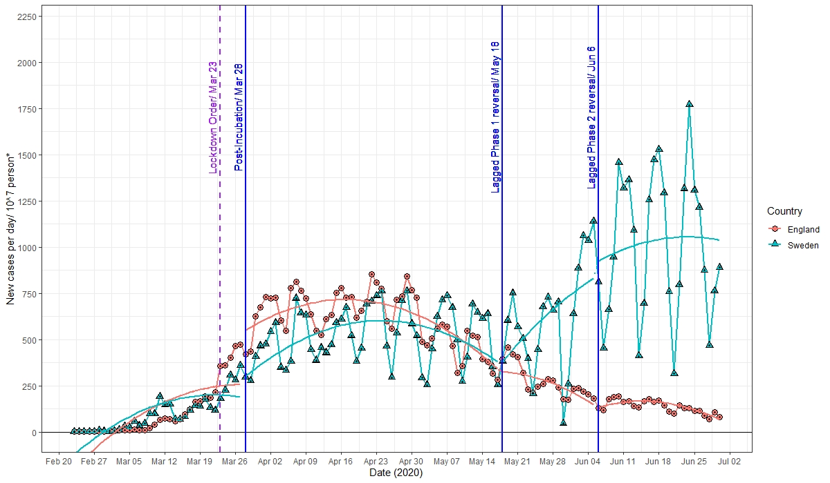
*Population size was adjusted to ten million for both countries in this figure. NB: Smoothened lines represent predicted daily cases in an interrupted time series model for each country

eFigure 4 Comparative time series analysis to assess the impact of England's lockdown order, and phase one and two loosenings of restrictions on daily deaths related to COVID-19 compared to Sweden, adjusted for population size.
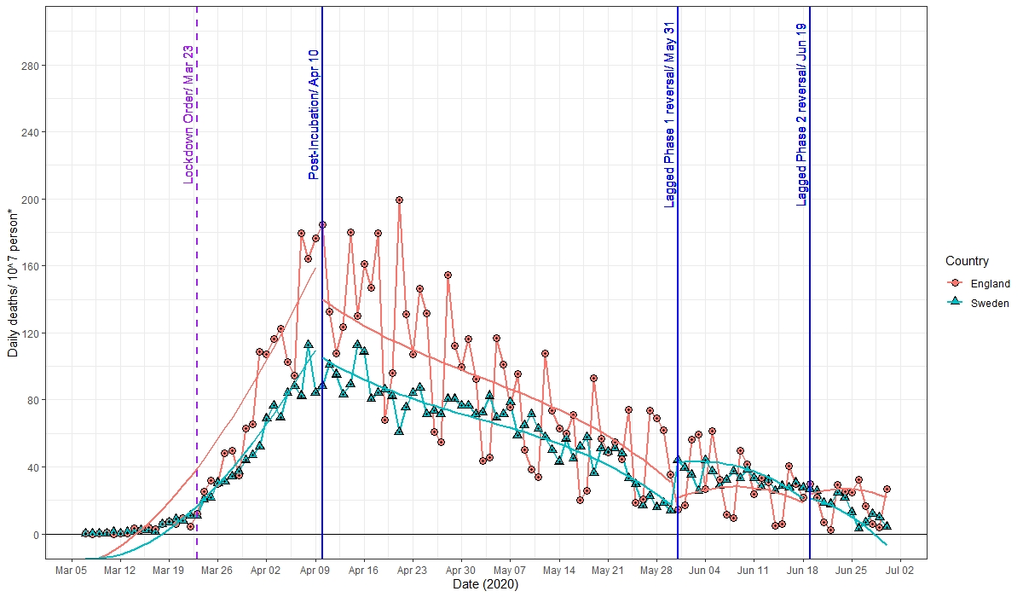
* Population size was adjusted to ten million for both countries in this figure. NB: Smoothened lines represent predicted daily deaths in an interrupted time series model for each country

References
1. Linden, A. and J.L. Adams, Applying a propensity score-based weighting model to interrupted time series data: improving causal inference in programme evaluation. J Eval Clin Pract, 2011. 17(6): p. 1231-8.

