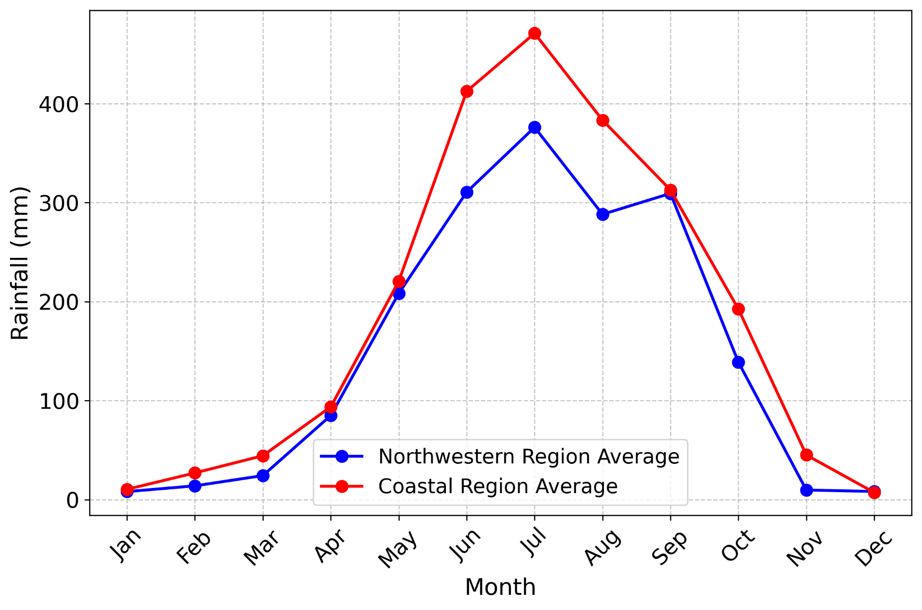
Figure S1: Monthly rainfall distribution in the coastal (southcentral and southwestern) and northwestern regions from 1980 to 2020. The northwestern region comprises five stations: Rajshahi, Rangpur, Dinajpur, Bogra, and Ishurdi.
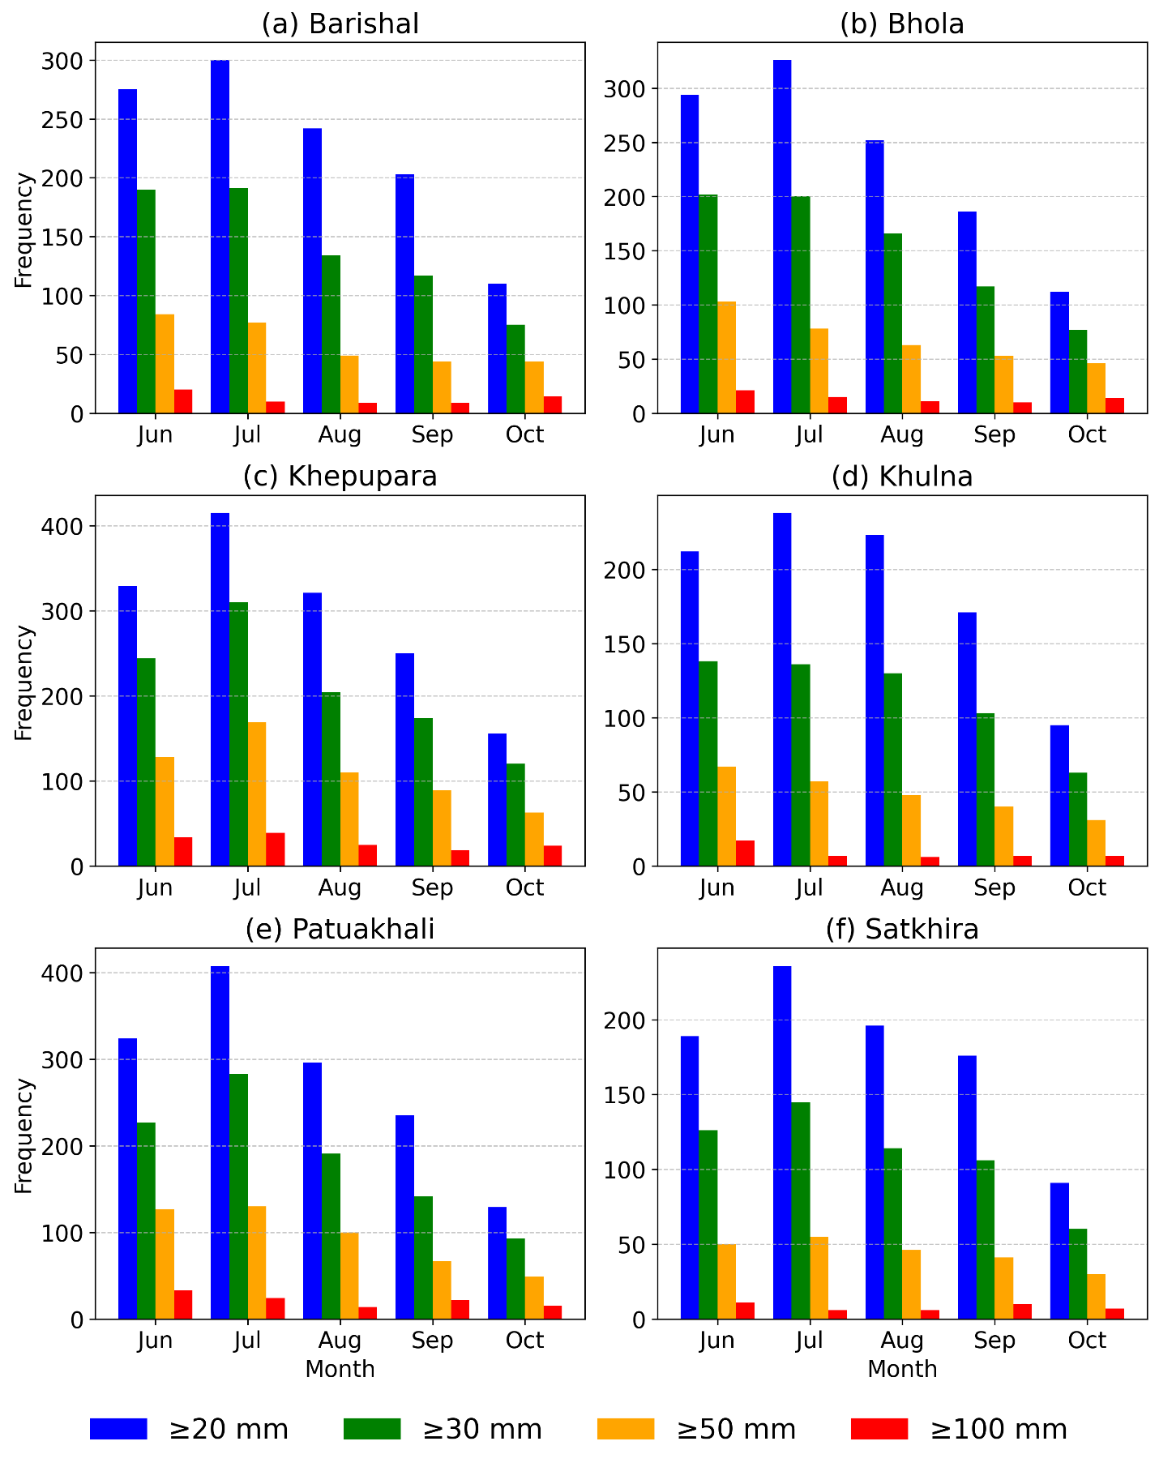
Figure S2: Frequency of extreme rainfall events at various thresholds in the study area during the monsoon months (1980–2020).

(b) Bhola
(a) Barishal
(c) Khepupara
(d) Khulna
(f) Satkhira
(e) Patuakhali
Figure S3. Box plot illustrating the rainfall (mm) observed at various stations across different Standard Meteorological Weeks (SMWs) during the period 1980–2020.

Table S1. Standard meteorological weeks
SMWs | Dates | SMWs | Dates
1 | 1 January–7 January | 27 | 2 July–8 July
2 | 8 January–14 January | 28 | 9 July–15 July
3 | 15 January–21 January | 29 | 16 July–22 July
4 | 22 January–28 January | 30 | 23 July–29 July
5 | 29 January–4 February | 31 | 30 July–5 August
6 | 5 February–11 February | 32 | 6 August–12 August
7 | 12 February–18 February | 33 | 13 August–19 August
8 | 19 February–25 February | 34 | 20 August–26 August
9* | 26 February–4 March | 35 | 27 August–2 September
10 | 5 March–11 March | 36 | 3 September–9 September
11 | 12 March–18 March | 37 | 10 September–16 September
12 | 19 March–25 March | 38 | 17 September–23 September
13 | 26 March–1 March | 39 | 24 September–30 September
14 | 2 April–8 April | 40 | 1 October–7 October
15 | 9 April–15 April | 41 | 8 October–14 October
16 | 16 April–22 April | 42 | 15 October–21 October
17 | 23 April–29 April | 43 | 22 October–28 October
18 | 30 April–6 May | 44 | 29 October–4 November
19 | 7 May–13 May | 45 | 5 November–11 November
20 | 14 May–20 May | 46 | 12 November–18 November
21 | 21 May–27 May | 47 | 19 November–25 November
22 | 28 May–3 June | 48 | 26 November–2 December
23 | 4 June–10 June | 49 | 3 December–9 December
24 | 11 June–17June | 50 | 10 December–16 December
25 | 18 June–24 June | 51 | 17 December–23 December
26 | 25 June–1 July | 52** | 24 December–31 December
* Week no. 9 will have 8 days during the leap year
** Week no. 52 will always have 8 days

