Journal name: Annals of Hematology

Comparison between Pola-R-CHP and R-CHOP regimens in patients newly diagnosed with diffuse large B-cell lymphoma: a propensity score-matched study

Yohei Sasaki^{a,b,}*, Manabu Matsunawa^{b}, Hidenori Hayashiª, Natsuki Kawamataª, Kazuki Nagaoª, Kai Kuroiwaª, Hinako Naritaª, Reiko Okamuraª, Shotaro Shimadaª, Megumi Watanukiª, Nana Araiª, Yukiko Kawaguchiª, Kouji Yanagisawaª, and Norimichi Hattoriª

ª Division of Hematology, Department of Medicine, Showa University School of Medicine, 1-5-8 Hatanodai, Shinagawa-Ku, Tokyo 142-8666, Japan
^{b} Department of Internal Medicine, Showa University Northern Yokohama Hospital, 35-1 Chigasakichuo, Tsuzuki-Ku, Yokohama-Shi, Kanagawa 224-8503, Japan

* Corresponding Author: Yohei Sasaki
Division of Hematology, Department of Medicine, Showa University School of Medicine, 1-5-8 Hatanodai, Shinagawa-Ku, Tokyo 142-8666, Japan
Phone: +81-3-3784-8338
Fax: +81-3-3784-8250
E-mail: ysasaki@med.showa-u.ac.jp
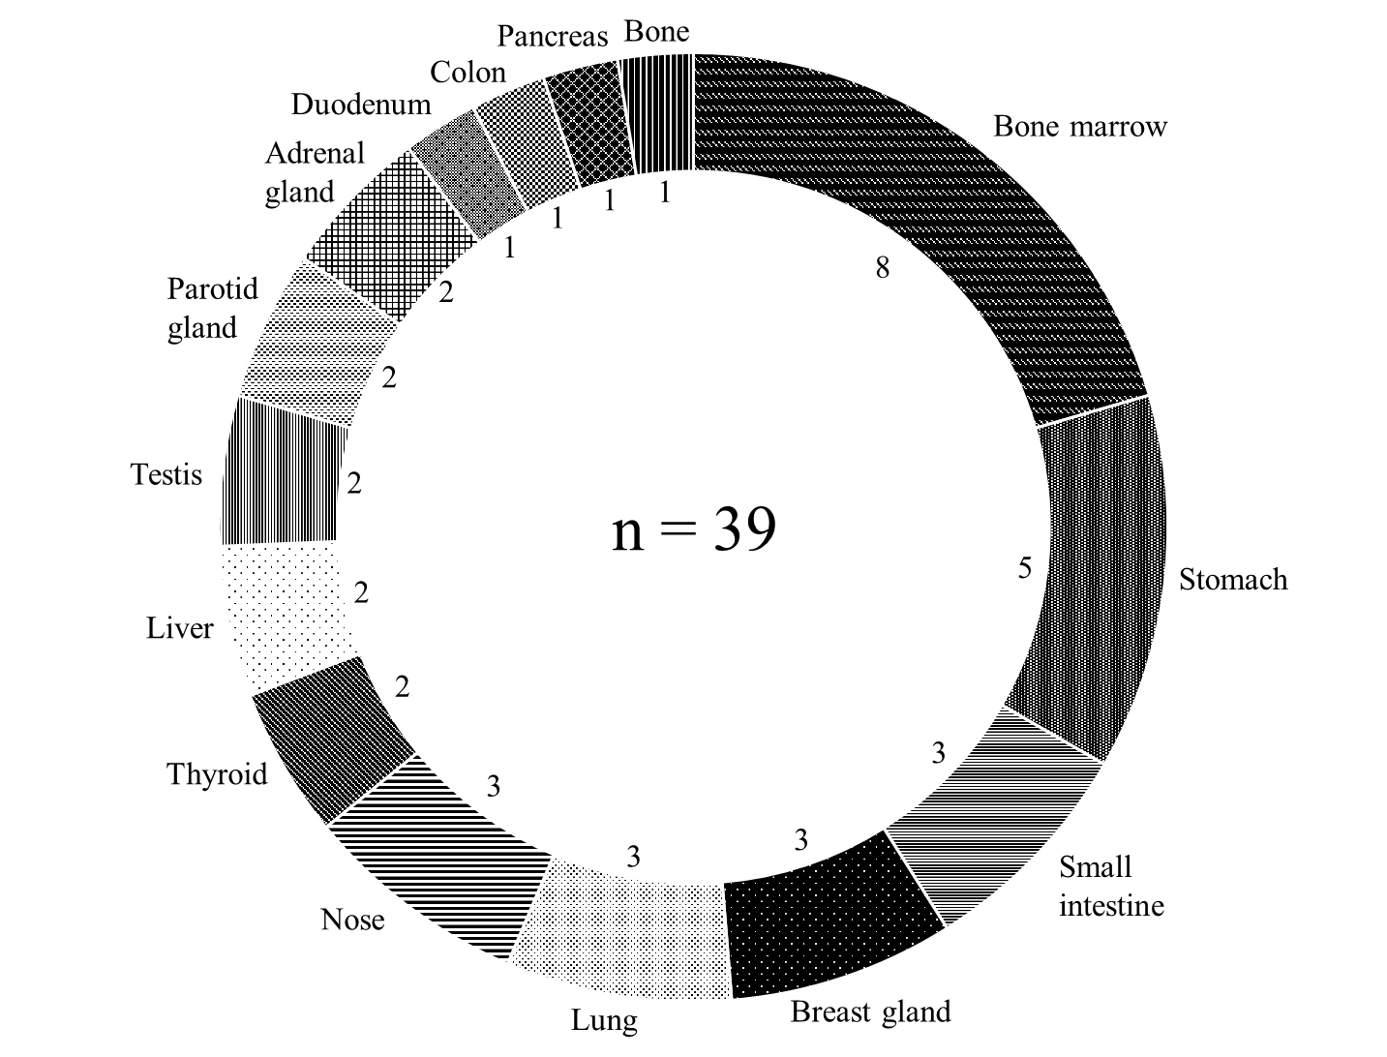
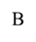

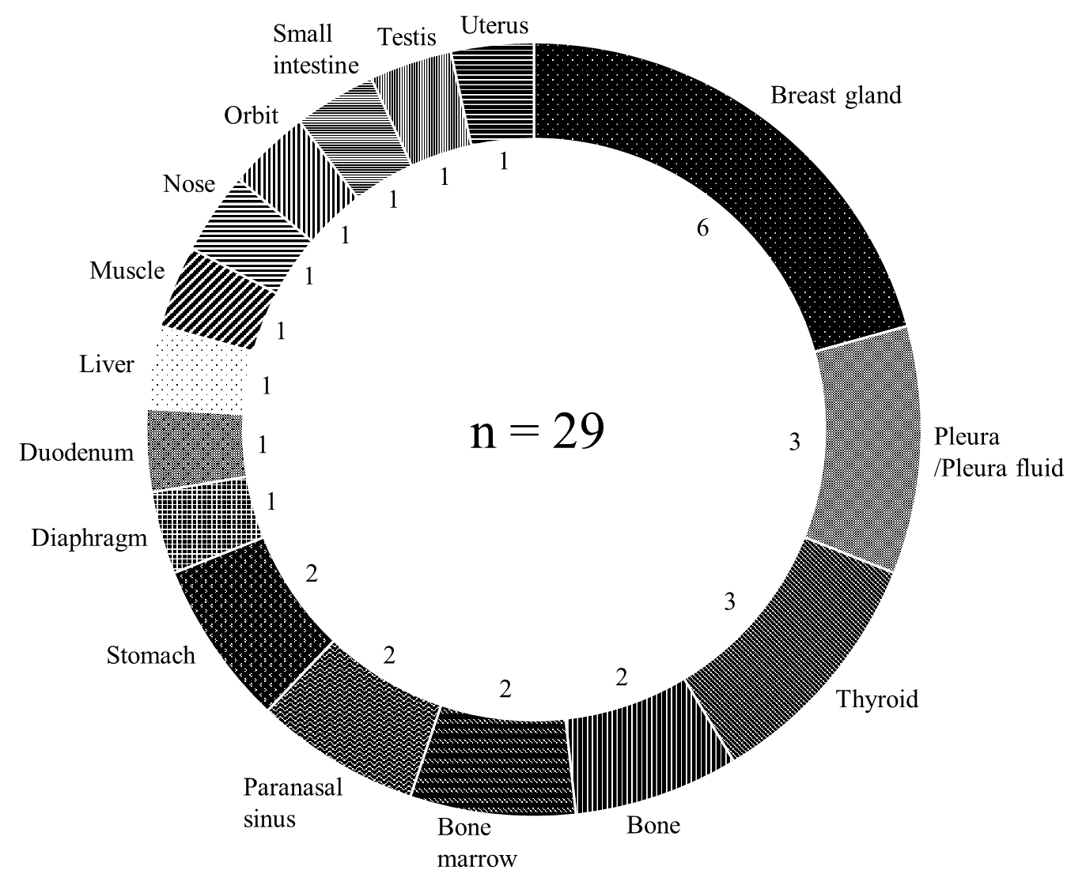

Online Resource 3. After propensity score matching, the overall distribution of extranodal sites in patients with newly diagnosed extranodal diffuse large B-cell lymphoma treated with (A) polatuzumab vedotin, rituximab, cyclophosphamide, doxorubicin, and prednisolone (Pola-R-CHP) and (B) rituximab, cyclophosphamide, doxorubicin, vincristine, and prednisolone (R-CHOP).

