Supplementary Information

Table S1. Search strategies and results
Supplementary Table 1a: Ovid Medline (R)
# | Query | Results
1 | Neural Networks, Computer/ | 51,460
2 | neural network*.mp. | 81,230
3 | Algorithms/ | 310,529
4 | Artificial Intelligence/ | 45,089
5 | artificial intelligen*.mp. | 52,177
6 | Intelligent system*.mp. | 839
7 | Deep Learning/ | 18,970
8 | deep learning.mp. | 38,712
9 | few-shot learning.mp. | 186
10 | Support Vector Machine/ | 10,289
11 | support vector machine*.mp. | 22,281
12 | Machine Learning/ | 38,071
13 | machine learning.mp. | 76,399
14 | self supervised learning.mp. | 456
15 | Diagnosis, Computer-Assisted/ | 24,313
16 | (aided diagnos* or comput* assist* diagnos*).mp. | 5,363
17 | Decision Support Systems, Clinical/ | 9,731
18 | decision support system*.mp. | 14,732
19 | Mobile Applications/ | 12,366
20 | digital health.mp. | 5,658
21 | Smartphone/ | 9,824
22 | Cluster Analysis/ | 70,549
23 | Software Design/ | 6,153
24 | computer vision.mp. | 4,796
25 | multi-classification.mp. | 167
26 | pre-train*.mp. | 4,672
27 | (k-nearest neighbo?r* or knearest neighbo?r*).mp. | 4,515
28 | contextual transformer.mp. | 8
29 | yolo.mp. | 470
30 | swin transformer.mp. | 138
31 | resnet*.mp. | 2,512
32 | SHAP.mp. | 1,076
33 | 1 or 2 or 3 or 4 or 5 or 6 or 7 or 8 or 9 or 10 or 11 or 12 or 13 or 14 or 15 or 16 or 17 or 18 or 19 or 20 or 21 or 22 or 23 or 24 or 25 or 26 or 27 or 28 or 29 or 30 or 31 or 32 | 574,847
34 | Skin/ | 213,520
35 | Skin Diseases/ | 63,663
36 | skin*.mp. | 849,728
37 | Dermatology/ | 21,690
38 | dermato*.mp. | 187,212
39 | skin manifestation*.mp. | 5,953
40 | lesion*.mp. | 871,933
41 | Skin Ulcer/ | 9,426
42 | Dermatitis/ | 13,651
43 | ulcer*.mp. | 268,993
44 | 34 or 35 or 36 or 37 or 38 or 39 or 40 or 41 or 42 or 43 | 1,937,179
45 | 33 and 44 | 26,190
46 | Early Diagnosis/ | 30,622
47 | Diagnosis, Differential/ | 469,604
48 | 34 or 35 or 36 or 37 or 38 or 39 or 40 or 41 or 42 or 43 or 46 or 47 | 2,336,905
49 | 33 and 48 | 33,458
50 | Skin Diseases, Infectious/ | 5,768
51 | Sexually Transmitted Diseases/ | 27,888
52 | Sexual* transmit*.mp. | 49,667
53 | Infectious disease*.mp. | 129,488
54 | Communicable Diseases/ | 34,640
55 | (Genital Disease* or Urogenital Abnormalit* or Urogenital Neoplasm* or urogenital disease*).mp. | 35,368
56 | Herpes Genitalis/ or Vulvar Diseases/ or Pruritus Vulvae/ or Vulvar Lichen Sclerosus/ or Vulvitis/ or Vulvodynia/ | 10,739
57 | (Vulvar Disease* or Pruritus Vulvae or Vulvar Lichen Sclerosus or Vulvitis).mp. | 5,618
58 | "Mpox (monkeypox)"/ | 2,579
59 | (Mpox or monkeypox).mp. | 3,505
60 | Monkeypox virus/ | 1,315
61 | Monkeypox virus.mp. | 1,717
62 | Syphilis/ | 23,832
63 | Sexually Transmitted Diseases, Bacterial/ or Chancroid/ | 1,975
64 | Syphilis, Cutaneous/ | 1,130
65 | chancre.mp. | 793
66 | Treponema pallidum/ | 4,547
67 | syphil?i*.mp. | 35,447
68 | Warts/ | 5,159
69 | Condylomata Acuminata/ | 5,602
70 | wart*.mp. | 18,343
71 | Molluscum Contagiosum/ | 1,548
72 | molluscum*.mp. | 2,156
73 | Molluscum contagiosum virus/ | 323
74 | Herpes Simplex/ | 15,510
75 | herpes*.mp. | 133,568
76 | Herpes Zoster/ | 11,763
77 | Herpes Genitalis/ | 4,895
78 | Herpesvirus 2, Human/ | 4,746
79 | Scabies/ | 3,943
80 | scabie*.mp. | 5,102
81 | Lichens/ | 3,424
82 | Lichen Planus/ | 6,168
83 | Lichen Sclerosus et Atrophicus/ | 1,420
84 | lichen*.mp. | 25,333
85 | 50 or 51 or 52 or 53 or 54 or 55 or 56 or 57 or 58 or 59 or 60 or 61 or 62 or 63 or 64 or 65 or 66 or 67 or 68 or 69 or 70 or 71 or 72 or 73 or 74 or 75 or 76 or 77 or 78 or 79 or 80 or 81 or 82 or 83 or 84 | 449,704
86 | 44 and 85 | 64,538
87 | 48 and 85 | 73,942
88 | 33 and 86 | 368
89 | 33 and 87 | 489
90 | Filtered date: from 1 Jan 2010 to 12 Apr 2024 | 318

Supplementary Table 1b: Embase via Ovid
# | Query | Results
1 | artificial neural network/ | 56,220
2 | convolutional neural network/ | 30,584
3 | algorithm/ | 381,696
4 | neural network*.mp. | 154,467
5 | artificial intelligence/ | 74,937
6 | artificial intelligence.mp. | 85,590
7 | deep learning/ | 54,689
8 | deep learn*.mp. | 77,353
9 | support vector machine/ | 43,271
10 | support vector machine*.mp. | 50,731
11 | automated pattern recognition/ | 17,677
12 | computer analysis/ | 126,942
13 | computer vision.mp. | 10,726
14 | machine learning/ | 115,599
15 | machine learn*.mp. | 160,862
16 | image analysis/ | 242,484
17 | image processing/ | 106,014
18 | automated pattern recognition/ | 17,677
19 | automat* diagnos*.mp. | 2,878
20 | image recogn*.mp. | 2,286
21 | computer assisted diagnosis/ | 44,466
22 | computer assist* diagnos*.mp. | 45,059
23 | decision support system/ | 28,169
24 | clinical decision support system/ | 6,799
25 | information system/ | 43,166
26 | clinic* decision support* system*.mp. | 8,879
27 | aid* diagnos*.mp. | 12,716
28 | machine learning software/ | 886
29 | medical image management software/ | 271
30 | healthcare software/ | 588
31 | artificial intelligence software/ | 836
32 | imaging software/ | 75,157
33 | open source software/ | 1,924
34 | software validation/ | 385
35 | camera software/ | 148
36 | clinical information management software/ | 121
37 | clinical management support software/ | 66
38 | medical information system software/ | 130
39 | patient health record information system software/ | 222
40 | smartphone/ | 28,988
41 | mobile phone/ | 23,197
42 | mobile application/ | 23,517
43 | k-nearest neighbo?r.mp. | 10,541
44 | contextual transformer*.mp. | 15
45 | image* annotat*.mp. | 556
46 | yolo.mp. | 978
47 | swin transformer*.mp. | 285
48 | resnet*.mp. | 5,381
49 | digital health.mp. | 9,818
50 | intelligent system*.mp. | 1,538
51 | pre?train* model*.mp. | 482
52 | multimodal*.mp. | 176,169
53 | multi?classif*.mp. | 170
54 | skin lesion classif*.mp. | 173
55 | self supervised learn*.mp. | 931
56 | few shot learn*.mp. | 474
57 | 1 or 2 or 3 or 4 or 5 or 6 or 7 or 8 or 9 or 10 or 11 or 12 or 13 or 14 or 15 or 16 or 17 or 18 or 19 or 20 or 21 or 22 or 23 or 24 or 25 or 26 or 27 or 28 or 29 or 30 or 31 or 32 or 33 or 34 or 35 or 36 or 37 or 38 or 39 or 40 or 41 or 42 or 43 or 44 or 45 or 46 or 47 or 48 or 49 or 50 or 51 or 52 or 53 or 54 or 55 or 56 | 1,472,100
58 | skin/ | 257,972
59 | skin disease/ | 98,336
60 | skin examination/ | 14,414
61 | skin manifestation/ | 40,818
62 | skin ulcer/ | 23,255
63 | skin manifestation*.mp. | 44,267
64 | dermatology/ | 57,244
65 | dermato*.mp. | 315,166
66 | lesion*.mp. | 1,576,121
67 | ulcer*.mp. | 497,138
68 | 58 or 59 or 60 or 61 or 62 or 63 or 64 or 65 or 66 or 67 | 2,543,917
69 | early diagnosis/ | 142,270
70 | differential diagnosis/ | 440,138
71 | 58 or 59 or 60 or 61 or 62 or 63 or 64 or 65 or 66 or 67 or 69 or 70 | 3,009,777
72 | genital skin/ | 114
73 | genital skin.mp. | 1,038
74 | lumpy skin disease/ | 496
75 | Lumpy skin disease virus/ | 308
76 | skin infection/ | 30,361
77 | viral skin disease/ | 1,183
78 | bacterial skin disease/ | 3,760
79 | sexually transmitted disease/ | 56,704
80 | sexually transmi*.mp. | 77,037
81 | infectious disease*.mp. | 176,710
82 | communicable disease/ | 39,130
83 | communicable disease*.mp. | 71,151
84 | genital system disease/ | 4,498
85 | vulva disease/ | 3,664
86 | penis disease/ | 5,017
87 | herpes simplex/ | 25,274
88 | Herpes simplex virus 1/ | 23,239
89 | Herpes simplex virus 2/ | 12,890
90 | genital herpes/ | 6,679
91 | herpes*.mp. | 176,822
92 | monkeypox/ | 4,306
93 | monkeypox*.mp. | 5,525
94 | Monkeypox virus/ | 2,180
95 | mpox*.mp. | 1,582
96 | syphilis/ | 46,252
97 | secondary syphilis/ | 2,829
98 | cutaneous syphilis/ | 69
99 | latent syphilis/ | 430
100 | syphilis serology/ | 3,996
101 | syphilis*.mp. | 57,375
102 | ulcus molle/ | 1,640
103 | chancroid.mp. | 1,136
104 | Treponema pallidum/ | 9,009
105 | treponema pallidum.mp. | 11,708
106 | wart/ | 730
107 | Wart virus/ | 46,407
108 | condyloma acuminatum/ | 9,928
109 | wart*.mp. | 79,200
110 | venereal.mp. | 10,386
111 | molluscum contagiosum/ | 3,737
112 | Molluscum contagiosum virus/ | 143
113 | molluscum contagiosum.mp. | 4,223
114 | herpes zoster/ | 31,473
115 | scabies/ | 7,812
116 | scabie*.mp. | 9,345
117 | "lichen (disease)"/ | 658
118 | lichen planus/ | 15,464
119 | lichen sclerosus et atrophicus/ | 5,639
120 | lichen*.mp. | 46,426
121 | 72 or 73 or 74 or 75 or 76 or 77 or 78 or 79 or 80 or 81 or 82 or 83 or 84 or 85 or 86 or 87 or 88 or 89 or 90 or 91 or 92 or 93 or 94 or 95 or 96 or 97 or 98 or 99 or 100 or 101 or 102 or 103 or 104 or 105 or 106 or 107 or 108 or 109 or 110 or 111 or 112 or 113 or 114 or 115 or 116 or 117 or 118 or 119 or 120 | 685,112
122 | 68 and 121 | 110,877
123 | 71 and 121 | 124,518
124 | 57 and 122 | 1,901
125 | 57 and 123 | 2,315
126 | Filtered date: from 1 Jan 2010 to 12 Apr 2024 | 1729

Supplementary Table 1c: IEEE Xplore
# | Query | Results
1 | (((All Metadata:skin OR All Metadata:dermato* OR All Metadata:sexually transmit* OR All Metadata:communicable disease* OR All Metadata:herpes OR All Metadata:monkeypox OR All Metadata:mpox OR All Metadata:chancre OR All Metadata:treponema pallidum OR All Metadata:syphilis OR All Metadata:wart* OR All Metadata:condylomata acuminata OR All Metadata:molluscum contagiosum OR All Metadata:scabie* OR All Metadata:lichen*)))  AND  ((All Metadata:artificial neural network OR All Metadata:image analys?s OR All Metadata:image recogni* OR All Metadata:artificial intelligent OR All Metadata:deep learning OR All Metadata:machine learning OR All Metadata:computer assist*))  Limited to journals and early access articles  Year range from 2010 to 2024 (search result date: 12 Apr 2024) | 2,213

Supplementary Table 1d: Web of Science
# | Query | Results
1 | ((((((((((((((((((((ALL=("image classif*")) OR ALL=("neural network*")) OR ALL=("computer assist* diagnos?s")) OR ALL=("aid* diagnos?s")) OR ALL=("computer vision")) OR ALL=("machine learning")) OR ALL=("deep learning")) OR ALL=("artificial intelligen*")) OR ALL=("image analys?s")) OR ALL=("image recogni*")) OR ALL=("automated pattern recongi*")) OR ALL=("k?nearest neighbo?r")) OR ALL=("YOLO")) OR ALL=("swin transformer")) OR ALL=("support vector machine")) OR ALL=("resnet*")) OR ALL=("pre?train* model*")) OR ALL=("multimodal*")) OR ALL=("lesion classif*")) OR ALL=("supervised learn*")) OR ALL=("few shot learn*") | 1,947,791
2 | ((((ALL=(skin)) OR ALL=("skin disease*")) OR ALL=("skin manifest*")) OR ALL=("dermato*")) OR ALL=("ulcer*") | 1,673,886
3 | (((((((((((((((ALL=(lichen*)) OR ALL=(scabie*)) OR ALL=(herpes)) OR ALL=("molluscum contagiosum")) OR ALL=("wart*")) OR ALL=("condylomata acuminata")) OR ALL=("syphil?i*")) OR ALL=(chancre)) OR ALL=("treponema pallidum")) OR ALL=(monkeypox)) OR ALL=(mpox)) OR TS=("*genital")) OR ALL=("genito*")) OR ALL=("communicable disease*")) OR ALL=("sexual health")) OR ALL=("sex* transmit*") | 709,597
4 | #2 AND #3 | 70,223
5 | #1 AND #4 | 351
6 | #1 AND #4 and 2024 or 2023 or 2022 or 2021 or 2020 or 2019 or 2018 or 2017 or 2016 or 2015 or 2014 or 2013 or 2012 or 2011 or 2010 (Publication Years) | 303

Supplementary Table 1e: Scopus
# | Query | Results
1 | ( ( TITLE-ABS-KEY ( "image classif*" ) ) OR ( TITLE-ABS-KEY ( "artificial neural network*" ) ) OR ( TITLE-ABS-KEY ( "convolutional neural network*" ) ) OR ( TITLE-ABS-KEY ( "computer assist* diagnos?s*" ) ) OR ( TITLE-ABS-KEY ( "aided diagnos?s*" ) ) OR ( TITLE-ABS-KEY ( "computer vision*" ) ) OR ( TITLE-ABS-KEY ( "machine learning" ) ) OR ( TITLE-ABS-KEY ( "deep learning" ) ) OR ( TITLE-ABS-KEY ( "artificial intelligen*" ) ) OR ( ( TITLE-ABS-KEY ( "image analys?s" ) OR TITLE-ABS-KEY ( "image recogni*" ) ) ) )  AND  ( ( ( TITLE-ABS-KEY ( lichen* ) ) OR ( TITLE-ABS-KEY ( scabie* ) ) OR ( TITLE-ABS-KEY ( herpes ) ) OR ( TITLE-ABS-KEY ( molluscum AND contagiosum ) ) OR ( ( TITLE-ABS-KEY ( wart* ) OR TITLE-ABS-KEY ( condylomata AND acuminata ) ) ) OR ( ( TITLE-ABS-KEY ( syphil?i* ) OR TITLE-ABS-KEY ( chancre ) OR TITLE-ABS-KEY ( treponema AND pallidum ) ) ) OR ( ( TITLE-ABS-KEY ( monkeypox ) OR TITLE-ABS-KEY ( mpox ) ) ) OR ( TITLE-ABS-KEY ( *genital ) OR TITLE-ABS-KEY ( genito* ) ) OR ( TITLE-ABS-KEY ( communicable AND disease* ) ) OR ( TITLE-ABS-KEY ( sexual* AND health ) ) OR ( TITLE-ABS-KEY ( sexual* AND transmit* ) ) ) AND ( ( TITLE-ABS-KEY ( skin* ) ) OR ( TITLE-ABS-KEY ( dermato* ) ) OR ( TITLE-ABS-KEY ( ulcer* OR lesion* OR lump* OR "skin manifest*" ) ) ) )  AND  PUBYEAR > 2009 AND PUBYEAR < 2024 | 1,384

Supplementary Table 1f: CINAHL
# | Query | Results
1 | (MH "Image Processing, Computer Assisted/CL/EV") OR (MH "Image Interpretation, Computer Assisted") OR (MH "Support Vector Machine") OR (MH "Neural Networks (Computer)") OR (MH "Machine Learning") OR (MH "Decision Making, Computer Assisted") OR (MH "Data Analysis, Computer Assisted") OR (MH "Decision Support Techniques") OR (MH "Deep Learning") OR (MH "Therapy, Computer Assisted") OR (MH "Diagnosis, Computer Assisted") OR (MH "Decision Support Systems, Clinical") OR (MH "Artificial Intelligence") OR (MH "Decision Support Systems, Management") OR (MH "Computer-Aided Design") OR (MH "Self-Directed Learning") OR "( neural network or deep-learning or machine learning ) OR artificial intelligence OR computer vision OR computer assisted decision support OR image analysis OR image processing OR image recognition OR image classification OR k-nearest neighbor OR swin-transformer OR yolo OR support vector machine"
2 | (MH "Skin Manifestations") OR (MH "Skin Diseases") OR (MH "Skin Diseases, Parasitic") OR (MH "Skin Diseases, Metabolic") OR (MH "Skin Diseases, Infectious") OR (MH "Skin Diseases, Genetic") OR (MH "Skin") OR (MH "Skin and Connective Tissue Diseases") OR (MH "Skin Neoplasms") OR "skin OR ( dermatology or skin diseases or skin condition ) OR skin disorders OR skin infection OR skin manifestations" OR (MH "Skin Pigmentation") OR (MH "Skin Abnormalities") OR (MH "Skin Ulcer") OR (MH "Skin Diseases, Papulosquamous") OR (MH "Skin Diseases, Vascular") OR (MH "Skin Diseases, Vesiculobullous") OR (MH "Skin Maceration") OR (MH "Staphylococcal Scalded Skin Syndrome") OR (MH "Neoplasms, Adnexal and Skin Appendage") OR (MH "Exanthema")
3 | (MH "Communicable Diseases") OR (MH "Sexually Transmitted Diseases") OR (MH "Sexually Transmitted Diseases, Viral") OR (MH "Sexually Transmitted Diseases, Protozoal") OR (MH "Sexually Transmitted Diseases, Fungal") OR (MH "Sexually Transmitted Diseases, Bacterial") OR (MH "Risk Control: Sexually Transmitted Diseases (STD) (Iowa NOC)") OR (MH "Skin Diseases, Infectious") OR (MH "Post-Infectious Disorders") OR "( *genital or genito* ) OR sexual health OR sexually transmitted diseases OR ( communicable disease or infectious disease ) OR herpes* OR ( monkeypox or monkey pox or monkey pox virus ) OR ( syphilis or treponema pallidum ) OR ( warts or condyloma acuminatum ) OR molluscum contagiosum OR scabies OR lichen" OR (MH "Genital Diseases") OR (MH "Virus Diseases") OR (MH "Genital Diseases, Female") OR (MH "Genital Diseases, Male") OR (MH "Health and Disease") OR (MH "Infection Control") OR (MH "Sexual Health Clinics") OR (MH "Sexual Health Services") OR (MH "Vulvar Diseases") OR (MH "Vaginal Diseases") OR (MH "Penile Diseases") OR (MH "Anus Diseases") OR (MH "Urologic Diseases") OR (MH "Urethral Diseases") OR (MH "Ureteral Diseases") OR (MH "Testicular Diseases") OR (MH "Skin Diseases") OR (MH "Skin Diseases, Vesiculobullous") OR (MH "Disease Transmission") OR (MH "Disease Surveillance") OR (MH "Disease Outbreaks") OR (MH "Skin Diseases, Vascular") OR (MH "Skin Diseases, Parasitic") OR (MH "Skin Diseases, Papulosquamous") OR (MH "Sweat Gland Diseases") OR (MH "Bacterial and Fungal Diseases") OR (MH "Skin and Connective Tissue Diseases") OR (MH "Sexual Intercourse") OR (MH "Sexual Abstinence") OR (MH "Sexual Partners") OR (MH "Sexual Behavior") OR (MH "Warts, Venereal") OR (MH "Herpes Genitalis") OR (MH "Herpes Zoster Vaccine") OR (MH "Syphilis") OR (MH "Genitalia") OR (MH "Warts") OR (MH "Scabies") OR (MH "Human Papillomavirus Viruses") OR (MH "Warts, Plantar") OR (MH "Lichen Planus") OR (MH "Herpes Simplex") OR (MH "Genitalia, Male") OR (MH "Herpes Zoster") OR (MH "Pelvic Floor Disorders")
4 | #2 AND #3
5 | #1 AND #4
6 | Year range from 2010 to 2024 (search result date: 12 Apr 2024) | 85

Table S2. Summary of included studies
Supplementary Table 2a: Syphilis
No | Author, Year | Image Data Source | Type of Lesions included | Sample Size (Target/Total) | Reference Conditions | Study Type | Best Performing AI Algorithm | AUC-ROC | Accuracy | Sensitivity | Specificity | PPV |  | Modified QUADAS-2
 |  |  |  |  |  |  |  |  |  |  |  |  |  | P | I | R
1 | Allan, 2024 [1] | ◆ Multiple (India, Sri Lanka, Singapore, Australia, United States, United Kingdom) | 6 | 190/1,570 | 1, 2, 4, 5, 15, 99 | MD | U-Net + Inception-ResNet-V2 | NR | 0.944 | 0.865  (0.712-0.955) | 0.985  (0.957 - 0.999) | 0.914  (0.822 - 0.999) | RoB | + | + | +
 |  |  |  |  |  |  |  |  |  |  |  |  | App | ? | + | +
AUC-ROC, Area Under the Curve-Receiver Operating Characteristic; PPV, Positive Predictive Value; P: Population; I: Index Test; R: Reference Standard; RoB: Risk of Bias; App: Applicability; NR: Not Reported; MD: Model Development and Internal Validation; MC: Model Comparison; EV: External Validation; PS-NR: Prospective study (Non-Randomised); CNN: Convolutional Neural Networks;
MSID: Mpox Image Dataset; MSLD: Mpox Skin Lesion Dataset;
◆ : reviewed by clinician/dermatologist; ❖ : confirmed by laboratory and reviewed by clinician/dermatologist
Reference conditions: (1=Syphilis chancre; 2=Condylomata lata; 3=Syphilis rash; 4=Herpes simplex; 5=Genital warts; 6=Mpox; 7=Molluscum Contagiosum; 8=Tinea Cruris; 9=Lichenoid conditions including lichen sclerosus, lichen planus; 10=Scabies; 11=Folliculitis; 12=Herpes Zoster; 13=Psoriasis; 14=Normal variant/healthy skin; 15=Balanitis; 19=Others)

Low Concern  Unsure  High Concern

Supplementary Table 2b: Herpes Simplex
No | Author, Year | Image Data Source | Type of Lesions included | Sample Size (Target/Total) | Reference Conditions | Study Type | Best Performing AI Algorithm | AUC-ROC | Accuracy | Sensitivity | Specificity | PPV |  | Modified QUADAS-2
 |  |  |  |  |  |  |  |  |  |  |  |  |  | P | I | R
1 | Gaffoor, 2023 [2] | Kaggle | 10 | 100/1,000 | 4, 5, 6, 7, 8, 13, 99 | MD, MC | SVM | NR | 0.100 | 0.100 | NR | 0.100 | RoB | - | ? | -
 |  |  |  |  |  |  |  |  |  |  |  |  | App | - | - | -
2 | Mehta, 2024 [3] | ❖ Private dataset from STI and genital diseases clinic in North India (Jan-2021 to Jun-2022) | 8 | 4/257 | 4, 5, 6, 7, 8, 9, 10, 99 | PS-NR | CNN-based app (DermAId) | NR | 0.689 | 0.300 | 0.992 | NR | RoB | + | + | +
 |  |  |  |  |  |  |  |  |  |  |  |  | App | - | + | +
3 | Wei, 2018 [4] | NR | 3 | 30/90 | 99 | MD | SVM | NR | 0.850 | NR | NR | NR | RoB | ? | ? | -
 |  |  |  |  |  |  |  |  |  |  |  |  | App | - | ? | -
4 | Yadav, 2023 [5] | DermNet | 3 | 810/3,468 | 99 | MD | VGG-16 | NR | 0.840 | NR | NR | NR | RoB | - | ? | -
 |  |  |  |  |  |  |  |  |  |  |  |  | App | - | - | -
5 | Allan, 2024 [1] | ◆ Multiple (India, Sri Lanka, Singapore, Australia, United States, United Kingdom) | 6 | 212/1,570 | 1, 2, 4, 5, 15, 99 | MD | U-Net + Inception-ResNet-V2 | NR | 0.944 | 0.930  (0.810-0.985) | 0.969  (0.935 - 0.989) | 0.870  (0.772 - 0.967) | RoB | + | + | +
 |  |  |  |  |  |  |  |  |  |  |  |  | App | ? | + | +
6 | Nurul, 2019 [6] | NR | 6 | NR/72 | 10, 99 | MD | Local Binary Pattern (LBP) + CNN | NR | 0.800 | NR | NR | NR | RoB | ? | - | -
 |  |  |  |  |  |  |  |  |  |  |  |  | App | - | - | -
7 | Sadik, 2023 [7] | HAM10000 + DermNet | 5 | 5,140/18,692 | 99 | MD, MC | Xception | 0.997 | 0.970 | 0.990 | NR | 0.925 | RoB | - | ? | -
 |  |  |  |  |  |  |  |  |  |  |  |  | App | ? | ? | -
AUC-ROC, Area Under the Curve-Receiver Operating Characteristic; PPV, Positive Predictive Value; P: Population; I: Index Test; R: Reference Standard; RoB: Risk of Bias; App: Applicability; NR: Not Reported; MD: Model Development and Internal Validation; MC: Model Comparison; EV: External Validation; PS-NR: Prospective study (Non-Randomised); CNN: Convolutional Neural Networks;
MSID: Mpox Image Dataset; MSLD: Mpox Skin Lesion Dataset;
◆ : reviewed by clinician/dermatologist; ❖ : confirmed by laboratory and reviewed by clinician/dermatologist
Reference conditions: (1=Syphilis chancre; 2=Condylomata lata; 3=Syphilis rash; 4=Herpes simplex; 5=Genital warts; 6=Mpox; 7=Molluscum Contagiosum; 8=Tinea Cruris; 9=Lichenoid conditions including lichen sclerosus, lichen planus; 10=Scabies; 11=Folliculitis; 12=Herpes Zoster; 13=Psoriasis; 14=Normal variant/healthy skin; 15=Balanitis; 19=Others)

Low Concern Unsure High Concern

Supplementary Table 2c: Genital Warts
No | Author, Year | Image Data Source | Type of Lesions included | Sample Size (Target/Total) | Reference Conditions | Study Type | Best Performing AI Algorithm | AUC-ROC | Accuracy | Sensitivity | Specificity | PPV |  | Modified QUADAS-2
 |  |  |  |  |  |  |  |  |  |  |  |  |  | P | I | R
1 | Assoc, 2019 [8] | Wise-Geek group | 3 | NR/240 | 99 | MD | k-nearest neighbor algorithm (k-NN) | NR | 0.982 | NR | NR | NR | RoB | - | ? | -
 |  |  |  |  |  |  |  |  |  |  |  |  | App | - | - | -
2 | Casuayan, 2020 [9] | ◆ Private dataset | 7 | 100/600 | 14, 99 | MD | Support Vector Machine (SVM) | NR | NR | 0.906 | NR | 0.936 | RoB | + | ? | +
 |  |  |  |  |  |  |  |  |  |  |  |  | App | - | - | ?
3 | Gaffoor, 2023 [2] | Kaggle | 10 | 100/1,000 | 4, 5, 6, 7, 8, 13, 99 | MD, MC | SVM | NR | 0.970 | 0.950 | NR | 0.100 | RoB | - | ? | -
 |  |  |  |  |  |  |  |  |  |  |  |  | App | - | - | -
4 | Mehta, 2024 [3] | ❖ Private dataset from STI and genital diseases clinic in North India (Jan-2021 to Jun-2022) | 8 | 95/257 | 4, 5, 6, 7, 8, 9, 10, 99 | MD, PS-NR | CNN-based app (DermAId) | NR | 0.689 | 0.558 | 1000 | NR | RoB | + | + | +
 |  |  |  |  |  |  |  |  |  |  |  |  | App | - | + | +
5 | Pangti, 2021 [10] | ❖ Hellenic Dermatological Atlas + DanDerm | 40 | NR/15,418 | 5, 7, 8, 9, 12, 14, 99 | MD, PS-NR | DenseNet-161 | 0.850 | NR | 0.571 (0.394 – 0.737) | 0.997 | 0.571 | RoB | + | + | +
 |  |  |  |  |  |  |  |  |  |  |  |  | App | ? | + | +
6 | Allan, 2024 [1] | ◆ Multiple (India, Sri Lanka, Singapore, Australia, United States, United Kingdom) | 6 | 217/1,570 | 1, 2, 4, 5, 15, 99 | MD | U-Net + Inception-ResNet-V2 | NR | 0.944 | 0.956 (0.849 - 0.995) | 0.964 (0.927 - 0.985) | 0.860 (0.764 - 0.956) | RoB | + | + | +
 |  |  |  |  |  |  |  |  |  |  |  |  | App | ? | + | +
7 | Zaar, 2020 [11] | ❖ Department of Dermatology and Venereology at Sahlgrenska University Hospital in Gothenburg (Apr-2018 to May-2019) | 44 | NR | 44 conditions | PS-NR | NR | NR | Top-1 Accuracy: 0.651  Top-5 Accuracy: 0.914 | NR | NR | NR | RoB | + | ? | +
 |  |  |  |  |  |  |  |  |  |  |  |  | App | ? | + | +
8 | Dodia, 2022 [12] | Google + DermNet | 5 | 45/257 | 99 | MD | VGG-16+XGBoost | NR | 0.94 | 1.000 | NR | 1.000 |  | - | - | -
 |  |  |  |  |  |  |  |  |  |  |  |  |  | - | - | -
AUC-ROC, Area Under the Curve-Receiver Operating Characteristic; PPV, Positive Predictive Value; P: Population; I: Index Test; R: Reference Standard; RoB: Risk of Bias; App: Applicability; NR: Not Reported; MD: Model Development and Internal Validation; MC: Model Comparison; EV: External Validation; PS-NR: Prospective study (Non-Randomised); CNN: Convolutional Neural Networks;
MSID: Mpox Image Dataset; MSLD: Mpox Skin Lesion Dataset;
◆ : reviewed by clinician/dermatologist; ❖ : confirmed by laboratory and reviewed by clinician/dermatologist
Reference conditions: (1=Syphilis chancre; 2=Condylomata lata; 3=Syphilis rash; 4=Herpes simplex; 5=Genital warts; 6=Mpox; 7=Molluscum Contagiosum; 8=Tinea Cruris; 9=Lichenoid conditions including lichen sclerosus, lichen planus; 10=Scabies; 11=Folliculitis; 12=Herpes Zoster; 13=Psoriasis; 14=Normal variant/healthy skin; 15=Balanitis; 19=Others)

Low Concern Unsure High Concern

Supplementary Table 2d: Mpox
No | Author, Year | Image Data Source | Type of Lesions included | Sample Size (Target/Total) | Reference Conditions | Study Type | Best Performing AI Algorithm | AUC-ROC | Accuracy | Sensitivity | Specificity | PPV |  | Modified QUADAS-2
 |  |  |  |  |  |  |  |  |  |  |  |  |  | P | I | R
1 | Abdelhamid, 2022 [13] | Kaggle | 2 | 279/572 | 14 | MD | GoogLeNet | NR | 0.938 | 0.625 | 0.998 | NR | RoB | - | - | -
 |  |  |  |  |  |  |  |  |  |  |  |  | App | - | - | -
2 | Adar, 2024 [14] | Kaggle | 4 | 279/770 | 14, 99 | MD | MobileNet-V2 | NR | 0.904 | 0.881 | NR | 0.933 | RoB | - | ? | -
 |  |  |  |  |  |  |  |  |  |  |  |  | App | - | - | -
3 | Agrawal, 2022 [15] | Kaggle | 4 | 222/870 | 14, 99 | MD | EfficientNet-B3 | NR | 0.930 | 0.940 | NR | 0.930 | RoB | - | ? | -
 |  |  |  |  |  |  |  |  |  |  |  |  | App | - | - | -
4.1 | Ahsan, 2024 [16] | Arxiv | 2 | 43/76 | 14 | MD | M-VGG16 | NR | 0.880 ± 0.076 | 0.880 ± 0.076 | NR | 0.900 ± 0.069 | RoB | - | - | -
 |  |  |  |  |  |  |  |  |  |  |  |  | App | - | - | -
4.2 | Ahsan, 2024 [16] | Arxiv | 2 | 587/1,754 | 99 | MD | M-VGG16 | NR | 0.760 ± 0.023 | 0.770 ± 0.022 | NR | 0.770 ± 0.022 | RoB | - | - | -
 |  |  |  |  |  |  |  |  |  |  |  |  | App | - | - | -
4.3 | Ahsan, 2024 [16] | Arxiv | 4 | 264/656 | 14, 99 | MD | M-Resnet50 | NR | 0.890 ± 0.021 | 0.840 ± 0.025 | NR | 0.830 ± 0.026 | RoB | - | - | -
 |  |  |  |  |  |  |  |  |  |  |  |  | App | - | - | -
4.4 | Ahsan, 2024 [16] | Arxiv | 2 | 866/2,524 | 14 | MD | M-VGG16 | NR | 0.770 ± 0.036 | 0.740 ± 0.038 | NR | 0.820 ± 0.026 | RoB | - | - | -
 |  |  |  |  |  |  |  |  |  |  |  |  | App | - | - | -
5.1 | Ahsan, 2023 [17] | Kaggle | 2 | 43/76 | 14 | MD | VGG-19 | NR | 0.930 | 0.940 | 0.850 | 0.940 | RoB | - | - | -
 |  |  |  |  |  |  |  |  |  |  |  |  | App | - | - | -
5.2 | Ahsan, 2023 [17] | Kaggle | 2 | 587/818 | 14 | MD | MobileNet-V2 | NR | 0.990 | 0.990 | 0.970 | 0.990 | RoB | - | - | -
 |  |  |  |  |  |  |  |  |  |  |  |  | App | - | - | -
6.1 | Ahsan, 2023 [18] | Kaggle | 2 | 43/76 | 14 | MD | Extreme Inception (Xception) | NR | 0.940 ± 0.759 | 0.940 ± 0.054 | NR | 0.940 ± 0.054 | RoB | - | ? | -
 |  |  |  |  |  |  |  |  |  |  |  |  | App | - | - | -
6.2 | Ahsan, 2023 [18] | Kaggle | 2 | 587/1,754 | 14 | MD | Extreme Inception (Xception) | NR | 0.800 ± 0.021 | 0.80 ± 0.021 | NR | 0.800 ± 0.021 | RoB | - | ? | -
 |  |  |  |  |  |  |  |  |  |  |  |  | App | - | - | -
6.3 | Ahsan, 2023 [18] | Kaggle | 4 | 264/659 | 14, 99 | MD | ResNet-101 | NR | 0.990 ± 0.800 | 0.990 ± 0.008 | NR | 0.990 ± 0.008 | RoB | - | ? | -
 |  |  |  |  |  |  |  |  |  |  |  |  | App | - | - | -
7 | Alcalá-Rmz, 2023 [19] | Kaggle | 4 | 1168/2,607 | 99 | MD | MiniGoogLeNet | 0.740 | 0.970 | NR | NR | NR | RoB | - | ? | -
 |  |  |  |  |  |  |  |  |  |  |  |  | App | - | - | -
8 | Alharbi, 2023 [20] | Kaggle | 2 | NR/770 | 99 | MD | GoogLeNet + Decision Tree Classifier | NR | 0.944 | 0.950 | 0.610 | 0.890 | RoB | - | - | -
 |  |  |  |  |  |  |  |  |  |  |  |  | App | - | - | -
9 | Alhasson, 2023 [21] | MSID | 4 | NR/770 | 14, 99 | MD | MobileNet-V2 | 0.990 | 0.990 | 1000 | NR | 0.950 | RoB | - | ? | -
 |  |  |  |  |  |  |  |  |  |  |  |  | App | - | - | -
10.1 | Almufareh, 2023 [22] | MSID | 4 | 279/477 | 14, 99 | MD | MobileNet-V2 | 0.981 | 0.960 | 1000 | 0.931 | NR | RoB | - | - | -
 |  |  |  |  |  |  |  |  |  |  |  |  | App | - | - | -
10.2 | Almufareh, 2023 [22] | MSLD | 4 | 102/228 | 14, 99 | MD | Inception-V3 | 0.986 | 0.933 | 0.880 | 1000 | NR | RoB | - | - | -
 |  |  |  |  |  |  |  |  |  |  |  |  | App | - | - | -
11.1 | Almutairi, 2022 [23] | MSID | 2 | NR/770 | 99 | MD | VGG-19 | 0.967 | 0.977 | 0.952 | 0.980 | 0.951 | RoB | - | ? | -
 |  |  |  |  |  |  |  |  |  |  |  |  | App | - | - | -
11.2 | Almutairi, 2022 [23] | MSLD | 2 | NR/659 | 99 | MD | VGG-16 | 0.967 | 0.975 | 0.949 | 0.945 | 0.950 | RoB | - | ? | -
 |  |  |  |  |  |  |  |  |  |  |  |  | App | - | - | -
12 | Aloraini, 2024 [24] | MSLD | 3 | NR/3,192 | 99 | MD | Vision Transformer | NR | 0.947 | 0.950 | NR | 0.950 | RoB | - | ? | -
 |  |  |  |  |  |  |  |  |  |  |  |  | App | - | - | -
13 | Alrusaini, 2023[25] | ◆ Google | 4 | 50/200 | 14, 99 | MD | VGG-16 | NR | 0.960 | 0.910 | NR | 0.920 | RoB | - | ? | +
 |  |  |  |  |  |  |  |  |  |  |  |  | App | - | - | ?
14 | Altun, 2023 [26] | Google + MSLD | 5 | 1200/1,742 | 99 | MD | MobileNet-V3s | 0.99 | 0.968 | 0.962 | NR | NR | RoB | - | ? | -
 |  |  |  |  |  |  |  |  |  |  |  |  | App | - | - | -
15 | Amin, 2023 [27] | MSID | 4 | NR/659 | 14, 99 | MD | Javeria Network (J-Net) + KNN | NR | 0.999 | 1000 | NR | 1000 | RoB | - | ? | -
 |  |  |  |  |  |  |  |  |  |  |  |  | App | - | - | -
16 | Arshed, 2024 [28] | MSID | 4 | 279/770 | 14, 99 | MD | Vision Transformer (ViT) | NR | 0.930 | 0.930 | NR | 0.930 | RoB | - | ? | -
 |  |  |  |  |  |  |  |  |  |  |  |  | App | - | - | -
17.1 | Asif, 2024 [29] | MSLD | 2 | 1428/3,192 | 99 | MD | Esemble Model | 1 | 1.000 | 1.000 | NR | 1.000 | RoB | - | + | -
 |  |  |  |  |  |  |  |  |  |  |  |  | App | ? | - | -
17.2 | Asif, 2024 [29] | MSID | 4 | 279/771 | 14, 99 | MD | Esemble Model ((MobileNetV1 + MobileNet-V2 + DenseNet-121 + DenseNet-169 + Inception-V3) | 0.998 | 0.942 | 0.942 | NR | 0.942 | RoB | - | + | -
 |  |  |  |  |  |  |  |  |  |  |  |  | App | ? | - | -
18 | Asif, 2023 [30] | MSLD | 4 | 1428/3,192 | 99 | MD | Esemble Model ((MobileNetV1 + MobileNet-V2 + DenseNet-121 + DenseNet-169 + Inception-V3) | NR | 0.978 | 1000 | NR | 0.952 | RoB | - | ? | -
 |  |  |  |  |  |  |  |  |  |  |  |  | App | - | - | -
19.1 | Attallah, 2023 [31] | MSID | 4 | 102/228 | 14, 99 | MD | Ensemble (Xception + ResNet-101 + ResNet-50) for MSID, (Xception + ResNet-101 + ResNet-18) | 0.950 | 0.971 | 0.957 | 0.983 | 0.982 | RoB | ? | + | -
 |  |  |  |  |  |  |  |  |  |  |  |  | App | - | - | -
19.2 | Attallah, 2023 [31] | MSLD | 4 | 102/228 | 14, 99 | MD | Ensemble (Xception + ResNet-101 + ResNet-50) for MSID, (Xception + ResNet-101 + ResNet-18) | 0.980 | 0.987 | 0.990 | 0.984 | 0.981 | RoB | - | + | -
 |  |  |  |  |  |  |  |  |  |  |  |  | App | - | - | -
20 | Bala, 2023 [32] | MSID | 4 | 279/770 | 14, 99 | MD | Modified DenseNet-201 | 0.985 | 0.919 | 0.919 | NR | 0.919 | RoB | - | + | -
 |  |  |  |  |  |  |  |  |  |  |  |  | App | - | - | -
21 | Bansal, 2023 [33] | Different sources | 6 | 412/1,503 | 14, 99 | MD | Ensemble (Majority voting among VGG-16, Inception-V3, MobileNet-V2) | NR | 0.900 | 0.850 | NR | 0.950 | RoB | - | + | -
 |  |  |  |  |  |  |  |  |  |  |  |  | App | - | - | -
22 | Bogar, 2023 [34] | MSLD | 3 | 102/456 | 99 | MD | EfficientNet-B3 | NR | 0.980 | 0.961 | - | 0.994 | RoB | - | ? | -
 |  |  |  |  |  |  |  |  |  |  |  |  | App | - | - | -
23.1 | Campana, 2024 [35] | MCSI | 4 | 100/400 | 14, 99 | MD | MobileNet-V3 (Small) | NR | 0.930 ± 0.410 | 0.877 ± 0.670 | 0.780 ± 0.123 | NR | RoB | ? | + | -
 |  |  |  |  |  |  |  |  |  |  |  |  | App | - | - | -
23.2 | Campana, 2024 [35] | MCSI | 4 | 100/400 | 14, 99 | MD | MobileNet-V3 (large) | NR | 0.882 ± 0.570 | 0.881 ± 0.550 | 0.960 ± 0.019 | NR | RoB | ? | + | -
 |  |  |  |  |  |  |  |  |  |  |  |  | App | - | - | -
24 | Chandrahaas, 2023 [36] | Google | 4 | 300/801 | 12, 99 | MD,MC | AlexNet | NR | 0.836 | NR | NR | NR | RoB | - | - | -
 |  |  |  |  |  |  |  |  |  |  |  |  | App | - | - | -
25.1 | Chauhan, 2023 [37] | MSLD | 2 | 43/76 | 99 | MD,MC | ResNet-50 | NR | 0.889 | 0.750 | 0.880 | NR | RoB | - | ? | -
 |  |  |  |  |  |  |  |  |  |  |  |  | App | - | - | -
25.2 | Chauhan, 2023 [37] | Monkeypox-2022 | 2 | 1,168/2,607 | 99 | MD,MC | ResNet-101 | NR | 0.936 | 0.890 | 1000 | NR | RoB | - | ? | -
 |  |  |  |  |  |  |  |  |  |  |  |  | App | - | - | -
26 | Chen, 2023 [38] | Monkeypox-2022 | 3 | NR/447 | 99 | MD | Self-supervised cross-domain adaption (SCA) | NR | 0.876 ± 0.004 | NR | NR | NR | RoB | - | ? | -
 |  |  |  |  |  |  |  |  |  |  |  |  | App | - | - | -
27 | Chen, 2023 [39] | Kaggle | 6 | 160/1,027 | 14, 99 | MD,MC | LaCTResNet-56 | 0.944 | 0.919 | 0.9 | NR | 0.947 | RoB | - | + | -
 |  |  |  |  |  |  |  |  |  |  |  |  | App | - | - | -
28 | Chintamaneni, 2024 [40] | MSID | 4 | NR/1,429 | 14, 99 | MD,MC | Custom Deep Learning Neural Network (CDCNN) - MonkeypoxNet | NR | 0.991 | 0.987 | 0.991 | 0.994 | RoB | - | ? | -
 |  |  |  |  |  |  |  |  |  |  |  |  | App | - | - | -
29 | Ciran, 2023 [41] | Kaggle | 4 | 279/770 | 14, 99 | MD | DenseNet-201+ResNet-101+DarkNet-53+SMOTE+BPSO+BGWO | NR | 0.995 | 0.990 | NR | 0.99 | RoB | - | ? | -
 |  |  |  |  |  |  |  |  |  |  |  |  | App | - | - | -
30 | Dahiya, 2023 [42] | Roboflow | 3 | NR/971 | 14, 99 | MD | YOLOv5 | NR | 0.983 | 0.928 | NR | 0.991 | RoB | - | + | -
 |  |  |  |  |  |  |  |  |  |  |  |  | App | - | - | -
31 | Dan, 2022 [43] | ◆ Monkeypox-2022 + MSLD + MSID | 4 | NR/2,090 | 8, 14, 99 | MD,MC | LSANet (Lesion-Specific Attention Network) | 0.987 ± 0.003 | 0.935 ± 0.001 | 0.916 ± 0.001 | 0.977 ± 0.004 | 0.940 ± 0.001 | RoB | - | + | +
 |  |  |  |  |  |  |  |  |  |  |  |  | App | - | - | ?
32 | Dwivedi, 2022 [44] | Kaggle | 6 | 160/847 | 14, 99 | MD, MC | EfficientNet-B3 | NR | 0.870 | 0.870 | NR | 0.920 | RoB | - | ? | -
 |  |  |  |  |  |  |  |  |  |  |  |  | App | - | - | -
33 | Eliwa, 2023 [45] | Kaggle |  | - | 99 | MD | CNN optimized by Grey Wolf Optimizer (GWO) | 0.927 | 0.953 | 0.982 | NR | 0.956 | RoB | - | - | -
 |  |  |  |  |  |  |  |  |  |  |  |  | App | - | - | -
34 | Ezenkwu, 2023 [46] | MSLD | 3 | 102/228 | 99 | MD, MC | Inception-V3 | NR | 0.942 ± 0.024 | 0.964 ± 0.020 | NR | 0.935 ± 0.039 | RoB | - | ? | -
 |  |  |  |  |  |  |  |  |  |  |  |  | App | - | - | -
35 | Fisranda, 2023 [47] | MSID | 4 | 56/770 | 14, 99 | MD, MC | YOLOv5n | NR | 0.982 | NR | NR | NR | RoB | - | - | -
 |  |  |  |  |  |  |  |  |  |  |  |  | App | - | - | -
36 | Gairola, 2022 [48] | Kaggle | 3 | 1,000/2,187 | 99 | MD, MC | GoogLeNet +VGG and RF classifier | 0.993 | 0.956 | 1000 | NR | 0.909 | RoB | - | ? | -
 |  |  |  |  |  |  |  |  |  |  |  |  | App | - | - | -
37 | Gupta, 2023 [49] | MSLD | 2 | 587/1,905 | 99 | MD | ResNet-50 | NR | 0.988 | 0.988 | NR | 0.988 | RoB | - | ? | -
 |  |  |  |  |  |  |  |  |  |  |  |  | App | - | - | -
38 | Gupta, 2023 [50] | Kaggle (Augmented) | 6 | 422/825 | 99 | MD, MC | EfficientNet-B3 | NR | 0.975 | 0.970 | NR | 0.970 | RoB | - | ? | -
 |  |  |  |  |  |  |  |  |  |  |  |  | App | - | - | -
39 | Haque, 2022 [51] | MSLD | 3 | 228/2,142 | 99 | MD,MC | Xception-CBAM-Dense | NR | 0.839 | 0.891 | NR | 0.907 | RoB | - | ? | -
 |  |  |  |  |  |  |  |  |  |  |  |  | App | - | - | -
40.1 | Haque, 2023 [52] | MSID | 4 | 279/770 | 14, 99 | MD,MC | Ensemble model with majority voting | NR | 0.987 | 1000 | NR | 1000 | RoB | - | ? | -
 |  |  |  |  |  |  |  |  |  |  |  |  | App | - | - | -
40.2 | Haque, 2023 [52] | Monkeypox-2022 | 4 | 43/171 | 14, 99 | MD,MC | Ensemble model with majority voting | NR | 0.894 | 0.800 | NR | 1000 | RoB | - | ? | -
 |  |  |  |  |  |  |  |  |  |  |  |  | App | - | - | -
40.3 | Harikiran, 2023 [52] | MSLD | 4 | 387/2,337 | 99 | MD | Modified ResNet-50 | NR | 0.947 | 0.883 | 0.883 | 0.913 | RoB | - | ? | -
 |  |  |  |  |  |  |  |  |  |  |  |  | App | - | - | -
40.4 | Harikiran, 2023 [52] | MSLD | 4 | 340/680 | 14, 99 | EV | Modified ResNet-50 | NR | 0.765 | 0.744 | 0.749 | 0.700 | RoB | - | ? | -
 |  |  |  |  |  |  |  |  |  |  |  |  | App | - | - | -
41 | Haripriya, 2024 [53] | MSID | 4 | 279/770 | 14, 99 | MD, MC | Gradient Boosting with Wavelets + GLCM features | NR | 0.844 | 0.835 | NR | 0.845 | RoB | - | ? | -
 |  |  |  |  |  |  |  |  |  |  |  |  | App | - | - | -
42 | Hossen, 2023 [54] | MSID | 4 | 279/770 | 14, 99 | MD | EfficientNet-B0 | NR | 0.965 | 0.965 | NR | 0.966 | RoB | - | + | -
 |  |  |  |  |  |  |  |  |  |  |  |  | App | - | - | -
43 | Huong, 2023 [55] | MSLD + MSID + Monkeypox-2022 | 4 | 264/659 | 14, 99 | MD.MC | MobileNet + Logistic Regression | NR | 0.970 | 0.980 | NR | 0.990 | RoB | - | - | -
 |  |  |  |  |  |  |  |  |  |  |  |  | App | - | - | -
44 | Hussain, 2023 [56] | Google | 2 | NR/1,139 | 14 | MD, MC | Ehanced CNN (Ensemble ResNet50, Inception-V3, VGG-16, Modified VGG16) | NR | 0.991 | 0.992 | NR | 0.991 | RoB | - | ? | -
 |  |  |  |  |  |  |  |  |  |  |  |  | App | - | - | -
45 | Ieee, 2023 [57] | Google | 2 | 102/228 | 99 | MD, MC | DarkNet-19 | 0.995 | 0.967 | 0.980 | 0.958 | 0.950 | RoB | - | ? | -
 |  |  |  |  |  |  |  |  |  |  |  |  | App | - | - | -
46 | Ieee, 2022 [58] | MSLD | 4 | 1,162/2,142 | 99 | MD, MC | EfficientNet-B7 | NR | 0.900 | 0.950 | NR | 0.830 | RoB | - | - | -
 |  |  |  |  |  |  |  |  |  |  |  |  | App | - | - | -
47 | Ieee, 2022 [59] | MSID | 4 | 279/770 | 14, 99 | MD,MC | MobileNet-V2 | NR | 0.914 | 0.868 | NR | 0.905 | RoB | - | ? | -
 |  |  |  |  |  |  |  |  |  |  |  |  | App | - | - | -
48 | Ieee, 2023 [60] | MSID | 4 | 279/770 | 14, 99 | MD,MC | ResNet50-based features with GWO | NR | 0.968 | 0.980 | NR | 0.953 | RoB | - | ? | -
 |  |  |  |  |  |  |  |  |  |  |  |  | App | - | - | -
49.1 | Islam, 2022 [61] | ◆ Web-scraped | 6 | 117/804 | 14, 99 | MD | ShuffleNet-V2 | NR | 0.790 | 0.580 | NR | 0.790 | RoB | - | + | +
 |  |  |  |  |  |  |  |  |  |  |  |  | App | - | - | ?
49.2 | Islam, 2022 [61] | ◆ Web-scraped | 6 | 117/804 | 14, 99 | MD,MC | ShuffleNet-V2 | NR | 0.790 | 0.580 | NR | 0.790 | RoB | - | + | +
 |  |  |  |  |  |  |  |  |  |  |  |  | App | - | - | ?
50 | Jahan, 2023 [62] | MSLD | 4 | 102/228 | 99 | MD,MC | Proposed model (FL + supervised CNN) | 0.930 | 0.900 | NR | NR | NR | RoB | - | ? | -
 |  |  |  |  |  |  |  |  |  |  |  |  | App | - | - | -
51 | Jaradat, 2023 [63] | Monkeypox-2022 + MSLD | 4 | 45/117 | 14, 99 | MD,MC | MobileNet-V2 | NR | 0.982 | 0.960 | NR | 0.990 | RoB | - | ? | -
 |  |  |  |  |  |  |  |  |  |  |  |  | App | - | - | -
52 | Kakulapati, 2023 [64] | Web-scraped | NR | NR/150 | 99 | MD,MC | UNET-VGG-16 | NR | NR | NR | NR | NR | RoB | - | ? | -
 |  |  |  |  |  |  |  |  |  |  |  |  | App | - | - | -
53 | Kaushal, 2023 [65] | Kaggle | 4 | 279/770 | 14, 99 | MD | VGG-16 | NR | 0.920 | NR | NR | NR | RoB | - | - | -
 |  |  |  |  |  |  |  |  |  |  |  |  | App | - | - | -
54 | Khafaga, 2022 [66] | MSID | 4 | 279/293 | 14, 99 | MD | Al-Brunei Earth radius optimisation-based stochastic fractal search (BERSFS-CNN) | NR | 0.988 | 0.857 | 0.992 | 0.760 | RoB | - | - | -
 |  |  |  |  |  |  |  |  |  |  |  |  | App | - | - | -
55 | Khan, 2024 [67] | Web-scraped | 4 | 752/3,073 | 14, 99 | MD | DenseNet-201 + Logistic Regression (DNLR-NET) | NR | 0.976 | 0.976 | NR | 0.976 | RoB | - | + | -
 |  |  |  |  |  |  |  |  |  |  |  |  | App | - | - | -
56 | Kottath, 2023 [68] | Kaggle | - | 1,116/2,288 | 99 | MD,MC | EfficientNet-B0 | 0.956 | 0.950 | 0.923 | 0.975 | 0.972 | RoB | - | + | -
 |  |  |  |  |  |  |  |  |  |  |  |  | App | - | - | -
57 | Krishnan, 2023 [69] | MSLD | 4 | 102/228 | 14, 99 | MD | 2D CNN-based autoencoder | NR | 0.980 | NR | NR | NR | RoB | - | ? | -
 |  |  |  |  |  |  |  |  |  |  |  |  | App | - | - | -
58 | Krishnan, 2024 [70] | MSLD | 4 | NR/2562 | 99 | MD | CNN with RootSIFT | NR | 0.997 | NR | NR | NR | RoB | - | ? | -
 |  |  |  |  |  |  |  |  |  |  |  |  | App | - | - | -
59 | Krishnan, 2023 [71] | MSLD | 4 | 102/228 | 14, 99 | MD | Hyper-parameter tuned transferable CNN (HPT-TCNN) | NR | 0.936 | 0.936 | 0.936 | 0.936 | RoB | - | - | -
 |  |  |  |  |  |  |  |  |  |  |  |  | App | - | - | -
60 | Kumar, 2023 [72] | ◆ Google + ArXiv | 4 | 143/492 | 14, 99 | MD,MC | XRS-YOLO v3-tiny | NR | 0.890 | 0.970 | NR | 0.960 | RoB | - | + | +
 |  |  |  |  |  |  |  |  |  |  |  |  | App | - | - | ?
61 | Kumar, 2022 [73] | MSLD | NR | 102/228 | 99 | MD | Vgg16Net + Naive Bayes | NR | 0.911 | 0.950 | NR | 0.905 | RoB | - | - | -
 |  |  |  |  |  |  |  |  |  |  |  |  | App | - | - | -
62 | Kundu, 2024 [74] | MSID + arXiv | 4 | 381/886 | 14, 99 | MD,MC | ViT-B32 | 0.990 | 0.979 | 0.960 | NR | 0.980 | RoB | - | ? | -
 |  |  |  |  |  |  |  |  |  |  |  |  | App | - | - | -
63 | Kundu, 2022 [75] | Kaggle | 4 | 102/228 | 99 | MD,MC | ViT | NR | 0.930 | 0.910 | NR | 0.930 | RoB | - | ? | -
 |  |  |  |  |  |  |  |  |  |  |  |  | App | - | - | -
64 | Kundu, 2023 [76] | MSLD | 4 | 102/228 | 99 | MD | EfficientNetV2-B3 + ResNet152-V2 | NR | 0.965 | 0.965 | NR | 0.966 | RoB | - | + | -
 |  |  |  |  |  |  |  |  |  |  |  |  | App | - | - | -
65 | Lakshmi, 2023 [77] | Kaggle + Web-scraped | 4 | 432/835 | 14, 99 | MD,MC | ResNet-101 | 0.980 | 0.940 | 0.940 | 0.940 | 0.940 | RoB | - | + | -
 |  |  |  |  |  |  |  |  |  |  |  |  | App | - | - | -
66 | Liu, 2023 [78] | MSLD | 4 | 102/228 | 99 | MD | VGG-16 Siamese network | 0.906 | 0.882 | 0.868 | NR | 0.904 | RoB | - | ? | -
 |  |  |  |  |  |  |  |  |  |  |  |  | App | - | - | -
67 | Liu, 2023 [79] | MSLD | NR | 102/228 | 99 | MD | Multilinear bilinear pooling of EfficientNet and DenseNet | NR | 0.945 ± 0.027 | 0.945 ± 0.027 | NR | 0.946 ± 0.027 | RoB | - | ? | -
 |  |  |  |  |  |  |  |  |  |  |  |  | App | - | - | -
68 | Madhu, 2023 [80] | MSID | 4 | NR/770 | 14, 99 | MD | Three Dimensional DenseUNet with LSTM | NR | 0.969 | 0.982 | NR | 0.978 | RoB | - | ? | -
 |  |  |  |  |  |  |  |  |  |  |  |  | App | - | - | -
69 | Magboo, 2023 [81] | MSID | 4 | 102/228 | 99 | MD, MC | Inception-V3 | NR | 0.956 | 0.950 | 0.960 | 0.950 | RoB | - | + | -
 |  |  |  |  |  |  |  |  |  |  |  |  | App | - | - | -
70 | Meena, 2024 [82] | MSLD | 4 | 102/228 | 99 | MD, MC | InceptionV3 | 0.976 | 0.980 | 0.980 | NR | 0.980 | RoB | - | + | -
 |  |  |  |  |  |  |  |  |  |  |  |  | App | - | - | -
71 | Muduli, 2023 [83] | MSLD | NR | 102/288 | 14 | MD, MC | VGG-16 + Xception + SVM | 1000 | 0.971 | 0.938 | 1000 | NR | RoB | - | ? | -
 |  |  |  |  |  |  |  |  |  |  |  |  | App | - | - | -
72 | Munoz-Saavedra, 2023 [84] | Web-scraped (such as CSC or WHO) | 3 | 100 /300 | 14, 99 | MD,MC | Ensemble of ResNet-50, EfficientNet-B0, and MobileNet-V2 | NR | 0.983 | 1000 | 0.975 | 0.952 | RoB | - | + | -
 |  |  |  |  |  |  |  |  |  |  |  |  | App | ? | - | -
73 | Nayak, 2023 [85] | MSID | 4 | 279/770 | 14, 99 | MD, MC | ResNet-18 | NR | 0.911 | 0.904 | NR | 0.947 | RoB | - | + | -
 |  |  |  |  |  |  |  |  |  |  |  |  | App | - | - | -
74 | Nayak, 2023 [86] | MSID | 4 | 102/228 | 99 | MD, MC | ResNet-18 | NR | 0.995 | 0.989 | 1000 | 1000 | RoB | - | + | -
 |  |  |  |  |  |  |  |  |  |  |  |  | App | - | - | -
75 | Nazmee, 2023 [87] | MSID | 4 | 1,116/1,172 | 14, 99 | MD, MC | MobileNet | 1000 | 0.970 | 0.968 | NR | 0.960 | RoB | - | + | -
 |  |  |  |  |  |  |  |  |  |  |  |  | App | - | - | -
76 | Ozaltin, 2023 [88] | MSLD | 4 | 102/228. | 99 | MD | MobileNet-V2 | 0.999 | 0.986 | 0.981 | 0.990 | 0.987 | RoB | - | + | -
 |  |  |  |  |  |  |  |  |  |  |  |  | App | - | - | -
77 | Oztel, 2023 [89] | MSLD + PAD-UFES-20 | 10 | 102/2,298 | 99 | MD,MC | ResNet-18 | NR | 0.743 | 0.714 | NR | 0.768 | RoB | - | ? | -
 |  |  |  |  |  |  |  |  |  |  |  |  | App | ? | - | -
78 | Pabbi, 2023 [90] | MSID | 4 | 279/770 | 14, 99 | MD | VGG-16 +Extra Trees Classifier | NR | 0.950 | 0.950 | NR | 0.950 | RoB | - | ? | -
 |  |  |  |  |  |  |  |  |  |  |  |  | App | - | - | -
79 | Pal, 2023 [91] | Kaggle | 4 | 102/228 | 14, 99 | MD | Inception-V3 | 0.941 | 0.966 | 0.960 | NR | 0.970 | RoB | - | ? | -
 |  |  |  |  |  |  |  |  |  |  |  |  | App | - | - | -
80 | Pal, 2023 [92] | MSLD + Monkeypox-2022 | NR | NR/9,900 (augmented) | 99 | MD, MC | Inception-V3 | NR | 0.950 | NR | NR | NR | RoB | - | ? | -
 |  |  |  |  |  |  |  |  |  |  |  |  | App | - | - | -
81 | Pasha, 2023 [93] | Web-scraped | NR | NR | 99 | MD, MC | Multilayer-CNN (ML-CNN) | NR | 0.991 | 0.991 | NR | 0.991 | RoB | - | - | -
 |  |  |  |  |  |  |  |  |  |  |  |  | App | - | - | -
82 | Pramanik, 2023 [94] | MSID | 4 | NR/926 | 14, 99 | MD, MC | InceptionNet-V3 | NR | 0.936 | 0.839 | 0.990 | 0.979 | RoB | - | - | -
 |  |  |  |  |  |  |  |  |  |  |  |  | App | - | - | -
83 | Pramanik, 2023 [95] | MSLD | 4 | 102/228 | 99 | MD, MC | Ensemble of InceptionV3, Xception and DenseNet169 | 0.990 | 0.934 | 0.968 | NR | 0.889 | RoB | - | + | -
 |  |  |  |  |  |  |  |  |  |  |  |  | App | - | - | -
84 | Prasher, 2023 [96] | MSLD | 4 | 102/228 | 99 | MD, MC | CNN with SGD optimizer | NR | 0.934 | NR | NR | NR | RoB | - | - | -
 |  |  |  |  |  |  |  |  |  |  |  |  | App | - | - | -
85 | Raha, 2024 [97] | MSID + DermNet | 8 | 279/1,285 | 7, 10, 14, 99 | MD, MC | Proposed attention-based MobileNetV2 | NR | 0.923 | 0.894 | 0.989 | 0.905 | RoB | - | + | -
 |  |  |  |  |  |  |  |  |  |  |  |  | App | - | ? | -
86 | Rai, 2023 [98] | MSLD | 4 | 279/720 | 14, 99 | MD, MC | Proposed MobileNetV2 with GAP + Dense 160 | NR | 0.885 | 0.874 | NR | 0.863 | RoB | - | + | -
 |  |  |  |  |  |  |  |  |  |  |  |  | App | - | - | -
87 | Rao, 2023 [99] | Web-scraped | 4 | - | 14, 99 | MD, MC | Proposed machine learning CNN | NR | 0.991 | 0.991 | NR | 0.991 | RoB | - | ? | -
 |  |  |  |  |  |  |  |  |  |  |  |  | App | - | - | -
88.1 | Ren, 2023 [100] | MSLD | 4 | 1,428/3,192 (Augmented) | 99 | MD, MC | DenseNet-201 | NR | 0.989 | NR | NR | NR | RoB | - | - | -
 |  |  |  |  |  |  |  |  |  |  |  |  | App | - | - | -
88.2 | Ren, 2023 [100] | Monkeypox-2022 | 4 | 301/1,468 | 14, 99 | MD, MC | DenseNet-201 | NR | 1.000 | NR | NR | NR | RoB | - | - | -
 |  |  |  |  |  |  |  |  |  |  |  |  | App | - | - | -
88.3 | Ren, 2023 [100] | Online (https://www.heywhale.com/mw/ dataset/62eb75d6fef0903951b1f199/ content) | 6 | 5,733/39,396 | 14, 99 | MD, MC | DenseNet-201 | NR | 0.999 | NR | NR | NR | RoB | - | - | -
 |  |  |  |  |  |  |  |  |  |  |  |  | App | - | - | -
89 | Sahin, 2022 [101] | MSLD | 4 | 102/228 | 99 | MD, MC | MobileNet-V2 | NR | 0.911 | 0.900 | NR | 0.900 | RoB | - | + | -
 |  |  |  |  |  |  |  |  |  |  |  |  | App | - | - | -
90 | Sathwik, 2023 [102] | MSID + DermNet | >4 | 102/228 | 99 | MD, MC | VGG-19, (Resnet-50 got same performance) | NR | 0.920 | 0.890 | NR | 0.930 | RoB | - | - | -
 |  |  |  |  |  |  |  |  |  |  |  |  | App | - | - | -
91 | Shah, 2022 [103] | MSLD + MSID + Monkeypox-2022 | 4 | 9,068/20,826  (Augmented) | 99 | MD, MC | MobileNet-V2 | NR | 0.988 | NR | NR | NR | RoB | - | - | -
 |  |  |  |  |  |  |  |  |  |  |  |  | App | - | - | -
92 | Sharma, 2023 [104] | MSID | 4 | 102/228 | 99 | MD | Proposed CNN model + Adam optimizer | NR | 0.922 | 0.910 | NR | 0.940 | RoB | - | ? | -
 |  |  |  |  |  |  |  |  |  |  |  |  | App | - | - | -
93 | Sharma, 2023 [105] | MSLD | 4 | 630/1,528  (Augmented) | 14,99 | MD | ResNet-18 | NR | 0.846 | 0.846 | NR | 0.847 | RoB | - | ? | -
 |  |  |  |  |  |  |  |  |  |  |  |  | App | - | - | -
94.1 | Sharma, 2023 [106] | Monkeypox-2022 | 4 | 164/361 | 14, 99 | MD | Modified VGG-16 | 0.833 | 0.830± 0.085 | 0.660 ± 0.120 | 0.89 ± 0.008 | 0.880 ± 0.072 | RoB | - | ? | -
 |  |  |  |  |  |  |  |  |  |  |  |  | App | - | - | -
94.2 | Sharma, 2023 [106] | Monkeypox-2022 | 4 | 164/361 | 14, 99 | MD | VGG-16 | 0.748 | 0.780 ± 0.022 | 0.650 ± 0.280 | 0.83 ± 0.019 | 0.750 ± 0.023 | RoB | - | ? | -
 |  |  |  |  |  |  |  |  |  |  |  |  | App | - | - | -
95 | Singh, 2022 [107] | MSID | 2 | NR | 14 | MD, MC | GoogLeNet | NR | 0.883 | 0.865 | NR | 0.863 | RoB | - | - | -
 |  |  |  |  |  |  |  |  |  |  |  |  | App | - | - | -
96 | Soe, 2023 [108] | ❖ Melbourne Sexual Health Centre (2010-2022) + Kaggle + Web-scraped | 9 | 635/2,200 | 1, 2, 3, 4, 5, 7, 8, 12 | MD, MC, EV | DenseNet-121 | 0.982 ± 0.002 | 0.951 ± 0.003 | 0.940 ± 0.006 | NR | 0.956 ± 0.000 | RoB | + | + | +
 |  |  |  |  |  |  |  |  |  |  |  |  | App | ? | + | +
97 | Sorayaie, 2023 [109] | Kaggle | 4 | 43/171 | 14, 99 | MD, MC | DenseNet-121 | 0.943 | 0.976 | 0.918 | 0.985 | 0.900 | RoB | - | + | -
 |  |  |  |  |  |  |  |  |  |  |  |  | App | - | - | -
98 | Supanich, 2023 [110] | MSLD + random image | 4 | 102/1,645 | 99 | MD, MC | EfficientNet-B4 | NR | 0.952 | 0.950 | NR | 0.950 | RoB | - | ? | -
 |  |  |  |  |  |  |  |  |  |  |  |  | App | - | - | -
99 | Surati, 2023 [111] | MSLD +MSID + Monkeypox-2022 | 3 | 755/2,323 | 99 | MD, MC | SENet + Inception-V3 | NR | 0.980 | 0.980 | NR | 0.981 | RoB | - | ? | -
 |  |  |  |  |  |  |  |  |  |  |  |  | App | - | - | -
100 | Taruno, 2023 [112] | Web-scraped | 2 | 102/228 | 99 | MD, MC | EfficientNet-B0 | NR | 0.851 | 0.785 | 0.918 | NR | RoB | - | ? | -
 |  |  |  |  |  |  |  |  |  |  |  |  | App | - | - | -
101 | Thieme, 2023 [113] | ❖ Danderm + DermIS + AD + DermNet + DermNet NZ + PAD-UFES-20 + Fitzpatrick 17k + Web-scraped + Prospective cohort of the Standford University Medical Center | NR | 676/139,198 | 99 | MD, EV, PS-NR | MPXV-CNN | 0.967 ± 0.003 | NR | 0.910 | 0.898 | NR | RoB | + | + | +
 |  |  |  |  |  |  |  |  |  |  |  |  | App | ? | + | +
102 | Thorat, 2024 [114] | MSLD | 2 | 102/228 | 99 | MD, MC | ResNet50-V2 | 0.986 | 0.987 | 1000 | 0.977 | 0.973 | RoB | - | + | -
 |  |  |  |  |  |  |  |  |  |  |  |  | App | - | - | -
103 | Tiwari, 2023 [115] | Kaggle | 4 | 43/161 | 14, 99 | MD, MC | MPox-DenseConvNet using HSV color channel | 0.990 | 0.990 | 1000 | NR | 0.990 | RoB | - | + | -
 |  |  |  |  |  |  |  |  |  |  |  |  | App | - | - | -
104 | Torky, 2022 [116] | - | 2 | 43/70 | 99 | MD, MC | DenseNet-121 | NR | 0.937 | 0.875 | NR | 1000 | RoB | - | ? | -
 |  |  |  |  |  |  |  |  |  |  |  |  | App | - | - | -
105 | Ural, 2023 [117] | Kaggle + Web-scraped | 4 | 100/400 | 14, 99 | MD, MC | VGG-16 | NR | 0.750 ± 0.071 | 1000 | 0.700 ± 0.140 | NR | RoB | - | ? | +
 |  |  |  |  |  |  |  |  |  |  |  |  | App | - | - | ?
106 | Uysal, 2023 [118] | MSLD | 4 | 279/770 | 14, 99 | MD, MC | Proposed CNN-LSTM hybrid model | 0.934 | 0.87 ± 0.035 | 0.870 | NR | 0.930 | RoB | - | + | -
 |  |  |  |  |  |  |  |  |  |  |  |  | App | - | - | -
107 | Uzun, 2023 [119] | Kaggle + Web-scraped | 2 | 102/342 | 99 | MD, MC | Customised CNN model | NR | 0.990 | 1000 | NR | 0.980 | RoB | - | + | -
 |  |  |  |  |  |  |  |  |  |  |  |  | App | - | - | -
108 | Vajpayee, 2023 [120] | MSID | 4 | 285/782 | 14, 99 | MD, MC | EfficientNet-V2L | 0.977 | 0.925 | 0.921 | NR | 0.925 | RoB | - | ? | -
 |  |  |  |  |  |  |  |  |  |  |  |  | App | - | - | -
109 | Yadav, 2024 [121] | MSLD + Web-scraped | 4 | 299/1,433 | 99 | MD | ResNet-50 + XGBoost | NR | 0.974 | 0.970 | NR | 0.980 | RoB | - | ? | -
 |  |  |  |  |  |  |  |  |  |  |  |  | App | - | - | -
110 | Yasmin, 2023 [122] | MSLD | 2 | 1,428/3,192 | 99 | MD, MC | Proposed PoxNet22 (based off InceptionV3) + Adam optimiser | NR | 0.990 | 0.990 | NR | 0.990 | RoB | - | ? | -
 |  |  |  |  |  |  |  |  |  |  |  |  | App | - | - | -
111 | Zi, 2022 [123] | MSLD | 2 | Mpox: 102/228 | 99 | MD, MC | Custom CNN | NR | 0.908 ± 0.011 | 0.910 ± 0.010 | NR | 0.900 ± 0.020 | RoB | - | ? | -
 |  |  |  |  |  |  |  |  |  |  |  |  | App | - | - | -
AUC-ROC, Area Under the Curve-Receiver Operating Characteristic; PPV, Positive Predictive Value; P: Population; I: Index Test; R: Reference Standard; RoB: Risk of Bias; App: Applicability; NR: Not Reported; MD: Model Development and Internal Validation; MC: Model Comparison; EV: External Validation; PS-NR: Prospective study (Non-Randomised); CNN: Convolutional Neural Networks;
MSID: Mpox Image Dataset; MSLD: Mpox Skin Lesion Dataset;
◆ : reviewed by clinician/dermatologist; ❖ : confirmed by laboratory and reviewed by clinician/dermatologist
Reference conditions: (1=Syphilis chancre; 2=Condylomata lata; 3=Syphilis rash; 4=Herpes simplex; 5=Genital warts; 6=Mpox; 7=Molluscum Contagiosum; 8=Tinea Cruris; 9=Lichenoid conditions including lichen sclerosus, lichen planus; 10=Scabies; 11=Folliculitis; 12=Herpes Zoster; 13=Psoriasis; 14=Normal variant/healthy skin; 15=Balanitis; 19=Others)

Low Concern Unsure High Concern

Supplementary Table 2e: Molluscum Contagiosum

No | Author, Year | Image Data Source | Type of Lesions included | Sample Size (Target/Total) | Reference Conditions | Study Type | Best Performing AI Algorithm | AUC-ROC | Accuracy | Sensitivity | Specificity | PPV |  | Modified QUADAS-2
 |  |  |  |  |  |  |  |  |  |  |  |  |  | P | I | R
1 | Danpakdee, 2017 [124] | Web-scrapped | 4 | 25/100 | 8, 12, 99 | MD,MC | Multi-layer perceptron with Back propagation (MLP) | NR | NR | NR | NR | NR | RoB | - | - | -
 |  |  |  |  |  |  |  |  |  |  |  |  | App | - | - | -
2 | Gaffoor, 2023 [2] | Kaggle | 10 | 100/1,000 | 4, 5, 6, 7, 8, 13, 99 | MD, MC | SVM | NR | 0.100 | 0.100 | NR | 0.100 | RoB | - | ? | -
 |  |  |  |  |  |  |  |  |  |  |  |  | App | - | - | -
3 | Mehta, 2024 [3] | ❖ Private dataset from STI and genital diseases clinic in North India (Jan-2021 to Jun-2022) | 8 | 14/257 | 4, 5, 6, 7, 8, 9, 10, 99 | PS-NR | CNN-based app (DermAId) | NR | 0.689 | 0.643 | 0.996 | NR | RoB | + | + | +
 |  |  |  |  |  |  |  |  |  |  |  |  | App | - | + | +
4 | Pangti, 2021 [10] | ❖ Hellenic Dermatological Atlas + DanDerm | 40 | 282/15,418 | 5, 7, 8, 9, 12, 14, 99 | MD, PS-NR | DenseNet-161 | 0.980 | NR | 0.846 (0.719 – 0.931) | 0.989 | 0.454 | RoB | + | + | +
 |  |  |  |  |  |  |  |  |  |  |  |  | App | ? | + | +
5 | Raha, 2024 [97] | MSID + DermNet | 8 | NR/1,285 | 6, 10, 14, 99 | MD, MC | Proposed attention-based MobileNetV2 | NR | 0.923 | NR | NR | NR | RoB | - | + | -
 |  |  |  |  |  |  |  |  |  |  |  |  | App | - | ? | -
6 | Zaar, 2020 [11] | ❖ Department of Dermatology and Venereology at Sahlgrenska University Hospital in Gothenburg (Apr-2018 to May-2019) | 44 | NR | 44 conditions | PS-NR | NR | NR | Top-1 Accuracy: 0.749  Top-5 Accuracy: 1.000 | NR | NR | NR | RoB | + | ? | +
 |  |  |  |  |  |  |  |  |  |  |  |  | App | ? | + | +
AUC-ROC, Area Under the Curve-Receiver Operating Characteristic; PPV, Positive Predictive Value; P: Population; I: Index Test; R: Reference Standard; RoB: Risk of Bias; App: Applicability; NR: Not Reported; MD: Model Development and Internal Validation; MC: Model Comparison; EV: External Validation; PS-NR: Prospective study (Non-Randomised); CNN: Convolutional Neural Networks;
MSID: Mpox Image Dataset; MSLD: Mpox Skin Lesion Dataset;
◆ : reviewed by clinician/dermatologist; ❖ : confirmed by laboratory and reviewed by clinician/dermatologist
Reference conditions: (1=Syphilis chancre; 2=Condylomata lata; 3=Syphilis rash; 4=Herpes simplex; 5=Genital warts; 6=Mpox; 7=Molluscum Contagiosum; 8=Tinea Cruris; 9=Lichenoid conditions including lichen sclerosus, lichen planus; 10=Scabies; 11=Folliculitis; 12=Herpes Zoster; 13=Psoriasis; 14=Normal variant/healthy skin; 15=Balanitis; 19=Others)

Low Concern Unsure High Concern

Dermatosis (Tinea Cruris)

No | Author, Year | Image Data Source | Type of Lesions included | Sample Size (Target/Total) | Reference Conditions | Study Type | Best Performing AI Algorithm | AUC-ROC | Accuracy | Sensitivity | Specificity | PPV |  | Modified QUADAS-2
 |  |  |  |  |  |  |  |  |  |  |  |  |  | P | I | R
1 | Bajwa, 2020 [125] | NR | 6 | 49/588 | 8, 10, 13, 99 | MD | ANN (Artificial Neural Network) | NR | NR | NR | NR | NR | RoB | - | - | -
 |  |  |  |  |  |  |  |  |  |  |  |  | App | - | - | -
2 | Danpakdee, 2017 [124] | Web-scrapped | 4 | 25/100 | 7, 12, 99 | MD,MC | Multi-layer perceptron with Back propagation (MLP) | NR | NR | NR | NR | NR | RoB | - | - | -
 |  |  |  |  |  |  |  |  |  |  |  |  | App | - | - | -
3 | Gaffoor, 2023 [2] | Kaggle | 10 | 100/1,000 | 4, 5, 6, 7, 8, 13, 99 | MD, MC | SVM | NR | 0.100 | 0.100 | NR | 0.100 | RoB | - | ? | -
 |  |  |  |  |  |  |  |  |  |  |  |  | App | - | - | -
4 | Hestiningsih, 2023 [126] | ◆ Google + DermNetnz | 3 | 48/180 | 10, 99 | MD, MC | NASNetMobile | NR | 0.916 | 0.916 | NR | 0.920 | RoB | - | ? | -
 |  |  |  |  |  |  |  |  |  |  |  |  | App | - | - | -
5 | Liu, 2020 [127] | ◆ Private dataset from a teledermatology service serving 17 primary care and specialist sites from 2 states in the U.S (2010-2018) | 26 | 294/20,838 | 11, 99 | MD,MC (comparison with clinician), EV | Inception-v4 | NR | 0.400 | 0.230 | NR | NR | RoB | + | + | +
 |  |  |  |  |  |  |  |  |  |  |  |  | App | ? | ? | +
6 | Mehta, 2024 [3] | ❖ Private dataset from STI and genital diseases clinic in North India (Jan-2021 to Jun-2022) | 8 | 15/257 | 4, 5, 6, 7, 8, 9, 10, 99 | PS-NR | CNN-based app (DermAId) | NR | 0.689 | 0.933 | 0.992 | NR | RoB | + | + | +
 |  |  |  |  |  |  |  |  |  |  |  |  | App | - | + | +
7 | Pangti, 2021 [10] | ❖ Hellenic Dermatological Atlas + DanDerm | 40 | 1,096/15,418 | 5, 7, 8, 9, 12, 14, 99 | MD, PS-NR | DenseNet-161 | 0.950 | NR | 0.817 (0.782 – 0.848) | 0.968 | 0.755 | RoB | + | + | +
 |  |  |  |  |  |  |  |  |  |  |  |  | App | ? | + | +
8 | Shen, 2024 [128] | ❖ Web-scraped + dermatologists' personal channels + publicly available resources in China (ImageNet, Derm) | 22 | 8,672/133,297 | 22 conditions,  (4, 8, 9, 11, 99) | MD, PS-NR | SwAV (Swapping Assignments between multiple Views) contrastive learning | NR | NR | 0.280 | NR | NR | RoB | ? | + | +
 |  |  |  |  |  |  |  |  |  |  |  |  | App | ? | + | +

AUC-ROC, Area Under the Curve-Receiver Operating Characteristic; PPV, Positive Predictive Value; P: Population; I: Index Test; R: Reference Standard; RoB: Risk of Bias; App: Applicability; NR: Not Reported; MD: Model Development and Internal Validation; MC: Model Comparison; EV: External Validation; PS-NR: Prospective study (Non-Randomised); CNN: Convolutional Neural Networks;
MSID: Mpox Image Dataset; MSLD: Mpox Skin Lesion Dataset;
◆ : reviewed by clinician/dermatologist; ❖ : confirmed by laboratory and reviewed by clinician/dermatologist
Reference conditions: (1=Syphilis chancre; 2=Condylomata lata; 3=Syphilis rash; 4=Herpes simplex; 5=Genital warts; 6=Mpox; 7=Molluscum Contagiosum; 8=Tinea Cruris; 9=Lichenoid conditions including lichen sclerosus, lichen planus; 10=Scabies; 11=Folliculitis; 12=Herpes Zoster; 13=Psoriasis; 14=Normal variant/healthy skin; 15=Balanitis; 19=Others)

Low Concern Unsure High Concern

Supplementary Table 2f: Lichenification (Lichen Sclerosus, Lichen Planus)

No | Author, Year | Image Data Source | Type of Lesions included | Sample Size (Target/Total) | Reference Conditions | Study Type | Best Performing AI Algorithm | AUC-ROC | Accuracy | Sensitivity | Specificity | PPV |  | Modified QUADAS-2
 |  |  |  |  |  |  |  |  |  |  |  |  |  | P | I | R
1 | Chaurasia, 2019 [129] | NR | 7 | NR | 99 | MD,MC | Support Vector Machine (SVM) | NR | 0.987 | 1.000 | NR | 1.000 | RoB | ? | ? | -
 |  |  |  |  |  |  |  |  |  |  |  |  | App | - | - | -
2 | Ieee, 2020 [130] | ◆ Dermnet + Web-scraped | 7 | NR/3,000 | 99 | MD | CNN model (customized) | NR | 0.730 | 0.680 | NR | 0.640 | RoB | - | ? | -
 |  |  |  |  |  |  |  |  |  |  |  |  | App | - | - | -
3 | Mehta, 2024 [3] | ❖ Private dataset from STI and genital diseases clinic in North India (Jan-2021 to Jun-2022) | 8 | 60/257 | 4, 5, 6, 7, 8, 9, 10, 99 | PS-NR | CNN-based app (DermAId) | NR | 0.689 | 0.559 | 0.965 | NR | RoB | + | + | +
 |  |  |  |  |  |  |  |  |  |  |  |  | App | - | + | +
4 | Pangti, 2021 [10] | ❖ Hellenic Dermatological Atlas + DanDerm | 40 | 220/15,418 | 5, 7, 8, 9, 12, 14, 99 | MD | DenseNet-161 | 0.880 | NR | Lichen planus: 0.696 (0.621 - 0.764)  Lichen sclerosus: 0.444 (0.215 - 0.692) | Lichen planus: 0.957  Lichen sclerosus: 0.999 | Lichen planus: 0.362  Lichen sclerosus: 0.615 | RoB | + | + | +
 |  |  |  |  |  |  |  |  |  |  |  |  | App | ? | + | +
5 | Shen, 2024 [128] | ❖ Web-scraped + dermatologists' personal channels + publicly available resources in China (ImageNet, Derm) | 22 | 8,672/133,297 | 22 conditions,  (4, 8, 9, 11, 99) | MD, PS-NR | SwAV (Swapping Assignments between multiple Views) contrastive learning | NR | 0.306 | 0.160 | NR | NR | RoB | ? | + | +
 |  |  |  |  |  |  |  |  |  |  |  |  | App | ? | + | +
6 | Zaar, 2020 [11] | ❖ Department of Dermatology and Venereology at Sahlgrenska University Hospital in Gothenburg (Apr-2018 to May-2019) | 44 | NR | 44 conditions | PS-NR | NR | NR | Top-1 Accuracy: 0.528  Top-5 Accuracy: 0.108 | NR | NR | NR | RoB | + | ? | +
 |  |  |  |  |  |  |  |  |  |  |  |  | App | ? | + | +

AUC-ROC, Area Under the Curve-Receiver Operating Characteristic; PPV, Positive Predictive Value; P: Population; I: Index Test; R: Reference Standard; RoB: Risk of Bias; App: Applicability; NR: Not Reported; MD: Model Development and Internal Validation; MC: Model Comparison; EV: External Validation; PS-NR: Prospective study (Non-Randomised); CNN: Convolutional Neural Networks;
MSID: Mpox Image Dataset; MSLD: Mpox Skin Lesion Dataset;
◆ : reviewed by clinician/dermatologist; ❖ : confirmed by laboratory and reviewed by clinician/dermatologist
Reference conditions: (1=Syphilis chancre; 2=Condylomata lata; 3=Syphilis rash; 4=Herpes simplex; 5=Genital warts; 6=Mpox; 7=Molluscum Contagiosum; 8=Tinea Cruris; 9=Lichenoid conditions including lichen sclerosus, lichen planus; 10=Scabies; 11=Folliculitis; 12=Herpes Zoster; 13=Psoriasis; 14=Normal variant/healthy skin; 15=Balanitis; 19=Others)

Low Concern Unsure High Concern

Supplementary Table 2g: Scabies

No | Author, Year | Image Data Source | Type of Lesions included | Sample Size (Target/Total) | Reference Conditions | Study Type | Best Performing AI Algorithm | AUC-ROC | Accuracy | Sensitivity | Specificity | PPV |  | Modified QUADAS-2
 |  |  |  |  |  |  |  |  |  |  |  |  |  | P | I | R
1 | Andryani, 2023 [131] | ISIC | 6 | 226/1,166 | 99 | MD | Inception ResNet-V2 | NR | 0.770 | 0.790 | NR | 0.800 | RoB | - | - | -
 |  |  |  |  |  |  |  |  |  |  |  |  | App | - | - | -
2 | Aziz, 2023 [132] | Private dataset from Indonesia | 2 | 200/400 | 14 | MD | Support Vector Machine (SVM) | NR | 0.990 | 0.98 | NR | 0.980 | RoB | ? | - | -
 |  |  |  |  |  |  |  |  |  |  |  |  | App | ? | - | -
3 | Bajwa, 2020 [125] | NR | 6 | 224/588 | 8, 10, 13, 99 | MD | ANN (Artificial Neural Network) | NR | NR | NR | NR | NR | RoB | - | - | -
 |  |  |  |  |  |  |  |  |  |  |  |  | App | - | - | -
4 | Mehta, 2024 [3] | ❖ Private dataset from STI and genital diseases clinic in North India (Jan-2021 to Jun-2022) | 8 | 8/257 | 4, 5, 6, 7, 8, 9, 10, 99 | PS-NR | CNN-based app (DermAId) | NR | 0.689 | 0.625 | 1000 | NR | RoB | + | + | +
 |  |  |  |  |  |  |  |  |  |  |  |  | App | - | + | +
5 | Oraño, 2023 [133] | DermNet | 8 | 369/4,500 | 13, 14, 99 | MC | CNN | NR | 0.849 | 0.919 | NR | NR | RoB | - | + | ?
 |  |  |  |  |  |  |  |  |  |  |  |  | App | - | - | ?
6 | Raha, 2024 [97] | MSID + Dermnet | 8 | 105/1,285 | 6, 7, 14, 99 | MD, MC | Proposed attention-based MobileNetV2 | NR | 0.923 | NR | NR | NR | RoB | - | + | -
 |  |  |  |  |  |  |  |  |  |  |  |  | App | - | ? | -
7 | Yotsu, 2023 [134] | Prospectively collected in the West African countries | 5 | 389/1,286 | 99 | MD, MC | ResNet-50 | NR | 0.846 | NR | NR | NR | RoB | + | ? | +
 |  |  |  |  |  |  |  |  |  |  |  |  | App | ? | - | +
8 | Nurul, 2019 [6] | NR | 6 | NR/72 | 4 | MD | Local Binary Pattern (LBP) + CNN | NR | 0.900 | NR | NR | NR | RoB | ? | - | -
 |  |  |  |  |  |  |  |  |  |  |  |  | App | - | - | -

AUC-ROC, Area Under the Curve-Receiver Operating Characteristic; PPV, Positive Predictive Value; P: Population; I: Index Test; R: Reference Standard; RoB: Risk of Bias; App: Applicability; NR: Not Reported; MD: Model Development and Internal Validation; MC: Model Comparison; EV: External Validation; PS-NR: Prospective study (Non-Randomised); CNN: Convolutional Neural Networks;
MSID: Mpox Image Dataset; MSLD: Mpox Skin Lesion Dataset;
◆ : reviewed by clinician/dermatologist; ❖ : confirmed by laboratory and reviewed by clinician/dermatologist
Reference conditions: (1=Syphilis chancre; 2=Condylomata lata; 3=Syphilis rash; 4=Herpes simplex; 5=Genital warts; 6=Mpox; 7=Molluscum Contagiosum; 8=Tinea Cruris; 9=Lichenoid conditions including lichen sclerosus, lichen planus; 10=Scabies; 11=Folliculitis; 12=Herpes Zoster; 13=Psoriasis; 14=Normal variant/healthy skin; 15=Balanitis; 19=Others)

Low Concern Unsure High Concern

Supplementary Table 2h: Folliculitis

No | Author, Year | Image Data Source | Type of Lesions included | Sample Size (Target/Total) | Reference Conditions | Study Type | Best Performing AI Algorithm | AUC-ROC | Accuracy | Sensitivity | Specificity | PPV |  | Modified QUADAS-2
 |  |  |  |  |  |  |  |  |  |  |  |  |  | P | I | R
1 | Liu, 2020 [127] | ◆ Private dataset from a teledermatology service serving 17 primary care and specialist sites from 2 states in the U.S (2010-2018) | 26 | 480/20,838 | 8, 99 | MD, EV, PS-NR | Inception-v4 | NR | 0.550 | 0.600 | NR | NR | RoB | + | + | +
 |  |  |  |  |  |  |  |  |  |  |  |  | App | ? | ? | +
2 | Shen, 2024 [128] | ❖ Web-scraped + dermatologists' personal channels + publicly available resources in China (ImageNet, Derm) | 22 | 900/133,297 | 22 conditions,  (4, 8, 9, 11, 99) | MD, PS-NR | SwAV (Swapping Assignments between multiple Views) contrastive learning | NR | 0.565 | 0.110 | NR | NR | RoB | ? | + | +
 |  |  |  |  |  |  |  |  |  |  |  |  | App | ? | + | +
3 | Zaar, 2020 [11] | ❖ Department of Dermatology and Venereology at Sahlgrenska University Hospital in Gothenburg (Apr-2018 to May-2019) | 44 | NR | 44 conditions | PS-NR | NR | NR | Top-1 Accuracy: 0.143  Top-5 Accuracy: 0.607 | NR | NR | NR | RoB | + | ? | +
 |  |  |  |  |  |  |  |  |  |  |  |  | App | ? | + | +

AUC-ROC, Area Under the Curve-Receiver Operating Characteristic; PPV, Positive Predictive Value; P: Population; I: Index Test; R: Reference Standard; RoB: Risk of Bias; App: Applicability; NR: Not Reported; MD: Model Development and Internal Validation; MC: Model Comparison; EV: External Validation; PS-NR: Prospective study (Non-Randomised); CNN: Convolutional Neural Networks;
MSID: Mpox Image Dataset; MSLD: Mpox Skin Lesion Dataset;
◆ : reviewed by clinician/dermatologist; ❖ : confirmed by laboratory and reviewed by clinician/dermatologist
Reference conditions: (1=Syphilis chancre; 2=Condylomata lata; 3=Syphilis rash; 4=Herpes simplex; 5=Genital warts; 6=Mpox; 7=Molluscum Contagiosum; 8=Tinea Cruris; 9=Lichenoid conditions including lichen sclerosus, lichen planus; 10=Scabies; 11=Folliculitis; 12=Herpes Zoster; 13=Psoriasis; 14=Normal variant/healthy skin; 15=Balanitis; 19=Others)

Low Concern Unsure High Concern

Supplementary Table 2i: Herpes Zoster

No | Author, Year | Image Data Source | Type of Lesions included | Sample Size (Target/Total) | Reference Conditions | Study Type | Best Performing AI Algorithm | AUC-ROC | Accuracy | Sensitivity | Specificity | PPV |  | Modified QUADAS-2
 |  |  |  |  |  |  |  |  |  |  |  |  |  | P | I | R
1 | Back, 2021 [135] | SD-HZ dataset (SD-198 + SD-260 + Custom dataset HZ-W) | 5 | 412/8,371 | 99 | MD | Deep Neural Network Ensemble-E | 0.927 | 0.920 | 0.830 | NR | 0.970 | RoB | ? | + | +
 |  |  |  |  |  |  |  |  |  |  |  |  | App | ? | - | ?
2 | Danpakdee, 2017 [124] | Web-scrapped | 4 | 25/100 | 7, 8, 99 | MD,MC | Multi-layer perceptron with Back propagation (MLP) | NR | NR | NR | NR | NR | RoB | - | - | -
 |  |  |  |  |  |  |  |  |  |  |  |  | App | - | - | -
3 | Eze, 2023 [136] | Web-scraped | 2 | 622/1,262 | 99 | MD, MC | MSHA (novel multi-modal contextual fusion model) | 0.990 | 0.950 | 0.960 | 0.940 | 0.940 | RoB | - | ? | -
 |  |  |  |  |  |  |  |  |  |  |  |  | App | - | - | -
4 | Krammer, 2022 [137] | ◆ Private dataset at the Department of Dermatology and Allergy, University Hospital, LMU Munich | 10 | 1,510/34,665 | 13, 99 | MD,MC | EfficientNet-B4 | NR | 0.957 | 0.907 | NR | 0.917 | RoB | + | + | +
 |  |  |  |  |  |  |  |  |  |  |  |  | App | - | - | ?
5 | Mejia, 2022 [138] | ◆ NR | Not relevant | NR/1,000 | 14 (lesion detection model) | MD | CNN (Lesion detection model) | NR | 0.896 | NR | 1000 | NR | RoB | - | ? | ?
 |  |  |  |  |  |  |  |  |  |  |  |  | App | - | - | ?
6 | Negi, 2024 [139] | Web-scraped | 2 | 650/1250 | 14 | MD | CNN with GELU activation and Nadam optimizer | NR | 0.971 | NR | NR | NR | RoB | - | ? | -
 |  |  |  |  |  |  |  |  |  |  |  |  | App | - | - | -
7 | Pangti, 2021 [10] | ❖ Hellenic Dermatological Atlas + DanDerm | 40 | 251/15,418 | 5, 7, 8, 9, 12, 14, 99 | MD, PS-NR | DenseNet-161 | 0.890 | NR | 0.667 (0.498 - 0.809) | 0.996 | 0.565 | RoB | + | + | +
 |  |  |  |  |  |  |  |  |  |  |  |  | App | ? | + | +
8 | Shen, 2024 [128] | ❖ Web-scraped + dermatologists' personal channels + publicly available resources in China (ImageNet, Derm) | 22 | 999/133,297 | 22 conditions,  (4, 8, 9, 11, 99) | MD, PS-NR | SwAV (Swapping Assignments between multiple Views) contrastive learning | NR | NR | 0.710 | NR | NR | RoB | ? | + | +
 |  |  |  |  |  |  |  |  |  |  |  |  | App | ? | + | +
AUC-ROC, Area Under the Curve-Receiver Operating Characteristic; PPV, Positive Predictive Value; P: Population; I: Index Test; R: Reference Standard; RoB: Risk of Bias; App: Applicability; NR: Not Reported; MD: Model Development and Internal Validation; MC: Model Comparison; EV: External Validation; PS-NR: Prospective study (Non-Randomised); CNN: Convolutional Neural Networks;
MSID: Mpox Image Dataset; MSLD: Mpox Skin Lesion Dataset;
◆ : reviewed by clinician/dermatologist; ❖ : confirmed by laboratory and reviewed by clinician/dermatologist
Reference conditions: (1=Syphilis chancre; 2=Condylomata lata; 3=Syphilis rash; 4=Herpes simplex; 5=Genital warts; 6=Mpox; 7=Molluscum Contagiosum; 8=Tinea Cruris; 9=Lichenoid conditions including lichen sclerosus, lichen planus; 10=Scabies; 11=Folliculitis; 12=Herpes Zoster; 13=Psoriasis; 14=Normal variant/healthy skin; 15=Balanitis; 19=Others)

Low Concern Unsure High Concern

Supplementary Table 2j: Psoriasis

No | Author, Year | Image Data Source | Type of Lesions included | Sample Size (Target/Total) | Reference Conditions | Study Type | Best Performing AI Algorithm | AUC-ROC | Accuracy | Sensitivity | Specificity | PPV |  | Modified QUADAS-2
 |  |  |  |  |  |  |  |  |  |  |  |  |  | P | I | R
1 | Bajwa, 2020 [125] | NR | 6 | 98/588 | 8, 10, 13, 99 | MD | ANN (Artificial Neural Network) | NR | NR | NR | NR | NR | RoB | - | - | -
 |  |  |  |  |  |  |  |  |  |  |  |  | App | - | - | -
2 | Casuayan, 2020 [9] | ◆ Private dataset | 7 | 100/600 | 14, 99 | MD | Support Vector Machine (SVM) | NR | NR | 0.867 | NR | 0.867 | RoB | + | ? | +
 |  |  |  |  |  |  |  |  |  |  |  |  | App | - | - | ?
3 | Chaurasia, 2019 [129] | NR | 7 | NR | 99 | MD | Support Vector Machine (SVM) | NR | 0.986 | 1.000 | NR | 1.000 | RoB | ? | ? | -
 |  |  |  |  |  |  |  |  |  |  |  |  | App | - | - | -
4 | Gaffoor, 2023 [2] | Kaggle | 10 | 100/1,000 | 4, 5, 6, 7, 8, 13, 99 | MD,  PS-NR | SVM | NR | 0.100 | 0.100 | NR | 0.100 | RoB | - | ? | -
 |  |  |  |  |  |  |  |  |  |  |  |  | App | - | - | -
5 | Oraño, 2023 [133] | DermNet | 8 | 677/4,500 | 10, 14, 99 | MC | CNN | NR | 0.849 | 0.838 | NR | NR | RoB | - | + | ?
 |  |  |  |  |  |  |  |  |  |  |  |  | App | - | - | ?
6 | Pangti, 2021 [10] | ❖ Hellenic Dermatological Atlas + DanDerm | 40 | 873/15,418 | 5, 7, 8, 9, 12, 14, 99 | MD | Modified Densenet-161 with optimised augmentation and inference pipelines | 0.930 | NR | 0.777  (0.732 - 0.817) | 0.961 | 0.628 | RoB | + | + | +
 |  |  |  |  |  |  |  |  |  |  |  |  | App | ? | + | +
7 | Zaar, 2020 [11] | ❖ Department of Dermatology and Venereology at Sahlgrenska University Hospital in Gothenburg (Apr-2018 to May-2019) | 44 | NR | 44 conditions | PS-NR | NR | NR | Top-1 Accuracy: 0.399;  Top-5 Accuracy: 0.111 | NR | NR | NR | RoB | + | ? | +
 |  |  |  |  |  |  |  |  |  |  |  |  | App | ? | + | +
AUC-ROC, Area Under the Curve-Receiver Operating Characteristic; PPV, Positive Predictive Value; P: Population; I: Index Test; R: Reference Standard; RoB: Risk of Bias; App: Applicability; NR: Not Reported; MD: Model Development and Internal Validation; MC: Model Comparison; EV: External Validation; PS-NR: Prospective study (Non-Randomised); CNN: Convolutional Neural Networks;
MSID: Mpox Image Dataset; MSLD: Mpox Skin Lesion Dataset;
◆ : reviewed by clinician/dermatologist; ❖ : confirmed by laboratory and reviewed by clinician/dermatologist
Reference conditions: (1=Syphilis chancre; 2=Condylomata lata; 3=Syphilis rash; 4=Herpes simplex; 5=Genital warts; 6=Mpox; 7=Molluscum Contagiosum; 8=Tinea Cruris; 9=Lichenoid conditions including lichen sclerosus, lichen planus; 10=Scabies; 11=Folliculitis; 12=Herpes Zoster; 13=Psoriasis; 14=Normal variant/healthy skin; 15=Balanitis; 19=Others)

Low Concern Unsure High Concern

Supplementary Table 2k: Candidiasis

No | Author, Year | Image Data Source | Type of Lesions included | Sample Size (Target/Total) | Reference Conditions | Study Type | Best Performing AI Algorithm | AUC-ROC | Accuracy | Sensitivity | Specificity | PPV |  | Modified QUADAS-2
 |  |  |  |  |  |  |  |  |  |  |  |  |  | P | I | R
1 | Pangti, 2021 [10] | ❖ Hellenic Dermatological Atlas + DanDerm | 40 | 305/15,418 | 5, 7, 8, 9, 12, 14, 99 | MD, PS-NR | DenseNet-161 | 0.810 | NR | 0.412 (0.184–0.671) | 0.998 | 0.412 | RoB | + | + | +
 |  |  |  |  |  |  |  |  |  |  |  |  | App | ? | + | +
AUC-ROC, Area Under the Curve-Receiver Operating Characteristic; PPV, Positive Predictive Value; P: Population; I: Index Test; R: Reference Standard; RoB: Risk of Bias; App: Applicability; NR: Not Reported; MD: Model Development and Internal Validation; MC: Model Comparison; EV: External Validation; PS-NR: Prospective study (Non-Randomised); CNN: Convolutional Neural Networks;
MSID: Mpox Image Dataset; MSLD: Mpox Skin Lesion Dataset;
◆ : reviewed by clinician/dermatologist; ❖ : confirmed by laboratory and reviewed by clinician/dermatologist
Reference conditions: (1=Syphilis chancre; 2=Condylomata lata; 3=Syphilis rash; 4=Herpes simplex; 5=Genital warts; 6=Mpox; 7=Molluscum Contagiosum; 8=Tinea Cruris; 9=Lichenoid conditions including lichen sclerosus, lichen planus; 10=Scabies; 11=Folliculitis; 12=Herpes Zoster; 13=Psoriasis; 14=Normal variant/healthy skin; 15=Balanitis; 19=Others)

Low Concern Unsure High Concern

Supplementary Table 2l: Balanitis

No | Author, Year | Image Data Source | Type of Lesions included | Sample Size (Target/Total) | Reference Conditions | Study Type | Best Performing AI Algorithm | AUC-ROC | Accuracy | Sensitivity | Specificity | PPV |  | Modified QUADAS-2
 |  |  |  |  |  |  |  |  |  |  |  |  |  | P | I | R
1 | Allan, 2024 [1] | ◆ Multiple (India, Sri Lanka, Singapore, Australia, United States, United Kingdom) | 6 | 290/1,570 | 1, 2, 4, 5, 15, 99 | MD | U-Net + Inception-ResNet-V2 | NR | 0.944 | 0.875 (0.732-0.958) | 0.995 (0.972 - 0.999) | 0.972 (0.919 - 0.999) | RoB | + | + | +
 |  |  |  |  |  |  |  |  |  |  |  |  | App | ? | + | +
2 | Zaar, 2020 [11] | ❖ Department of Dermatology and Venereology at Sahlgrenska University Hospital in Gothenburg (Apr-2018 to May-2019) | 44 | NR | 44 conditions | PS-NR | NR | NR | Top-1 Accuracy: 0.331  Top-5 Accuracy: 0.778 | NR | NR | NR | RoB | + | ? | +
 |  |  |  |  |  |  |  |  |  |  |  |  | App | ? | + | +
AUC-ROC, Area Under the Curve-Receiver Operating Characteristic; PPV, Positive Predictive Value; P: Population; I: Index Test; R: Reference Standard; RoB: Risk of Bias; App: Applicability; NR: Not Reported; MD: Model Development and Internal Validation; MC: Model Comparison; EV: External Validation; PS-NR: Prospective study (Non-Randomised); CNN: Convolutional Neural Networks;
MSID: Mpox Image Dataset; MSLD: Mpox Skin Lesion Dataset;
◆ : reviewed by clinician/dermatologist; ❖ : confirmed by laboratory and reviewed by clinician/dermatologist
Reference conditions: (1=Syphilis chancre; 2=Condylomata lata; 3=Syphilis rash; 4=Herpes simplex; 5=Genital warts; 6=Mpox; 7=Molluscum Contagiosum; 8=Tinea Cruris; 9=Lichenoid conditions including lichen sclerosus, lichen planus; 10=Scabies; 11=Folliculitis; 12=Herpes Zoster; 13=Psoriasis; 14=Normal variant/healthy skin; 15=Balanitis; 19=Others)

Low Concern Unsure High Concern

Supplementary Table 2m: Penile Cancer

No | Author, Year | Image Data Source | Type of Lesions included | Sample Size (Target/Total) | Reference Conditions | Study Type | Best Performing AI Algorithm | AUC-ROC | Accuracy | Sensitivity | Specificity | PPV |  | Modified QUADAS-2
 |  |  |  |  |  |  |  |  |  |  |  |  |  | P | I | R
1 | Allan, 2024 [1] | ◆ Multiple (India, Sri Lanka, Singapore, Australia, United States, United Kingdom) | 6 | 211/1,570 | 1, 2, 4, 5, 15, 99 | MD | U-Net + Inception-ResNet-V2 | NR | 0.944 | 0.793  (0.603-0.920) | 0.986  (0.959 - 0.997) | 0.885  (0.762 - 0.999) | RoB | + | + | +
 |  |  |  |  |  |  |  |  |  |  |  |  | App | ? | + | +

AUC-ROC, Area Under the Curve-Receiver Operating Characteristic; PPV, Positive Predictive Value; P: Population; I: Index Test; R: Reference Standard; RoB: Risk of Bias; App: Applicability; NR: Not Reported; MD: Model Development and Internal Validation; MC: Model Comparison; EV: External Validation; PS-NR: Prospective study (Non-Randomised); CNN: Convolutional Neural Networks;
MSID: Mpox Image Dataset; MSLD: Mpox Skin Lesion Dataset;
◆ : reviewed by clinician/dermatologist; ❖ : confirmed by laboratory and reviewed by clinician/dermatologist
Reference conditions: (1=Syphilis chancre; 2=Condylomata lata; 3=Syphilis rash; 4=Herpes simplex; 5=Genital warts; 6=Mpox; 7=Molluscum Contagiosum; 8=Tinea Cruris; 9=Lichenoid conditions including lichen sclerosus, lichen planus; 10=Scabies; 11=Folliculitis; 12=Herpes Zoster; 13=Psoriasis; 14=Normal variant/healthy skin; 15=Balanitis; 19=Others)

Low Concern Unsure High Concern

Supplementary Table 2n: Multiple sexually transmitted infections

No | Author, Year | Image Data Source | Type of Lesions included | Sample Size (Target/Total) | Reference Conditions | Study Type | Best Performing AI Algorithm | AUC-ROC | Accuracy | Sensitivity | Specificity | PPV |  | Modified QUADAS-2
 |  |  |  |  |  |  |  |  |  |  |  |  |  | P | I | R
1 | Soe, 2024 [140] | ❖ Melbourne Sexual Health Centre (Jan-2010 to Jan-2023) | 15 | 1,583 (STIs)/4,913 | 8, 9, 14, 15, 99 | MD, MC | CNN+ FCN (Fully Connected Neural Network) | 0.893 ± 0.018 | 0.692 ± 0.093 | 0.951 ± 0.003 | 0.622 ± 0.116 | 0.433 ± 0.061 | RoB | + | + | +
 |  |  |  |  |  |  |  |  |  |  |  |  | App | ? | + | +

AUC-ROC, Area Under the Curve-Receiver Operating Characteristic; PPV, Positive Predictive Value; P: Population; I: Index Test; R: Reference Standard; RoB: Risk of Bias; App: Applicability; NR: Not Reported; MD: Model Development and Internal Validation; MC: Model Comparison; EV: External Validation; PS-NR: Prospective study (Non-Randomised); CNN: Convolutional Neural Networks;
MSID: Mpox Image Dataset; MSLD: Mpox Skin Lesion Dataset;
◆ : reviewed by clinician/dermatologist; ❖ : confirmed by laboratory and reviewed by clinician/dermatologist
Reference conditions: (1=Syphilis chancre; 2=Condylomata lata; 3=Syphilis rash; 4=Herpes simplex; 5=Genital warts; 6=Mpox; 7=Molluscum Contagiosum; 8=Tinea Cruris; 9=Lichenoid conditions including lichen sclerosus, lichen planus; 10=Scabies; 11=Folliculitis; 12=Herpes Zoster; 13=Psoriasis; 14=Normal variant/healthy skin; 15=Balanitis; 19=Others)

Low Concern Unsure High Concern

Table S3. CLEAR Derm^{[141]} Checklist for included studies

No | Author, Year | Data |  |  |  |  |  |  |  |  |  |  |  |  |  |  | Technique |  |  |  | Technical Assessment |  |  |  | Application
No | Author, Year | Image types | Image artifacts (e.g., image quality, pen markings) | Technical acquisition details | Preprocessing procedures | Synthetic images made public if used | Public images adequately referenced | Patient-level metadata: sex and gender distribution, etc. | Skin tone information and procedure for assessment | Potential biases by patient information and metadata | Data set partitions | Sample sizes of training, validation, and test sets | External test set | Multivendor images | Class distribution and balance | Out-of-distribution images | Labeling method | References to accepted diagnostic labels | Histopathologic review for malignant neoplasms | Detailed description of algorithm development | How to publicly evaluate algorithm | Performance measures | Benchmarking, technical comparison, and novelty | Bias assessment | Use cases and target conditions | Potential impacts on healthcare team & patients
1 | Abdelhamid, 2022 | - | - | - | + | ∅ | + | - | - | - | + | - | - | - | - | - | - | - | ∅ | + | - | + | - | - | - | -
2 | Adar, 2024 | - | - | - | + | ∅ | + | - | - | - | + | + | - | - | - | - | - | - | ∅ | + | - | + | - | - | - | -
3 | Agrawal, 2022 | - | - | - | + | ∅ | + | - | - | - | + | + | - | - | - | - | - | - | ∅ | + | - | + | + | ? | - | -
4 | Ahsan, 2024 | - | - | - | ? | ∅ | + | - | - | - | + | + | - | - | - | - | - | - | ∅ | + | - | + | + | - | - | -
5 | Ahsan, 2023 | - | - | - | ? | ∅ | + | - | - | - | + | + | - | - | - | - | - | - | ∅ | + | - | + | ? | - | - | -
6 | Ahsan, 2023 | - | - | - | ? | ∅ | ? | - | - | - | + | + | - | - | - | - | - | - | ∅ | + | - | + | + | - | - | -
7 | Alcalá-Rmz, 2023 | - | - | - | + | ∅ | ? | - | - | - | + | ? | - | - | - | - | - | - | ∅ | + | - | ? | ? | - | - | -
8 | Alharbi, 2023 | - | - | - | ? | ∅ | ? | - | - | - | + | ? | - | - | - | - | - | - | ∅ | + | - | + | + | - | - | -
9 | Alhasson, 2023 | - | - | - | ? | ∅ | ? | - | - | - | + | + | - | - | - | - | - | - | ∅ | + | - | + | ? | - | - | -
10 | Almufareh, 2023 | - | - | - | + | ∅ | + | - | - | - | + | + | - | - | - | - | - | - | ∅ | + | - | + | + | - | - | -
11 | Almutairi, 2022 | ? | - | - | ? | ∅ | + | - | - | - | + | + | - | - | - | - | - | - | ∅ | + | - | + | ? | - | - | -
12 | Aloraini, 2024 | - | - | - | - | ∅ | + | - | - | - | + | ? | - | - | - | - | - | - | ∅ | + | - | + | + | - | - | -
13 | Alrusaini, 2023 | - | - | - | ? | ∅ | - | - | - | - | + | ? | - | - | - | - | ? | - | ∅ | + | - | + | + | - | - | -
14 | Altun, 2023 | - | - | - | ? | ∅ | ? | - | - | - | + | ? | - | - | - | - | - | - | ∅ | + | - | + | + | - | - | -
15 | Amin, 2023 | - | - | - | ? | ∅ | + | - | - | - | + | ? | - | - | - | - | - | - | ∅ | + | - | + | + | - | - | -
16 | Andryani, 2023 | - | - | - | + | ∅ | ? | - | - | - | + | ? | - | - | - | - | - | - | ∅ | + | - | + | + | - | - | -
17 | Arshed, 2024 | ? | - | - | + | ∅ | + | - | - | - | + | + | - | - | - | - | - | - | ∅ | + | - | + | + | - | - | -
18 | Asif, 2024 | - | - | - | + | ∅ | + | - | - | - | + | + | + | - | - | - | - | - | ∅ | + | - | + | + | - | - | -
19 | Asif, 2023 | - | - | - | + | ∅ | + | - | - | - | + | + | + | - | - | - | - | - | ∅ | + | - | + | + | - | - | -
20 | Assoc, 2019 | - | - | - | + | ∅ | ? | - | - | - | ? | ? | - | - | - | - | - | - | ∅ | + | - | ? | ? | - | - | -
21 | Attallah, 2023 | - | - | - | + | ∅ | + | - | - | - | + | + | - | - | - | - | - | - | ∅ | + | - | + | + | - | - | -
22 | Aziz, 2023 | ? | - | ? | + | ∅ | - | - | - | - | + | - | - | - | - | - | - | - | ∅ | + | - | + | + | - | - | -
23 | Back, 2021 | ? | ? | ? | + | ∅ | + | - | - | - | + | + | - | ? | - | - | - | - | ∅ | + | - | + | + | - | - | -
24 | Bajwa, 2020 | - | ? | - | + | ∅ | - | - | - | - | + | + | - | - | - | - | - | - | ∅ | + | - | + | + | ? | - | -
25 | Bala, 2023 | + | - | - | + | ∅ | ? | - | - | - | + | + | - | - | - | - | - | - | ∅ | + | - | + | + | - | - | -
26 | Bansal, 2023 | - | - | - | + | ∅ | - | - | - | - | + | + | - | - | - | - | - | - | ∅ | + | - | + | + | - | - | -
27 | Bogar, 2023 | - | - | - | + | ∅ | + | - | - | - | + | + | - | - | - | - | - | - | ∅ | + | - | ? | + | - | - | -
28 | Campana, 2024 | - | - | - | + | ∅ | + | - | + | + | + | + | - | - | + | - | - | - | ∅ | + | - | + | + | + | - | -
29 | Casuayan, 2020 | - | - | - | + | ∅ | ∅ | - | + | - | + | + | - | - | - | - | + | - | ∅ | + | - | ? | ? | - | - | -
30 | Chandrahaas, 2023 | - | - | - | - | ∅ | - | - | - | - | ? | ? | - | - | - | - | - | - | ∅ | ? | - | ? | ? | - | - | -
31 | Chauhan, 2023 | - | - | - | - | ∅ | ? | - | - | - | + | + | - | - | - | - | - | - | ∅ | ? | - | + | + | - | - | -
32 | Chaurasia, 2019 | - | - | - | + | ∅ | - | - | - | - | ? | - | - | - | - | - | - | - | ∅ | + | - | + | + | - | - | -
33 | Chen, 2023 | - | - | - | + | ∅ | + | - | - | - | + | ? | + | - | - | - | - | - | ∅ | + | - | + | + | - | - | -
34 | Chen, 2023 | - | - | - | ? | ∅ | + | - | - | - | + | + | + | - | - | - | - | - | ∅ | + | - | + | + | - | - | -
35 | Chintamaneni, 2024 | - | - | - | + | ∅ | + | - | - | - | + | ? | - | - | - | - | - | - | ∅ | + | - | + | + | - | - | -
36 | Ciran, 2023 | ? | - | - | + | ∅ | + | - | - | - | - | ? | - | - | - | - | - | - | ∅ | + | - | + | + | - | - | -
37 | Dahiya, 2023 | - | - | - | + | ∅ | + | - | - | - | + | + | - | - | - | - | - | - | ∅ | + | - | + | + | - | - | -
38 | Dan, 2022 | - | ? | - | + | ∅ | ? | - | - | - | + | + | - | - | - | - | - | - | ∅ | + | - | + | + | - | - | -
39 | Danpakdee, 2017 | ? | - | - | + | ∅ | - | - | - | - | - | - | - | - | - | - | - | - | ∅ | + | - | ? | + | - | - | -
40 | Dodia, 2022 | - | ? | - | + | ∅ | + | - | - | - | ? | ? | - | - | - | - | - | - | ∅ | + | - | + | + | - | - | -
41 | Dwivedi, 2022 | - | - | - | + | ∅ | + | - | - | - | + | - | - | - | - | - | - | - | ∅ | + | - | ? | + | - | - | -
42 | Eliwa, 2023 | - | - | - | - | ? | + | - | - | - | + | - | - | - | - | - | - | - | ∅ | + | - | + | + | - | - | -
43 | Eze, 2023 | - | - | - | + | ∅ | + | - | - | - | + | + | - | - | - | - | - | - | ∅ | + | - | + | + | - | - | -
44 | Ezenkwu, 2023 | ? | - | - | + | ∅ | + | - | - | - | + | + | - | - | - | - | - | - | ∅ | + | - | + | + | ? | - | -
45 | Fisranda, 2023 | - | - | - | ? | ∅ | + | - | - | - | + | ? | - | - | - | - | - | - | ∅ | + | - | ? | + | - | - | -
46 | Gaffoor, 2023 | - | ? | - | + | ∅ | - | - | - | - | ? | ? | - | - | - | - | - | - | ∅ | ? | - | + | - | - | - | -
47 | Gairola, 2022 | - | - | - | + | ∅ | + | - | - | - | ? | + | - | - | - | - | - | - | ∅ | + | - | + | + | - | - | -
48 | Gupta, 2023 | - | - | - | + | ∅ | - | - | - | - | + | ? | - | - | - | - | - | - | ∅ | ? | - | + | + | - | - | -
49 | Gupta, 2023 | - | - | - | + | ∅ | + | - | - | - | + | - | - | - | - | - | - | - | ∅ | + | - | + | + | - | - | -
50 | Haque, 2022 | - | - | - | + | ∅ | + | - | - | - | + | ? | - | - | - | - | - | - | ∅ | + | - | + | + | - | - | -
51 | Haque, 2023 | - | - | - | + | ∅ | + | - | - | - | + | + | - | - | - | - | - | - | ∅ | + | - | + | + | - | - | -
52 | Harikiran, 2023 | - | - | - | + | ∅ | + | - | - | - | + | + | - | - | - | - | - | - | ∅ | + | - | + | + | - | - | -
53 | Haripriya, 2024 | - | - | - | + | ∅ | + | - | - | - | + | - | - | - | - | - | - | - | ∅ | + | - | + | + | - | - | -
54 | Hestiningsih, 2023 | - | - | - | + | ∅ | ? | - | - | - | ? | ? | - | - | - | - | - | - | ∅ | + | - | + | + | - | - | -
55 | Hossen, 2023 | ? | - | - | + | ∅ | + | - | - | - | + | + | - | - | - | - | - | - | ∅ | + | - | + | + | - | - | -
56 | Huong, 2023 | ? | - | - | + | ∅ | + | - | - | - | - | - | - | - | - | - | - | - | ∅ | + | - | + | + | - | - | -
57 | Hussain, 2023 | - | - | - | - | ∅ | - | - | - | - | + | + | - | - | - | - | - | - | ∅ | + | - | + | + | - | - | -
58 | Ieee, 2023 | ? | ? | - | + | ∅ | - | - | - | - | + | + | - | - | - | - | - | - | ∅ | + | - | + | + | - | - | -
59 | Ieee, 2022 | - | - | - | - | ∅ | + | - | - | ? | + | + | - | - | - | - | - | - | ∅ | + | - | + | + | - | - | -
60 | Ieee, 2022 | - | - | - | + | ∅ | + | - | - | - | + | + | - | - | - | - | - | - | ∅ | + | - | + | + | - | - | -
61 | Ieee, 2020 | - | - | - | + | ∅ | - | - | - | - | + | + | - | - | - | - | - | - | ∅ | + | - | + | + | - | - | -
62 | Ieee, 2023 | - | - | - | + | ∅ | + | - | - | - | + | + | - | - | - | - | - | - | ∅ | + | - | + | + | - | - | -
63 | Islam, 2022 | ? | - | - | + | ∅ | + | - | - | - | + | + | - | - | - | - | + | - | ∅ | + | - | + | + | - | - | -
64 | Jahan, 2023 | ? | - | - | + | ∅ | + | - | - | - | + | + | - | - | - | - | - | - | ∅ | + | - | + | + | - | - | -
65 | Jaradat, 2023 | - | - | - | + | ∅ | + | - | - | - | ? | ? | + | - | - | - | - | - | ∅ | + | - | + | + | - | - | -
66 | Kakulapati, 2023 | - | - | - | + | ∅ | - | - | - | - | + | ? | - | - | - | - | - | - | ∅ | + | - | + | + | - | - | -
67 | Kaushal, 2023 | - | - | - | + | ∅ | + | - | - | - | + | + | - | - | - | - | - | - | ∅ | + | - | + | + | - | - | -
68 | Khafaga, 2022 | - | - | - | + | ∅ | - | - | - | - | - | - | - | - | - | - | - | - | ∅ | + | - | + | + | - | - | -
69 | Khan, 2024 | - | - | - | + | ∅ | - | - | - | - | + | + | - | - | - | - | - | - | ∅ | + | - | + | + | - | - | -
70 | Kottath, 2023 | - | - | - | - | ∅ | - | - | - | - | + | + | - | - | - | - | - | - | ∅ | + | - | + | + | - | - | -
71 | Krammer, 2022 | ? | - | - | + | ∅ | ∅ | - | - | - | + | + | - | - | - | - | + | - | ∅ | + | - | + | + | - | - | -
72 | Krishnan, 2023 | - | - | - | + | ∅ | - | - | - | - | + | + | - | - | - | - | - | - | ∅ | + | - | + | + | - | - | -
73 | Krishnan, 2024 | - | - | - | + | ∅ | - | - | - | - | + | + | - | - | - | - | - | - | ∅ | + | - | + | + | - | - | -
74 | Krishnan, 2023 | - | - | - | + | ∅ | ? | - | - | - | + | + | - | - | - | - | - | - | ∅ | + | - | + | + | - | - | -
75 | Kumar, 2023 | - | - | - | + | ∅ | + | - | - | - | + | + | - | - | - | - | + | - | ∅ | + | - | + | + | ? | - | -
76 | Kumar, 2022 | - | - | - | - | ∅ | + | - | - | - | + | - | - | - | - | - | - | - | ∅ | + | - | + | + | - | - | -
77 | Kundu, 2024 | - | - | - | + | ∅ | + | - | - | - | + | + | - | - | - | - | - | - | ∅ | + | - | + | + | - | - | -
78 | Kundu, 2022 | - | - | - | + | ∅ | + | - | - | - | + | - | - | - | - | - | - | - | ∅ | + | - | + | + | - | - | -
79 | Kundu, 2023 | - | - | - | + | ∅ | + | - | - | - | + | + | - | - | - | - | - | - | ∅ | + | - | + | + | - | - | -
80 | Lakshmi, 2023 | - | ? | - | + | ∅ | + | - | - | - | + | + | - | - | - | - | - | - | ∅ | + | - | + | + | - | - | -
81 | Liu, 2023 | - | - | - | + | ∅ | + | - | - | - | + | + | - | - | - | - | - | - | ∅ | + | - | + | + | - | - | -
82 | Liu, 2023 | - | - | - | + | ∅ | + | - | - | - | + | + | - | - | - | - | - | - | ∅ | + | - | + | + | - | - | -
83 | Liu, 2020 | + | - | + | + | ∅ | ∅ | + | + | ? | + | + | - | + | + | - | + | + | ∅ | + | - | + | + | + | + | +
84 | Madhu, 2023 | - | - | - | + | ∅ | + | - | - | - | + | + | - | - | - | - | - | - | ∅ | + | - | + | + | - | - | -
85 | Magboo, 2023 | - | - | - | + | ∅ | + | - | - | - | + | + | - | - | - | - | - | - | ∅ | + | - | + | + | - | - | -
86 | Meena, 2024 | - | - | - | ? | ∅ | + | - | - | - | + | ? | - | - | - | - | - | - | ∅ | + | - | + | + | - | - | -
87 | Mehta, 2024 | - | ? | ? | - | ∅ | ∅ | - | - | - | ∅ | ∅ | - | - | - | + | + | - | + | + | - | + | + | - | + | -
88 | Mejia, 2022 | - | ? | ? | + | ∅ | - | - | - | - | - | ? | - | - | - | - | ? | - | ∅ | + | - | + | + | - | ? | -
89 | Muduli, 2023 | - | - | - | + | ∅ | + | - | - | - | + | + | - | - | - | - | - | - | ∅ | + | - | + | + | - | - | -
90 | Munoz-Saavedra, 2023 | ? | - | - | + | ∅ | + | - | - | - | + | + | - | - | - | - | - | - | ∅ | + | - | + | + | - | - | -
91 | Nayak, 2023 | ? | - | - | - | ∅ | + | - | - | - | + | + | - | - | - | - | - | - | ∅ | + | - | + | + | - | - | -
92 | Nayak, 2023 | - | - | - | + | ∅ | + | - | - | - | + | + | - | - | - | - | - | - | ∅ | + | - | + | + | - | - | -
93 | Nazmee, 2023 | - | - | - | + | ∅ | + | - | - | - | + | + | - | - | - | - | - | - | ∅ | + | - | + | + | - | - | -
94 | Negi, 2024 | - | - | - | + | ∅ | + | - | - | - | + | + | - | - | - | - | - | - | ∅ | + | - | + | + | - | - | -
95 | Oraño, 2023 | - | - | - | - | ∅ | + | - | - | - | + | + | - | - | - | - | - | - | ∅ | + | - | + | + | - | ? | -
96 | Ozaltin, 2023 | ? | - | - | + | ∅ | + | - | - | - | + | + | - | - | - | - | - | - | ∅ | + | - | + | + | - | - | -
97 | Oztel, 2023 | - | - | - | + | ∅ | + | ? | - | - | + | + | - | - | - | - | - | - | ∅ | + | - | + | + | - | - | -
98 | Pabbi, 2023 | - | - | - | + | ∅ | - | - | - | - | ? | ? | - | - | - | - | - | - | ∅ | + | - | + | ? | - | - | -
99 | Pal, 2023 | - | - | - | + | ∅ | - | - | - | - | + | + | - | - | - | - | - | - | ∅ | + | - | + | + | - | - | -
100 | Pal, 2023 | - | - | - | + | ∅ | + | - | - | - | + | ? | + | - | - | - | - | - | ∅ | + | - | + | + | - | - | -
101 | Pangti, 2021 | - | - | - | + | ∅ | + | ∅ | - | ? | + | + | + | - | - | - | + | - | ? | + | - | + | + | ? | - | -
102 | Pasha, 2023 | - | - | - | + | ∅ | - | - | - | - | - | - | - | - | - | - | - | - | ∅ | + | - | + | + | - | - | -
103 | Pramanik, 2023 | - | - | - | + | ∅ | + | - | - | - | + | + | - | - | - | - | - | - | ∅ | + | - | + | + | - | - | -
104 | Pramanik, 2023 | - | - | - | + | ∅ | + | - | - | - | + | ? | - | - | - | - | - | - | ∅ | + | - | + | + | - | - | -
105 | Prasher, 2023 | - | - | - | ? | ∅ | ? | - | - | - | - | - | - | - | - | - | - | - | ∅ | + | - | ? | ? | - | - | -
106 | Raha, 2024 | - | - | - | + | ∅ | + | - | - | - | + | + | - | - | - | - | - | - | ∅ | + | - | + | + | - | - | -
107 | Rai, 2023 | - | - | - | + | ∅ | ? | - | - | - | + | + | - | - | - | - | - | - | ∅ | + | - | + | + | - | - | -
108 | Rao, 2023 | - | - | - | ? | ∅ | - | - | - | - | - | - | - | - | - | - | - | - | ∅ | + | - | + | + | - | - | -
109 | Ren, 2023 | - | - | - | ? | ∅ | + | - | - | - | + | + | - | - | - | - | - | - | ∅ | + | - | + | + | - | - | -
110 | Sadik, 2023 | - | - | - | + | ∅ | + | - | - | - | + | + | - | - | - | - | - | - | ∅ | + | - | + | + | - | - | -
111 | Sahin, 2022 | - | - | - | + | ∅ | + | - | - | - | + | + | - | - | - | - | - | - | ∅ | + | - | + | + | - | ? | -
112 | Sathwik, 2023 | - | - | - | ? | ∅ | + | - | - | - | - | - | - | - | - | - | - | - | ∅ | + | - | + | + | - | - | -
113 | Shah, 2022 | - | - | - | + | ∅ | ? | - | - | - | + | + | - | - | - | - | - | - | ∅ | + | - | + | + | - | - | -
114 | Sharma, 2023 | - | - | - | ? | ∅ | + | - | - | - | ? | ? | - | - | - | - | - | - | ∅ | + | - | + | + | - | - | -
115 | Sharma, 2023 | - | - | - | + | ∅ | + | - | - | - | + | + | - | - | - | - | - | - | ∅ | + | - | + | + | - | - | -
116 | Sharma, 2023 | - | - | - | + | ∅ | - | - | - | - | ? | ? | - | - | - | - | - | - | ∅ | + | - | + | ? | - | - | -
117 | Shen, 2024 | - | ? | ? | + | ∅ | ? | ? | ? | ? | + | + | + | - | ? | + | + | + | ∅ | + | - | + | + | + | + | -
118 | Singh, 2022 | - | - | - | - | ∅ | + | - | - | - | ? | - | - | - | - | - | - | - | ∅ | ? | - | + | + | - | - | -
119 | Soe, 2023 | ? | ? | - | + | ∅ | + | - | - | - | + | + | + | - | ? | - | + | - | ∅ | + | - | + | + | ? | ? | -
120 | Sorayaie, 2023 | - | - | - | + | ∅ | + | - | - | - | + | + | - | - | - | - | - | - | ∅ | + | - | + | + | - | ? | -
121 | Supanich, 2023 | - | - | - | + | ∅ | + | - | - | - | + | + | - | - | - | + | - | - | ∅ | + | - | + | + | - | ? | -
122 | Surati, 2023 | - | - | - | - | ∅ | ? | - | - | - | + | - | - | - | - | - | - | - | ∅ | + | - | + | + | - | - | -
123 | Taruno, 2023 | - | - | - | + | ∅ | ? | - | - | - | + | + | - | - | - | - | - | - | ∅ | + | - | + | + | - | - | -
124 | Thieme, 2023 | ? | ? | ? | + | ∅ | + | ? | + | + | + | + | + | + | + | - | + | - | ∅ | + | - | + | ? | + | ? | -
125 | Thorat, 2024 | - | - | - | + | ∅ | + | - | ? | ? | + | + | - | - | - | - | - | - | ∅ | + | - | + | + | ? | - | -
126 | Tiwari, 2023 | - | - | - | ? | ∅ | - | - | - | - | + | + | - | - | - | - | - | - | ∅ | + | - | + | + | - | - | -
127 | Torky, 2022 | - | - | - | - | ∅ | - | - | - | - | + | + | - | - | - | - | - | - | ∅ | + | - | + | + | - | - | -
128 | Ural, 2023 | - | - | - | + | ∅ | + | - | - | - | + | + | - | - | - | - | + | - | ∅ | + | - | + | + | - | - | -
129 | Uysal, 2023 | - | - | - | + | ∅ | + | - | - | - | + | + | - | - | - | - | - | - | ∅ | + | - | + | + | - | - | -
130 | Uzun, 2023 | - | - | - | - | ∅ | + | - | - | - | + | + | - | - | - | - | - | - | ∅ | + | - | + | + | - | - | -
131 | Vajpayee, 2023 | - | - | - | - | ∅ | - | - | - | - | + | + | - | - | - | - | - | - | ∅ | + | - | + | + | - | - | -
132 | Wei, 2018 | - | - | - | + | ∅ | ∅ | - | - | - | + | + | - | - | - | - | - | - | ∅ | + | - | + | + | - | - | -
133 | Yadav, 2023 | ? | - | - | + | ∅ | + | - | - | - | - | - | - | - | - | - | - | - | ∅ | + | - | + | + | - | - | -
134 | Yadav, 2024 | - | - | - | + | ∅ | + | - | - | - | - | - | - | - | - | - | - | - | ∅ | + | - | + | + | - | - | -
135 | Yasmin, 2023 | - | - | - | + | ∅ | + | - | - | - | ? | ? | - | - | - | - | - | - | ∅ | + | - | + | + | - | - | -
136 | Yotsu, 2023 | ? | ? | ? | + | ∅ | ∅ | + | ? | + | + | + | - | - | - | - | + | - | ∅ | + | - | + | + | + | ? | -
137 | Zi, 2022 | - | - | - | ? | ∅ | ? | - | - | - | - | - | - | - | - | - | - | - | ∅ | + | - | + | + | - | - | -
138 | Allan, 2024 | - | - | - | + | ∅ | ∅ | ? | - | ? | + | + | - | - | - | - | + | - | ∅ | + | - | + | + | ? | ? | -
139 | Zaar, 2020 | ? | ? | ? | ∅ | ∅ | ∅ | ? | ? | + |  | ∅ | + | - | ? | - | + | + | ? | ∅ | - | + | + | + | + | -
140 | Nurul, 2019 | - | - | - | ? | ∅ | - | - | - | - | ? | ? | - | - | - | - | - | - | ∅ | + | - | ? | ? | - | - | -
141 | Soe, 2024 | - | ? | ? | + | ∅ | ∅ | + | - | ? | + | + | - | - | + | - | + | - | ∅ | + | - | + | + | ? | ? | -
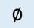

Present; Partially Present; Absent; Not Applicable;

Table S3. Duplicate images in Mpox datasets

Mpox Dataset | Total Images | Number of Duplicates | % of Duplicates | Sources
Monkeypox Skin Images Dataset (MSID) | 772 | 25 | 3.24% | https://www.kaggle.com/datasets/dipuiucse/monkeypoxskinimagedataset
Mpox Close Skin Images (MCSI) | 400 | 8 | 2.00% | https://zenodo.org/records/7948350
Mpox Skin Lesion Dataset (MSLD) | 755 | 5 | 0.66% | https://www.kaggle.com/datasets/nafin59/monkeypox-skin-lesion-dataset
MSID Vs MCSI | 1172 | 95 | 8.11%
MSID Vs MSLD | 1527 | 66 | 4.32%
MSLD Vs MCSI | 1155 | 84 | 7.27%

Figure S1. Meta-analysis Findings (Forest plots and SROC graphs)

- Mpox
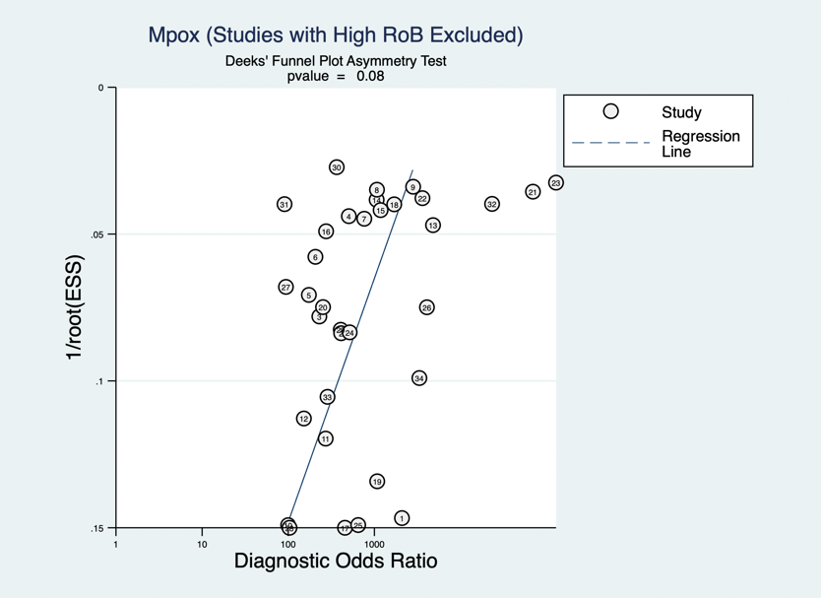
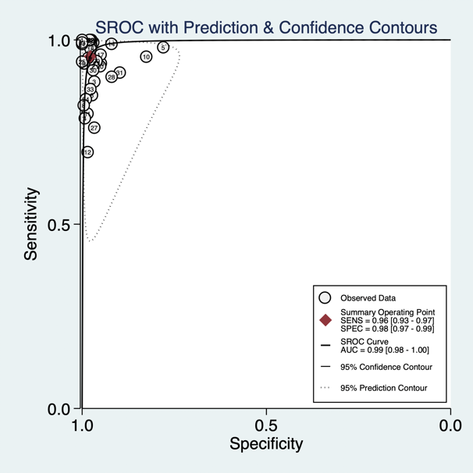
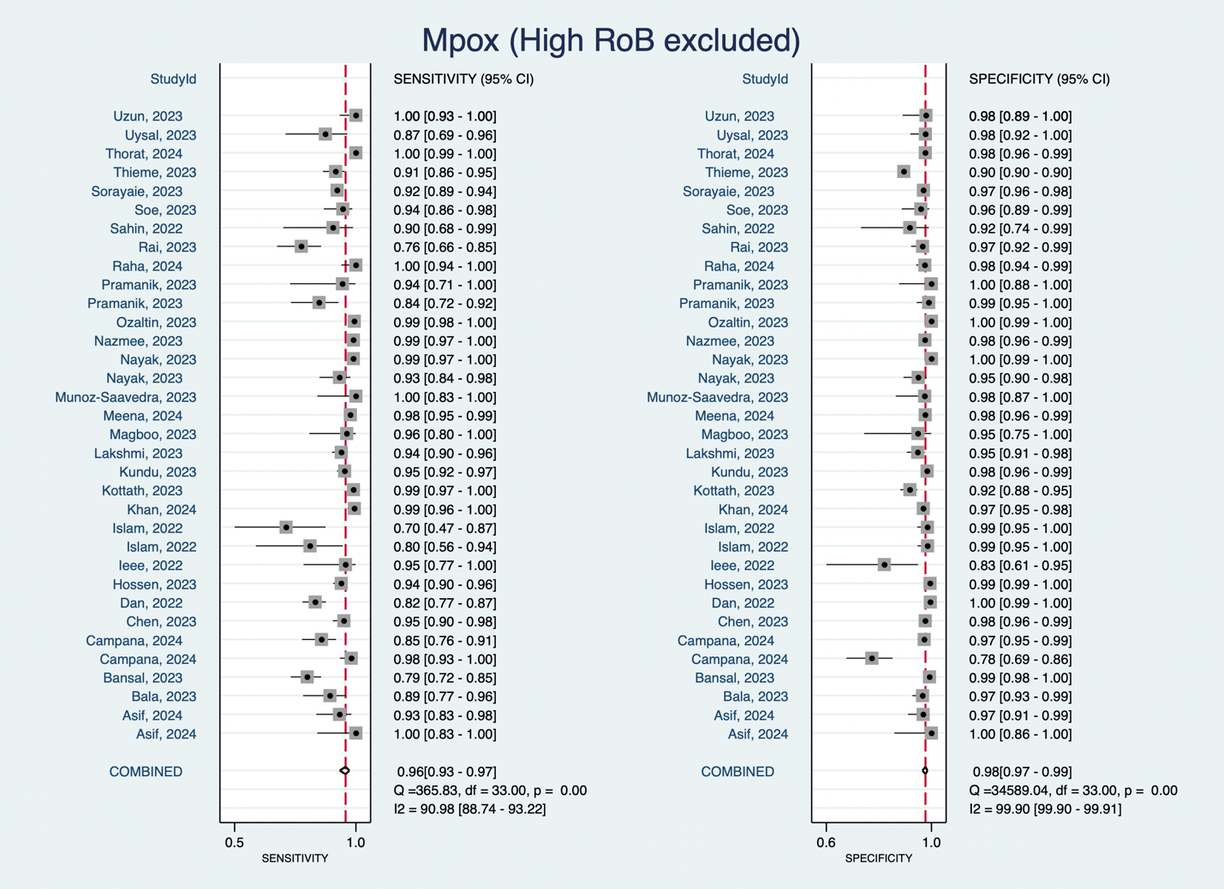

- Herpes Simplex
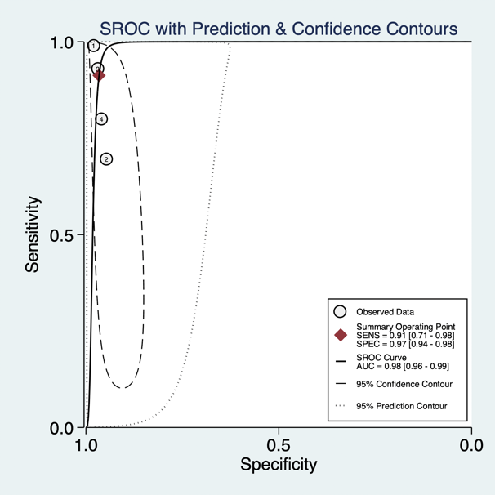
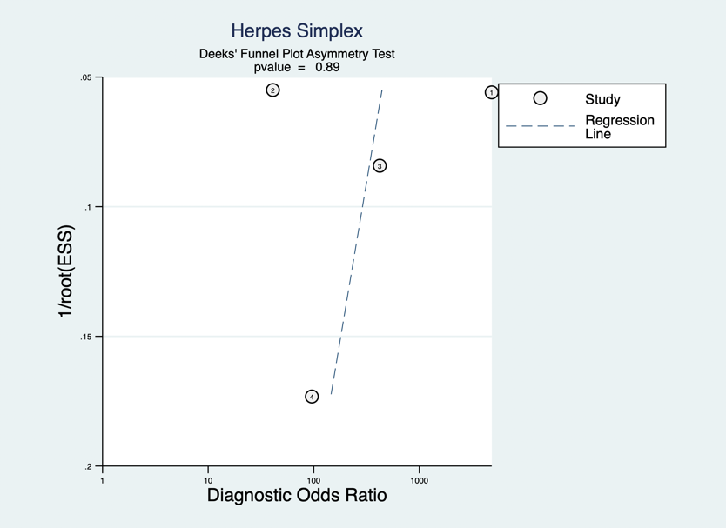
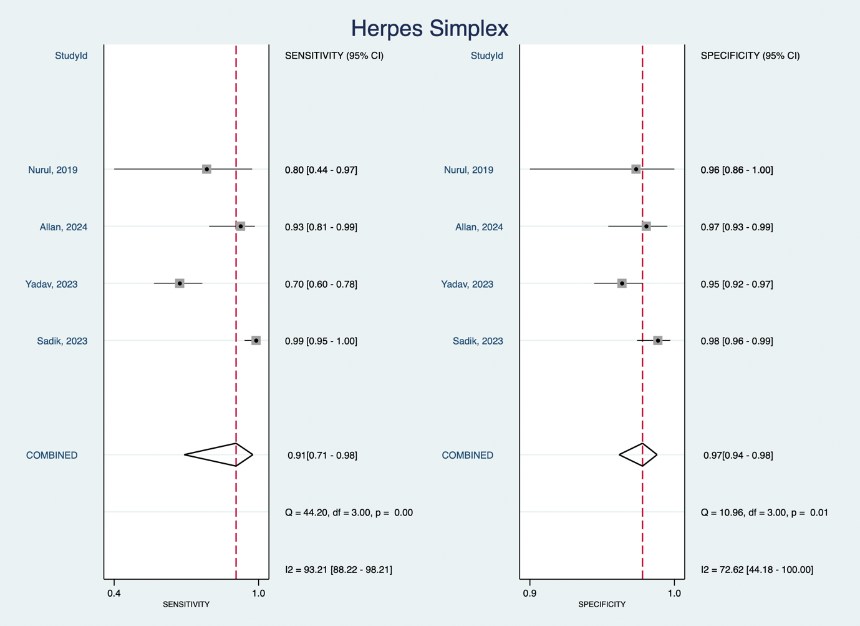

- Genital Warts
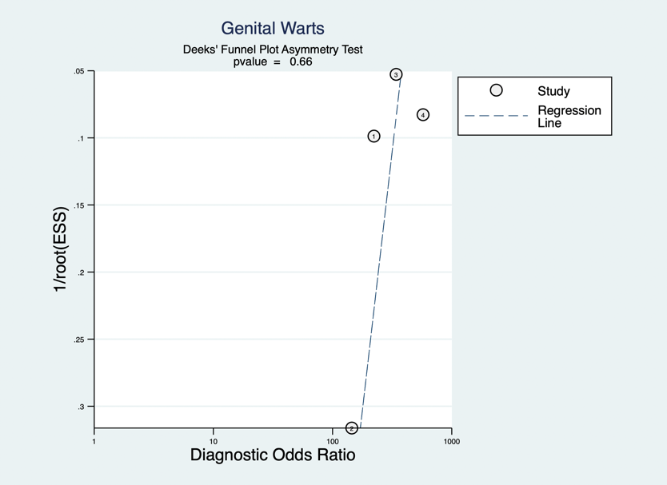
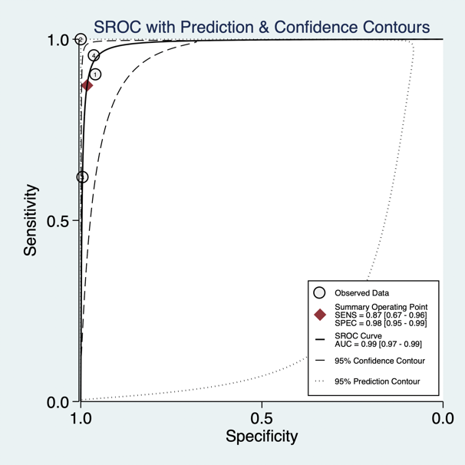
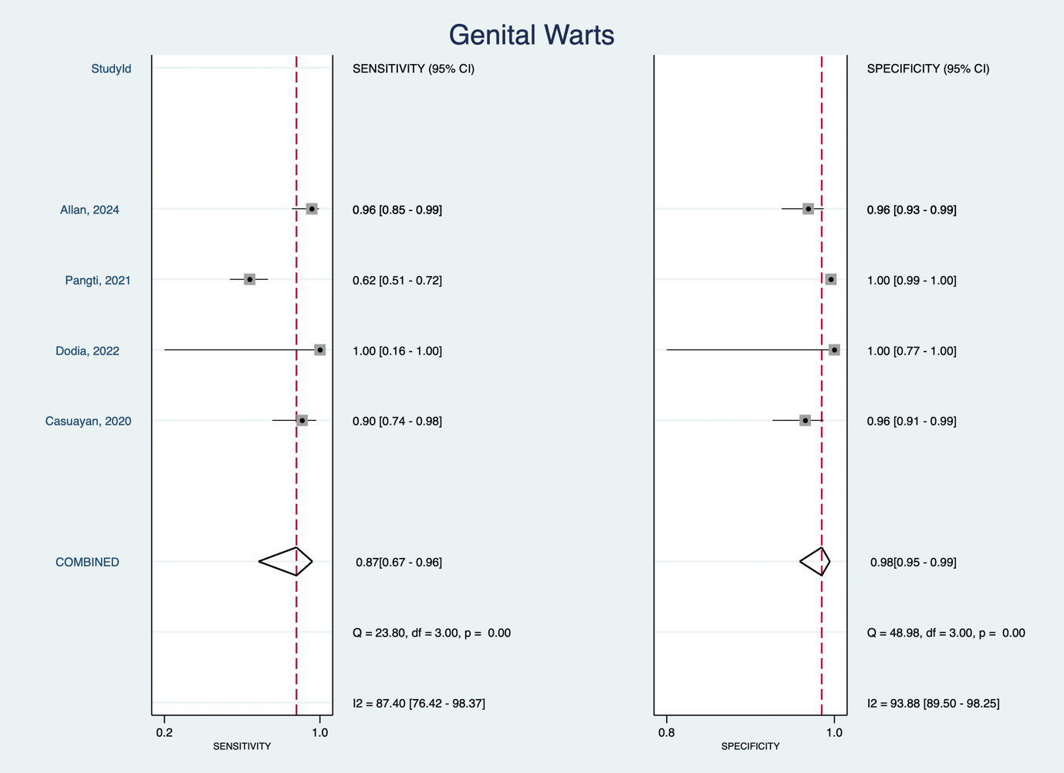

- Psoriasis
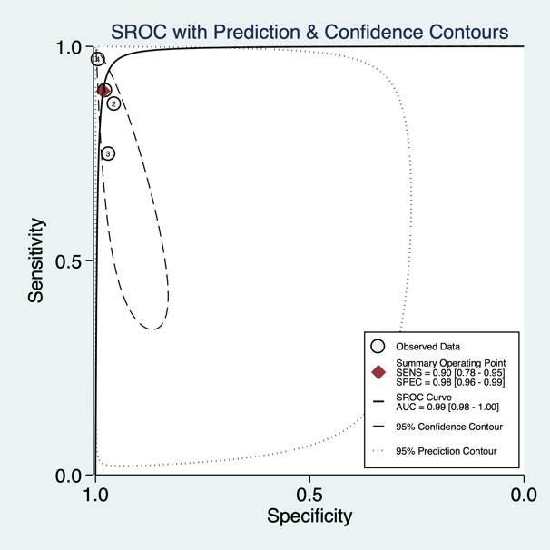
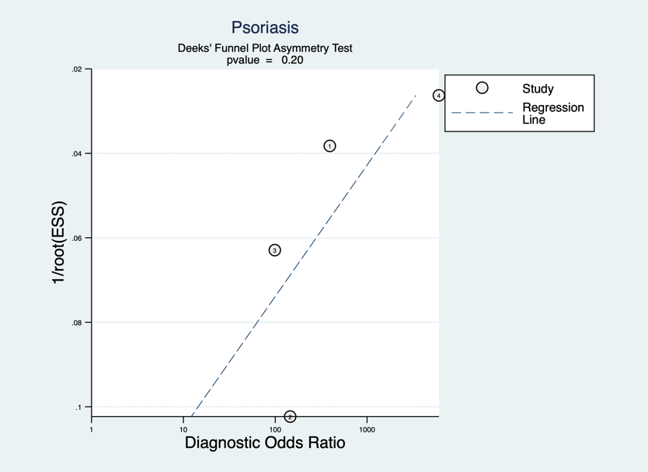
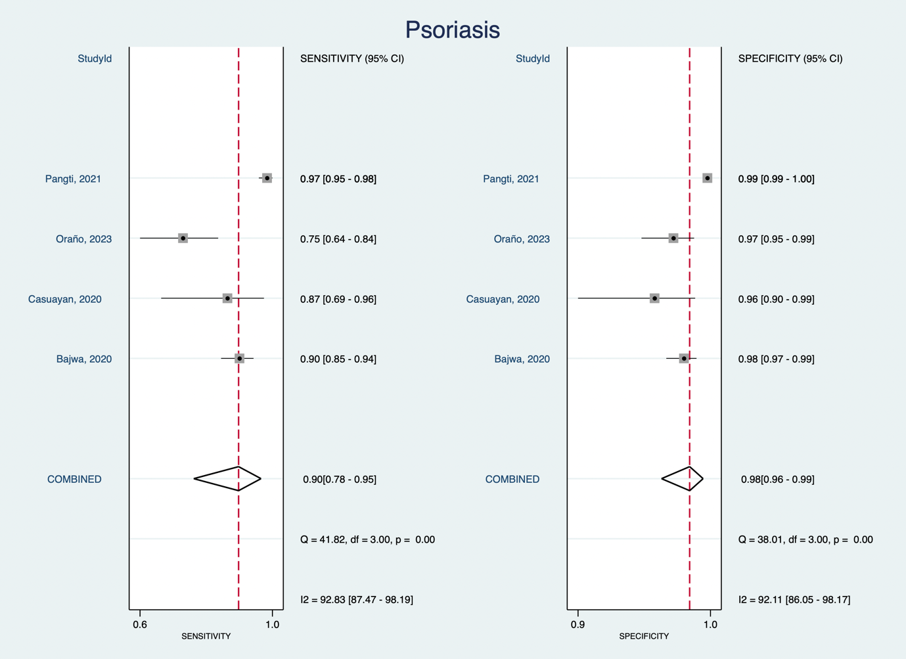

- Scabies
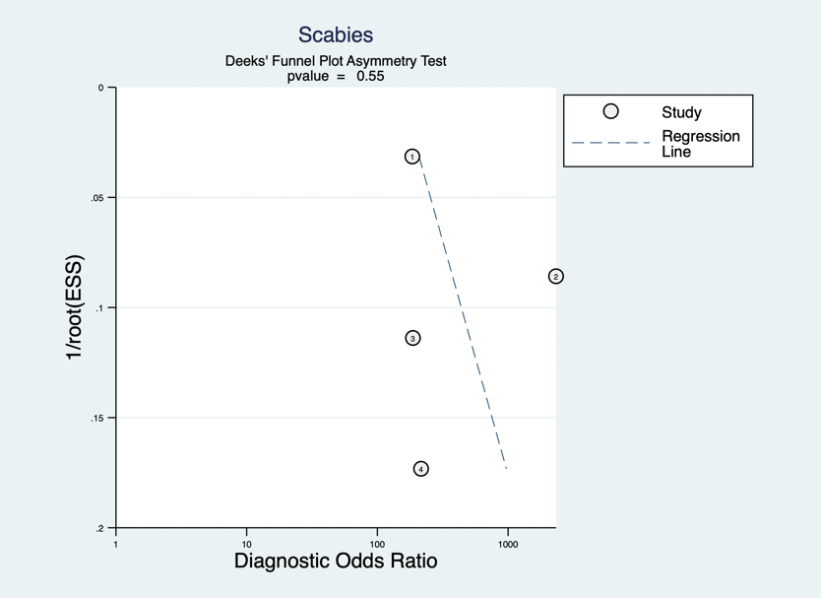
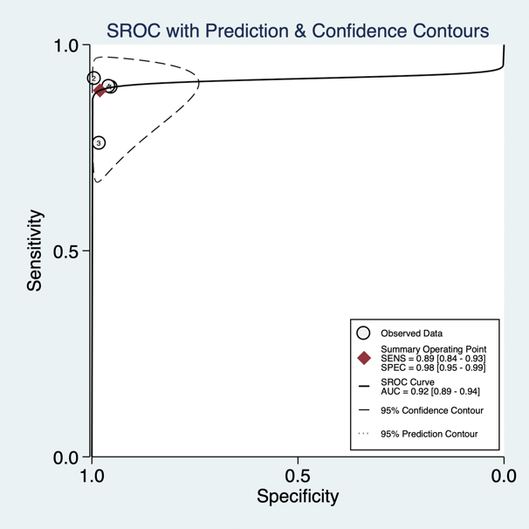
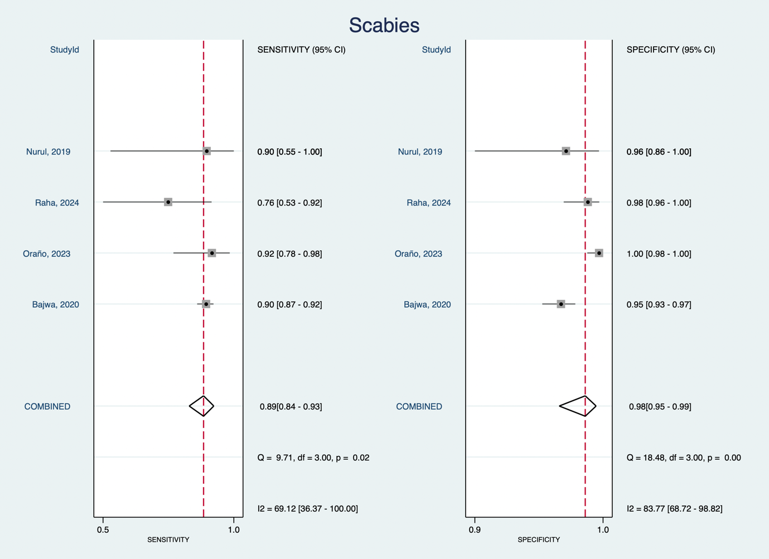

References

1. Allan-Blitz L-T, Ambepitiya S, Tirupathi R, Klausner JD: The Development and Performance of a Machine-Learning Based Mobile Platform for Visually Determining the Etiology of 5 Penile Diseases. Mayo Clinic Proceedings: Digital Health 2024, 2(2):280-288.
2. Gaffoor N, Soomro S: Skin Disease Detection and Classification Using ResNet-50 and Support Vector Machine: An Effective Approach for Dermatological Diagnosis. In: 2023; 2023: 140-145.
3. Mehta N, Khan E, Choudhary R, Dholakia D, Goel S, Gupta S: The performance of an artificial intelligence-based computer vision mobile application for the image diagnosis of genital dermatoses: a prospective cross-sectional study. International Journal of Dermatology 2024((Mehta, Khan, Choudhary, Goel, Gupta) Department of Dermatology and Venereology, All India Institute of Medical Sciences, New Delhi, India(Dholakia) Rajiv Gandhi Cancer Institute and Research Centre, New Delhi, India).
4. Wei L-S, Gan Q, Ji T: Skin Disease Recognition Method Based on Image Color and Texture Features. Computational and mathematical methods in medicine 2018, 2018(101277751):8145713.
5. Yadav A, Sharma V, Seth J: Skin Disease Recognition by VGG-16 Model. In: 2023; 2023: 833-847.
6. Akmalia N, Sihombing P, Suherman: Skin Diseases Classification Using Local Binary Pattern and Convolutional Neural Network. In: 2019 3rd International Conference on Electrical, Telecommunication and Computer Engineering (ELTICOM): 16-17 Sept. 2019 2019; 2019: 168-173.
7. Sadik R, Majumder A, Biswas AA, Ahammad B, Rahman MM: An in-depth analysis of Convolutional Neural Network architectures with transfer learning for skin disease diagnosis. Healthcare Analytics 2023, 3((Sadik, Majumder, Ahammad) Department of Computer Science and Engineering, Jahangirnagar University, Savar, Dhaka, Bangladesh(Biswas, Rahman) Department of Computer Science and Engineering, Daffodil International University, Dhaka, Bangladesh):100143.
8. Assoc Comp M, Nosseir A, Shawky MA: Automatic Classifier for Skin Disease Using k-NN and SVM. In.; 2019: 259-262.
9. Casuayan De Goma J, Devaraj M: Recognizing Common Skin Diseases in the Philippines Using Image Processing and Machine Learning Classification. In: 2020; 2020: 68-72.
10. Pangti R, Mathur J, Chouhan V, Kumar S, Rajput L, Shah S, Gupta A, Dixit A, Dholakia D, George M et al: A machine learning-based, decision support, mobile phone application for diagnosis of common dermatological diseases. Journal of the European Academy of Dermatology and Venereology 2021, 35(2):536-545.
11. Zaar O, Larson A, Polesie S, Saleh K, Tarstedt M, Olives A, Suarez A, Gillstedt M, Neittaanmaki N: Evaluation of the diagnostic accuracy of an online artificial intelligence application for skin disease diagnosis. Acta Dermato-Venereologica 2020, 100(16):1-6.
12. Dodia D, Jakharia H, Soni R, Borade S, Jain N: Human Skin Disease Detection using MLXG model. In: CVMLH-2022: Workshop on Computer Vision and Machine Learning for Healthcare: 2022; 2022: 1-14.
13. Abdelhamid AA, El-Kenawy ESM, Khodadadi N, Mirjalili S, Khafaga DS, Alharbi AH, Ibrahim A, Eid MM, Saber M: Classification of Monkeypox Images Based on Transfer Learning and the Al-Biruni Earth Radius Optimization Algorithm. MATHEMATICS 2022, 10(19).
14. Adar T, Delice EK, Delice O: A user-friendly AI-based clinical decision support system for rapid detection of pandemic diseases: Covid-19 and Monkeypox. Journal of Intelligent and Fuzzy Systems 2024, 46(2):5343-5358.
15. Agrawal S, Castelino K, Mehta J, Bhavathankar P: EfficientNet-B3 and Image Processing for Monkeypox Detection using Skin Lesion Images. In: 2022; 2022.
16. Ahsan MM, Alam TE, Haque MA, Ali MS, Rifat RH, Nafi AAN, Hossain MM, Islam MK: Enhancing Monkeypox diagnosis and explanation through modified transfer learning, vision transformers, and federated learning. Informatics in Medicine Unlocked 2024, 45((Ahsan, Alam) Department of Industrial and Systems Engineering, University of Oklahoma, Norman, OK 73019, United States(Haque) Department of Cyber-Physical Systems, Clark Atlanta University, Atlanta, GA 30314, United States(Ali, Hossain, Islam) Department):101449.
17. Ahsan MM, Ali MS, Hassan MM, Abdullah TA, Gupta KD, Bagci U, Kaushal C, Soliman NF: Monkeypox Diagnosis With Interpretable Deep Learning. IEEE Access 2023, 11:81965-81980.
18. Ahsan MM, Uddin MR, Ali MS, Islam MK, Farjana M, Sakib AN, Al Momin K, Luna SA: Deep transfer learning approaches for Monkeypox disease diagnosis. EXPERT SYSTEMS WITH APPLICATIONS 2023, 216.
19. Alcalá-Rmz V, Villagrana-Bañuelos KE, Celaya-Padilla JM, Galván-Tejada JI, Gamboa-Rosales H, Galván-Tejada CE: Convolutional Neural Network for Monkeypox Detection. In., vol. 594; 2023: 89-100.
20. Alharbi AH, Towfek SK, Abdelhamid AA, Ibrahim A, Eid MM, Khafaga DS, Khodadadi N, Abualigah L, Saber M: Diagnosis of Monkeypox Disease Using Transfer Learning and Binary Advanced Dipper Throated Optimization Algorithm. BIOMIMETICS 2023, 8(3).
21. Alhasson HF, Almozainy E, Alharbi M, Almansour N, Alharbi SS, Khan RU: A Deep Learning-Based Mobile Application for Monkeypox Detection. APPLIED SCIENCES-BASEL 2023, 13(23).
22. Almufareh MF, Tehsin S, Humayun M, Kausar S: A Transfer Learning Approach for Clinical Detection Support of Monkeypox Skin Lesions. Diagnostics 2023, 13(8):1503.
23. Almutairi SA: DL-MDF-OH<SUP>2</SUP>: Optimized Deep Learning-Based Monkeypox Diagnostic Framework Using the Metaheuristic Harris Hawks Optimizer Algorithm. ELECTRONICS 2022, 11(24).
24. Aloraini M: An effective human monkeypox classification using vision transformer. INTERNATIONAL JOURNAL OF IMAGING SYSTEMS AND TECHNOLOGY 2024, 34(1).
25. Alrusaini OA: Deep Learning Models for the Detection of Monkeypox Skin Lesion on Digital Skin Images. INTERNATIONAL JOURNAL OF ADVANCED COMPUTER SCIENCE AND APPLICATIONS 2023, 14(1):637-644.
26. Altun M, Guruler H, Ozkaraca O, Khan F, Khan J, Lee Y: Monkeypox Detection Using CNN with Transfer Learning. Sensors (Basel, Switzerland) 2023, 23(4).
27. Amin J, Gul N, Naqvi SA: J-Net:Convolutional Neural Network based on Grey Binary Wolf Optimization Model for Classification of Skin Lesion. In: 2023; 2023.
28. Arshed MA, Rehman HA, Ahmed S, Dewi C, Christanto HJ: A 16 x 16 Patch-Based Deep Learning Model for the Early Prognosis of Monkeypox from Skin Color Images. COMPUTATION 2024, 12(2).
29. Asif S, Zhao M, Li Y, Tang F, Zhu Y: CGO-ensemble: Chaos game optimization algorithm-based fusion of deep neural networks for accurate Mpox detection. Neural networks : the official journal of the International Neural Network Society 2024, 173(drv, 8805018):106183.
30. Asif S, Zhao M, Tang F, Zhu Y, Zhao B: Metaheuristics optimization-based ensemble of deep neural networks for Mpox disease detection. Neural networks : the official journal of the International Neural Network Society 2023, 167(drv, 8805018):342-359.
31. Attallah O: MonDiaL-CAD: Monkeypox diagnosis via selected hybrid CNNs unified with feature selection and ensemble learning. DIGITAL HEALTH 2023, 9.
32. Bala D, Hossain MS, Hossain MA, Abdullah MI, Rahman MM, Manavalan B, Gu N, Islam MS, Huang Z: MonkeyNet: A robust deep convolutional neural network for monkeypox disease detection and classification. Neural networks : the official journal of the International Neural Network Society 2023, 161(drv, 8805018):757-775.
33. Bansal M, Arora R, Keshari S, Panchal S: Discerning Monkeypox from Other Viruses of the Poxviridae Family in a Deep Learning Paradigm. In: 2023; 2023: 23-42.
34. Bogar SM, Deshmukh P, Reddy CVR, Muvva S: Monkeypox Detection using CNN-Based Pretrained Models. In: 2023; 2023: 173-178.
35. Campana MG, Colussi M, Delmastro F, Mascetti S, Pagani E: A Transfer Learning and Explainable Solution to Detect mpox from Smartphones images. PERVASIVE AND MOBILE COMPUTING 2024, 98.
36. Chandrahaas BV, Mohanty SN, Panda SK, Michael G: An Empirical Study on Classification of Monkeypox Skin Lesion Detection. EAI Endorsed Transactions on Pervasive Health and Technology 2023, 9(1).
37. Chauhan N, Bala A: Comparative performance analysis of CNN with Transfer Learning Models for Detection of Monkeypox Skin disease. In: 2023 4th IEEE Global Conference for Advancement in Technology (GCAT): 2023; 2023.
38. Chen B, Han Y, Yan L: A Few-shot learning approach for Monkeypox recognition from a cross-domain perspective. Journal of biomedical informatics 2023, 144(100970413, d2m):104449.
39. Chen J, Han J: A study on the recognition of monkeypox infection based on deep convolutional neural networks. Frontiers in immunology 2023, 14(101560960):1225557.
40. Chintamaneni V, Krishna BH, Suresh M, Bukkaptanm K, Sujatha CN, Swaraja K, Kumar PM: Deep Learning-Based Diagnostic Model for Automated Detection of Monkeypox: Introducing MonkeypoxNet. TRAITEMENT DU SIGNAL 2024, 41(1):493-502.
41. Ciran A, Ozbay E: Optimization-Based Feature Selection in Deep Learning Methods for Monkeypox Skin Lesion Detection. In: 2023 7th International Symposium on Multidisciplinary Studies and Innovative Technologies: 2023; 2023.
42. Dahiya N, Sharma YK, Rani U, Hussain S, Nabilal KV, Mohan A, Nuristani N: Hyper-parameter tuned deep learning approach for effective human monkeypox disease detection. Scientific reports 2023, 13(1):15930.
43. Dan R, Wu Q, Ji X, Gu R, Chen X, Jia G, Huang X, Ye X, Wang Y: LSANet: Lesion-Specific Attention Network for Monkeypox Categorization. In: 2022; 2022: 210-217.
44. Dwivedi M, Tiwari RG, Ujjwal N: Deep Learning Methods for Early Detection of Monkeypox Skin Lesion. In: 2022 8th International Conference on Signal Processing and Communication (ICSC): 2022; 2022: 343-348.
45. Eliwa EHI, El Koshiry AM, Abd El-Hafeez T, Farghaly HM: Utilizing convolutional neural networks to classify monkeypox skin lesions. Scientific reports 2023, 13(1):14495.
46. Ezenkwu CP, Stephen BUA, Affiah I, Daniel B: A Green AI Model Selection Strategy for Computer-Aided Mpox Detection. In: 2023 IEEE AFRICON: 2023; 2023.
47. Fisranda F, Austin F, Sadrawi M: Comparison Analysis of YOLO, ResNet, and EfficientNet for contagious skin diseases. In: 2023; 2023.
48. Gairola AK, Kumar V: Monkeypox Disease Diagnosis using Machine Learning Approach. In: 2022; 2022: 423-427.
49. Gupta A, Bhagat M, Jain V: Blockchain-enabled healthcare monitoring system for early Monkeypox detection. JOURNAL OF SUPERCOMPUTING 2023, 79(14):15675-15699.
50. Gupta P, Mittal U, Jha T, Agarwal M, Tiwari A: Efficient Prediction and Analysis of Monkeypox Skin Lesion: A Comparative Study for Web based Application. In: 2023; 2023.
51. Haque ME, Ahmed MR, Nila RS, Islam S: Human Monkeypox Disease Detection Using Deep Learning and Attention Mechanisms. In: 2022; 2022: 1069-1073.
52. Haque R, Sultana A, Haque P: Ensemble of Fine-tuned Deep Learning Models for Monkeypox Detection: A Comparative Study. In: 2023; 2023.
53. Haripriya KP, Hannah Inbarani H: Performance Analysis of Various Feature Extraction Methods for Classification of Pox Virus Images. In: 2024; 2024: 211-223.
54. Hossen MR, Alfaz N, Sami A, Tanim SA, Bin Sarwar T, Islam MK: An EfficientNet to Classify Monkeypox-Comparable Skin Lesions Using Transfer Learning. In: 2023; 2023.
55. Huong LH, Khang NH, Quynh L, Thang L, Canh DM, Sang HP: A Proposed Approach for Monkeypox Classification. INTERNATIONAL JOURNAL OF ADVANCED COMPUTER SCIENCE AND APPLICATIONS 2023, 14(8):643-651.
56. Hussain SM, Ghouse S: Detection and prediction of monkey pox disease by enhanced convolutional neural network approach. International Journal of Public Health Science 2023, 12(2):673-681.
57. Ieee, Gupta K, Bajaj V: A self-assessment framework for initial screening of human monkeypox. In.; 2023: 168-173.
58. Ieee, Gürbüz S, Aydin G: Monkeypox Skin Lesion Detection Using Deep Learning Models. In.; 2022: 66-70.
59. Ieee, Irmak MC, Aydin T, Yaganoglu M: Monkeypox Skin Lesion Detection with MobileNetV2 and VGGNet Models. In.; 2022.
60. Ieee, Trang K, Nguyen AH, Thao NGM, Vuong BQ, Ton-That L: Performance Enhancement in Pre-Trained Deep Learning Models for Monkeypox Skin Lesions Identification Using Feature Selection Algorithms. In.; 2023: 56-61.
61. Islam T, Hussain, Chowdhury FUH, Islam BMR: Can Artificial Intelligence Detect Monkeypox from Digital Skin Images? bioRxiv 2022((Islam) Department of Computer Science and Engineering, Northern University Bangladesh, Dhaka 1215, Bangladesh(Hussain, Chowdhury) Department of Medicine, Dhaka Medical College Hospital, Dhaka 1000, Bangladesh(Islam) Health Information Unit, Directorate G).
62. Jahan N, Bajwa G, Akilan T: Federated Learning-Assisted Self-supervised CNN for Monkeypox Diagnosis. In: 2023; 2023.
63. Jaradat AS, Al Mamlook RE, Almakayeel N, Alharbe N, Almuflih AS, Nasayreh A, Gharaibeh H, Gharaibeh M, Gharaibeh A, Bzizi H: Automated Monkeypox Skin Lesion Detection Using Deep Learning and Transfer Learning Techniques. International journal of environmental research and public health 2023, 20(5).
64. Kakulapati V: Analysis of Monkey Pox (MPox) Detection Using UNETs and VGG16 Weights. In: 2023; 2023: 321-332.
65. Kaushal C: Monkeypox and other Skin Conditions Detection Utilizing CNN with VGG16 Transfered Language. In: 2023; 2023: 931-938.
66. Khafaga DS, Ibrahim A, El-Kenawy ESM, Abdelhamid AA, Karim FK, Mirjalili S, Khodadadi N, Lim WH, Eid MM, Ghoneim ME: An Al-Biruni Earth Radius Optimization-Based Deep Convolutional Neural Network for Classifying Monkeypox Disease. Diagnostics 2022, 12(11):2892.
67. Khan SUR, Asif S, Bilal O, Ali S: Deep hybrid model for Mpox disease diagnosis from skin lesion images. INTERNATIONAL JOURNAL OF IMAGING SYSTEMS AND TECHNOLOGY 2024, 34(2).
68. Kottath AV, Malarvel M: Comparison of Deep Learning Models for Monkeypox Disease Detection. In: 2023; 2023.
69. Krishnan T, Selvakumar K, Vairachilai S: Monkeypox Detection Through Watershed Segmentation and Appending 2D CNN Based Auto Encoder Monkeypox Detection Through CNN-Auto Encoder. International Journal on Recent and Innovation Trends in Computing and Communication 2023, 11(9s):598-606.
70. Krishnan T, Selvakumar K, Vairachilai S: MULTI-TASK LEARNING FOR MONKEYPOX SKIN LESION SEGMENTATION AND CLASSIFICATION USING CNN AND ROOTSIFT. Journal of Theoretical and Applied Information Technology 2024, 101(1):339-349.
71. Krishnan VG, Liya BS, Lakshmi SV, Sathyamoorthy K, Ganesan S: Monkeypox Detection Using Hyper-Parameter Tuned Based Transferable CNN Model. International Journal of Experimental Research and Review 2023, 33:18-29.
72. Kumar A: An XNOR-ResNet and spatial pyramid pooling-based YOLO v3-tiny algorithm for Monkeypox and similar skin disease detection. IMAGING SCIENCE JOURNAL 2023, 71(1):50-65.
73. Kumar V: Analysis of CNN features with multiple machine learning classifiers in diagnosis of monkeypox from digital skin images. medRxiv 2022((Kumar) Graphic Era Deemed to be University, India).
74. Kundu D, Rahman MM, Rahman A, Das D, Siddiqi UR, Alam MGR, Dey SK, Muhammad G, Ali Z: Federated Deep Learning for Monkeypox Disease Detection on GAN-Augmented Dataset. IEEE ACCESS 2024, 12:32819-32829.
75. Kundu D, Siddiqi UR, Rahman MM: Vision Transformer based Deep Learning Model for Monkeypox Detection. In: 2022; 2022: 1021-1026.
76. Kundu NK, Karim M, Kobir S, Farid DM: Attention Based Feature Fusion Network for Monkeypox Skin Leison Detection. In: 2023; 2023.
77. Lakshmi M, Das R: Classification of Monkeypox Images Using LIME-Enabled Investigation of Deep Convolutional Neural Network. DIAGNOSTICS 2023, 13(9).
78. Liu R: Convolutional Siamese network-based few-shot learning for monkeypox detection under data scarcity. In: 2023; 2023.
79. Liu W: Implementation of detection of skin lesions in monkeypox based on a deep learning model - using an improved bilinear pooling model. In: 2023; 2023.
80. Madhu HS, Rallapalli S, Thatikonda R: Three Dimensional DenseUNet with CKHA Segmentation Technique for Monkeypox Disease Prediction. In: 2023; 2023.
81. Magboo VPC, Magboo MSA: Comparative Analysis of Optimization Algorithms Applied to Monkeypox Classification. In: 2023; 2023.
82. Meena G, Mohbey KK, Kumar S: Monkeypox recognition and prediction from visuals using deep transfer learning-based neural networks. Multimedia Tools and Applications 2024.
83. Muduli D, Naidu AVSC, Durga KV, Rahul K, Kumar MJ, Sharma SK: Enhancing Monkeypox Skin Lesion Detection: A Fusion Approach of VGG 16 and Xception Features with SVM Classifier. In: 2023; 2023.
84. Munoz-Saavedra L, Escobar-Linero E, Civit-Masot J, Luna-Perejon F, Civit A, Dominguez-Morales M: A Robust Ensemble of Convolutional Neural Networks for the Detection of Monkeypox Disease from Skin Images. Sensors (Basel, Switzerland) 2023, 23(16).
85. Nayak T, Chadaga K, Sampathila N, Mayrose H, Bairy GM, Prabhu S, Katta SS, Umakanth S: Detection of Monkeypox from skin lesion images using deep learning networks and explainable artificial intelligence. APPLIED MATHEMATICS IN SCIENCE AND ENGINEERING 2023, 31(1).
86. Nayak T, Chadaga K, Sampathila N, Mayrose H, Gokulkrishnan N, Bairy GM, Prabhu S, S SK, Umakanth S: Deep learning based detection of monkeypox virus using skin lesion images. Medicine in Novel Technology and Devices 2023, 18((Nayak, Sampathila, Mayrose, Gokulkrishnan, Bairy G) Department of Biomedical Engineering, Manipal Institute of Technology, Manipal Academy of Higher Education, Karnataka, Manipal 576104, India(Chadaga, Prabhu) Department of Computer Science and Engineeri):100243.
87. Nazmee N, Ali MS, Mahmud S, Alam K, Chakrabarty A, Fahim-Ul-Islam M: Enhancing Monkeypox Diagnosis: A Machine Learning Approach for Skin Lesion Classification. In: 2023; 2023.
88. Ozaltin O, Yeniay O: DETECTION OF MONKEYPOX DISEASE FROM SKIN LESION IMAGES USING MOBILENETV2 ARCHITECTURE. COMMUNICATIONS FACULTY OF SCIENCES UNIVERSITY OF ANKARA-SERIES A1 MATHEMATICS AND STATISTICS 2023, 72(2):482-499.
89. Oztel I, Oztel GY, Sahin VH: Deep Learning-Based Skin Diseases Classification using Smartphones. ADVANCED INTELLIGENT SYSTEMS 2023, 5(12).
90. Pabbi V, Khullar V, Angurala M: Efficient Skin Lesion based Classification System for Monkeypox Detection using VGG16 and Ensemble Learning. In: 2023; 2023: 24-27.
91. Pal M, Mahal A, Mohapatra RK, Obaidullah AJ, Sahoo RN, Pattnaik G, Pattanaik S, Mishra S, Aljeldah M, Alissa M et al: Deep and Transfer Learning Approaches for Automated Early Detection of Monkeypox (Mpox) Alongside Other Similar Skin Lesions and Their Classification. ACS OMEGA 2023, 8(35):31747-31757.
92. Pal S, Mishra AK: Artificial Intelligence-Based Framework for Predicting Monkeypox Disease. In: 2023; 2023.
93. Pasha MS, Poornima A, Athapuram D: Skin Image Analysis for Monkeypox Diagnosis: Multi-Layer CNN Model Advancements. Journal of Cardiovascular Disease Research 2023, 14(2):2381-2393.
94. Pramanik A, Chowdhury F, Sultana S, Rahman MM, Bijoy MHI, Rahman MS: Monkeypox Detection from Various Types of Poxes: A Deep Learning Approach. In: 2023; 2023.
95. Pramanik R, Banerjee B, Efimenko G, Kaplun D, Sarkar R: Monkeypox detection from skin lesion images using an amalgamation of CNN models aided with Beta function-based normalization scheme. PloS one 2023, 18(4):e0281815.
96. Prasher S, Nelson L, Gomathi S: Pre-trained Deep learning model for Monkeypox Prediction using Dermoscopy Images in Healthcare. In: 2023; 2023.
97. Raha AD, Gain M, Debnath R, Adhikary A, Qiao Y, Hassan MM, Bairagi AK, Islam SMS: Attention to Monkeypox: An Interpretable Monkeypox Detection Technique Using Attention Mechanism. IEEE Access 2024, 12:51942-51965.
98. Rai S, Joshi RC, Dutta MK: PoxDetector: A Deep Convolutional Neural Network for Skin Lesion Classification using Android Application. In: 2023; 2023: 363-368.
99. Rao ML, Mahesh AV, Manikanth MNVJ, Sailaja J, Bhargavi KN: MONKEYPOX DETECTION AND CLASSIFICATION USING MULTI-LAYER CONVOLUTIONAL NEURAL NETWORK FROM SKIN IMAGES. ARPN Journal of Engineering and Applied Sciences 2023, 18(21):2364-2379.
100. Ren GY: Monkeypox Disease Detection with Pretrained Deep Learning Models. INFORMATION TECHNOLOGY AND CONTROL 2023, 52(2):288-296.
101. Sahin VH, Oztel I, Yolcu Oztel G: Human Monkeypox Classification from Skin Lesion Images with Deep Pre-trained Network using Mobile Application. Journal of medical systems 2022, 46(11):79.
102. Sathwik AS, Naseeba B, Kiran JC, Lokesh K, Ch VSD, Challa NP: Early Detection of Monkeypox Skin DiseaseUsing Patch Based DL Model and Transfer Learning Techniques. EAI Endorsed Transactions on Pervasive Health and Technology 2023, 9.
103. Shah A: Monkeypox Skin Lesion Classification Using Transfer Learning Approach. In: 2022; 2022.
104. Sharma A, Gupta S, Anand V: Proposed Convolution Architecture for Monkeypox Detection using Dermoscopy Images. In: 2023; 2023.
105. Sharma K, Kumar V, Mittal M: MonkeyPox, Measles and ChickenPox Detection through Image-Processing using Residual Neural Network (ResNet). In: 2023; 2023.
106. Sharma N, Mohanty SN, Mahato S, Pattanaik CR: A novel dataset and local interpretable model-agnostic explanations (LIME) for monkeypox prediction. INTELLIGENT DECISION TECHNOLOGIES-NETHERLANDS 2023, 17(4):1297-1308.
107. Singh U, Songare LS: Analysis and Detection of Monkeypox using the GoogLeNet Model. In: 2022; 2022: 1000-1008.
108. Soe NN, Yu Z, Latt PM, Lee D, Rahman R, Ge Z, Ong J, Fairley CK, Zhang L: Distinguishing monkeypox from common skin lesions using artificial intelligence in a sexual health clinic: a feasibility study. Journal of Medical Internet Research 2023, 20(5):XVI-XVI.
109. Sorayaie Azar A, Naemi A, Babaei Rikan S, Bagherzadeh Mohasefi J, Pirnejad H, Wiil UK: Monkeypox detection using deep neural networks. BMC infectious diseases 2023, 23(1):438.
110. Supanich W, Kulkarineetham S, Tamboonlertchai W, Suato T: Classification of Mpox Images Using Transfer Learning on Lightweight Models. In: 2023; 2023.
111. Surati S, Trivedi H, Shrimali B, Bhatt C, Travieso-González CM: An Enhanced Diagnosis of Monkeypox Disease Using Deep Learning and a Novel Attention Model Senet on Diversified Dataset. MULTIMODAL TECHNOLOGIES AND INTERACTION 2023, 7(8).
112. Taruno PEN, Nugraha GS, Dwiyansaputra R, Bimantoro F: Monkeypox Classification based on Skin Images using CNN: EfficientNet-B0. In: 2023; 2023.
113. Thieme AH, Zheng Y, Machiraju G, Sadee C, Mittermaier M, Gertler M, Salinas JL, Srinivasan K, Gyawali P, Carrillo-Perez F et al: A deep-learning algorithm to classify skin lesions from mpox virus infection. Nature medicine 2023, 29(3):738-747.
114. Thorat R, Gupta A: Transfer learning-enabled skin disease classification: the case of monkeypox detection. MULTIMEDIA TOOLS AND APPLICATIONS 2024.
115. Tiwari S, Maheshwari P: MPox-DenseConvNet: A Transfer Learning Based Convolutional Neural Network for Monkeypox Detection and Assessment using Color Models. In: 2023; 2023: 175-180.
116. Torky M, Bakheit A, Bakry M, Hassanien AE: Deep learning Model for Recognizing Monkey Pox based on Dense net-121 Algorithm. medRxiv 2022((Torky) Faculty of Artificial Intelligence, Egyptian Russian University, Egypt(Bakheit, Bakry) Higher Institute of Computer Science and Information Systems, Culture and Science City, 6th of October City 12573, Egypt(Hassanien) Faculty of Computers and Art).
117. Ural AB: A Computer-Aided Feasibility Implementation to Detect Monkeypox from Digital Skin Images with Using Deep Artificial Intelligence Methods. TRAITEMENT DU SIGNAL 2023, 40(1):383-388.
118. Uysal F: Detection of Monkeypox Disease from Human Skin Images with a Hybrid Deep Learning Model. Diagnostics 2023, 13(10):1772.
119. Uzun Ozsahin D, Mustapha MT, Uzun B, Duwa B, Ozsahin I: Computer-Aided Detection and Classification of Monkeypox and Chickenpox Lesion in Human Subjects Using Deep Learning Framework. Diagnostics 2023, 13(2):292.
120. Vajpayee H, Arora C, Voleti R, Chaudhary A, Raj G, Agrawal AP: An effective classification of Skin Disease using Deep Learning Techniques. In: 2023; 2023: 580-585.
121. Yadav S, Qidwai T: Machine learning-based monkeypox virus image prognosis with feature selection and advanced statistical loss function. Medicine in Microecology 2024, 19((Yadav) Faculty of Biotechnology, Shri Ramswaroop Memorial University, Lucknow Deva Road, Uttar Pradesh 225003, India(Qidwai) Faculty of Biotechnology, Shri Ramswaroop Memorial University, Lucknow Deva Road, Uttar Pradesh 225003, India):100098.
122. Yasmin F, Hassan MM, Hasan M, Zaman S, Kaushal C, El-Shafai W, Soliman NF: PoxNet22: A Fine-Tuned Model for the Classification of Monkeypox Disease Using Transfer Learning. IEEE Access 2023, 11:24053-24076.
123. Zi S: Monkeypox Diagnosis with Convolutional Neural Networks Combined with Colour Space Models. In: 2022; 2022: 1179-1184.
124. Danpakdee N, Songpan W: Classification Model for Skin Lesion Image. In., vol. 424; 2017: 553-561.
125. Bajwa UI, Alam S, Ul Haq N, Ratyal NI, Anwar MW: Skin disease classification using neural network. Current Medical Imaging Reviews 2020, 16(6):711-719.
126. Hestiningsih I, Thohari ANA, Kamarudin ND: Mobile Skin Disease Classification using MobileNetV2 and NASNetMobile. International Journal on Advanced Science, Engineering and Information Technology 2023, 13(4):1472-1479.
127. Liu Y, Jain A, Eng C, Way DH, Lee K, Bui P, Kanada K, de Oliveira Marinho G, Gallegos J, Gabriele S et al: A deep learning system for differential diagnosis of skin diseases. Nature medicine 2020, 26(6):900-908.
128. Shen Y, Li H, Sun C, Ji H, Zhang D, Hu K, Tang Y, Chen Y, Wei Z, Lv J: Optimizing skin disease diagnosis: harnessing online community data with contrastive learning and clustering techniques. npj Digital Medicine 2024, 7(1):28.
129. Chaurasia V, Pal S: Skin diseases prediction: Binary classification machine learning and multi model ensemble techniques. Research Journal of Pharmacy and Technology 2019, 12(8):3829-3832.
130. Ieee, Rimi TA, Sultana N, Foysal MFA: Derm-NN: Skin Diseases Detection Using Convolutional Neural Network. In.; 2020: 1205-1209.
131. Andryani NAC, Juwono FH, Sianturi PJ: ARTIFICIAL INTELLIGENCE APPROACH FOR AUTOMATIC MULTICLASS SKIN DISEASES IDENTIFICATION. JOURNAL OF ENGINEERING SCIENCE AND TECHNOLOGY 2023, 18:99-111.
132. Aziz MA, Pujiono P, Arief Soeleman M, Rosidin S: Scabies Skin Classification Using SVM Method With GLCM Feature Extraction. In: International Seminar on Application for Technology of Information and Communication: 2023; 2023: 221-226.
133. Oraño JFV, Padao FRF, Malangsa RD: A Deep Convolutional Neural Network for Skin Rashes Classification. In: 2023; 2023: 339-348.
134. Yotsu RR, Ding Z, Hamm J, Blanton RE: Deep learning for AI-based diagnosis of skin-related neglected tropical diseases: A pilot study. PLoS neglected tropical diseases 2023, 17(8):e0011230.
135. Back S, Lee S, Shin S, Yu Y, Yuk T, Jong S, Ryu S, Lee K: Robust Skin Disease Classification by Distilling Deep Neural Network Ensemble for the Mobile Diagnosis of Herpes Zoster. IEEE ACCESS 2021, 9:20156-20169.
136. Eze MC, Vafaei LE, Eze CT, Tursoy T, Ozsahin DU, Mustapha MT: Development of a Novel Multi-Modal Contextual Fusion Model for Early Detection of Varicella Zoster Virus Skin Lesions in Human Subjects. PROCESSES 2023, 11(8).
137. Krammer S, Li Y, Jakob N, Boehm AS, Wolff H, Tang P, Lasser T, French LE, Hartmann D: Deep learning-based classification of dermatological lesions given a limited amount of labelled data. Journal of the European Academy of Dermatology and Venereology 2022, 36(12):2516-2524.
138. Mejia Lara JV, Arias Velasquez RM: Low-cost image analysis with convolutional neural network for herpes zoster. Biomedical Signal Processing and Control 2022, 71((Mejia Lara) Pontificia Universidad Catolica del Peru, Peru(Arias Velasquez) Universidad Tecnologica del Peru, Peru):103250.
139. Negi Y, Marimuthu P, Rauniyar NR, Patil US, Shaheen H: Herpes Zoster Identification Using Optimized Deep Neural Network. In: 2024; 2024: 361-370.
140. Soe NN, Yu Z, Latt PM, Lee D, Ong JJ, Ge Z, Fairley CK, Zhang L: Evaluation of artificial intelligence-powered screening for sexually transmitted infections-related skin lesions using clinical images and metadata. BMC Med 2024, 22(1):296.
141. Daneshjou R, Barata C, Betz-Stablein B, Celebi ME, Codella N, Combalia M, Guitera P, Gutman D, Halpern A, Helba B et al: Checklist for Evaluation of Image-Based Artificial Intelligence Reports in Dermatology: CLEAR Derm Consensus Guidelines From the International Skin Imaging Collaboration Artificial Intelligence Working Group. JAMA Dermatol 2022, 158(1):90-96.

