Black yeasts are efficient heterologous hosts of a wide range of fungal polyketides

Supplementary material

Adrian E. Gadar-Lopez¹, Ana Calheiros de Carvalho¹, Xiaowei Li¹, Daniela Rago¹, Linda Ahonen¹, Charlotte H. Gotfredsen², Marie V. Lukassen³, Carolina Cano-Prieto¹, Ling Chen¹, Sidharth Jayachandran¹, Jeppe S. Brogaard¹, Miriam von Bargen¹, Laasya Bhagavan¹, Tomas Strucko³, Adrian Frey¹, Dushica Arsovska¹, Erin C. Carr⁴, Sheila I. Jensen¹, Steven D. Harris⁴, Uffe H. Mortensen³, Jay D. Keasling^{1,5,6,7,8}, Pablo Cruz-Morales^{1*}
¹Novo Nordisk Foundation Center for Biosustainability, Technical University of Denmark, Kongens Lyngby, Denmark.
²Department of Chemistry, Technical University of Denmark, Kgs Lyngby, DK-2800, Denmark
³Department of Biotechnology and Biomedicine, Technical University of Denmark, Kgs. Lyngby, Denmark
⁴Department of Plant Pathology, Entomology and Microbiology, Iowa State University, Ames, IA 50011
⁵Biological Systems and Engineering Division, Lawrence Berkeley National Laboratory, Berkeley, California, USA
⁶Joint BioEnergy Institute, Lawrence Berkeley National Laboratory, Emeryville, California, USA
⁷Department of Chemical and Biomolecular Engineering, University of California, Berkeley, California, USA*
⁸Department of Bioengineering, University of California, Berkeley, California, USA
*Correspondence pcruzm@biosustain.dtu.dk

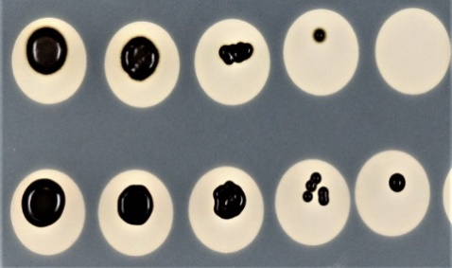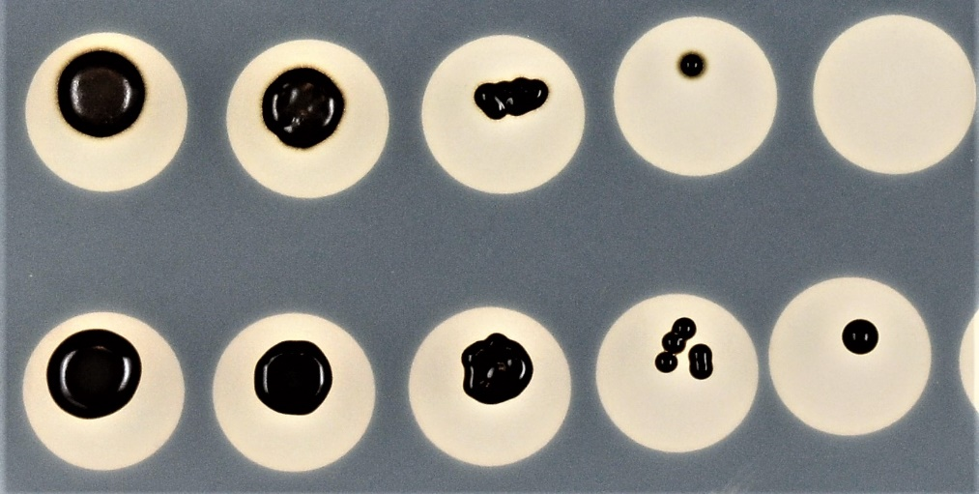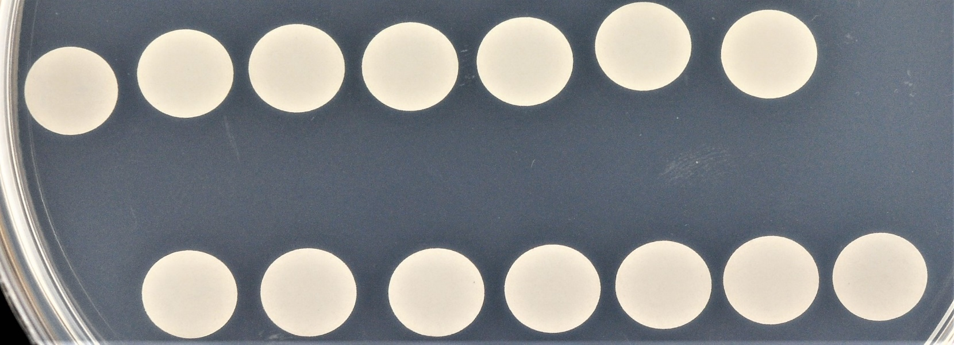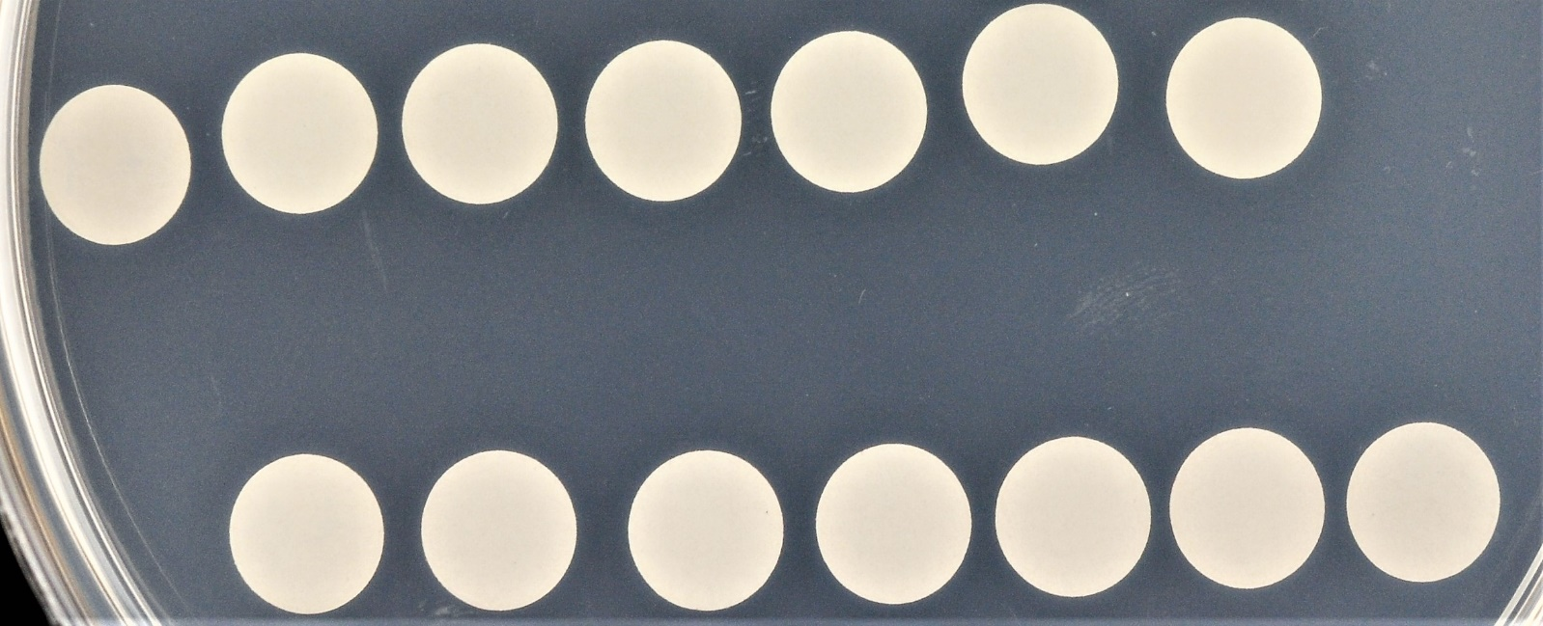
1
10⁻¹
10⁻²
10⁻³
10⁻⁴
E. viscosa JF 03-3F
E. viscosa JF 03-4F
1
10⁻¹
10⁻²
10⁻³
10⁻⁴
Dilution
Minimal media
Minimal media + 50 µg mL⁻¹ Hygromycin B
Supplementary figure 1. Determination of lethal concentration of Hygromycin B in E. viscosa JF 03-3F and JF 03-4F. Serial dilutions of E. viscosa starting at 1x10⁷ cells mL⁻¹.

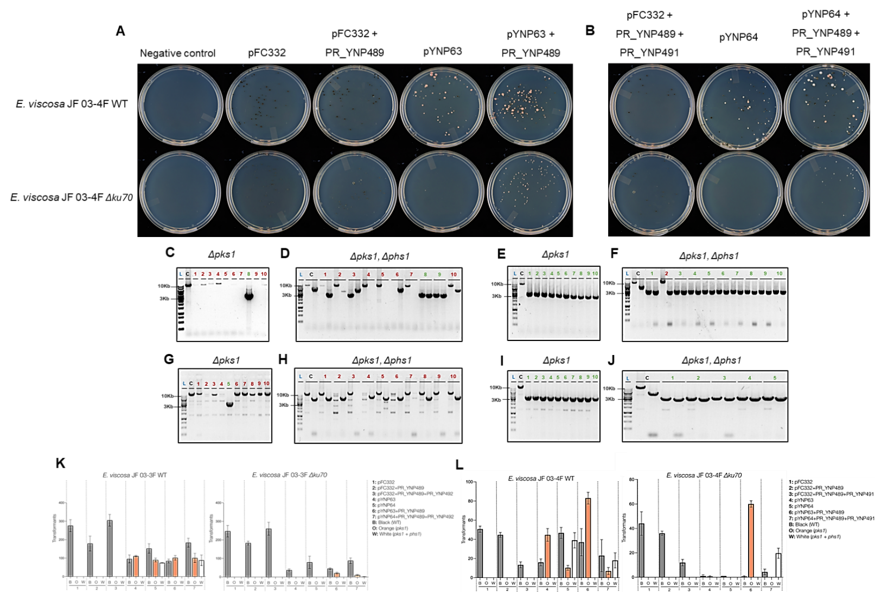
Supplementary figure 2. Technique to assess protospacer efficiency¹ (TAPE) experiments in E. viscosa. A) Transformation plates of ssDNA-mediated pks1 deletions. Δku70 strains displayed a higher lethality compared with the WT when transformed with pYNP63; B) Transformation plates of ssDNA-mediated pks1-phs1 deletions. Δku70 strains displayed a higher lethality compared with the WT when transformed with pYNP64; C) diagnostic PCRs of E. viscosa JF 03-4F WT transformants displaying an orange phenotype. One transformant out of ten successfully deleted pks1 (in green, well 8); D) diagnostic PCRs of E. viscosa JF 03-4F WT transformants displaying a white phenotype. Two transformants out of ten successfully deleted pks1-phs1 (in green, wells 8 and 9); E) diagnostic PCRs of E. viscosa JF 03-4F Δku70 transformants displaying an orange phenotype. All analyzed transformants successfully deleted pks1 (in green, wells 1 to 10); F) diagnostic PCRs of E. viscosa JF 03-4F Δku70 transformants displaying a white phenotype. Nine transformants out of ten successfully deleted pks1-phs1 (in green, wells 1, and 3 to10); G) diagnostic PCRs of E. viscosa JF 03-3F WT transformants displaying an orange phenotype. One transformant out of ten successfully deleted pks1 (in green, well 5); H) diagnostic PCRs of E. viscosa JF 03-3F WT transformants displaying a white phenotype. Transformants with full pks1-phs1 deletions were not found; I) diagnostic PCRs of E. viscosa JF 03-3F Δku70 transformants displaying an orange phenotype. All analyzed transformants successfully deleted pks1 (in green, wells 1 to 10); J) diagnostic PCRs of E. viscosa JF 03-3F Δku70 transformants displaying a white phenotype. Five transformants out of five successfully deleted pks1-phs1 (in green, wells 1 to 5); K) Colony counting during TAPE experiments in E. viscosa JF 03-3F. The WT strain can repair its DNA by NHEJ when transformed with Cas9-sgRNA plasmids targeting pks1 and pks1-phs1. In contrast, a higher lethality was observed in Δku70 strains since NHEJ pathway is not active. When a ssDNA oligo was provided, Δku70 strains can repair a DNA double strand brake and deleted the targeted genes; L) Colony counting during TAPE experiments in E. viscosa JF 03-4F. The WT strain can repair its DNA by NHEJ when transformed with Cas9-sgRNA plasmids targeting pks1 and pks1-phs1. In contrast, a higher lethality was observed in Δku70 strains since NHEJ pathway is not active. When a ssDNA oligo was provided, Δku70 strains can repair a DNA double strand brake and deleted the targeted genes.

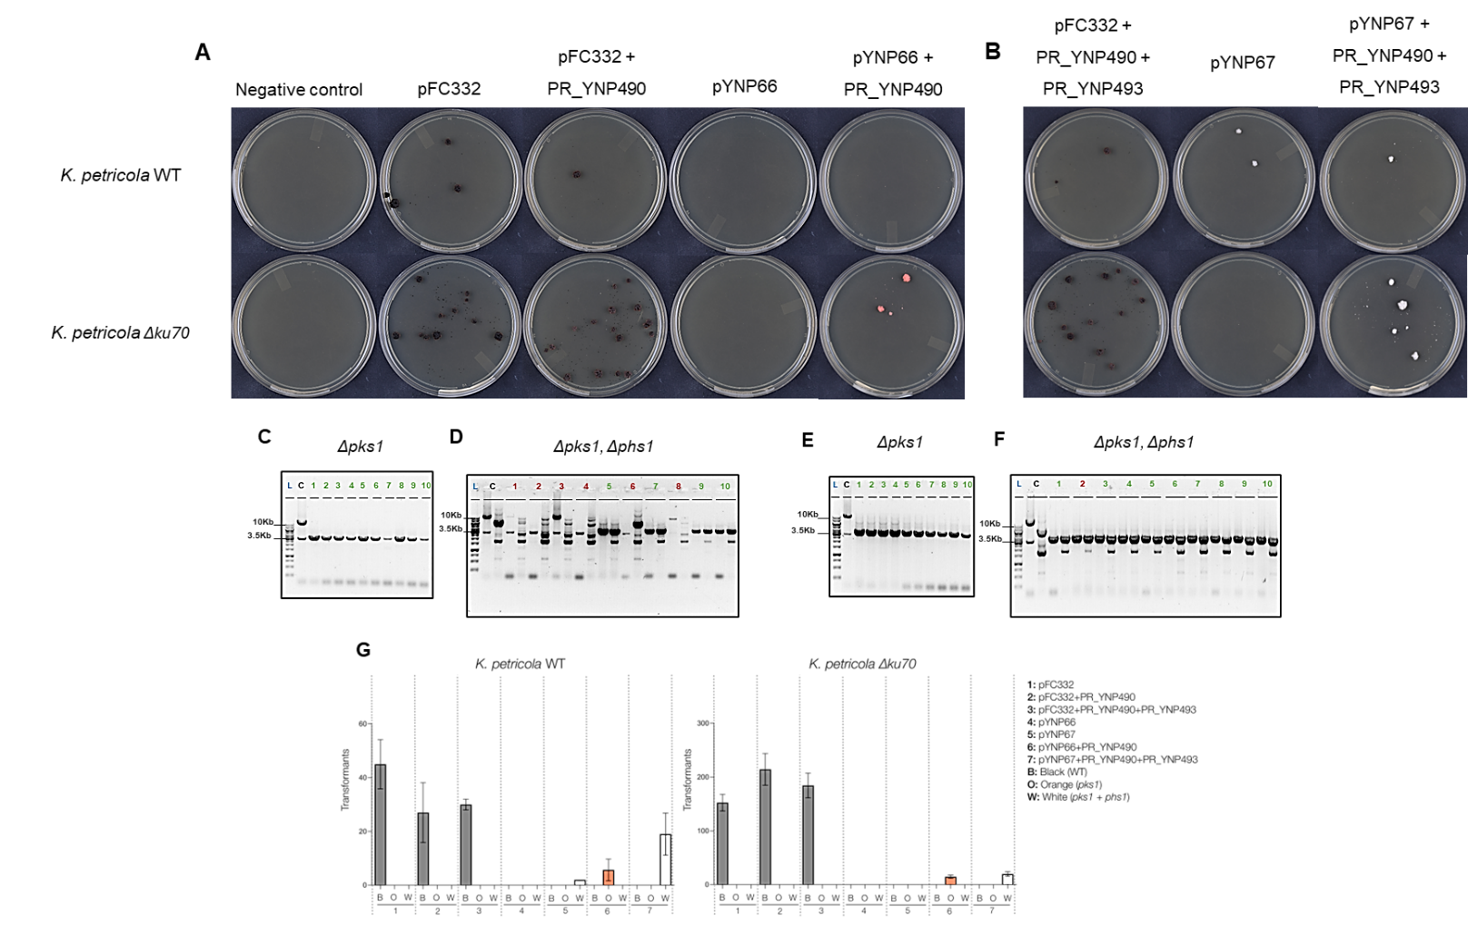

Supplementary figure 3 Technique to assess protospacer efficiency¹ (TAPE) K. petricola. A) Transformation plates of ssDNA-mediated pks1 deletions. Similar lethality was observed in both WT and Δku70 strains when transformed with pYNP66; B) Transformation plates of ssDNA-mediated pks1-phs1 deletions. Δku70 strains displayed a higher lethality compared with the WT when transformed with pYNP67; C) diagnostic PCRs of K. petricola WT transformants displaying an orange phenotype. All analyzed transformants successfully deleted pks1 (in green, wells 1- 10); D) diagnostic PCRs of K. petricola WT transformants displaying a white phenotype. Three transformants out of ten successfully deleted pks1-phs1 (in green, wells 5, 7, 9, and 10); E) diagnostic PCRs of K. petricola Δku70 transformants displaying an orange phenotype. All analyzed transformants successfully deleted pks1 (in green, wells 1 to 10); F) diagnostic PCRs of K. petricola Δku70 transformants displaying a white phenotype. Nine transformants out of ten successfully deleted pks1-phs1 (in green, wells 1, and 3 to10); G) Colony counting during TAPE experiments in K. petricola. Similar number of colonies were obtained in WT and Δku70 when transformed with Cas9-sgRNA plasmids targeting pks1 and pks1-phs1.
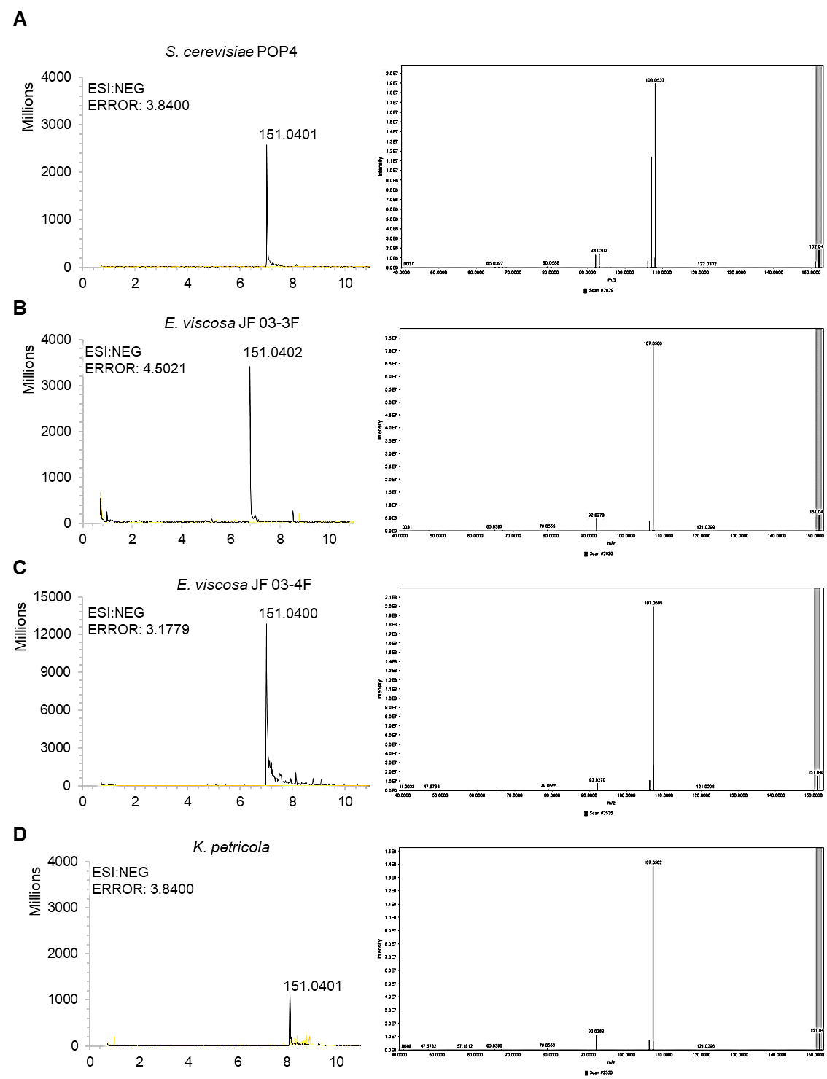
Supplementary figure 4. Total ion chromatograms and mass fragmentation spectrum of 6-MSA obtained from the LC-MS analysis of extracts from producer strains. A) S. cerevisiae POP4; B) E. viscosa JF 03-3F; C) E. viscosa JF 03-4F; D) K. petricola. Chromatograms are displayed in negative mode.
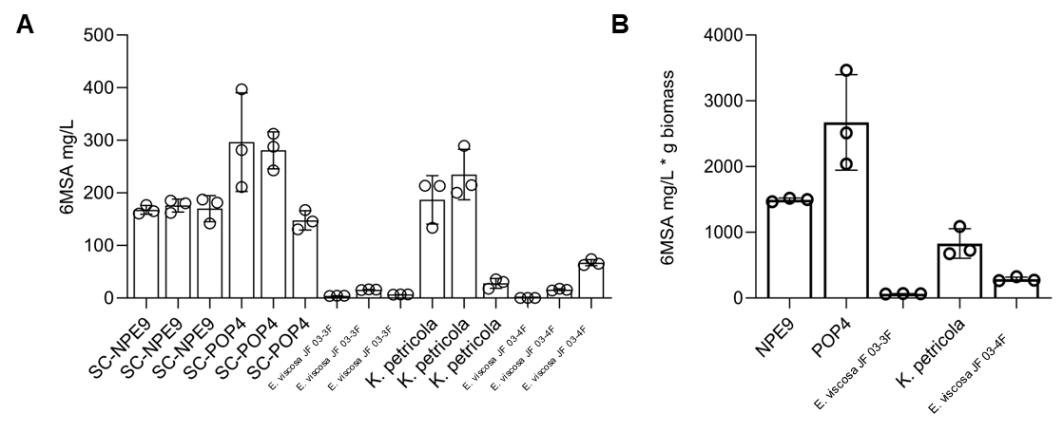
Supplementary figure 5. Absolute and relative concentrations of 6-MSA producing strains. A) absolute concentrations of 6-MSA. S. cerevisiae NPE9_1: 167.55 mg/L +- 8.30mg, NPE9_2: 175.83 mg/L +- 12.36 mg, NPE9_3: 170.18 mg/L +- 24.80 mg; S. cerevisiae POP4_1: 296.33 mg/L +- 93.79 mg, POP4_2: 280.90 mg/L +- 35.25 mg, POP4_3: 147.81 mg/L +- 18.39 mg; E. viscosa JF 03-3F_1: 4.11 mg/L +- 0.19 mg, JF 03-3F_2: 15.80 mg/L +- 0.66 mg, JF 03-3F_3: 6.78 mg/L +- 0.26 mg; E. viscosa JF 03-4F_1: 0 mg/L, JF 03-4F_2: 15.98 mg/L +- 1.62 mg, JF 03-4F_3: 67.31 mg/L +- 5.88 mg; K. petricola_1: 186.80 mg/L +- 46.02 mg, K. petricola_2: 234.85 mg/L +- 47.92 mg, K. petricola_3: 27.96 mg/L +- 9.36 mg; B) relative concentrations of 6-MSA in the highest average producer replicate. S. cerevisiae NPE9_2) 1.494 g/L +- 27.19 mg; S. cerevisiae POP4_1: 2.671 g/L +- 726.64 mg; E. viscosa JF 03-3F_2: 64.47 mg/L +- 3.72 mg; E. viscosa JF 03-4F_3: 286.99 mg/L +- 32.49 mg; K. petricola_2: 829.84 mg/L +- 225.58 mg.

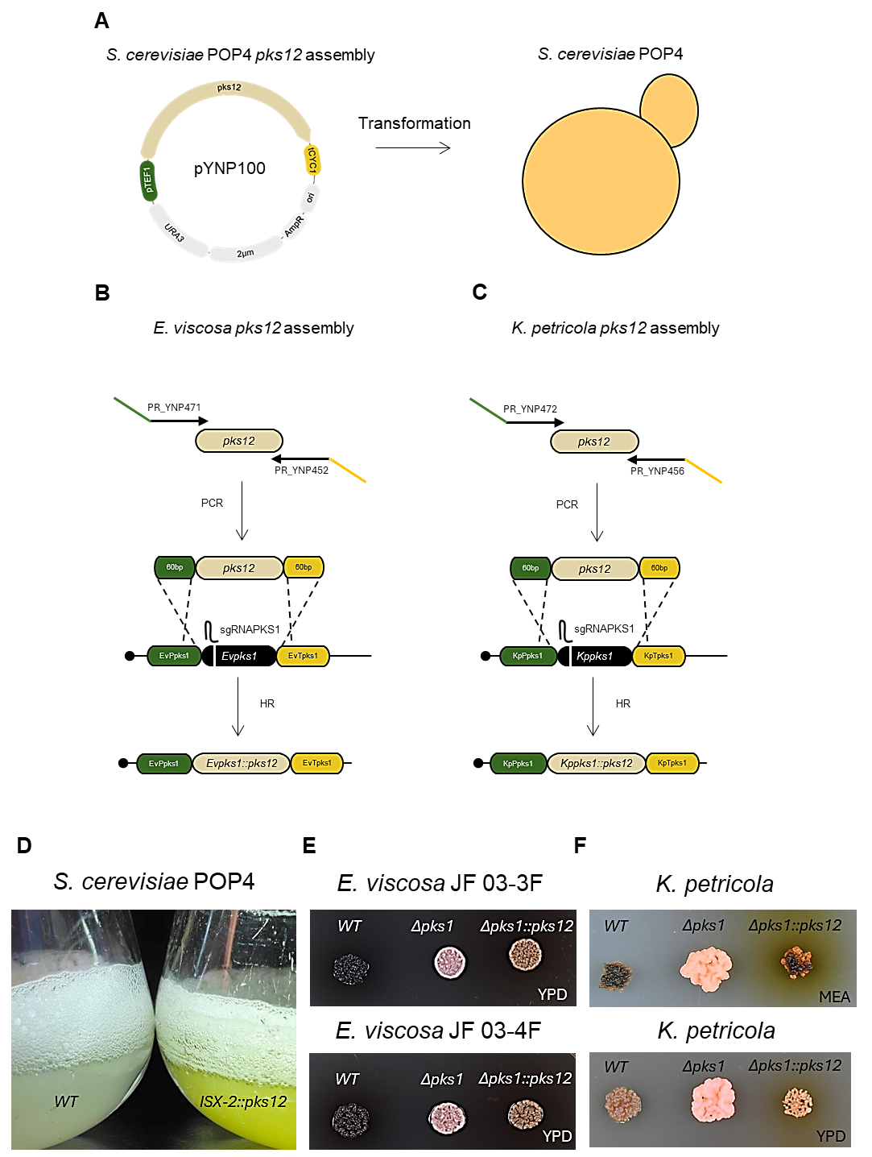
Supplementary figure 6. pks12 assembly and heterologous expression. A) A 2µ high-copy plasmid (pYNP100) containing an intron-less F. acaciae-mearnsii pks12 gene under the control of S. cerevisiae TEF1 promoter and CYC1 terminator was transformed into S. cerevisiae POP4. Image created with BioRender.com; B) F. acaciae-mearnsii pks12 was PCR-amplified from pYNP100 using primers flanked with 60bp homology to the E. viscosa pks1 promoter and terminator, and the PCR product was transformed together with plasmid pYNP63 to integrate it into the pks1 locus, taking advantage of the endogenous pks1 promoter and terminator during YWA1 production; C) F. acaciae-mearnsii pks12 was PCR-amplified from pYNP100 using primers flanked with 60bp homology to the K. petricola pks1 promoter and terminator, and the PCR product was transformed together with plasmid pYNP66 to integrate it into the pks1 locus, taking advantage of the endogenous pks1 promoter and terminator during YWA1 production; D) A yellow phenotype was observed in S. cerevisiae POP4 during production of YWA1 in liquid cultures; E) A brown phenotype was observed in colonies of E. viscosa YWA1 producer strains; F) A brown phenotype was observed in colonies of K. petricola YWA1 producer strains.
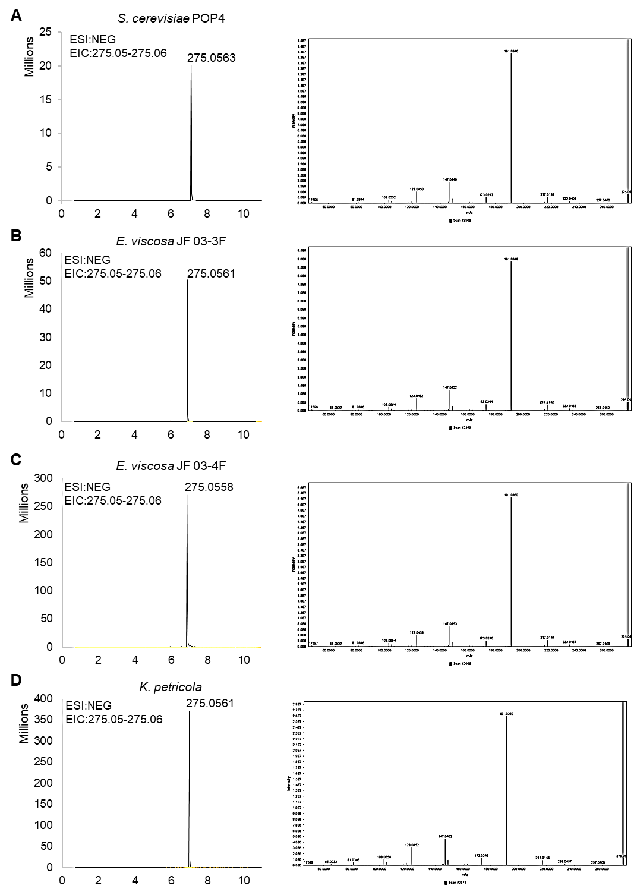
Supplementary figure 7. Extracted ion chromatograms (m/z 275.05556 calculated for [C₁₄H₁₁O₆]⁺ ) and mass fragmentation spectrum of YWA1 obtained from LC-MS analysis of extracts from producer strains. A) S. cerevisiae POP4; B) E. viscosa JF 03-3F; C) E. viscosa JF 03-4F; D) K. petricola. Chromatograms are displayed in negative mode.
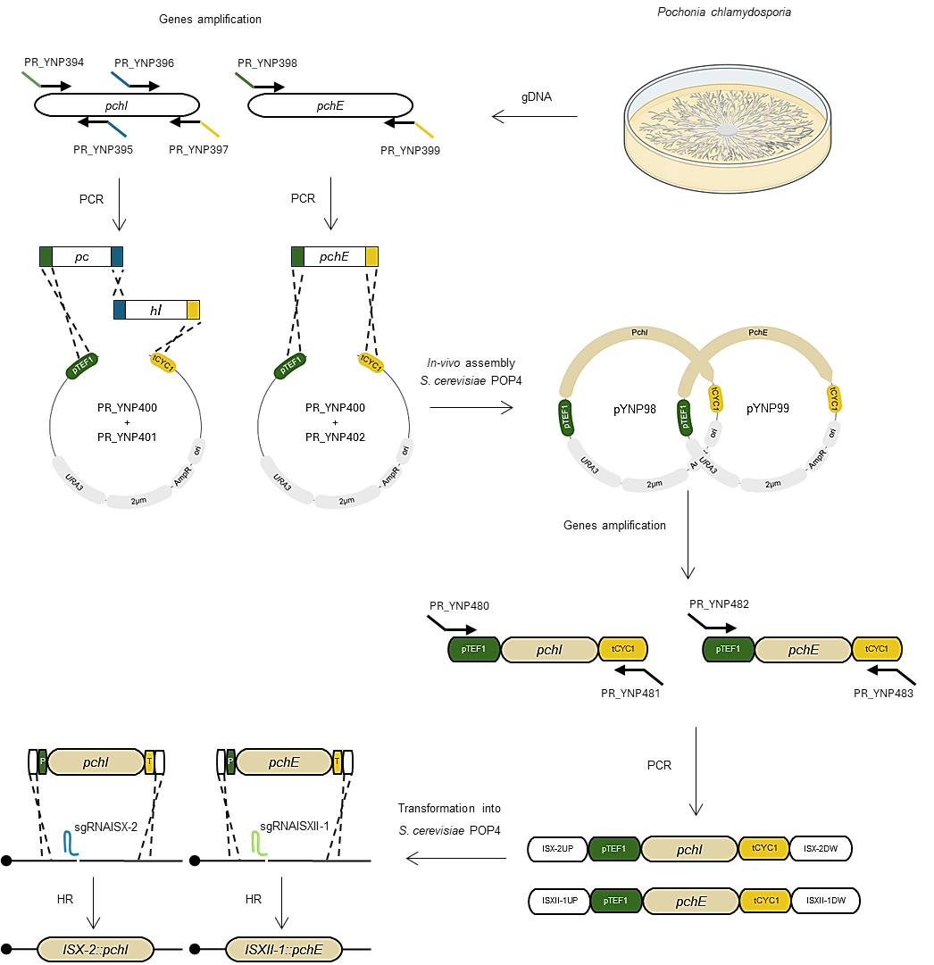
Supplementary figure 8. Monocillin II assembly and heterologous expression in S. cerevisiae POP4. Intron-less pchI and pchE genes were PCR-amplified from P. chlamydosporia genomic DNA and assembled in-vivo into 2µ high-copy plasmid backbones containing TEF1 promoter and CYC1 terminator using S. cerevisiae POP4, resulting in plasmids pYNP98 and pYNP99. Thereafter, pchI and pchE genes were PCR-amplified from assembled plasmids pYNP98 and pYNP99 using primers flanked with 60bp homology sequences to ISX-2 and ISXII-1. Finally, the obtained PCRs were transformed into S. cerevisiae POP4 together with a Cas-sgRNA plasmid (pYNP120) and integrated into S. cerevisiae POP4 genome. Image created with BioRender.com
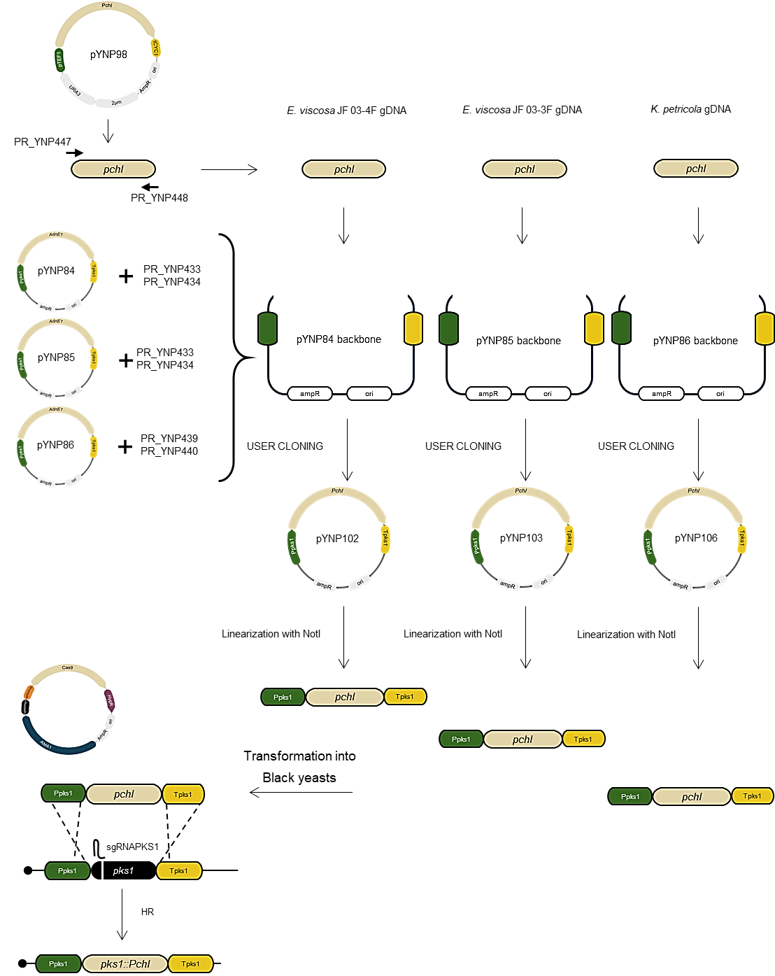
Supplementary figure 9. Monocillin II pchI assembly and heterologous expression in black yeasts. pchI was PCR-amplified from pYNP98 and cloned into plasmid backbones pYNP84, pYNP85, pYNP86. Thereafter, pchI constructs were linearized and transformed into black yeasts together with a Cas9-sgRNA plasmid targeting the pks1-phs1 loci. Image created with BioRender.com
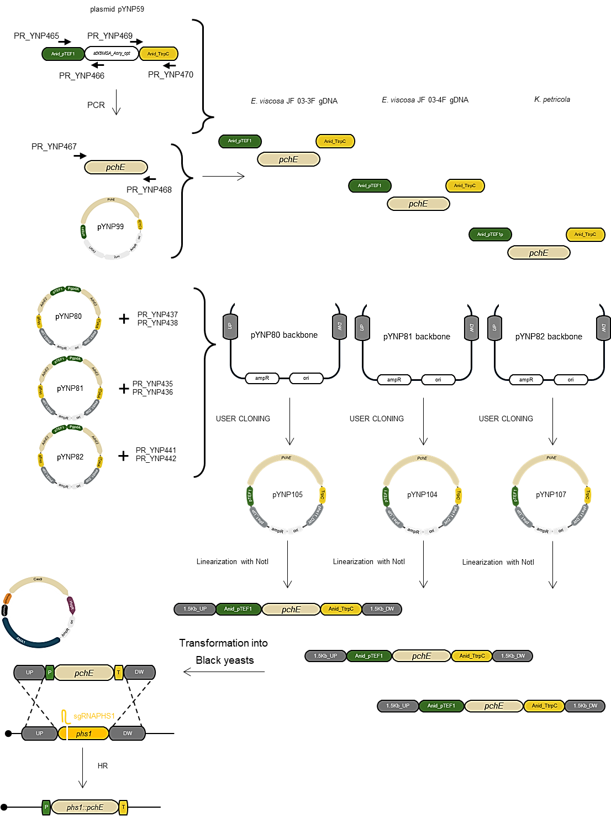
Supplementary figure 10. Monocillin II pchE assembly and heterologous expression in black yeasts. A. nidulans TEF1 promoter and trpC terminator were amplified from plasmid pYNP59, and pchE was PCR-amplified from pYNP99. PCRs products were cloned into plasmid backbones pYNP105, pYNP104, pYNP107. Thereafter, pchE constructs were linearized and transformed into black yeasts together with a Cas9-sgRNA plasmid targeting the pks1-phs1 loci. Image created with BioRender.com
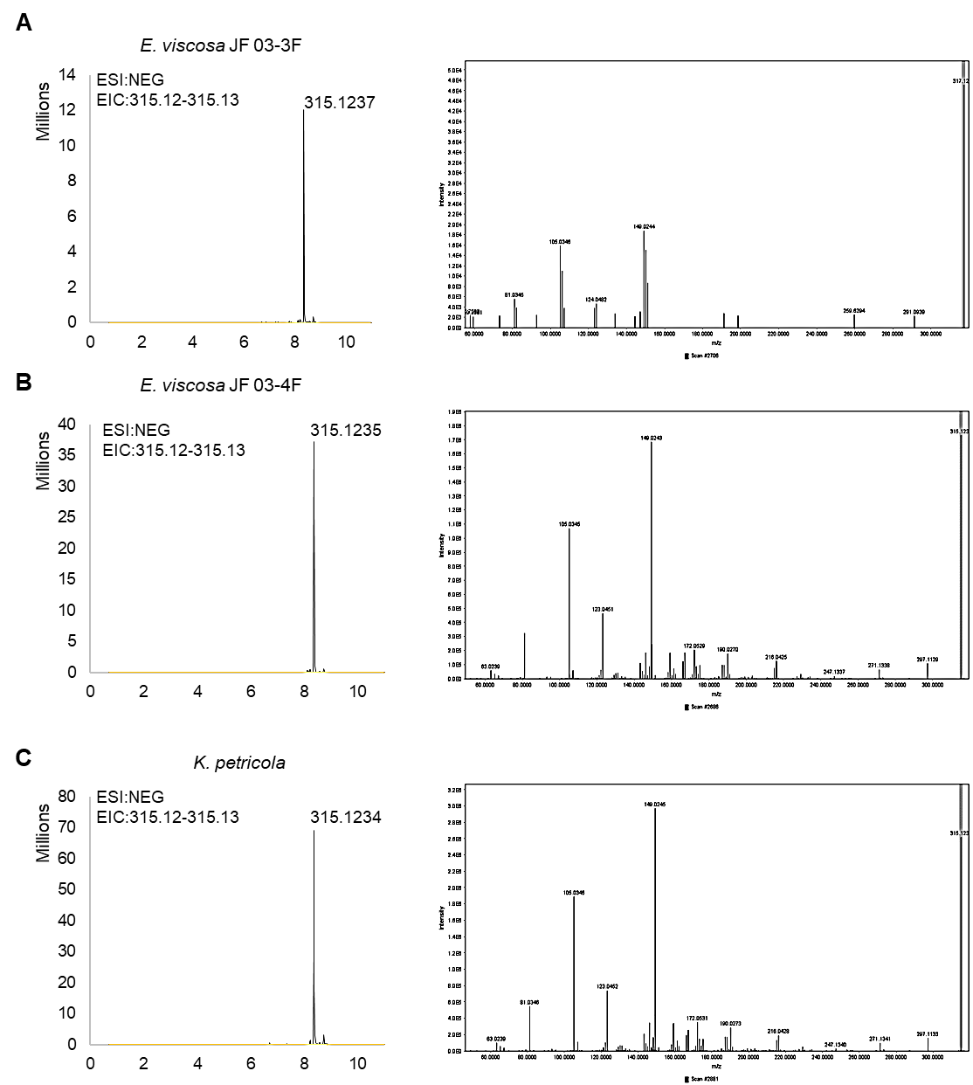
Supplementary figure 11.
Extracted ion chromatograms (m/z 315.1232 calculated for [C₁₈H₁₉O₅]⁺ ) and mass fragmentation spectrum of Monocillin II obtained from LC-MS analysis of extracts from producer strains.
A) E. viscosa JF 03-3F; B) E. viscosa JF 03-4F; C) K. petricola. Chromatograms are displayed in negative mode. .
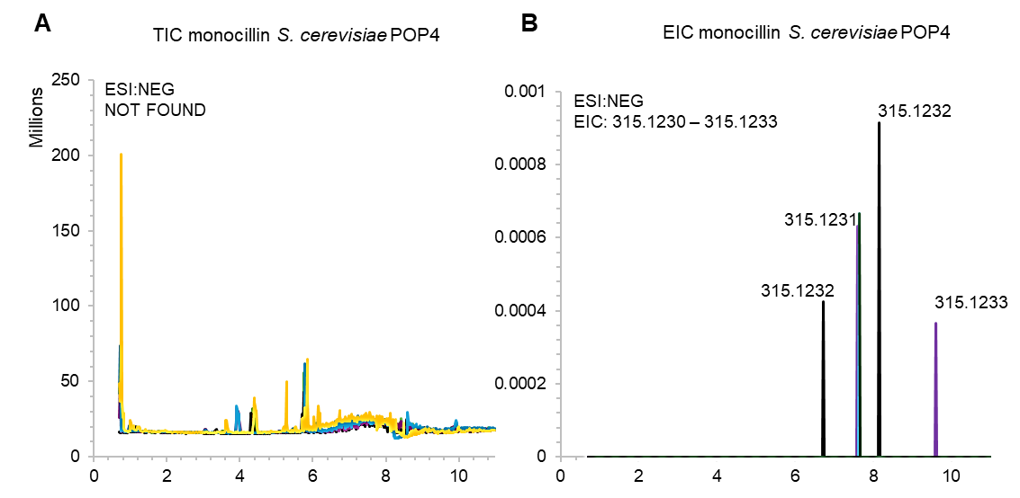
Supplementary figure 12. Monocillin II expression in S. cerevisiae POP4. A) Total ion chromatogram obtained from LC-MS analysis of S. cerevisiae POP4 extracts.; B) Extracted ion chromatogram for m/z 315.1232 calculated for [C₁₈H₁₉O₅]⁺. Control is shown in yellow and samples of four biological replicates are shown in black, blue, purple, and green colors. Chromatograms are displayed in negative mode.

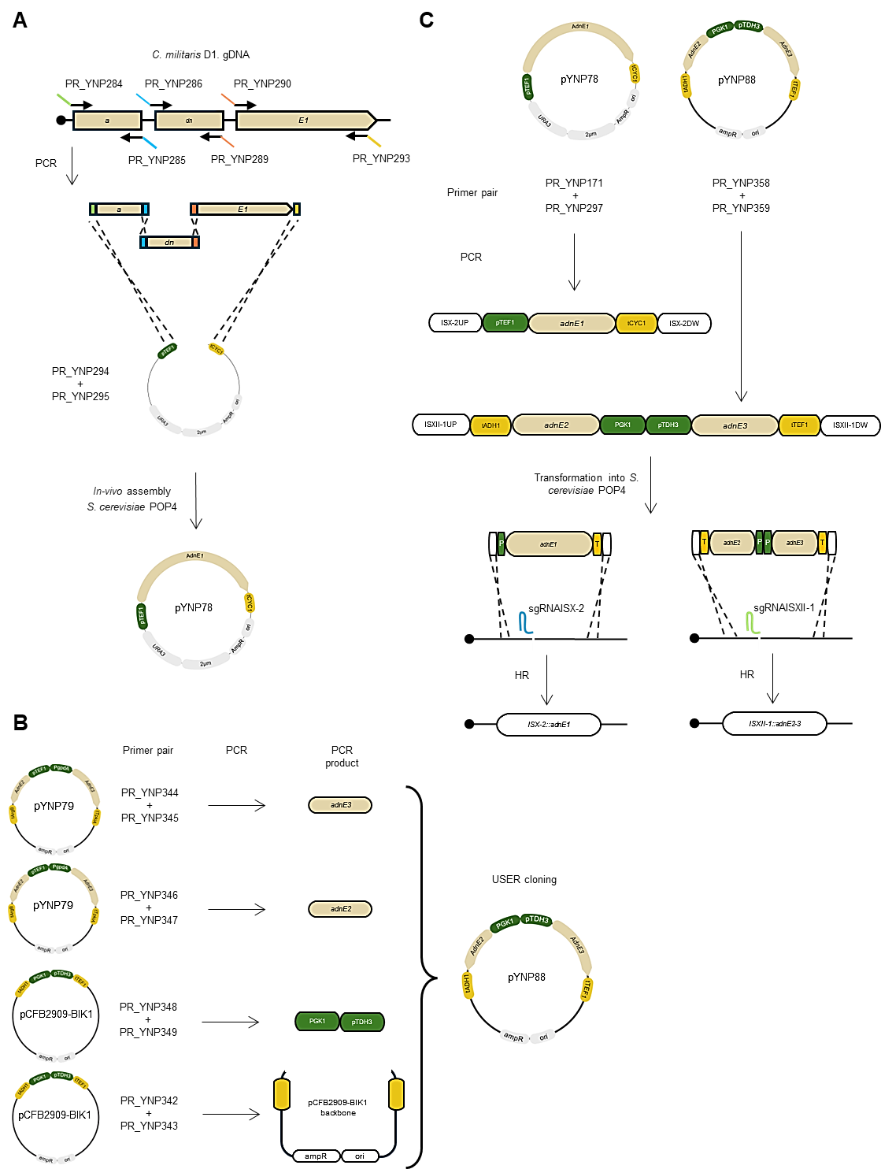
Supplementary figure 13. adnE assembly and heterologous expression in S. cerevisiae POP4. A) adnE1 exons were amplified from C. militaris D1. genomic DNA and in-vivo assembled in S. cerevisiae POP4, resulting in plasmid pYNP78 expressing adnE1 under the control of TEF1 promoter and CYC1 terminator; B) adnE2 and adnE3 were amplified from plasmid pYNP79, and PGK1 and TDH3 promoters were amplified from pCFB2909. PCR products were cloned into pCFB2909 backbone, resulting in plasmid pYNP88 expressing adnE2 and adnE3 under the control PGK1 and TDH3 promoters, and ADH1 and TEF1 terminators, respectively; C) adnE1, adnE2, and adnE3 were PCR-amplified from plasmids pYNP78 and pYNP88 using primers with 60bp homology to the integration sites ISX-2 and ISXII-1, and transformed into S. cerevisiae POP4 together with a Cas9-sgRNA plasmid pYNP120 targeting both integration sites. Image created with BioRender.com

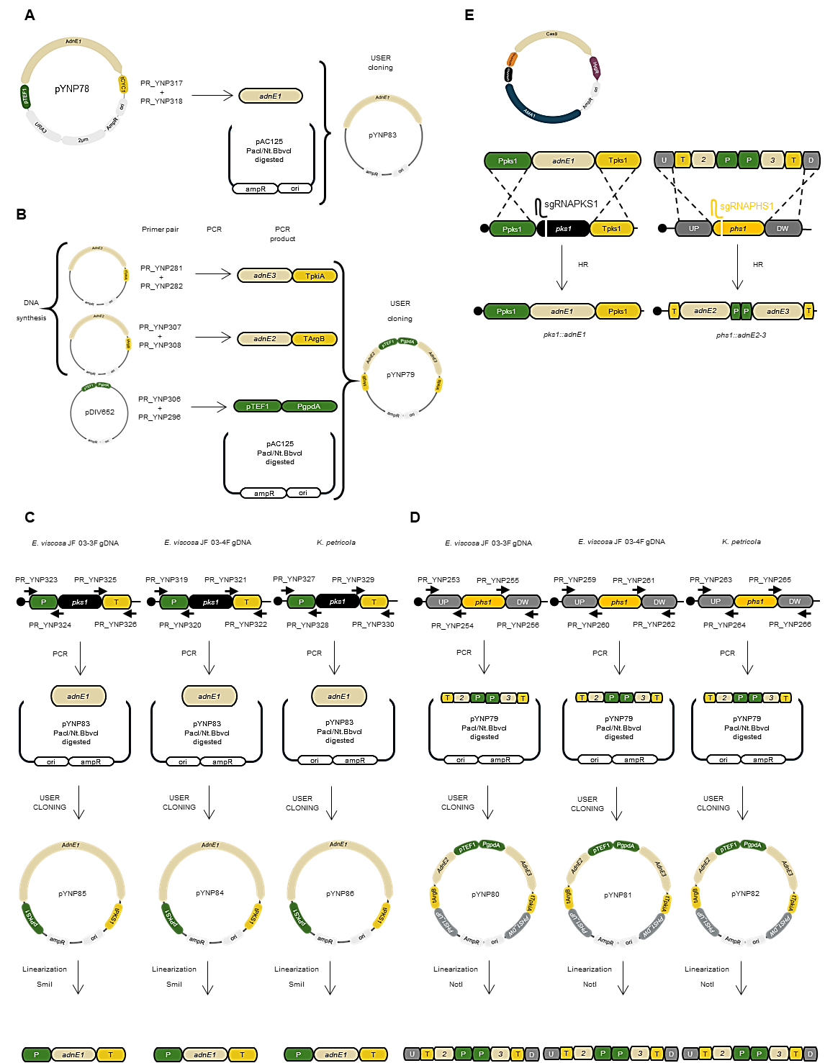
Supplementary figure 14. adnE assembly and heterologous expression in black yeasts POP4. A) adnE1 was PCR-amplified from pYNP78, resulting in plasmid pYNP83; B) adnE2-TArgB and adnE3-TpkiA were amplified from synthesized plasmids. A. nidulans TEF1 and gpdA promoters were amplified from pDIV652. The PCR products were cloned into plasmid pAC125, resulting in plasmid pYNP79; C) 1Kb of pks1 promoters and terminators were PCR-amplified from black yeasts genomic DNA and cloned into PacI/Nt.bbvcI digested plasmid pYNP83, resulting in plasmids pYNP84, pYNP85, pYNP86 expressing adnE1 under the control of pks1 promoter and terminator; D) 1.5Kb upstream and downstream DNA sequences from phs1 were PCR-amplified from black yeasts genomic DNA and cloned into PacI/Nt.bbvcI digested plasmid pYNP79, resulting in plasmids pYNP80, pYNP81, pYNP82 expressing adnE2 and adnE3 under the control of A. nidulans TEF1 and gpdA promoters, and argB and pkiA terminators, respectively; E) The constructed plasmids harboring adnE genes were linearized transformed into black yeasts together with Cas9-sgRNA plasmids and integrated into pks1 and phs1 loci. Image created with BioRender.com

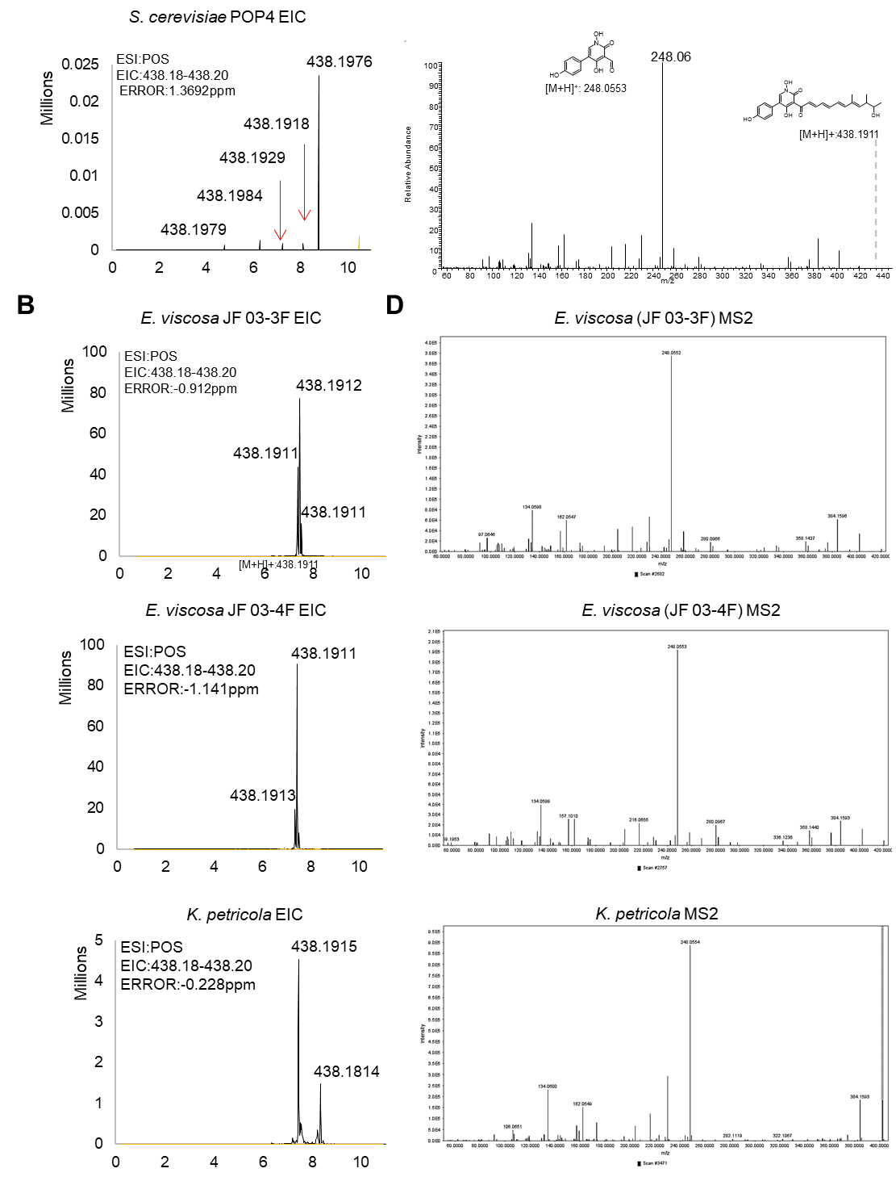

Supplementary figure 15. Extracted ion chromatograms and mass fragmentation spectra of YNP1 in different hosts. All chromatograms are displayed in positive mode. A) Extracted ion chromatogram for m/z 438.1917 calculated for [C₂₅H₂₇NO₆]⁺ obtained from LC-MS analysis of S. cerevisiae POP4 extracts: targeted mass was found on noise levels; B) Extracted ion chromatograms and mass fragmentation during heterologous production of YNP1 in black yeasts: m/z 438.1912 was found in all strains; C) The mass fragmentation pattern found in black yeasts corresponded to a pyridine moiety and an unsaturated acyl chain.

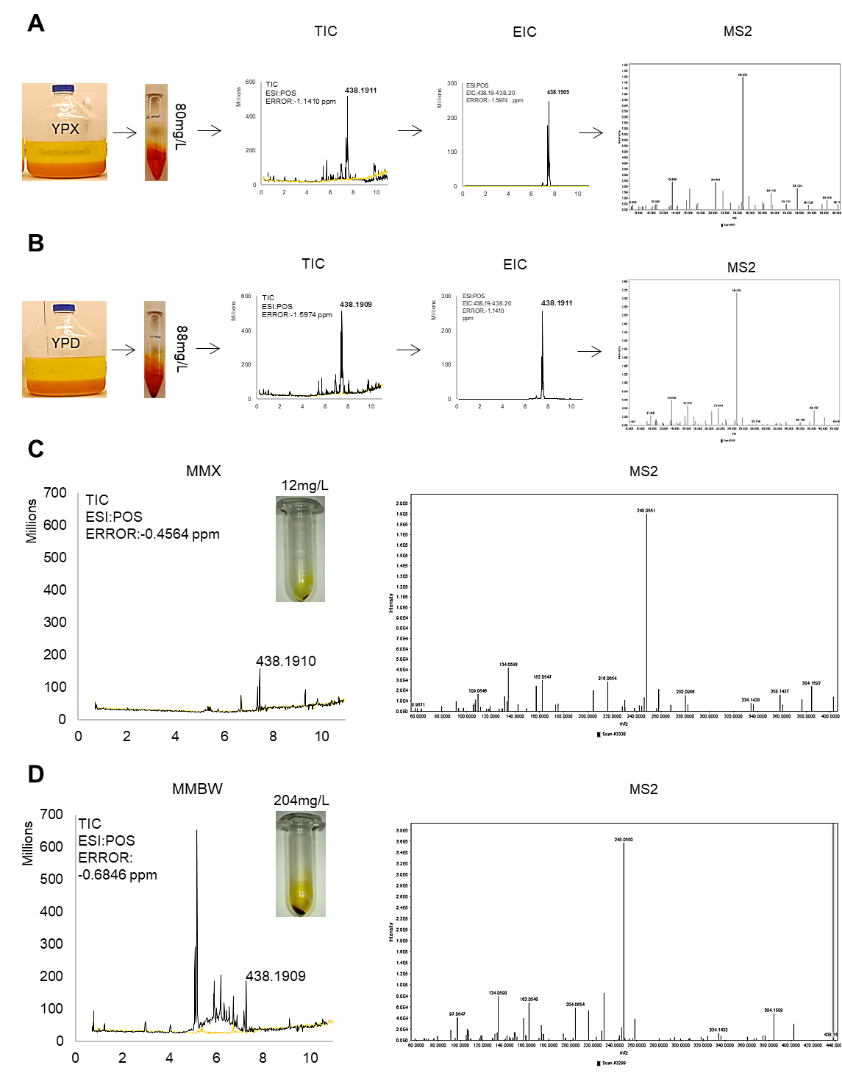
Supplementary figure 16. Production of YNP1 in E. viscosa JF 03-4F different media. A) Process of extraction, chromatograms and mass fragmentation spectra during production of YNP1 in 1L of YPX media; B) Process of extraction, chromatograms and mass fragmentation spectrum during production of YNP1 in 1L YPD media; C) Total ion chromatogram and mass fragmentation spectrum during production of YNP1 in 50mL of MMX media; D) Total ion chromatogram and mass fragmentation spectrum during production of YNP1 in 50mL of MMBW media.

17-Hydroxyfarinosone
Yellow solid; ¹H (800 MHz, DMSO-d₆,): δ = 17.64 (s, 1H, C4-OH), 11.64 (s, 1H, N-OH), 9.48 (s, 1H, C4´-OH), 8.01 (d, J = 15.2 Hz, 1H, H-8), 7.55 (s, 1H, H-6), 7.60 (m, 1H, H-9), 7.28 (d, J = 8.6 Hz, 2H, H-2´, H-6´), 6.78 (d, J = 8.6, 2H, H-3´, H-5´), 6.63 (dd, J = 11.7 Hz and 14.9 Hz, 1H, H-10), 6.95 (dd, J = 14.5, 1H, H-11), 6.45 (dd, J = 15.2 Hz and 11.0 Hz, 1H, H-12), 6.56 (d, J = 15.3 Hz 1H, H-13), 5.85 (s, 1H, H-15), 4.52 (d,1H, C-17-OH), 3.17 (m, 1H, H-16), 3.51 (m, 1H, H-17), 2.01 (s, 3H, H-20), 1.20 (s, 3H, H-19), 1.04 (d, 3H, H-18).
HRMS (ESI+) m/z calcd for [C₂₅H₂₇NO₆]⁺ 438.1917; found 438.1915.

Supplementary figure 17. ¹H-¹H COSY and ¹H-¹³C HMBC main correlations of 17-Hydroxylfarinosone.

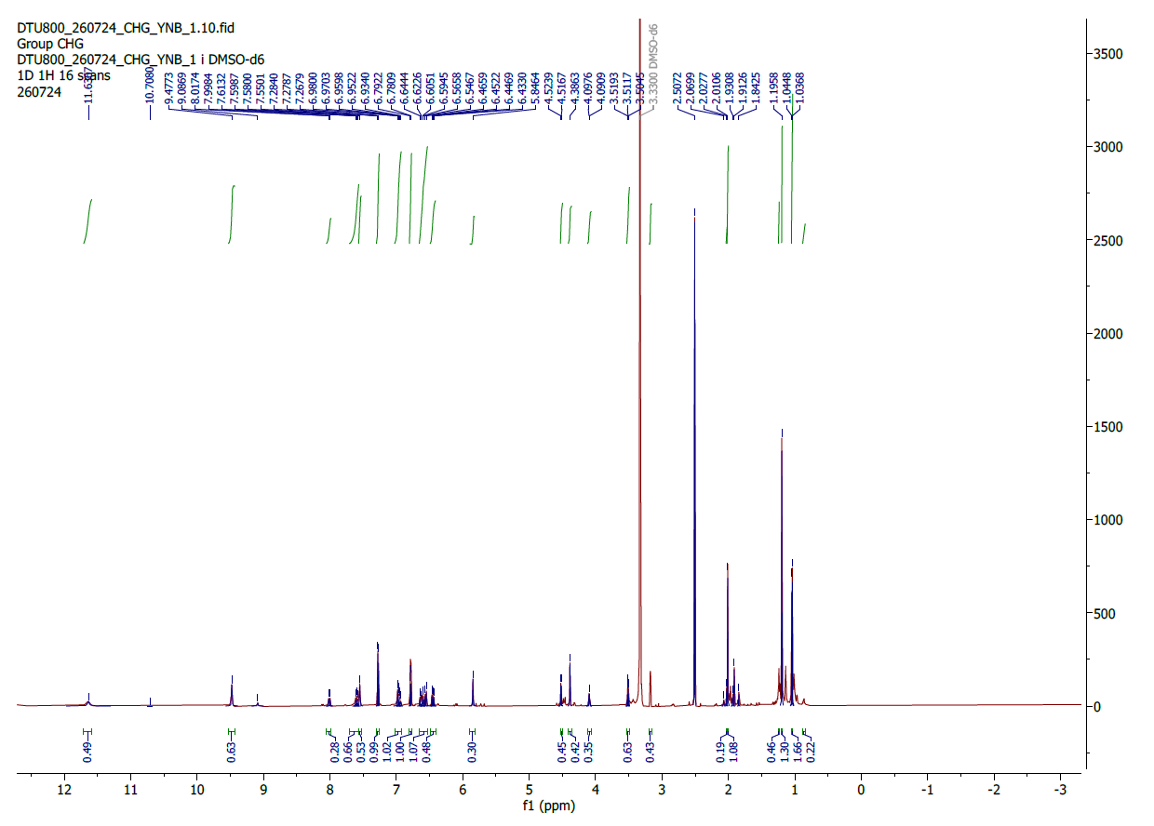
Supplementary figure 18. ¹H NMR Spectra of 17-Hydroxylfarinosone (800 MHz, DMSO-d₆).
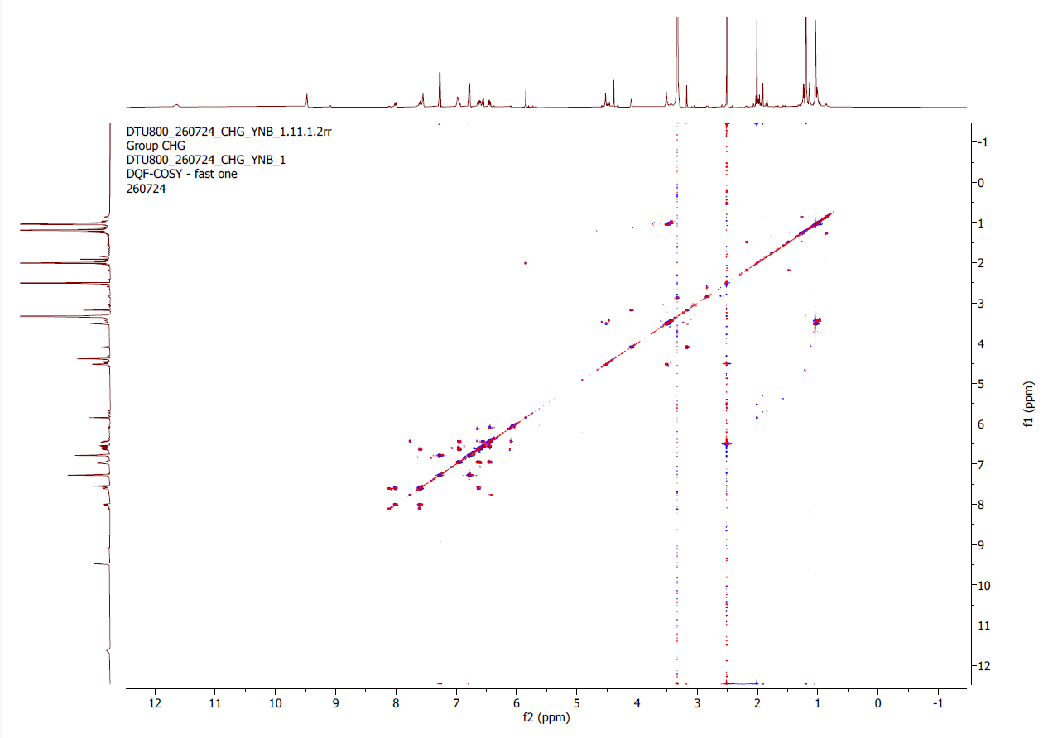
Supplementary figure 19. ¹H-¹H COSY NMR Spectrum of 17-Hydroxylfarinosone (800 MHz, DMSO-d₆).

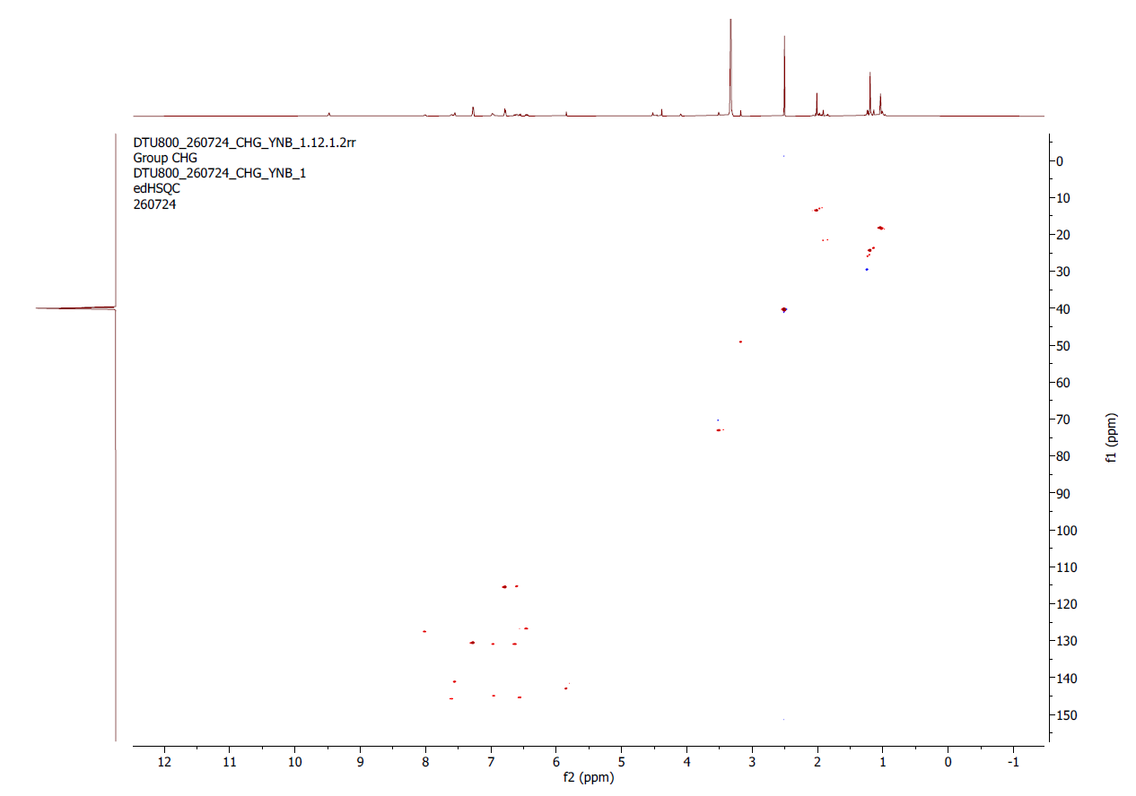
Supplementary figure 20. ¹H-¹³C HSQC NMR Spectrum of 17-Hydroxylfarinosone (800 MHz, DMSO-d₆).
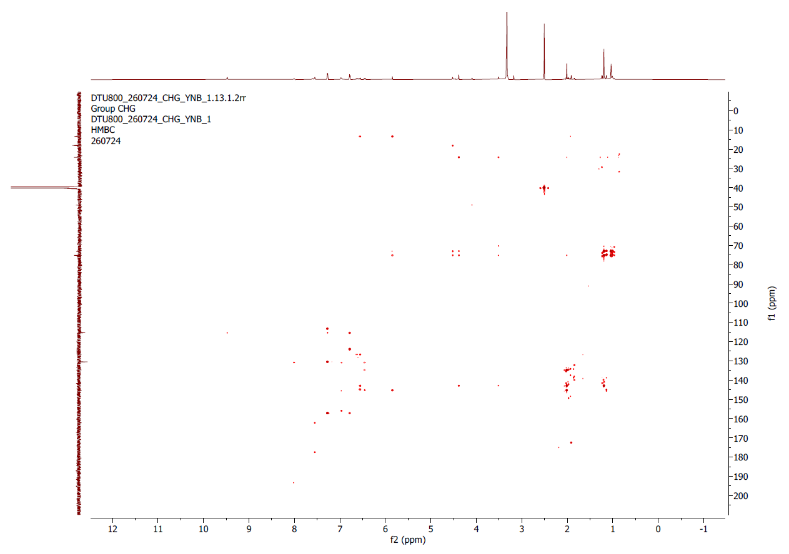
Supplementary figure 21. ¹H-¹³C HMBC NMR Spectrum of 17-Hydroxylfarinosone (800 MHz, DMSO-d₆).

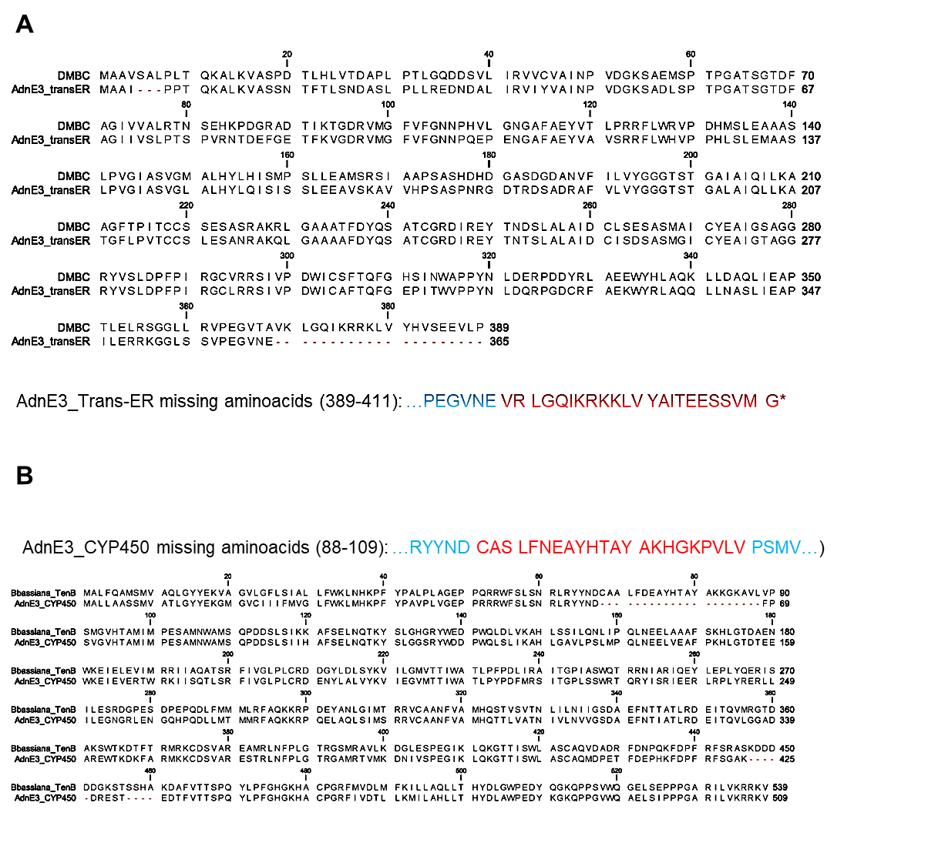
Supplementary figure 22. BLASTP of adnE3 amino acid sequence. The retrieved amino acid sequences by gene calling is shown in blue. The missing amino acids found during BLASTp search are shown in red. A) Trans-ER domain aligned against Beauveria bassiana DMBC: the missing c-terminal amino acids found within adnE3 reading frame are shown in red; B) CYP450 domain aligned against B. bassiana TenC: the missing amino acids found within adnE3 reading frame are shown in red.

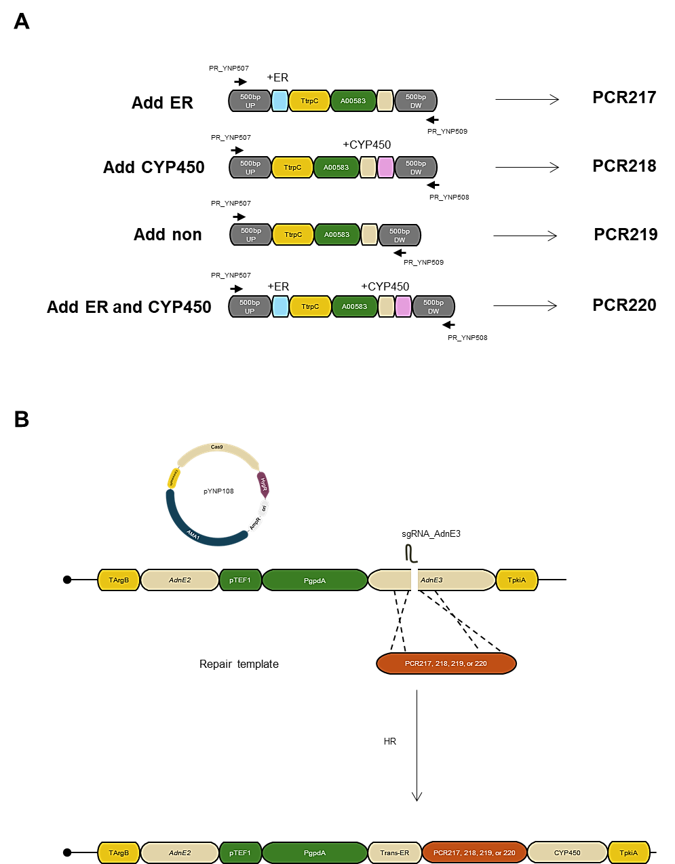
Supplementary figure 23. Introduction of missing DNA sequences within adnE3 A) Different versions of the missing DNA sequences of the trans-ER and CYP450 domains in adnE3 were synthesized and PCR-amplified: the added trans-ER sequence is marked in blue and the missing CYP450 sequence in pink; B) PCRs containing one, non, or both Trans-ER and CYP450 missing DNA sequences were transformed into E. viscosa JF 03-4F YNP1 producer strain together with Cas9-sgRNA plasmid pYNP108 targeting the connecting DNA sequence between Trans-ER and CYP450 domains and integrated by homologous recombination. Image created with BioRender.com
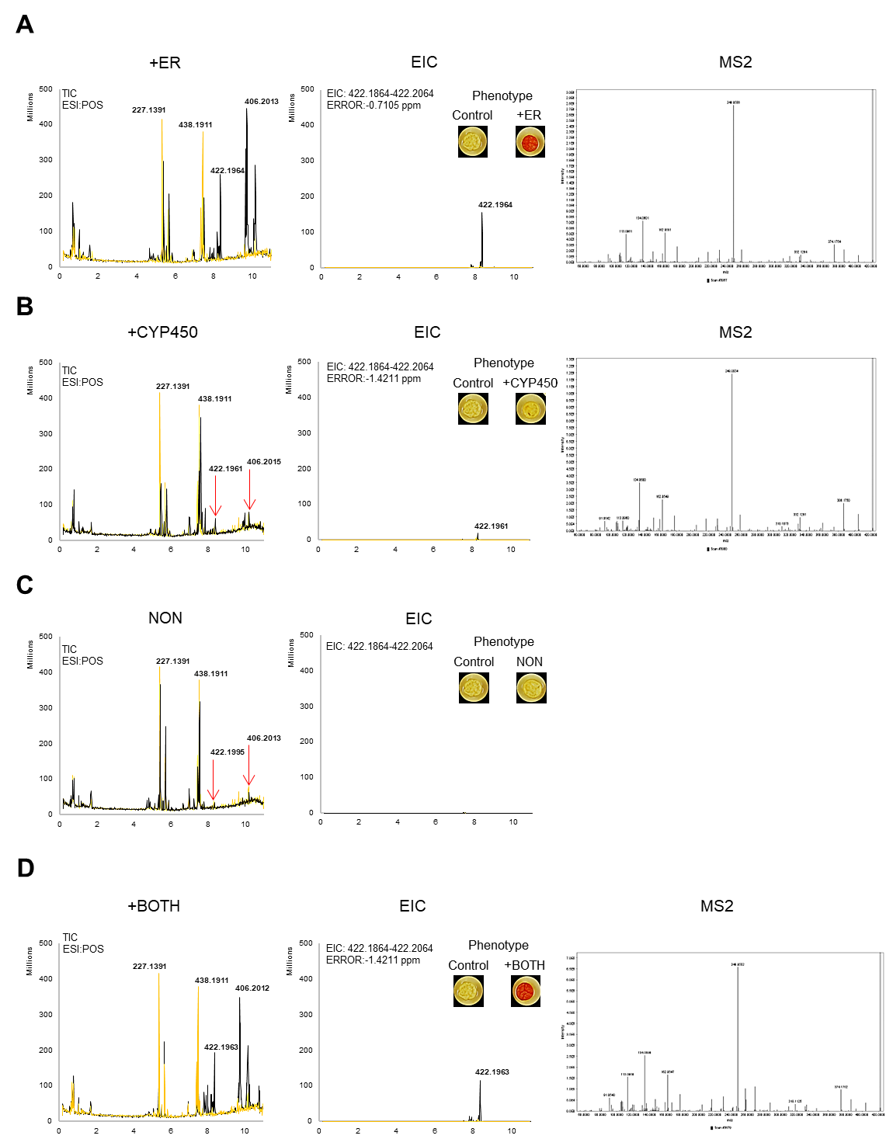
Supplementary figure 24. Introduction of missing DNA sequences within adnE3 A) Introduction of the missing trans-ER sequence results in the appearance of two abundant peaks m/z 422.1964 (farinosone B) and 406.2015 (farinosone A), although m/z 438.1911 (YNP1) is produced in with less abundance; B) Introduction of the missing CYP450 sequence results in similar peaks compared to the parental strain; C) By not introducing any of the missing sequences result in similar peaks compared to the parental strain; D) Introduction of the missing trans-ER sequence results in the appearance of two abundant peaks m/z 422.1927 (farinosone B) and 406.2015 (farinosone A), and m/z 438.1911 (YNP1) is produced in very low abundance.
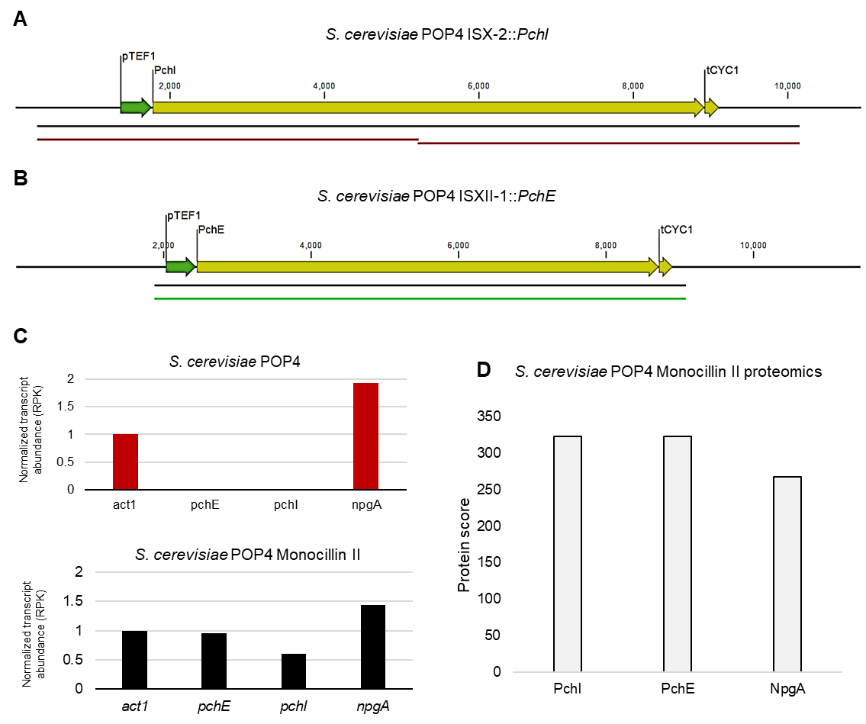
Supplementary figure 25. Monocillin II omics analysis in S. cerevisiae POP4. A) Genome sequencing results confirmed the integrity of pchI chromosomal integration in S. cerevisiae POP4; B) Genome sequencing results confirmed the integrity of pchE chromosomal integration in S. cerevisiae POP4; C) Transcriptomics results confirmed the expression of pchI, pchE, and npgA transcripts. The RNA-seq reads were mapped to the refence coding sequences, the number of mapped reads divided by the gene length to obtain reads per kilobase values, then these values were normalized to the RPK value of act1 a housekeeping gene. D) Proteomics results confirmed the presence of PchI, PchE, and NpgA

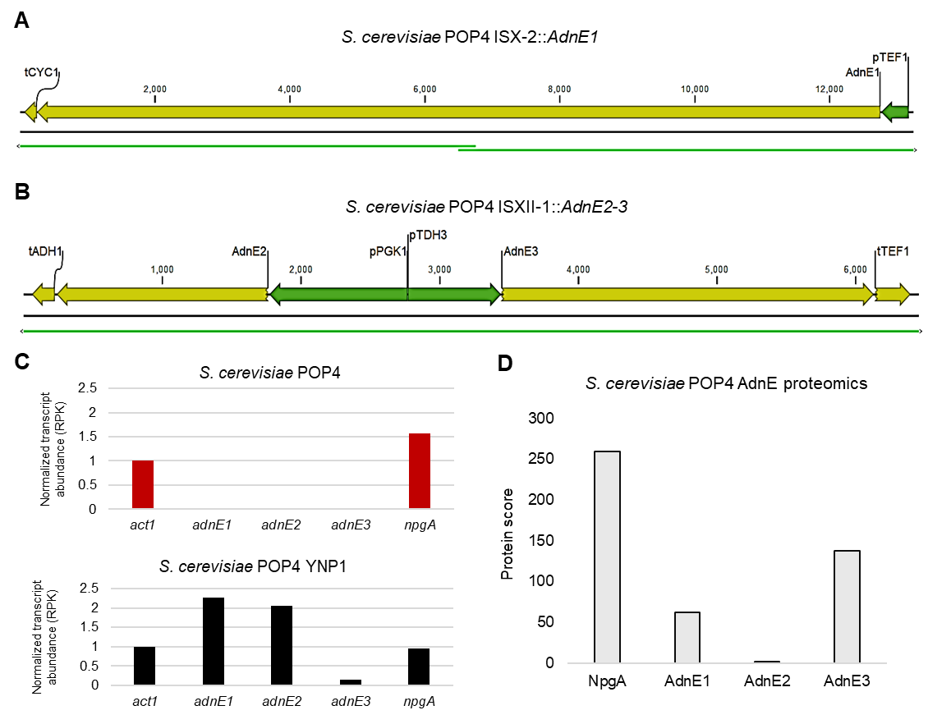
Supplementary figure 26 Omics analyses of adnE genes expression in S. cerevisiae POP4. A) Genome sequencing results confirmed the sequence integrity of adnE1 chromosomal integration in S. cerevisiae POP4; B) Genome sequencing results confirmed the sequence integrity of adnE2-3 chromosomal integration in S. cerevisiae POP4; C) Transcriptomics results confirmed the expression of adnE1-2-3 and npgA transcripts; The RNA-seq reads were mapped to the refence coding sequences, the number of mapped reads divided by the gene length to obtain reads per kilobase values, then these values were normalized to the RPK value of act1 a housekeeping gene. D) Proteomics results confirmed the presence of AdnE1-2-3 and NpgA.

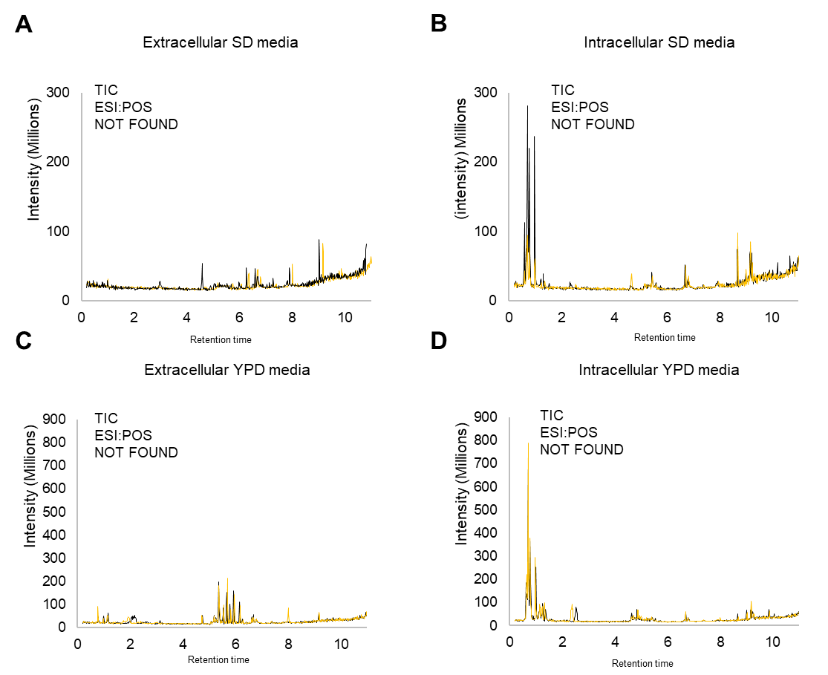

Supplementary figure 27. Plasmid-based expression of adnE1 in S. cerevisiae POP4. A) Total ion chromatogram of extracellular phase in synthetic defined media (-ura) (genomic integration of adnE1-2-3, and adnE1 in a 2µ plasmid); B) Total ion chromatogram obtained from LC-MS analysis of the intracellular extract after cultivation in synthetic dropout media (-ura) (genomic integration of adnE1-2-3, and adnE1 in a 2µ plasmid); C) Total ion chromatogram obtained from LC-MS analysis of the extracellular phase after cultivation in YPD (genomic integration of adnE1-2-3); D) Total ion chromatogram obtained from LC-MS analysis of the intracellular phase in YPD (genomic integration of adnE1-2-3).

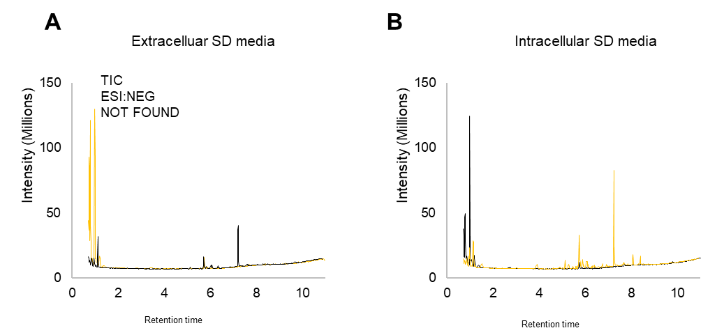
Supplementary figure 28. Plasmid-based expression of adnE1 in S. cerevisiae BJ-5464-NpgA. A) Total ion chromatogram obtained from LC-MS analysis of extracellular phase after cultivation in synthetic dropout media (-ura); B) Total ion chromatogram obtained from the LC-MS analysis of the intracellular phase after cultivation in dropout media (-ura).

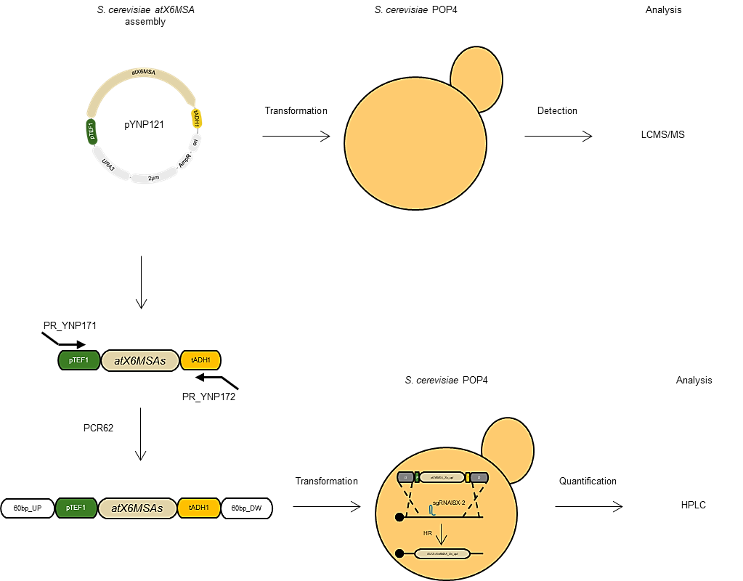
Supplementary figure 29. Assembly and heterologous production of 6-MSA in S. cerevisiae POP4. A) For 6-MSA detection, a S. cerevisiae codon optimized version of atX6MSA was expressed using a 2µ plasmid (pYNP121). B) for 6-MSA quantification, an atX6MSA was amplified from pYNP121 using a primer pair containing 60bp homologous sequences to S. cerevisiae ISX-2 and integrated into S. cerevisiae genome using a Cas-sgRNA plasmid targeting ISX-2 and integrated by homologous recombination. Image created with BioRender.com

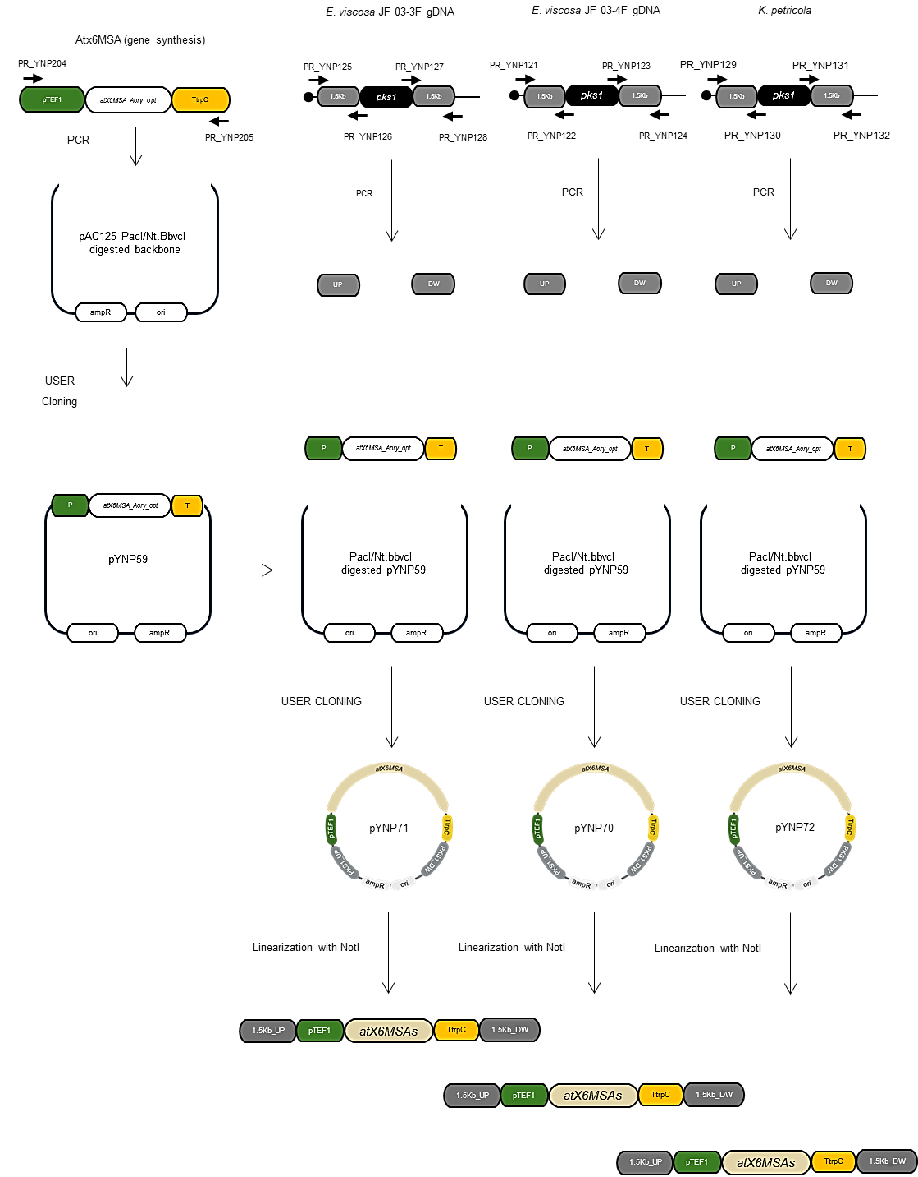
Supplementary figure 30. Assembly and heterologous production of 6-MSA in black yeasts. An A. oryzae codon optimized version of atx6MSA was cloned, resulting in pYNP59 expressing atX6MSA under the control of A. nidulans TEF1 promoter and trpC terminator. pYNP59 was prepared for another round of cloning and the upstream and downstream DNA sequences from pks1 genes were cloned, resulting in plasmid pYNP70, pYNP71, pYNP72. Plasmids were linearized with NotI and linearized fragments were used during transformations. Image created with BioRender.com
Supplementary table 1. PKS abundance per class across the fungal kingdom. The PKS counts were done using the data available in supplementary file 1 containing the information regarding the genomes, PKS repertoire, and domain organization per PKS used to calculate the values in this table.
Class | PKS | Genomes | Average PKS per genome
Dothidiomycetes | 2885 | 238 | 12.12185
Eurotiomycetes | 5386 | 253 | 21.28854
Lecanoromycetes | 656 | 30 | 21.86667
Leotiomycetes | 874 | 60 | 14.56667
Orbiliomycetes | 159 | 32 | 4.96875
Pezizomycetes | 27 | 16 | 1.6875
Sordariomycetes | 4485 | 227 | 19.75771
Saccharomycetes | 5 | 660 | 0.007576
Schizosaccharomycetes | 0 | 11 | 0
Ustilaginomycetes | 68 | 59 | 1.152542
Microbotryomycetes | 0 | 49 | 0
Agaricomycetes | 309 | 139 | 2.223022
Tremellomycetes | 0 | 157 | 0
Mucoromycetes | 0 | 26 | 0
Chytridiomycetes | 1 | 8 | 0.125

Supplementary table 2. Annotated biosynthetic repertoire of S. cerevisiae S288C
Region | Type | From | To | Known or predicted product | Comment
Region 2.1 | NRPS-like | 449,748 | 493,926 | Alpha aminoadipate reductase
Region 2.2 | betalactone | 648,707 | 678,351 | none
Region 8.1 | terpene | 474,845 | 496,179 | none

Supplementary table 3. Annotated biosynthetic repertoire of A. oryzae RIB40
Region | Type | From | To | Known or predicted product | Comment
Region 1.1 | NRPS-like | 73,520 | 117,330 | none
Region 1.2 | T1PKS | 124,128 | 172,243 | none
Region 1.3 | T1PKS | 181,612 | 230,673 | none
Region 1.4 | T1PKS | 331,024 | 379,315 | none
Region 1.5 | T3PKS | 2,263,763 | 2,305,294 | none
Region 1.6 | betalactone | 3,156,943 | 3,192,763 | none
Region 1.7 | indole | 3,555,717 | 3,577,076 | none
Region 1.8 | NRPS | 3,744,319 | 3,792,098 | none
Region 1.9 | T1PKS,NRPS-like | 3,830,161 | 3,908,629 | asparasone A
Region 1.10 | T1PKS | 4,255,163 | 4,307,775 | none
Region 1.11 | NRPS-like | 4,585,612 | 4,636,376 | choline
Region 1.12 | fungal-RiPP-like | 5,655,521 | 5,716,610 | none
Region 2.1 | NRPS,NRPS-like | 1 | 45,587 | imizoquin A-D/TMC-2A-2B
Region 2.2 | NRPS | 72,485 | 117,267 | aspirochlorine
Region 2.3 | terpene,NRPS,T1PKS | 611,200 | 757,136 | leporin B
Region 2.4 | T1PKS | 981,844 | 1,029,715 | none
Region 2.5 | T1PKS,NRPS-like | 1,274,209 | 1,366,811 | none
Region 2.6 | fungal-RiPP-like | 1,593,683 | 1,655,400 | none
Region 2.7 | NRPS-like | 4,634,855 | 4,677,890 | none
Region 2.8 | NRPS | 5,056,199 | 5,100,650 | none
Region 2.9 | NRPS-like | 6,202,300 | 6,245,365 | aspergillic acid
Region 3.1 | fungal-RiPP-like | 1 | 99,339 | none
Region 3.2 | terpene | 177,444 | 198,579 | none
Region 3.3 | NRPS-like | 198,910 | 242,235 | none
Region 3.4 | NI-siderophore | 737,036 | 768,807 | none
Region 3.5 | T1PKS | 1,108,364 | 1,153,810 | aflavarin
Region 3.6 | NRPS | 1,366,059 | 1,420,399 | Ferricrocin-like
Region 3.7 | T1PKS | 2,271,904 | 2,318,926 | none
Region 3.8 | NRPS | 3,469,600 | 3,513,616 | astellolide A
Region 3.9 | NRPS,terpene | 4,018,632 | 4,061,847 | flavunoidine
Region 3.10 | fungal-RiPP-like | 4,214,296 | 4,276,503 | none
Region 3.11 | T1PKS | 4,676,911 | 4,726,797 | none
Region 3.12 | T1PKS,indole | 5,072,130 | 5,123,684 | Aflatoxin (inactive) | Inactive
Region 4.1 | NRPS-like | 1,301,389 | 1,344,742 | none
Region 4.2 | terpene | 1,445,541 | 1,466,775 | none
Region 4.3 | terpene | 2,867,141 | 2,889,545 | none
Region 4.4 | T1PKS | 3,017,795 | 3,064,445 | YWA1
Region 4.5 | NRPS | 3,244,838 | 3,294,071 | (-)-ditryptophenaline
Region 4.6 | NRPS | 3,586,918 | 3,643,241 | none
Region 4.7 | indole | 3,660,508 | 3,681,848 | none
Region 4.8 | fungal-RiPP-like | 3,690,917 | 3,751,871 | none
Region 4.9 | T1PKS | 4,088,475 | 4,135,764 | 2,4'-dihydroxy-3'-methoxypropiophenone
Region 4.10 | terpene | 4,166,314 | 4,190,918 | none
Region 5.1 | fungal-RiPP-like | 65,571 | 132,685 | none
Region 5.2 | T1PKS | 163,924 | 227,433 | none
Region 5.3 | terpene | 279,032 | 300,671 | none
Region 5.4 | indole | 764,849 | 786,289 | none
Region 5.5 | T3PKS | 835,662 | 879,901 | none
Region 5.6 | T1PKS | 928,435 | 974,509 | dichlorodiaporthin
Region 5.7 | T3PKS | 2,565,021 | 2,606,344 | none
Region 5.8 | NRPS,indole | 2,722,501 | 2,768,479 | none
Region 5.9 | terpene | 2,818,017 | 2,840,970 | none
Region 5.10 | fungal-RiPP | 4,089,079 | 4,129,971 | ustiloxin B
Region 5.11 | terpene | 4,431,365 | 4,454,401 | none
Region 5.12 | T1PKS | 4,507,251 | 4,533,889 | pyranoviolin A
Region 6.1 | indole | 462,192 | 483,509 | none
Region 6.2 | fungal-RiPP-like | 485,056 | 546,088 | none
Region 6.3 | NRPS | 858,835 | 910,798 | none
Region 6.4 | NRPS-like | 1,195,158 | 1,238,286 | actinopolymorphol
Region 6.5 | terpene,T1PKS | 1,320,623 | 1,387,169 | none
Region 6.6 | isocyanide,terpene | 1,403,884 | 1,446,006 | none
Region 6.7 | NRPS-like,NRPS | 2,146,226 | 2,213,034 | beta-lactam
Region 6.8 | T3PKS | 2,340,986 | 2,384,039 | none
Region 6.9 | NRPS | 2,612,286 | 2,668,300 | nidulanin A
Region 6.10 | T1PKS | 3,082,284 | 3,130,623 | none
Region 6.11 | NRPS-like | 3,274,048 | 3,316,510 | none
Region 6.12 | terpene,T1PKS | 3,406,480 | 3,475,492 | none
Region 7.1 | T1PKS | 13,990 | 61,492 | none
Region 7.2 | NRPS | 101,832 | 162,723 | none
Region 7.3 | terpene | 282,746 | 303,902 | none
Region 7.4 | fungal-RiPP-like | 699,003 | 803,474 | asperipin 2a
Region 7.5 | NRPS-like | 809,519 | 852,899 | none
Region 7.6 | terpene | 1,033,957 | 1,055,373 | heptelidic acid
Region 7.7 | indole | 1,879,408 | 1,900,782 | none
Region 7.8 | T1PKS | 2,759,105 | 2,804,451 | none
Region 8.1 | NRPS | 321,563 | 382,616 | none
Region 8.2 | NRPS | 447,398 | 493,228 | none
Region 8.3 | NRPS,T1PKS | 669,369 | 725,911 | none
Region 8.4 | NRPS | 810,726 | 859,335 | none
Region 8.5 | NRPS-like | 2,034,165 | 2,077,266 | none
Region 8.6 | NRPS-like | 2,223,650 | 2,266,963 | none
Region 8.7 | T1PKS | 2,267,047 | 2,323,362 | none
Region 8.8 | NRPS-like | 2,406,469 | 2,449,772 | none
Region 8.9 | terpene | 2,850,398 | 2,872,007 | none
Region 8.10 | T1PKS | 3,081,938 | 3,129,701 | none
Region 8.11 | T1PKS | 3,256,011 | 3,302,476 | 8-methyldiaporthin

Supplementary table 4. Annotated biosynthetic repertoire of A. niger ATCC1015
Region | Type | From | To | Known or predicted product | Comment
Region 3.1 | RiPP-like | 13,903 | 24,593 | none
Region 4.1 | NRPS | 497,116 | 556,436 | nidulanin A
Region 4.2 | NRPS,T1PKS | 881,716 | 933,859 | terrestric acid
Region 4.3 | NRPS-like | 1,145,593 | 1,191,030 | none
Region 4.4 | terpene | 1,276,204 | 1,298,225 | none
Region 4.5 | terpene | 1,453,412 | 1,474,647 | none
Region 4.6 | NRPS | 2,738,580 | 2,792,907 | none
Region 4.7 | fungal-RiPP-like | 2,822,651 | 2,892,062 | none
Region 4.8 | T3PKS | 2,958,617 | 2,999,847 | none
Region 4.9 | terpene | 3,090,546 | 3,112,870 | none
Region 4.10 | fungal-RiPP-like | 3,129,195 | 3,190,285 | none
Region 5.1 | NRPS,T1PKS | 89,313 | 141,272 | pyranoviolin A
Region 5.2 | fungal-RiPP-like | 163,994 | 224,973 | none
Region 5.3 | T1PKS | 557,376 | 605,393 | burnettiene A/preburnettiene B/preburnettiene A
Region 6.1 | NRPS | 36,477 | 88,338 | none
Region 6.2 | NRPS,T1PKS | 101,073 | 152,922 | pyranonigrin E
Region 6.3 | terpene | 658,373 | 679,494 | none
Region 6.4 | T1PKS | 935,825 | 985,142 | none
Region 6.5 | T1PKS | 997,475 | 1,050,266 | none
Region 6.6 | NRPS-like,T1PKS | 1,102,965 | 1,157,728 | none
Region 6.7 | NRPS-like,T1PKS | 1,398,556 | 1,469,970 | none
Region 6.8 | terpene | 1,589,849 | 1,611,344 | none
Region 6.9 | T1PKS,NRPS | 1,615,231 | 1,667,250 | none
Region 6.10 | fungal-RiPP-like,T1PKS | 1,732,845 | 1,834,298 | TAN-1612
Region 6.11 | T1PKS | 2,370,151 | 2,417,642 | none
Region 7.1 | T1PKS | 1 | 36,684 | aflavarin
Region 7.2 | T1PKS | 106,484 | 154,976 | none
Region 9.1 | NRPS-like | 272,999 | 316,052 | none
Region 9.2 | T1PKS,NRPS-like | 1,090,748 | 1,147,657 | none
Region 9.3 | NRPS-like | 1,332,541 | 1,377,026 | none
Region 9.4 | NI-siderophore | 1,378,528 | 1,408,671 | none
Region 9.5 | NRPS | 1,560,588 | 1,607,665 | none
Region 10.1 | NRPS | 1 | 40,418 | none
Region 10.2 | T1PKS | 44,093 | 94,370 | none
Region 10.3 | terpene,NRPS | 161,597 | 208,662 | none
Region 10.4 | terpene | 212,481 | 235,561 | none
Region 10.5 | T1PKS | 385,531 | 431,995 | none
Region 10.6 | NRPS | 722,303 | 768,653 | none
Region 10.7 | terpene | 1,073,785 | 1,095,400 | none
Region 10.8 | T1PKS,fungal-RiPP-like | 1,130,613 | 1,248,465 | duclauxin
Region 10.9 | NRPS-like | 1,255,361 | 1,298,378 | none
Region 10.10 | NRPS | 1,329,221 | 1,375,775 | none
Region 10.11 | T1PKS | 1,414,457 | 1,469,935 | none
Region 11.1 | NRPS | 1 | 52,416 | none
Region 11.2 | fungal-RiPP-like | 244,016 | 304,854 | none
Region 12.1 | NRPS-like | 111,725 | 154,820 | none
Region 13.1 | T1PKS | 13,780 | 59,143 | yanuthone D
Region 13.2 | terpene | 408,658 | 429,812 | none
Region 15.1 | NRPS-like | 94,288 | 138,118 | none
Region 15.2 | T1PKS | 139,401 | 187,969 | none
Region 15.3 | NRPS-like | 225,667 | 268,986 | none
Region 15.4 | NRPS | 1,262,721 | 1,308,430 | none
Region 15.5 | T1PKS,NRPS | 2,089,099 | 2,141,198 | none
Region 15.6 | T1PKS | 2,421,821 | 2,469,643 | none
Region 15.7 | NRPS-like | 2,604,456 | 2,647,242 | none
Region 15.8 | terpene | 2,832,140 | 2,854,703 | none
Region 16.1 | NRPS,T1PKS | 1 | 38,652 | none
Region 16.2 | fungal-RiPP-like,T1PKS | 184,634 | 288,555 | none
Region 16.3 | indole | 544,714 | 566,073 | none
Region 17.1 | T1PKS | 566,439 | 614,743 | none
Region 17.2 | T1PKS | 979,639 | 1,027,813 | none
Region 17.3 | T1PKS | 1,203,469 | 1,251,016 | none
Region 17.4 | NRPS | 1,783,005 | 1,840,536 | none
Region 18.1 | NRPS-like,fungal-RiPP-like | 44,548 | 124,649 | none
Region 18.2 | NRPS-like | 243,741 | 284,620 | none
Region 19.1 | T1PKS | 1,045,756 | 1,092,569 | none
Region 19.2 | NRPS | 1,093,624 | 1,145,686 | none
Region 20.1 | NI-siderophore,fungal-RiPP-like | 147,623 | 211,342 | none
Region 20.2 | NRPS | 237,152 | 293,644 | none
Region 20.3 | NRPS,T1PKS | 465,139 | 573,613 | none
Region 20.4 | T1PKS | 655,187 | 702,955 | none
Region 20.5 | terpene,fungal-RiPP-like | 718,650 | 791,630 | none
Region 21.1 | terpene | 425,655 | 447,466 | none
Region 21.2 | T1PKS | 593,306 | 643,437 | none
Region 21.3 | isocyanide | 681,483 | 723,723 | none
Region 21.4 | T1PKS | 1,753,171 | 1,812,221 | fumonisin-like
Region 21.5 | fungal-RiPP-like | 1,990,714 | 2,056,022 | none
Region 21.6 | NRPS-like | 2,888,567 | 2,940,372 | none
Region 21.7 | betalactone | 3,265,572 | 3,294,682 | none
Region 21.8 | NRPS-like | 3,680,736 | 3,724,529 | none
Region 22.1 | indole | 460,098 | 481,548 | none
Region 22.2 | T1PKS,NRPS-like | 584,885 | 640,047 | none
Region 22.3 | NRPS,T1PKS | 682,321 | 752,972 | none
Region 23.1 | T1PKS,NRPS | 470,512 | 521,905 | none
Region 23.2 | terpene | 527,440 | 548,657 | none
Region 23.3 | T1PKS,NRPS-like | 1,157,902 | 1,206,477 | pyrophen/campyrone B
Region 24.1 | NRPS-like,NRPS | 103,119 | 168,526 | none
Region 24.2 | T1PKS | 286,503 | 334,715 | none
Region 24.3 | NRPS,T1PKS | 375,065 | 482,946 | azanigerone s
Region 24.4 | terpene | 587,333 | 608,289 | none
Region 24.5 | NRPS-like | 1,155,541 | 1,201,510 | kojic acid
Region 24.6 | T1PKS | 1,223,371 | 1,271,548 | none
Region 24.7 | T1PKS | 1,321,446 | 1,368,125 | YWA1
Region 24.8 | terpene | 1,415,601 | 1,436,356 | none
Region 24.9 | terpene | 1,515,308 | 1,537,624 | none

Supplementary table 5. Annotated biosynthetic repertoire of A. nidulans IBT29539
Region | Type | From | To | Known or predicted product
Region 1.1 | T1PKS,NRPS-like | 119,085 | 178,463 | none
Region 1.2 | T1PKS | 186,271 | 234,310 | none
Region 1.3 | NRPS | 776,758 | 823,124 | none
Region 1.4 | T1PKS | 1,522,669 | 1,568,214 | asperthecin
Region 1.5 | indole,T1PKS | 3,092,076 | 3,155,930 | none
Region 2.1 | NRPS | 96,874 | 158,684 | aspercryptins
Region 2.2 | T1PKS | 186,866 | 233,367 | F9775A/F9775B/orsellinic acid
Region 2.3 | NRPS-like | 743,960 | 787,193 | none
Region 2.4 | T1PKS | 1,116,199 | 1,162,873 | none
Region 2.5 | terpene | 1,257,070 | 1,279,462 | none
Region 2.6 | terpene | 1,292,718 | 1,315,061 | none
Region 2.7 | NRPS-like | 2,595,331 | 2,638,584 | none
Region 2.8 | T1PKS | 3,525,341 | 3,581,457 | none
Region 2.9 | NRPS | 3,904,481 | 3,956,952 | fellutamide B
Region 3.1 | NRPS-like | 835,230 | 878,599 | none
Region 3.2 | NRPS | 1,411,062 | 1,456,237 | N-Acetyltryptophan
Region 3.3 | fungal-RiPP-like | 3,245,715 | 3,306,361 | none
Region 4.1 | fungal-RiPP-like | 456,860 | 517,759 | none
Region 4.2 | T1PKS | 1,055,894 | 1,145,772 | none
Region 4.3 | T1PKS | 2,706,898 | 2,796,511 | none
Region 5.1 | fungal-RiPP-like,T1PKS | 251,483 | 332,132 | paraherquonin
Region 5.2 | NRPS,T1PKS | 372,716 | 424,651 | aspyridone A/aspyridone B
Region 5.3 | indole | 622,992 | 644,367 | none
Region 5.4 | NRPS,NRPS-like,indole | 679,561 | 755,025 | terrequinone A
Region 5.5 | NRPS-like | 1,943,029 | 1,987,466 | none
Region 5.6 | terpene | 2,779,471 | 2,800,103 | none
Region 5.7 | NRPS-like | 2,882,578 | 2,926,390 | none
Region 5.8 | betalactone | 3,035,403 | 3,059,406 | none
Region 6.1 | indole,NRPS,T1PKS | 8,452 | 93,676 | none
Region 6.2 | terpene | 148,531 | 169,843 | none
Region 6.3 | betalactone | 341,306 | 370,977 | none
Region 6.4 | NRPS-like,T1PKS | 770,461 | 854,543 | microperfuranone
Region 6.5 | terpene | 857,965 | 879,531 | none
Region 6.6 | terpene | 1,192,659 | 1,213,838 | none
Region 6.7 | T1PKS | 1,321,776 | 1,368,556 | aspernidine A
Region 6.8 | NRPS-like | 2,309,165 | 2,352,581 | none
Region 6.9 | NRPS | 3,289,871 | 3,341,183 | betalactam
Region 7.1 | T1PKS | 132,386 | 180,547 | none
Region 7.2 | T1PKS | 460,420 | 508,155 | none
Region 7.3 | NRPS-like | 1,522,767 | 1,566,533 | none
Region 7.4 | T1PKS | 1,796,436 | 1,844,294 | aspernidgulene A1/aspernidgulene A2/aspernidgulene B1
Region 7.5 | T1PKS | 2,565,308 | 2,623,145 | none
Region 7.6 | NRPS-like | 2,659,148 | 2,702,326 | none
Region 7.7 | indole | 3,560,138 | 3,581,539 | none
Region 7.8 | NRPS-like | 3,735,929 | 3,779,204 | none
Region 7.9 | NRPS,T1PKS | 4,210,453 | 4,282,984 | emericellamide A/emericellamide B
Region 7.10 | terpene | 4,357,303 | 4,378,844 | none
Region 7.11 | isocyanide | 4,426,984 | 4,469,144 | none
Region 8.1 | NRPS | 18,230 | 69,458 | none
Region 8.2 | NRPS | 999,461 | 1,058,626 | nidulanin A
Region 8.3 | T1PKS | 1,648,237 | 1,709,104 | asperfuranone
Region 8.4 | betalactone | 2,236,202 | 2,266,635 | none
Region 8.5 | terpene | 2,815,091 | 2,836,281 | none
Region 8.6 | NRPS | 2,924,113 | 2,978,540 | none
Region 8.7 | T1PKS | 3,204,692 | 3,252,661 | none
Region 8.8 | T1PKS | 4,367,684 | 4,413,245 | none
Region 8.9 | terpene | 4,703,260 | 4,724,512 | none
Region 8.10 | NRPS | 4,773,417 | 4,831,610 | none

Supplementary table 6. Annotated biosynthetic repertoire of E. viscosa JF 03-3F
Region | Type | From | To | Known or predicted product
Region 1.1 | terpene | 1,150,812 | 1,172,827 | Carotenoids (phs1 locus)
Region 1.2 | NRPS-like | 4,162,606 | 4,206,445 | none
Region 1.3 | betalactone | 5,242,023 | 5,273,622 | none
Region 1.4 | NRPS-like | 5,303,394 | 5,357,519 | none
Region 2.1 | T3PKS | 1,181,000 | 1,222,332 | none
Region 2.2 | NRP-metallophore,NRPS | 1,719,259 | 1,778,392 | none
Region 2.3 | T1PKS | 1,845,641 | 1,892,849 | none
Region 2.4 | NRPS-like | 3,581,318 | 3,627,007 | none
Region 3.1 | NRPS-like | 641,282 | 686,269 | none
Region 3.2 | NRPS | 2,314,302 | 2,372,952 | none
Region 4.1 | terpene | 304,162 | 325,397 | none
Region 5.1 | NRPS | 673,682 | 718,086 | none
Region 6.1 | phosphonate-like | 437,840 | 478,727 | none
Region 9.1 | T1PKS | 208,054 | 254,751 | Melanin (pks1 locus)
Region 9.2 | NRPS-like | 663,059 | 705,967 | none
Region 9.3 | terpene | 726,043 | 747,206 | none
Region 9.4 | terpene | 801,428 | 823,705 | none
Region 10.1 | NRPS-like | 173,381 | 216,702 | none
Region 10.2 | terpene | 811,071 | 832,701 | none
Region 13.1 | NRPS | 183,669 | 230,073 | none
Region 19.1 | NRPS-like | 4,218 | 86,328 | none
Region 19.2 | T1PKS | 116,458 | 164,024 | none

Supplementary table 7. Annotated biosynthetic repertoire of E. viscosa JF 03-4F
Region | Type | From | To | Known or predicted product
Region 1.1 | T3PKS | 1,217,848 | 1,259,180 | none
Region 1.2 | NRP-metallophore,NRPS | 1,778,533 | 1,835,633 | none
Region 1.3 | T1PKS | 1,903,060 | 1,950,268 | none
Region 1.4 | NRPS-like | 3,627,792 | 3,673,699 | none
Region 2.1 | NRPS-like | 57,358 | 111,483 | none
Region 2.2 | betalactone | 141,241 | 172,840 | none
Region 2.3 | NRPS-like | 1,212,877 | 1,256,716 | none
Region 3.1 | NRPS | 442,084 | 486,488 | none
Region 3.2 | terpene | 1,787,332 | 1,809,609 | none
Region 3.3 | terpene | 1,857,261 | 1,878,424 | none
Region 3.4 | NRPS-like | 1,910,638 | 1,953,540 | none
Region 3.5 | T1PKS | 2,324,092 | 2,370,789 | Melanin (pks1 locus)
Region 4.1 | terpene | 2,084,026 | 2,105,430 | None
Region 4.2 | NRPS-like | 2,692,748 | 2,736,090 | None
Region 5.1 | NRPS-like | 885,752 | 930,739 | None
Region 5.2 | NRPS | 2,551,955 | 2,610,605 | None
Region 5.3 | T1PKS | 2,738,319 | 2,785,814 | None
Region 5.4 | NRPS-like | 2,811,597 | 2,892,770 | None
Region 7.1 | phosphonate-like | 939,617 | 980,504 | None
Region 8.1 | terpene | 759,991 | 781,226 | None
Region 9.1 | terpene | 700,845 | 722,860 | Carotenoids (phs1 locus)
Region 14.1 | NRPS | 479,648 | 526,001 | none

Supplementary table 8. Annotated biosynthetic repertoire of K. petricola CBS123872
Region | Type | From | To | Known or predicted product
Region 2.1 | terpene | 524,006 | 541,770 | none
Region 5.1 | T3PKS | 208,718 | 249,996 | none
Region 6.1 | T1PKS | 115,175 | 160,702 | Melanin (pks1 locus)
Region 9.1 | terpene | 130,363 | 151,846 | none
Region 19.1 | NRPS | 116,133 | 170,824 | none
Region 36.1 | NRPS | 69,558 | 113,346 | none
Region 42.1 | NRPS-like | 114,288 | 158,517 | none
Region 45.1 | NRPS-like | 6,475 | 49,800 | none
Region 55.1 | fungal-RiPP-like | 1 | 37,979 | none
Region 65.1 | terpene | 127,276 | 139,897 | none
Region 96.1 | NRPS-like | 25,407 | 68,553 | none
Region 97.1 | NRPS-like | 12,564 | 56,088 | none
Region 112.1 | terpene | 51,811 | 73,816 | Carotenoids (phs1 locus)
Region 123.1 | NRPS-like | 20,362 | 64,195 | none

Supplementary table 9. Genome sizes of S. cerevisiae, A. oryzae, A. niger, A. nidulans, E. viscosa JF 03-3F, E. viscosa JF 03-4F
Species | Strain ID | Genome size (Mb) | Reference
A. nidulans | IBT29539 | 29.8 | 2,3
A. niger | ATCC1015 | 34.85 | 1,4
A. oryzae | RIB40 | 37.9 | 5,6
E. viscosa | JF 03-3F/ CBS148801 | 28.3 | 7
E. viscosa | JF 03-4F/  CBS148802 | 28.2 | 7
K. petricola | CBS123872 | 27.8 | 8
S. cerevisiae | S288C | 12.1 | 9

Supplementary table 10. Strain list
sYNPID | NAME | GENOTYPE | REFERENCE
sYNP19185 | A. nidulans NID1 | argB2, pyrG89, veA1, nkuAΔ | 2
sYNP19186 | A. niger NIG96 | pyrG1, kusAΔ | 1
sYNP19187 | A. oryzae ORY4 | pyrGΔ, ku70Δ | 5
 | S. cerevisiae CEN.PK113-5D | MATa ura3-52 TRP1 LEU2 HIS3 | 10
 | S. cerevisiae IMX581(Y40593) | MATa ura3-52 can1Δ::cas9-natNT2 TRP1 LEU2 HIS3 | 11
sYNP19188 | S. cerevisiae NPE9 | MATa, ura3-52, can1Δ::cas9-natNT2, TRP1, LEU2, HIS3, GAL80::pTEF1-npgA | This work
sYNP19189 | S. cerevisiae POP4 | MATa ura3-52 can1Δ::cas9-natNT2 TRP1 LEU2 HIS3, GAL80::pTEF1-npgA, XI-1::pTPI1-eutE_pGND1-metK1_pCIT2-gapN, tACC1::gRNA | This work
sYNP19190 | S. cerevisiae BJ5464-NpgA | MATa ura3-52 trp1 leu2- Δ1 his3- Δ200 pep4::HIS3 prb1- Δ 1.6R can1 GAL | 12,13
sYNP12568 | E. viscosa J3-03-3F | WT | 7
sYNP12569 | E. viscosa J3-03-4F | WT | 7
sYNP12566 | K. petricola CBS123872 | WT | 8
sYNP14083 | E. viscosa J3-03-3F ku70Δ | ku70Δ27 | This work
sYNP14084 | E. viscosa J3-03-4F ku70Δ | ku70Δ27-28 | This work
sYNP14085 | K. petricola CBS123872 Δku70 | Δku70 | This work
sYNP19191 | E. viscosa J3-03-3F Δpks1 | ku70Δ27, Δpks1 | This work
sYNP19192 | E. viscosa J3-03-4F Δpks1 | ku70Δ27-28, Δpks1 | This work
sYNP19193 | K. petricola CBS123872 Δpks1 | Δku70, Δpks1 | This work
sYNP19194 | E. viscosa J3-03-3F Δpks1, Δphs1 | ku70Δ27, Δpks1, Δphs1 | This work
sYNP19195 | E. viscosa J3-03-4F Δpks1, Δphs1 | ku70Δ27-28, Δpks1, Δphs1 | This work
sYNP19196 | K. petricola CBS123872 Δpks1, Δphs1 | Δku70, Δpks1, Δphs1 | This work
sYNP19197 | S. cerevisiae NPE9_6MSA_REP1 | MATa, ura3-52, can1Δ::cas9-natNT2, TRP1, LEU2, HIS3, GAL80::pTEF1-npgA, ISX-2:: pTEF1-atX6MSA-tADH1 | This work
sYNP19198 | S. cerevisiae NPE9_6MSA_REP2 | MATa, ura3-52, can1Δ::cas9-natNT2, TRP1, LEU2, HIS3, GAL80::pTEF1-npgA, ISX-2:: pTEF1-atX6MSA-tADH1 | This work
sYNP19199 | S. cerevisiae NPE9_6MSA_REP3 | MATa, ura3-52, can1Δ::cas9-natNT2, TRP1, LEU2, HIS3, GAL80::pTEF1-npgA, ISX-2:: pTEF1-atX6MSA-tADH1 | This work
sYNP14092 | S. cerevisiae POP4_6MSA_REP1 | MATa ura3-52 can1Δ::cas9-natNT2 TRP1 LEU2 HIS3, GAL80::pTEF1-npgA, XI-1::pTPI1-eutE_pGND1-metK1_pCIT2-gapN, tACC1::gRNA, ISX-2:: pTEF1-atX6MSA-tADH1 | This work
sYNP14093 | S. cerevisiae POP4_6MSA_REP2 | MATa ura3-52 can1Δ::cas9-natNT2 TRP1 LEU2 HIS3, GAL80::pTEF1-npgA, XI-1::pTPI1-eutE_pGND1-metK1_pCIT2-gapN, tACC1::gRNA, ISX-2:: pTEF1-atX6MSA-tADH1 | This work
sYNP14094 | S. cerevisiae POP4_6MSA_REP3 | MATa ura3-52 can1Δ::cas9-natNT2 TRP1 LEU2 HIS3, GAL80::pTEF1-npgA, XI-1::pTPI1-eutE_pGND1-metK1_pCIT2-gapN, tACC1::gRNA, ISX-2:: pTEF1-atX6MSA-tADH1 | This work
sYNP19200 | E. viscosa J3-03-3F_6MSA_REP1 | ku70Δ27, Δpks1::pTEF1-atX6MSA-TtrpC | This work
sYNP19201 | E. viscosa J3-03-3F_6MSA_REP2 | ku70Δ27, Δpks1::pTEF1-atX6MSA-TtrpC | This work
sYNP19202 | E. viscosa J3-03-3F_6MSA_REP3 | ku70Δ27, Δpks1::pTEF1-atX6MSA-TtrpC | This work
sYNP19203 | E. viscosa J3-03-4F_6MSA_REP1 | ku70Δ27-28, Δpks1::pTEF1-atX6MSA-TtrpC | This work
sYNP19204 | E. viscosa J3-03-4F_6MSA_REP2 | ku70Δ27-28, Δpks1::pTEF1-atX6MSA-TtrpC | This work
sYNP19205 | E. viscosa J3-03-4F_6MSA_REP3 | ku70Δ27-28, Δpks1::pTEF1-atX6MSA-TtrpC | This work
sYNP19206 | K. petricola_6MSA_REP1 | Δku70, Δpks1::pTEF1-atX6MSA-TtrpC | This work
sYNP19207 | K. petricola_6MSA_REP2 | Δku70, Δpks1::pTEF1-atX6MSA-TtrpC | This work
sYNP19208 | K. petricola_6MSA_REP3 | Δku70, Δpks1::pTEF1-atX6MSA-TtrpC | This work
sYNP19209 | S. cerevisiae POP4_YWA1 | MATa ura3-52 can1Δ::cas9-natNT2 TRP1 LEU2 HIS3, GAL80::pTEF1-npgA, XI-1::pTPI1-eutE_pGND1-metK1_pCIT2-gapN, tACC1::gRNA, [pYNP100-pTEF1-FaYWA1-tCYC1 (URA3)] | This work
sYNP19210 | E. viscosa J3-03-3F_YWA1 | ku70Δ27, Δpks1::pks12 | This work
sYNP19211 | E. viscosa J3-03-4F_YWA1 | ku70Δ27, Δpks1::pks12 | This work
sYNP19212 | K. petricola_YWA1 | Δku70, Δpks1::pks12 | This work
sYNP19213 | S. cerevisiae POP4_Monocillin_REP1 | MATa ura3-52 can1Δ::cas9-natNT2 TRP1 LEU2 HIS3, GAL80::pTEF1-npgA, XI-1::pTPI1-eutE_pGND1-metK1_pCIT2-gapN, tACC1::gRNA, ISX-2:: pTEF1-pchI-tCYC1, ISXII-1:: pTEF1-pchE-tCYC1 | This work
sYNP19214 | S. cerevisiae POP4_Monocillin_REP2 | MATa ura3-52 can1Δ::cas9-natNT2 TRP1 LEU2 HIS3, GAL80::pTEF1-npgA, XI-1::pTPI1-eutE_pGND1-metK1_pCIT2-gapN, tACC1::gRNA, ISX-2:: pTEF1-pchI-tCYC1, ISXII-1:: pTEF1-pchE-tCYC1 | This work
sYNP19215 | S. cerevisiae POP4_Monocillin_REP3 | MATa ura3-52 can1Δ::cas9-natNT2 TRP1 LEU2 HIS3, GAL80::pTEF1-npgA, XI-1::pTPI1-eutE_pGND1-metK1_pCIT2-gapN, tACC1::gRNA, ISX-2:: pTEF1-pchI-tCYC1, ISXII-1:: pTEF1-pchE-tCYC1 | This work
sYNP19216 | S. cerevisiae POP4_Monocillin_REP4 | MATa ura3-52 can1Δ::cas9-natNT2 TRP1 LEU2 HIS3, GAL80::pTEF1-npgA, XI-1::pTPI1-eutE_pGND1-metK1_pCIT2-gapN, tACC1::gRNA, ISX-2:: pTEF1-pchI-tCYC1, ISXII-1:: pTEF1-pchE-tCYC1 | This work
sYNP19217 | E. viscosa J3-03-3F_Monocillin | ku70Δ27, Δpks1::pchI, Δphs1::pTEF1-pchE-TtrpC | This work
sYNP19218 | E. viscosa J3-03-4F_Monocillin | ku70Δ27-28, Δpks1::pchI, Δphs1::pTEF1-pchE-TtrpC | This work
sYNP19219 | K. petricola_Monocillin | Δku70, Δpks1::pchI, Δphs1::pTEF1-pchE-TtrpC | This work
sYNP19220 | S. cerevisiae POP4_YNP1 | MATa ura3-52 can1Δ::cas9-natNT2 TRP1 LEU2 HIS3, GAL80::pTEF1-npgA, XI-1::pTPI1-eutE_pGND1-metK1_pCIT2-gapN, tACC1::gRNA, ISX-2:: pTEF1-adnE1-tCYC1, ISXII-1::tADH1-adnE2-pPGKA-pTDH3-adnE3-tTEF1 | This work
sYNP19221 | E. viscosa J3-03-3F_YNP1 | ku70Δ27, Δpks1::adnE1, Δphs1::tArgB-adnE2-pTEF1-pgpdA-adnE3-TpkiA | This work
sYNP19222 | E. viscosa J3-03-4F_YNP1 | ku70Δ27-28, Δpks1::adnE1, Δphs1::tArgB-adnE2-pTEF1-pgpdA-adnE3-TpkiA | This work
sYNP19223 | K. petricola_YNP1 | Δku70, Δpks1::adnE1, Δphs1::tArgB-adnE2-pTEF1-pgpdA-adnE3-TpkiA | This work
sYNP19224 | E. viscosa J3-03-4F_FIX_ER | ku70Δ27-28, Δpks1::adnE1, Δphs1::TArgB-adnE2-pTEF1-pgpdA-FIXER-TtrpC-pA00583-CYP450-TpkiA | This work
sYNP19225 | E. viscosa J3-03-4F_FIX_CYP450 | ku70Δ27-28, Δpks1::adnE1, Δphs1::TArgB-adnE2-pTEF1-pgpdA-ER-TtrpC-pA00583-FIXCYP450-TpkiA | This work
sYNP19226 | E. viscosa J3-03-4F_FIX_NON | ku70Δ27-28, Δpks1::adnE1, Δphs1::TArgB-adnE2-pTEF1-pgpdA-ER-TtrpC-pA00583-CYP450-TpkiA | This work
sYNP19227 | E. viscosa J3-03-4F_FIX_BOTH | ku70Δ27-28, Δpks1::adnE1, Δphs1::TArgB-adnE2-pTEF1-pgpdA-FIXER-TtrpC-pA00583-FIXCYP450-TpkiA | This work
sYNP19228 | S. cerevisiae POP4_YNP1_pYNP78 | MATa ura3-52 can1Δ::cas9-natNT2 TRP1 LEU2 HIS3, GAL80::pTEF1-npgA, XI-1::pTPI1-eutE_pGND1-metK1_pCIT2-gapN, tACC1::gRNA, ISX-2:: pTEF1-adnE1-tCYC1, ISXII-1::tADH1-adnE2-pPGKA-pTDH3-adnE3-tTEF1, [pYNP78-pTEF1-adnE1-tCYC1 (URA3)] | This work
sYNP19229 | S. cerevisiae BJ5464_pYNP78 | MATa ura3-52 trp1 leu2- Δ1 his3- Δ200 pep4::HIS3 prb1- Δ 1.6R can1 GAL, [pYNP78-pTEF1-adnE1-tCYC1 (URA3)] | This work

Supplementary table 11. Primer list
PR_YNPID | PRIMER NAME | PRIMER SEQUENCE
PR_YNP121 | ELIM_PKS1_UP_FW | GGGTTTAAUAAGAGAGTATCGTCCACCGCTG
PR_YNP122 | ELIM_PKS1_UP_RV | GGACTTAAUATGTTGCTGGGTGATGAGTCG
PR_YNP123 | ELIM_PKS1_DW_FW | GGCATTAAUGATGTAGAGGACGAGCGACCAC
PR_YNP124 | ELIM_PKS1_DW_RV | GGTCTTAAUACTGCCGGATCTTCGACTAGG
PR_YNP125 | EVIS_PKS1_UP_FW | GGGTTTAAUTCTCCGCGTGGTGCCAAC
PR_YNP126 | EVIS_PKS1_UP_RV | GGACTTAAUAACGCATCTCGAATGAGGGTC
PR_YNP127 | EVIS_PKS1_DW_FW | GGCATTAAUTGGTAGGTGAAGTGACAGCGC
PR_YNP128 | EVIS_PKS1_DW_RV | GGTCTTAAUATGGGAGGAGTAACATCACGC
PR_YNP129 | KP_PKS1_UP_FW | GGGTTTAAUTCCTGAACGGTGAATACGCC
PR_YNP130 | KP_PKS1_UP_RV | GGACTTAAUAGTGAAATGTGAATGAGTGTCGAC
PR_YNP131 | KP_PKS1_DW_FW | GGCATTAAUGCAACCACACGAACCTACTCAC
PR_YNP132 | KP_PKS1_DW_RV | GGTCTTAAUCGTAGGTAGCTGCACAGGATAAC
PR_YNP135 | PgpdA_FW | GGGTTTAAUGCGTAAGCTCCCTAATTGGC
PR_YNP136 | Ttrpc_RV | GGTCTTAAUGAGCCAAGAGCGGATTCCTC
PR_YNP171 | Sc_IS_X2_60BP_UP_FW_6MSA | ATATTAAGTAAATTGCCTCCATTTCTTTTTCCTCGGGCAGAGAAACTCGCAGGCAACTTGTAAGAGCTCGCACACACCATAG
PR_YNP172 | Sc_IS_X2_60BP_UP_RV_6MSA | GCGGAGGAATAGTATGATAAATCTTCAGCATAGATGGGTAACGGGATCCCTCTGTGAGGGGCGGTACCAAGCTTACTCGAG
PR_YNP177 | KP_KU70_HH_sgRNA1_FW | AGTAAGCUCGTCCGACGAGTCCGGCTACAAGCGTTTTAGAGCTAGAAATAGCAAGTTAAA
PR_YNP178 | KP_KU70_HH_sgRNA1_RV | AGCTTACUCGTTTCGTCCTCACGGACTCATCAGCGACGACGGTGATGTCTGCTCAAGCG
PR_YNP181 | EX_KU70_HH_sgRNA1_FW | AGTAAGCUCGTCCGTCCGGTTCATCCTTCGATGTTTTAGAGCTAGAAATAGCAAGTTAAA
PR_YNP182 | EX_KU70_HH_sgRNA1_RV | AGCTTACUCGTTTCGTCCTCACGGACTCATCAGCGTCCGCGGTGATGTCTGCTCAAGCG
PR_YNP185 | KP_KU70_1KB_UP_FW | GGGTTTAAUATCGAGCCTGGTGGGTGC
PR_YNP186 | KP_KU70_1KB_UP_RV | ATCTAGAAGCUGGAACCCGTCGGAAG
PR_YNP187 | KP_KU70_1KB_DW_FW | AGCTTCTAGAUACGGTTACATCAATGGCCTTC
PR_YNP188 | KP_KU70_1KB_DW_RV | GGTCTTAAUCTCAGGGCACAGCGTACACC
PR_YNP189 | EXVIS_KU70_1KB_UP_FW | GGGTTTAAUCACTTCCATAATTCGTTCAGCG
PR_YNP190 | EXVIS_KU70_1KB_UP_RV | ATCTAGACGGUAAGGTAAGTTGTCGGCC
PR_YNP191 | EXVIS_KU70_1KB_DW_FW | ACCGTCTAGAUCGATGATGAAGTGCCTGATTGC
PR_YNP192 | EXVIS_KU70_1KB_DW_RV | GGTCTTAAUTAGCGATGGCAGAGTACCTTG
PR_YNP193 | EXLIM_KU70_1KB_UP_FW | GGGTTTAAUTAGCGATGGCAGAGTACCTTG
PR_YNP194 | EXLIM_KU70_1KB_UP_RV | ATCTAGATGAUGATGAAGTGCCTGATTGC
PR_YNP195 | EXLIM_KU70_1KB_DW_FW | ATCATCTAGAUCGGTAGGGTAAGTTGTCGGC
PR_YNP196 | EXLIM_KU70_1KB_DW_RV | GGTCTTAAUCACTTCCATAATTCGTTCAGCG
PR_YNP204 | 6MSA_AORY_OPT_PACI_ASISI_FW | GGGTTTAAUGCTGAGGGTTTAATTAAGTCCTCAGCGAATGCACGCGATCGCAC
PR_YNP205 | 6MSA_AORY_OPT_PACI_RV | GGTCTTAAUGCTGAGGTCTTAATTAATGCCTCAGCAACAAGTGTACCTGTGCATTCTGG
PR_YNP213 | Afum_pU3_FW | GGGTTTAAUGATCACATAGATGCTCGGTTGACA
PR_YNP214 | Afum_tU3_RV | GGTCTTAAUACCCTGAGAAGATAGATGTGAATGTG
PR_YNP216 | EX_PKS1_sgRNA_1_FW | ATCCGCCGATUCACTGAGTTTTAGAGCTAGAAATAGCAAGTTAAAATAAG
PR_YNP217 | EX_PKS1_sgRNA_1_tRNA_RV | AATCGGCGGAUGCGTGCATCATCCGTGAATCGAAC
PR_YNP219 | EX_PHS1_sgRNA_1_tRNA_RV | ATAGTGTAUGAGACGGTGCATCATCCGTGAATCGAAC
PR_YNP222 | KP_PKS1_sgRNA_1_FW | ACGTGTTCGGUGACCAAAGTTTTAGAGCTAGAAATAGCAAGTTAAAATAAG
PR_YNP223 | KP_PKS1_sgRNA_1_tRNA_RV | ACCGAACACGUAGTGCATCATCCGTGAATCGAAC
PR_YNP224 | KP_PHS1_sgRNA_1_FW | ATCCGCCUGGTTTTAGAGCTAGAAATAGCAAGTTAAAATAAG
PR_YNP225 | KP_PHS1_sgRNA_1_tRNA_RV | AGGCGGAUAAGCTGCACCGTGCATCATCCGTGAATCGAAC
PR_YNP244 | EX_PHS1_sgRNA_1_FW | ATACACTAUCCCAGTTTTAGAGCTAGAAATAGCAAGTTAAAATAAG
PR_YNP253 | EVIS_PHS1_UP_FW | GGGTTTAAUCCGTTGTACCAGCCTACAGTCTC
PR_YNP254 | EVIS_PHS1_UP_RV | GGACTTAAUCAGGTCAACAAGGTTGGGAATC
PR_YNP255 | EVIS_PHS1_DW_FW | GGCATTAAUTGCACTTATTGATAGATAGACTACCCT
PR_YNP256 | EVIS_PHS1_DW_RV | GGTCTTAAUGGCAACAGCTCGTTATAGGCG
PR_YNP259 | ELIM_PHS1_UP_FW | GGGTTTAAUGGCAACAGCTCGTTATAGGCG
PR_YNP260 | ELIM_PHS1_UP_RV | GGACTTAAUTGCACTTATTGATAGATAGACTACCCT
PR_YNP261 | ELIM_PHS1_DW_FW | GGCATTAAUCAGGTCAACAAGGTTGGGAATC
PR_YNP262 | ELIM_PHS1_DW_RV | GGTCTTAAUCTAGCTCGCCTTCGGCTC
PR_YNP263 | KP_PHS1_UP_FW | GGGTTTAAUGTATTTGCCACGCTAATCTTCTTG
PR_YNP264 | KP_PHS1_UP_RV | GGACTTAAUGATGTGCAGACGTCTACGCG
PR_YNP265 | KP_PHS1_DW_FW | GGCATTAAUATCTGCGTCTAACGGCTCTCG
PR_YNP266 | KP_PHS1_DW_RV | GGTCTTAAUAGACAATGTCGGCCTTCAGAG
PR_YNP281 | ADNE_TRANSER_FW | ACTACCGCGAUGGCTGCTATACCTCCCACTC
PR_YNP282 | ADNE_TRANSERER_TpkiA_PACI_INT_RV | GGTCTTAAUGCTGAGGTCTTAATTAATGCCTCAGCCCTCTTATTGTGCGTTCTATGTTC
PR_YNP284 | ADNE_YNP16_SYNTHASE_F1_FW | ATGTCTCCAATGAAACCTGAGAAG
PR_YNP285 | ADNE_YNP16_SYNTHASE_F1_RV | CATAGTATCGCCGTCGTCGG
PR_YNP286 | ADNE_YNP16_SYNTHASE_F2_FW | ATAAGCCGCTACTATGGCCCCCTACAAATCCCGACGACGGCGATACTATGGCCCAAAATGGCTCCTGG
PR_YNP289 | ADNE_YNP16_SYNTHASE_F3_RV | CGTCGCTCCAGTGCCTGC
PR_YNP290 | ADNE_YNP16_SYNTHASE_F4_FW | AATTTCCTCGCTGCAAGATCTTGGAGGTTGGTGCAGGCACTGGAGCGACGACCAGCGCGGTTCTGAATG
PR_YNP293 | ADNE_YNP16_SYNTHASE_F5_RV | CTAAGATCCCTTCTCTCCCATATAAGG
PR_YNP294 | SC_pTEF1_ADNE_50bp_RV | GGCTCCGGAATACGACGCAGCACCGCCTTCTCAGGTTTCATTGGAGACATTTGTAATTAAAACTTAGATTAGATTGCTATG
PR_YNP295 | SC_tCYC1_ADNE_50bp_FW | AGAGTGACGCGCAGATGGTTTTTCCTTATATGGGAGAGAAGGGATCTTagATCCGCTCTAACCGAAAAGGAAG
PR_YNP296 | Anid_GAPDH_RV | ATCGCGGTAGUGATGTCTGCTC
PR_YNP297 | Sc_AdnE1_60bp_X-2_RV | GCGGAGGAATAGTATGATAAATCTTCAGCATAGATGGGTAACGGGATCCCTCTGTGAGGGCTTCGAGCGTCCCAAAACC
PR_YNP306 | Anid_pTEF1_rv | AAACATGGUGAAGGTTGTGTTATGTTTTGTG
PR_YNP307 | CORDYCEPS_YNP16_CP450_FW | ACCATGTTUGCCCATCTAGAAATCGC
PR_YNP308 | Anid_tArgB_pac_asisi_int_RV | GGGTTTAAUGCTGAGGGTTTAATTAAGTCCTCAGCGAATGCACGCGATCGCACGCATTCACCTACAGCCATTGCGAAACC
PR_YNP317 | YNP_16_SYNTHETASE_PAC_INT_FW | GGGTTTAAUGCTGAGGGTTTAATTAAGTCCTCAGCATGTCTCCAATGAAACCTGAGAAG
PR_YNP318 | YNP_16_SYNTHETASE_PAC_INT_RV | GGTCTTAAUGCTGAGGTCTTAATTAATGCCTCAGCCTAAGATCCCTTCTCTCCCATATAAG
PR_YNP319 | ELIM_PKS1_1KB_UP_FW | GGGTTTAAUCATTCCCGTATTGTCTTGTATTGAG
PR_YNP320 | ELIM_PKS1_1KB_UP_RV | GGACTTAAUGTTGCTGGGTGATGAGTCGA
PR_YNP321 | ELIM_PKS1_1KB_DW_FW | GGCATTAAUAGGACGAGCGACCACATTTTC
PR_YNP322 | ELIM_PKS1_1KB_DW_RV | GGTCTTAAUACGTCAGTAAGATATGATAGTACCGTTAG
PR_YNP323 | EVIS_PKS1_1KB_UP_FW | GGGTTTAAUCGTGCTCGATTTGTCTTTACATTC
PR_YNP324 | EVIS_PKS1_1KB_UP_RV | GGACTTAAUGTTGCTGGGTGATGAGTCGAC
PR_YNP325 | EVIS_PKS1_1KB_DW_FW | GGCATTAAUAGGACGAGCGACCACATTTTC
PR_YNP326 | EVIS_PKS1_1KB_DW_RV | GGTCTTAAUTACCGTTAGTACACACCTACCCG
PR_YNP327 | KP_PKS1_1KB_UP_FW | GGGTTTAAUCCGGATAAGCTCTGGCAAC
PR_YNP328 | KP_PKS1_1KB_UP_RV | GGACTTAAUAGTGAAATGTGAATGAGTGTCGAC
PR_YNP329 | KP_PKS1_1KB_DW_FW | GGCATTAAUGCAACCACACGAACCTACTCAC
PR_YNP330 | KP_PKS1_1KB_DW_RV | GGTCTTAAUCACCGCCCGAGTATTGAGG
PR_YNP342 | SC_tTEF1_FW | AGTCAGTACUGACAATAAAAAGATTCTTGT
PR_YNP343 | SC_tADH1_RV | ACGCATTCCGUTGGCGAATTTCTTATGATTTATG
PR_YNP344 | SC_TRANSER_CP450_FW | ACAAACAAAAUGGCTGCTATACCTCCCACTC
PR_YNP345 | SC_TRANSER_CP450_RV | AGTACTGACUAGACTTTGCGTCTCTTGACGAG
PR_YNP346 | SC_CP450_FW | ACGGAATGCGUCTACTTGTAGAACGCAATCTTCACTCC
PR_YNP347 | SC_CP450_RV | AATCTGTCAUGTTTGCCCATCTAGAAATCGC
PR_YNP348 | SC_pTDH3_RV | ATTTTGTTTGUTTATGTGTGTTTATTCGAAACTAAG
PR_YNP349 | SC_PGK1_FW | ATGACAGATUTGTTTTATATTTGTTGTAAAAAGTAGATAATTAC
PR_YNP358 | SC_60BP_XII-1_TRANSER_CP450_FW | TTGGCAAATCCCAGATTTGGCTTTGATTTTGGCATCGGTTCGGTTCTTTCAAATATCTTCGAGCGACCTCATGCTATACCTG
PR_YNP359 | SC_60BP_XII-1_TRANSER_CP450_RV | AGAAGTGGCTTGTAAAATTTATTATTACAGTCACTCAGACAGAGCACTAAACTGAACTAGATTAAGGGTTCTCGAGAGCTCG
PR_YNP394 | PCH_MONOCILLIN_SC50TEF1_G1_F1_FW | TTGCTCATTAGAAAGAAAGCATAGCAATCTAATCTAAGTTTTAATTACAAATGCCCTCTGCAACTGCC
PR_YNP395 | PCH_MONOCILLIN_G1_F1_50F2_RV | AACTCCAGAATCTCGAGATTTGGCCGTTGGTGTATGGCCAAGGAGATAAACTGGATGAGCTGATCGTTTGAAG
PR_YNP396 | PCH_MONOCILLIN_G1_F2_FW | TTTATCTCCTTGGCCATACACC
PR_YNP397 | PCH_MONOCILLIN_G1_F2_RV | TCTTCTTTGCAATCTGCACCG
PR_YNP398 | PCH_MONOCILLIN_SC50TEF1_G2_FW | TTGCTCATTAGAAAGAAAGCATAGCAATCTAATCTAAGTTTTAATTACAAATGAAGTCGCATACTTCGGCTG
PR_YNP399 | PCH_MONOCILLIN_SC50CYC1_G2_RV | GGACCTAGACTTCAGGTTGTCTAACTCCTTCCTTTTCGGTTAGAGCGGATTCATCGCCCAAAGTGCTCAA
PR_YNP400 | SC_pTEF1_RV | TTGTAATTAAAACTTAGATTAGATTGCTATG
PR_YNP401 | SC_tCYC1_MONOCILLIN_G1_FW | TCTTGGCGCTATGCCGATGGAGCAGTTTGCGGTGCAGATTGCAAAGAAGATTGTGGGATATTCGTAGATCCGCTCTAACCGAAAAGGAAG
PR_YNP402 | SC_tCYC1_FW | ATCCGCTCTAACCGAAAAGGAAG
PR_YNP433 | EX_pPKS1_RV | AGGACTTAAUGTTGCTGGGTGATGAGTCGAC
PR_YNP434 | EX_tPKS1_FW | AGGCATTAAUAGGACGAGCGACCACATTTTC
PR_YNP435 | EX_lim_phs1_up_rv | AGGACTTAAUTGCACTTATTGATAGATAGACTACCCTTATTG
PR_YNP436 | EX_lim_phs1_dw_fw | AGGCATTAAUCAGGTCAACAAGGTTGGGAATC
PR_YNP437 | EX_vis_phs1_up_rv | AGGACTTAAUCAGGTCAACAAGGTTGGGAATC
PR_YNP438 | EX_vis_phs1_dw_fw | AGGCATTAAUTGCACTTATTGATAGATAGACTACCCTTATTG
PR_YNP439 | KP_pPKS1_RV | AGGACTTAAUAGTGAAATGTGAATGAGTGTCGAC
PR_YNP440 | KP_tPKS1_FW | AGGCATTAAUGCAACCACACGAACCTACTCAC
PR_YNP441 | KP_phs1_up_rv | AGGACTTAAUGATGTGCAGACGTCTACGCG
PR_YNP442 | KP_phs1_dw_fw | AGGCATTAAUATCTGCGTCTAACGGCTCTCG
PR_YNP447 | MONOCILLIN_G1_FW | ATTAAGTCCUCAGCATGCCCTCTGCAACTGCC
PR_YNP448 | MONOCILLIN_G1_RV | ATTAATGCCUCAGCCTACGAATATCCCACAATCTTCTTTG
PR_YNP452 | EX_60BP_PKS1_YWA1_RV | AAAGTTCTACATCCGCTTCTATCAGGTATCTCGTAGCATGAAAATGTGGTCGCTCGTCCTCTAATTGTCCAAGGCCCGAG
PR_YNP456 | KP_60BP_PKS1_YWA1_RV | AGTAGTTGATCCAGACAACACCATGATATGCCAGTCAAGTGAGTAGGTTCGTGTGGTTGCCTAATTGTCCAAGGCCCGAG
PR_YNP465 | Anid_TEF1_MONOCILLIN_FW | ATTAAGTCCUCGAGACAGCAGAATCACCGC
PR_YNP466 | Anid_TEF1_MONOCILLIN_RV | ATGGTGAAGGUTGTGTTATGTTTTGTG
PR_YNP467 | MONOCILLIN_G2_CORRECTED_FW | ACCTTCACCAUGAAGTCGCATACTTCGGCTG
PR_YNP468 | MONOCILLIN_G2_CORRECTED_RV | AAATCATCAUCGCCCAAAGTGCTCA
PR_YNP469 | Anid_TrpC_MONOCILLIN_FW | ATGATGATTUAATAGCTCCATGTCAACAAG
PR_YNP470 | Anid_TrpC_MONOCILLIN_RV | ATTAATGCCUAACAAGTGTACCTGTGCATTCTGG
PR_YNP471 | EX_60BP_PKS1_YWA1_FW | TATTTCTCCCCCTCGTTAAGCAACGCTCGTTGGAAGTTCGTCGACTCATCACCCAGCAACATGGAGGTATTCGTTTTTGGGG
PR_YNP472 | KP_60BP_PKS1_YWA1_FW | TGTTTTTCTGCTCGTTAAGAACCGCACCCGAAGTACGTCGACACTCATTCACATTTCACTATGGAGGTATTCGTTTTTGGGG
PR_YNP480 | SC_60BP_X2_MONOCILLIN_G1_CORRECTED_FW | ATATTAAGTAAATTGCCTCCATTTCTTTTTCCTCGGGCAGAGAAACTCGCAGGCAACTTGTAAGAGCTCGCACACACCATAG
PR_YNP481 | SC_60BP_X2_MONOCILLIN_G1_CORRECTED_RV | GCGGAGGAATAGTATGATAAATCTTCAGCATAGATGGGTAACGGGATCCCTCTGTGAGGGGATCTTCGAGCGTCCCAAAAC
PR_YNP482 | SC_60BP_XII-1_MONOCILLIN_G2_CORRECTED_FW | TTGGCAAATCCCAGATTTGGCTTTGATTTTGGCATCGGTTCGGTTCTTTCAAATATCTTCTAAGAGCTCGCACACACCATAG
PR_YNP483 | SC_60BP_XII-1_MONOCILLIN_G2_CORRECTED_RV | AGAAGTGGCTTGTAAAATTTATTATTACAGTCACTCAGACAGAGCACTAAACTGAACTAGGATCTTCGAGCGTCCCAAAAC
PR_YNP489 | EX_90bp_PKS1_del | TTAAGCAACGCTCGTTGGAAGTTCGTCGACTCATCACCCAGCAACAGGACGAGCGACCACATTTTCATGCTACGAGATACCTGATAGAAG
PR_YNP490 | KP_90bp_PKS1_del | TAAGAACCGCACCCGAAGTACGTCGACACTCATTCACATTTCACTGCAACCACACGAACCTACTCACTTGACTGGCATATCATGGTGTTG
PR_YNP491 | ELIM_90bp_PHS1_del | AACGGGATATCTTGACGGAAGAAGATTCCCAACCTTGTTGACCTGTGCACTTATTGATAGATAGACTACCCTTATTGGTGTTCCTGAAGT
PR_YNP492 | EVIS_90bp_PHS1_del | AACGGGATATCTTGACGGAAAAAGATTCCCAACCTTGTTGACCTGTGCACTTATTGATAGATAGACTACCCTTATTGGTGTTCCTGAAGT
PR_YNP493 | KP_90bp_PHS1_del | TTGATTTCGCGTAGACGTCTGCACATCAACTTGCGCATCGCGATCATCTGCGTCTAACGGCTCTCGACTTCTGCTTGTGTAGCGGGCCTT
PR_YNP507 | FIX-NONFIX_ER_FW | CTCTAGCCATTCAACTACTCAAGG
PR_YNP508 | FIX_CYP_RV | TCGAGATATAGCGCTGCGTAC
PR_YNP509 | NONFIX_CYP_RV | CGCTCTACTTCAATCTCCTTCC

Supplementary table 12. PCR reactions
PCR# | PR_FW | PR_RV | TEMPLATE | PRODUCT SIZE | PRODUCT
44 | PR_YNP121 | PR_YNP122 | E. viscosa JF 03-4F gDNA | 1.6Kb | E. viscosa JF 03-4F_PKS1_1.5KB_UP
45 | PR_YNP123 | PR_YNP124 | E. viscosa JF 03-4F gDNA | 1.6Kb | E. viscosa JF 03-4F_PKS1_1.5KB_DW
46 | PR_YNP125 | PR_YNP126 | E. viscosa JF 03-3F gDNA | 1.6Kb | E. viscosa JF 03-3F_PKS1_1.5KB_UP
47 | PR_YNP127 | PR_YNP128 | E. viscosa JF 03-3F gDNA | 1.55Kb | E. viscosa JF 03-3F_PKS1_1.5KB_DW
48 | PR_YNP129 | PR_YNP130 | K. petricola gDNA | 1.55Kb | K. petricola_PKS1_1.5KB_UP
49 | PR_YNP131 | PR_YNP132 | K. petricola gDNA | 1.55Kb | K. petricola_PKS1_1.5KB_DW
62 | PR_YNP171 | PR_YNP172 | pYNP121 | 6.2Kb | 60bp_6MSA_S. cerevisiae_ISX-2
63 | PR_YNP135 | PR_YNP178 | pFC334 | 0.536Kb | K. petricola_KU70_HH_sgRNA1_FW
64 | PR_YNP177 | PR_YNP136 | pFC334 | 0.4Kb | K. petricola_KU70_HH_sgRNA1_RV
67 | PR_YNP135 | PR_YNP182 | pFC334 | 0.536Kb | E. viscosa_KU70_HH_sgRNA1_FW
68 | PR_YNP181 | PR_YNP136 | pFC334 | 0.4Kb | E. viscosa_KU70_HH_sgRNA1_RV
71 | PR_YNP185 | PR_YNP186 | K. petricola gDNA | 1Kb | K. petricola_KU70_1KB_UP
72 | PR_YNP187 | PR_YNP188 | K. petricola gDNA | 1Kb | K. petricola_KU70_1KB_DW
73 | PR_YNP189 | PR_YNP190 | E. viscosa JF 03-3F gDNA | 1Kb | E. viscosa JF 03-3F_KU70_1KB_UP
74 | PR_YNP191 | PR_YNP192 | E. viscosa JF 03-3F gDNA | 1Kb | E. viscosa JF 03-3F_KU70_1KB_DW
75 | PR_YNP193 | PR_YNP194 | E. viscosa JF 03-4F gDNA | 1Kb | E. viscosa JF 03-4F _KU70_1KB_UP
76 | PR_YNP195 | PR_YNP196 | E. viscosa JF 03-4F gDNA | 1Kb | E. viscosa JF 03-4F _KU70_1KB_UP
77 | PR_YNP204 | PR_YNP205 | pYNP19 | 6.9Kb | atX6MSA_AORY_OPT
81 | PR_YNP213 | PR_YNP217 | pFC902 | 0.568Kb | AFU3P_EX_PKS1_SGRNA
82 | PR_YNP216 | PR_YNP214 | pFC902 | 0.4Kb | E. viscosa_PKS1_SGRNA_FW_AFU3T
83 | PR_YNP216 | PR_YNP219 | pFC902 | 0.171Kb | E. viscosa_PKS1_SGRNA_FW_PHS1_SGRNA_1
84 | PR_YNP244 | PR_YNP214 | pFC902 | 0.4Kb | E. viscosa_PHS1_SGRNA_1_FW_AFU3T
87 | PR_YNP213 | PR_YNP223 | pFC902 | 0.568Kb | AFU3P_KP_PKS1_SGRNA
88 | PR_YNP222 | PR_YNP214 | pFC902 | 0.4Kb | K. petricola_PKS1_SGRNA_FW_AFU3T
89 | PR_YNP222 | PR_YNP225 | pFC902 | 0.171Kb | K. petricola_PKS1_SGRNA_FW_PHS1_SGRNA_1
90 | PR_YNP224 | PR_YNP214 | pFC902 | 0.4Kb | KP_PHS1_SGRNA_1_FW_AFU3T
103 | PR_YNP253 | PR_YNP254 | E. viscosa JF 03-3F gDNA | 1.5Kb | E. viscosa JF 03-3F_PHS1_1.5KB_UP
104 | PR_YNP255 | PR_YNP256 | E. viscosa JF 03-3F gDNA | 1.5Kb | E. viscosa JF 03-3F_PHS1_1.5KB_DW
105 | PR_YNP259 | PR_YNP260 | E. viscosa JF 03-4F gDNA | 1.5Kb | E. viscosa JF 03-4F_PHS1_1.5KB_UP
106 | PR_YNP261 | PR_YNP262 | E. viscosa JF 03-4F gDNA | 1.5Kb | E. viscosa JF 03-4F_PHS1_1.5KB_DW
107 | PR_YNP263 | PR_YNP264 | K. petricola gDNA | 1.5Kb | K. petricola _PHS1_1.5KB_UP
108 | PR_YNP265 | PR_YNP266 | K. petricola gDNA | 1.5Kb | K. petricola _PHS1_1.5KB_DW
109 | PR_YNP281 | PR_YNP282 | pYNP20 | 3.3Kb | C. militaris AdnE3- Anid_tTpkiA
110 | PR_YNP306 | PR_YNP296 | pDIV652 | 3.2Kb | Anid_pTEF1-Anid_pgpdA
114 | PR_YNP286 | PR_YNP289 | C. militaris D1. gDNA | 3.3Kb | C. militaris D1. AdnE1_F2
115 | PR_YNP290 | PR_YNP293 | C. militaris D1. gDNA | 8Kb | C. militaris D1. AdnE1_F3
116 | PR_YNP307 | PR_YNP308 | pYNP21 | 2Kb | C. militaris AdnE2- Anid_tArgB
117 | PR_YNP284 | PR_YNP285 | C. militaris D1. gDNA | 1.3Kb | C. militaris D1. AdnE1_F1
122 | PR_YNP294 | PR_YNP295 | pYNP121 | 6.3Kb | Sc_pTEF1_2um_Sc_tCYC1
129 | PR_YNP317 | PR_YNP318 | pYNP78 | 13Kb | C. militaris D1. AdnE1
130 | PR_YNP319 | PR_YNP320 | E. viscosa JF 03-4F gDNA | 1Kb | E. viscosa JF 03-4F_PKS1_1KB_UP
131 | PR_YNP321 | PR_YNP322 | E. viscosa JF 03-4F gDNA | 1Kb | E. viscosa JF 03-4F_PKS1_1KB_DW
132 | PR_YNP323 | PR_YNP324 | E. viscosa JF 03-3F gDNA | 1Kb | E. viscosa JF 03-3F_PKS1_1KB_UP
133 | PR_YNP325 | PR_YNP326 | E. viscosa JF 03-3F gDNA | 1Kb | E. viscosa JF 03-3F_PKS1_1KB_DW
134 | PR_YNP327 | PR_YNP328 | K. petricola gDNA | 1Kb | K. petricola_PKS1_1KB_UP
135 | PR_YNP329 | PR_YNP330 | K. petricola gDNA | 1Kb | K. petricola_PKS1_1KB_DW
142 | PR_YNP342 | PR_YNP343 | plasmid andreas | 4.9Kb | Sc_tTEF1-Sc_tADH1
143 | PR_YNP344 | PR_YNP345 | pYNP79 | 2.7Kb | AdnE3
144 | PR_YNP346 | PR_YNP347 | PYNP79 | 1.6Kb | AdnE2
145 | PR_YNP348 | PR_YNP349 | pCFB2909 | 1.7Kb | Sc_pTDH3-Sc_PGK1
146 | PR_YNP171 | PR_YNP297 | pYNP78 | 13.3Kb | 60bp_Sc_ISX-2_AdnE1
147 | PR_YNP358 | PR_YNP359 | pYNP88 | 6.5Kb | 60bp_Sc_ISXII-1-AdnE2-AdnE3
168 | PR_YNP394 | PR_YNP395 | P. chamydosporia gDNA | 4Kb | PchI_F1
169 | PR_YNP396 | PR_YNP397 | P. chamydosporia gDNA | 3.3Kb | PchI_F2
170 | PR_YNP398 | PR_YNP399 | P. chamydosporia gDNA | 6.4Kb | PchE
171 | PR_YNP400 | PR_YNP401 | pYNP78 | 6.3Kb | pYNP78 backbone
183 | PR_YNP400 | PR_YNP402 | pYNP78 | 6.3Kb | pYNP78 backbone
184 | PR_YNP480 | PR_YNP481 | pYNP98 | 8Kb | 60bp_Sc_ISX-2_PchI
185 | PR_YNP482 | PR_YNP483 | pYNP99 | 7Kb | 60bp_Sc_ISXII-1_PchE
186 | PR_YNP433 | PR_YNP434 | pYNP84 | 5Kb | PYNP84 BACKBONE
187 | PR_YNP433 | PR_YNP434 | pYNP85 | 5Kb | PYNP85 BACKBONE
188 | PR_YNP435 | PR_YNP436 | pYNP81 | 6Kb | PYNP81 BACKBONE
189 | PR_YNP437 | PR_YNP438 | pYNP80 | 6Kb | PYNP80 BACKBONE
190 | PR_YNP439 | PR_YNP440 | pYNP86 | 5Kb | PYNP86 BACKBONE
191 | PR_YNP441 | PR_YNP442 | pYNP82 | 6Kb | PYNP82 BACKBONE
194 | PR_YNP447 | PR_YNP448 | pYNP98 | 7.2Kb | PchI
196 | PR_YNP471 | PR_YNP452 | pYNP100 | 6.4Kb | EX_60bp_PKS1_YWA1
197 | PR_YNP472 | PR_YNP456 | pYNP100 | 6.4Kb | KP_60bp_PKS1_YWA1
202 | PR_YNP465 | PR_YNP466 | pYNP59 | 0.9Kb | Anid_pTEF1
203 | PR_YNP467 | PR_YNP468 | pYNP99 | 6.3Kb | PchE
204 | PR_YNP469 | PR_YNP470 | pYNP59 | 0.6Kb | Anid_tTrpC
217 | PR_YNP507 | PR_YNP509 | FIX_ER_SYNTHETIC_DNA | 3.6Kb | FIX ER
218 | PR_YNP507 | PR_YNP508 | FIX_CYP_SYNTHETIC_DNA | 3.6Kb | FIX CYP450
219 | PR_YNP507 | PR_YNP509 | FIX_NON_SYNTHETIC_DNA | 3.6Kb | FIX NON
220 | PR_YNP507 | PR_YNP508 | FIX_BOTH_SYNTHETIC_DNA | 3.6Kb | FIX BOTH

Supplementary Table 13. Cloning reactions
CLONING ID | F1 | F2 | F3 | BACKBONE | RESULTING PLASMID
CLO_38 | PCR63 | PCR64 |  | pFC332 | pYNP52
CLO_40 | PCR67 | PCR68 |  | pFC332 | pYNP54
CLO_46 | PCR81 | PCR82 |  | pFC332 | pYNP63
CLO_47 | PCR81 | PCR83 | PCR84 | pFC332 | pYNP64
CLO_49 | PCR87 | PCR88 |  | pFC332 | pYNP66
CLO_50 | PCR87 | PCR89 | PCR90 | pFC332 | pYNP67
CLO_42 | PCR71 | PCR72 |  | pAC125 | pYNP56
CLO_43 | PCR73 | PCR74 |  | pAC125 | pYNP57
CLO_44 | PCR75 | PCR76 |  | pAC125 | pYNP58
CLO_45 | PCR77 |  |  | pAC125 | pYNP59
CLO_53 | PCR44 | PCR45 |  | PYNP59 | pYNP70
CLO_54 | PCR46 | PCR47 |  | pYNP59 | pYNP71
CLO_55 | PCR48 | PCR49 |  | pYNP59 | pYNP72
CLO_61 | PCR117 | PCR114 | PCR115 | PCR122 | pYNP78
CLO_62 | PCR109 | PCR110 | PCR116 | pAC125 | pYNP79
CLO_63 | PCR103 | PCR104 |  | pYNP79 | pYNP80
CLO_64 | PCR105 | PCR106 |  | pYNP79 | pYNP81
CLO_65 | PCR107 | PCR108 |  | pYNP79 | pYNP82
CLO_66 | PCR129 |  |  | pAC125 | pYNP83
CLO_67 | PCR130 | PCR131 |  | pYNP83 | pYNP84
CLO_68 | PCR132 | PCR133 |  | pYNP83 | pYNP85
CLO_69 | PCR134 | PCR135 |  | pYNP83 | pYNP86
CLO_71 | PCR143 | PCR144 | PCR145 | PCR142 | pYNP88
CLO_81 | PCR168 | PCR169 | PCR171 | pYNP78 | pYNP98
CLO_82 | PCR170 | PCR183 |  | pYNP78 | pYNP99
CLO_85 | PCR194 |  |  | PCR186 | pYNP102
CLO_86 | PCR194 |  |  | PCR187 | pYNP103
CLO_87 | PCR203 | PCR204 | PCR202 | PCR188 | pYNP104
CLO_88 | PCR203 | PCR204 | PCR202 | PCR189 | pYNP105
CLO_89 | PCR194 |  |  | PCR190 | pYNP106
CLO_90 | PCR203 | PCR204 | PCR202 | PCR191 | pYNP107
CLO_100 | PCR215 | PCR216 |  | pFC332 | pYNP118

Supplementary table 14. Plasmids used in this work
pYNPID | PLASMID DESCRIPTION | PURPOSE | REFERENCE
pAC125 | Backbone vector with USER cloning cassette (PacI/Nt.BbvCI) AmpR marker | General cloning | 14
pFC332 | AMA1 plasmid with Aspergillus optimized Cas9 and hph selection marker | Cloning of sgRNA | 15
pFC334 | AMA1 plasmid with Aspergillus optimized Cas9, argB selection marker and yA specific sgRNA expressed with ribozymes | Amplification of sgRNAs | 15
pFC902 | The vector has a U3 promoter and terminator controlled gene encoding a transcript containing the sgRNA flanked by a tRNA-Gly repeat; and a gene encoding cas9 controlled by Ptef1 and Ttef1 | Amplification of sgRNAs | 1
pDIV652 | Plasmid containing A. nidulans PgpdA and pTEF1 promoters | Template for A. nidulans promoters amplification | U.H.M lab
pCFB2909-BIK1 | Plasmid containing S. cerevisiae pTDH3 and pgkA promoters, and tADH1 and TEF1 terminators | Template for S. cerevisiae promoters and plasmid backbone | U.H.M lab
pYNP20 | Plasmid containing ADNE3 coding sequence and tTpkiA terminator | Template of ADNE3 | This work
pYNP21 | Plasmid containing ADNE2 coding sequence and tArgB terminator | Template of ADNE2 | This work
pYNP52 | Cas9-sgRNA vector | Targets K. petricola KU70 | This work
pYNP54 | Cas9-sgRNA vector | Targets E. viscosa KU70 | This work
pYNP56 | DONR_KP_KU70_DEL_XBAI | Integrative plasmid with ~500bp overhangs into K. petricola KU70 | This work
pYNP57 | DONR_EVJ3_KU70_DEL_XBAI | Integrative plasmid with ~500bp overhangs into E. viscosa JF 03-3F KU70 | This work
pYNP58 | DONR_EVJ4_KU70_DEL_XBAI | Integrative plasmid with ~500bp overhangs into E. viscosa JF 03-4F KU70 | This work
pYNP59 | Plasmid expressing 6MSA flanked with USER cloning sites | Vector for cloning upstream and downstream homologous sequences | This work
pYNP63 | Cas9-sgRNA vector | Targets E. viscosa PKS1 | This work
pYNP64 | Multiplex Cas9-sgRNA vector | Targets E. viscosa PKS1-PHS1 | This work
pYNP66 | Cas9-sgRNA vector | Targets K. petricola PKS1 | This work
pYNP67 | Multiplex Cas9-sgRNA vector | Targets K. petricola PKS1-PHS1 | This work
pYNP70 | DONR_EVJ4_PKS1_ATX6MSAORYOPT | Integrative plasmid with ~1.5Kb overhangs into E. viscosa JF 03-4F PKS1 | This work
pYNP71 | DONR_EVJ3_PKS1_ATX6MSAORYOPT | Integrative plasmid with ~1.5Kb overhangs into E. viscosa JF 03-3F PKS1 | This work
pYNP72 | DONR_KP_PKS1_ATX6MSAORYOPT | Integrative plasmid with ~1.5Kb overhangs into K. petricola PKS1 | This work
pYNP78 | Plasmid expressing ADNE1 | Vector for heterologous expression of AdnE1 in S. cerevisiae | This work
pYNP79 | Plasmid expressing ADNE2-ADNE3 flanked with USER cloning sites | Vector for cloning upstream and downstream homologous sequences | This work
pYNP80 | DONR_EVJ3_PHS1_ADNE2-ADNE3 | Integrative plasmid with ~1.5Kb overhangs into E. viscosa JF 03-3F PHS1 | This work
pYNP81 | DONR_EVJ4_PHS1_ADNE2-ADNE3 | Integrative plasmid with ~1.5Kb overhangs into E. viscosa JF 03-4F PHS1 | This work
pYNP82 | DONR_KP_PHS1_ADNE2-ADNE3 | Integrative plasmid with ~1.5Kb overhangs into K. petricola PHS1 | This work
pYNP83 | Plasmid containing ADNE1 coding sequence flanked with USER cloning sites | Vector for cloning upstream and downstream homologous sequences | This work
pYNP84 | DONR_EVJ4_PKS1_ADNE1 | Integrative plasmid with ~1Kb overhangs into E. viscosa JF 03-4F PKS1 | This work
pYNP85 | DONR_EVJ3_PKS1_ADNE1 | Integrative plasmid with ~1Kb overhangs into E. viscosa JF 03-3F PKS1 | This work
pYNP86 | DONR_KP_PKS1_ADNE1 | Integrative plasmid with ~1Kb overhangs into K. petricola PKS1 | This work
pYNP88 | Plasmid expressing ADNE2-ADNE3 | Vector for heterologous expression of AdnE2-AdnE3 in S. cerevisiae | This work
pYNP98 | Plasmid expressing PchI | Vector for heterologous expression of PchI in S. cerevisiae | This work
pYNP99 | Plasmid expressing PchE | Vector for heterologous expression of PchE in S. cerevisiae | This work
pYNP100 | Plasmid expressing YWA1 | Vector for heterologous expression of YWA1 in S. cerevisiae | This work
pYNP102 | DONR_EVJ4_PKS1_PCHI | Integrative plasmid with ~1Kb overhangs into E. viscosa JF 03-4F PKS1 | This work
pYNP103 | DONR_EVJ3_PKS1_PCHI | Integrative plasmid with ~1Kb overhangs into E. viscosa JF 03-3F PKS1 | This work
pYNP104 | DONR_EVJ4_PHS1_PCHE | Integrative plasmid with ~1.5Kb overhangs into E. viscosa JF 03-4F PHS1 | This work
pYNP105 | DONR_EVJ3_PHS1_PCHE | Integrative plasmid with ~1.5Kb overhangs into E. viscosa JF 03-3F PHS1 | This work
pYNP106 | DONR_KP_PKS1_PCHI | Integrative plasmid with ~1Kb overhangs into K. petricola PKS1 | This work
pYNP107 | DONR_KP_PHS1_PCHE | Integrative plasmid with ~1.5Kb overhangs into K. petricola PHS1 | This work
pYNP118 | Cas9-sgRNA vector | Targets AdnE3 | This work
pYNP119 | Cas9-sgRNA vector | Targets ISX-2 | This work
pYNP120 | Multiplex Cas9-sgRNA vector | Targets ISX-2 and ISXII-1 | This work
pYNP121 | Plasmid expressing 6MSA | Vector for heterologous expression of 6MSA in S. cerevisiae | This work

Supplementary table 15. Protospacers used in this work
PLASMID | PROTOSPACER | REFERENCE
pYNP52 | CGACGAGTCCGGCTACAAGC | This work
pYNP54 | CGTCCGGTTCATCCTTCGAT | This work
pYNP63 | CGCATCCGCCGATTCACTGA | This work
pYNP64 | CCGTCTCATACACTATCCCA | This work
pYNP66 | CTACGTGTTCGGTGACCAAA | 16
pYNP67 | CGGTGCAGCTTATCCGCCTG | 16
pYNP118 | CTCTTGCTCGAGGTGCAATT | This work
pYNP119 | CTCTCGAAGTGGTCACGTGC | 17
pYNP120 | GGTATGTGCAGTTGATTCAC | 17

References:
1. Nødvig, C. S. et al. Efficient oligo nucleotide mediated CRISPR-Cas9 gene editing in Aspergilli. Fungal Genet. Biol. 115, 78–89 (2018).
2. Nielsen, J. B., Nielsen, M. L. & Mortensen, U. H. Transient disruption of non-homologous end-joining facilitates targeted genome manipulations in the filamentous fungus Aspergillus nidulans. Fungal Genet. Biol. 45, 165–170 (2008).
3. Aspergillus nidulans FGSC A4 genome assembly ASM1142v1. NCBI https://www.ncbi.nlm.nih.gov/datasets/genome/GCF_000011425.1/.
4. Andersen, M. R. et al. Comparative genomics of citric-acid-producing Aspergillus niger ATCC 1015 versus enzyme-producing CBS 513.88. Genome Res. 21, 885–897 (2011).
5. Jarczynska, Z. D. et al. DIVERSIFY: A Fungal Multispecies Gene Expression Platform. ACS Synth. Biol. 10, 579–588 (2021).
6. Aspergillus oryzae RIB40 genome assembly ASM18445v3. NCBI https://www.ncbi.nlm.nih.gov/datasets/genome/GCF_000184455.2/.
7. Carr, E. C. et al. Characterization of a novel polyextremotolerant fungus, Exophiala viscosa, with insights into its melanin regulation and ecological niche. G3 GenesGenomesGenetics 13, jkad110 (2023).
8. Cellular responses of microcolonial rock fungi to long-term desic...: Ingenta Connect. https://www.ingentaconnect.com/content/wfbi/sim/2008/00000061/00000001/art00012;jsessionid=ge0mmj5t69lpg.x-ic-live-03.
9. Saccharomyces cerevisiae S288C genome assembly R64. NCBI https://www.ncbi.nlm.nih.gov/datasets/genome/GCF_000146045.2/.
10. Entian, K.-D. & Kötter, P. 25 Yeast Genetic Strain and Plasmid Collections. in Methods in Microbiology (eds. Stansfield, I. & Stark, M. J.) vol. 36 629–666 (Academic Press, 2007).
11. Mans, R. et al. CRISPR/Cas9: a molecular Swiss army knife for simultaneous introduction of multiple genetic modifications in Saccharomyces cerevisiae. FEMS Yeast Res. 15, fov004 (2015).
12. Jones, E. W. [31] Tackling the protease problem in Saccharomyces cerevisiae. in Methods in Enzymology vol. 194 428–453 (Academic Press, 1991).
13. Ma, S. M. et al. Complete Reconstitution of a Highly Reducing Iterative Polyketide Synthase. Science 326, 589–592 (2009).
14. Versatile Enzyme Expression and Characterization System for Aspergillus nidulans, with the Penicillium brevicompactum Polyketide Synthase Gene from the Mycophenolic Acid Gene Cluster as a Test Case | Applied and Environmental Microbiology. https://journals.asm.org/doi/10.1128/aem.01768-10.
15. Nødvig, C. S., Nielsen, J. B., Kogle, M. E. & Mortensen, U. H. A CRISPR-Cas9 System for Genetic Engineering of Filamentous Fungi. PloS One 10, e0133085 (2015).
16. Voigt, O. et al. An advanced genetic toolkit for exploring the biology of the rock-inhabiting black fungus Knufia petricola. Sci. Rep. 10, 22021 (2020).
17. Li, X. et al. Metabolic network remodelling enhances yeast’s fitness on xylose using aerobic glycolysis. Nat. Catal. 4, 783–796 (2021).

