Table S1. Farms information and samples collection
Farm | Location | Nature of region | Farming system | Date of sampling | Animal species | Age | Number of animals | Number of samples
F1 | Heliopolis | Urban | Intensive | September 2021 | Cattle | 02-05 months | 15 | 08
F2 | Heliopolis | Urban | Intensive | September 2021 | Cattle | 01-04 years | 09 | 09
F3 | Heliopolis | Urban | Intensive | September 2021 | Cattle | 03-05 years | 11 | 11
F4 | Heliopolis | Urban | Intensive | December 2021 | Cattle | 01-07 years | 20 | 18
F5 | Heliopolis | Urban | Intensive | December 2021 | Cattle | 04-10 years | 06 | 06
F6 | Heliopolis | Urban | Intensive | December 2021 | Cattle | 01-04 years | 05 | 05
F7 | Heliopolis | Urban | Semi-extensive | December 2021 | Cattle | 01-05 years | 10 | 10
F8 | Bouati Mahmoud | Rural | Semi-extensive | February 2022 | Sheep | 05 months - 03 years | 51 | 30
F9 | Bouati Mahmoud | Rural | Semi-extensive | February 2022 | Cattle | 03-05 years | 05 | 05
F10 | Bouati Mahmoud | Rural | Semi-extensive | February 2022 | Sheep | 08 months -02 years | 44 | 30
F11 | Bouati Mahmoud | Rural | Semi-extensive | February 2022 | Sheep | 04 months - 03 years | 88 | 10
F12 | Bouati Mahmoud | Rural | Semi-extensive | February 2022 | Cattle | 01-04 years | 06 | 03
F13 | Bouati Mahmoud | Rural | Semi-extensive | February 2022 | Sheep | 06 months - 05 years | 35 | 20
F14 | Bouati Mahmoud | Rural | Semi-extensive | February 2022 | Cattle | 04-06 years | 04 | 04
F15 | Bouati Mahmoud | Rural | Semi-extensive | February 2022 | Cattle | 03-07 years | 04 | 04
F16 | Bouati Mahmoud | Rural | Semi-extensive | February 2022 | Sheep | 09 months - 04 years | 20 | 10
F17 | Bouati Mahmoud | Rural | Semi-extensive | February 2022 | Cattle | 02-08 years | 05 | 05
F18 | Bouati Mahmoud | Rural | Semi-extensive | February 2022 | Sheep | 03 months -02 years | 33 | 10
F19 | Medjez Ammar | Urban | Semi-extensive | March 2022 | Sheep | 06 months -04 years | 60 | 30
F20 | Hammam Debagh | Rural | Semi-extensive | March 2022 | Cattle | 02-06 years | 07 | 03
F21 | Hammam Debagh | Rural | Semi-extensive | March 2022 | Cattle | 01-04 years | 20 | 10
F22 | Hammam Debagh | Rural | Semi-extensive | March 2022 | Cattle | 03-06 years | 08 | 04
F23 | Bouati Mahmoud | Rural | Semi-extensive | May 2022 | Cattle | 03-05 years | 13 | 10
F24 | Bouati Mahmoud | Rural | Semi-extensive | May 2022 | Cattle | 02-03 years | 07 | 05
F25 | Bouati Mahmoud | Rural | Semi-extensive | May 2022 | Cattle | 01-04 years | 06 | 05
F26 | Bouati Mahmoud | Rural | Semi-extensive | May 2022 | Cattle | 06-10 years | 08 | 06
F27 | Bouati Mahmoud | Rural | Semi-extensive | May 2022 | Cattle | 05-07 years | 06 | 04
F28 | Bouati Mahmoud | Rural | Semi-extensive | May 2022 | Cattle | 06-08 years | 12 | 10

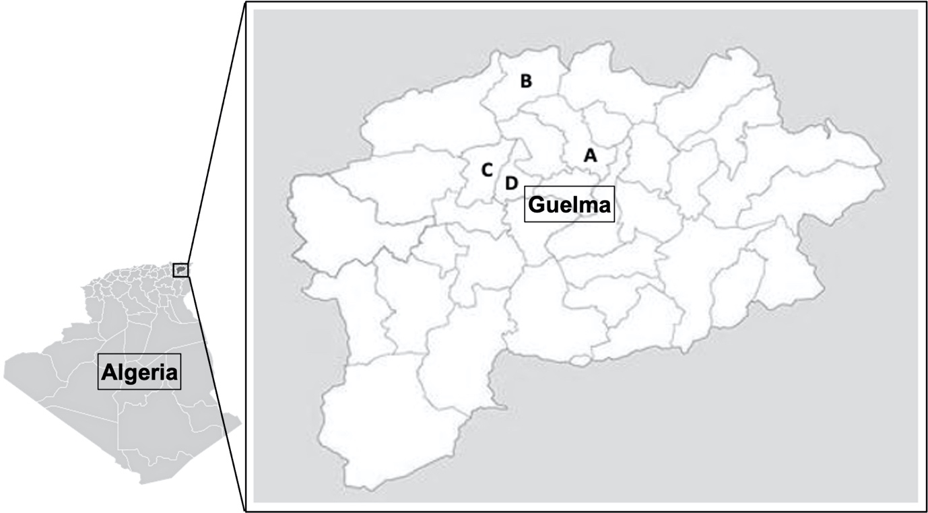
Figure S1. Sampling area (A: Heliopolis; B: Bouati Mahmoud; C: Hammam Debagh; B: Medjez Amma

