Ultrafast Switching and High-Endurance Nonvolatile Memory Using Ferroelectric Janus Monolayers
Ngoc Thanh Duong^{1, #}, Swathi Krishna ^{1, #}, Minh Chien Nguyen², Hang Sik Kim¹, Hamza Zad Gul¹, Soo Ho Choi³, Minjeong Kim¹, Thi Uyen Tran¹, Vu Khac Dat¹, Van Dam Do², Huong Thi Thanh Nguyen¹, Young Min Kim¹, Woo Jong Yu², Ki Kang Kim^{1, *}, and Seong Chu Lim^{1,4 *}

¹ Department of Energy Science, Sungkyunkwan University, Suwon 16419, Republic of Korea
² Department of Electrical & Computer Engineering, Sungkyunkwan University, Suwon 16419, Republic of Korea
³ Department of Electrical and Computer Engineering, Nick Holonyak, Jr. Micro and Nanotechnology Laboratory, University of Illinois Urbana-Champaign, Urbana, IL 61801, USA
⁴ Department of Smart Fabrication Technology, Sungkyunkwan University, Suwon 16419, Republic of Korea

# These authors contributed equally to this work.
* Corresponding email to: kikangkim@skku.edu, and seonglim@skku.edu

Supplementary Information includes:
Supplementary Figures 1 to 22

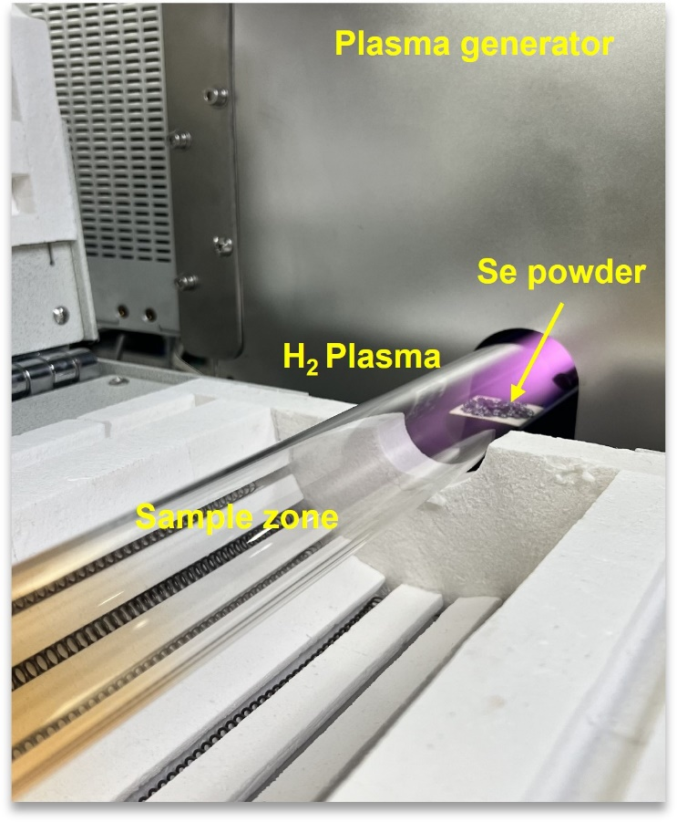
Supplementary Fig. 1. Photograph of the RPECVD growth zone showing hydrogen plasma generation (purple glow) within the plasma chamber, with Se pellets serving as the Se source. During the conversion process, a monolayer MoS₂ sample was positioned in the designated sample zone and exposed to hydrogen plasma while selenium was simultaneously supplied at a chamber pressure of 250 mTorr.
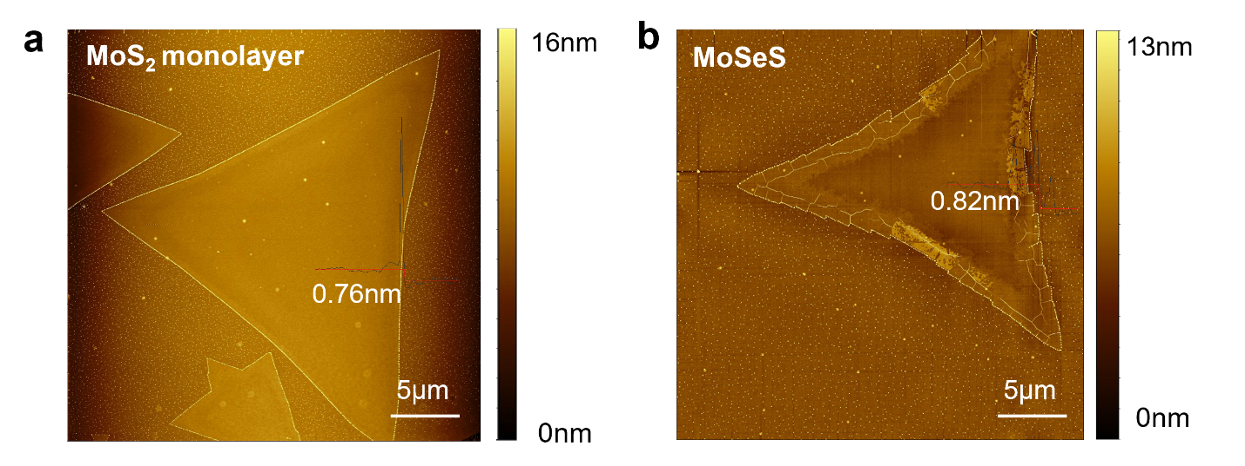
Supplementary Fig. 2. a,b, Atomic force microscopy images of (a) pristine monolayer MoS₂ with a thickness of 0.76 nm and (b) MoSeS with a thickness of 0.82 nm after selenization. The analysis indicates that the initial MoS₂ sample, with a thickness of 0.76 nm, transformed into a MoSeS sample with an increased thickness of 0.82 nm. This slight increase in thickness is attributed to the substitution of selenium (Se) atoms for sulfur (S) atoms during the growth process, as selenium has a larger atomic radius than sulfur.

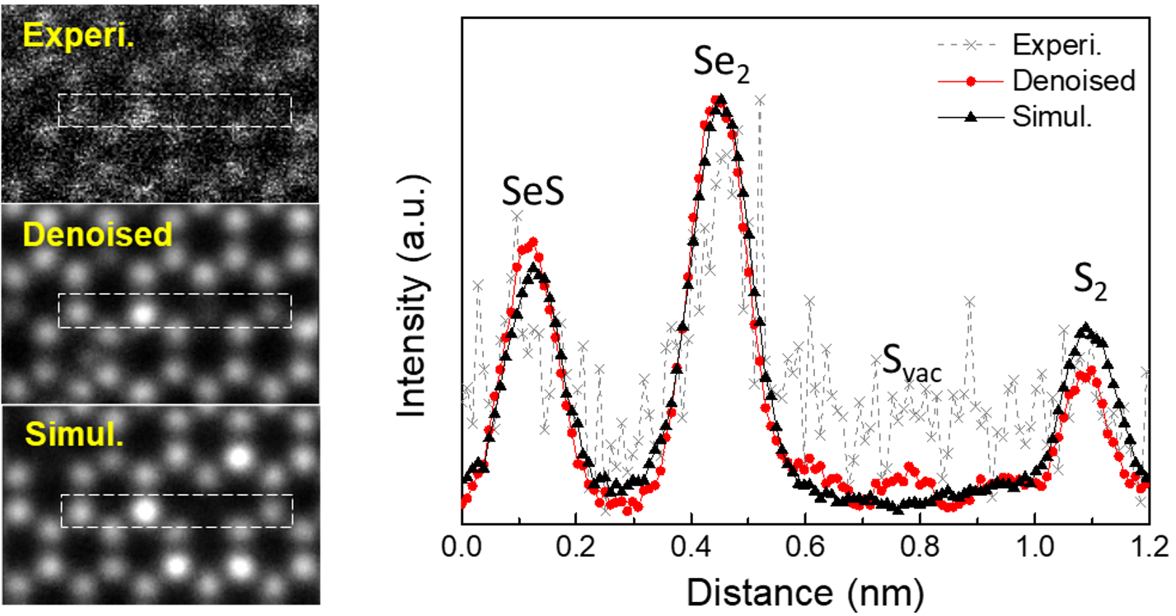
Supplementary Fig. 3. Intensity line profiles along the atomic columns of MoSeS in the ADF-STEM. ADF-STEM image of MoSeS and denoised image are compared with the simulation data. The line profiles along the white box show the intensities of atomic columns: Se₂ > SeS > S₂ > S_{vac}.

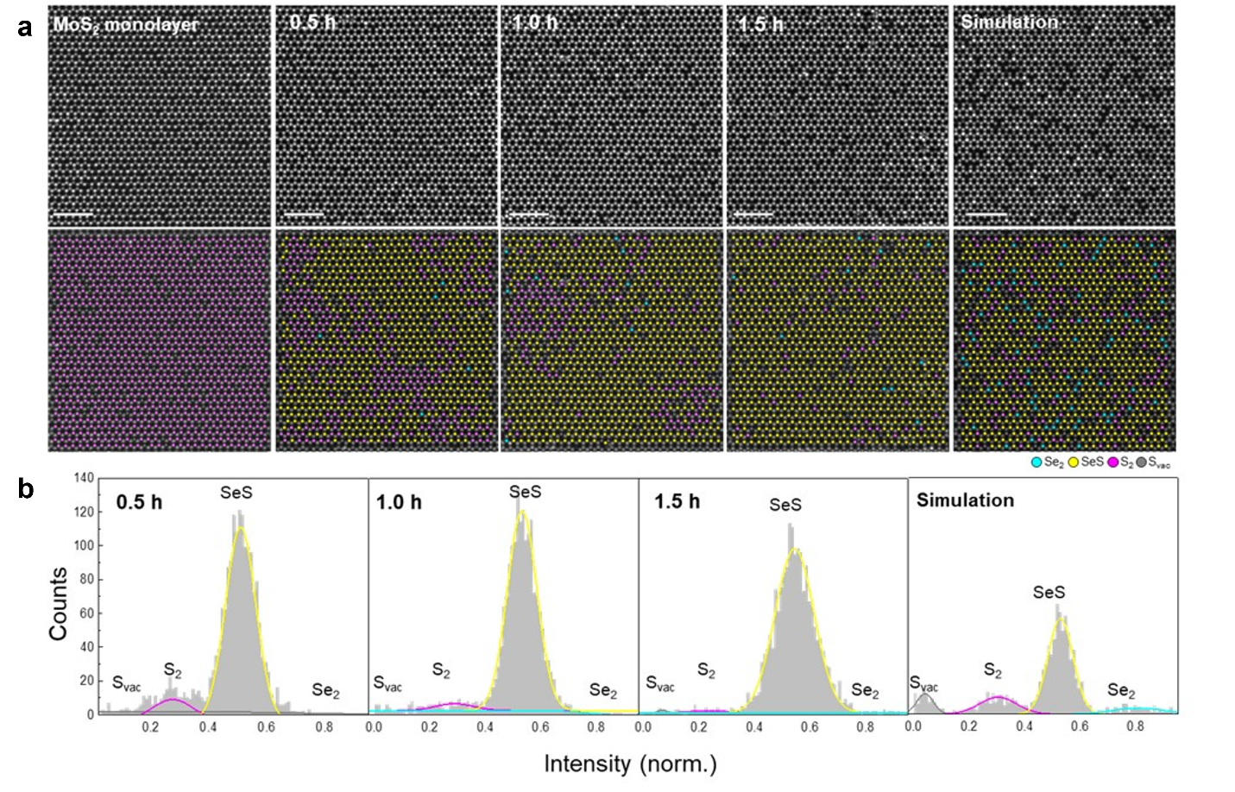
Supplementary Fig. 4. Progression of the conversion from pristine MoS₂ to MoSeS as a function of time. a, ADF-STEM images of pristine MoS₂ and MoSeS after hydrogen plasma treatment for 0.5, 1.0, and 1.5 h, accompanied by simulation data. The false-color mapped images highlight specific atomic sites: Se₂ (cyan), SeS (yellow), S₂ (pink), and S_{vac} (gray). b, Normalized intensity histograms of atomic sites from the images for MoSeS treated for 0.5, 1.0, and 1.5 h, compared with simulation results.

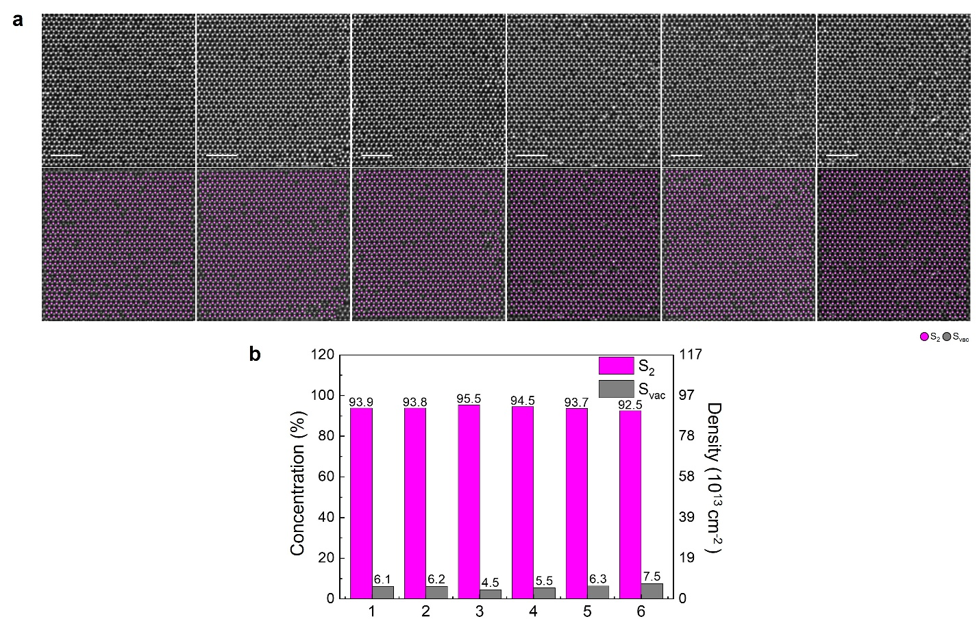
Supplementary Fig. 5. a, ADF-STEM and false-color mapped images of pristine MoS₂ at multiple positions, highlighting atomic site identification for S₂ (pink) and S_{vac}​ (gray). b, Bar graph for the average concentration of S_{vac}​, revealing that pristine MoS₂ contains approximately 6.02% S_{vac}​.

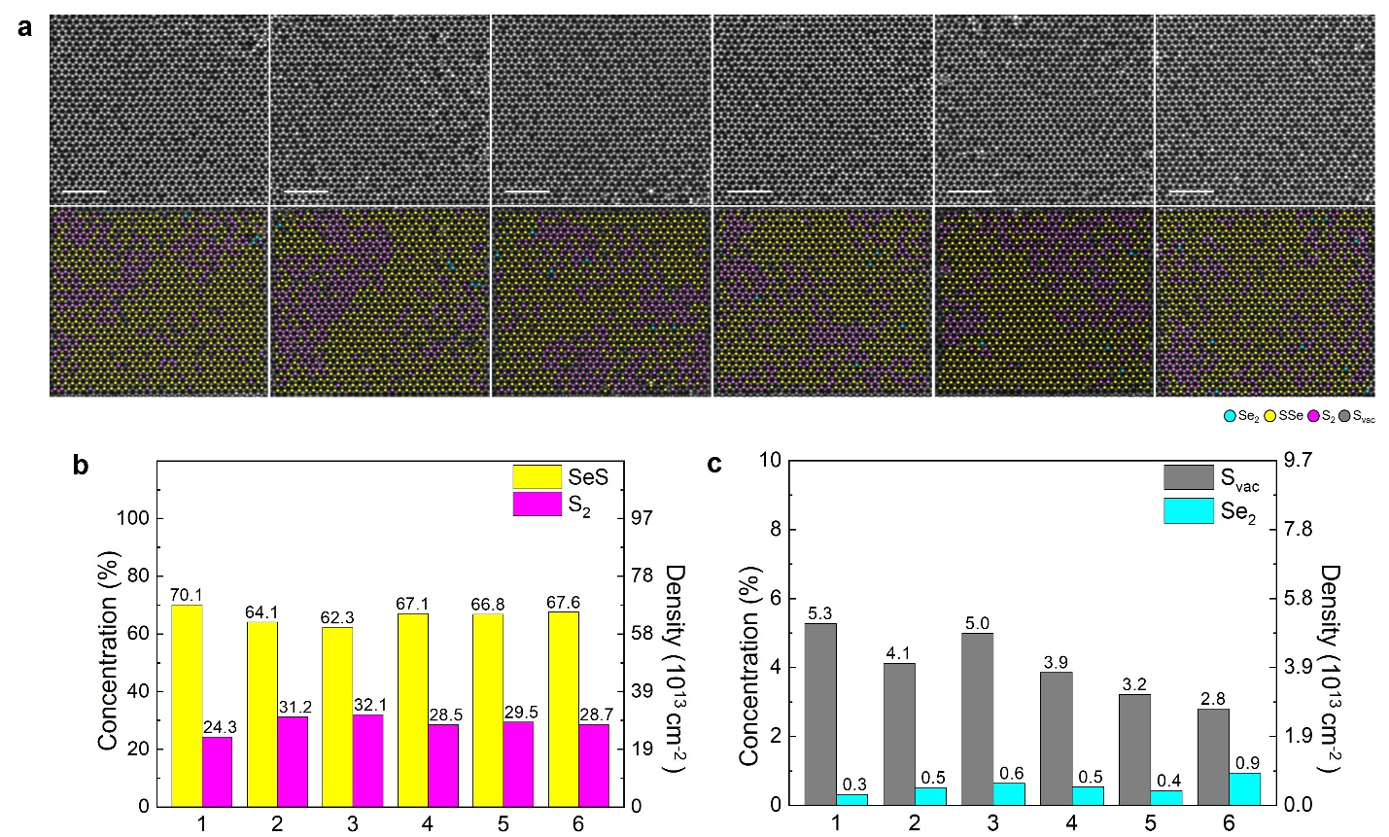
Supplementary Fig. 6. a, ADF-STEM and false-color mapped images of MoSeS (0.5h) at multiple positions, highlighting atomic site identification for Se₂ (cyan), SeS (yellow), S₂ (pink), and S_{vac} (gray). b,c, Bar graphs for the average concentration of (b) SeS and S₂, (c) S_{vac}​ and Se₂. The analysis reveals that MoSeS (0.5h) MoS₂ contains approximately 66.3% SeS, 29.1% S2, 4.1% S_{vac}, and 0.5% Se₂.

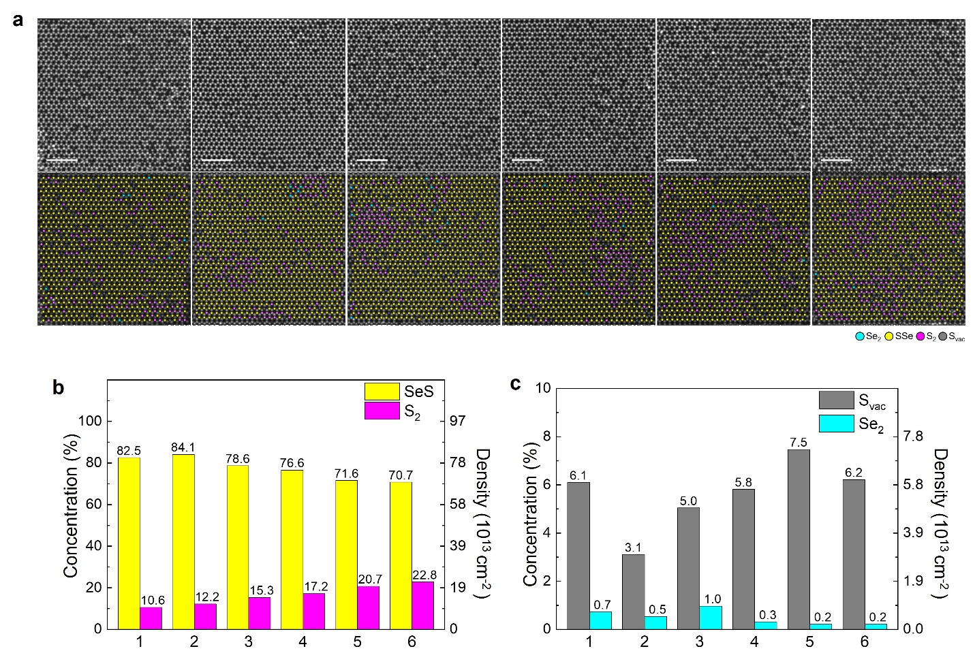
Supplementary Fig. 7. a, ADF-STEM and false-color mapped images of MoSeS (1 h) at multiple positions, highlighting atomic site identification for Se₂ (cyan), SeS (yellow), S₂ (pink), and S_{vac} (gray). b,c, Bar graphs for the average concentration of (b) SeS and S₂, (c) S_{vac}​ and Se₂. The analysis reveals that MoSeS (1 h) MoS₂ contains approximately 77.4% SeS, 16.5% S2, 5.6% S_{vac}, and 0.5% Se₂.

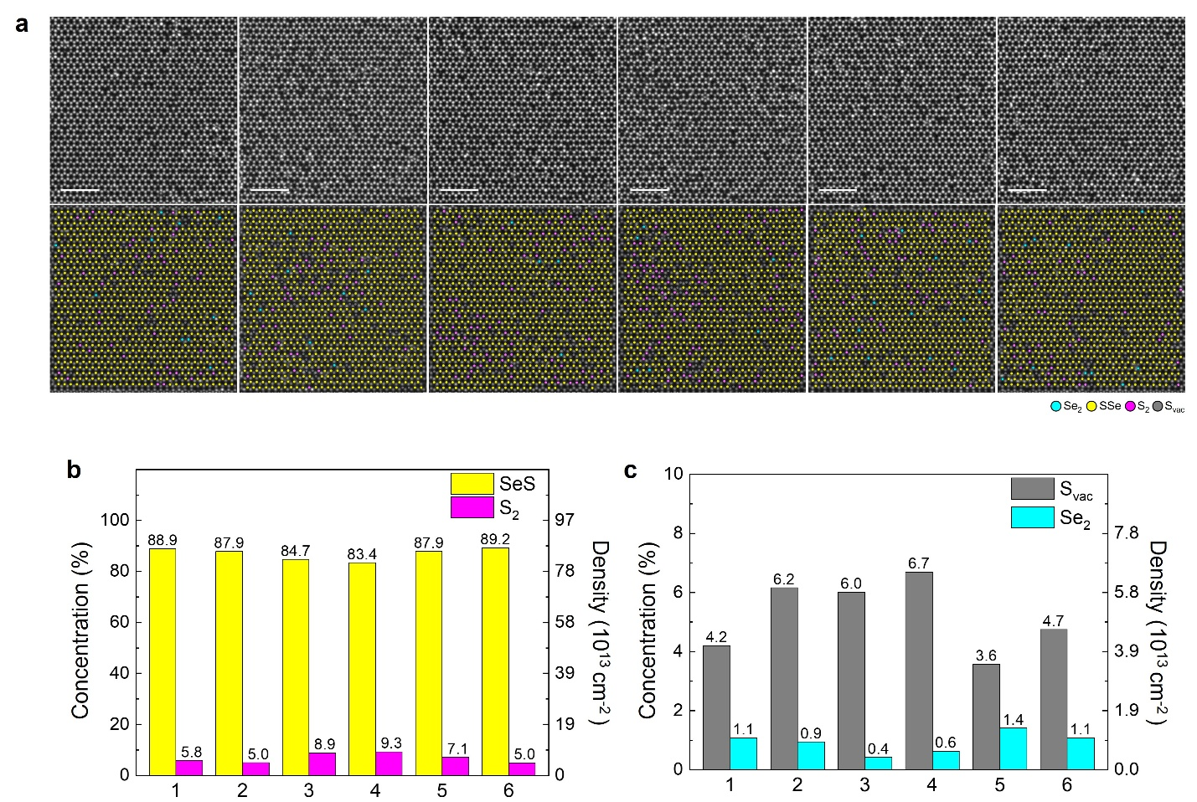
Supplementary Fig. 8. a, ADF-STEM and false-color mapped images of MoSeS (1.5 h) at multiple positions, highlighting atomic site identification for Se₂ (cyan), SeS (yellow), S₂ (pink), and S_{vac} (gray). b,c, Bar graphs for the average concentration of (b) SeS and S₂, (c) S_{vac}​ and Se₂. The analysis reveals that MoSeS (1.5 h) MoS₂ contains approximately 87.0% SeS, 6.9% S2, 5.2% S_{vac}, and 0.9% Se₂.

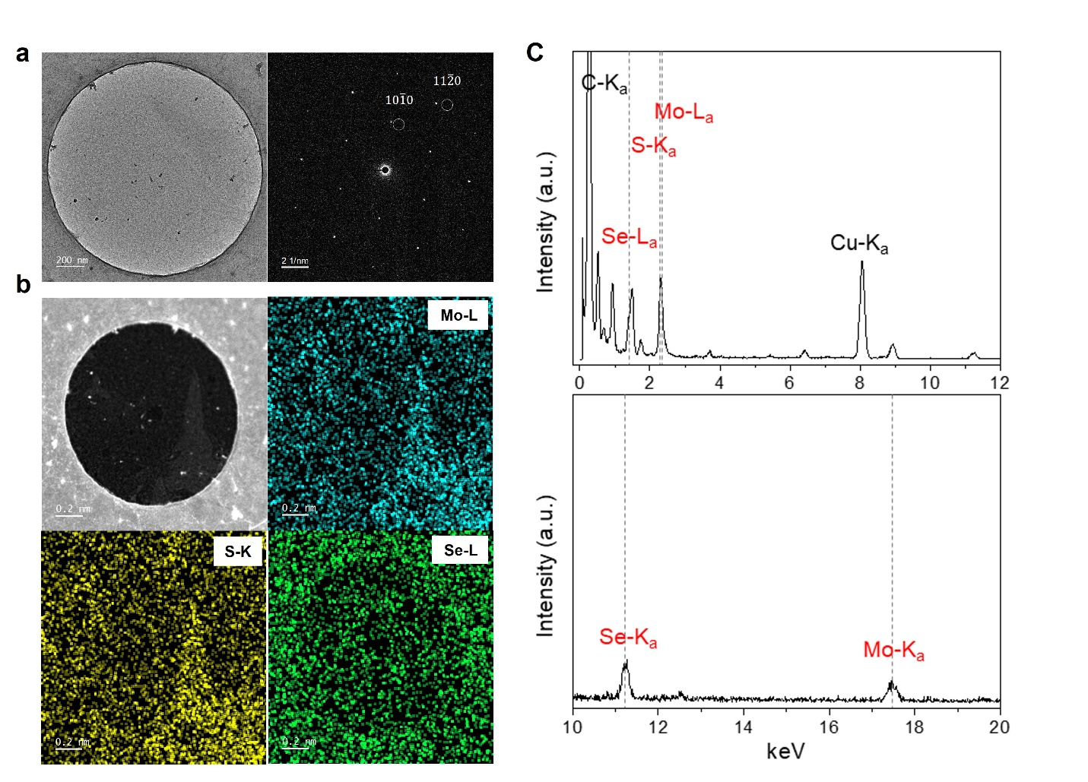

Supplementary Fig. 9. Structural and chemical analysis of the 87% converted MoSeS. a, Low-magnification high-resolution TEM image and corresponding SAED pattern of MoSeS monolayer, with the typical hexagonal pattern of 2H-MoS₂. b, STEM-ADF image and STEM-EDX mapping image on the same region as in (a) show the presence of Mo, S and Se elements. c, Photon count vs energy range spectra of the EDX mapping showing distinct Mo, S and Se peaks in the mapped region.

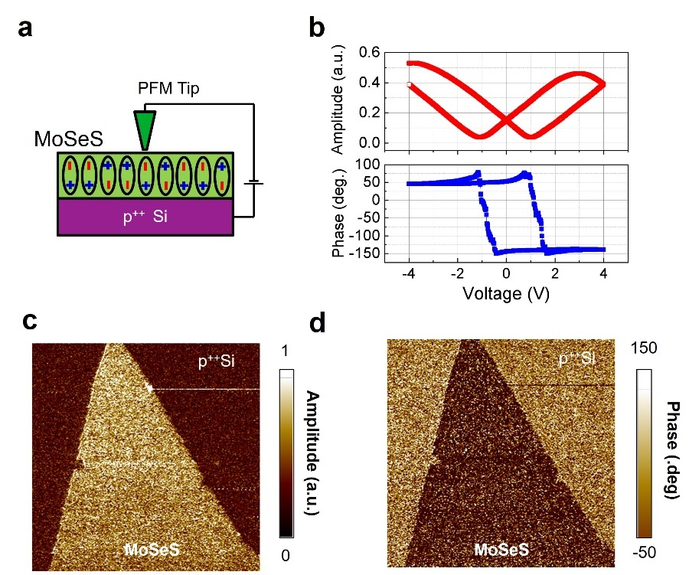
Supplementary Fig. 10. PFM measurements. a, Schematic of the PFM measurement setup for the MoSeS sample, transferred onto a conductive p⁺⁺ Si substrate. An AC bias was applied via a Pt-coated tip to investigate the polarization domains of the sample. b, Hysteresis loops of phase and amplitude observed during sweeping of the sample bias. Due to the intrinsic ferroelectric properties of the target material, the sample undergoes expansion or contraction depending on the direction of the electric field. The discrepancy between the electric fields in the ferroelectric domain of monolayer MoSeS and the AC voltage applied by the tip induces linear mechanical deformation in the cantilever, resulting in increased deflection, referred to as the PFM amplitude. c, d, PFM images of the MoSeS flake: (c) amplitude and (d) phase, showing significant contrast relative to the substrate, reflecting the dipole orientation of the sample. The pronounced hysteresis loops of phase versus applied voltage indicate a strong phase change of approximately 180° for the monolayer MoSeS flake, while the amplitude curve exhibits a butterfly-like shape, with coercive voltages of -0.5 V and 1.5 V, characteristic of ferroelectricity.

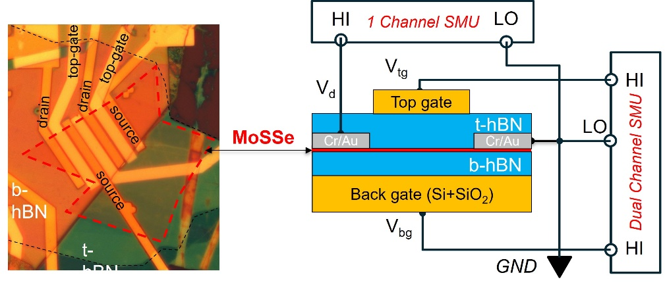
Supplementary Fig. 11. Micrograph image of the hBN/MoSeS/hBN device and the hardware setup used for dual-gate DC measurements at room and low temperatures.

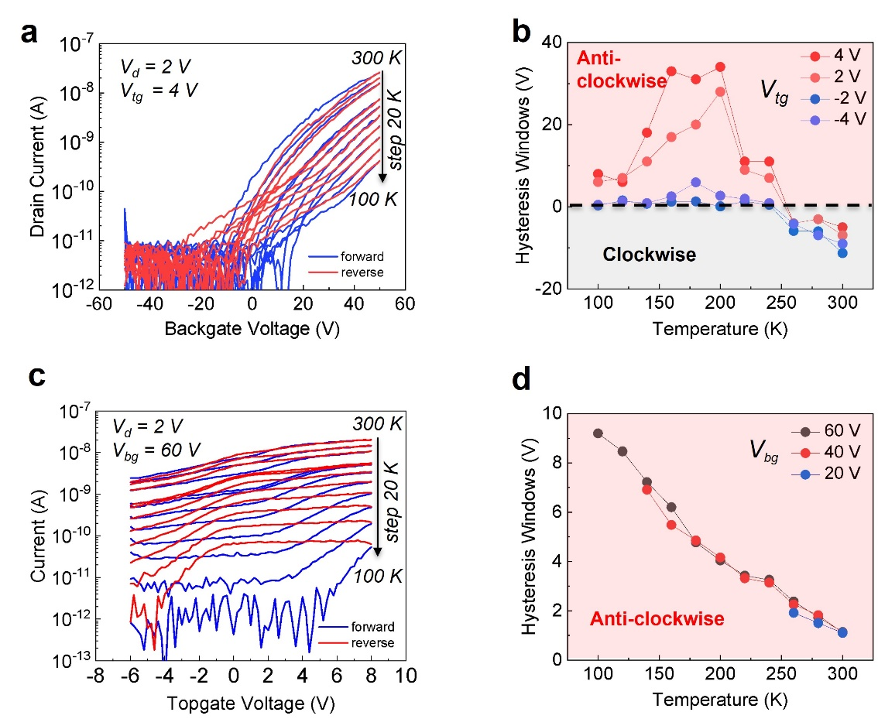
Supplementary Fig. 12. a, Temperature-dependent back-gate sweep transfer curves (I_{d} – V_{bg}) at a constant top gate bias, V_{tg} of 4 V. b, Variation in hysteresis windows as a function of temperatures at different V_{tg} values. c, Temperature-dependent top-gate sweep transfer curves (I_{d} – V_{tg}) at a constant back-gate bias, V_{bg} of 60 V. d, Variation in hysteresis windows as a function of temperatures at different V_{bg} values.

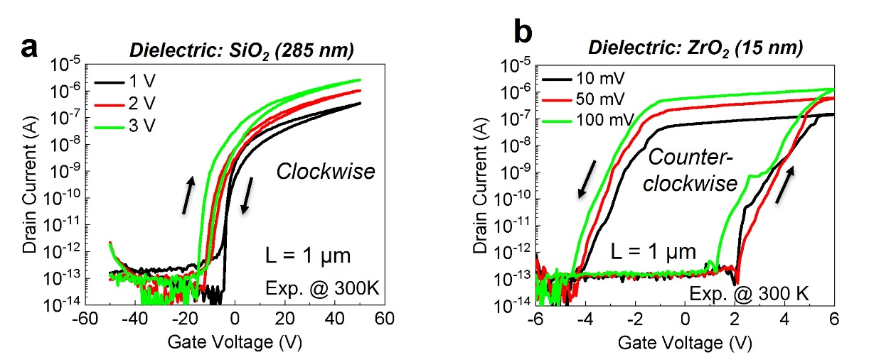
Supplementary Fig. 13. a, b, Dual sweep transfer curves (I_{d} – V_{g}) of two different MoSeS FET devices at room temperature, employing (a) 285 nm SiO₂ and (b) 15 nm ZrO₂ as dielectric.

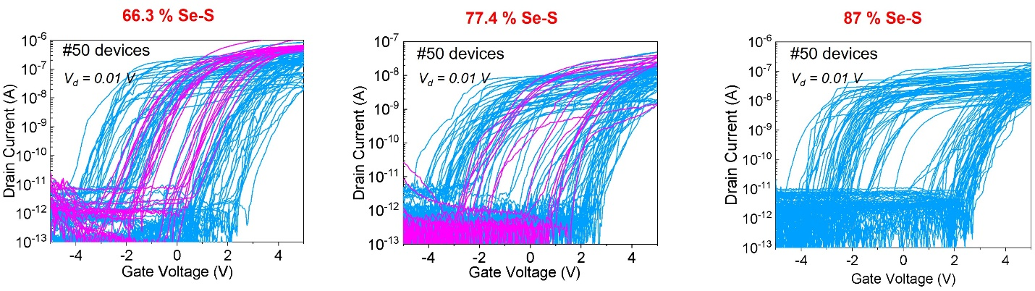Supplementary Fig. 14. Dual sweep transfer curves (I_{d} – V_{g}) of three batches of MoSeS SFe-FET devices at room temperature, fabricated with three different Se-S concentrations (66.3%, 77.4%, and 87.0%) in MoS₂ samples. Fifty devices were measured for each batch with channel length (L) of 1 µm. The blue curves represent counterclockwise hysteresis, while the magenta curves represent clockwise hysteresis. Due to a low conversion rate of the MoSeS sample with a treatment time of 0.5 and 1.0 hours, several areas of full-film monolayer remain MoS₂ or partially converted to MoSeS. Thus, several devices in these two batches do not obtain counterclockwise hysteresis. Memory windows exhibit significant fluctuations, varying from negative to positive values across 50 devices per batch. This can also be realized in the distribution functions of dual threshold voltage shown in the left and central panels of Fig. 2d.

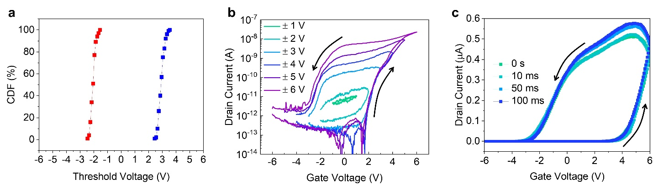
Supplementary Fig. 15. a, Cumulative Distribution Function extracted from threshold voltage for 100 cycles of transfer curves. Due to the minimal cycle-to-cycle variation in high and low threshold voltages (Vth), characterized by standard deviations of 0.18 and 0.22, and mean values of −2.01 V and 2.96 V respectively, (Fig 3b) cumulative probability in the context of a normal Gaussian distribution represents the likelihood that a variable assumes a value less than or equal to a specified threshold. This metric quantifies the probability of a random variable falling within a given range. b, Transfer curve measurements with multiple gate voltage sweeping ranges, showing that the threshold voltage (V_{th}) remains constant with negligible variation across different V_{g} ranges. c, DC sweep delay showing negligible impact on the counterclockwise hysteresis. The measurement is conducted the exclusion of capacitive gating effects and the influence of mobile ions in the ZrO₂ oxide on the counterclockwise hysteresis, which is significantly affected by the DC sweep delay.

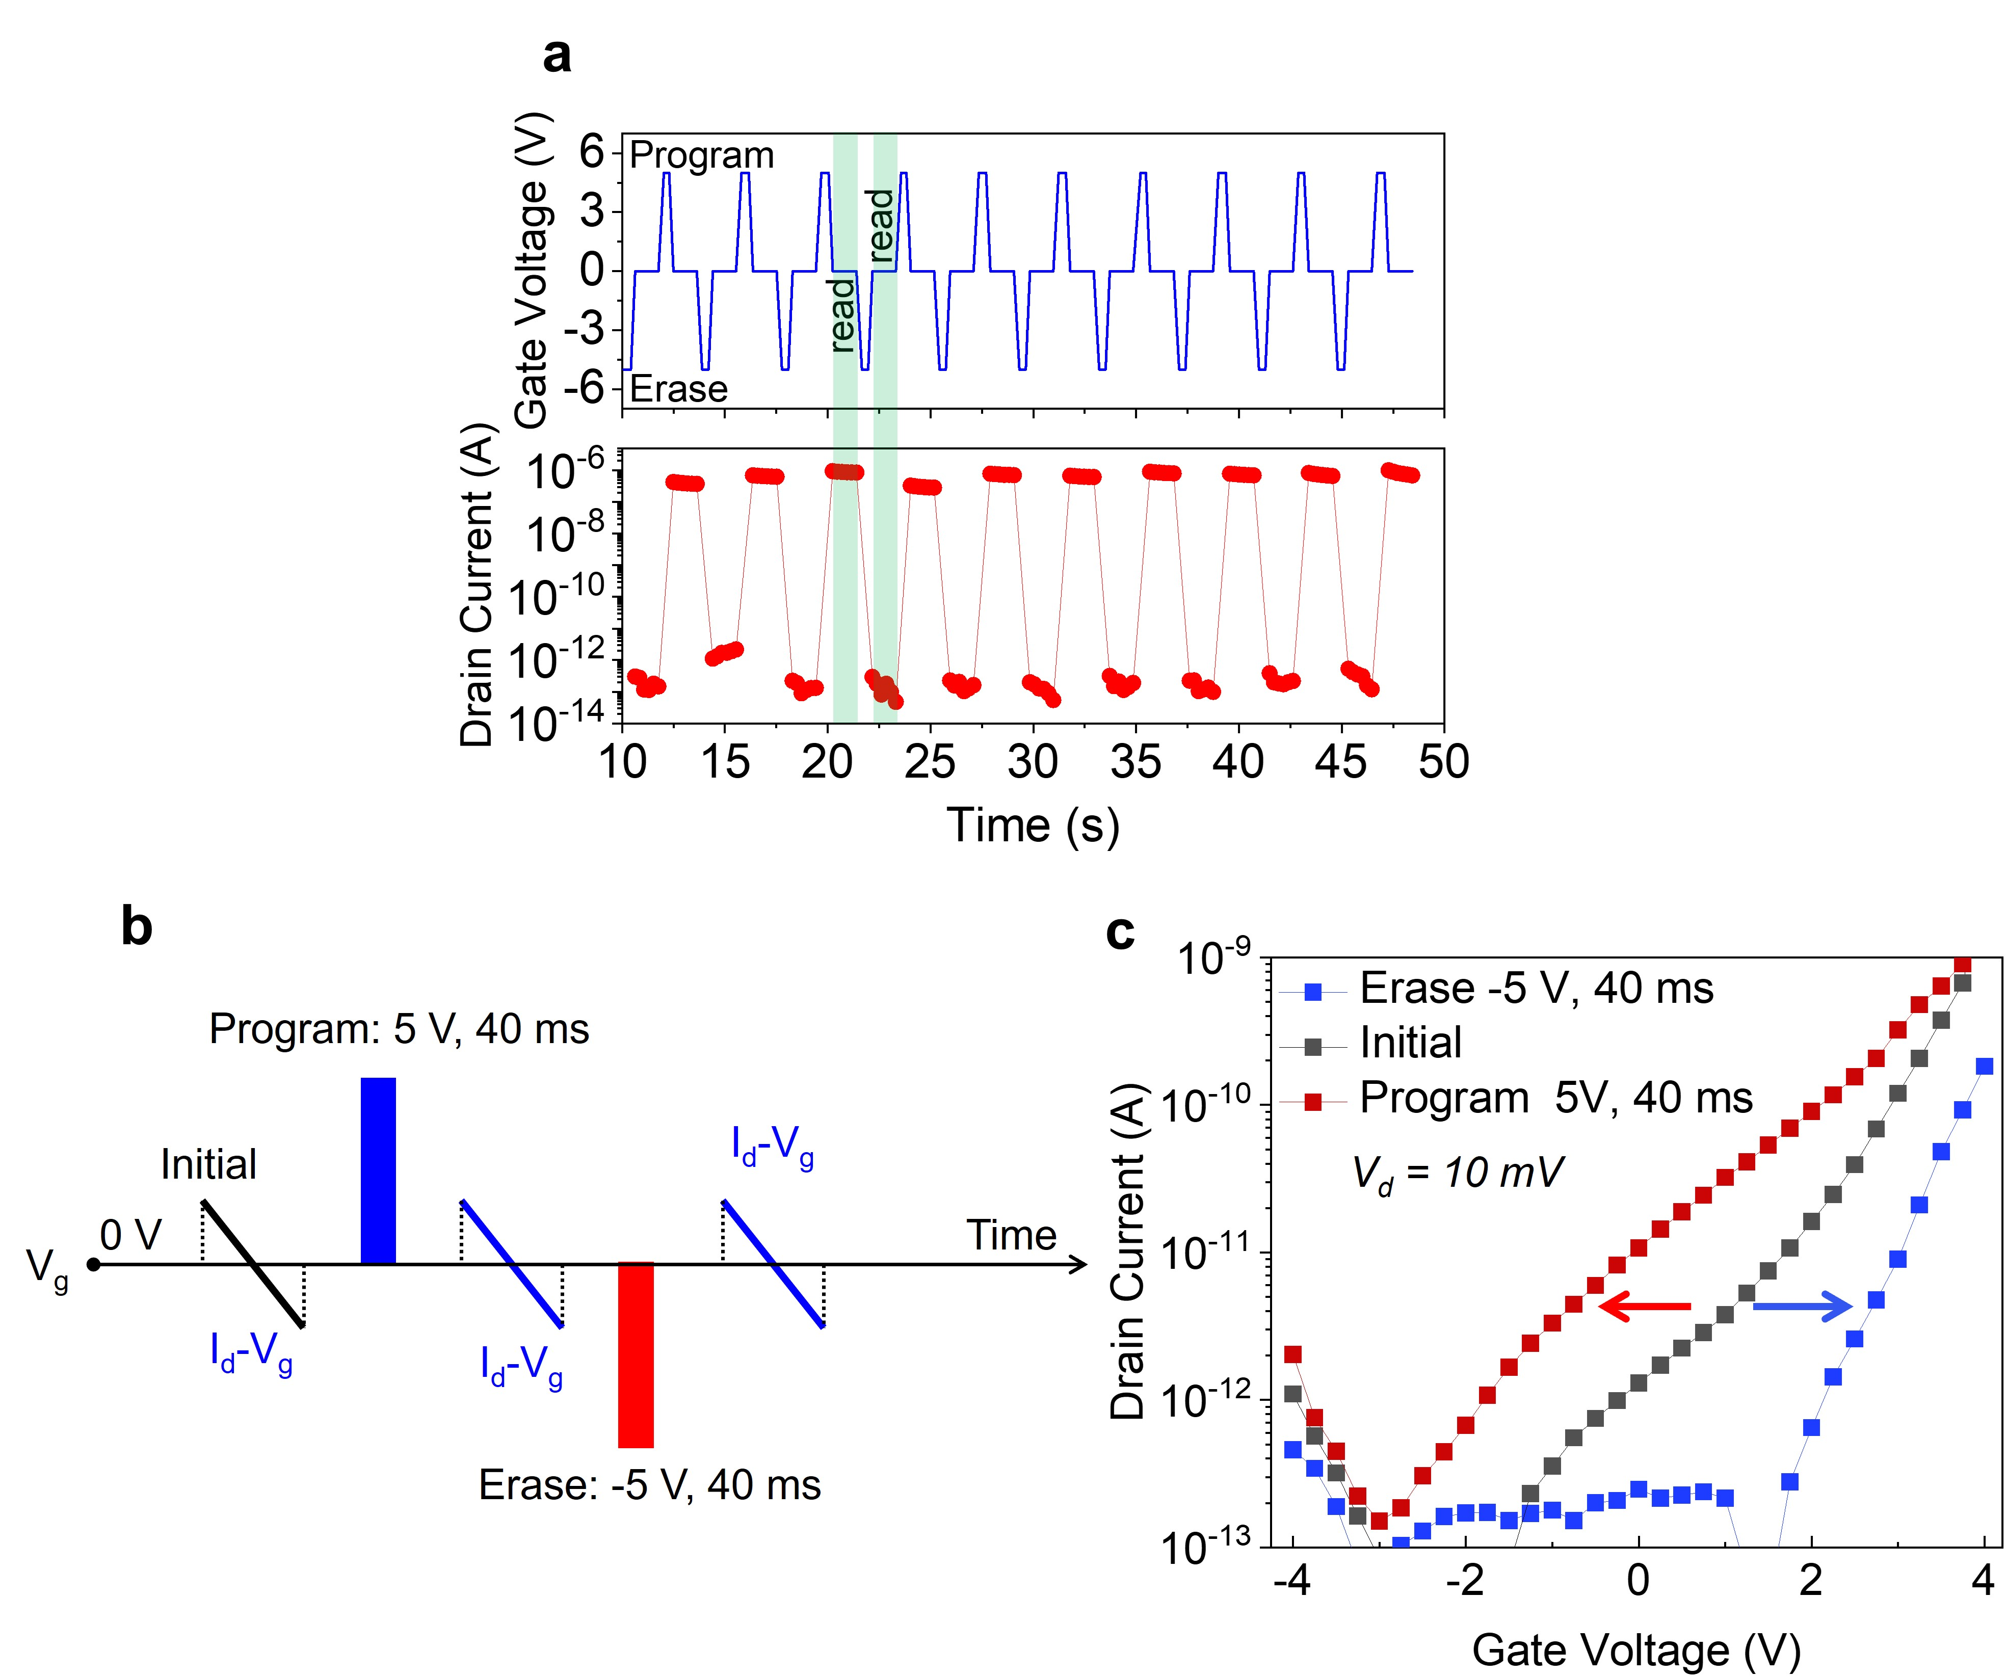
Supplementary Fig. 16. a, Ten program/erase cycles with program (V_{g} = 5 V), erase (V_{g} = −5 V), and retention of the drain current at V_{g} = 0 V. The high stability is attributed to the significant on-off ratio observed at V_{g} ​= 0 V, as demonstrated in the typical transfer characteristics of the MoSeS SFe-FET. b, Measurement scheme for transfer curves following program or erase V_{g}​ pulses. Applying a programming pulse or an erasing pulse before direct current transfer characteristic measurements is used to controllably adjust the threshold voltage (V_{th}​) based on the preceding pulse. The DC sweep range is kept below the pulse amplitude to avoid influencing the switching dipole. c, Single-sweep transfer curve of the MoSeS SFe-FET after applying program or erase pulses with amplitudes of V_{g} = 5 V or V_{g} = −5 V, respectively, and a pulse width of 40 ms. The V_{th} can be adjusted by 5 V depending on whether a programming pulse (5 V, 40 ms) or an erase pulse (−5 V, 40 ms) is applied.

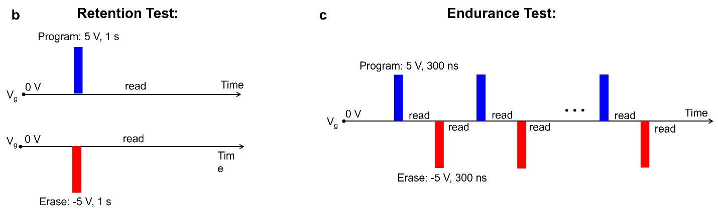Supplementary Fig. 17. a, b, Pulse scheme for (a) retention and (b) endurance measurements.

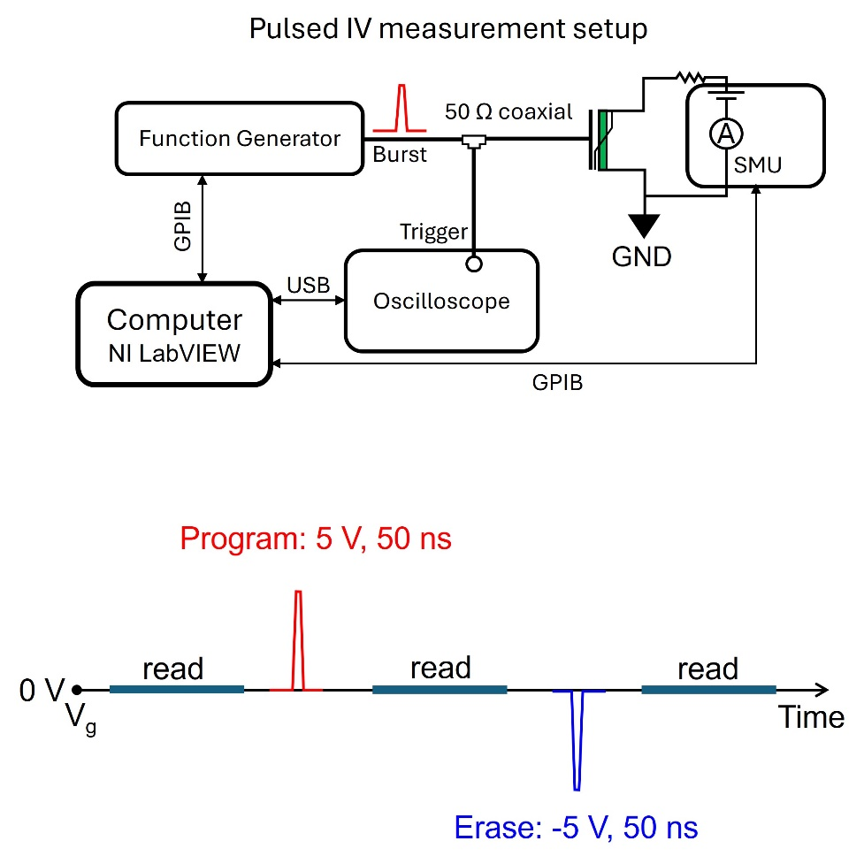
Supplementary Fig. 18. Hardware setup for ultrafast pulse I-V measurement. An arbitrary waveform generator (120 MHz) generates nanosecond pulses in burst mode and applies them to the MoSeS SFe-FET device. A mixed-domain oscilloscope captures the output waveform, while an SMU reads the device conductance before and after pulsing.

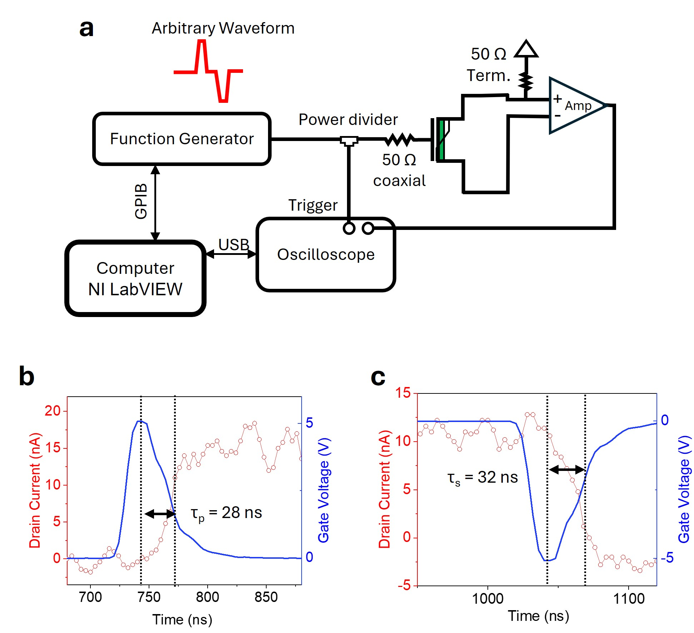
Supplementary Fig. 19. Hardware setup of transient IV measurement. a. Waveform/Function Generator 120 MHz programs the nanoseconds arbitrary pulse cycles in burst mode. The drain current is pre-amplified by FEMTO DHPCA 100 at the trans-impedance of 10⁷ V/A. A mixed-domain oscilloscope captures the output waveform in trigger mode. Perfect impedance matching must be maintained throughout the circuit to minimize reflectance when the function generator frequency exceeds 1 MHz. The 50 Ohm coaxial cable was used, and a 50 Ohm termination was employed to eliminate reflections when using 50 Ohm cables. b, c The ultrafast response of the Janus SFe-FET memory cell was observed with (b) program and (c) erase pulses, yielding extracted response times of τ_{p} = 28 ns and τ_{e} = 32 ns, respectively.

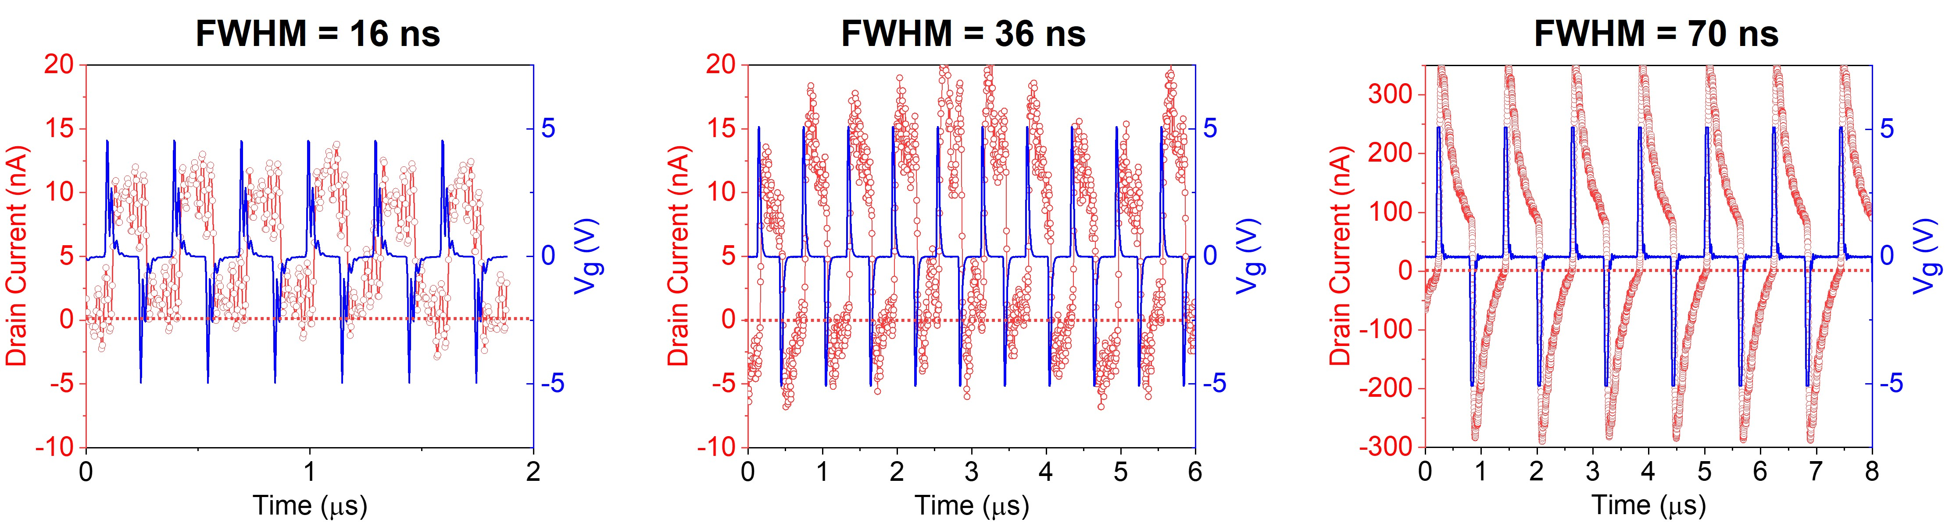
Supplementary Fig. 20. Dependency of switching ratio on the Full Width at Half Maximum (FWHM) of Program and Erase spikes. In transient IV measurements, we compare the low resistance state (LRS) and high resistance state (HRS) at varying pulse durations of FWHM (16 ns, 36 ns, and 70 ns). Notably, the LRS/HRS ratio of the drain current significantly increases over time with increasing FWHM. A reflection effect is observed at an FWHM = 16 ns, causing pulse distortion, because the function generator is programmed at over 40 MSa/s.

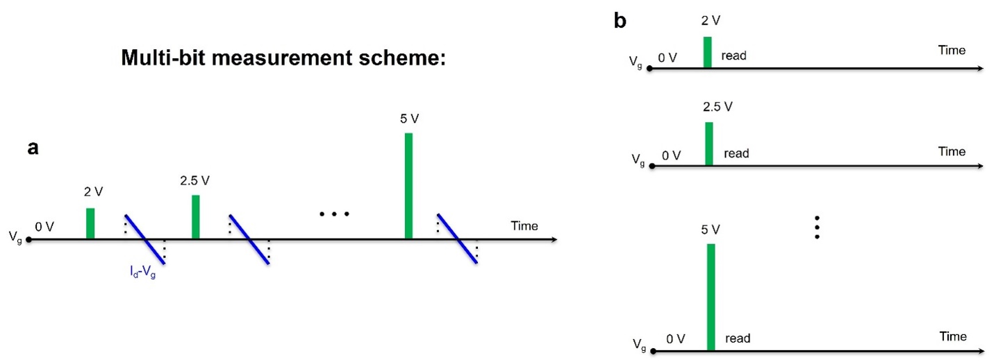

Supplementary Fig. 21. a, b, Pulse scheme for the multi-bit operation of (a) transfer curve measurement and (b) conductance retention measurement.

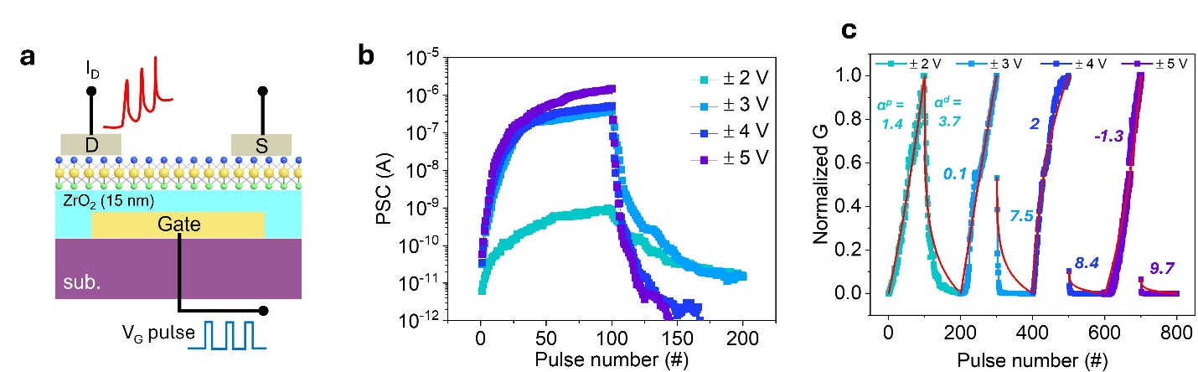
Supplementary Fig. 22. a, Cross-section schematic of SFe-FET showing a V_{g} pulse train and sequential response drain current I_{d} that mimics the action potential in pre-synaptic current and PSC. This represents the fundamental information transmission mechanism through a biological synapse inspired by the human brain. b, LTP and LTD data plotted on a semilogarithmic scale, demonstrating an ultra-high G_{min}/G_{max} ratio. c, Normalized conductance (G) as a function of pulse numbers for different voltage magnitudes.

