Supporting Information

Active Learning
In this study, we employed the open-source deep learning framework PyTorch to model a Convolutional Neural Network (CNN) and perform Inverse Binary Optimization, leveraging these models for Active Learning. Initially, we generated a dataset of 25 random binary vectors representing nanophotonic structures and simulated their Figure of Merit (FOM) values. The dataset was split into 80% for training and 20% for validation to train the machine learning model, where the relationship between the input binary vector $\vec{x}$(structure) and the output $y$(FOM) was defined as the objective function.
In the initial cycle, due to the limited size of the dataset, the CNN model may have low predictive accuracy, and thus the identified optimal binary vector ${\vec{x}}_{*}$ may not represent the true global minimum. To address this, we simulate the actual FOM of ${\vec{x}}_{*}$ and add this result to the dataset. If ${\vec{x}}_{*}$ is already present in the dataset, a new random binary vector $\vec{x}$ is generated, its FOM is calculated, and then added to the dataset. The updated dataset is then used to retrain the CNN model, and the optimization cycle is repeated iteratively.
Benchmarking result
To verify that the active learning approach successfully identifies the global optimal binary vector, we used the Transfer Matrix Method (TMM) to compute the outputs of all possible binary vectors for the case where N=16. The calculations revealed that the global minimum of the actual FOM is 1.4418, and the corresponding optimal structure is “0 1 1 1 0 0 0 1 0 0 1 1 1 1 1 0”.
The converged minimum value identified by the CNN-IBO model, y_min​, was also 1.4418, and the corresponding PML structure was “0 1 1 1 0 0 0 1 0 0 1 1 1 1 1 0”. This result confirms that the model successfully identified the global optimal binary vector.
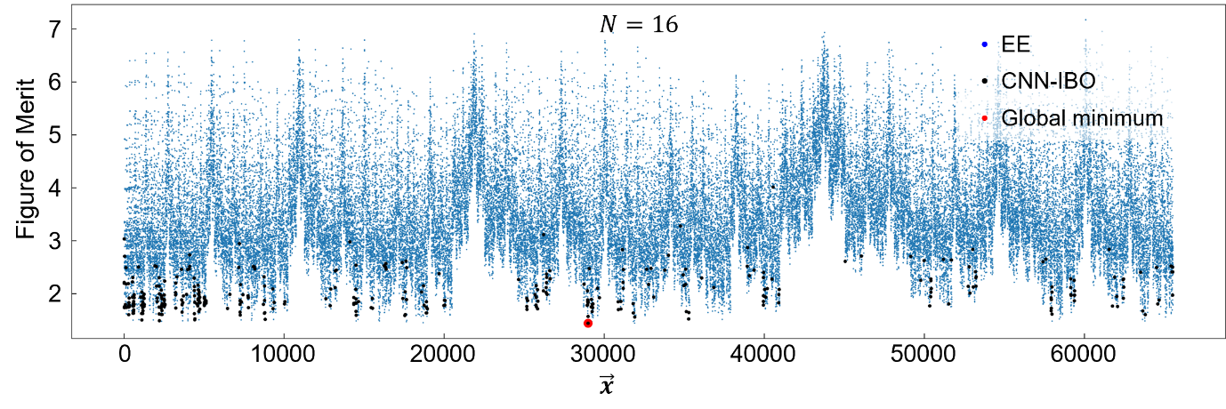Figure S1| For N=16 in the TRC case, the plot shows the FOM values (blue) computed for all possible PML structures using the Transfer Matrix Method (TMM). The optimal structures identified by CNN-IBO at each Active Learning cycle are indicated in black. The global minimum FOM (red) is 1.4417, demonstrating that the active learning process successfully identified the globally optimal binary vector.

Feature map of CNN-based surrogate function
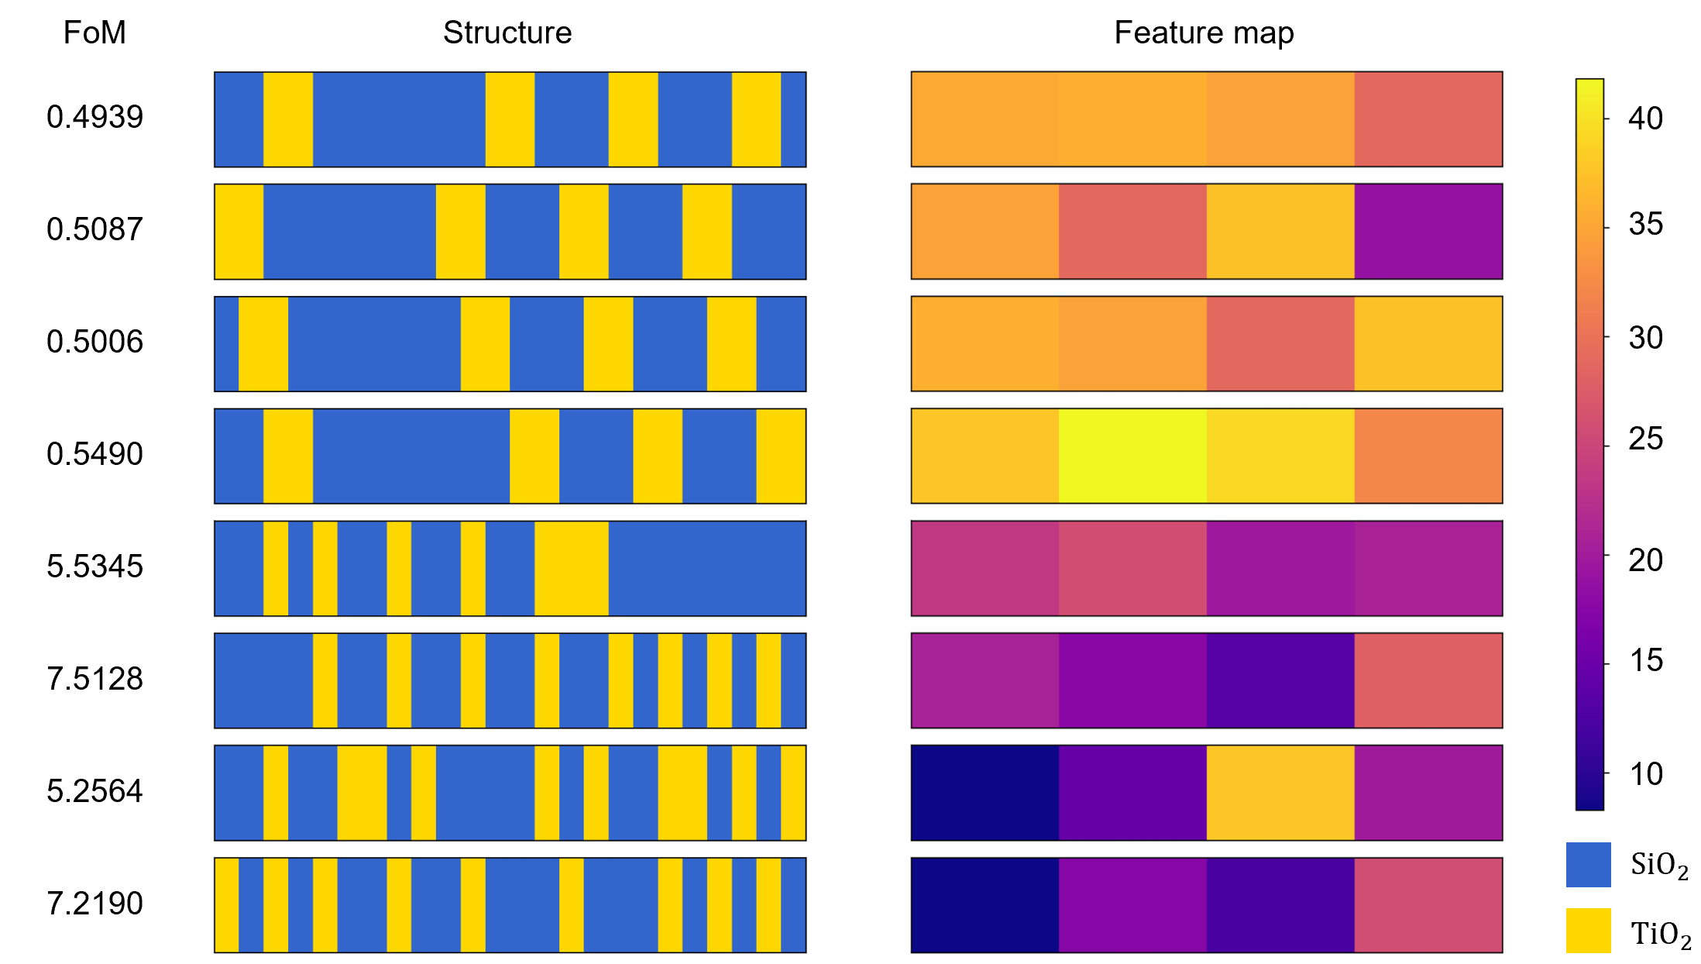
Figure S2| The feature map of the CNN-based surrogate function at N = 24 for the PML structure in Figure 2 of the main text.

Optimization of learning rates in IBO for different design tasks
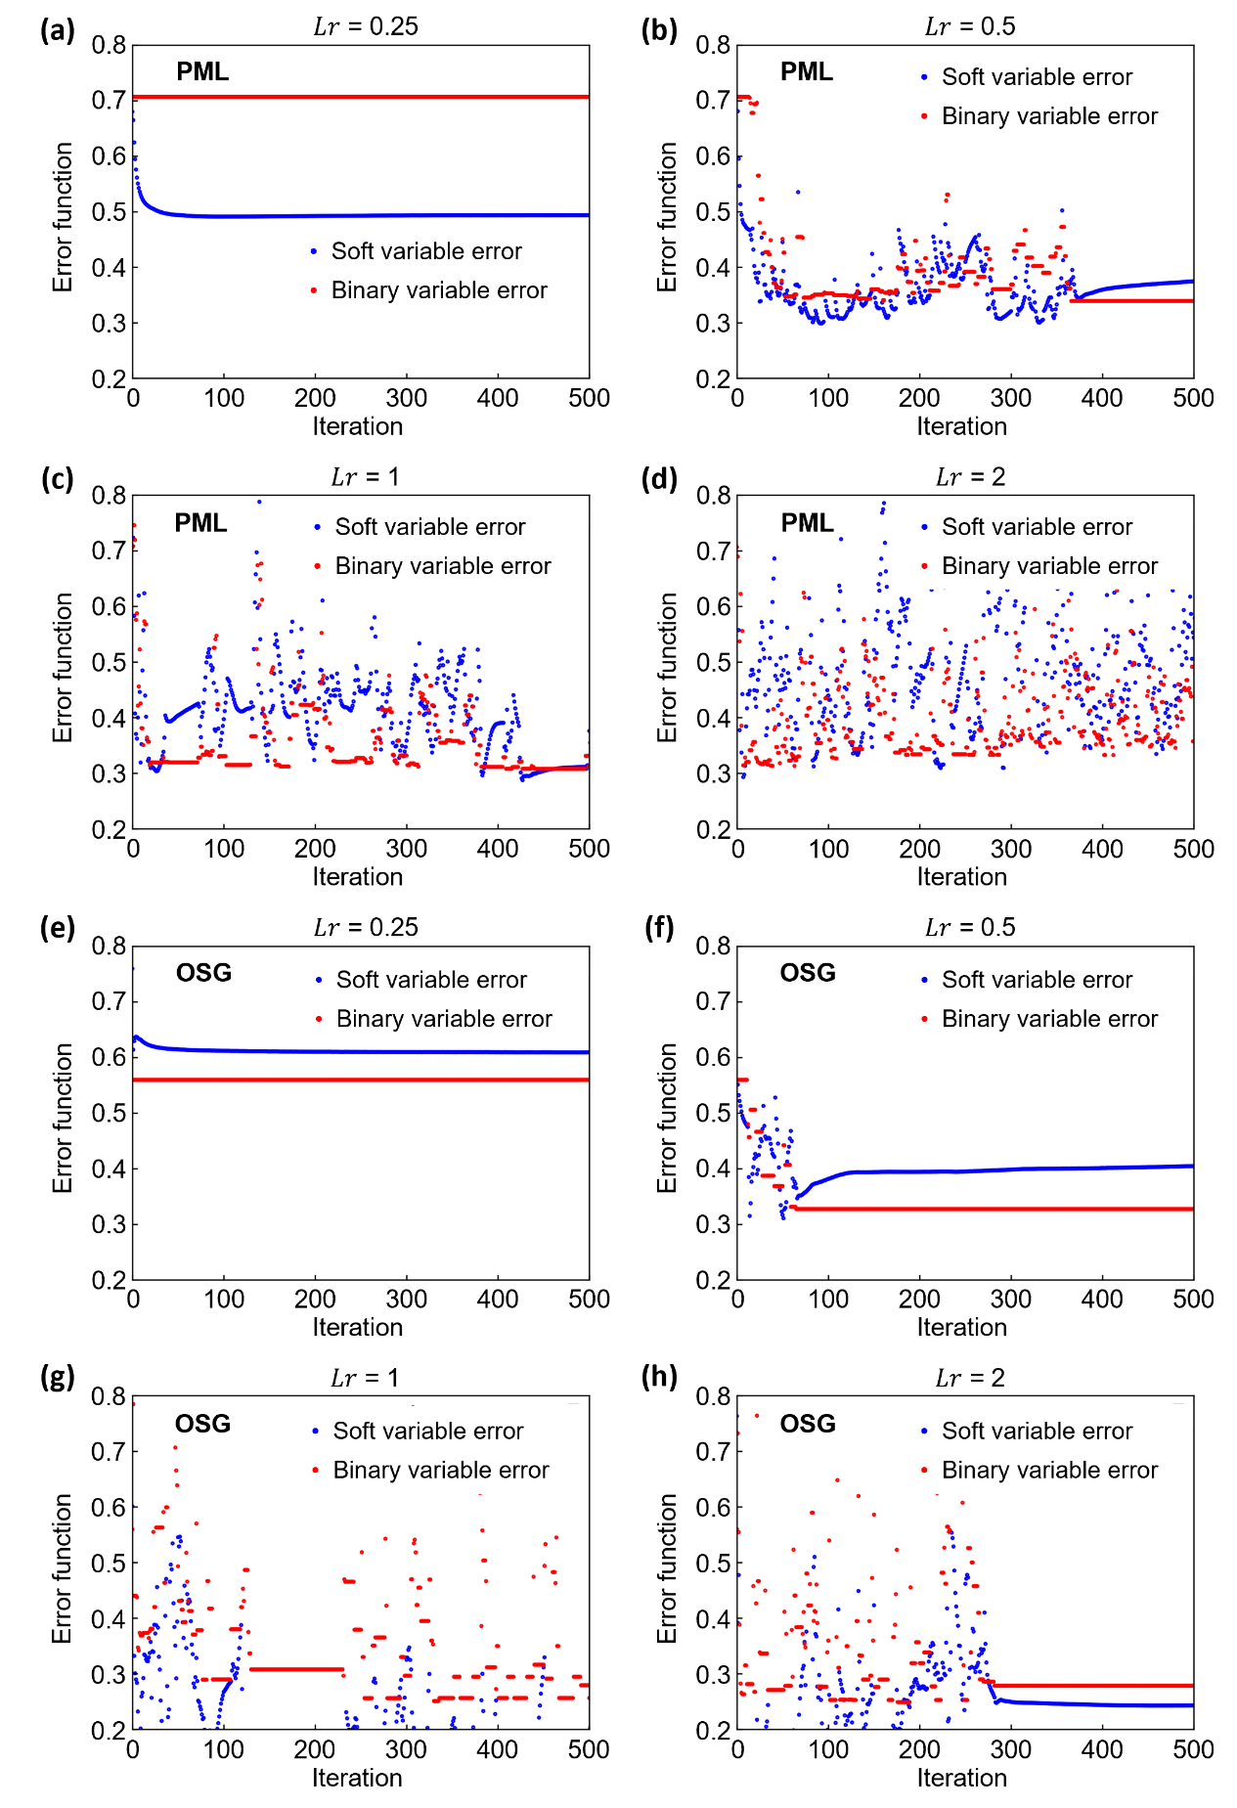
Figure S3| The IBO performance depending on the learning rate (Lr) for different nanophotonic design tasks. (a)–(d) the error function values as a function of the iteration steps in the IBO method with different learning rates (Lr = 0.25, 0.5, 1.0, and 2.0), using the surrogate model trained on the PML structure (N = 48) with 3,000 data points. (e)–(h) the corresponding results for the OSG structure (N = 40). Due to the increased design space, the global minimum was not determined by the EE method in these cases. The plots show the error function values at the locally optimized soft variables (blue dots) and their corresponding projected binary vectors (red dots) for each iteration step.
The learning rate (Lr) of the gradient descent algorithm is a key hyperparameter that significantly affects the performance of the IBO method. As the IBO strategy is proposed for the first time in this study, there is no established guideline for selecting optimal learning rate values from prior literature. Therefore, we empirically selected four learning rates—0.25, 0.5, 1.0, and 2.0—based on preliminary tests. In the initial design task involving the visible-light filter based on the PML structure (N = 24), we observed that an Lr of 1.0 consistently led to stable convergence and superior optimization performance. To examine whether this learning rate is generally effective across different design tasks, we conducted additional investigations using larger and more complex datasets: the PML structure with N = 48 and 3,000 data points, and the OSG structure with N = 40. The results are shown in Figure S4, where (a)–(d) correspond to the PML task and (e)–(h) correspond to the OSG task. In both cases, we evaluated the IBO method under the same four learning rates (0.25, 0.5, 1.0, and 2.0). For the larger PML design task, we found that learning rates of 0.25 and 0.5 led to premature convergence to local minima, similar to our previous observations. In contrast, a learning rate of 1.0 enabled the IBO to explore the design space more effectively, yielding better optimization trajectories with steadily decreasing error function values. At a higher learning rate of 2.0, the optimization process became less stable, resulting in suboptimal performance compared to Lr = 1.0. Similar tendencies were observed for the OSG design task. Learning rates of 0.25 and 0.5 resulted in limited exploration and early trapping in local optima, while Lr = 1.0 provided a balance between exploration and convergence speed. As with the PML case, Lr = 2.0 led to decreased stability and slightly degraded performance. In these experiments, the global minimum was not identified due to the expanded design space, and the exhaustive enumeration (EE) method was not applicable. Nevertheless, the consistent outcomes across different design tasks indicate that a learning rate of 1.0 offers robust and reliable optimization performance for the IBO method. These findings support the empirical choice of learning rates in our study and demonstrate the general applicability of the selected values across different nanophotonic design problems.

Training Curves of Surrogate Functions

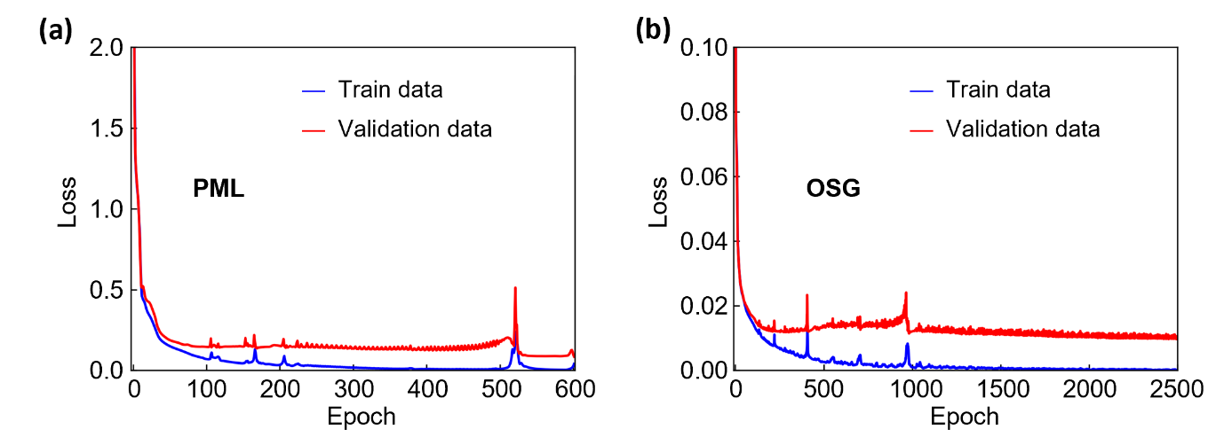
Figure S4| Training curves of the CNN model for designing various nanophotonic structures. (a and b) The calculated loss as a function of epoch for the surrogate function of (a) the visible-light filter and (b) theasymmetric-light transmitter.
To evaluate potential overfitting and the generalization capability of the CNN model used in this study, we trained the model on two datasets: one for the PML structure (N = 48) and the other for the OSG structure (N = 40). The CNN model was trained without any additional regularization techniques such as L2 regularization or dropout. Instead, early stopping was applied based on the validation loss to prevent overfitting. Figure S2 shows the training and validation loss curves for both tasks. In the case of the PML structure, the model converged at epoch 602, where the validation loss reached as low as 8.52 × 10⁻². Both the training and validation losses consistently decreased as the number of epochs increased, indicating stable learning behavior without signs of overfitting. For the OSG structure, convergence was achieved around epoch 2565, with the validation loss decreasing to 9.47 × 10⁻³. Similar to the PML case, both the training and validation losses show a clear downward trend throughout the training process, confirming that the CNN model effectively captured the underlying design space without overfitting. These results demonstrate that the baseline CNN model can be successfully trained for different nanophotonic design tasks, maintaining reliable generalization performance even without the application of explicit regularization methods.

Accuracies of Various Surrogate Functions

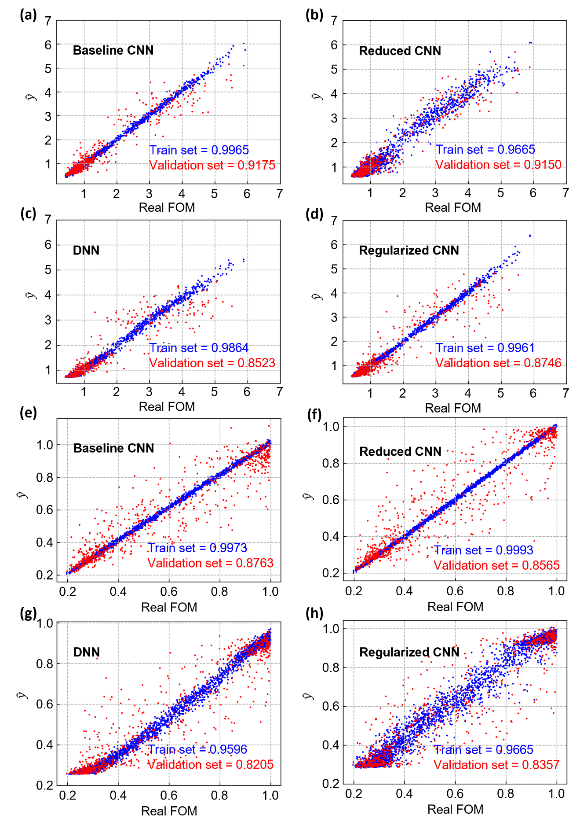
Figure S5| Parity plots comparing different surrogate models for nanophotonic structure design. Four surrogate models(Baseline CNN, Reduced CNN, DNN, and Regularized CNN) were trained and evaluated using the PML and OSG datasets. (a)–(d) show results for the PML dataset, and (e)–(h) for the OSG dataset. The baseline CNN achieves the highest R² score on the validation data, demonstrating superior predictive performance.
In addition to evaluating potential overfitting, we further assessed the fitting performance and generalization capability of the CNN model by comparing it with several alternative surrogate model architectures. To this end, we trained and evaluated four different models using the PML dataset (N = 48) and the OSG dataset (N = 40). The baseline CNN model, which used only early stopping, was compared against a Reduced CNN model with decreased model complexity, a deep neural network (DNN) consisting of four hidden layers with 128 nodes per layer with both dropout and early stopping applied, and a Regularized CNN model, in which additional L2 regularization and dropout layers were incorporated into the baseline CNN. The results of this comparison are presented in Figure S3, where (a)–(d) correspond to the PML dataset and (e)–(h) to the OSG dataset. The baseline CNN consistently achieved the highest R² scores on the validation datasets for both PML and OSG structures, demonstrating superior predictive performance compared to the other architectures. Although the Reduced CNN model exhibited similar performance to the baseline CNN in both tasks, the baseline CNN showed slightly higher R² scores. In contrast, the DNN model failed to accurately predict data points with lower output values, particularly in the OSG dataset. A similar tendency was observed with the Regularized CNN model, which also struggled to fit the lower value region of the OSG data. These observations indicate that the baseline CNN model employed in this study provides a reliable balance between model complexity and generalization capability. Despite not using additional regularization techniques such as L2 regularization or dropout, the baseline CNN effectively captured the complex design space of both PML and OSG structures, maintaining robust predictive accuracy across different tasks.

