Supplementary Information: Institutional “Paris Agreement Compatible” Mitigation Scenarios Evaluated Against the Paris Agreement 1.5°C Goal

Robert J. Brecha^{1,2,*}, Gaurav Ganti¹, Robin D. Lamboll³, Zebedee Nicholls^{4,5,6}, Bill Hare¹, Jared Lewis^{5,6}, Malte Meinshausen^{4,5,6}, Michiel Schaeffer^{1,7}, Matthew J. Gidden^{1,8}

¹ Climate Analytics, Berlin, Germany
² Hanley Sustainability Institute, Renewable and Clean Energy Program and Physics Dept., University of Dayton, Dayton, OH, USA
³ Grantham Institute for Climate Change and the Environment, Imperial College London, UK
⁴ Australian-German Climate and Energy College, The University of Melbourne, Australia
⁵ School of Geography, Earth an Atmospheric Sciences, The University of Melbourne, Australia
⁶ Climate Resource, Melbourne, Australia
⁷ The Global Center on Adaptation, the Netherlands
⁸ International Institute for Applied Systems Analysis, Laxenburg, Austria

*Corresponding author: robert.brecha@climateanalytics.org
Table of Contents
Supplementary Information: Institutional “Paris Agreement Compatible” Mitigation Scenarios Evaluated Against the Paris Agreement 1.5°C Goal 1
1. Evaluating the Constant Quantile Extension (CQE) method 2
2. Evaluating uncertainty due to the infilling method 3
3. Climate assessment – key characteristics of the pathways 4
References 5

Evaluating the Constant Quantile Extension (CQE) method

As described in the Methods section of the main text we truncate each pathway (i.e., model and scenario combination) at 2050 and then use the CQE method to extend them till 2100 and calculate the error as:

$$ϵ=Σ_{i}\sqrt{Σ_{t}\frac{(p_{i,t}-q_{i,t})^{2}}{n_{t }σ_{t}^{2}}}/n_{i }$$
where $ϵ$ is the error, p_{i,t} is the CQE-extended value of pathway i at time t, q_{i,t} is the originally projected value at that time, $n_{i (t)}$is the number of pathways (times) being summed over and $σ_{t}$is the standard deviation of original projections at that time. Table S1 shows the relative errors of using the CQE method on the SR1.5 database. It indicates that the errors are generally low - on average 0.23 (0.30 excluding the HFCs), compared to values above 0.5 when using any of the infilling techniques that infer one species from another¹⁹.
Table S1: a measure of the average root mean squared errors arising from reconstructing the data in the SR1.5 database after 2050 using the Constant Quantile Extension method, normalised by the standard deviation of the data at each future time, for each emission category.
Emission Species | Relative Error ($ϵ)$
BC | 0.35805
CH4 | 0.177191
CO2 | 0.21437
CO2|AFOLU | 0.499959
CO2|Energy and Industrial Processes | 0.224759
CO | 0.518171
HFC|HFC134a | 0.099771
HFC|HFC143a | 0.083332
HFC|HFC227ea | 0.009422
HFC|HFC23 | 0.113181
HFC|HFC32 | 0.158816
HFC|HFC43-10 | 0.096444
HFC|HFC125 | 0.083339
N2O | 0.265455
NH3 | 0.148526
NOx | 0.325515
OC | 0.476686
SF6 | 0.118234
Sulfur | 0.315327
VOC | 0.372913

Evaluating uncertainty due to the infilling method

Table S2 Comparison of multi-gas emission pathways across different infilling methods
Variable | Infill  Type | IEA  NZE |  | IEA  SDS 2020 |  | BP  Net Zero |  | Shell  Sky 1.5 |  | Equinor  Rebalance
 | Infill  Type | 2030 | 2050 | 2030 | 2050 | 2030 | 2050 | 2030 | 2050 | 2030 | 2050
Energy and Industrial Process CO₂  (Mt CO₂ / yr) | EQW | 21283 | 0 | 26824 | 10219 | 28516 | 3685 | 36239 | 19867 | 28853 | 12454
Energy and Industrial Process CO₂  (Mt CO₂ / yr) | RMS | 21283 | 0 | 26824 | 10219 | 28516 | 3685 | 36239 | 19867 | 28853 | 12454
Energy and Industrial Process CO₂  (Mt CO₂ / yr) | QRW | 21283 | 0 | 26824 | 10219 | 28516 | 3685 | 36239 | 19867 | 28853 | 12454
AFOLU CO₂  (Mt CO₂ / yr) | EQW | -1196 | -7698 | 59 | -2022 | 309 | -3897 | 891 | -5214 | 310 | -1469
AFOLU CO₂  (Mt CO₂ / yr) | RMS | 2261 | 1857 | 381 | -2024 | -103 | -4766 | 891 | -5214 | 1809 | -1201
AFOLU CO₂  (Mt CO₂ / yr) | QRW | 19 | -1272 | 422 | -1841 | 537 | -1498 | 891 | -5214 | 560 | -1640
CH₄  (Mt CH₄ / yr) | EQW | 217 | 112 | 261 | 190 | 275 | 146 | 426 | 281 | 276 | 206
CH₄  (Mt CH₄ / yr) | RMS | 255 | 190 | 259 | 210 | 283 | 214 | 426 | 281 | 234 | 177
CH₄  (Mt CH₄ / yr) | QRW | 248 | 193 | 273 | 199 | 284 | 195 | 426 | 281 | 286 | 203
N₂O  (kt N₂O / yr) | EQW | 7329 | 5490 | 9250 | 7948 | 9657 | 6596 | 12573 | 11813 | 9657 | 8596
N₂O  (kt N₂O / yr) | RMS | 9042 | 9404 | 9460 | 8830 | 9939 | 9149 | 12573 | 11813 | 6841 | 7707
N₂O  (kt N₂O / yr) | QRW | 8974 | 8287 | 9674 | 8214 | 9877 | 8175 | 12573 | 11813 | 9917 | 8376

There is strong uncertainty in the infilled gases for the Equinor Rebalance and IEA NZE scenarios, depending on the method selected to derive the relationship between the lead gas (CO2 emissions from energy and industrial processes) and the infilled gases. In this section, we evaluate the uncertainty for the CH₄ and N₂O emissions (as an example).

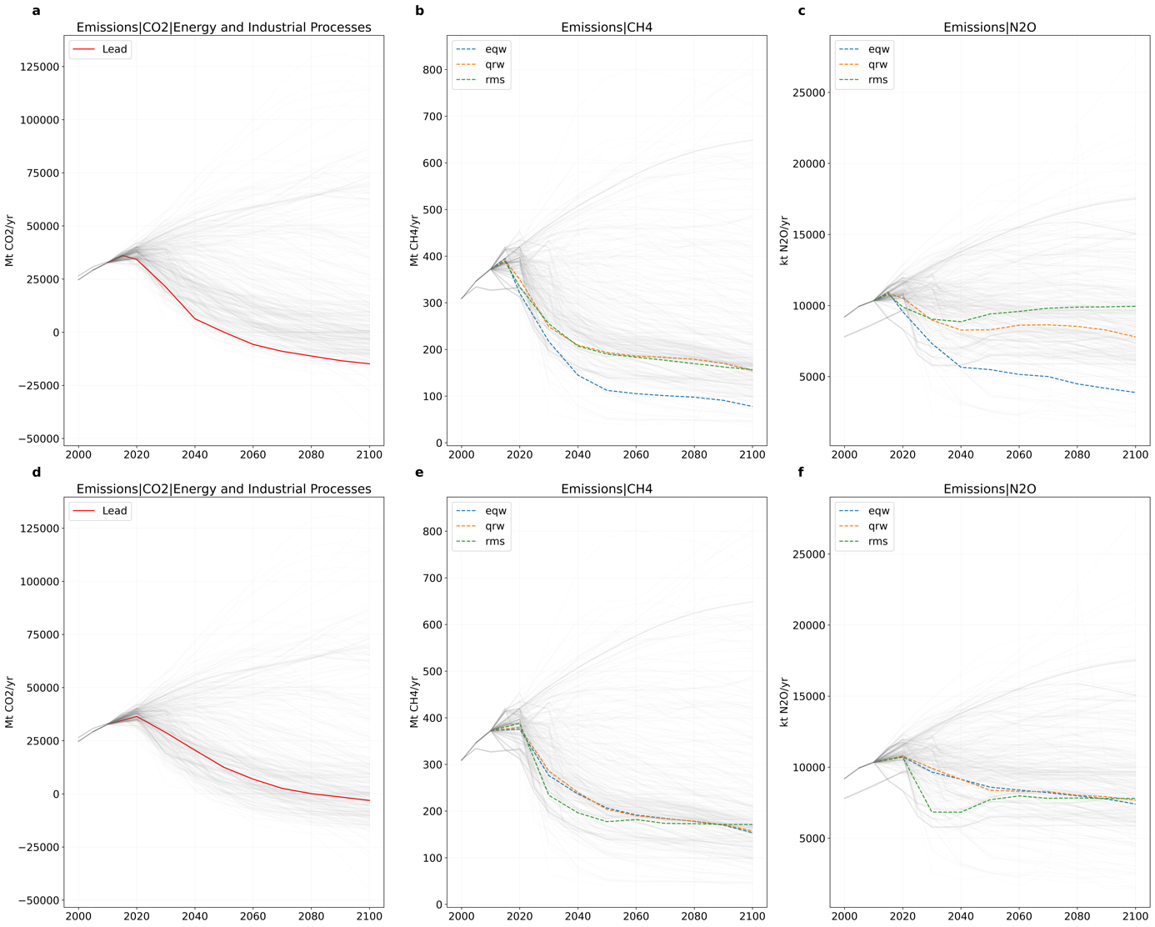
Figure S1: Effect of the infilling method for a given lead gas for (a – c) IEA NZE scenario and (d – f) Equinor Rebalance scenario

The RMS pathway selection method can lead to the infilling of relatively extreme emissions that are not necessarily driven by the lead gas. The IEA NZE scenario demonstrates this – while the lead gas emissions drop steeply, the pathway that is selected has relatively high N₂O emissions (rms line in Figure S1b and c) that indicate a model-specific result. A similar effect is observed for the corresponding emissions for the Equinor Rebalance scenario. On the other hand, the EQW method’s inherent assumption of monotonicity can lead to large reductions in the infilled gas without a clear correlation to the lead gas reduction – we see this in the stringent CH₄ reductions in the IEA NZE scenario in panel b (for more details see previously published discussion of the methods¹⁹). Hence as a default case for the main results, we select the Quantile Rolling Windows (QRW) approach to provide a balanced and consistent approach to infer the missing emissions.

Climate assessment – key characteristics of the pathways

The categorisation of pathways on the basis of their climate impact follows the categorisation scheme adopted in SR1.5⁶³, where categories were constructed based on the probability of exceeding a given temperature target. The categories and their respective exceedance probabilities (P) are adapted from SR1.5 and presented in the table below:

Table S3 SR1.5 climate categories for pathways
Pathway category | Criteria for assignment
Below 1.5°C | P1.5°C <= 0.50
1.5°C low overshoot | 0.50 < P1.5°C <= 0.67 and P1.5°C (2100) <= 0.50
1.5°C high overshoot | 0.67 < P1.5°C and P1.5°C (2100) <= 0.50
Lower 2°C | P2.0°C <= 0.34 (excluding above)
Higher 2°C | 0.34 < P2.0°C <= 0.50
Above 2°C | P2.0°C > 0.50

We present the variation of the climate categorization across the different infilling methods assessed in this study. In only one case is there a change in categorization due to infilling method because the scenario results lie near the boundary between two categories.

Table S4 Categorisation across different infilling methods
Scenario/IF method | QRW | RMS | EQW
IEA (NZE) | 1.5C low overshoot | 1.5C high overshoot | 1.5C low overshoot
BP (Net Zero) | 1.5C high overshoot | 1.5C high overshoot | 1.5C high overshoot
BP (Rapid) | Lower 2C | Lower 2C | Lower 2C
Equinor (Rebalance) | Lower 2C | Lower 2C | Lower 2C
IEA (SDS) | Lower 2C | Lower 2C | Lower 2C
Shell (Sky) | Lower 2C | Lower 2C | Lower 2C

Mitigation lever results

Table S5 Comparison of mitigation levers
Mitigation  Lever | Pathway | Source | Level compared to 2010 (%)  Median  (Interquartile Range)
Mitigation  Lever | Pathway | Source | 2030 | 2050
E_{t} | Below 1.5C [7] | SR15 | 84 (96, 82) | 89 (112, 85)
E_{t} | 1.5C low overshoot [43] | SR15 | 103 (109, 92) | 112 (122, 95)
E_{t} | 1.5C high overshoot [35] | SR15 | 125 (129, 118) | 138 (147, 120)
E_{t} | Lower 2C [74] | SR15 | 113 (126, 103) | 127 (138, 112)
E_{t} | Higher 2C [58] | SR15 | 124 (133, 112) | 144 (151, 122)
E_{t} | Above 2C [188] | SR15 | 134 (143, 127) | 160 (178, 148)
E_{t} | Rebalance | equinor | 113 | 98
E_{t} | Sky | shell | 124 | 149
E_{t} | SDS | IEA | 109
E_{t} | NZE2050 | IEA | 106 | 93
CI_{t} | Below 1.5C [7] | SR15 | 47 (50, 42) | 4 (10, 3)
CI_{t} | 1.5C low overshoot [43] | SR15 | 62 (72, 57) | 11 (18, -0)
CI_{t} | 1.5C high overshoot [35] | SR15 | 73 (82, 66) | 9 (22, 3)
CI_{t} | Lower 2C [74] | SR15 | 71 (81, 61) | 29 (34, 23)
CI_{t} | Higher 2C [58] | SR15 | 80 (82, 74) | 38 (45, 28)
CI_{t} | Above 2C [188] | SR15 | 94 (103, 88) | 84 (98, 61)
CI_{t} | Rebalance | Equinor | 79 | 40
CI_{t} | Sky 1.5 | Shell | 89 | 40
CI_{t} | SDS | IEA | 76
CI_{t} | NZE | IEA | 62 | 0

References
1. Lamboll, R. D., Nicholls, Z. R. J., Kikstra, J. S., Meinshausen, M. & Rogelj, J. Silicone v1.0.0: An open-source Python package for inferring missing emissions data for climate change research. Geosci. Model Dev. 13, 5259–5275 (2020).
2. Rogelj, J. et al. Chapter 2: Mitigation Pathways Compatible with 1.5°C in the Context of Sustainable Development. in Global Warming of 1.5°C. An IPCC Special Report on the impacts of global warming of 1.5°C above pre-industrial levels and related global greenhouse gas emission pathways, in the context of strengthening the global response to the threat of climate change (eds. Masson-Delmotte, V. et al.) (IPCC, 2018).

