List of Tables
Table S1 Response Surface Test Plan and Results
Table S2 Basic information of whole genome sequence of Aeribacillus pallidus GW- E
Table S3 Putative genes related to nitrogen metabolism in Aeribacillus pallidus GW-E
Table S4 Putative genes involved in temperature related in Aeribacillus pallidus GW -E
Table S5 Basic information of COG functional annotation categories of Aeribacillus pallidus GW- E genome.

List of Figures
Fig.S1 Single factor test results
Fig. S2 Basic information of COG functional annotation categories of Aeribacillus pallidus GW-E genome.

Table S1 Response Surface Test Plan and Results
sample number | level |  |  | Ammonia nitrogen conversion rate(%)
sample number | Temperature(℃) | pH | C/N | Ammonia nitrogen conversion rate(%)
1 | 60 | 7 | 10 | 79.21%
2 | 50 | 8 | 15 | 86.38%
3 | 60 | 8 | 15 | 82.30%
4 | 55 | 8 | 10 | 90.43%
5 | 50 | 8 | 5 | 52.54%
6 | 55 | 8 | 10 | 98.25%
7 | 55 | 8 | 10 | 98.00%
8 | 55 | 9 | 15 | 99.89%
9 | 60 | 9 | 10 | 88.21%
10 | 60 | 8 | 5 | 75.21%
11 | 55 | 9 | 5 | 83.24%
12 | 55 | 8 | 10 | 97.16%
13 | 50 | 9 | 10 | 79.84%
14 | 55 | 7 | 5 | 70.05%
15 | 50 | 7 | 10 | 75.24%
16 | 55 | 7 | 15 | 89.23%
17 | 55 | 8 | 10 | 96.22%

Table S2 Basic information of whole genome sequence of Aeribacillus pallidus sp.GW-E
Item | Result
Genome Size(bp） | 3,821,580bp
GC Content(%) | 39.08%
Depth | 111.79
Protein coding genes | 3668
Gene Total Len (bp) | 3,113,958 bp
Gene Average Len(bp) | 848.95 bp
Gene Density | 0.96
Gene Len/Genome (%) | 81.48%
tRNAs | 83
rRNAs | 20
Tandem repeats | 33
Genomics islands | 18

Table S3 Putative genes related to nitrogen metabolism in Aeribacillus pallidus sp.GW-E
Gene ID | Gene Name | KO ID | Description | Size (bp)
gene0262 | npd | K00459 | secondary thiamine-phosphate synthase enzyme YjbQ | 1086
gene0924 | npd | K00459 | secondary thiamine-phosphate synthase enzyme YjbQ | 402
gene1279 | glnA | K00459 | nitronate monooxygenase | 1359
gene2109 | glnA | K01915 | type I glutamate--ammonia ligase | 1335
gene1976 | gdhA | K00262 | glutamate dehydrogenas | 1380
gene2254 | nirA | K00366 | ferredoxin--nitrite reductase | 1626
gene2415 | gudB | K00260 | Glu/Leu/Phe/Val dehydrogenase | 1257
gene2501 | gltD | K00266 | glutamate synthase subunit beta | 1482
gene2502 | gltB | K00265 | glutamate synthase large subunit | 4560
gene3291 | - | K01501 | carbon-nitrogen hydrolase family protein | 957
gene3478 | - | K01501 | carbon-nitrogen hydrolase family protein | 1137

Table S4 Putative genes involved in temperature related genes in Aeribacillus pallidus sp.GW-E
Geng ID | Gene name | KO ID | NR Description | Size (bp)
gene1665 | cspA | K03704 | cold-shock protein CspD | 204 bp
gene1820 | cspA | K03704 | cold-shock protein CspD | 201 bp
gene2337 | - | K13993 | hypothetical protein | 468 bp
gene2987 | - | K13993 | Hsp20/alpha crystallin family protein | 441 bp
gene0063 | lysS | K04567 | RNA-binding S4 domain-containing protein | 264 bp
gene1817 | - | K06994 | transporter | 3126 bp
gene2680 | recD | K03581 | ATP-dependent RecD-like DNA helicase | 2376 bp
gene0826 | vacB | K12573 | ribonuclease R | 2298 bp
gene2153 | rbfA | K02834 | 30S ribosome-binding factor RbfA | 360 bp
gene2459 | punA | K03783 | purine-nucleoside phosphorylase | 819 bp
gene0005 | gyrB | K02470 | DNA gyrase subunit B | 1932 bp
gene0078 | hslO | K04083 | Hsp33 family molecular chaperone HslO | 885 bp
gene0123 | ctsR | K03708 | transcriptional regulator of stress and heat shock response | 678 bp
gene0439 | groES | K04078 | Chaperonin GroES (HSP10family) | 285 bp
gene0440 | groEL | K04077 | Chaperonin GroEL (HSP60 family) | 1623 bp
gene2636 | dnaJ | K03686 | molecular chaperone DnaJ | 1131 bp
gene2270 | dksA | K06204 | molecular chaperone DnaK | 291 bp
gene2637 | dksA | K04043 | molecular chaperone DnaK | 1833 bp
gene2638 | GRPE | K03687 | nucleotide exchange factor GrpE  （heat shock protein HSP-70 | 633 bp
gene0075 | Ftsh | K03798 | metalloprotease FtsH | 1962 bp
gene2819 | Ftsh | K04088 | FtsH protease activity modulator HflK | 1011 bp
gene1080 | clpB | K03695 | ATP-dependent chaperone ClpB | 2640 bp
gene1853 | clpC | K03696 | ClpA/ClpB-like protein | 768 bp

Table S5 Basic information of COG functional annotation categories of Aeribacillus pallidus sp.GW-E genome.
Sample Name | COG Category No. | COG Type No. | Gene No. | Percent of All Genes (%)
A1 | 4 | 23 | 2990 | 81.52
Note: 1) Sample Name: Sample Name; 2) COG Category No.: The number of COG categories; 3) COG Type No.: Number of COG types; 4) Gene No.: Number of genes; （5）Percent of All Genes： The percentage of genes with COG annotations among all genes.

Fig.S1 Single factor test results
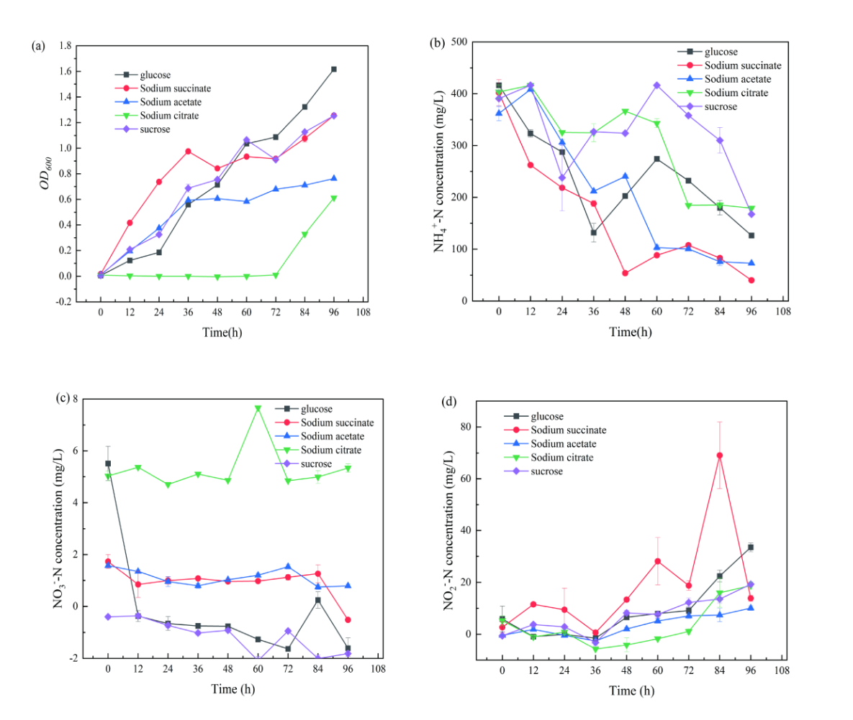
Figure 1.1 The effect of different carbon sources on the heterotrophic nitrification performance of bacterial strains GW-E
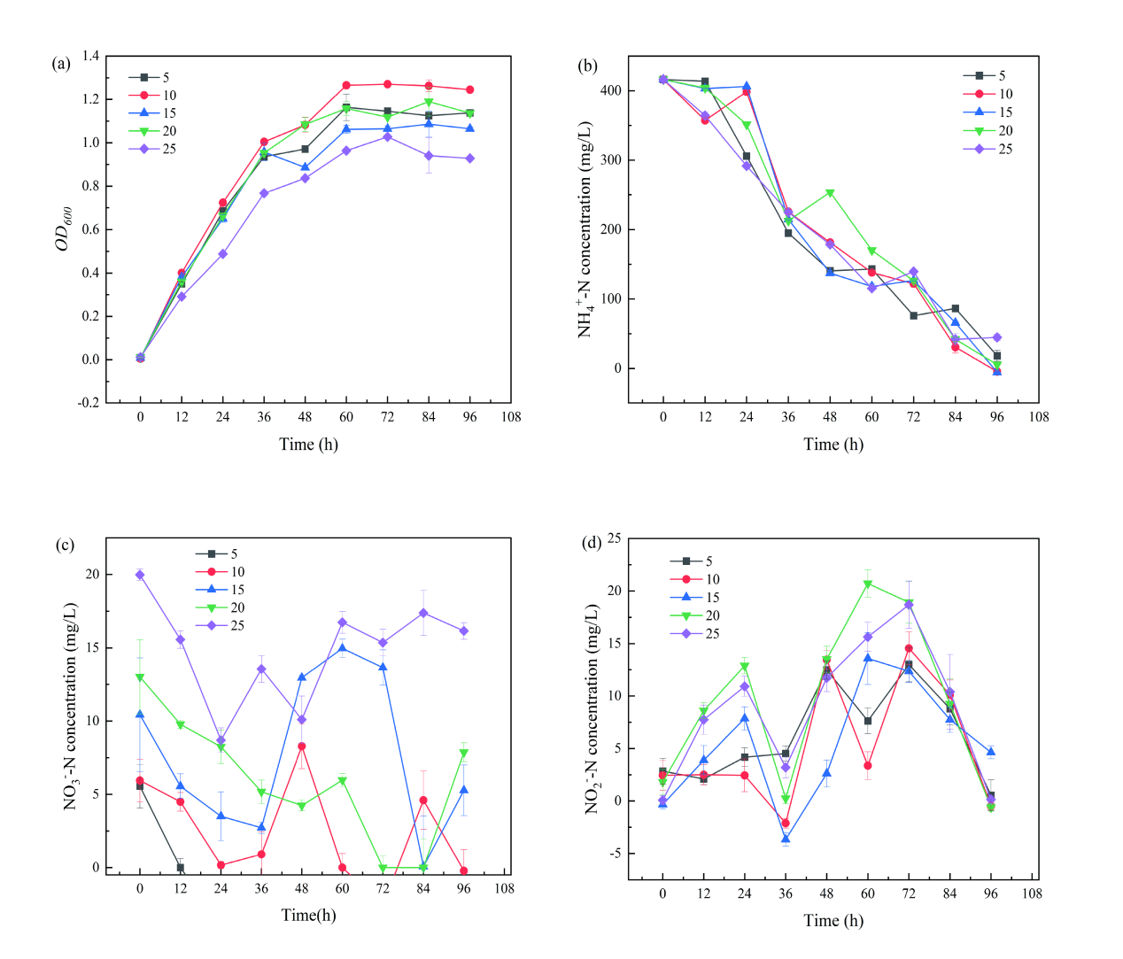
Figure 1.2 The effect of different C/N ratios on the heterotrophic nitrification performance of bacterial strains GW-E
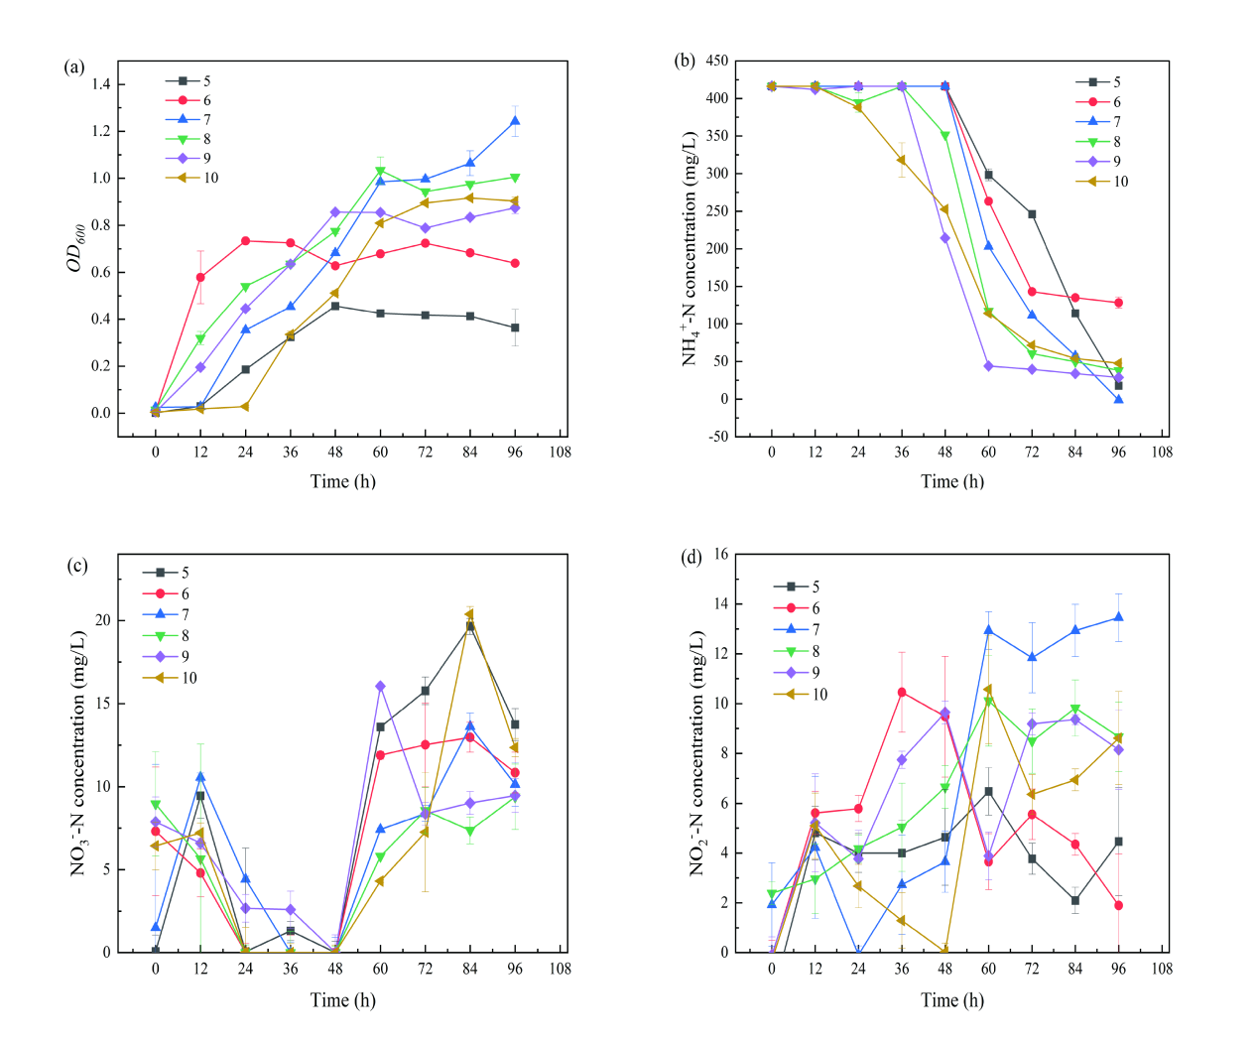
Figure 1.3 The effect of different pH on the heterotrophic nitrification performance of bacterial strains GW-E

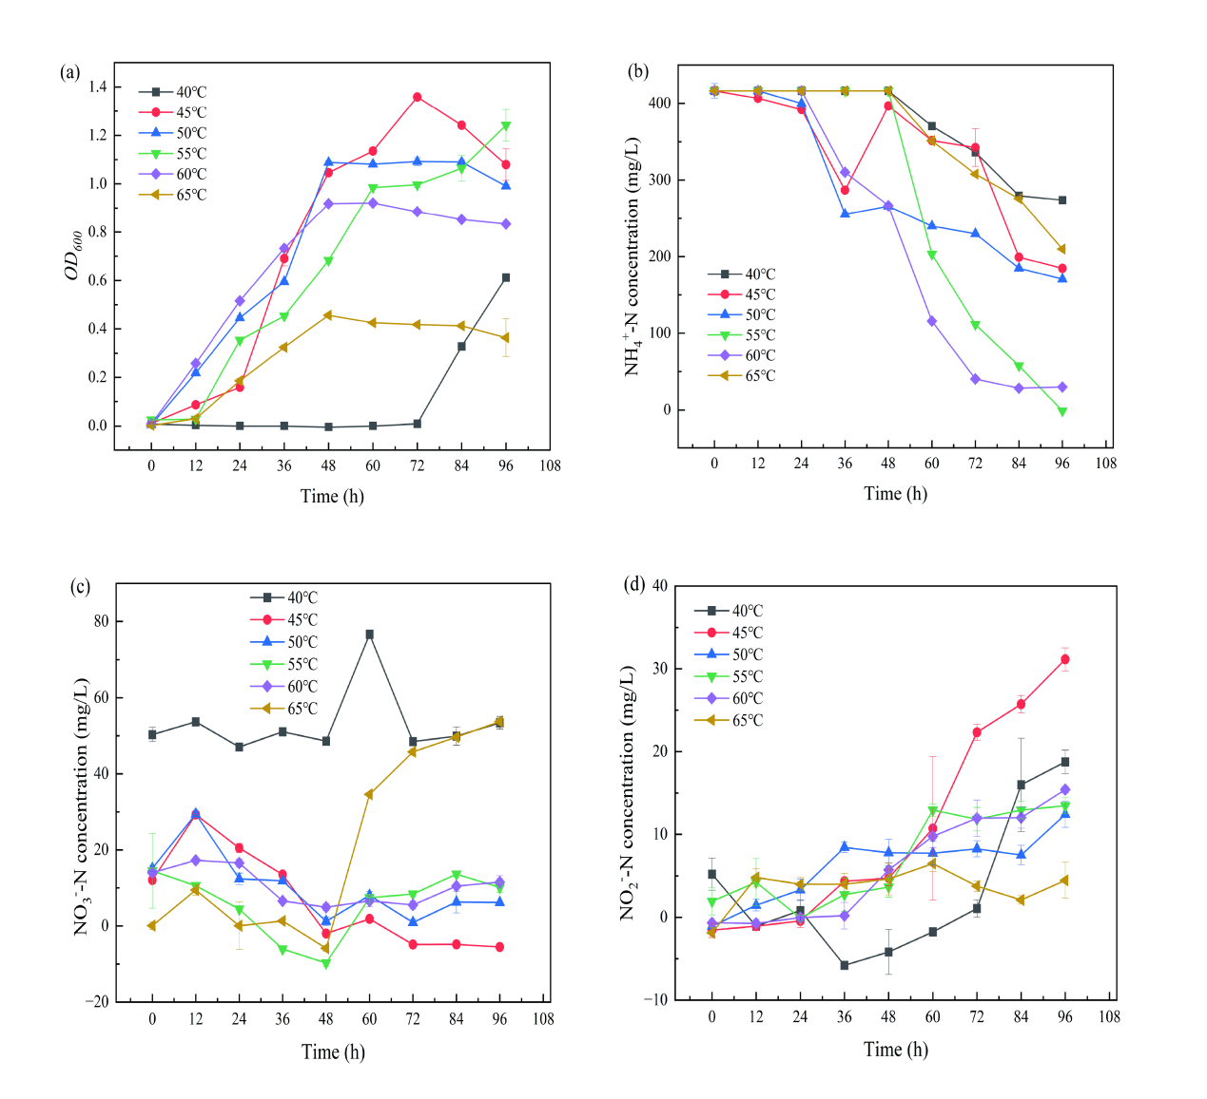
Figure 1.4 The effect of different temperature on the heterotrophic nitrification performance of bacterial strains GW-E

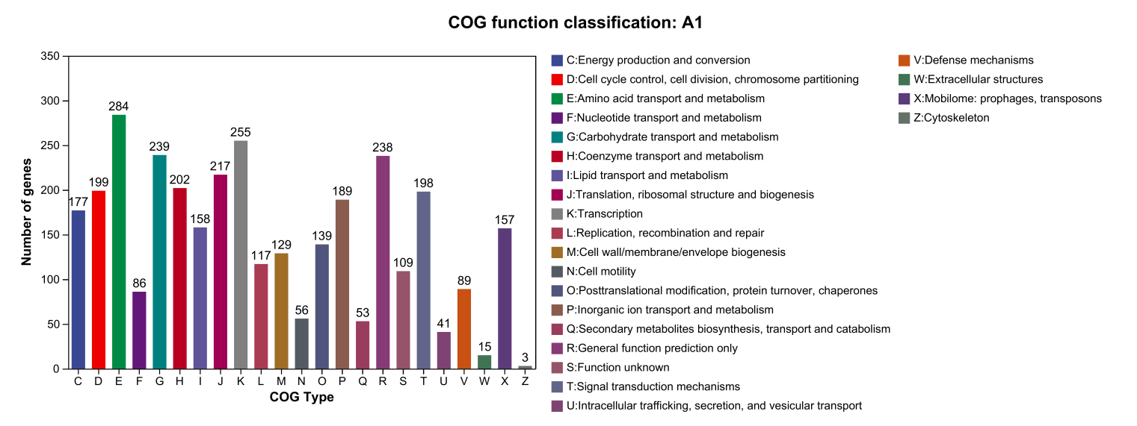
Fig. S2 Basic information of COG functional annotation categories of Aeribacillus pallidus GW-E genome.

