Supplemental results

Table 1. Clinical features of cohort’s patients carrying a VUS. Abbreviations: Y : years ; M : months ; OFC: occipital frontal circumference; NA : non available ; ADHD: attention deficit hyperactivity disorder; ASD: autism spectrum disorder; UCS: unilateral convergent strabismus.
 | Individual 11 | Individual 12 | Individual 13 | Individual 14 | Individual 15 | Individual 16 | Individual 17
 | Other VUS | Missense | Missense | Missense | Missense | Other VUS | Other VUS
Gender | Male | Male | Male | Male | Male | Male | Male
Age | 38Y | 2Y6M | 4Y | 12Y1M | 19Y2M | 4Y | 9Y9M
Gestation and birth
Events during pregnancy | - | - | - | - | - | - | Abnormal bright spot in intestines
Age of delivery (weeks of gestational age) | 42 | 38+3 | 39 | 37 | 38+3 | 38+6 | 40
Events during delivery/perinatal period | Induction of labour | - | - | - | - | - | At birth: terminal bradycardia and respiratory depression, APGAR: 6/9, required stimulation, suction, and blow-by  Good recovery, return home at day of life 3
Birth weight: g (percentile) | 3,175 (4th) | 4,190 (98th) | 3,100 (28th) | 3,120 (65th) | 3,330 (57th) | 2,940 (19th) | 3,118 (16th)
Birth length: cm (percentile) | NA | 54 (97th) | 51 (63th) | 50 (76th) | 50 (55th) | 48 (18th) | 49.5 (23th)
Birth OFC: cm (percentile) | NA | 33.5 (32th) | 33 (15th) | 33 (41th) | 34.5 (58th) | 33 (16th) | 34 (23th)
Events during neonatal period | - | Uncomplicated hyperbilirubinemia | - | - | - | - | -
Last measurements
Weight: kg (percentile) | NA | 15.4 (88th) | 21 (97th) | 42 (55th) | 69 (49th) | 15.4 (33th) | 39.6 (88th)
Height: cm (percentile) | 175.5 (43th) | 98.5 (97th) | 112 (99th) | 150 (52th) | 176 (46th) | 105 (74th) | 144.4 (86th)
OFC: cm (percentile) | 56.5 (83th) | NA | 52 (87th) | 54 (56th) | 58 (98th) | 49 (17th) | 55.5 (98th)
Intellectual disability (ID) | + | Suspected | Suspected | + | + | Suspected | +
Type | Moderate ID | NA | NA | Mild ID | Mild ID | N | Severe ID
Developmental delay | + | + | + | - | - | + | +
Type | Global | Global | Global | No motor developmental delay | No motor developmental delay | Language | Language
Age of sitting | NA | NA | 9M | 9M | 9M | NA | 7M
Age of walking | 18-20M | 10M | 17M | 16M | 17M | 17M | 13M
Age of first words | 3Y | 13M | 3Y | NA | NA | 2Y7M | 4Y
Age of first sentences | 5-6Y | Not acquired | Not acquired | NA | NA | Not acquired | 4Y
Language at last assessment | Sentences | 1-2 words | Some echolalia, expression by shouting, comprehension limited to few simple commands | Normal | Normal | Words association | Begins to have language development at a 30M level, with upward deviation to a 3 year-old level
Other neurodevelopmental disorders | ADHD | ASD | ASD, hyperactive behavior | Concentration disorder | NA | Attention deficit | ASD, agitation
Psychiatric disorders | - | - | Behavioral disorders (auto-aggressiveness, anger), selective eating and orality disorder | Anxiety, verbal and physical aggressiveness | Anxiety, depression, child psychosis, suicide attempt | - | Aggressiveness
Seizures | - | - | - | - | NA | - | -
Other neurologic features | - | Generalized hypotonia | - | NA | NA | - | Hypotonia
Brain imagery | NA | Stable subcentimeter cystic space in the right temporal lobe without any suspicious features, and bifrontal periventricular gray matter heterotopias | NA | Unremarkable | NA | Unremarkable | Pituitary gland within normal limits
Morphological features
Abnormal morphological features | + | + | + | + | + | + | -
Details | Thick eyebrows, broad nose, wide philtrum, full lips, bilateral clinodactyly, medial deviation of his distal interphalangeal joints, wide sandal gap | Epicanthal folds, flat nasal bridge, wide mouth, bifid uvula | Abnormal front hair implantation, eyesbrows with thin external tier, bulbous nose, short philtrum, two café-au-lait stain | High-arched palate | High-arched palate | Small anteverted nose, large philtrum, large ears | -
Visual impairments | - | Myopia, astigmatism | - | - | NA | - | Low myopia
Strabismus | - | - | - | UCS | NA | - | -
Auditory impairments | - | - | - | NA | NA | - | -
Other clinical features | - | Laryngomalacia, obstructive sleep apnea | Decreased pain sensitivity (reported by parents) | Sacrococcygeal cyst | Sacrococcygeal cyst | - | -

Table 2. a- Molecular details of all missense variants in the present cohort and the secondarily reclassified p.(Arg574Gln) variant. Molecular details and ACMG criteria for the p.(Arg385Cys), p.(Ser491Cys) and p.(Arg661Trp) variants classified as variant of uncertain significance (VUS), and the reclassified as likely benign p.(Arg574Gln) variant.
 | Individual 11 | Individual 12 | Individuals 13 and 14 | Siblings with reclassified variant
Variant (NM_021120.4) | c.1153C>T | c.1472C>G | c.1981C>T | c.1721G>A
Variant (protein) | p.(Arg385Cys) | p.(Ser491Cys) | p.(Arg661Trp) | p.(Arg574Gln)
DLG3 variant evidenced by | Exome sequencing | Genes panel | Exome sequencing | Genes panel
GnomAD v4.1.0 | 1 male | Absent | Absent | 18 males and 24 females
Frequency in European non-Finnish males in gnomAD v4.1.0 | 0.000001 | / | / | 0.00006
Domain | PDZ-associated domain of NMDA receptors | No | Guanylate kinase domain | No
Tolerance (MetaDome) | Neutral (0.79) | Intolerant (0.27) | Intolerant (0.47) | Intolerant (0.29)
In silico scores | Overall damaging effect (polyphen-2: 0.98; CADD: 27.6; REVEL 0.54) | Contradictory (CADD: 26; polyphen-2: 0.97; REVEL: 0.431)  No splicing effect | Damaging effect (CADD: 25.9; polyphen-2: 1; REVEL: 0,614) | Overall damaging effect (CADD: 24.8; Polyphen-2: 0.428; REVEL: 0.74)  Uncertain splicing effect (SPiP: 47.89; spliceAI: negative)
Modeling (Figure 2) | Predicted to have little impact on structure and on surface charge but could be sufficient to induce a perturbation of the third PDZ domain | Little structural impact expected but disulfide bridge formation cannot be ruled out | Important structural perturbation | Visible change in surface charge with no interaction predicted with the third PDZ domain
Fauchère and Pliska hydrophobicity scale | From -1.01 (hydrophilic) to 1.54 (hydrophobic) | From -0.04 (slightly hydrophilic) to 1.54 (hydrophobic) | From -1.01 (hydrophilic) to 2.25 (hydrophobic) | From -1.01 (hydrophilic) to -0.22 (hydrophilic)
ACMG classification and  ACMG criteria | 3  PP3 BP1 | 3  PM2 BP1 | 3  PM2 PP3 BP1 | 2  PP3 BS1 BP1
Final reclassification | VUS | VUS | VUS | Likely benign

Table 2. b- Molecular and clinical details of literature patients’ carriers of a missense variant. “Causal” is indicated when the authors classified a variant as causal for the patient’s phenotype but precise original variant classification was not available. *This variant was present in an individual in association with the NM_021120:c.48G>C variant, which is not represented in this table as we were unable to confirm its nomenclature. Abbreviations: ASD: autism spectrum disorder; DD: developmental delay; ID: intellectual disability, ADHD: attention deficit with hyperactivity.
Variants (cDNA) | Variants (protein) | Main clinical features | GnomAD v4.1.0 | In silico scores | Original variant classification | Reclassification and ACMG criteria | Reported in
c.18C>G | p.(His6Gln) | Seizure, ASD, DD, ID | Absent | CADD: 25.2; Polyphen-2: 0.93, REVEL: 0.151 | Causal | - | He et al.  Case 1
c.128G>T | p.(Gly43Val) | Seizure without neurodevelopmental disorder and normal brain MRI | 5 males and 18 females | CADD: 23.4; Polyphen-2: 0.999, REVEL: 0.107 | Causal | Likely benign  BP1 BS1 | He et al.  Case 2
c.128G>T | p.(Gly43Val) | Seizure without neurodevelopmental disorder and normal brain MRI |  |  |  |  | He et al.  Case 3
c.251C>T | p.(Pro84Leu) | No description available | 6 males and 10 females | CADD: 22.8; Polyphen-2: 0.001, REVEL: 0.084 | 4 | Likely benign  BP1 BP4 BS1 | Marinakis et al.  Patient 8068
c.304G>A* | p.(Gly102Ser)* | Tall stature, macrocephaly, mild ID | 2067 males and 4616 females | CADD: 19.82; Polyphen-2: 0.001; REVEL: 0.064 | 3 | Likely benign  BP1 BS1 | Tzschach et al.  Patient 122038
c.463C>T | p.(Pro155Ser) | Seizure, gray matter heterotopias, mild ID | Absent in males, 3 females | CADD: 22.9; Polyphen-2: 0.898; REVEL:0.207 | Causal | - | He et al.  Case 4
c.593G>A | p.(Arg198Gln) | Seizure, ASD, ADHD, speech delay | 6 males and 9 females | CADD: 22.3; Polyphen-2: 0.724; REVEL: 0.115 | Causal | Likely benign  BP1 BS1 | He et al.  Case 5
c.1415G>A | p.(Arg472His) | Seizure, ID, speech delay | 2 males and 6 females | CADD: 30; Polyphen-2: 0.999; REVEL: 0.373 | Causal | - | He et al.  Case 6
c.1424C>T | p.(Ser475Leu) | ID | 13 males and 25 females | CADD: 24.5; Polyphen,-2: 0.952; REVEL: 0.266 | 3 | Likely benign  BP1 BS1 | Ibarluzea et al.  Family ID1010 (siblings)
c.1424C>T | p.(Ser475Leu) | ID
c.1486C>T | p.(Leu496Phe) | Moderate ID, global DD, cerebellar ataxia | Absent | CADD: 25.2; Polyphen-2: 0.999; REVEL: 0.159 | 3 | - | Taşkiran et al.  Family 5 (siblings)
c.1486C>T | p.(Leu496Phe) | Severe ID, global DD, cerebellar ataxia
c.1721G>A | p.(Arg574Gln) | ID, morphological features, ataxia, hypotonia, microcephaly, seizure | 18 males and 24 females | CADD: 24.8; Polyphen-2: 0.971; REVEL: 0.741; SPiP: 47.89 | 4 | Likely benign  BP1 BS1 | Bowling et al.  Patient 00063-C
c.1792G>A | p.(Asp598Asn) | Global DD, seizure or encephalopathy, gastrointestinal disorder, hearing loss or visual impairment | Absent | CADD: 23.7; Polyphen-2: 0; REVEL: 0.167 | 3 | - | van der Ven et al.  Patient HH_NEO064
c.1861C>T | p.(Arg621Trp) | Epileptic encephalopathy | Absent in males, 3 females | CADD: 28.4; Polyphen-2: 0.999; REVEL: 0.698 | 4 | - | Jiang et al  Patient ID 28
c.1998T>A | p.(Asn666Lys) | Seizure without neurodevelopmental disorder and normal brain MRI | Absent in males, 1 female | CADD: 20.7; Polyphen-2: 0.974; REVEL: 0.083 | Causal | - | He et al.  Case 7
c.2101C>T | p.(Leu701Phe) | ID, morphological features, language delay, ADHD, seizure, hirsutism, bone growth acceleration | Absent | CADD: 25; Polyphen-2: 1; REVEL: 0.504 | 3 | - | Chen et al.  Patient P21
c.2267G>A | p.(Arg756Gln) | Global DD, ID, epilepsy, behavioral disorder | 2 males and 5 females | CADD: 25.1; Polyphen-2: 0.7; REVEL: 0.071 | Causal | - | Alagoz et al.  Case 1
c.2359G>A | p.(Gly787Ser) | DD, ID, ASD | Absent in males, 1 female | CADD: 27; Polyphen-2: 1; REVEL: 0.534 | Causal | - | Alagoz et al.  Case 2
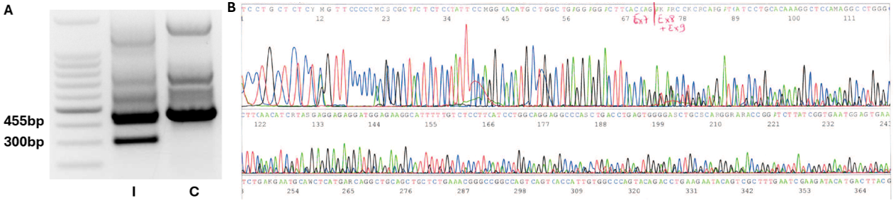
Figure 1. RT-PCR on RNA and Sanger sequencing performed in individual 4. (A) Electrophoresis showed two bands : one of the expected size (455bp) and the other around 300bp on the gel. Abbreviations: M: marker, I: individual 4, C: negative control. (B) Direct DNA sequencing results showing a dual sequence after exon 7 and the absence of exon 8 in heterozygous state. Separation between the end of exon 7 and the beginning of exon 8 or 9 is represented by a red line. Abbreviation: Ex: exon.

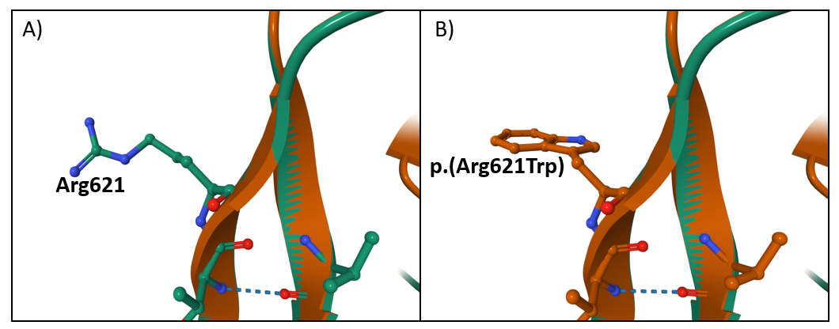
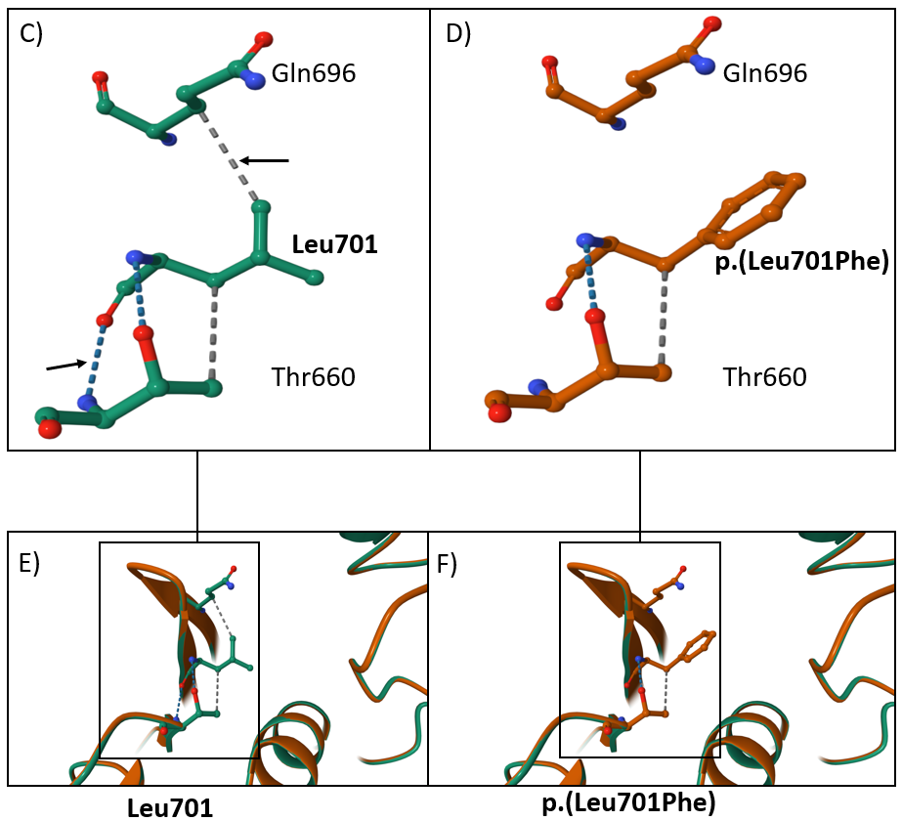
Figure 2. Modelling of two missense VUS from the literature. The prediction models for the p.(Leu496Phe) and the p.(Asp598Asn) variants are of low confidence and are not shown in the figure. A) and B) show wild-type residue 621 and the missense p.(Arg621Trp) variant respectively. No difference in binding is found. C) and E) show wild-type residue 701 and its environment, and bonds of interest lost with the variant (black arrows). D) and F) show the p.(Leu701Phe) variant and the loss of a hydrogen bond (blue dotted line) and a non-covalent hydrophobic bond (grey dotted line).

