Supplementary materials

Calibration is required for use of electromagnetic soil moisture sensors to accurately measure the water content of tree stems and sawdust
Jiaming Wang¹, Neil C. Turner², and Hailong He^{1, 3,} *
¹ College of Natural Resources and Environment, Northwest Agriculture and Forestry University, Yangling 712100, China
² UWA Institute of Agriculture, The University of Western Australia M062, 35 Stirling Highway, Perth, WA 6009, Australia
³ Department of Soil Science, University of Manitoba, Winnipeg, MB R3T 2N2, Canada
* Correspondence: hailong.he@hotmail.com (H.H.)

Supplementary figures
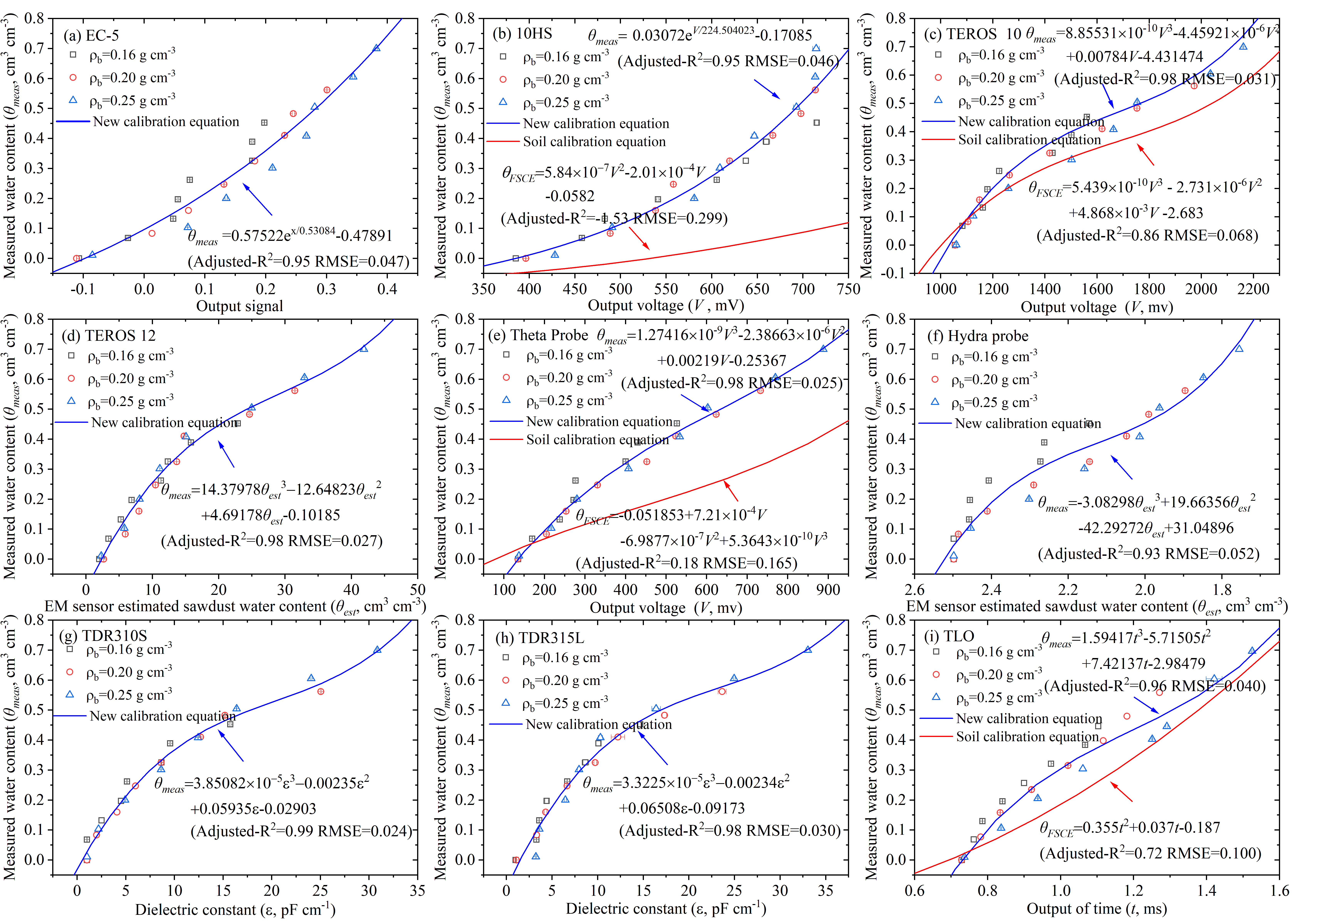
Fig. S1. Sensor output of nine commercial soil moisture sensors: (a) EC-5, (b) 10HS, (c) TEROS 10, (d) TEROS 12, (e) Theta Probe ML2X, (f) Hydra Probe, (g) TDR310S, (h) TDR315L, and (j) TLO against measured water content (θ_{meas}) of poplar sawdust at three different bulk densities and eight volumetric water contents. Line of best fit (blue line) and the factory-supplied calibration equation (FSCE) for soil water content when provided (red dashed line) and their equations are shown. See Table 3 for the equations. Experiment 1.

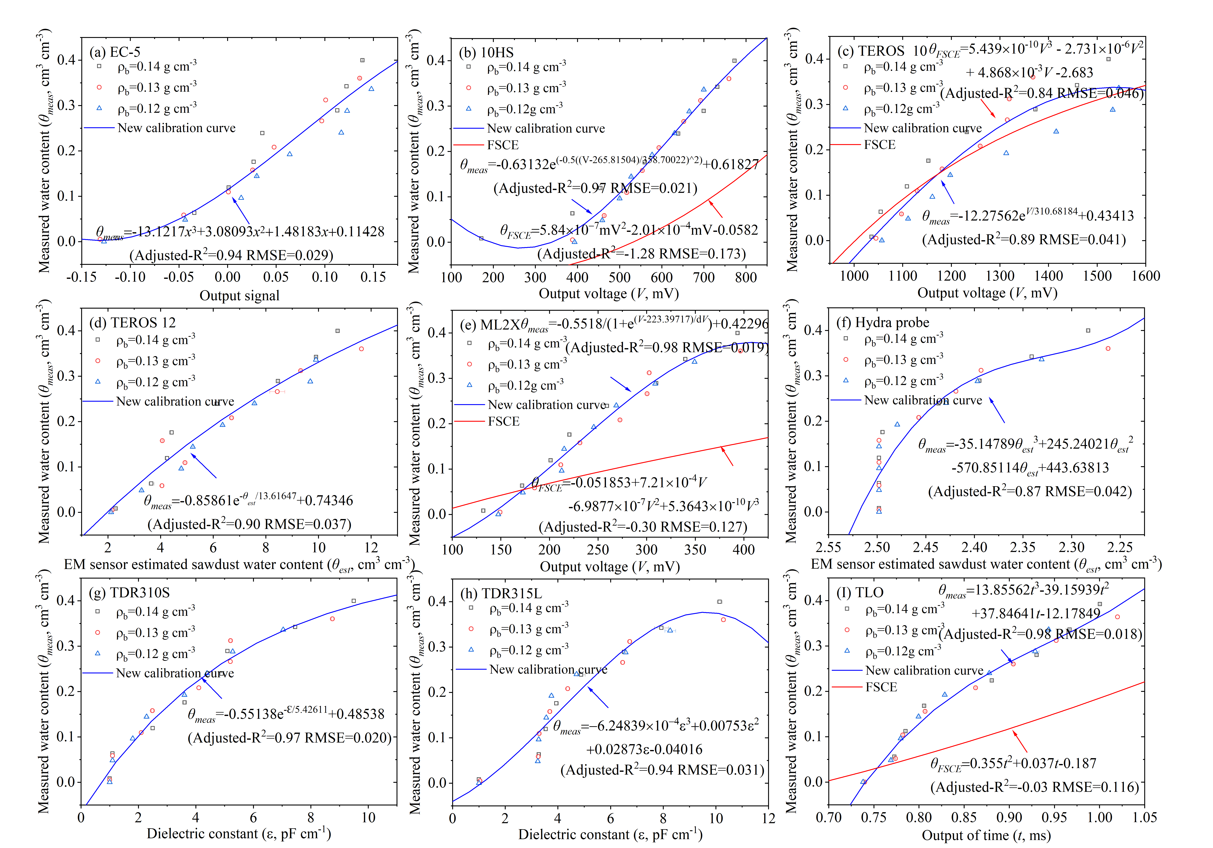
Fig. S2. Sensor output of nine commercial soil moisture sensors: (a) EC-5, (b) 10HS, (c) TEROS 10, (d) TEROS 12, (e) Theta Probe ML2X, (f) Hydra Probe, (g) TDR310S, (h) TDR315L, and (j) TLO against measured volumetric water content (θ_{meas}) of fir sawdust at three different bulk densities and a range of volumetric water contents. Line of best fit (blue line) and the factory-supplied calibration equation (FSCE) for soil water content when provided (red dashed line) and their equations are shown. See Table 3 for the equations. Experiment 1.
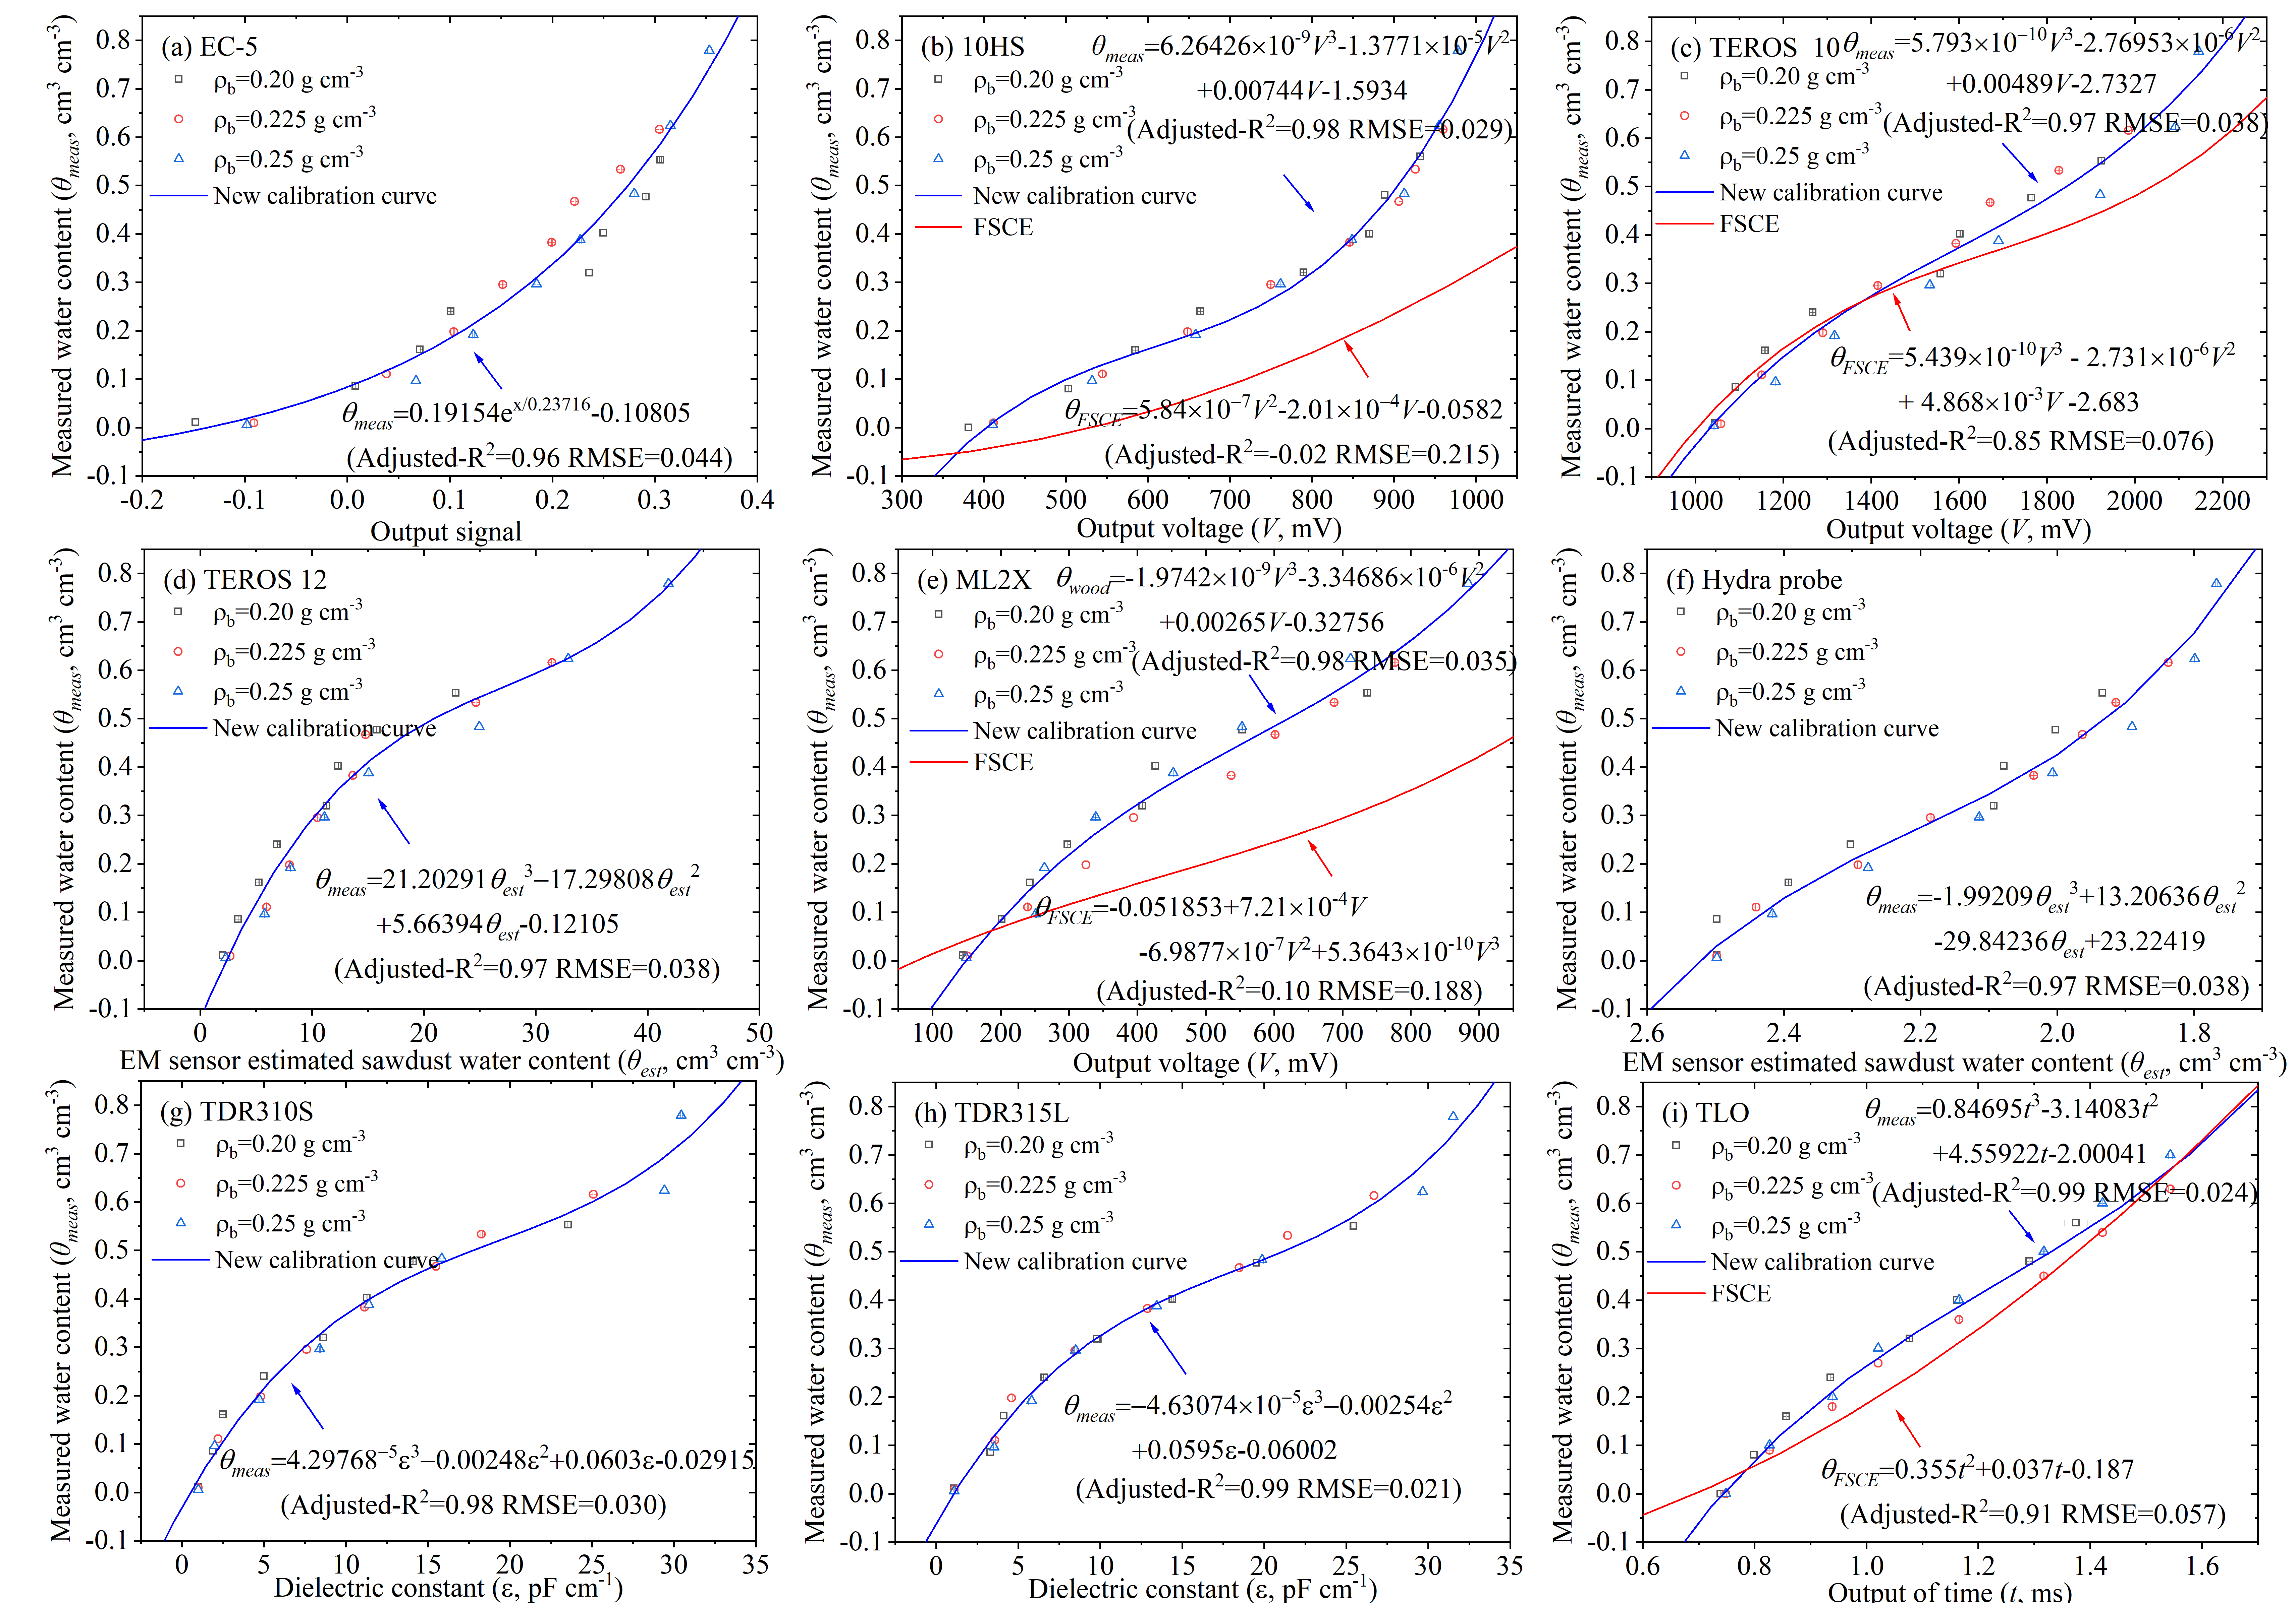
Fig. S3. Sensor output of nine commercial soil moisture sensors: (a) EC-5, (b) 10HS, (c) TEROS 10, (d) TEROS 12, (e) Theta Probe ML2X, (f) Hydra Probe, (g) TDR310S, (h) TDR315L, and (j) TLO against measured water content (θ_{meas}) of pine sawdust at three different bulk densities and a range of volumetric water contents. Line of best fit (blue line) and the factory-supplied calibration equation (FSCE) for soil water content when provided (red dashed line) and their equations are shown. See Table 3 for the equations. Experiment 1.
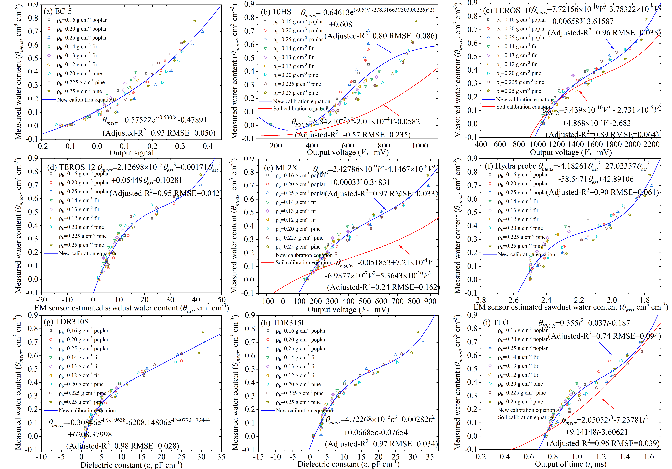
Fig. S4. Sensor output of nine commercial soil moisture sensors: (a) EC-5, (b) 10HS, (c) TEROS 10, (d) TEROS 12, (e) Theta Probe ML2X, (f) Hydra Probe, (g) TDR310S, (h) TDR315L, and (j) TLO against measured water content (θ_{meas}) of sawdust from poplar, fir and pine trees at three different bulk densities and a range of volumetric water contents. Line of best fit (blue line) of the combined data of the three species and the factory-supplied calibration equation (FSCE) for soil water content when provided (red dashed line) and their equations are shown. See Table 3 for the equations. Experiment 1.
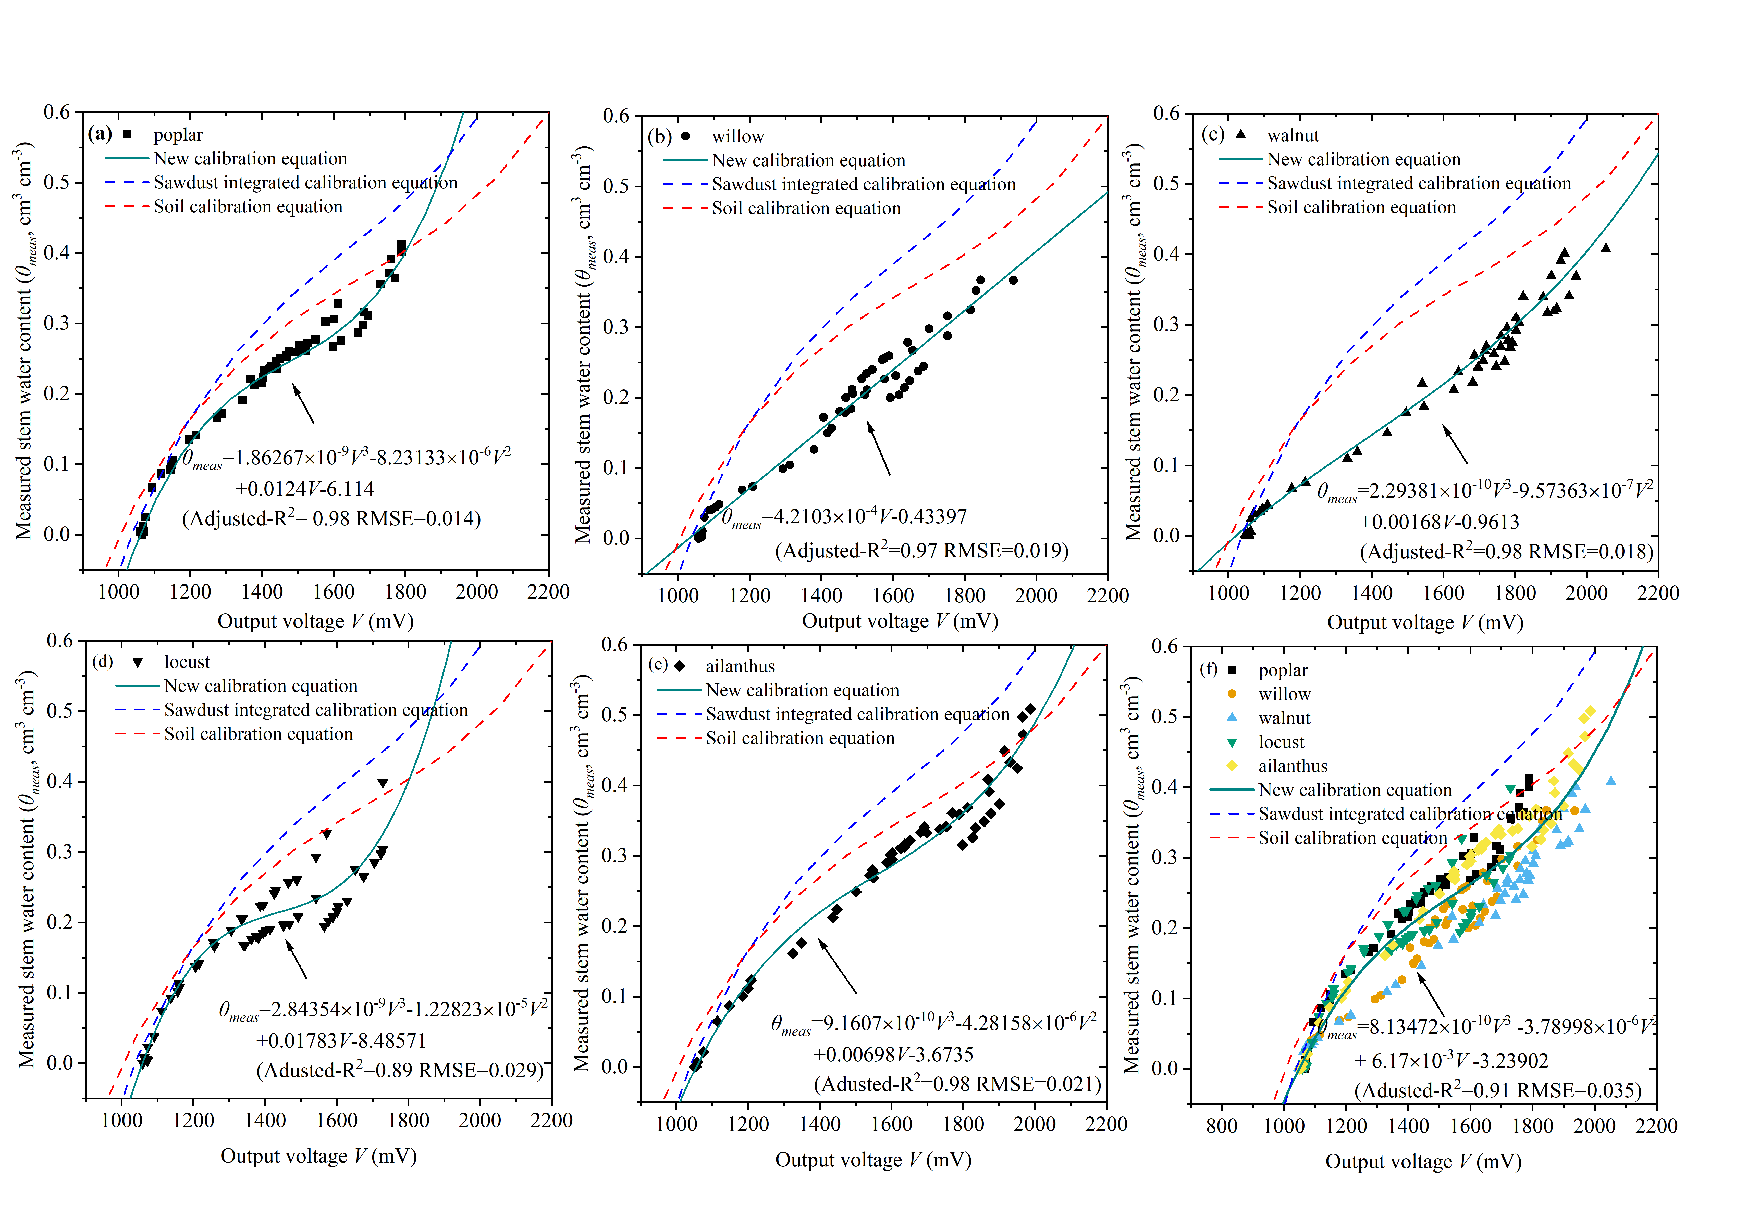
Fig. S5. Sensor output of the TEROS 10 against measured water content of tree stems segments (θ_{meas,} solid symbols) of five tree species: (a) poplar (b) willow (c) walnut (d) locust (e) ailanthus, and (f) the combination of all five species. The best-fit relationship to the data is shown by the solid green line and the equation is given. The dashed lines are for the best-fit calibration equations for the combination of all three species (blue), and the factory-supplied calibration equation (FSCE) for soil water content (red dashed line). See Table 4 for the equations. Experiment 2.
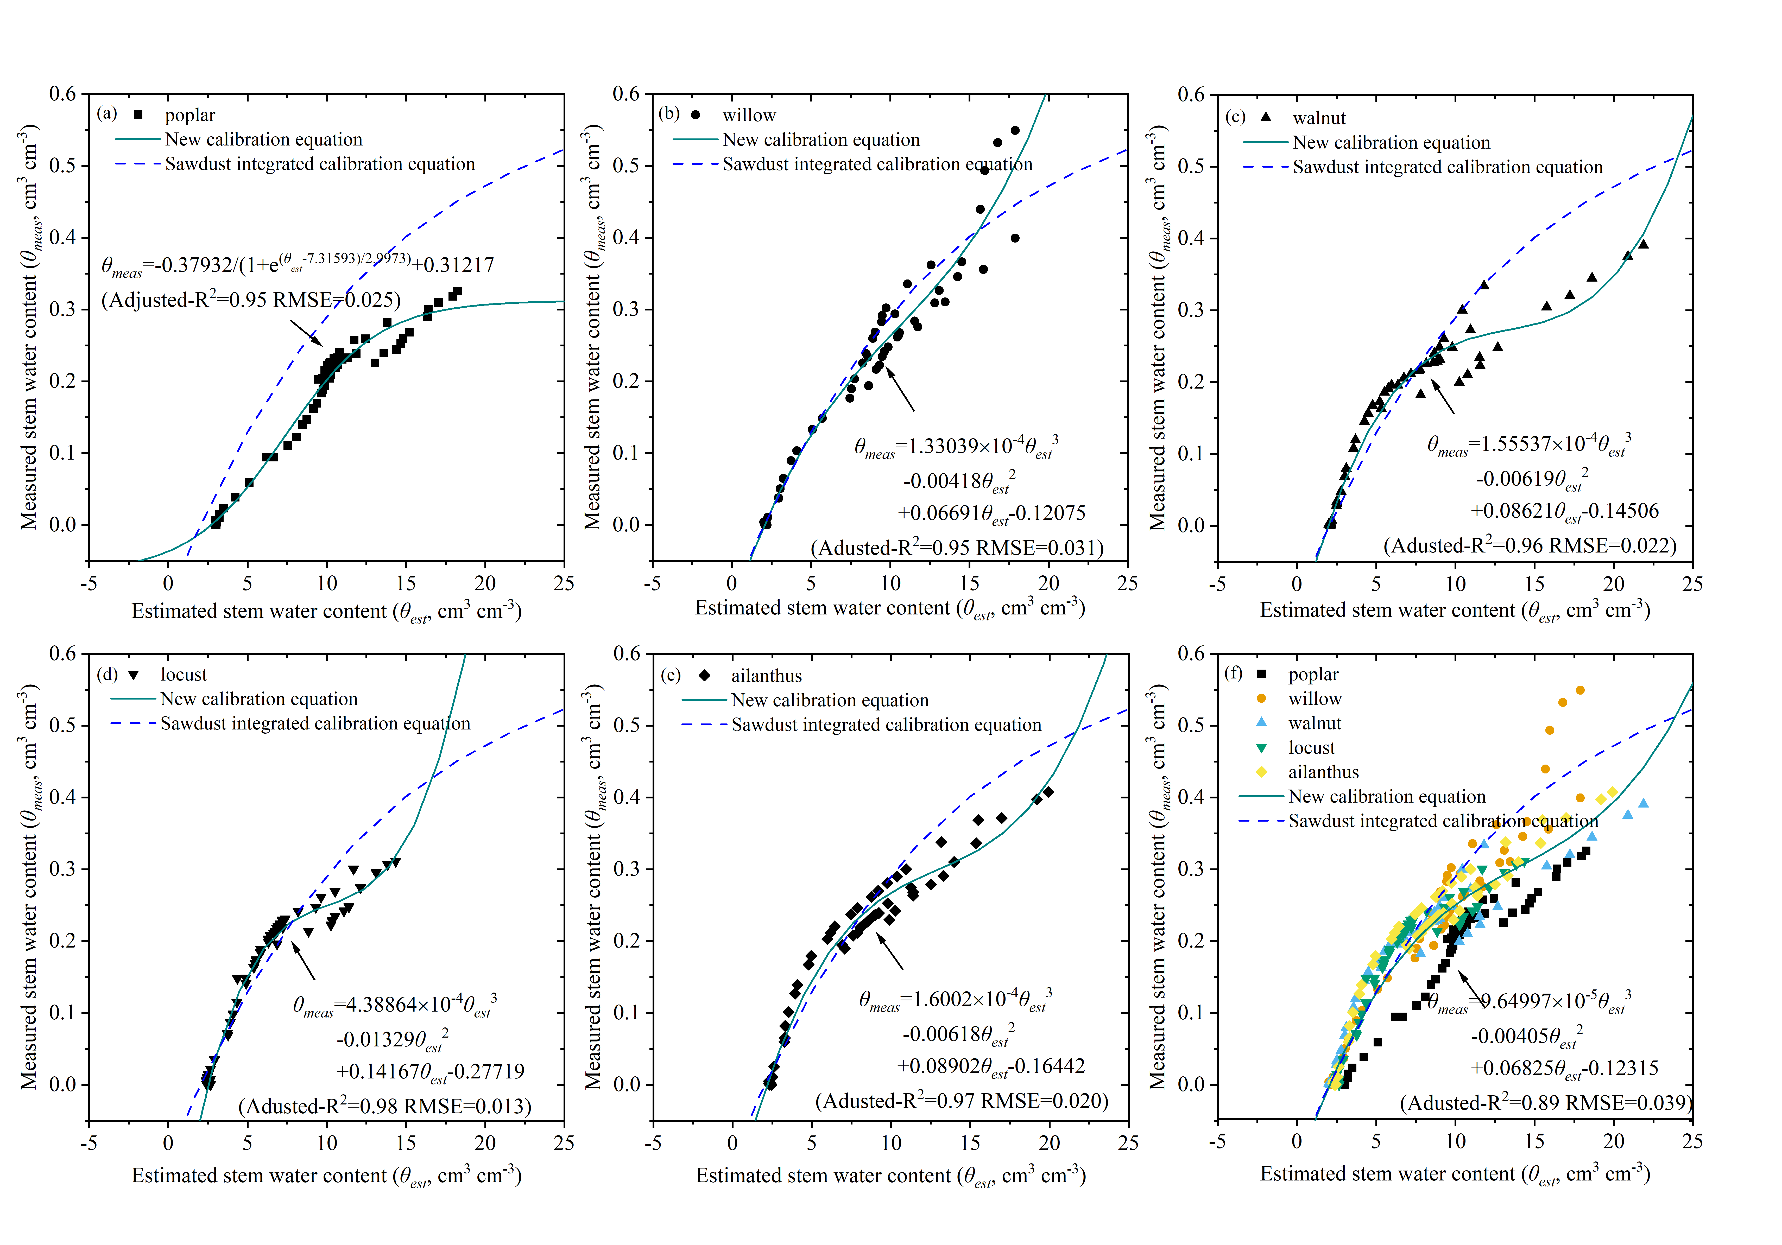
Fig. S6. Sensor output of the TEROS 12 (θ_{est}) against measured water content of tree stems segments (θ_{meas,} solid symbols) of five tree species: (a) poplar (b) willow (c) walnut (d) locust (e) ailanthus, and (f) the combination of all five species. The best-fit relationship to the data is shown by the solid green line and the equation is given. The dashed lines are for the best-fit calibration equations for the combination of all three species (blue). See Table 4 for the equations. Experiment 2.
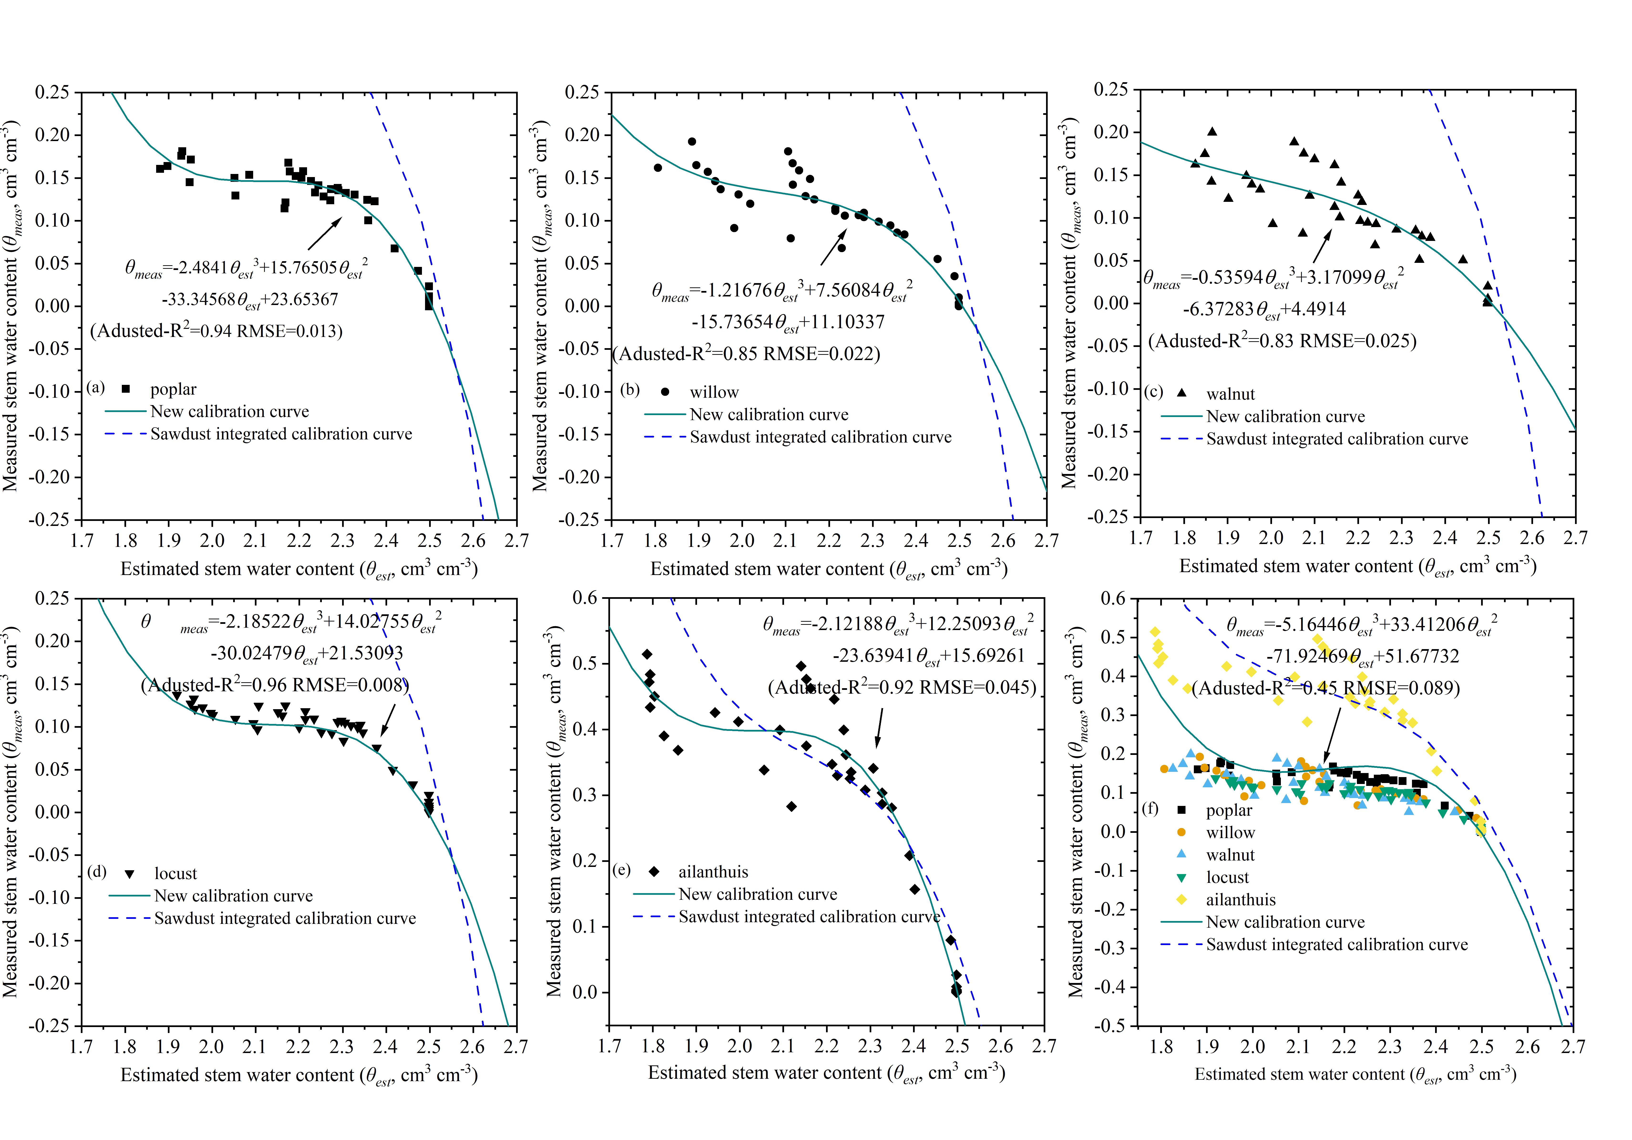
Fig. S7. Sensor output of the Hydra Probe (θ_{est}) against measured water content of tree stems segments (θ_{meas,} solid symbols) of five tree species: (a) poplar (b) willow (c) walnut (d) locust (e) ailanthus, and (f) the combination of all five species. The best-fit relationship to the data is shown by the solid green line and the equation is given. The dashed lines are for the best-fit calibration equations for the combination of all three species (blue). See Table 4 for the equations. Experiment 2.

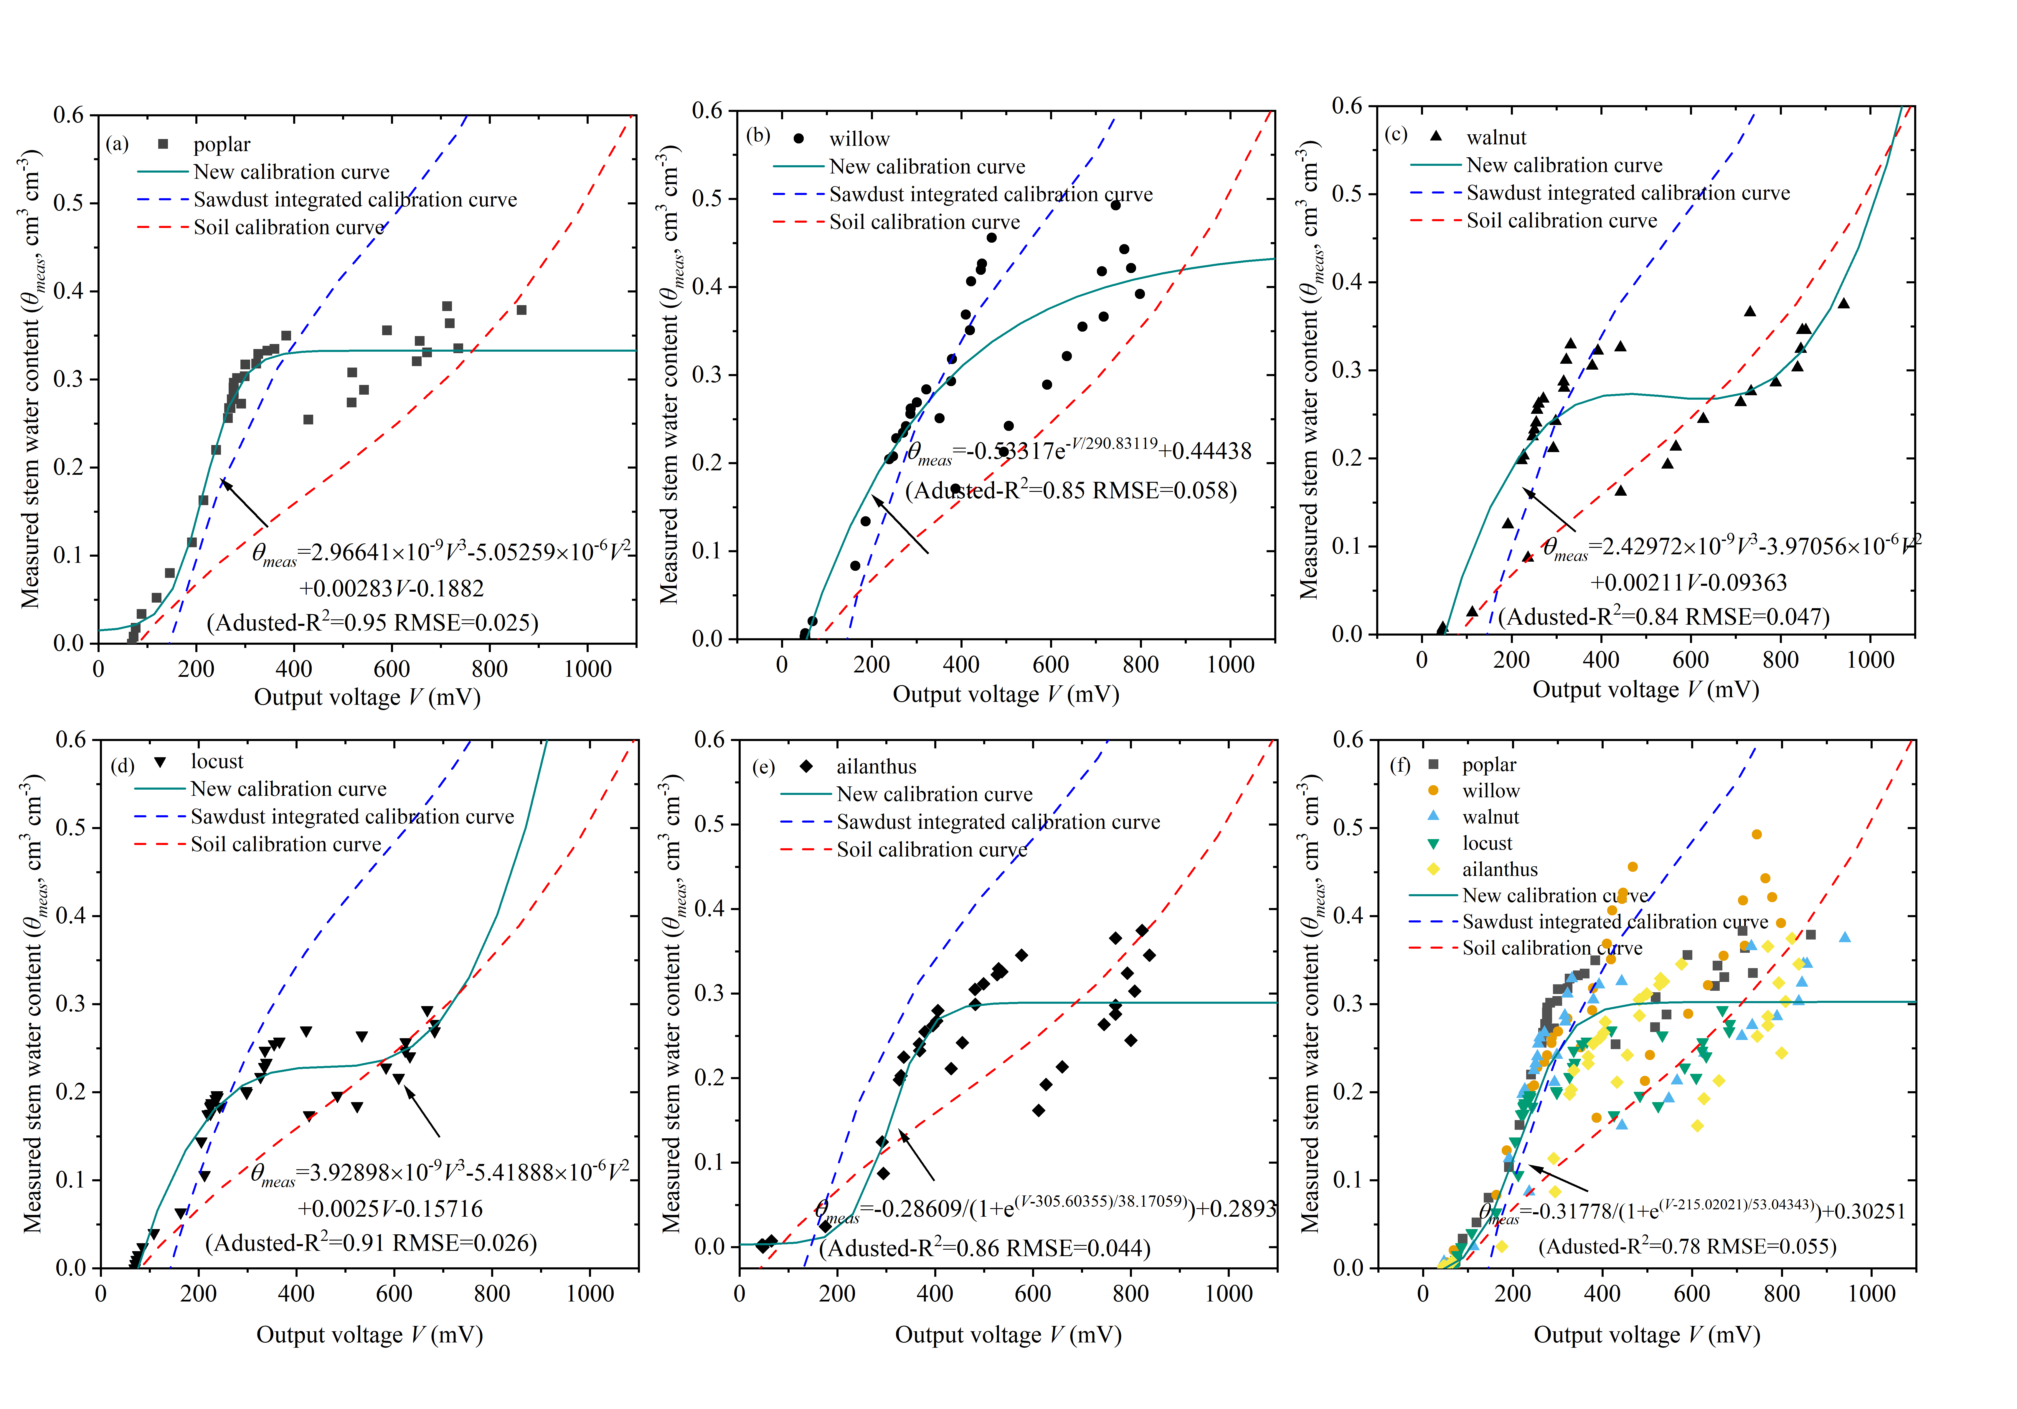

Fig. S8. Sensor output of the Theta Probe ML2X (output voltage) against measured water content of tree stems segments (θ_{meas,} solid symbols) of five tree species: (a) poplar (b) willow (c) walnut (d) locust (e) ailanthus, and (f) the combination of all five species. The best-fit relationship to the data is shown by the solid green line and the equation is given. The dashed lines are for the best-fit calibration equations for the sawdust of poplar (green), fir (purple) and pine (light blue), the combination of all three species (blue), and the factory-supplied calibration equation (FSCE) for soil water content (red dashed line). See Table 4 for the equations. Experiment 2.

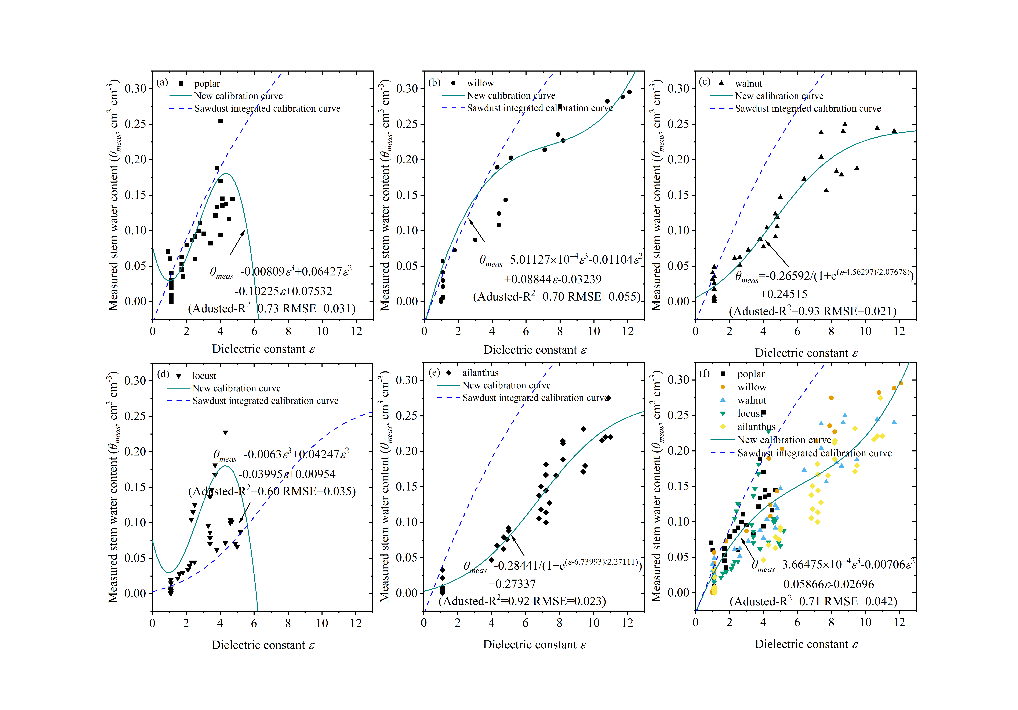
Fig. S9. Sensor output of the TDR310S (dielectric constant) against measured water content of tree stems segments (θ_{meas,} solid symbols) of five tree species: (a) poplar (b) willow (c) walnut (d) locust (e) ailanthus, and (f) the combination of all five species. The best-fit relationship to the data is shown by the solid green line and the equation is given. The dashed lines are for the best-fit calibration equations for the combination of all three species (blue). See Table 4 for the equations. Experiment 2.

