Table 1: Baseline characteristics
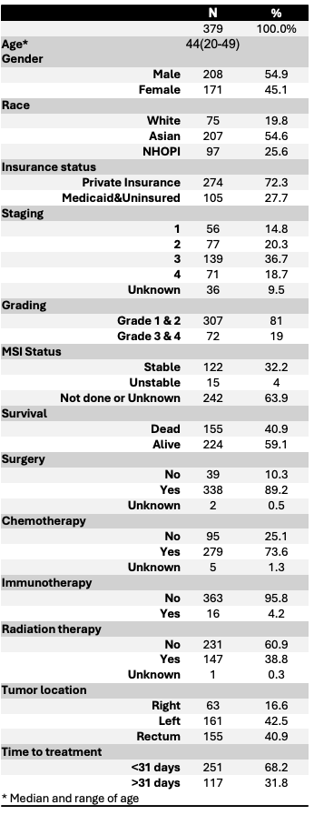
NHOPI: Native Hawaiians and Other Pacific Islander
Table 2: Baseline characteristics stratified by race
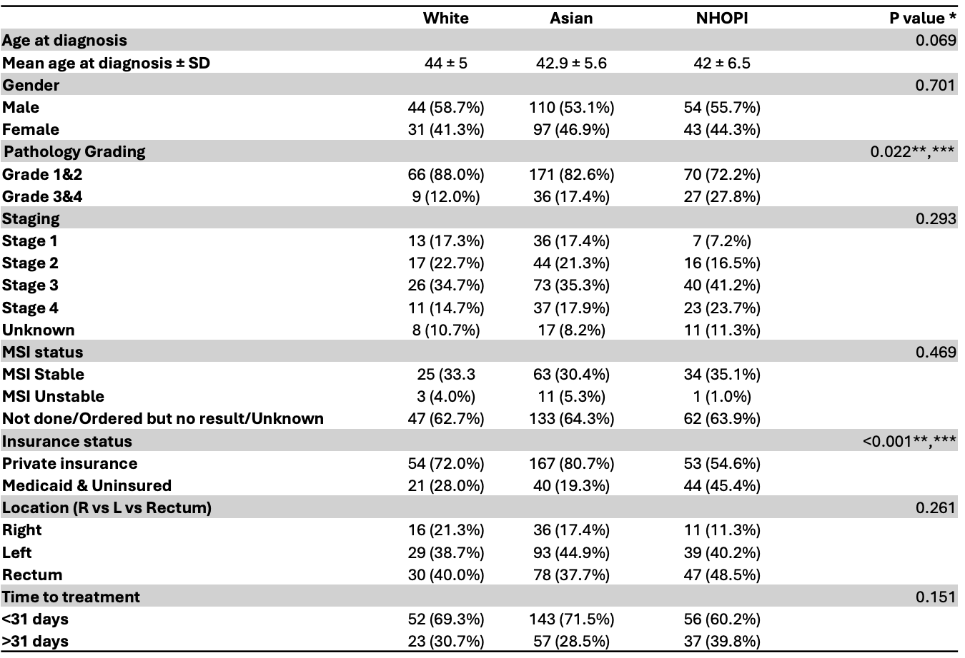
NHOPI: Native Hawaiians and Other Pacific Islanders
SD: Standard deviation
* p value using Pearson Chi-square for categorical data, using ANOVA for continuous data
** Significant difference between White and NHOPI
*** Significant difference between Asian and NHOPI

Table 3: Univariate and multivariate analysis of survival
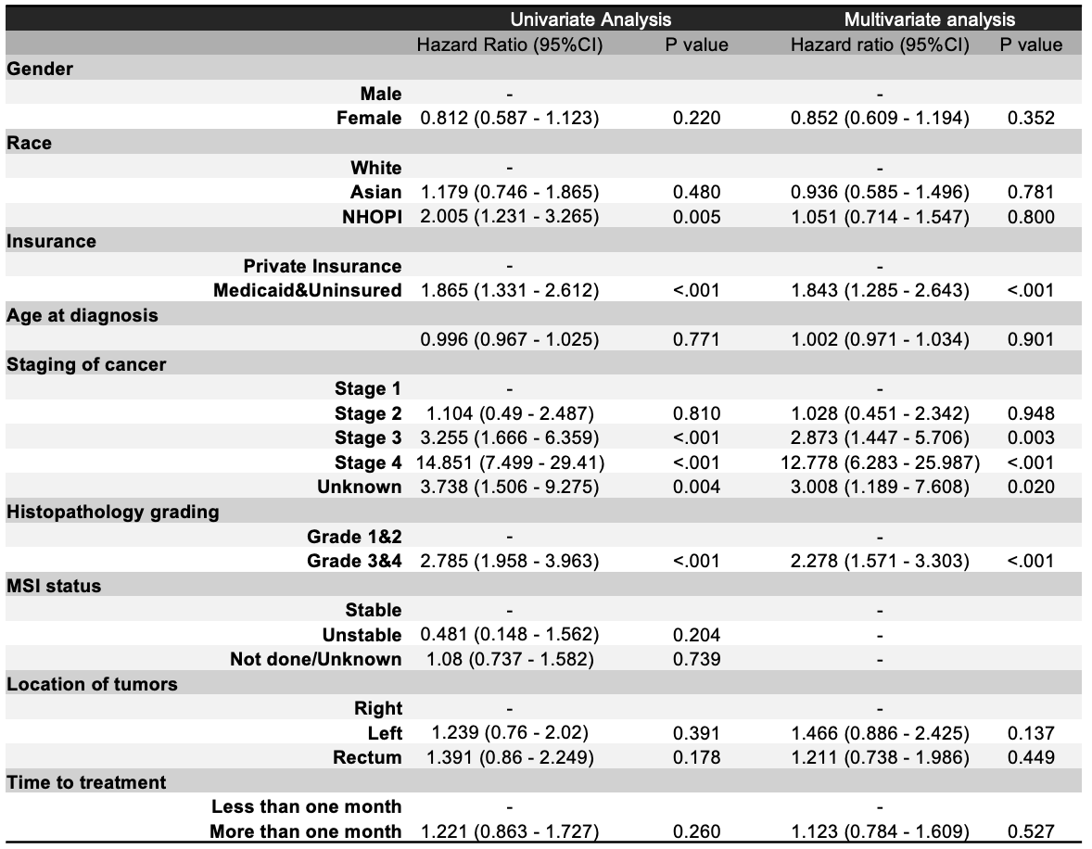
NHOPI: Native Hawaiians and Other Pacific Islanders

