Electronic Supporting Information
An ultrasound-assisted synthesis of novel Thiazole-pyrimidine hybrids: in-vitro PPA enzyme inhibition, DFT analysis, Molecular docking, MD simulation
Dilip C. Kanjariya¹● Hem N. Naik¹● Meet J. Sherashiya²● Prof. Yogesh T. Naliapara²●Mohammad Rizwan Alam³● Prof. Mohamed F AlAjmi ⁴● Prof. Smita Jauhari*¹
¹ Department of Chemistry, Sardar Vallabhbhai National Institute of Technology (SVNIT), Surat 395007, Gujarat, India.
² Department of Chemistry, Saurashtra University, Rajkot-360005, Gujarat, India.
³ Department of Hospital Pathology, Uijeongbu St. Mary’s Hospital, College of Medicine, The Catholic University of Korea, Seoul, South Korea.
⁴ Department of Pharmacognosy, College of Pharmacy, King Saud University, Riyadh-11451
*Corresponding author email: sjauhari190@gmail.com

Figure S1 - S12: Residues interaction in the active site of the porcine pancreatic α-amylase enzyme (PDB ID: 1OSE) complex with ligands in 2D and 3D.
Figure S13: BOILED-Egg model for the novel synthesized thiazole-pyrimidine hybrids (P1 to P15).
Figure S14 - S43: ¹H and ¹³C NMR spectra of the novel synthesized thiazole-pyrimidine hybrids (P1 to P15).

In silico studies
Figure S1. residues interaction in the active site of the porcine pancreatic α-amylase enzyme (PDB ID: 1OSE) complex with ligand P1 in 2D and 3D.
Figure S2. residues interaction in the active site of the porcine pancreatic α-amylase enzyme (PDB ID: 1OSE) complex with ligand P4 in 2D and 3D.
Figure S3. residues interaction in the active site of the porcine pancreatic α-amylase enzyme (PDB ID: 1OSE) complex with ligand P5 in 2D and 3D.

Figure S4. residues interaction in the active site of the porcine pancreatic α-amylase enzyme (PDB ID: 1OSE) complex with ligand P7 in 2D and 3D.

Figure S5. residues interaction in the active site of the porcine pancreatic α-amylase enzyme (PDB ID: 1OSE) complex with ligand P8 in 2D and 3D.

Figure S6. residues interaction in the active site of the porcine pancreatic α-amylase enzyme (PDB ID: 1OSE) complex with ligand P9 in 2D and 3D.

Figure S7. residues interaction in the active site of the porcine pancreatic α-amylase enzyme (PDB ID: 1OSE) complex with ligand P10 in 2D and 3D.

Figure S8. residues interaction in the active site of the porcine pancreatic α-amylase enzyme (PDB ID: 1OSE) complex with ligand P11 in 2D and 3D.

Figure S9. residues interaction in the active site of the porcine pancreatic α-amylase enzyme (PDB ID: 1OSE) complex with ligand P12 in 2D and 3D.
Figure S10 residues interaction in the active site of the porcine pancreatic α-amylase enzyme (PDB ID: 1OSE) complex with ligand P13 in 2D and 3D.
Figure S11. residues interaction in the active site of the porcine pancreatic α-amylase enzyme (PDB ID: 1OSE) complex with ligand P14 in 2D and 3D.
Figure S12. residues interaction in the active site of the porcine pancreatic α-amylase enzyme (PDB ID: 1OSE) complex with ligand P15 in 2D and 3D.

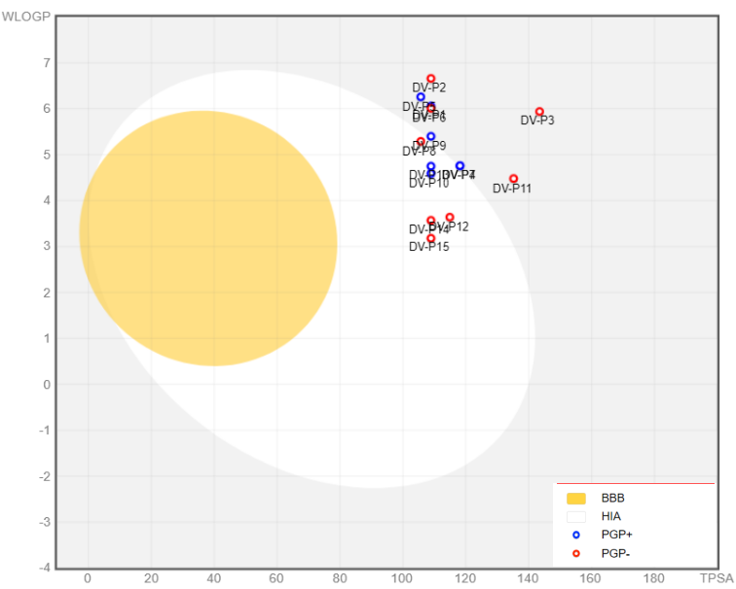
Figure S13. BOILED-Egg model for the novel synthesized thiazole-pyrimidine hybrids (P1 to P15) shows the blue and red points PGP positive and negative concerning the location of the molecules in the WLOGP vs TPSA graph, as well as the spontaneous evaluation of the white part of passive Human gastrointestinal absorption (HIA) and the yellow section of brain penetration which means blood-brain barrier (BBB).

Figure S14. ¹H-NMR spectrum of P1
Figure S15. ¹³C-NMR spectrum of P1

Figure S16. ¹H-NMR spectrum of P2
Figure S17. ¹³C-NMR spectrum of P2

Figure S18. ¹H-NMR spectrum of P3
Figure S19. ¹³C-NMR spectrum of P3

Figure S20. ¹H-NMR spectrum of P4
Figure S21. ¹³C-NMR spectrum of P4

Figure S22. ¹H-NMR spectrum of P5
Figure S23. ¹³C-NMR spectrum of P5

Figure S24. ¹H-NMR spectrum of P6
Figure S25. ¹³C-NMR spectrum of P6

Figure S26. ¹H-NMR spectrum of P7
Figure S27. ¹³C-NMR spectrum of P7

Figure S28. ¹H-NMR spectrum of P8
Figure S29. ¹³C-NMR spectrum of P8

Figure S30. ¹H-NMR spectrum of P9
Figure S31. ¹³C-NMR spectrum of P9

Figure S32. ¹H-NMR spectrum of P10
Figure S33. ¹³C-NMR spectrum of P10

Figure S34. ¹H-NMR spectrum of P11
Figure S35. ¹³C-NMR spectrum of P11

Figure S36. ¹H-NMR spectrum of P12
Figure S37. ¹³C-NMR spectrum of P12

Figure S38. ¹H-NMR spectrum of P13
Figure S39. ¹³C-NMR spectrum of P13

Figure S40. ¹H-NMR spectrum of P14
Figure S41. ¹³C-NMR spectrum of P14

Figure S42. ¹H-NMR spectrum of P15
Figure S43. ¹³C-NMR spectrum of P15

