Uncropped gels for Western Blots in Figure 2
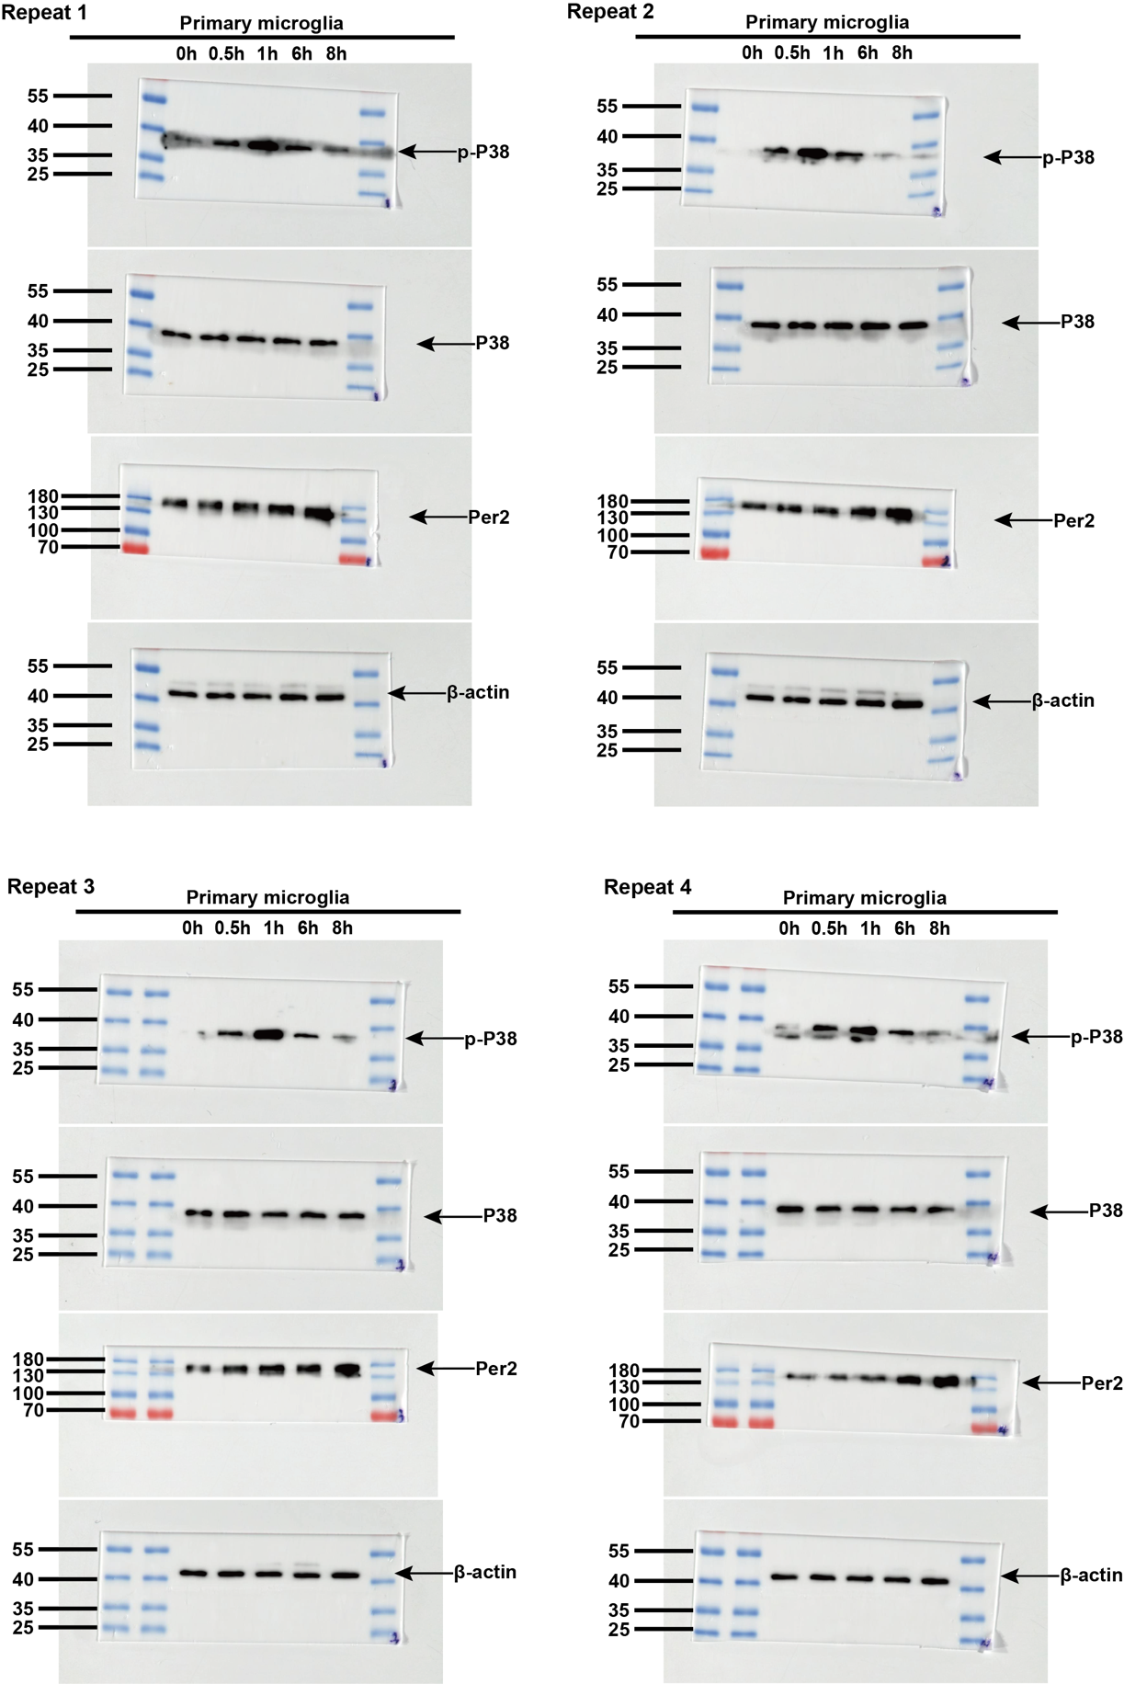
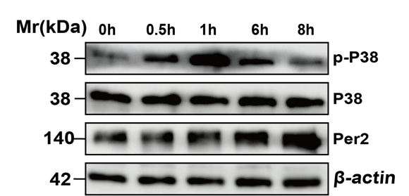
Fig. 2D

Fig. 2G

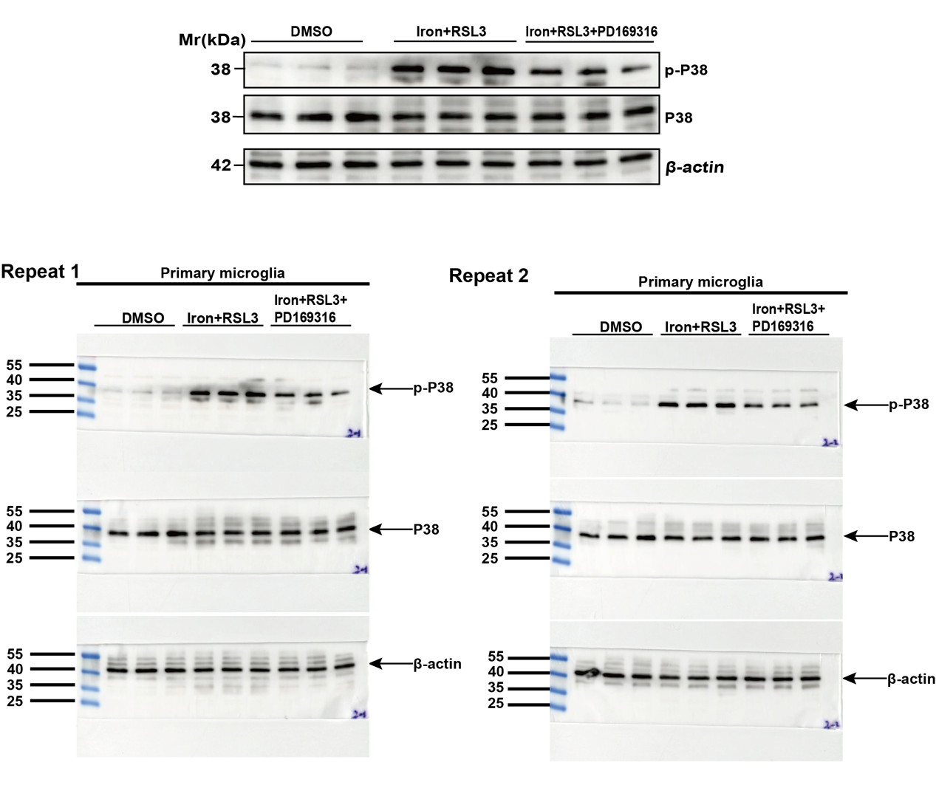

Fig. 2I

Uncropped gels for Western Blots in Figure 5
Fig. 5A
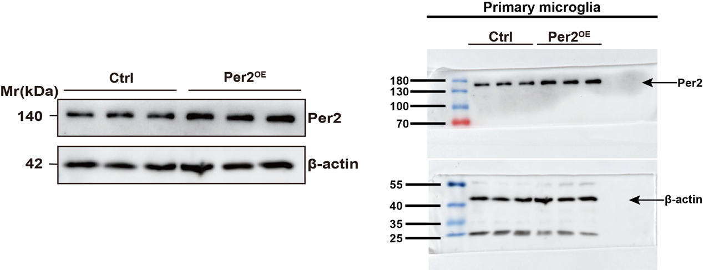

Uncropped gels for Western Blots in Figure 6
Fig. 6D

Uncropped gels for Western Blots in Figure 7
Fig. 7A
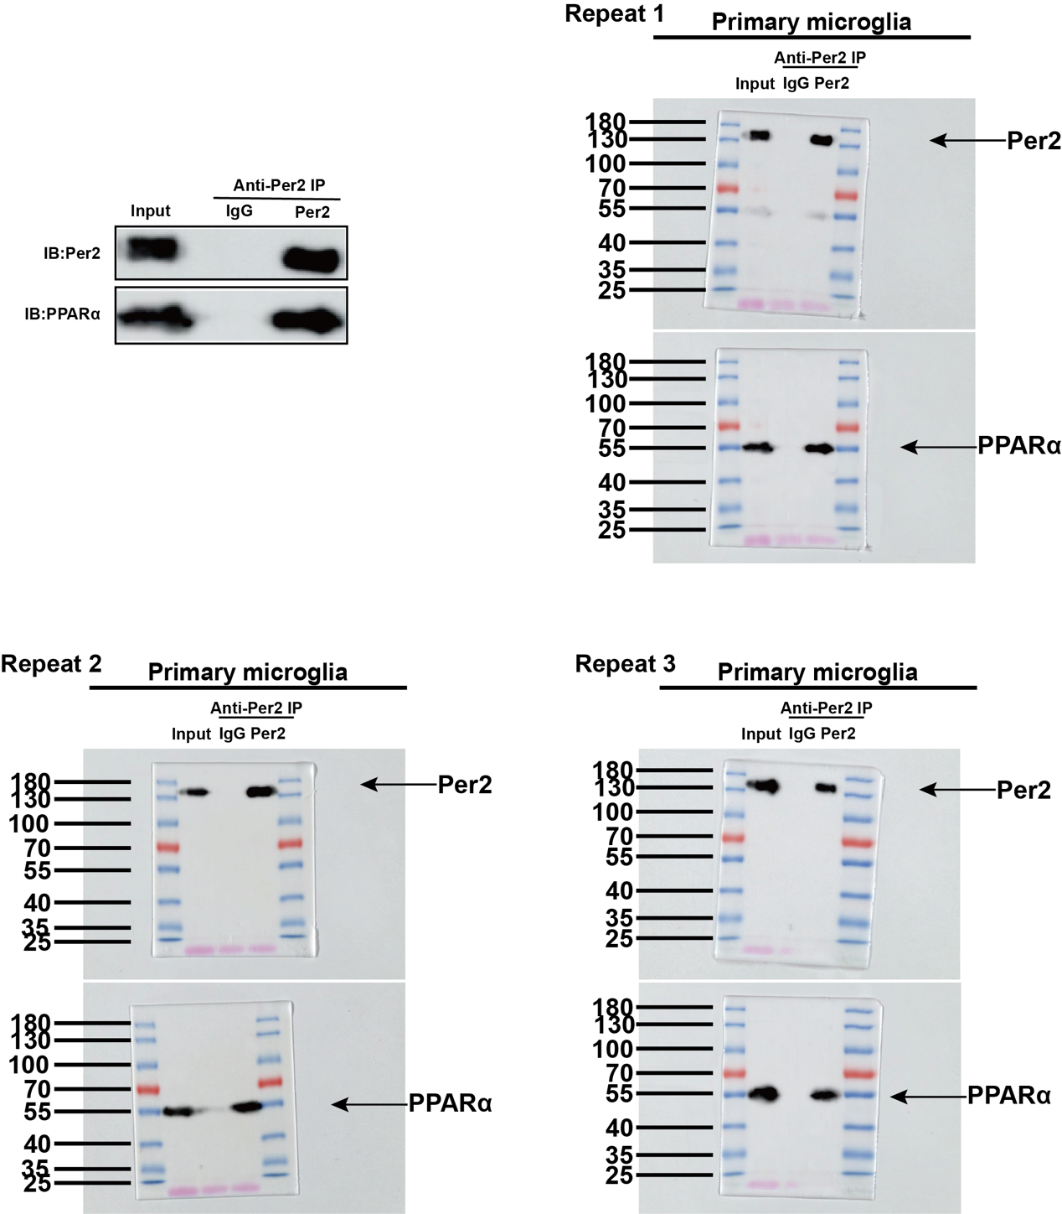

Fig. 7B
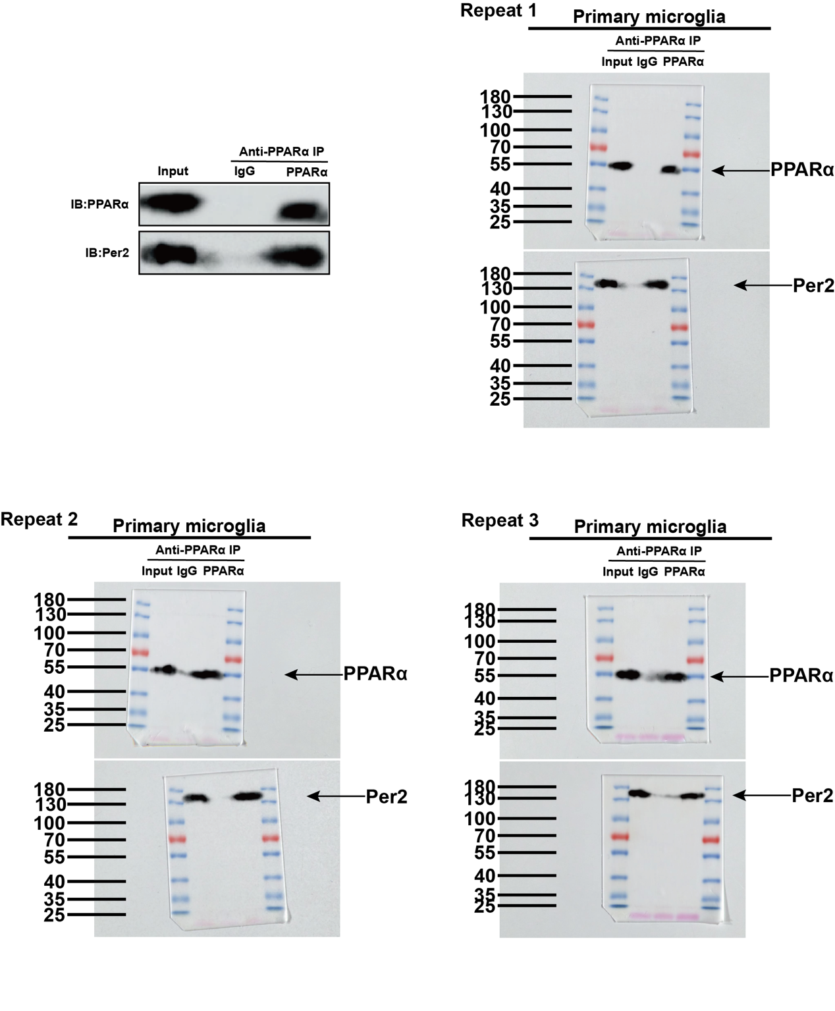

Fig. 7C
