Per2 deficiency in microglia alleviates motor dysfunction by inhibiting ferroptosis in spinal cord injury
Pengfei Bie^{a,d}, Dongpo Suª, Yang Gao^{a,d}, Liang Wu^{c}, Zhanfeng Niu^{c}, Yanbin Zhao^{a,d}, He Heª, Zhanfeng Jiangª, Zhong Zeng^{e}, Yaolin Zhang^{b}, Heng Fan^{b,*}, and Hechun Xia^{b,c,*}
ª The first school of clinical medicine, Ningxia Medical University, Yinchuan 750004, Ningxia Hui Autonomous Region, People’s Republic of China.
^{b} Ningxia Key Laboratory of Stem Cell and Regenerative Medicine, Institute of Medical Sciences, General Hospital of Ningxia Medical University, Yinchuan 750004, Ningxia Hui Autonomous Region, People’s Republic of China.
^{c} Department of Neurosurgery, General Hospital of Ningxia Medical University, Yinchuan 750004, Ningxia Hui Autonomous Region, People’s Republic of China.
^{d} Department of Neurosurgery, People’s Hospital of Ningxia Hui Autonomous Region (the third school of clinical medicine, Ningxia Medical University), Yinchuan 750002, Ningxia Hui Autonomous Region, People’s Republic of China.
^{e} Department of Orthopaedics, The Affiliated Hospital of Yangzhou University, Yangzhou 225000, Jiangsu, People’s Republic of China.
*Corresponding authors: Email: fangheng@nxmu.edu.cn; xhechun@nyfy.com.cn.

SUPPLEMENTARY FIGURES
Supplementary Figure 1 Microglia undergo ferroptosis after SCI. a BMS scores during 28 days of recovery after SCI in sham and SCI mice (n = 6 animals per group). b-e The levels of MDA, Fe, GSH-Px, and GSH were detected by corresponding assay kits (n = 5 animals per group). f Representative TEM images of the microglia of sham and SCI mice. Red arrow: healthy mitochondria. Yellow arrow: damaged mitochondria. Scale bars, 5 μm or 1 μm. All data are presented as the mean ± SEM. P values were determined by two-way ANOVA with Tukey’s test for multiple comparisons (a), and one-way ANOVA with Tukey’s multiple-comparisons test (b, c, d, and e). *P<0.05; **P<0.01; ***P<0.001; ****P<0.0001; ns, not significant.

Supplementary Figure 2 Microglia proliferate at the lesion epicenter after SCI. a Immunofluorescence images showing expression of proliferate marker Ki67 at 0.25, 1, 3, 7, and 14 dpi, as well as in uninjured mice. Scale bars, 20 μm. b Quantification of the percentage of proliferating microglia (Iba1⁺Ki67⁺ cells) at 0.25, 1, 3, 7, and 14 dpi, as well as in uninjured mice (n = 4 animals per group). All data are presented as the mean ± SEM. P values were determined by one-way ANOVA with Tukey’s multiple-comparisons test (b). **P<0.01; ****P<0.0001; ns, not significant.

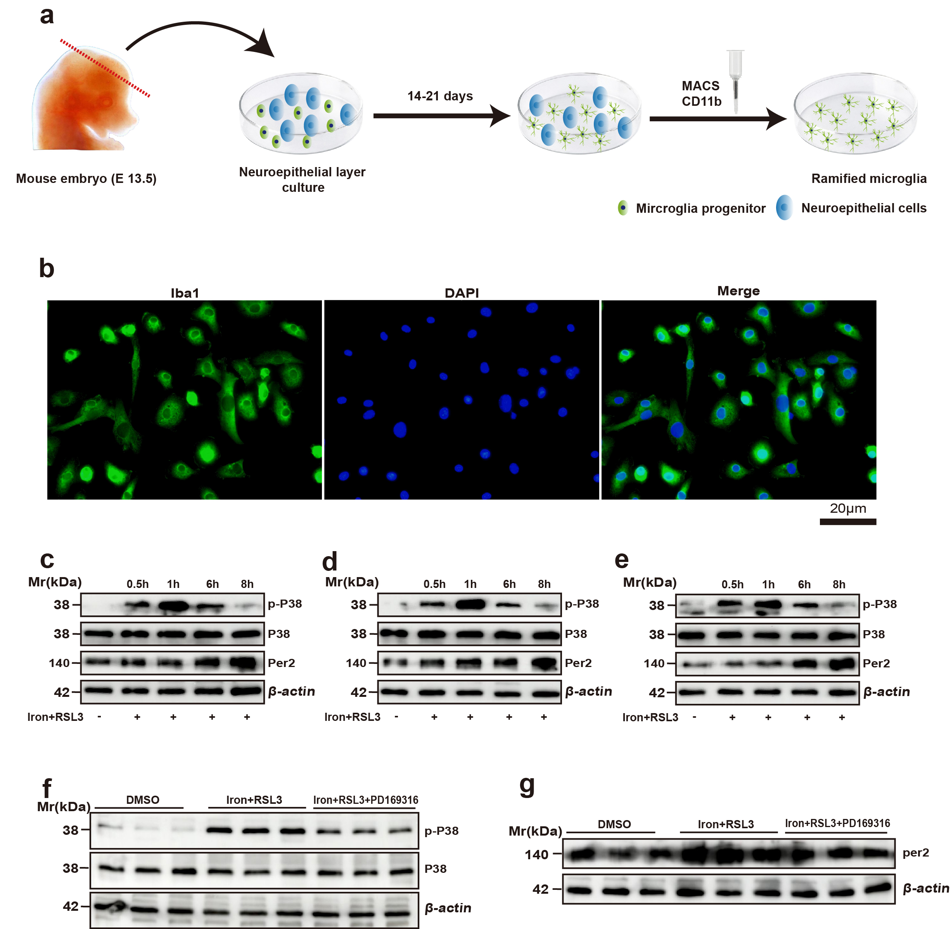

Supplementary Figure 3 A method to obtain bankable and expandable adult-like microglia and the repeated immunoblots. a Mouse head neuroepithelial layer (NEL) was dissected at E13.5 and was cultured for 14-21 days, then CD11b⁺ cells were isolated from cultured NEL using a MACS system. b Iba1 was conducted to verify the primary microglia. Scale bars, 20 μm. c-e Repeated immunoblots of Fig. 2d. f Repeated immunoblots of Fig. 2g. g Repeated immunoblots of Fig. 2i.

Supplementary Figure 4
Per2 global knockout benefits motor function recovery via inhibiting microglial ferroptosis. a qRT-PCR analysis of Per2 mRNA levels in microglia from WT and global Per2^{GKO} mice (n = 4 biological repeats for each group). b Immunofluorescence image showing expression of proliferate marker Ki67 in WT and Per2^{GKO} mice at 3dpi. Scale bars, 20 μm. c Quantification of the percentage of proliferating microglia (Iba1⁺Ki67⁺ cells) in WT and Per2^{KO} mice at 3dpi (n = 4-5 animals per group). d BMS scores during 28 days of recovery after SCI in Per2^{GKO} and WT mice. (n=6 animals per group). e Representative TEM images of the microglia of WT and Per2^{GKO} mice. Red arrow: damaged mitochondria. Yellow arrow: relatively mild damaged mitochondria. Scale bars, 5 μm or 1 μm. f Representative Immunofluorescence images of Iba1 and Acsl4, showing lower Acsl4 expression in microglia of the spinal cord in Per2^{GKO} mice at 3 dpi than in WT mice. Scale bars, 100 μm or 20 μm. g Quantification of the relative fluorescence intensity of Acsl4 (n = 4 animals per group). h Nissl staining to observe the number of neurons in spinal cord tissues of the different groups, Arrows indicate neurons containing Nissl bodies. Scale bars, 100 μm or 20 μm. i Quantification of the Nissl bodies (n = 4 animals per group). j Representative immunofluorescence images of NeuN in spinal cord tissues of the different groups. Scale bars, 200 μm. k Quantification of the number of NeuN⁺ neurons (n = 5 animals per group). l The levels of IGF-1 in the serum of mice (n = 4 animals per group) were detected by Elisa kits. All data are presented as the mean ± SEM. P values were determined by two-tailed unpaired Student’s t-test (a, c, g, i, and k), one-way ANOVA with Tukey’s multiple-comparisons test (l), and two-way ANOVA with Tukey’s test for multiple comparisons (d), *P<0.05; **P<0.01; ***P<0.001; ****P<0.0001; ns, not significant.
Supplementary Figure 5 Microglia-specific Per2 knockout mice. Given the circadian rhythm of Per2 levels, all specimens were collected between 2-4 PM. a Immunofluorescence images of Hexb (red) and Per2 (green) in the spinal cord in Per2^{flox/flox} and Per2^{CKO} mice, indicating Per2 knockout in the microglia of the spinal cord in Per2^{CKO} mice (white arrows indicate microglial Per2 expression). Scale bars, 20 μm. b Immunofluorescence image showing expression of proliferate marker Ki67 in Per2^{flox/flox} and Per2^{CKO} mice at 3dpi. Scale bars, 20 μm. c Quantification of the percentage of proliferating microglia (Hexb⁺Ki67⁺ cells) in Per2^{flox/flox} and Per2^{CKO} mice at 3dpi (n = 5 animals per group). All data are presented as the mean ± SEM. P values were determined by two-tailed unpaired Student’s t-test (c). ns, not significant.

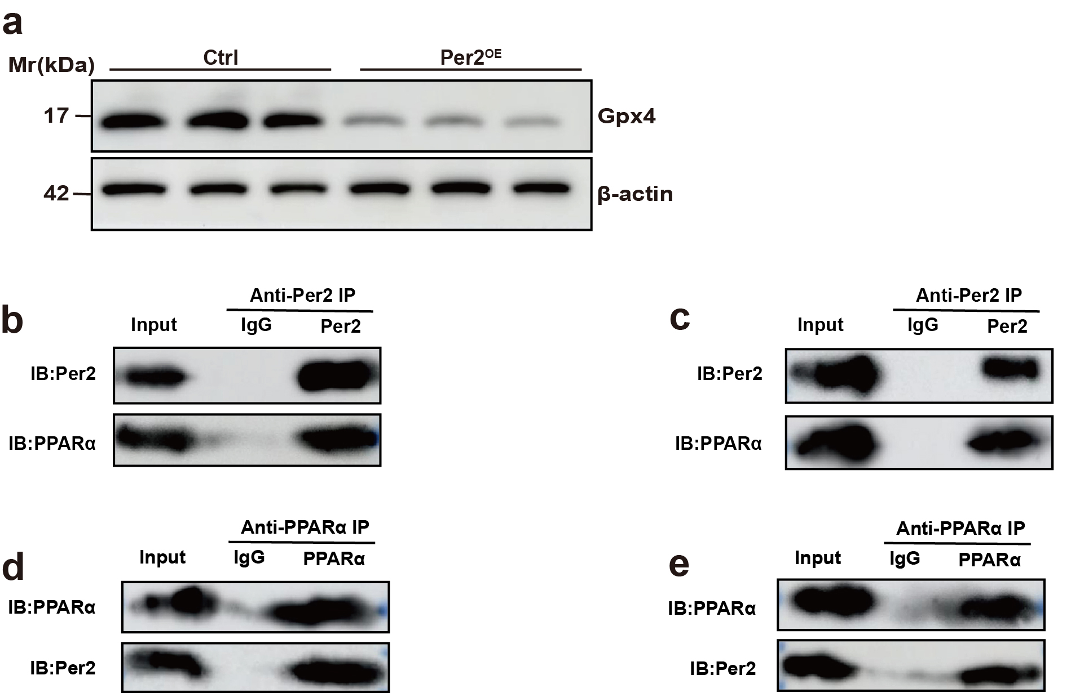

Supplementary Figure 6 The Repeated immunoblots. a Repeated immunoblots of Fig. 6d. b, c Repeated immunoblots of Fig. 7a. d, e Repeated immunoblots of Fig. 7b.

Table1. The primer used in this article.
Gene primers | Forward (5’-3’) | Reverse (5’-3’)
Acsl4 | CTCACCATTATATTGCTGCCTGT | TCTCTTTGCCATAGCGTTTTTCT
Per2 | CACACTTGCCTCCGAAATAACTC | AGCGCACGGCTGTCTGA
Gpx4 | GCCTGGATAAGTACAGGGGTT | CATGCAGATCGACTAGCTGAG
Ptgs2 | TGAGCAACTATTCCAAACCAGC | GCACGTAGTCTTCGATCACTATC
β-actin | AGCCATGTACGTAGCCATCC | GCTGTGGTGGTGAAGCTGTA

