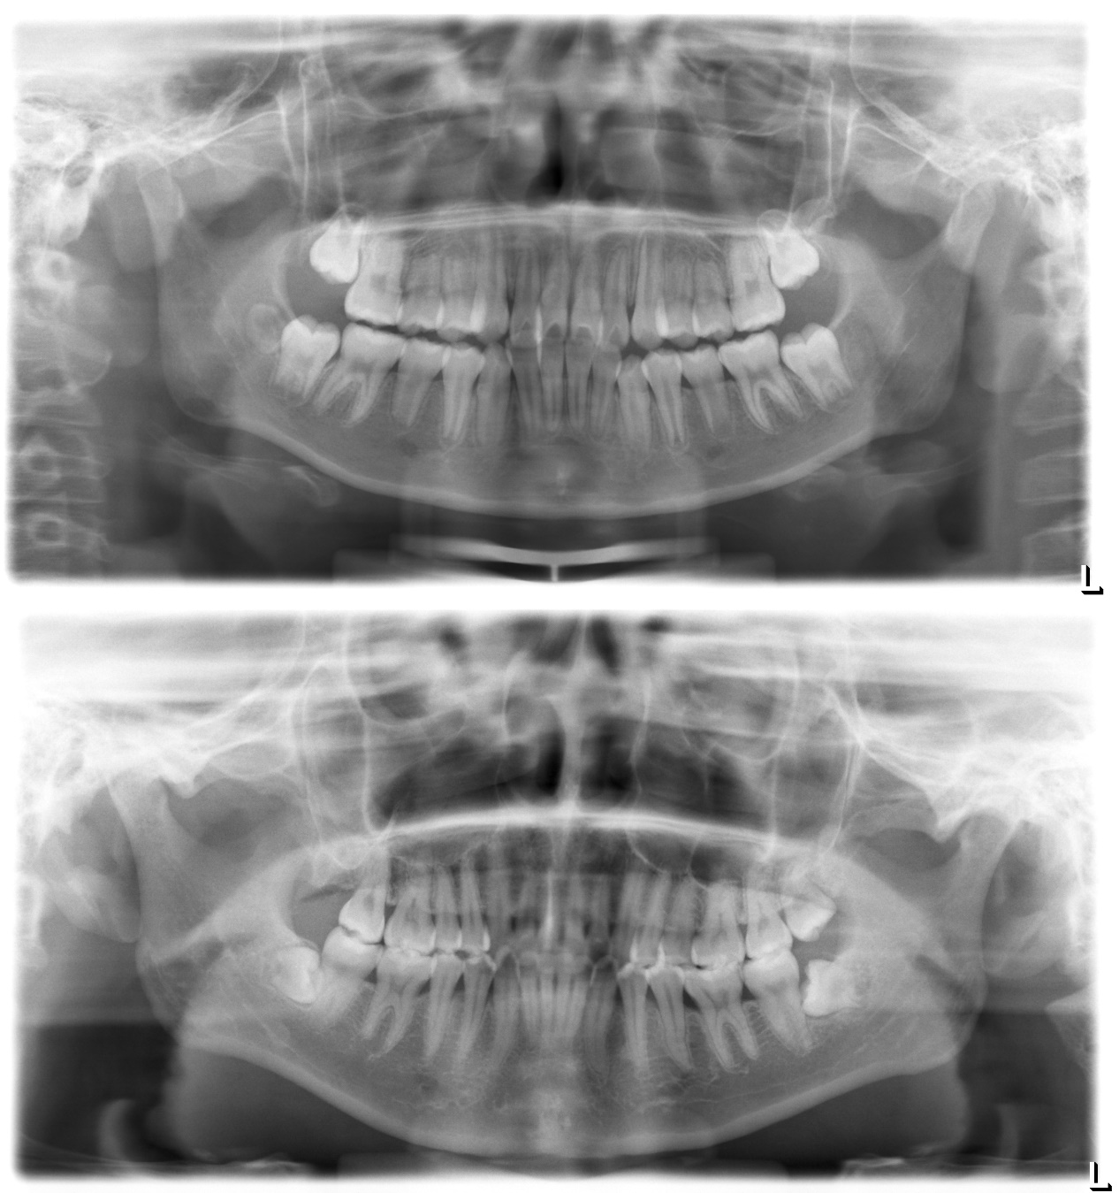
Figure S1. Full oral panorama for stage A (up) and stage D (down) tooth germ, corresponding to Figure 1A.

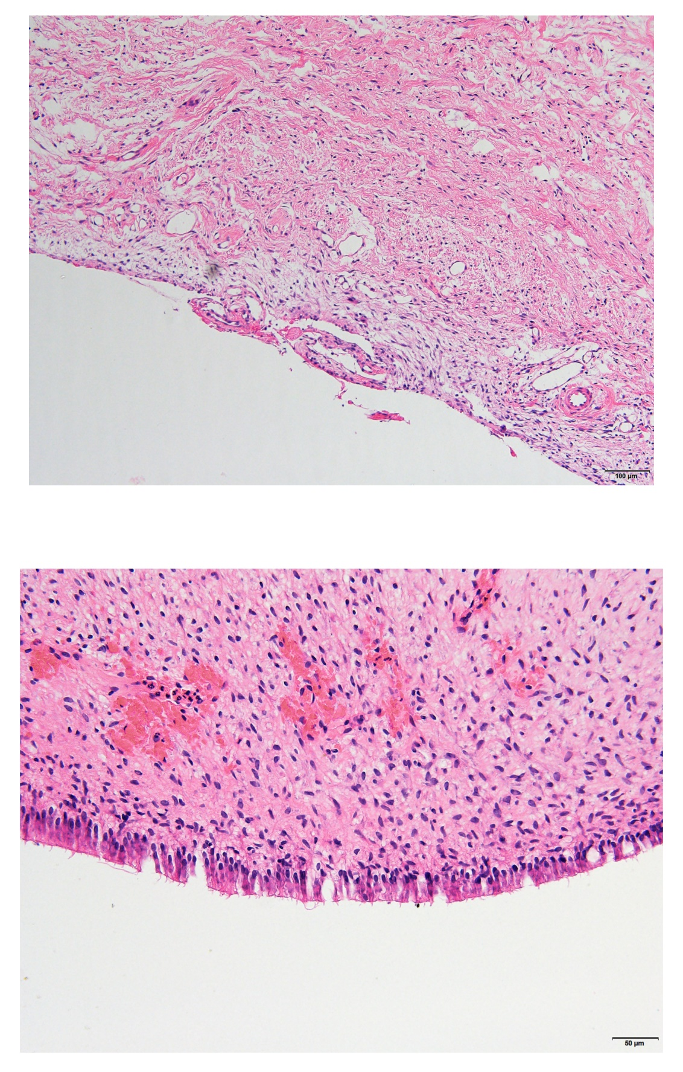

Figure S2. H-E staining of tooth germ slices, corresponding to Figure 1F (up) and Figure 1G (down). Upper panel indicated osteoblast morphology, and lower panel indicated odontoblast morphology.

Figure S3. A: pseudotime trajectory for selected gene expression. B: ligand-receptor activity predicted by nichenetr. C: ligand-target activity predicted by nichenet.

Figure S4. Similar to Figure S3, but for APSC self-renewal.

Figure S5. Similar to Figure S3, but for osteoclast transformation.

