Supplementary Information

Phosphorus-modified Basic Nickel Silicate Derivated from Vermiculite for Efficient Oxygen Evolution Reaction

Jing Gaoª, Ting Zhouª, Jianqiang Tangª, lei Wang^{a*}, Hang Zhang^{a*}, Shengliang Zhong^{a*}
ª College of Chemistry and Material, Jiangxi Normal University, Nanchang 330022, People’s Republic of China

* Corresponding author.
E-mail addresses: wangleifly2006@126.com,
slzhong@jxnu.edu.cn (Shengliang Zhong).
Experimental procedures
Materials. VMT was purchased from Xinlei Mineral Factory (Hebei, China). Nickel chloride hexahydrate (NiCl₂⋅6H₂O) and sodium hypophosphite (NaH₂PO₂·H₂O) were purchased from Aladin Ltd. (Shanghai, China). HCl aqueous solution was obtained from Xilong Chemical Co. Ltd. Ammonia (28 wt%) and ethanol were supplied by Zhiyuan Chemical Reagent Factory. (Tianjin, China). Nafion (5 wt%) were purchased from Suzhou Sinero Technology Co. Ltd. The distilled water was used in the experiment by homemade. All reagents used in the experiments were of analytical grade and used without any further purification.

Materials Characterization. Field-emission scanning electro microscope (FESEM) and energy-dispersive X-ray (EDS) were obtained with a Hitachi S-3400 N scanning electron microscope. The microstructure of the product was further analyzed by using JEOL JEM 2100F high-resolution transmission electron microscopy (HRTEM). Fourier transform infrared spectra (FTIR) spectra were recorded on a Thermo Nicolet 6700 FTIR spectrometer in the range of 400-4000 cm⁻¹. The crystalline structure of the sample was measured by X-ray diffraction (XRD) technique by a Rigaku/Max-3A X-ray diffractometer with Cu-K_{α} radiation in the 2-Theta (θ) region of 5 ~ 80° (the scanning rate is 5°/min). X-ray photoelectron spectroscopy (XPS) was performed on the surface chemistry of the samples using a Thermo ESCALAB 250Xi analyzer (Al Ka irradiation, hv = 1486.6 eV). The XPS peak assignment using Multi Peak Spectrum software and the Perkins-Elmer manual for X-ray photoelectron spectroscopy data analysis. Origin Pro 2018 software completed the deconvolution of the peaks based on the Shirley background-corrected Gauss-Lorentz curve fitting.

Electrochemical measurements. The working electrode was made by following procedure: 5 mg of the catalyst was dispersed in 960 μL of ethanol solution and 40 μL of 5 wt% Nafion solution under 40 min ultrasonic to form a homogeneous ink. Then, 5 µL (2.5 μL in two parts) of the catalyst ink dropped onto the surface of a glassy carbon electrode with an area of 0.070 cm⁻². All electrochemical tested in this work were performed on a CHI760E electrochemical workstation in 1 M KOH. A traditional three-electrode system was adopted, with the catalyst loaded glassy carbon electrode as the working electrode, carbon rod as the counter electrode, and Hg/HgO (pH =14) as the reference electrode . All potentials were calibrated according to the Nernst equation E_{RHE} = E_{Hg/HgO} + E'+ 0.0591*pH with 80% IR compensation. All measured potentials are converted to reversible hydrogen electrode (RHE) potentials. Tested with linear scanning voltammetry (LSV) at a scan rate of 5 mV/s. The Tafel curve is calculated according to the Tafel formula η=a+bx logj. The Electrochemical impedance spectroscopy (EIS) was tested at an open-circuit voltage of 5 mV in the frequency range of 10⁻²~10⁵ Hz. The electrochemical surface area (ECSA) is calculated from a double-layer capacitance and the ECSA is assessed by cyclic voltammetry (CV) curves at different scan rates for OER in the potential range of 0.98 V to 1.08 V (vs. RHE). The stability is tested at a constant overpotential/current density.

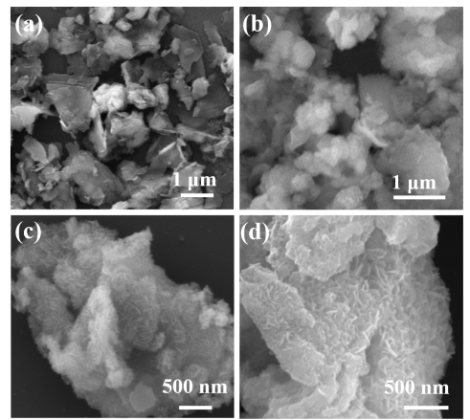
Figure S1. FESEM of VMT (a); V-SiO₂ (b); NiSi (c); NiSi-P-325 (d)

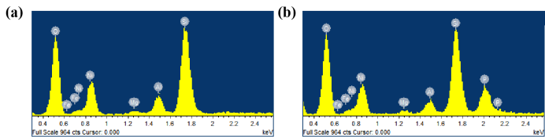
Figure S2. EDS diagrams of (a) NiSi and (b) NiSi-P-325.

Figure S3. XRD patterns of VMT, V-SiO₂, NiSi.

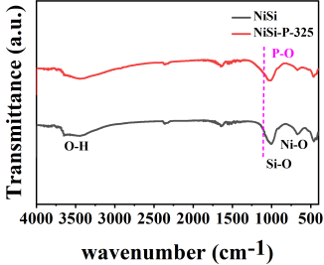
Figure S4. IR spectra of NiSi and NiSi-P-325.

Figure S6. LSV curves of Ni₁, Ni₂, Ni₃

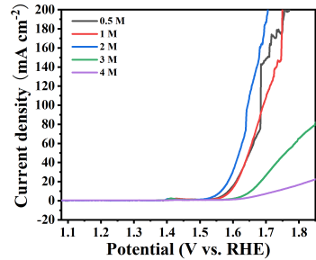
Figure S6. LSV curves of NiSi-P-325 prepared from vermiculite treated with different concentrations of hydrochloric acid treatments.

Figure S7. CV curves of NiSi (a), NiSi-P-300 (b), NiSi-P-300 (c), NiSi-P-300 (d) in the non-Faradic region.

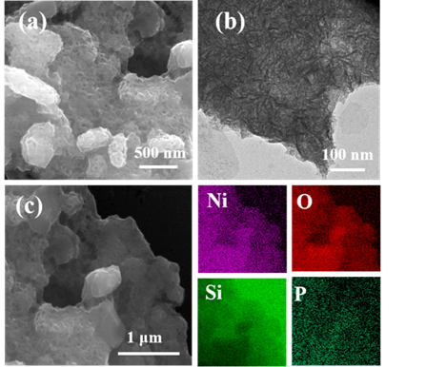

Figure S8. (a) FESEM, (b) TEM, (c) FESEM-EDS mapping images of NiSi-P after OER electrocatalysis

Figure S9. (a) Ni 2p, (b) Si 2p, (c) P 2p XPS spectrum of NiSi-P before and after OER electrocatalysis

Table S1. Chemical Composition (wt %) Analysis of VMT and V-SiO₂
Sample |  | SiO₂ |  | MgO |  | Al₂O₃ |  | Fe₂O₃ |  | CaO
VMT |  | 38.37 |  | 9.68 |  | 13.9 |  | 32.68 |  | 5.36
V-SiO₂ |  | 81.08 |  | 1.32 |  | 6.93 |  | 9.74 |  | 0.93

Table S2. OER performance of transition metal oxide/hydroxide in 1.0 M KOH.

Catalyst | Substrate | Overpotential  @10 mA cm⁻²  (mV) | Tafel slope  (mV dec⁻¹) | Ref.
NiSi-P-325 | GCE | 334 | 65.5 | This work
NCS:P | GCE | 394 | 67 | [1]
FeSHN | GCE | 381 | 66.5 | [2]
ACFP 64 | Carbon fiber paper | 329 | --- | [3]
CoSi-P | GCE | 309 | 121 | [4]
Fe-Co₂SiO₄ | GCE | 330 | 64 | [5]
NSO-Fex | Ni Foam | 286 | 44.2 | [6]

[1] C. Qiu, L. Ai& J. Jiang Layered Phosphate-Incorporated Nickel–Cobalt Hydrosilicates for Highly Efficient Oxygen Evolution Electrocatalysis. ACS Sustain. Chem. Eng. 6:4492-4498 (2018).
[2] J. Zhu, S. Li, Z. Zhuang, S. Gao, X. Hong, X. Pan, et al. Ultrathin Metal Silicate Hydroxide Nanosheets with Moderate Metal–Oxygen Covalency Enables Efficient Oxygen Evolution. Energy Environ. Mater. 5:231-237 (2021).
[3] J. Zhu, L. Xia, W. Yang, R. Yu, W. Zhang, W. Luo, et al. Activating inert sites in cobalt silicate hydroxides for oxygen evolution through atomically doping. Energy Environ. Mater. 5:655-661 (2022).
[4] C. T. Ding, Y. Yu, Y. Wang, Y. Mu, X. Y. Dong, C. G. et al. Phosphate-modified cobalt silicate hydroxide with improved oxygen evolution reaction. J. Colloid Interface Sci. 648:251-258 (2023).
[5] J. Zhang, Z. Li, G. Bai, Q. Wang, J. Zhang, W. Wang, et al. Nickel-iron layered silicate nanomembrane as efficient electrocatalyst for oxygen evolution reaction in alkaline media. Fuel 332 (2023).

