Supplementary Material for

Ion-Engine Hydrogel Based Solar Desalination for Water-electricity Cogeneration with Record-Breaking Milliampere Current

Yu Chen,ª† Chengwei Ye,ª† Jiajun He,ª Liangti Qu,*^{, b} Shaochun Tang*^{, a}

ª National Laboratory of Solid State Microstructures, Collaborative Innovation Center of Advanced Microstructures, Jiangsu Key Laboratory of Artificial Functional Materials, College of Engineering and Applied Sciences, Nanjing University, Nanjing 210093, P. R. China.
^{b} State Key Laboratory of Flexible Electronics Technology, Key Laboratory of Organic Optoelectronics & Molecular Engineering, Ministry of Education, Department of Chemistry, Tsinghua University, Beijing, 100084 P. R. China
Corresponding authors *E-mails: lqu@mail.tsinghua.edu.cn; tangsc@nju.edu.cn.
†These authors contributed equally to this work.

Supplementary Figures and Tables
Figure S1. The radial distribution function and coordination number plots of Cu²⁺-O_{TFSI}.
Figure S2. RDFs and CNs of Cu²⁺-TFSI⁻ and Gdm⁺-TFSI⁻, respectively.
Figure S3. Binding energy of Cu-O_{PVA}. The inset shows the corresponding structure and electrostatic potential distribution.
Figure S4. The mean-squared displacement of anion and cation in A) PVA/Cu(TFSI)₂-GdmCl and B) PVA/Cu(TFSI)₂-GdmCl.
Figure S5. MD snapshots of PVA/Cu(TFSI)₂-GdmCl using NaCl solutions as the solvent (System Ⅱ), respectively.
Figure S6. Elemental mapping results of PVA/Cu(TFSI)₂-GdmCl. Scale bars: 1 μm.
Figure S7. A. F-NMR spectra of Cu(TFSI)_{2,} PVA/Cu(TFSI)_{2,} and PVA/Cu(TFSI)₂-GdmCl showing chemical shifts of F on TFSI-. B. XPS N 1s spectra showing the binding energy of Gdm+.
Figure S8. FTIR spectra of PVA, Cu(TFSI)_{2,} GdmCl, and PVA/Cu(TFSI)₂-GdmCl.
Figure S9. Solar absorbance of PVA/Cu(TFSI)₂-GdmCl ionogels and CNT layer.
Figure S10. Temperature distribution of SWEG in bulk seawater during desalination under 1.5G irradiation.
Figure S11. A. The V_{load} and I_{load} values and B. power density of the SWEG with various resistances.
Figure S12. Water evaporation mass change from SWEG under natural light and 1 sun.
Figure S13. A. I-V curves of the residual brine and freshwater with different evaporation time measured by the electrolytic cell (left), and B. the corresponding power density that have been tested with a 10 Ω resistor connected.
Figure S14. Water evaporation mass change from SWEG under different solar intensity (500W m⁻², 1000W m⁻², 1500W m⁻², 2000W m⁻²).
Figure S15. The A. V_{oc,} and B. I_{sc} of SWEG using CNT-CNT electrode, Pt-Pt electrode, Ag-Ag electrode, Au-CNT electrode pairs.
Figure S16. Power density variations by adjusting the contact area between the two electrodes and SMEG.
Figure S17. Electric performance of SWEG with different thickness of PVA/Cu(TFSI)₂-GdmCl.
Figure S18. V_{oc} response versus time curve of SWEG with switching the top and bottom electrodes.
Figure S19. Photographs of outdoor experiments of an integrated large-scale freshwater-electricity cogeneration plant incorporating SWEG systems.
Figure S20. The V_{oc}, and I_{sc} of the 8×15 series-parallel SWEG.
Figure S21. The electrical output performance and solar flux of SWEG systems in real outdoor work.
Table S1. Detailed information about the calculated RDF and CN for Cu²⁺-O_{PVA} and Cu²⁺-O_{TFSI}.
Table S2. Comparison of the power generation performance, including V_{oc}, I_{sc}, and theoretical maximum power output of SWEG with other reported SSEG, where P_{max}≈V_{oc}×I_{sc} / 4.

Figure S1. The radial distribution function and coordination number plots of Cu²⁺-O_{TFSI}

Figure S2. RDFs and CNs of Cu²⁺-TFSI⁻ and Gdm⁺-TFSI⁻, respectively.

Figure S3. Binding energy of Cu-O_{PVA}. The inset shows the corresponding structure and electrostatic potential distribution.

Figure S4. The mean-squared displacement of anion and cation in A) PVA/Cu(TFSI)₂-GdmCl and B) PVA/Cu(TFSI)₂-GdmCl.

Figure S5. MD snapshots of PVA/Cu(TFSI)₂-GdmCl using NaCl solutions as the solvent (System Ⅱ), respectively.
Figure S6. Elemental mapping results of PVA/Cu(TFSI)₂-GdmCl. Scale bars: 1 μm.

Figure S7. A. F-NMR spectra of Cu(TFSI)_{2,} PVA/Cu(TFSI)_{2,} and PVA/Cu(TFSI)₂-GdmCl showing chemical shifts of F on TFSI-. B. XPS N 1s spectra showing the binding energy of Gdm+.
Figure S8. FTIR spectra of PVA, Cu(TFSI)_{2,} GdmCl, and PVA/Cu(TFSI)₂-GdmCl.

Figure S9. Solar absorbance of PVA/Cu(TFSI)₂-GdmCl ionogels and CNT layer.

Figure S10. Temperature distribution of SWEG in bulk seawater during desalination under 1.5G irradiation.

Figure S11. A. The V_{load} and I_{load} values and B. power density of the SWEG with various resistances.
Figure S12. Water evaporation mass change from SWEG under natural light and 1 sun.

Figure S13. A. I-V curves of the residual brine and freshwater with different evaporation time measured by the electrolytic cell (left), and B. the corresponding power density that have been tested with a 10 Ω resistor connected.
Figure S14. Water evaporation mass change from SWEG under different solar intensity (500W m⁻², 1000W m⁻², 1500W m⁻², 2000W m⁻²).

Figure S15. The A. V_{oc,} and B. I_{sc} of SWEG using CNT-CNT electrode, Pt-Pt electrode, Ag-Ag electrode, Au-CNT electrode pairs.
Figure S16. Power density variations by adjusting the contact area between the two electrodes and SMEG.
Figure S17. Electric performance of SWEG with different thickness of PVA/Cu(TFSI)₂-GdmCl.
Figure S18. V_{oc} response versus time curve of SWEG with switching the top and bottom electrodes.

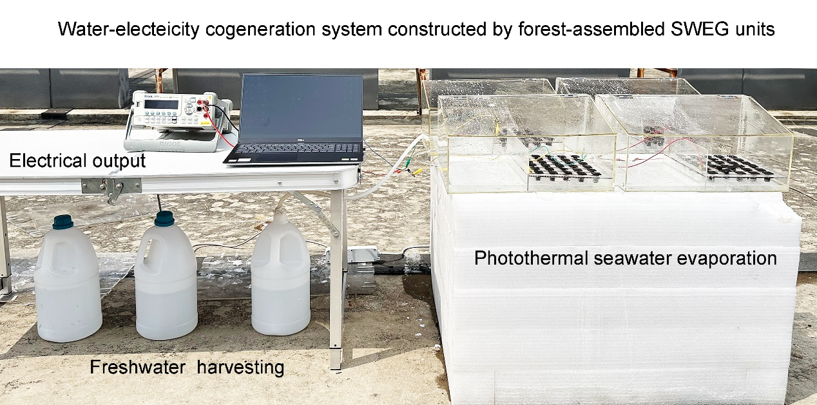
Figure S19. Photographs of outdoor experiments of an integrated large-scale freshwater-electricity cogeneration plant incorporating SWEG systems.
Figure S20. The V_{oc}, and I_{sc} of the 8×15 series-parallel SWEG.

Figure S21. The electrical output performance and solar flux of SWEG systems in real outdoor work.
Table S1. Detailed information about the calculated RDF and CN for Cu²⁺-O_{PVA} and Cu²⁺-O_{TFSI}.
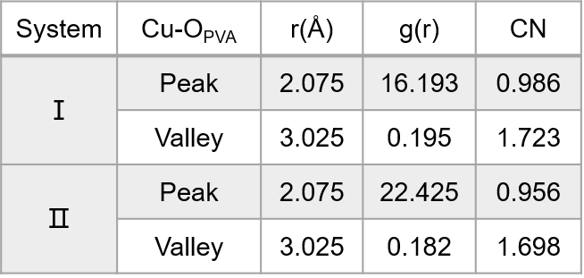
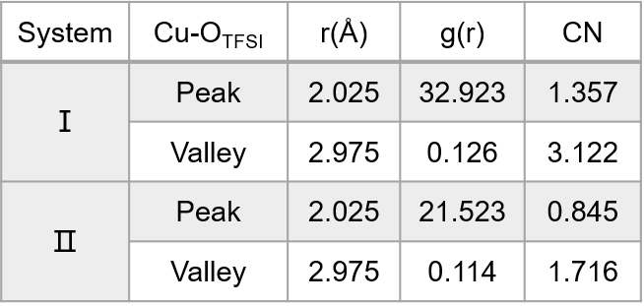

Table S2. Comparison of the power generation performance, including V_{oc}, I_{sc}, and theoretical maximum power output of SWEG with other reported SSEG, where P_{max}≈V_{oc}×I_{sc} / 4.
Reference | MEGs | V_{oc}/V | I_{sc}/μA | P_{max}/μW | Reports
Ref 1 | GS biofilms | 0.53 | 2.28 | 0.30 | Sci. Adv. (2022) 8, eabm8047
Ref 2 | G. biofilms | 0.45 | 1.5 | 0.17 | Nat. Commun. (2022) 13:4369
Ref 4 | SSEG | 0.78 | 7.5 | 1.46 | Nat. Commun. (2022) 13:3643
Ref 5 | 2D-WEG | 0.73 | 16.8 | 3.07 | Nat. Commun. (2022) 13:6819
Ref 6 | IENG | 0.432 | 64.2 | 6.93 | Nat. Commun. (2022) 13:5077
Ref 7 | mc-WEG | 0.24 | 31 | 1.86 | Nat. Commun. (2023) 14:5702
Ref 8 | R. p cell | 0.4 | 5 | 0.5 | Nat. Commun. (2024) 15:4992
Ref 9 | HEGs | 0.63 | 140 | 22.05 | Adv. Mater. (2024) 36, 2310795
Ref 10 | leaf | 0.25 | 0.05 | 0.003 | Nat. Water (2024) 2, 988
Ref 11 | HEG | 0.25 | 93 | 5.81 | Energy Environ. Sci. (2023) 16, 2494
Ref 12 | MXene films | 0.4 | 4 | 0.4 | Nat. Nanotech. (2024) 19, 1316
Avg. values | / | 0.424 | 30.4 | 3.22 | /
This work | SWEG | 0.68 | 1200 | 204 | /

