Supplemental materials
Supplemental Methods:
For each sample, we merged the BAM file containing HiFi reads with the BAM file containing "fail" reads (full length reads with both adapter sequences that do not meet Q20 quality cutoff) using `pbmerge` v3.4.0 (https://github.com/PacificBiosciences/pbtk) in order to increase sensitivity to detect repeat expansions. We then aligned the reads in the resulting merged BAMs to hg38 reference genome with pbmm2 v1.16.0 (https://github.com/PacificBiosciences/pbmm2) using the "HIFI" preset ("--preset HiFi"). We then genotyped and visualized the ATXN10 repeat in each sample using TRGT v2.0.0-rc1¹. The genotyping ("trgt genotype" command) was was performed with "targeted" preset ("--preset targeted") and capturing 200 bps of flanking sequence around the ATXN10 repeat ("--output-flank-len 200"). The visualization ("trgt plot" command) was configured to generate the so-called waterfall plots² ("--plot-type waterfall") and use 200 bp flanks ("--flank-len 200").

References:
1. Dolzhenko E, English A, Dashnow H, et al. Characterization and visualization of tandem repeats at genome scale. Nature Biotechnology 2024;42:1606-1614.
2. Rajan-Babu I-S, Dolzhenko E, Eberle MA, Friedman JM. Sequence composition changes in short tandem repeats: heterogeneity, detection, mechanisms and clinical implications. Nature Reviews Genetics 2024;25:476-499.

Supplemental Table 1. Femtopulse trace for sample 50.01 showing DNA size distribution as a QC step for long-read sequencing
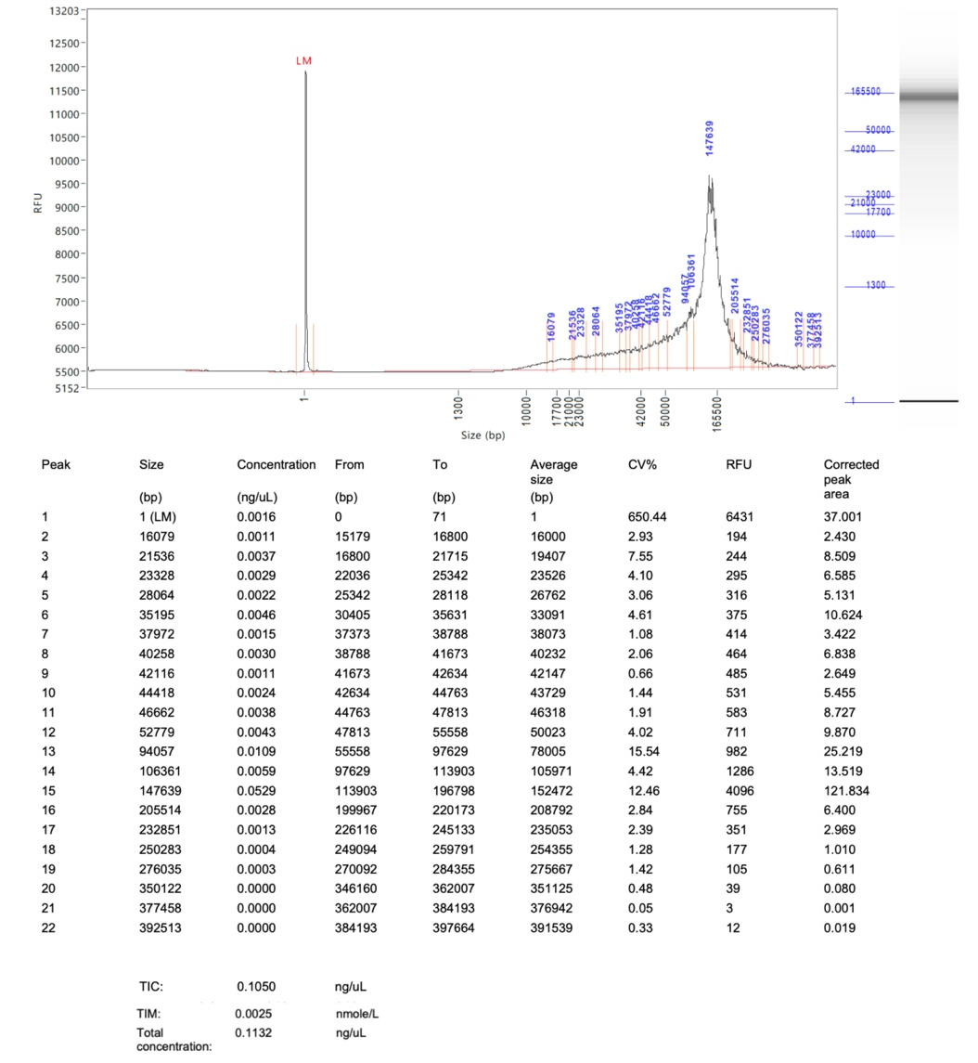

Supplemental Table 2. QC and informatics summary for optical genome mapping results
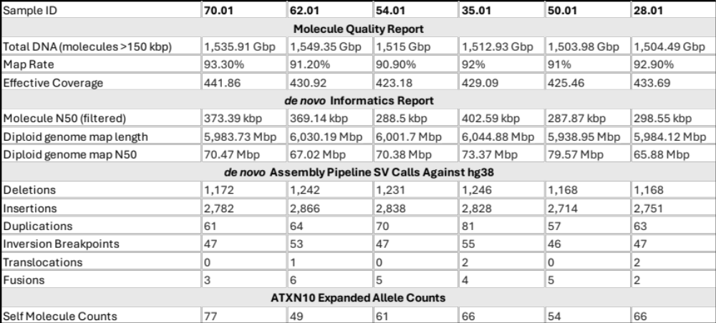

Supplemental Table 3. Complete list of clinical symptoms and features
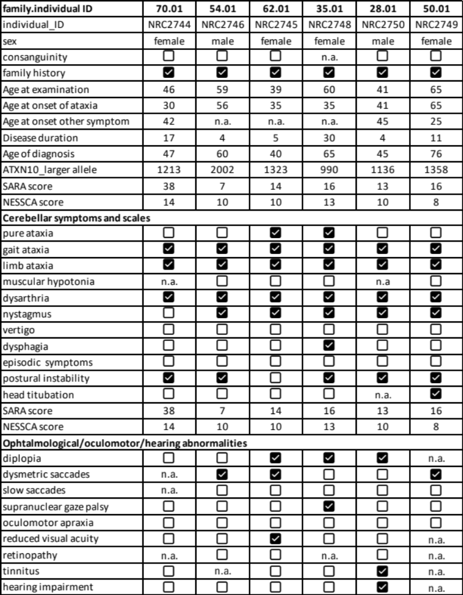

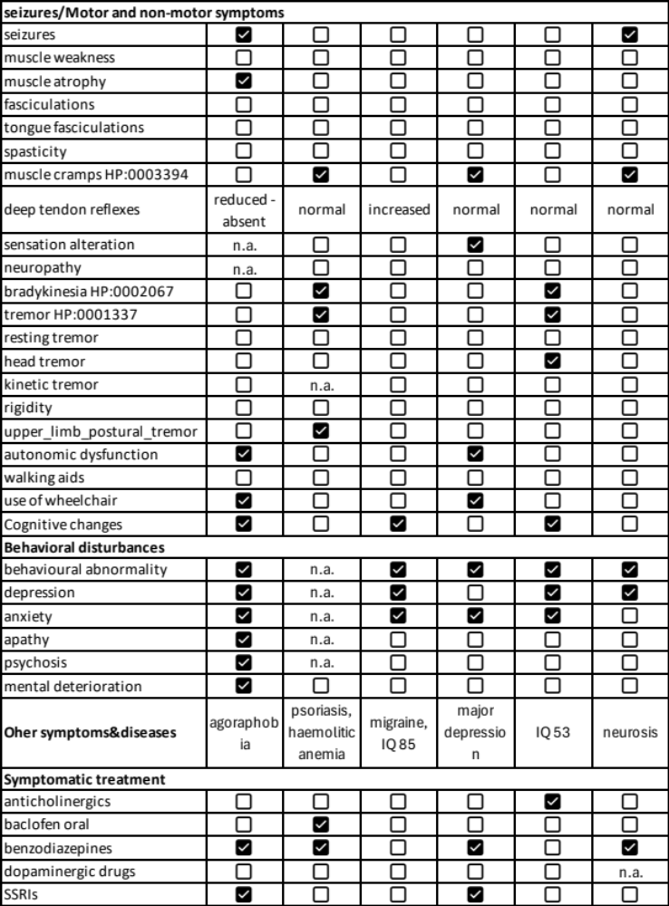
Supplemental Table 4. Specific counts of ATXN10 allele from a 20-gene panel and a single gene analysis with PacBio long-read sequencing
20-gene panel
Sample ID | 70.01 | 62.01 | 54.01 | 35.01 | 50.01 | 28.01
ATXN10 repeat unit | ATTCT | ATTCT | ATTCT | ATTCT | ATTCT | ATTCT
ATXN10 read count allele 0 | 392 | 434 | 462 | 219 | 312 | 371
ATXN10 consensus size allele 0 | 75 | 70 | 70 | 65 | 75 | 70
ATXN10 min size allele 0 | 65 | 65 | 64 | 59 | 66 | 63
ATXN10 max size allele 0 | 1900 | 75 | 4871 | 70 | 3103 | 81
ATXN10 motif counts allele 0 | 15 | 14 | 14 | 13 | 15 | 14
ATXN10 read count allele 1 | 171 | 181 | 154 | 152 | 160 | 216
ATXN10 consensus size allele 1 | 6032 | 6593 | 9942 | 4944 | 6723 | 5664
ATXN10 min size allele 1 | 3948 | 3659 | 6534 | 2145 | 70 | 1666
ATXN10 max size allele 1 | 7157 | 8048 | 15855 | 5827 | 8635 | 7905
ATXN10 motif counts allele 1 | 1213 | 1323 | 2002 | 990 | 1358 | 1136
Single gene (ATXN10)
Sample ID | 70.01 | 62.01 | 54.01 | 35.01 | 50.01 | 28.01
ATXN10 repeat unit | ATTCT | ATTCT | ATTCT | ATTCT | ATTCT | ATTCT
ATXN10 read count allele 0 | 404 | 521 | 386 | 505 | 388 | 471
ATXN10 consensus size allele 0 | 75 | 70 | 70 | 65 | 75 | 70
ATXN10 min size allele 0 | 69 | 63 | 63 | 59 | 67 | 60
ATXN10 max size allele 0 | 2809 | 75 | 7095 | 140 | 722 | 120
ATXN10 motif counts allele 0 | 15 | 14 | 14 | 13 | 15 | 14
ATXN10 read count allele 1 | 195 | 245 | 106 | 330 | 211 | 300
ATXN10 consensus size allele 1 | 5990 | 6603 | 9877 | 4956 | 6686 | 5693
ATXN10 min size allele 1 | 4499 | 69 | 7901 | 67 | 2362 | 1353
ATXN10 max size allele 1 | 7833 | 9618 | 10612 | 5564 | 16841 | 10581
ATXN10 motif counts allele 1 | 1203 | 1325 | 1990 | 992 | 1352 | 1141

Supplemental Table 5. Size comparison between Bionano OGM and PacBio LRS

ID | % Diff OGM vs PureTarget | % Diff OGM vs sgRNA
2744 70.01 | 2.30% | 2.98%
2745 62.01 | 1.96% | 1.81%
2746 54.01 | 0.75% | 1.40%
2748 35.01 | 1.69% | 1.93%
2749 50.01 | 1.02% | 1.56%
2750 28.01 | 1.56% | 1.06%

Supplemental Table 6. PacBio long-read sequencing specific counts of 20-gene panel.
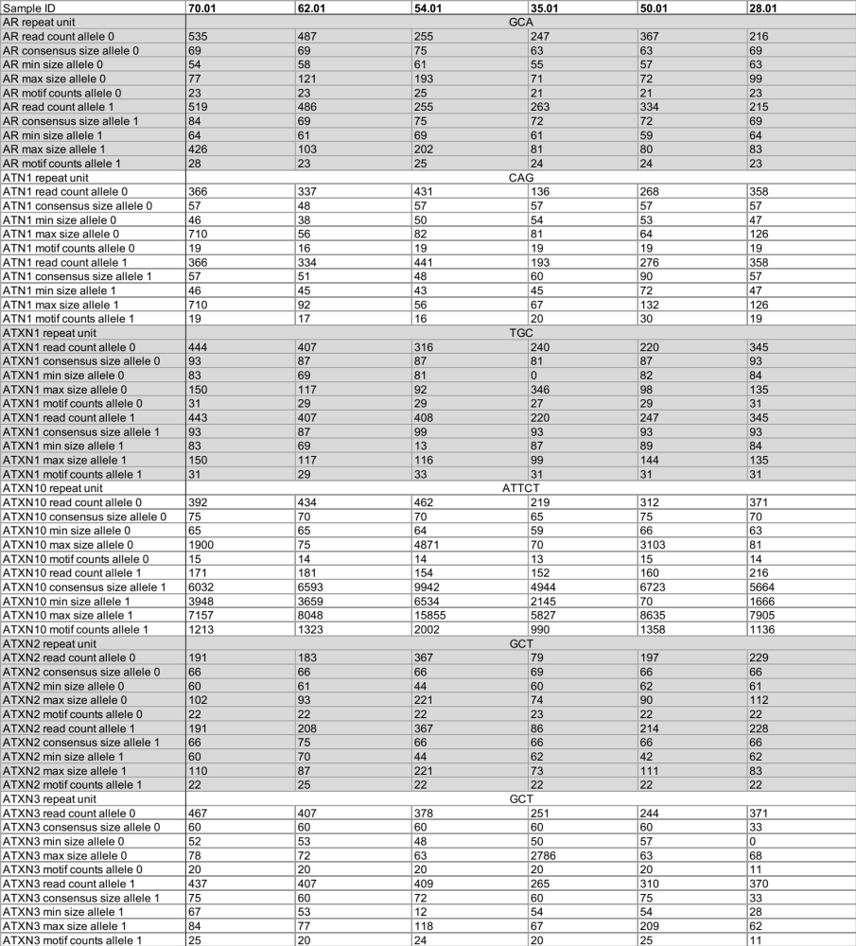

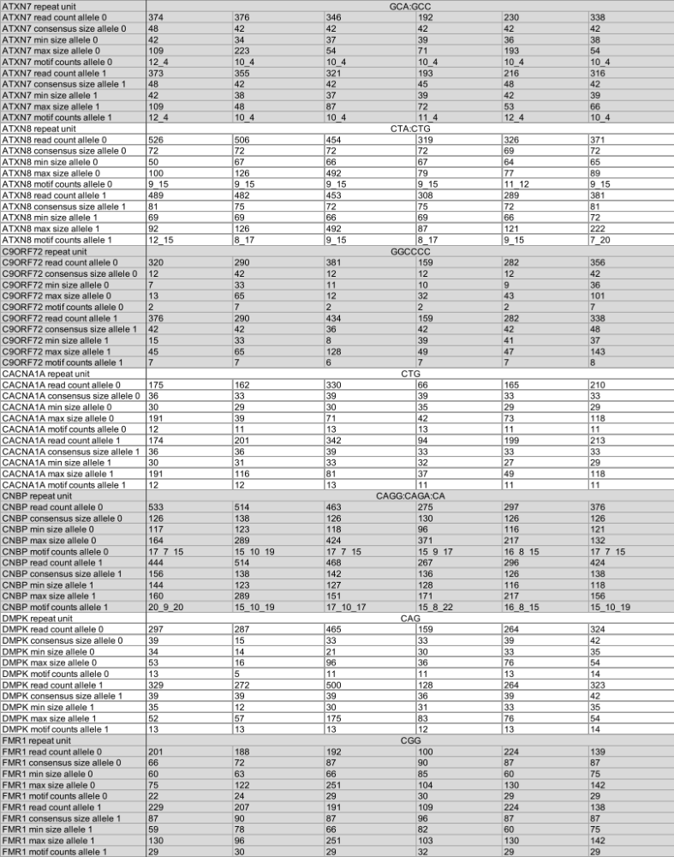

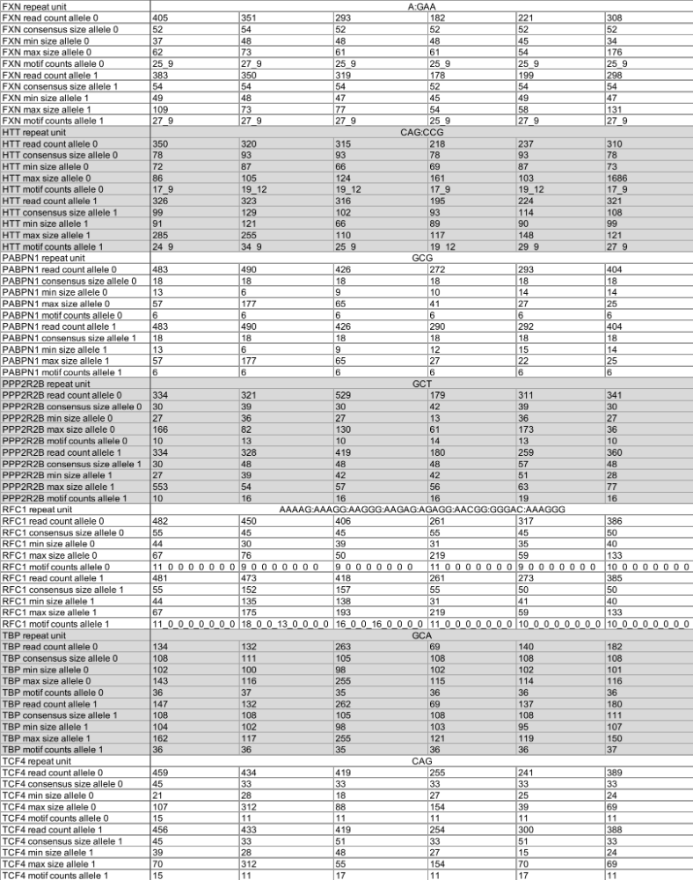

Supplemental Figure 1.
Pedigree 70.01
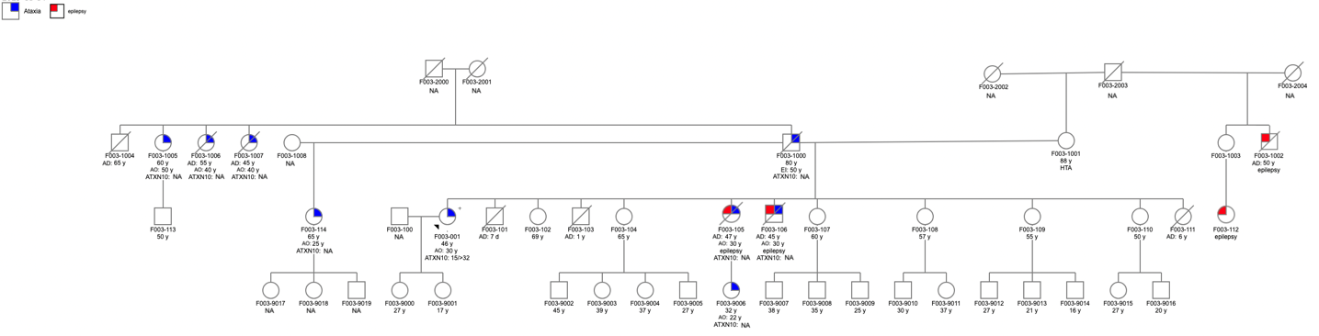
Pedigree 54.01
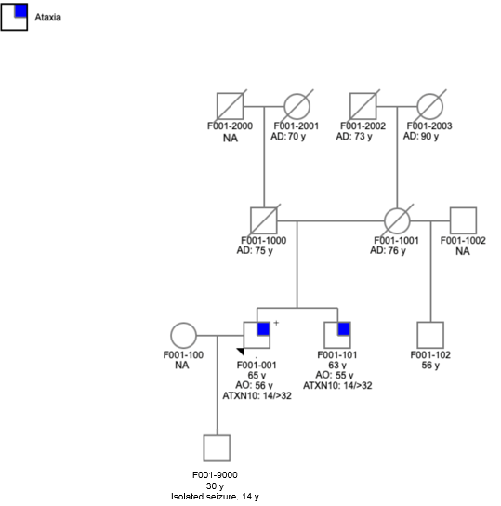
Pedigree 65.01
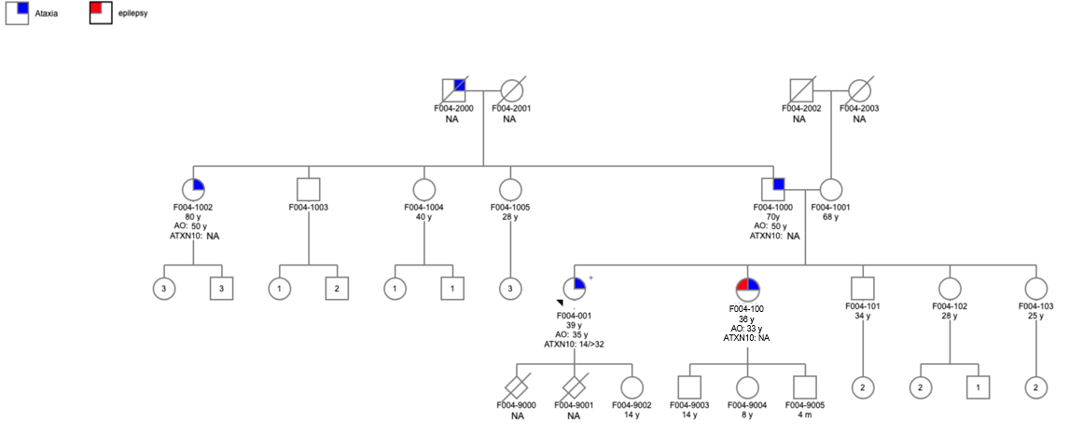

Pedigree 35.01
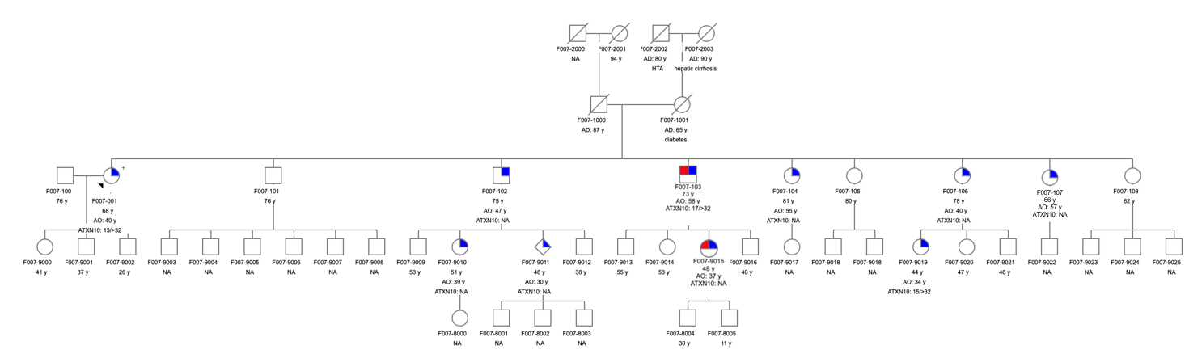
Pedigree 28.01
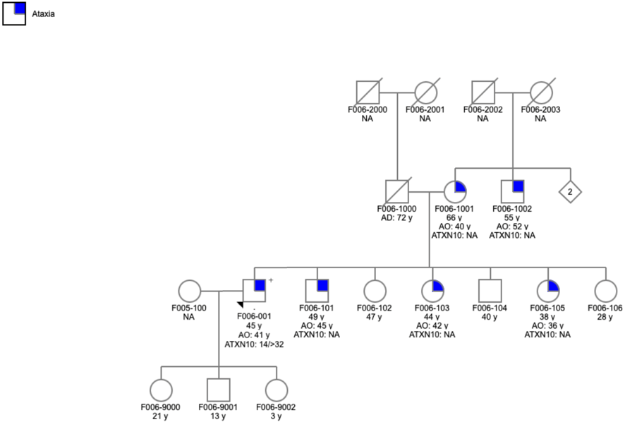
Pedigree 50.01
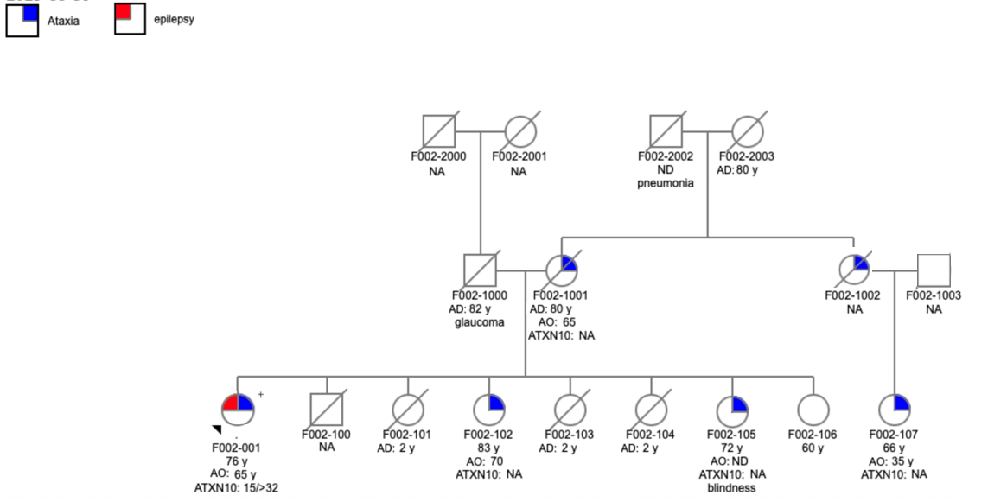
Figure legend. Pedigrees of the six Peruvian families. The pedigrees were drawn with the Progeny online tool and followed the standard nomenclature. Squares indicate males, circles females, blue indicates ataxia and red indicates epilepsy, AO = age at onset.
Supplemental Figure 2.

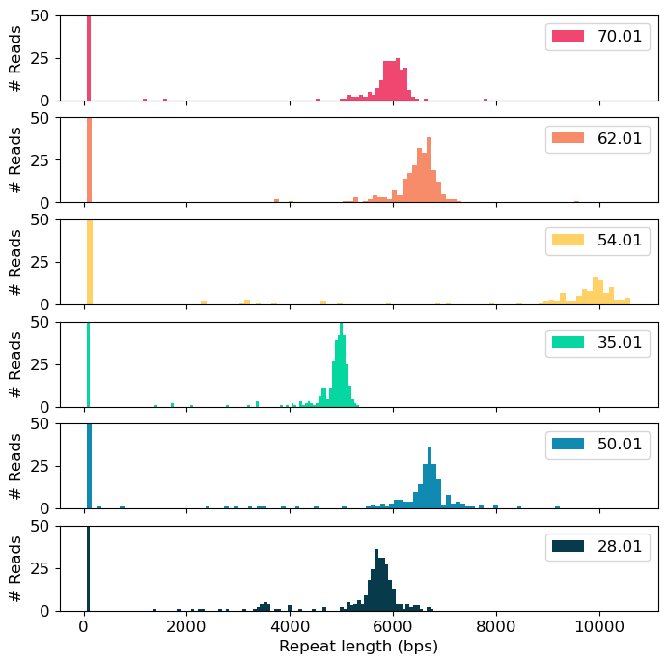

Figure legend. Histograms of LRS ATXN10 repeat expansions. The histograms for the six index cases show the somatic variability of the expanded repeat. The plot is clipped at 50 reads. The short allele is therefore not showing all reads.
Supplemental Figure 3.

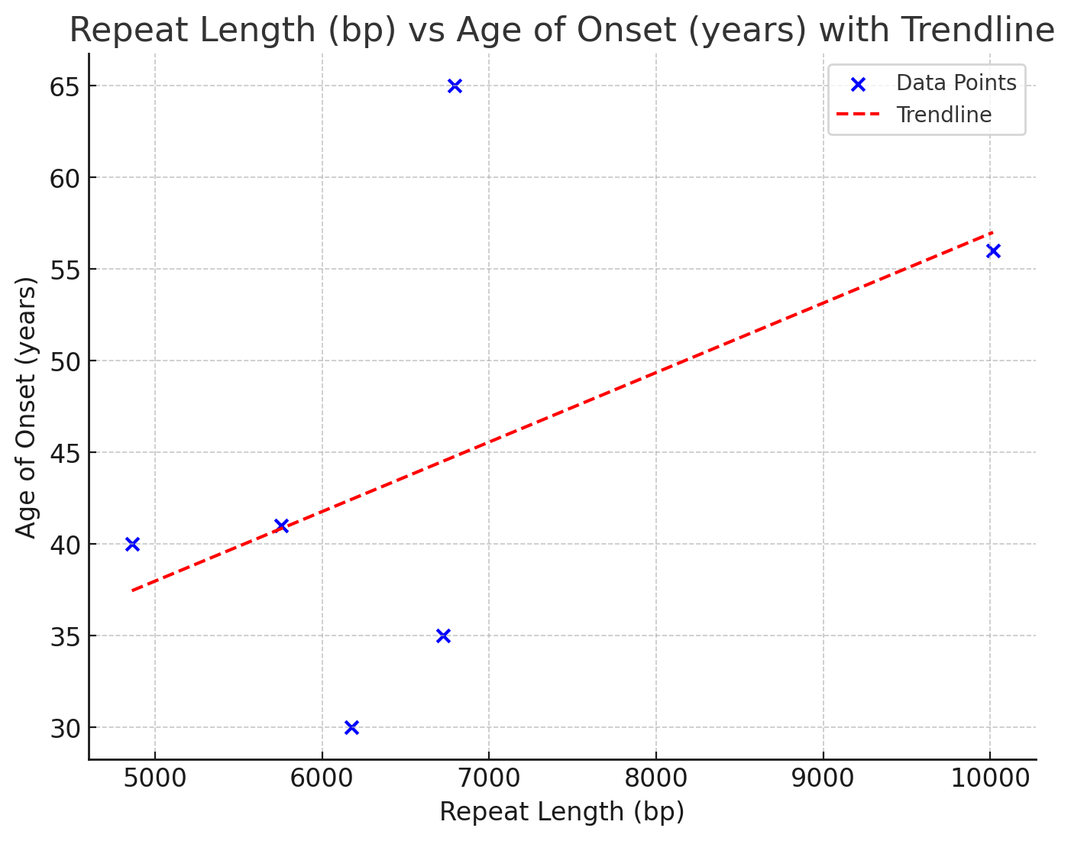

Figure legend. Repeat length over age at onset. Plotting the length of the repeat expansions shows that there is no correlation between length and age at onset. Usually, the longer the allele is the earlier the age at disease onset.

