Supplementary Information
Supplementary Tables
Supplementary Table S1. Genomes used for the synteny analysis. Strains are listed to disambiguate multiple assemblies on TriTrypDB.
Species | Source
Crithidia acanthocephali TCC037E | NCBI (GCA_000482105.1)
Crithidia bombi 08.076 | NCBI (GCA_900240985.1)
Crithidia expoeki BJ08.175 | NCBI (GCA_900240875.1)
Crithidia fasciculata CfC1 | TriTrypDB-64
Leishmania braziliensis MHOM/BR/75/M2904 | TriTrypDB-64
Leishmania major Friedlin | TriTrypDB-64
Leptomonas pyrrhocoris H10 | TriTrypDB-64

Supplementary Table S2. Genome assemblies used for the phylogenetic reconstruction.
Species | Source
Crithidia bombi 08.076 | NCBI (GCA_900240985.1)
Crithidia brevicula S14 | NCBI (GCA_030849845.1)
Crithidia expoeki BJ08.175 | NCBI (GCA_900240875.1)
Crithidia fasciculata CfC1 | TriTrypDB-64
Crithidia mellificae ATCC 30254 | NCBI (GCA_002216565.1)
Crithidia thermophila CT-IOC 054 | NCBI (GCA_030849055.1)
Leishmania braziliensis MHOM/BR/75/M2904 | TriTrypDB-64
Leishmania donovani HU3 | TriTrypDB-64
Leishmania mexicana MHOM/GT/2001/U1103 | TriTrypDB-64
Leishmania major Friedlin | TriTrypDB-64
Leptomonas pyrrhocoris H10 | TriTrypDB-64
Leptomonas seymouri ATCC 30220 | TriTrypDB-64
Lotmaria passim SF | NCBI (ASM63599v1)

Supplementary Figures 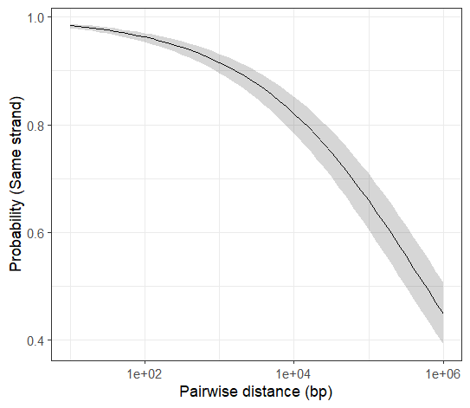
Supplementary Figure 1. Relationship between pairwise distance between genes and probability that both are located on the same strand. 97% of adjacent gene pairs are located on the same strand. Genes within 1 Kb of one another have a >90% chance of being on the same strand, and those within 10Kb have a >80% chance. Trendline and shaded band show estimated model means and 95% confidence intervals.
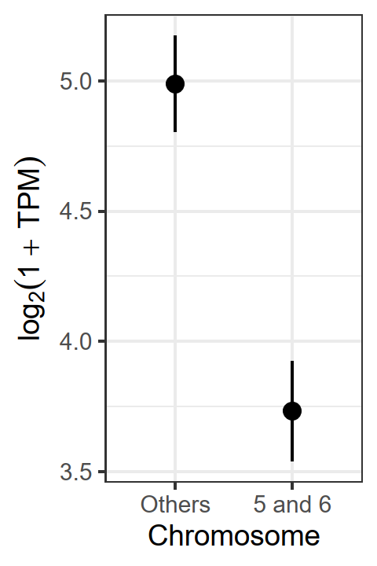
Supplementary Figure 2. Paralogous Chromosomes 5 and 6 have lower per-gene expression levels relative to the rest of the genome. Points show model means and 95% confidence intervals. Y-axis shows log-transformed expression level in transcripts per million, pooled across all samples and excluding genes on the maxicircle.

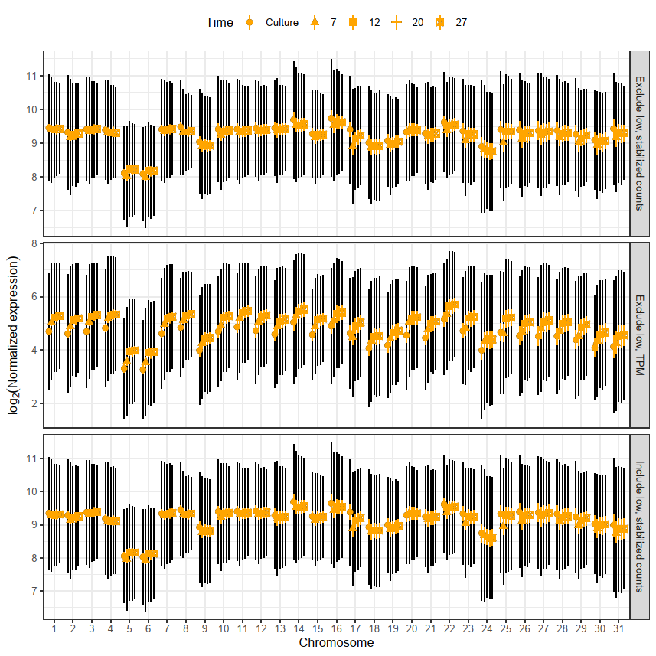
Supplementary Figure 3. Paralogous chromosomes 5 and 6 have lower per-gene expression levels relative to the rest of the genome. Points show means ± 2 SE (orange) and ± 1 SD (black), with different shapes corresponding to each of the samples types (cultured cells and cells in bee guts at different time points post-inoculation). Y-axis shows transcripts per million or variance-stabilized read count, normalized to account for gene length, with or without exclusion of genes with low expression levels. “Maxi” refers to the mitochondrial maxicircle.
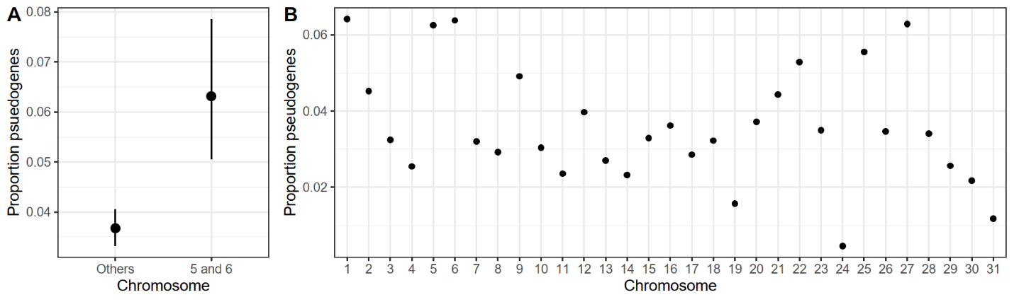

Supplementary Figure 4. Paralogous Chromosomes 5 and 6 have a higher proportion of predicted pseudogenes relative to the rest of the genome. (A) Points and error bars show model means and 95% confidence intervals from the binomial model. (B) Proportions of annotated genes on each chromosome that correspond to predicted pseudogenes.

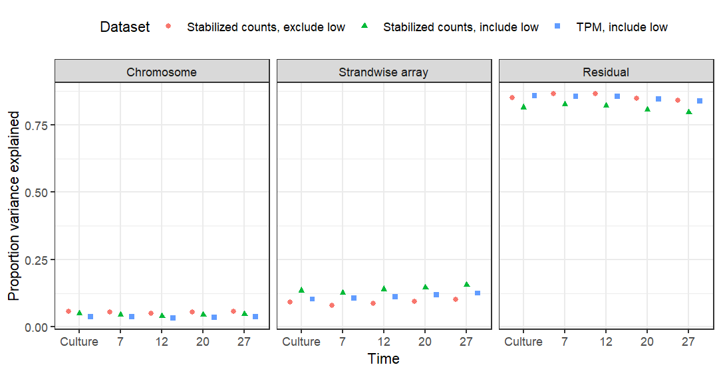
Supplementary Figure 5. Same-stranded arrays explained 8-16% of variance in expression level when modeled as a random effect. X-axis shows the five sample groups. Shapes indicate estimates for data sets with variance-stabilized read counts (with and without low-count genes) and transcripts per million (TPM) as the response variable.

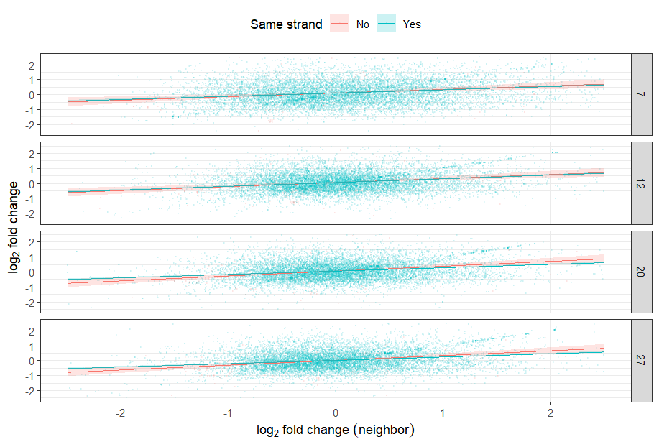
Supplementary Figure 6. Adjacent genes are correlated in extent of differential expression. Y- and X-axes show log₂-fold changes of each pair of neighboring genes relative to cultured cells. Trendlines show correlations with 95% CI shaded bands, in red for neighbors on opposite strands and blue for neighbors on the same strand. Panels in rows indicate sample groups corresponding to different time points post-inoculation.

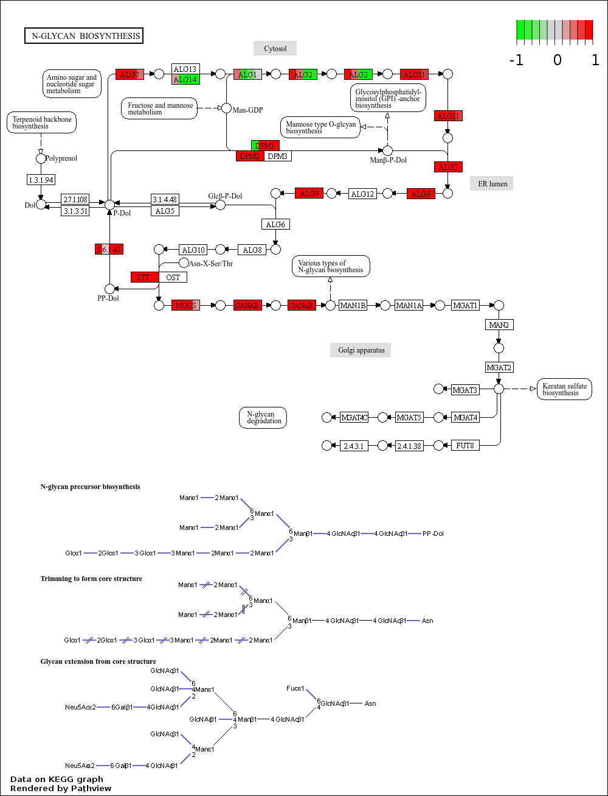Supplementary Figure 7. Differential expression of genes putatively involved in N-glycan biosynthesis. Boxes denote genes or Enzyme Commission (EC) codes. Horizontally striped shading corresponds to the T-statistic for expression level in gut vs. culture at each time point post-inoculation (7, 12, 20, and 27 d). ALG: asparagine-linked glycosylation. DPM: dolichol-phosphate mannosyltransferase. GANAB: mannosyl-oligosaccharide alpha-1,3-glucosidase (neutral alpha-glucosidase AB). MOGS: mannosyl-oligosaccharide glucohydrolase. STT: dolichyl-diphosphooligosaccharide protein glycosyltransferase. The figure was rendered using the Pathview web server (pathview.uncc.edu).

Supplementary Data
Supplementary Data S1. RNAseq read counts used for transcriptome analysis.
Supplementary Data S2. GO assignments made by Pannzer2.
Supplementary Data S3. KEGG assignments made by BlastKoala.
Supplementary Data S4. GSEA results from the GO analysis.
Supplementary Data S5. GSEA results from the KEGG analysis.

