Supplementary information for
Cold welding without direct contact
Yizhong Guo^{1,9}, Deping Guo^{2,3,9}, Cheng Qian^{4,9}, Zhanxin Wang¹, Jiao Teng⁵, Haibo Long¹, Shengcheng Mao¹, Ang Li¹, Cong Wang², Ze Zhang⁶, Feng Ding^{4*}, Wei Ji^{2*}, Yang Lu^{7*}, Lihua Wang^{1*} & Xiaodong Han^{1,8*}
¹Beijing Key Lab of Microstructure and Properties of Advanced Materials, Beijing University of Technology, Beijing, China.
²Beijing Key Laboratory of Optoelectronic Functional Materials & Micro-Nano Devices; Key Laboratory of Quantum State Construction and Manipulation, Renmin University of China, Beijing, China.
³College of Physics and Electronic Engineering, Sichuan Normal University, Chengdu, China.
⁴Suzhou Laboratory, Suzhou, Jiangsu, P. R. China.
⁵Department of Material Physics and Chemistry, University of Science and Technology Beijing, Beijing, China.
⁶Department of Materials Science, Zhejiang University, Hangzhou, China.
⁷Department of Mechanical Engineering, The University of Hong Kong, Pokfulam, Hong Kong, China.
⁸Department of Materials Science and Engineering, Southern University of Science and Technology, Shenzhen, China.
⁹These authors contributed equally: Yizhong Guo, Deping Guo, Cheng Qian.
*Corresponding author, e-mail: dingf@szlab.ac.cn; wji@ruc.edu.cn; ylu1@hku.hk; wlh@bjut.edu.cn; xdhan@bjut.edu.cn

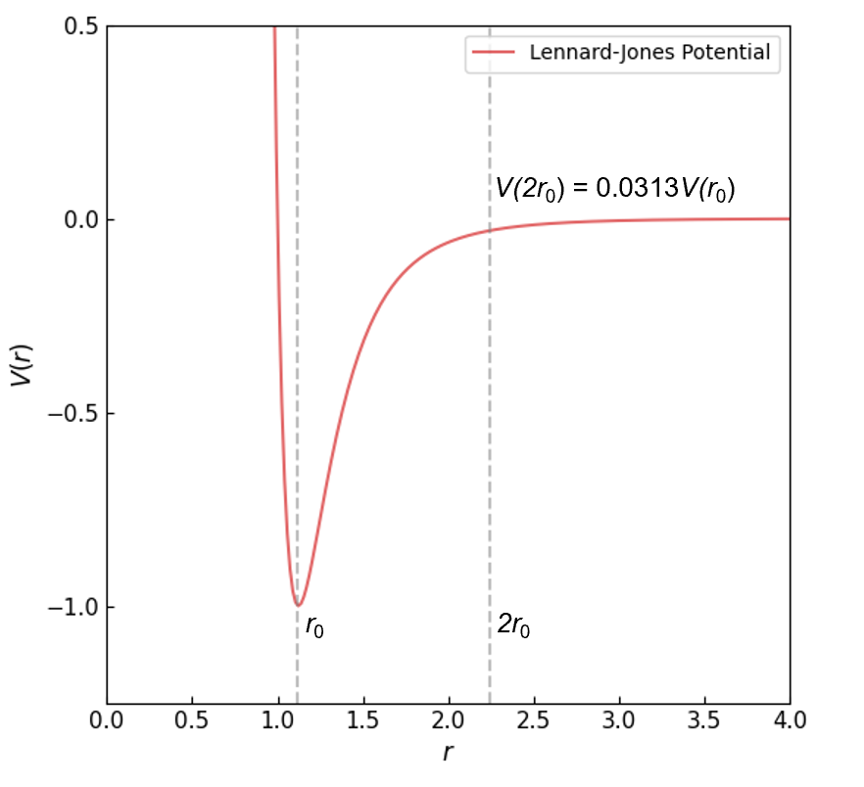
Supplementary Fig. 1 | The reduced Lennard-Jones 12-6 potential, $V\left(r\right)=4ε\left[{\left(σ/r\right)}^{12}-{\left(σ/r\right)}^{6}\right]$, where 𝜀 = 1.0 is the depth of the potential well, and 𝜎 = 1.0 is the distance at which the potential energy is zero. The equilibrium distance, r₀, is the equilibrium bond length of the atoms, while 2r₀ is twice the equilibrium bond length. The interaction V(2r₀) is approximately 3.13% of V(r₀).

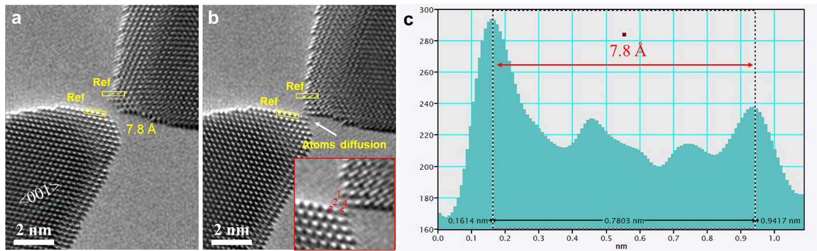
Supplementary Fig. 2 | Cold welding of two nanocrystals at the critical distance of ~ 7.8 Å. a,b, The columns of atoms denoted “1” to “5” diffuse to the tips and form diatomic chains during cold welding. c, The distance was 7.8 Å by measuring the spacing between two tips of nanocrystals.

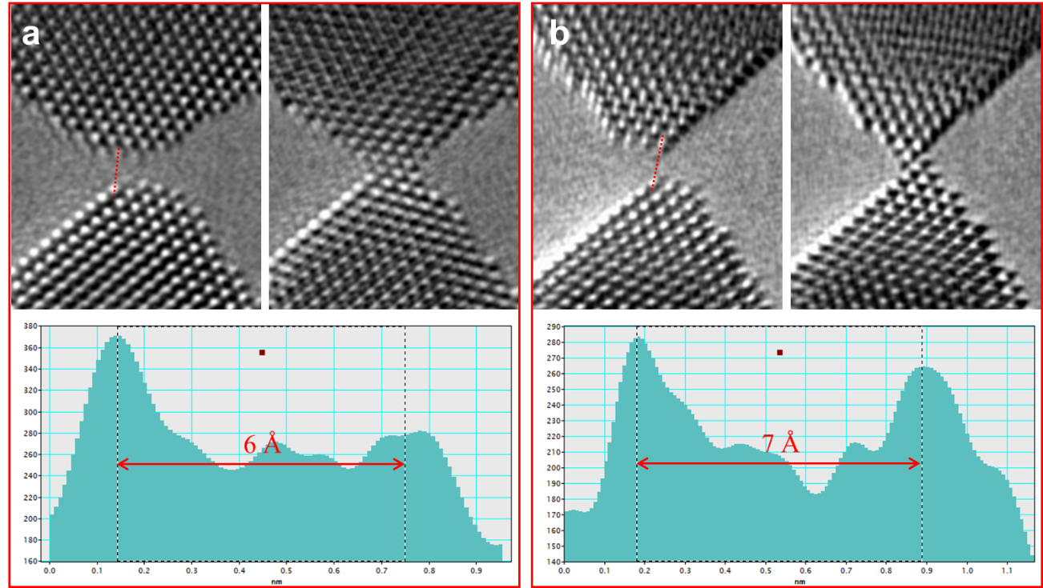
Supplementary Fig. 3 | Two examples of cold welding at distances of 6 Å and 7 Å.

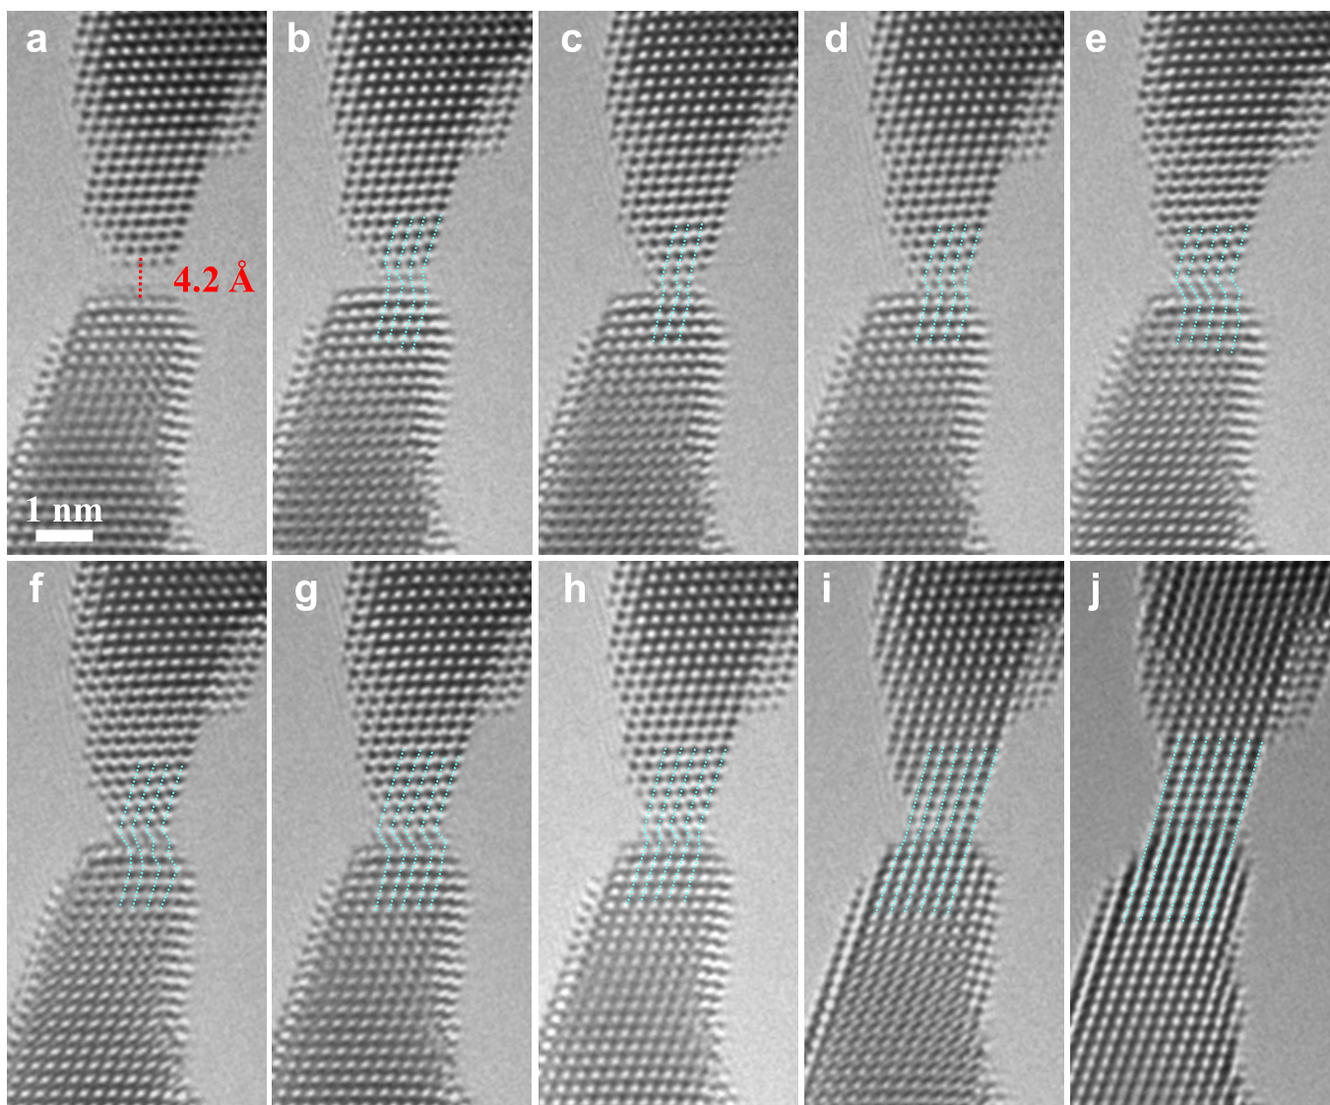
Supplementary Fig. 4 | In situ HR-TEM images of cold welding without direct contact. a, Welding at a distance of 4.2 Å. b–i, Atoms diffused between the tips of the nanocrystals, resulting in the cold welding. The green dotted lines represent the (111) plane between the nanocrystals, indicating an interface between the nanocrystals. j, The interface disappeared owing to the shuffling and rearrangement of atoms.
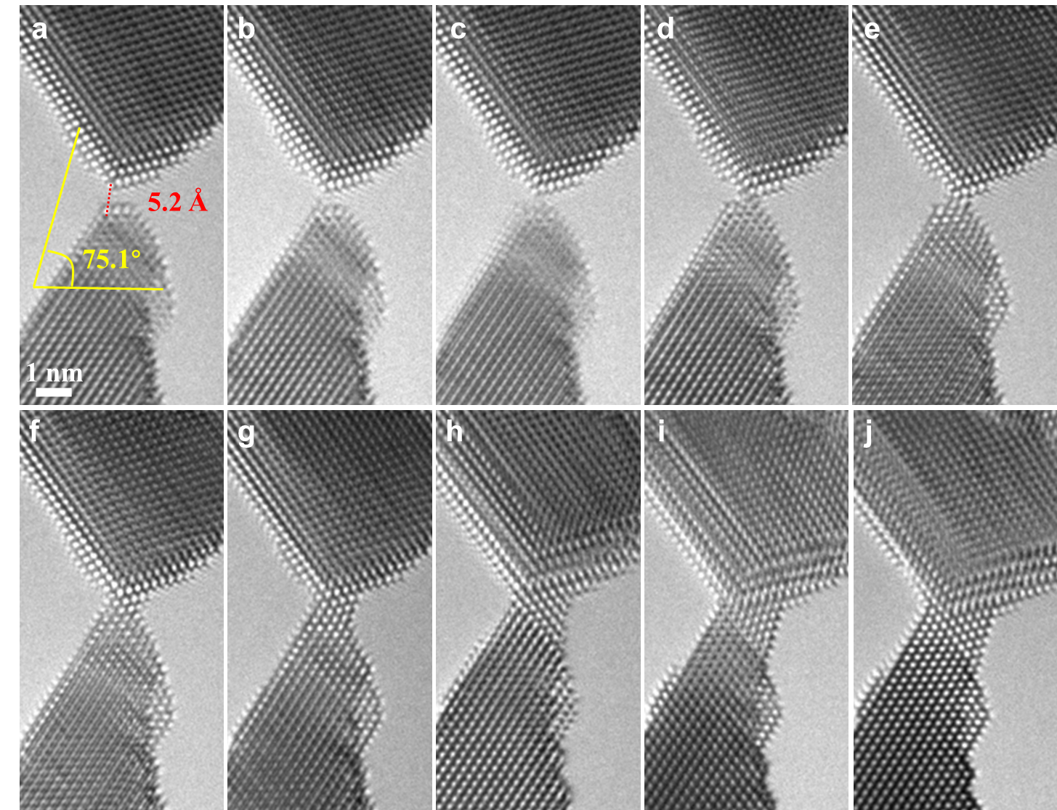
Supplementary Fig. 5 | In situ HR-TEM images of the cold welding of two non-contacting nanocrystals with a misorientation angle of 75.1° and distance of 5.2 Å.

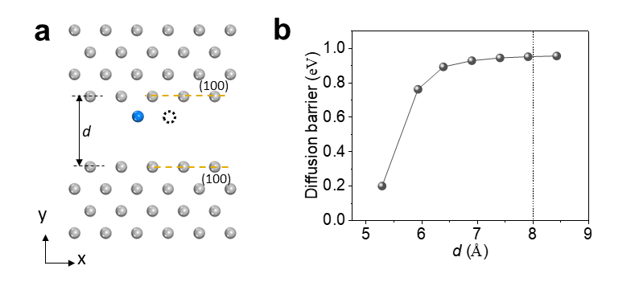
Supplementary Fig. 6 | Diffusion barriers in the surface-to-surface model at various distances. a, Schematic of initial (blue sphere) and final (black dashed circle) states for an on-surface diffusion process. b, Diffusion barriers at various distances derived using DFT from the model depicted in (a).

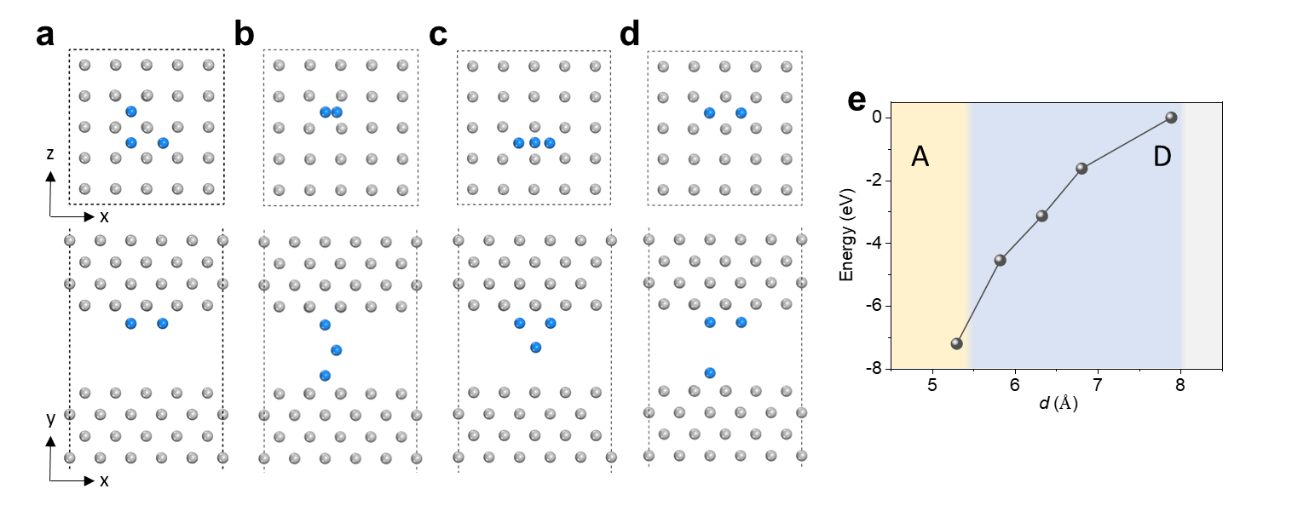
Supplementary Fig. 7 | Likely configurations for the adsorption of three adatoms at the gap of the (100)/(100) surface-to-surface model. a–d, Top- (up panel) and side-views (down-panel) of four adsorption configurations (a) to (d). All diffusing atoms are highlighted in blue. Only surface Pt atoms are shown in the top views. e, Adsorption energy of the most stable one among all four configurations as a function of the gap distance. As indicated by the plot, configuration (a) is the most stable at shorter gap distances and configuration (d) is the most preferred for larger gaps.
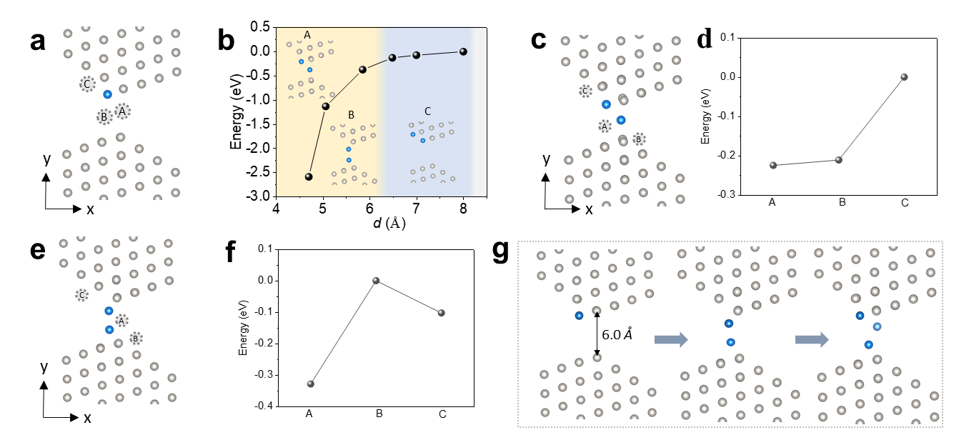
Supplementary Fig. 8 | Likely configurations for the adsorption of one or two additional adatoms in the gap of a (100)-(111)/ (100)-(111) edge-to-edge model. a, Three considered adatom adsorption sites A to C in the presence of a pre-adsorbed adatom (highlighted in blue). These sites are highlighted in dashed circles, hereinafter. b, Adsorption energy of the most stable site among all three sites as a function of the gap distance. c, At the gap distance of 5.0 Å, the second adatom prefers site A, as depicted in (a). Given these two adatoms, the third adatom has three likely adsorption sites A to C. d, Relative total energies of sites A to C indicates site A is the most energetically preferred. At the gap distance of 6.0 Å, the second atom prefers site B, as depicted in panel (e), in which three considered adsorption sites were considered for the third adatom. f, Total energies of these three sites indicate site A is the most preferred. g, A schematic plot of cold welding at 6 Å according to the revealed adsorption energies for those configurations.

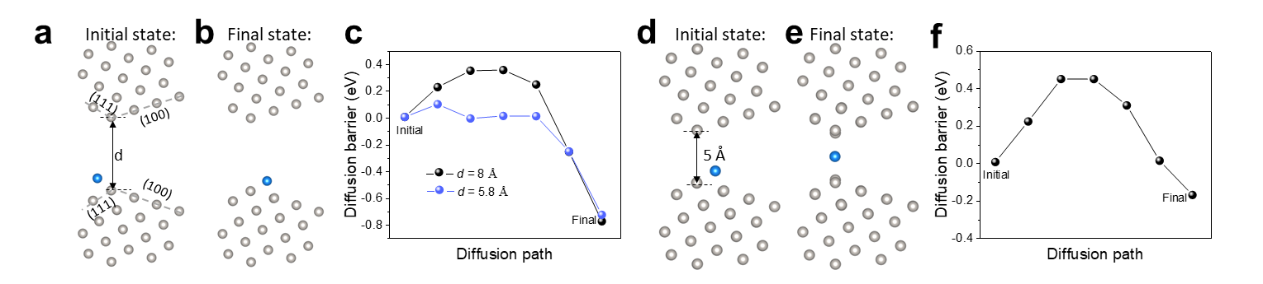
Supplementary Fig. 9 | Diffusion barriers in the edge-to-edge model at various distances. Schematics of the initial (a) and final (b) configurations. c, Diffusion barriers from the initial (a) to final (b) states at 8 Å and 5.8 Å. Schematics of the initial (d) and final (e) configurations at the gap distance of 5 Å, while the diffusion barrier is plotted in panel (f).

