SUPPLEMENTARY MATERIALS AND METHODS
Electrode Contact Yield
Bipolar EMG was successfully recorded from 13/14 RPNIs and 26/26 implanted residual muscles. We could not consistently record bipolar EMG from one of P4’s median RPNIs, labelled Median RPNI 2. This was most likely not due to a lack of RPNI reinnervation, rather it is suspected one of the electrode contacts or pin connection was non-functional. Monopolar EMG could be recorded from the positive contact as shown in Figure S1. Furthermore, electrically stimulating the positive contact with a 100µS pulse width square wave at 20Hz consistently elicited sensations in the phantom middle and index fingers with a perception threshold of 2.7±0.6mA (mean ± std, n = 6 sessions). More information on afferent signaling can be found in Gonzalez et al. 2024⁷¹, where this RPNI is also labelled P4 Median RPNI 2.
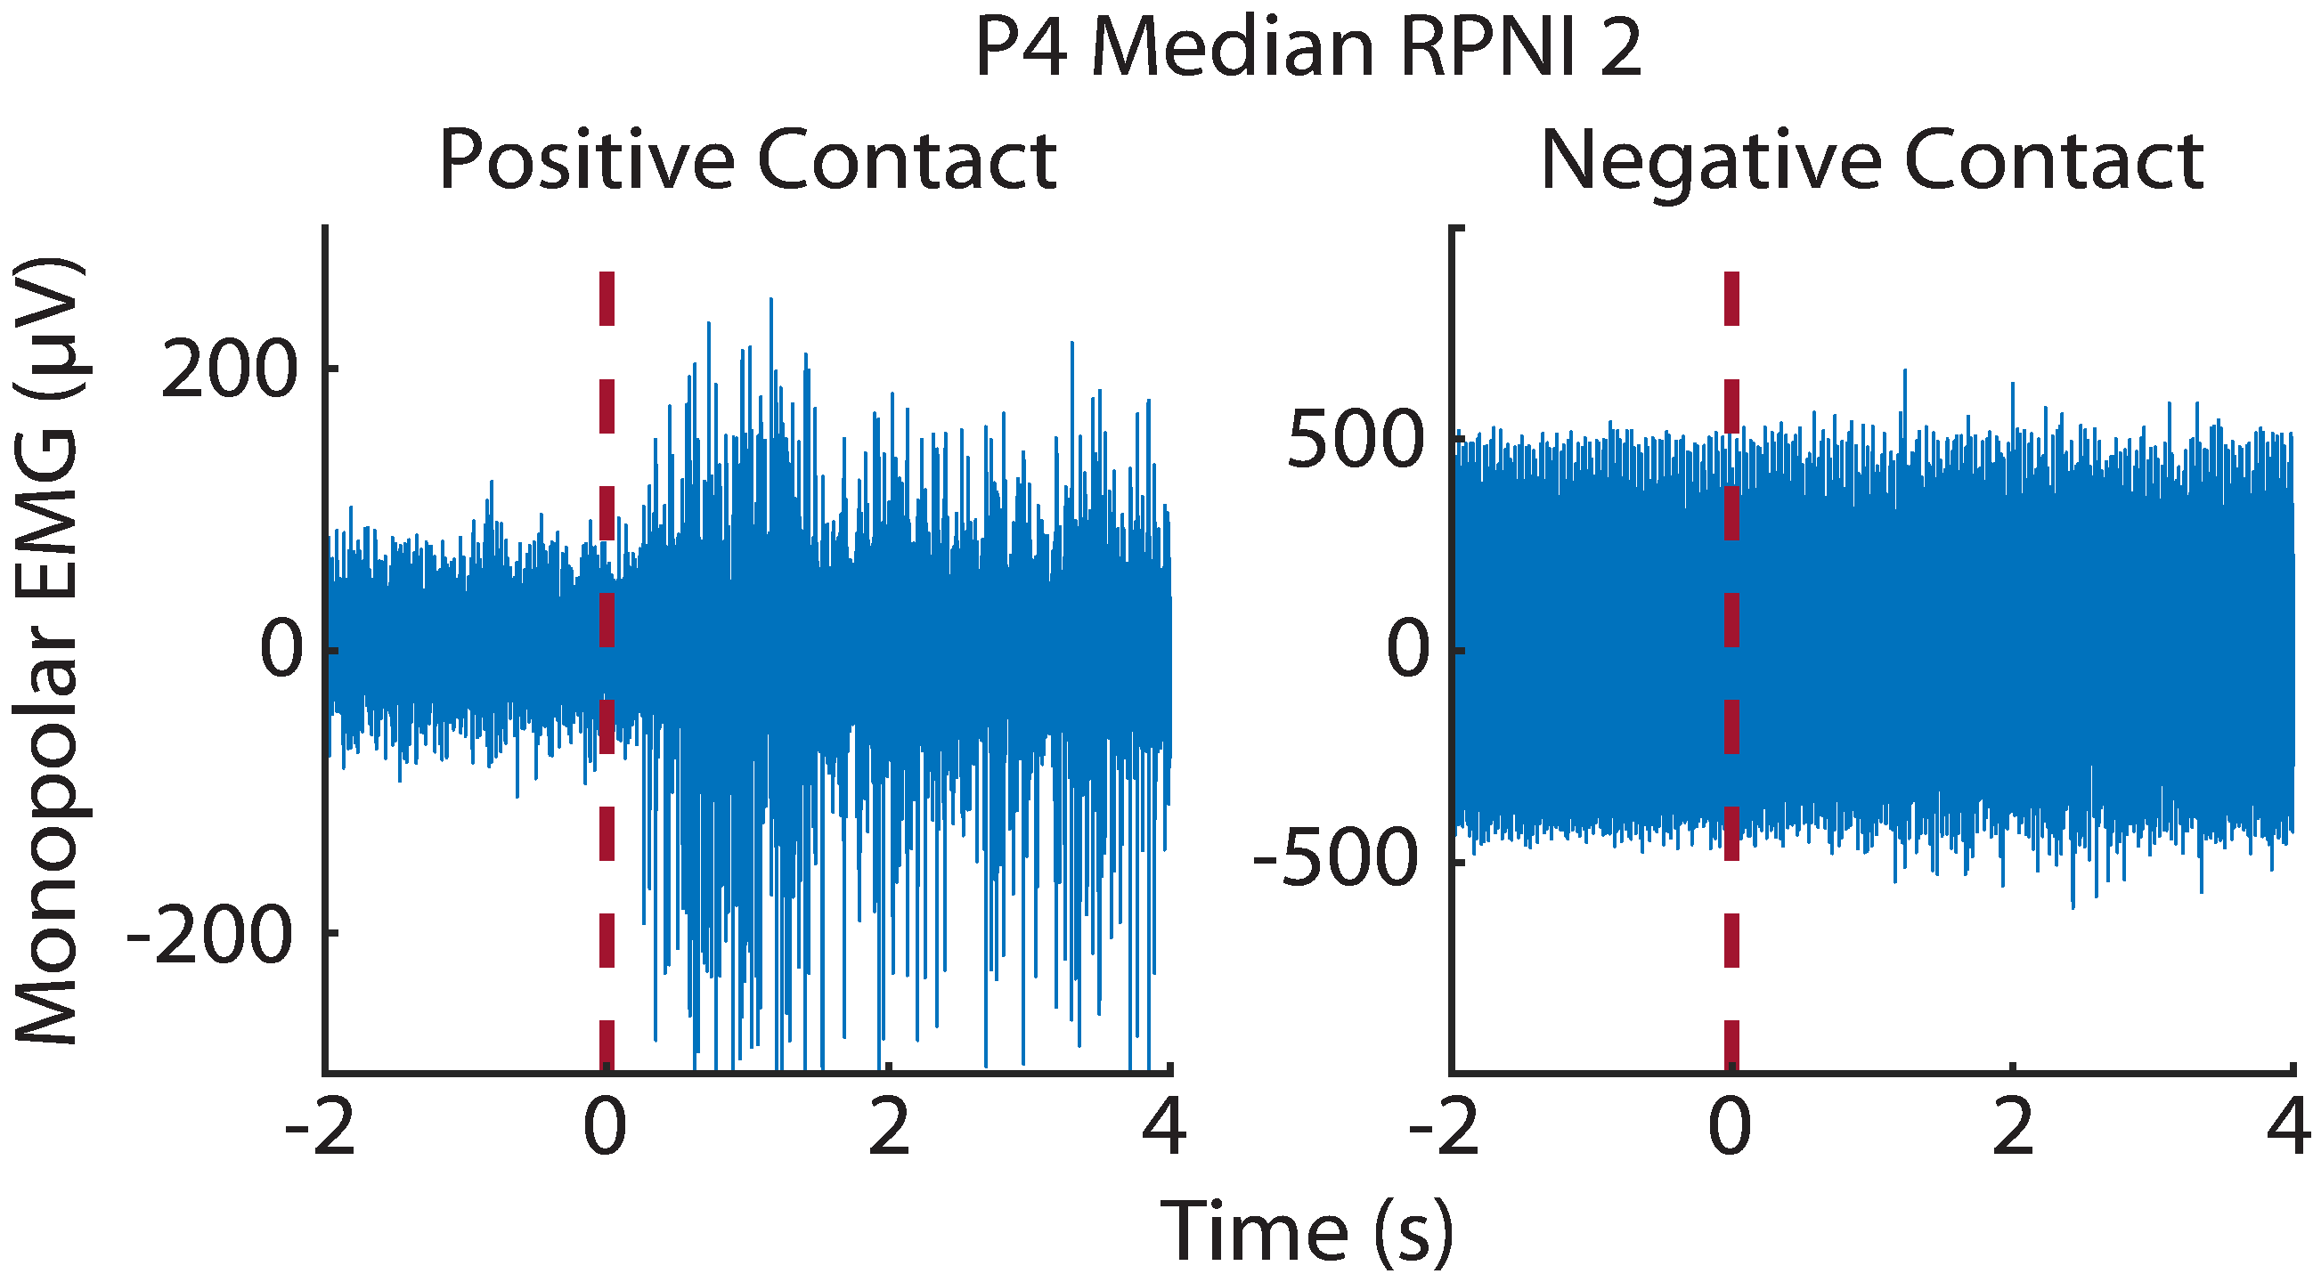
Figure S1. Individual contact recordings of the non-functional bipolar electrode 354 days after RPNI creation and electrode implantation. Monopolar EMG was recorded on the positive contact during middle finger flexion cued at time T = 0 seconds. Negative contact recorded large amplitude noise.
Viewing RPNIs Under Ultrasound
As previously reported, RPNIs can be identified under ultrasound. Figure S2 shows ultrasound images of P1-P3’s implanted RPNIs collected with a Philips SonoSite HFL50 probe. Although we confirmed the presence of RPNIs in P4, we were unable to collocate and consistently identify the RPNIs. This difficulty may have been due to altered nerve anatomy from his previous TMR operation. We originally attempted to track the size of each RPNI graft via ultrasound to determine if electrode implantation led to RPNI tissue degeneration. However, we were not confident in our ability to identify RPNI borders with consistent probe alignment. Therefore, we relied on SNRs as the primary indicator of RPNI tissue degeneration. If future studies wish to use ultrasound to view RPNIs, electrically stimulating the RPNIs may induce isolated contractions to aid in identification.
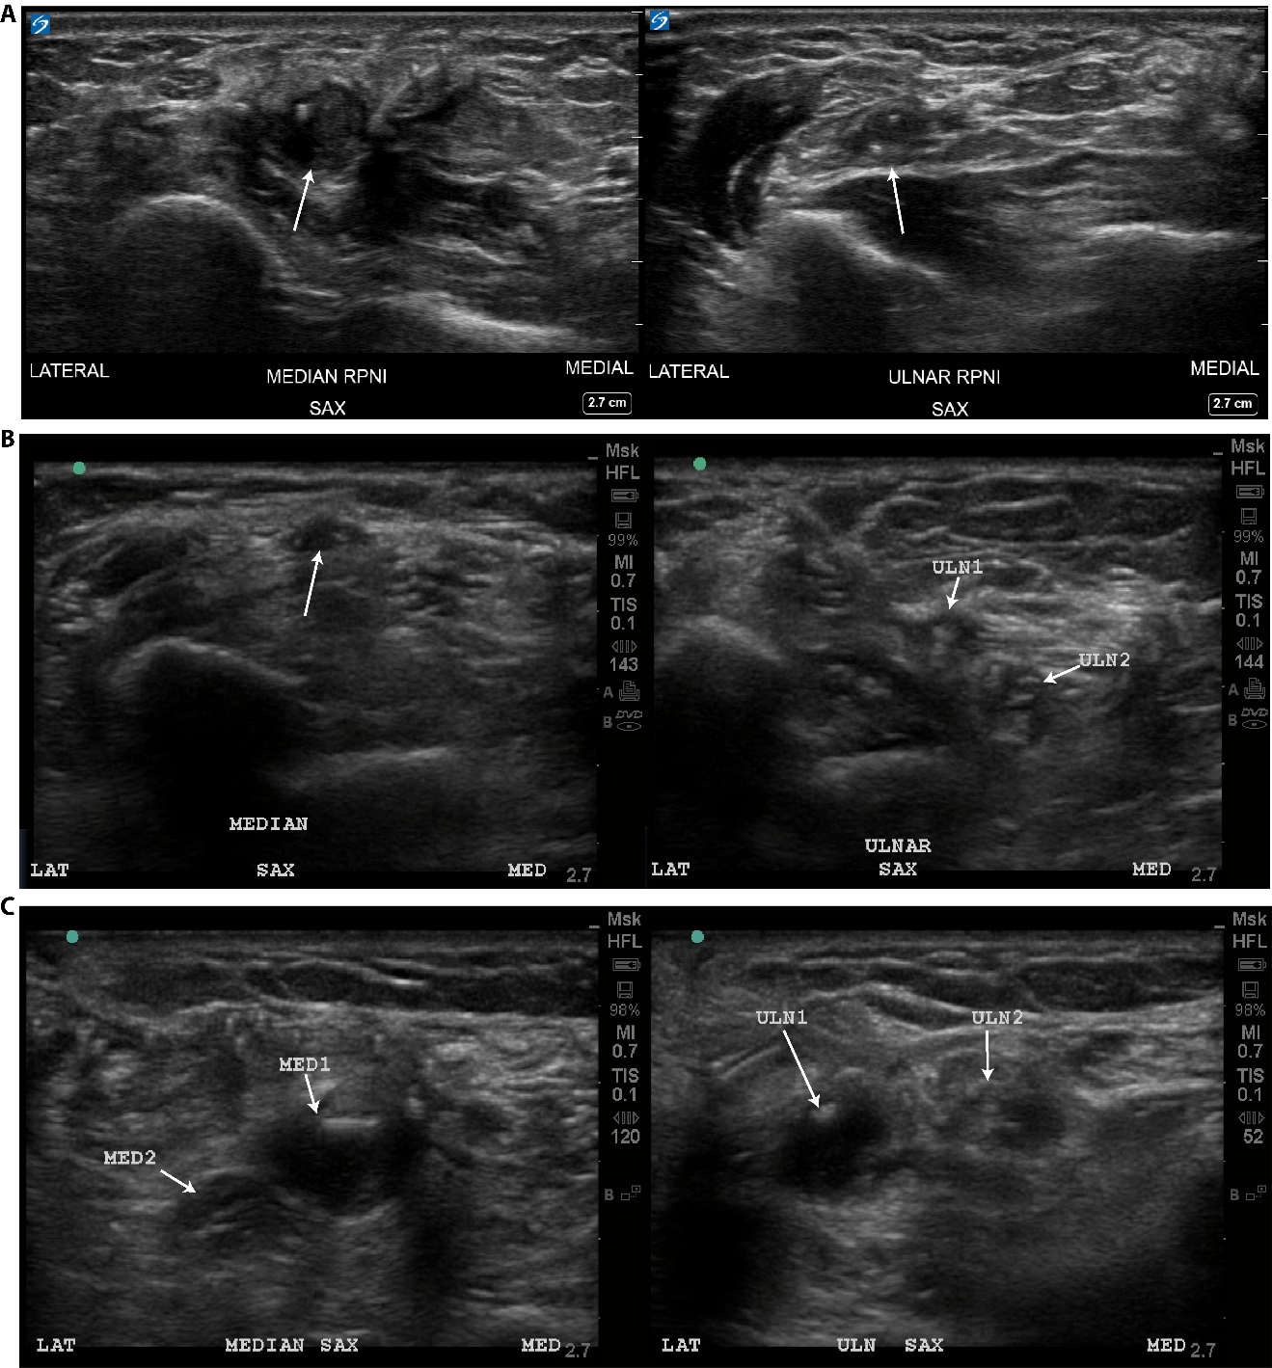
Figure S2. Ultrasound images of Median RPNIs (left) and Ulnar RPNIs (right). (A) P1 taken 337 days after electrode implantation, (B) P2 taken 1609 days after electrode implantation, and (C) P3 taken 225 days after electrode implantation.

