Effect of Early Adjunctive Vasopressin Initiation for Septic Shock Patients: A Target Trial Emulation
Supplemental Material
Table S1. Summary of the protocol of a target trial estimating the effect of early vasopressin start* versus an intervention that never allows for vasopressin start 2
Table S2. Specification of the covariate models. 6
Table S3. Baseline characteristics and intervention of eligible cohort before and after imputation 7

Figure S1. Schematic illustration of the conceptual framework 3
Figure S2. Schematic illustration of the three-step process for the computation algorithm for the parametric g-formula. The figure is an adaptation from the work of Taubman et al. and Urner et al. [Taubman 2009, Urner 2023] 4
Figure S3. Schematic illustration of how the ICU course was simulated for two key clinical situations: a) a hypothetical patient under their an intervention that never allows for vasopressin start and a treatment strategy that allows to start vasopressin in the first 6h. The figure is an adaptation from the work of Urner et al. [Urner 2023] 5
Figure S4. Imputed dataset versus no imputed dataset 8
Figure S5. Flow diagram 9
Figure S6. Parametric versus nonparametric estimates of covariate means under usual care over time 10
Figure S7. 30-day ICU mortality risk difference according to the timing of vasopressin introduction 12
Figure S8. Norepinephrine equivalent dose course according to the timing of vasopressin start 13
Figure S9. 30-day ICU mortality relative risk according to norepinephrine equivalent dose threshold for vasopressin introduction 14
Figure S10. Norepinephrine equivalent dose course according to noradrenaline equivalent dose threshold for vasopressin introduction 15

Table S1. Summary of the protocol of a target trial estimating the effect of early vasopressin start* versus an intervention that never allows for vasopressin start
Component | Hypothetical randomized trial | Emulation
Inclusion criteria | - All adult patients admitted to ICU with a septic shock within 6h of admission | Same as hypothetical trial
Exclusion criteria | - Received vasopressin within the first hour of ICU admission  - Transferred from another ICU  - Admission for palliative care or organ donation  - Fulfill septic shock criteria ≥ 6 hours after ICU admission | Same as hypothetical trial
Treatment strategies | - Vasopressin start within 6h of ICU admission | Same as hypothetical trial
Treatment assignment | Patients are randomly assigned to start vasopressin within 6h of ICU admission or never to start.  Stratification performed based on age, sex, APACHE III score, mechanical ventilation. Treatment allocation is concealed. | We assume that patients would be randomly assigned with stratification for the following baseline variables: age, sex, APACHE III score, mechanical ventilation.
Follow-up | The follow-up starts at the time of assignment to drug strategy and ends at either  - Death  - 30 days of ICU stay  whichever comes first | Same as hypothetical trial
Primary outcome | 30-day ICU mortality | Same as hypothetical trial
Causal contrast | Per protocol effect | Observational analogue of the per protocol effect
Statistical analysis | In the per-protocol analysis, patients are censored when they deviate from their assigned strategy. The per-protocol effect is estimated after adjustment for baseline variables and for time-varying variables associated with adherence to a drug strategy. | Same as hypothetical trial.  The per-protocol effect under full adherence is estimated using the parametric g-formula [Young 2011]. The value of each density function for all possible covariate histories is estimated under parametric modeling assumptions. The approximated sum over all histories is subsequently calculated via Monte Carlo simulation [Hernan 2018].
* Early vasopressin start is a start within 6 hours of ICU admission.
Abbreviations: ICU, intensive care unit; APACHE: Acute Physiology And Chronic Health Evaluation
Adapted from M. Hernán and J. Robins on how to emulate a target trial using observational data [Hernan 2016]

Figure S1. Schematic illustration of the conceptual framework
Adapted from Urner et al, Limiting Dynamic Driving Pressure in Patients Requiring Mechanical Ventilation, Crit Care, 2023 [Urner 2023]

Figure S2. Schematic illustration of the three-step process for the computation algorithm for the parametric g-formula. The figure is an adaptation from the work of Taubman et al. and Urner et al. [Taubman 2009, Urner 2023]

Figure S3. Schematic illustration of how the ICU course was simulated for two key clinical situations: a) a hypothetical patient under their an intervention that never allows for vasopressin start and a treatment strategy that allows to start vasopressin in the first 6h. The figure is an adaptation from the work of Urner et al. [Urner 2023]
Based on the covariate history (solid orange lines), regression models were used in Step 2 of the parametric g-formula to simulate covariates for the following day (dashed orange lines). If the simulated value for the intervention variable (Vasopressin) was “No” during the first 6 hours (e.g., Vasopressin given), an intervention was performed (Vasopressin start within 6 hours) or no vasopressin start during the follow-up (Never treated).

Table S2. Specification of the covariate models.
Time-varying covariates | Distribution assumption | Parameters of the covariate model
Vasopressin | Binary | - Vasopressin (cumulative average)  - Noradrenaline equivalent dose (current value and lag 1)
Inotrope | Binary | - Inotrope (lag 1)  - Noradrenaline equivalent dose (current value and lag 1)
Arterial lactate | Normal bounded | - Arterial lactate (lag 1)  - mSOFA  - Noradrenaline equivalent dose (current value and lag 1)
Noradrenaline equivalent dose* | Normal bounded | - Noradrenaline equivalent dose cumulative average
mSOFA | Normal bounded | - mSOFA Cumulative average (lag 1)  - APACHE III score
30-day ICU mortality | Binary | - APACHE III score  - Invasive mechanical ventilation*  - Renal replacement therapy*  - Age  - Sex  - Noradrenaline equivalent dose (current value and cumulative average)  - Inotrope use (current value)  - Arterial lactate (current value)  - mSOFA (current value)
Abbreviations: mSOFA, modified sequential organ failure assessment (total SOFA score without the cardiovascular component); APACHE, Acute Physiology and Chronic Health Evaluation.
All covariate models included time as a parameter with a flexible function form. Lag 1 and values represent the first lag of the covariate relative to the current time.
*Within 6 hours of ICU admission

Baseline missing variables were minimal and imputed using multiple imputation. Missing time-varying variable were then imputed by carrying the last observation forward. Table S3 displays the rate of missing baseline variables. Figure S10 shows the mean time course of imputed and non imputed datasets.
Table S3. Baseline characteristics and intervention of eligible cohort before and after imputation
Variable | Number of non missing data | Before imputation | After imputation
Age (years), Mean ± SD | 3,052 | 62 ± 16 | 62 ± 16
Sex female, n (%) | 3,052 | 1,216 (40) | 1,230 (40)
Body mass index (kg.m⁻²), Mean ± SD | 3,102 | 30 ± 9 | 30 ± 9
Chronic respiratory disease, n (%) | 3,052 | 143 (4.7) | 146 (4.7)
Chronic cardiovascular disease, n (%) | 3,052 | 95 (3.1) | 98 (3.2)
Chronic liver disease, n (%) | 3,052 | 175 (5.7) | 177 (5.7)
Diabetes, n (%) | 3,052 | 109 (3.6) | 112 (3.6)
Chronic immunosuppression, n (%) | 3,052 | 534 (17) | 543 (17)
Hemopathy, n (%) | 3,052 | 217 (7.1) | 221 (7.1)
Metastatic cancer, n (%) | 3,052 | 98 (3.2) | 100 (3.2)
APACHE III score, Mean ± SD | 3,052 | 83 ± 29 | 83 ± 29
APACHE III risk of death, Mean ± SD | 3,052 | 0.40 ± 0.27 | 40 ± 27
SOFA score, Mean ± SD | 2,060 | 7.3 ± 3.1 | 7.0 ± 3.1
Maximum noradrenaline dose (µg.kg⁻¹.min⁻¹) at 6h, Median (Q1 - Q3) | 3,105 | 0.15 (0.06 - 0.28) | 0.15 (0.06 - 0.28)
Invasive ventilation at 6h, n (%) | 3,105 | 1,864 (60) | 1,864 (60)
CRRT at 6h, n (%) | 3,105 | 109 (3.5) | 109 (3.5)
Peak lactate at 6h, mmol.L⁻¹, Mean ± SD | 3,105 | 4.50 ± 3.23 | 4.5 ± 3.2
Nadir pH at 6h, Mean ± SD | 3,105 | 7.23 ± 0.14 | 7.23 ± 0.14
Peak serum creatinine at 6h, µmol.L⁻¹, Median (Q1 - Q3) | 2,803 | 143 (95 - 222) | 142 (94 - 222)
Peak white cell count at 6h, 10⁹.L⁻¹, Mean ± SD | 2,761 | 18 ± 14 | 17 ± 14
Invasive ventilation at 24h, n (%) | 3,105 | 1,920 (62) | 1,920 (62)
CRRT at 24h, n (%) | 3,105 | 317 (10) | 317 (10)
Maximum noradrenaline dose (µg.kg⁻¹.min⁻¹) at 24h, Median (Q1 - Q3) | 3,105 | 0.17 (0.07 - 0.32) | 0.17 (0.07 - 0.32)
Peak lactate at 24h, mmol.L⁻¹, Mean ± SD | 3,105 | 5.0 ± 3.6 | 5.0 ± 3.6
Nadir pH at 24h, Mean ± SD | 3,105 | 7.23 ± 0.14 | 7.23 ± 0.14
Peak serum creatinine at 24h, µmol.L⁻¹, Mean ± SD | 3,066 | 194 ± 156 | 194 ± 156
Peak white cell count at 24h, 109.L⁻¹, Mean ± SD | 3,058 | 19 ± 14 | 19 ± 14
Hydrocortisone, n (%) | 3,102 | 1,544 (50) | 1,545 (50)
Noradrenaline, n (%) | 3,105 | 3,013 (97) | 3,013 (97)
Adrenaline, n (%) | 3,105 | 676 (22) | 676 (22)
Vasopressin, n (%) | 3,105 | 1,209 (39) | 1,209 (39)
Dopamine, n (%) | 3,105 | 76 (2.4) | 76 (2.4)
Metaraminol, n (%) | 3,105 | 767 (25) | 767 (25)
Dobutamine, n (%) | 3,105 | 256 (8.2) | 256 (8.2)
Milrinone, n (%) | 3,105 | 89 (2.9) | 89 (2.9)
Continuous values are presented as mean±SD or median (Q1 - Q3), categorical variables are presented as n (%)
Abbreviations: ICU, Intensive care unit; APACHE, Acute Physiology And Chronic Health Evaluation, SOFA, Sequential organ failure assessment; CRRT, Continuous renal replacement therapy

Figure S4. Imputed dataset versus no imputed dataset

Figure S5. Flow diagram
ICU, Intensive Care Unit

Figure S6. Parametric versus nonparametric estimates of covariate means under usual care over time
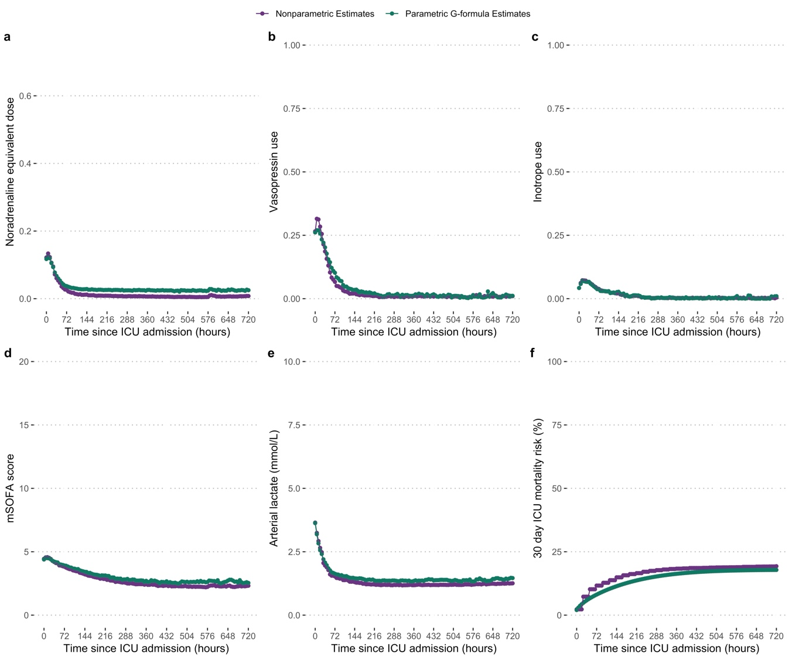
Comparable parametric versus nonparametric estimates of the covariate suggests correct model specification for the parametric g-formula.

Figure S7. 30-day ICU mortality risk difference according to the timing of vasopressin introduction
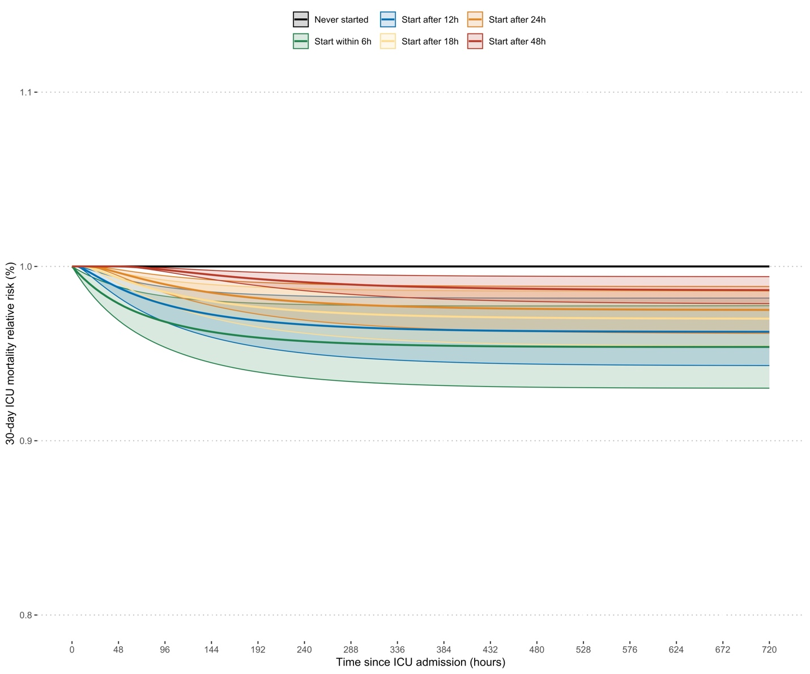

Figure S8. Norepinephrine equivalent dose course according to the timing of vasopressin start
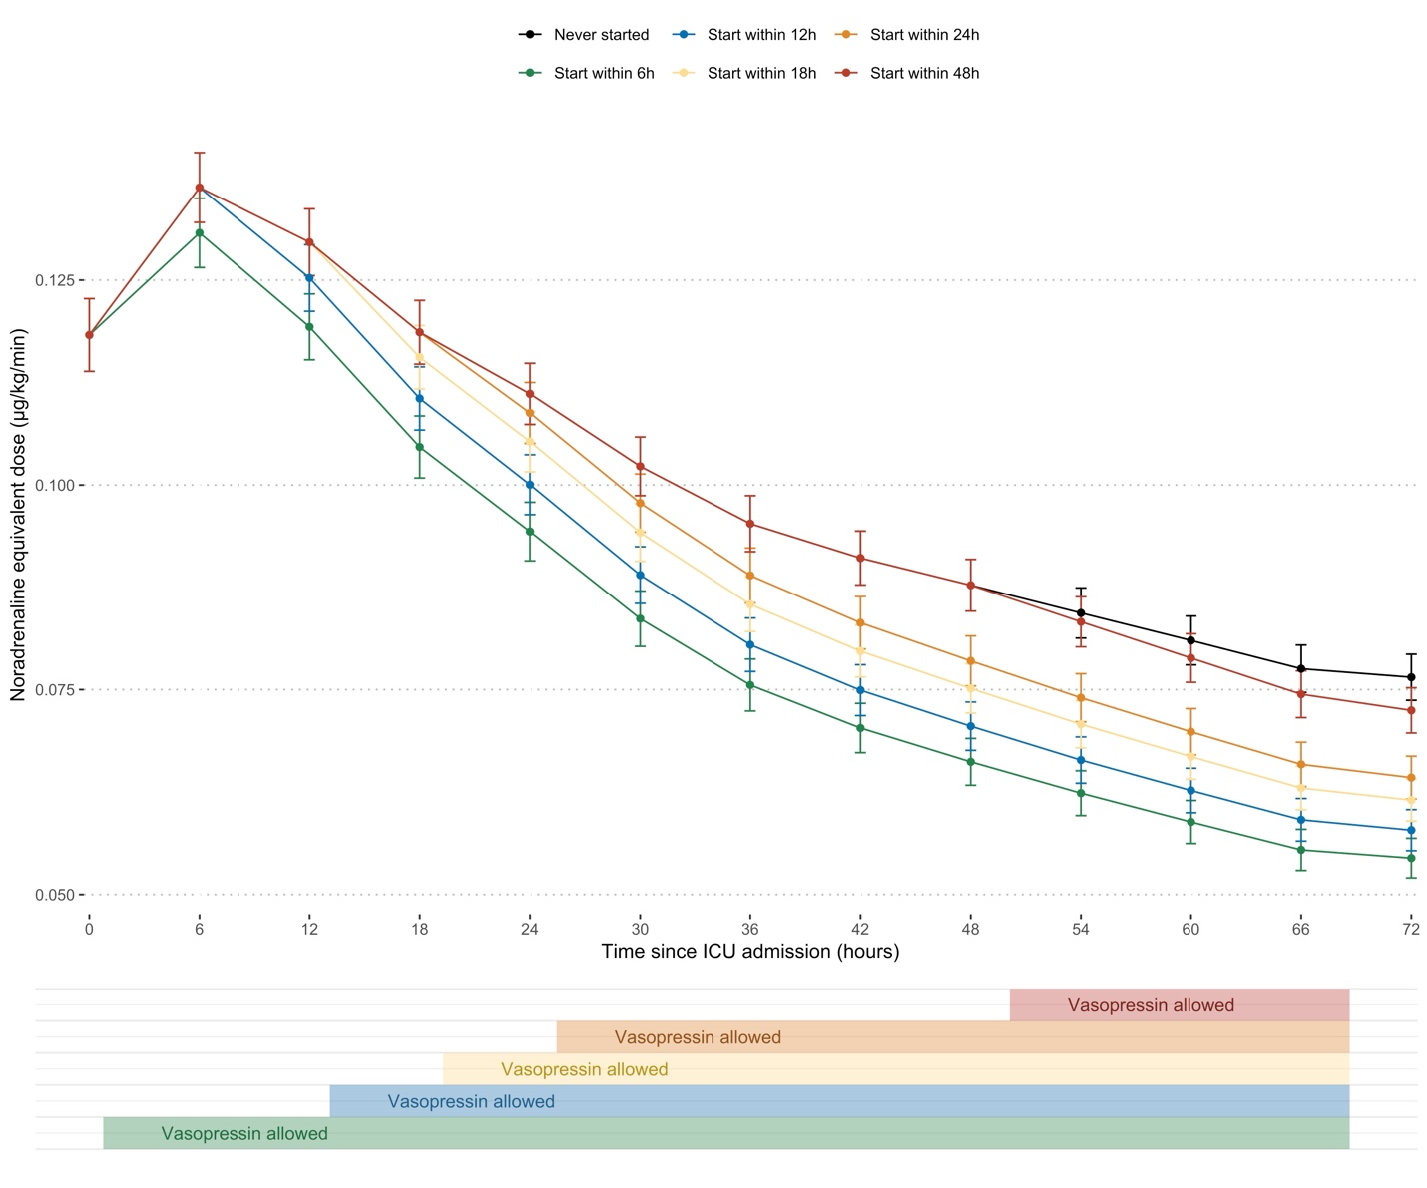

Figure S9. 30-day ICU mortality relative risk according to norepinephrine equivalent dose threshold for vasopressin introduction
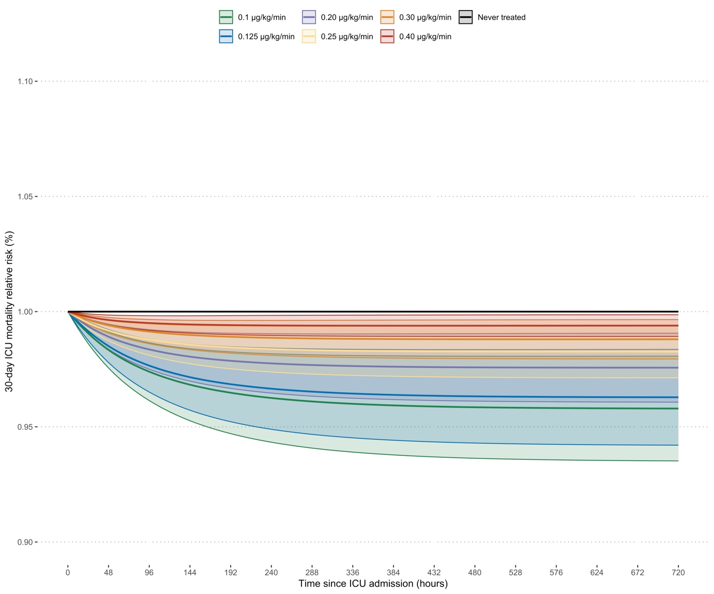

Figure S10. Norepinephrine equivalent dose course according to noradrenaline equivalent dose threshold for vasopressin introduction
