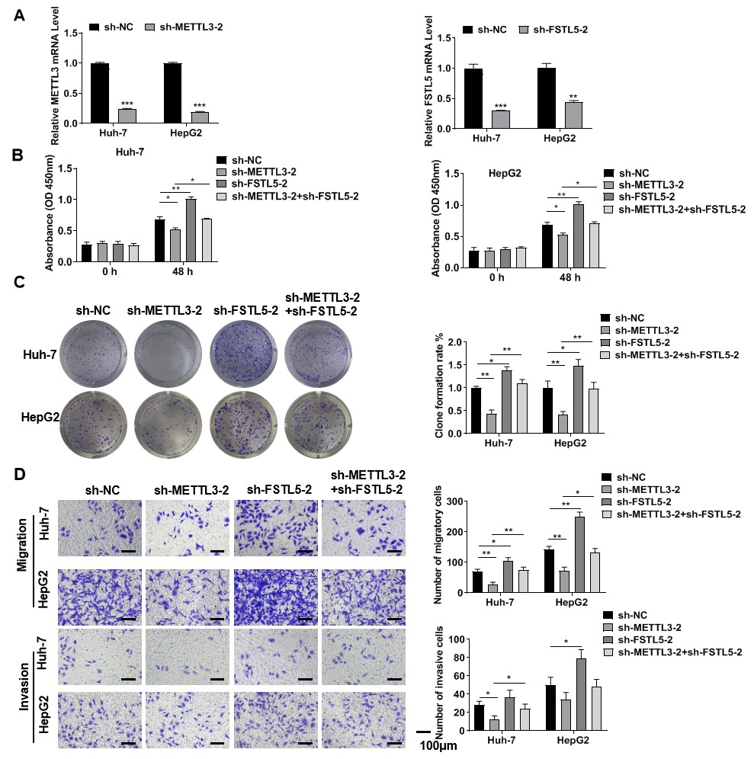Figure S1. Downregulated METTL3 inhibits HCC cell proliferation, migration, and invasion by up-regulating FSTL5.
(A) The transfection efficiency of sh-METTL3-2 and sh-FSTL5-2 in Huh-7 and HepG2 cells, respectively, was confirmed by RT-qPCR assay. (B) CCK-8 and (C) colony formation assays were used to detect cell proliferation. (D) Transwell analysis detected cell migrations and invasion. Bar = 100 μm. The data represent three separate experiments and are expressed as mean ± SEM. ***p < 0.001, *p < 0.05, **p < 0.01.

Supplementary table 1. Characteristics of participants

Parameters | Total 28 (100%)
Age
≥50 | 17 (60.71%)
<50 | 11 (39.29%)
Gender
Female | 13 (46.43%)
Male | 15 (53.57%)
Tumor size (cm)
<5 | 16 (57.14%)
≥5 | 12 (42.86%)
Pathological stage
I+II | 18 (64.29%)
III+VI | 10 (35.71%)
HBeAg
Positive | 10 (35.71%)
Negative | 18 (64.29%)
Number of nodules
Single | 20 (71.43%)
≥2 | 8 (28.57%)
Macrovascular invasion
No | 12 (42.86%)
Yes | 16 (57.14%)

Supplementary table 2 Sequences of shRNA
Gene | Sequence (5’-3’)
sh-METTL3-1 | ACCTCGAGATCCTAGAGCTATTAAATTCAAGAGATTTAATAGCTCTAGGATCTCTT
sh-METTL3-2 | ACCTCGTTAGAGAAGAAGTTGCTACATCAAGAGTGTAGCAACTTCTTCTCTAACTT
sh-FSTL5-1 | ACCTCGATGATGGGTCCTTGTATATTTCAAGAGAATATACAAGGACCCATCATCTT
sh-FSTL5-2 | ACCTCGGTTGAAGAATGGAATTGATATCAAGAGTATCAATTCCATTCTTCAACCTT

Supplementary table 3. Primer sequences of genes in RT-qPCR assay
Gene | Forward Primer (5’-3’) | Reverse Primer (5’-3’)
FSTL5 | ATACGCTGAGTGTGGTTTGC | CTTCATCCACTTCCACAGCG
METTL3 | CAAGCTGCACTTCAGACGAA | GCTTGGCGTGTGGTCTTT
miR-186-5p | TCAAAGAATTCTCCTTTTGGGCT | CGCTTCACGAATTTGCGTGTCAT
U6 | GCTTCGGCAGCACATATACTAA | AACGCTTCACGAATTTGCGT
GAPDH | TGTGTCCGTCGTGGATCTGA | CCTGCTTCACCACCTTCTTGA

