Ainscough et al. A microfluidic chip for pulmonary arterial hypertension

SUPPLEMENTARY INFORMATION

SUPPLEMENTARY METHODS
Simulation of PA-on-a-chip
Finite Element Method-based simulations were used to simulate the 3D fluid structure interaction within the PAOC device using COMSOL Multiphysics version 4.4. PDMS walls model parameters are shown in Table S1 and a schematic of the model is shown in figure M1.

Table S1. Rigid PDMS walls model parameters
Th | 10[um] | Membrane thickness
W | 1[mm] | channel thickness
H_{EC} | 200[um] | Rest endothelial channel height
L_{un} | 1[cm] | artery on a chip union length
L_{arm} | 0.5[cm] | channel arm length
H_{SMC} | 200[um] | Rest smooth muscle cell channel height
D_{pin} | 1[mm] | steel connector diameter
D_{con} | 1.1[mm] | entry/exit connector port diameter
Q_{EC} | 0.35[ml/min] | endothelial cell channel volumetric flux
Q_{SMC} | 10[ul/h] | smooth muscle channel volumetric flux
P_{EC_out} | See Equation S1 | outlet pressure endothelial channel
P_{SMC_out} | See Equation S1 | outlet pressure smooth muscle channel
E_{pdms} | 1[MPa] | PDMS Young's Modulus
nu_{pdms} | 0.499 | PDMS Poisson’s ratio
θ | pi/4[rad] | SMC channel arm rotation angle theta
td | 1[mm] | tube diameter
tl | 160[cm] | tube length
mu_{w25} | 8.9E-4[Pa*s] | dynamic viscosity of water
rho_{w25} | 0.997[g/cm^3] | density of water
E_{pet} | 2950[MPa] | PET Young's modulus. E_{PET} values from databases were 2.67, 2.95, 2.985, 3 and 3.15 GPa. The average value was used.¹⁻⁵
rho_{pet} | 1250[kg/m^3] | density of PET. The density of PET ranges from 1100 - 1400kgm⁻³, thus the average value of 1250kgm⁻³ was chosen.¹⁻⁵
nu_{pet} | 0.34 | PET Poisson’s ratio. The Poisson’s ratio varies from 0.33-0.35and thus 0.34 was chosen as the average value.

Rigid PDMS wall simulation setup
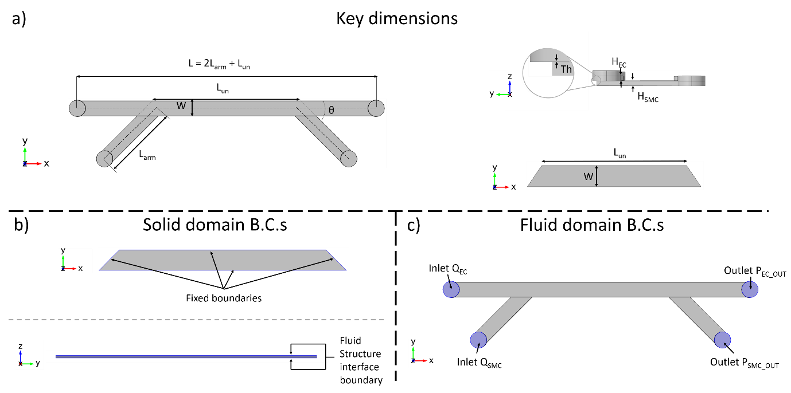
Figure M1. Geometry and boundary conditions of Rigid PDMS wall model. a) key dimensions of the microchannels and PET membrane; channel width ‘W’, channel length ‘L’, coculture region length ‘L_{un}’, channel arm length ‘L_{arm}’, smooth muscle channel arm bend angle ‘θ’, membrane thickness ‘Th’, and channel heights for the endothelial and smooth muscle channels ‘H_{EC}’ and ‘H_{SMC}’ respectively. b) PET membrane domain boundary conditions; fixed (top) and Fluid-Structure Interface boundaries. c) Fluid domain boundary conditions; Volumetric flow rates Q_{EC} and Q_{SMC} are applied at the inlets of the endothelial and smooth muscle channels respectively. Outlet pressures P_{EC_OUT} and P_{SMC_OUT} are applied at the outlets of the endothelial and smooth muscle channel respectively.

The rigid PDMS wall model geometry is composed of three domains: one solid and two fluid. These correspond with the PET membrane and the two fluid channels. The PET membrane was modelled as a linear Elastic material with Properties listed in table S1. Whereas the fluid domain was modelled as water whose properties are given in table S1. The solid (PET membrane) surfaces not in conformal contact with the fluid domains were fixed. The final two faces of the PET membrane were given a fluid structure interface boundary condition.
Q_{EC} and Q_{SMC} are the volumetric flow rates at the Endothelial channel inlet and Smooth muscle cell channel inlet, respectively. At the outlets of each channel, the Hagen-Poiseuille equation shown in equation S1 is applied. Q is replaced by Q_{EC} in the EC channel and Q_{SMC} in the SMC channel. L_{tube} and D_{tube} for both channels are replaced by tl and td respectively. Lastly, the no slip boundary condition is applied to rigid walls in the channel (non-PET membrane walls).
$$P_{out}= \frac{128μQL_{tube}}{π{D_{tube}}^{4}}$$
Equation S1 – Hagen-Poiseuille equation to obtain outlet pressure P_{out}.
The final boundary condition is the fluid structure interface boundary in which all four equations below need to be fulfilled. Where ‘σ’ is the stress tensor of the solid, ‘n’ is the vector normal to the wall, ‘Γ’ is the stress tensor of the fluid, ‘u_{f}’ is the fluid velocity vector, ‘u_{w}’ is the wall velocity vector, ‘u_{s}’ is the deformation of the solid, ‘t’ is time, and ‘u_{m}’ is the deformation of mesh.
$σ∙n=Γ∙n$ $u_{f}=u_{w}$ $u_{w}=\frac{∂u_{s}}{∂t}$ $\frac{∂u_{s}}{∂t}=\frac{∂u_{m}}{∂t}$
A custom meshing sequence was applied to the model with 4524195 degrees of freedom. The Simulation time was 5 hours 30 min 8 sec and required 31.44 GB physical memory and 56.89 GB virtual memory.
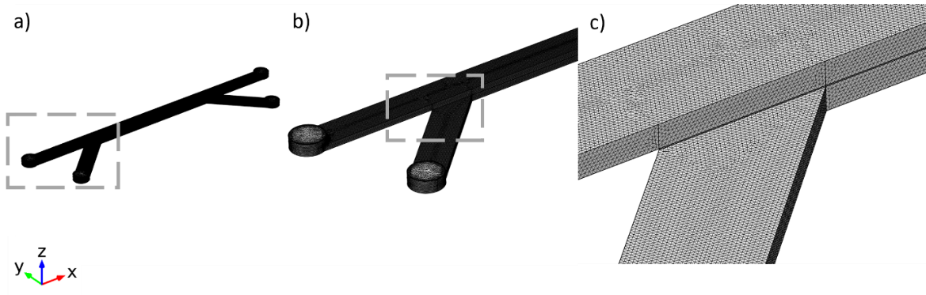
Figure M2. Tetrahedral mesh in rigid PDMS walls model. a) Full model elements are too fine to see. b) 2x zoom reveals some of the coarser elements at the inlets c) Tetrahedral mesh

Table S2. Demographics of blood donors, heritable PAH patients and healthy volunteers. Data represented as median (range).
 |  | Control  (n=5) | HPAH  (n=5)
Females |  | 4/5 | 3/5
Age (years) |  | 29 (23- 56) | 43 (30-58)
Time from diagnosis (months) |  | - | 84 (29-171)
mPAP (mmHg) |  | - | 58 (58-70)
Six minute walk distance (m) |  | - | 366 (261-441)
WHO Functional Class | I | - | 3
WHO Functional Class | II | - | 1
Anticoagulants |  | - | 3
Statins |  | - | 1
ER Antagonists |  | - | 5
PDE5 Inhibitors |  | - | 5
Prostanoids |  | - | 2
mPAP, mean Pulmonary Arterial Pressure; ER, Endothelin-Receptor; PDE5, Phosphodiesterase type 5. Treatment: at sampling.

Table S3. PAH ECFC BMPR2 genotype

Diagnosis | BMPR2 Variant type | Variant
1.1: Idiopathic PAH | Stop gained | 2:203383766 C>G
1.2.1: Heritable PAH - BMPR2 | Missense variant | 2:203329555 T>C
1.1: Idiopathic PAH | Splice region variant | NM_001204.6:c.418+5G>A
1.1: Idiopathic PAH | Frameshift | NM_001204.6c.1958_1 959delCT
1.1: Idiopathic PAH | Stop gained | NM_001204.6:c.2617C>T

Table S4. RT reaction mix. Negative controls using the No-RT Control Mix (5x) we added into each plate to check for DNA/RNA contaminations. cDNA synthesis was completed using a SimpliAmp™ Thermal Cycler (Applied Biosystems, UK) with the following conditions:

Component | 20μl Reaction | Final Concentration
LunaScript RT SuperMix (5x) | 4µl | 1x
RNA sample | variable | 50 or 100ng
Nuclease-free water | Remainder up to 20µl | -

Table S5. RT cycle.

Cycle Step | Temperature | Time | Cycles
Primer Annealing | 25°C | 2 minutes | 1
cDNA Synthesis | 55°C | 10 minutes | 1
Heat Inactivation | 95°C | 1 minute | 1

Table S6. qPCR master mix components
9μl of the qPCR master mix and 1μl of 1ng/μl cDNA was added to each well of a 384-well skirted PCR plate (StarLab, UK, E1042-3840). A negative control for each gene of interest was added to the plate which contained 1μl Nuclease-free water instead of 1μl cDNA, plus 9μl of appropriate qPCR master mix. Plates were sealed using a MicroAmp Optical Adhesive Film (Thermo Fisher Scientific, 4311971), inverted to mix samples and centrifuged for 1 minute at 1000xG. qPCR was performed using a QuantStudio 12K Flex Real-Time PCR System (Applied Biosystems, USA). Amplification was achieved over 40 cycles that consisted of the following conditions:

qPCR Master Mix
Component | 10μl Reaction | Final Concentration
Luna Universal qPCR Master Mix | 5μl | 1X
10 μM forward primer | 0.5μl | 0.25 μM
10 μM reverse primer | 0.5μl | 0.25 μM
Nuclease-free water | 3μl | -

Cycle Stage | Temperature | Time | Cycles
Hold Stage | 50°C | 2 minutes | 1
Hold Stage | 95°C | 5 minutes | 1
PCR Stage | 95°C | 15 seconds | 40
PCR Stage | 62°C | 30 seconds | 40
Melt Curve Stage | 95°C | 15 seconds | 1
Melt Curve Stage | 60°C | 1 minute | 1
Melt Curve Stage | 95°C | 15 seconds | 1

All primer sequences were designed from FASTA sequences (PubMed, NCBI). At least one primer in a pair spanned an exon–exon junction. The relative expression of a gene was determined using the 2^{-∆∆Ct} method, with target genes normalised to glyceraldehyde 3-phosphate dehydrogenase (GAPDH) expression.

Table S7. List of primers

VEGFA | Forward | AGGGAAAGGGGCAAAAACGAAAG
VEGFA | Reverse | ACAAATGCTTTCTCCGCTCTG
KLF2 | Forward | GTGAGAAGCCCTACCACTGCAACT
KLF2 | Reverse | CCGGTTCTCTGGGTCCAATAAATA
PECAM / CD31 | Forward | TGGAAGGAGTGCCCAGTCCCA
PECAM / CD31 | Reverse | CGGAAGGATAAAACGCGGTCCTG
BMPR2 | Forward | TCAAGAACGGCTATGTGCGTTT
BMPR2 | Reverse | TGTCCCCTTTTGATTTCTCCCAA
KCNK1 | Forward | GGTGGTGGCCATCGTCCAT
KCNK1 | Reverse | GGCAATAAGGCCAAGTAGCAGG
LDHA | Forward | TGTAAAATACAGCCCGAACTGCAAG
LDHA | Reverse | TGGAATCTCCATGTTCCCCAAGG
eNOS | Forward | GCCGGAACAGCACAAGAGT
eNOS | Reverse | GAGGATGCCAAGGCCGC
GAPDH | Forward | CGGATTTGGTCGTATTGGGCG
GAPDH | Reverse | GCCTTCTCCATGGTGGTGAAGAC

Table S8. Primary and secondary antibodies used for immunostaining.

Name | Species | Company | Cat No | Dilution
AlexaFluor488 (Anti-Rabbit) | Goat | Life Technologies | A11034 | 1:300
VE-Cadherin  (AlexaFluor 488 Conjugated) | Mouse | eBioscience | 53-1449-42 | 1:100
α-Smooth Muscle Actin  (AlexaFluor647 Conjugated) | Mouse | Abcam | ab196919 | 1:100
Smooth muscle calponin | Rabbit | Abcam | ab46794 | 1:100
Alexa fluor-546 (Anti-Rabbit) | Goat | Life Technologies | A11010 | 1:100
Alexa Fluor Plus 594 (Anti-Mouse) | Goat | Life Technologies | A32742 | 1:300
Alexa Fluor Plus 594 (Anti-Rabbit) | Goat | Life Technologies | A32740 | 1:300
ERG (Anti-Rabbit) | Rabbit | Abcam | ab92513 | 1:100
vWF (Anti-human) | Rabbit | Dako | A0082 | 1:500
α-Smooth Muscle Actin (Anti-human) | Mouse | Dako | M0851 | 1:1000
FITC Anti-Rabbit | Goat | Jackson ImmunoResearch Inc | 111-095-003 | 1:100
TRITC Anti-Mouse | Goat | Sigma-Aldrich | T5393 | 1:100

Supplementary Table S9. Antibodies Used For Western blotting.
Name | Species | Company | Cat No | Dilution
human β-actin | Mouse | Santa Cruz | sc-47778 | 1:2000
human BMPR2 | Mouse | BD Biosciences | 612292 | 1:1000
HRP-labelled anti-mouse | Sheep | GE Healthcare | NA931 | 1:2000

SUPPLEMENTARY FIGURES (RESULTS)

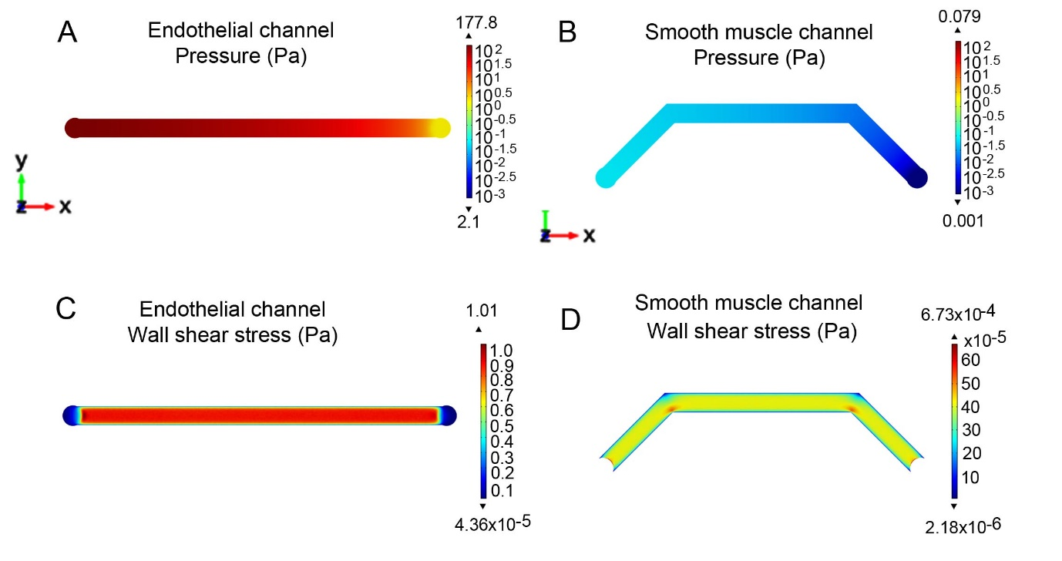

Figure S1. Pressure changes in microfluidic channels of PA-on-a-chip in a rigid PDMS wall model. A) Pressure field acting on ECs. B) Pressure field acting on SMCs. C) WSS acting on ECs and D) WSS acting on SMCs. Volumetric flow rate in endothelial channel QEC = 0.35 mL/min and in smooth muscle channel QSMC=10µL/h, with outlet tube diameter and length of 1mm and 1.6m respectively. Changes in pressure field and wall shear stress as presented as 2D colour maps, COMSOL modelling.

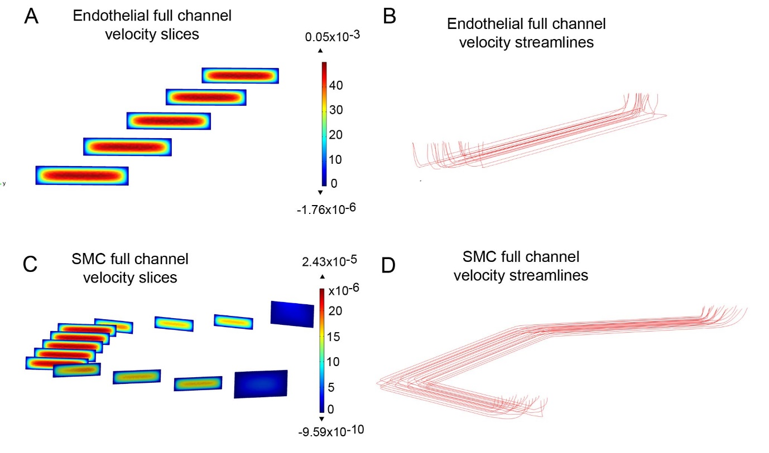
Figure S2 Visual representations of the velocity field in microfluidic channels of PA-on-a-chip. A) Velocity slices perpendicular to flow direction in the endothelial channel. B) Velocity streamlines of laminar flow within endothelial channel. C) Velocity slices perpendicular to flow direction in the SMC channel. D) Velocity streamlines of laminar flow within the SMC channel. Changes in velocity field in (A and C) are presented as 2D colour maps, with units ms-1 of fluid through the channel, assuming that volumetric flow rate in endothelial and smooth muscle channel is QEC = 0.35mL/min, and QSMC = 10µL/h, respectively; COMSOL modelling.
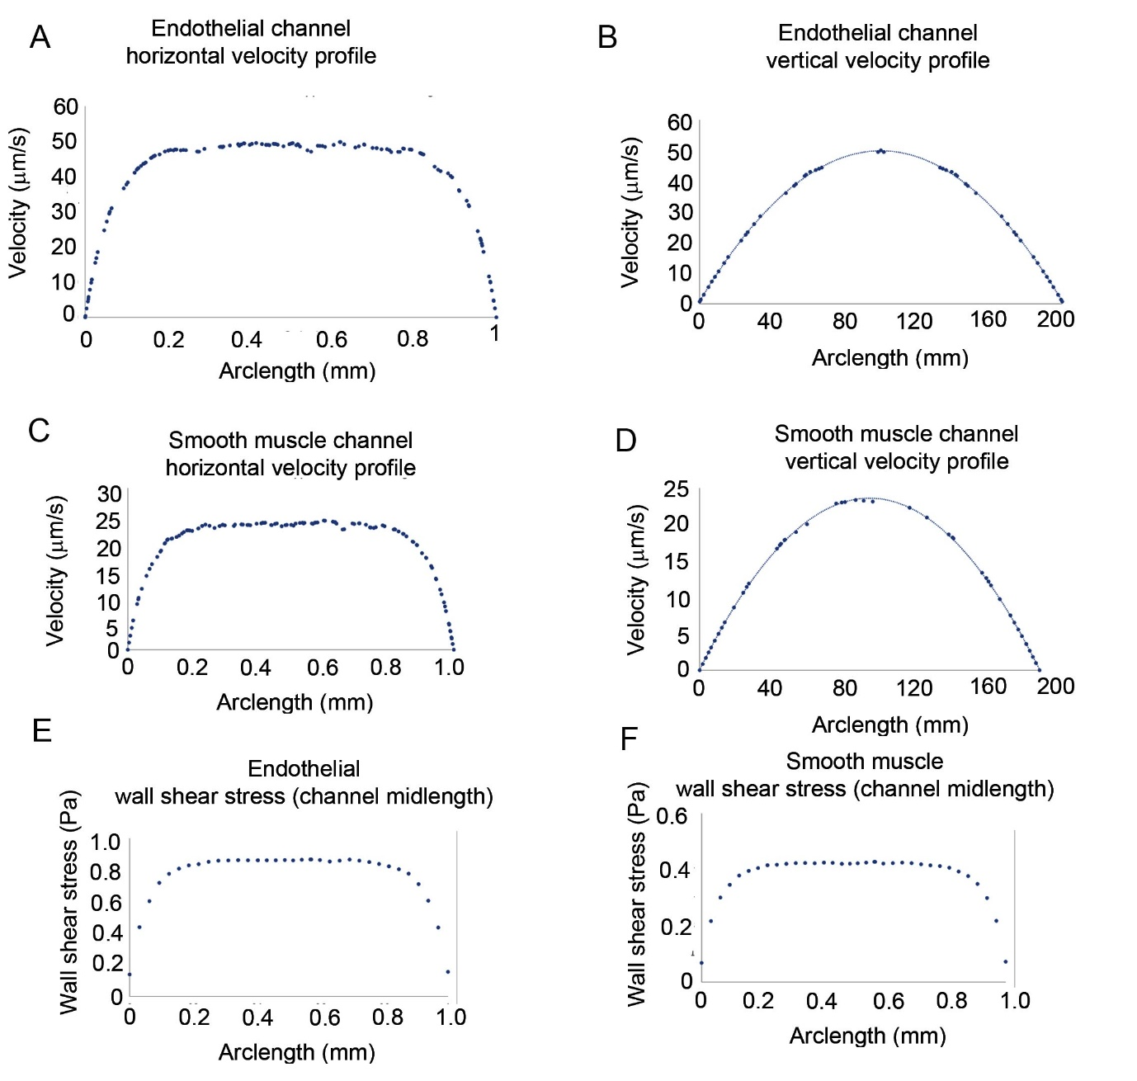

Figure S3. Velocity profiles along vertical and horizontal lines of symmetry in the channel cross section in PA-on-a-chip. A) EC channel horizontal velocity profile. B) EC channel vertical velocity profile. C) SMC channel horizontal velocity profile. D) SMC channel vertical velocity profile. E) EC channel floor WSS acting on ECs at channel mid-length. F) SMC channel ceiling WSS acting on SMCs at channel mid-length. The analysis was done in COMSOL, at the mid-channel cross section, with volumetric flow rate QEC = 0.35 ml/min and QSMC=10µl/h.
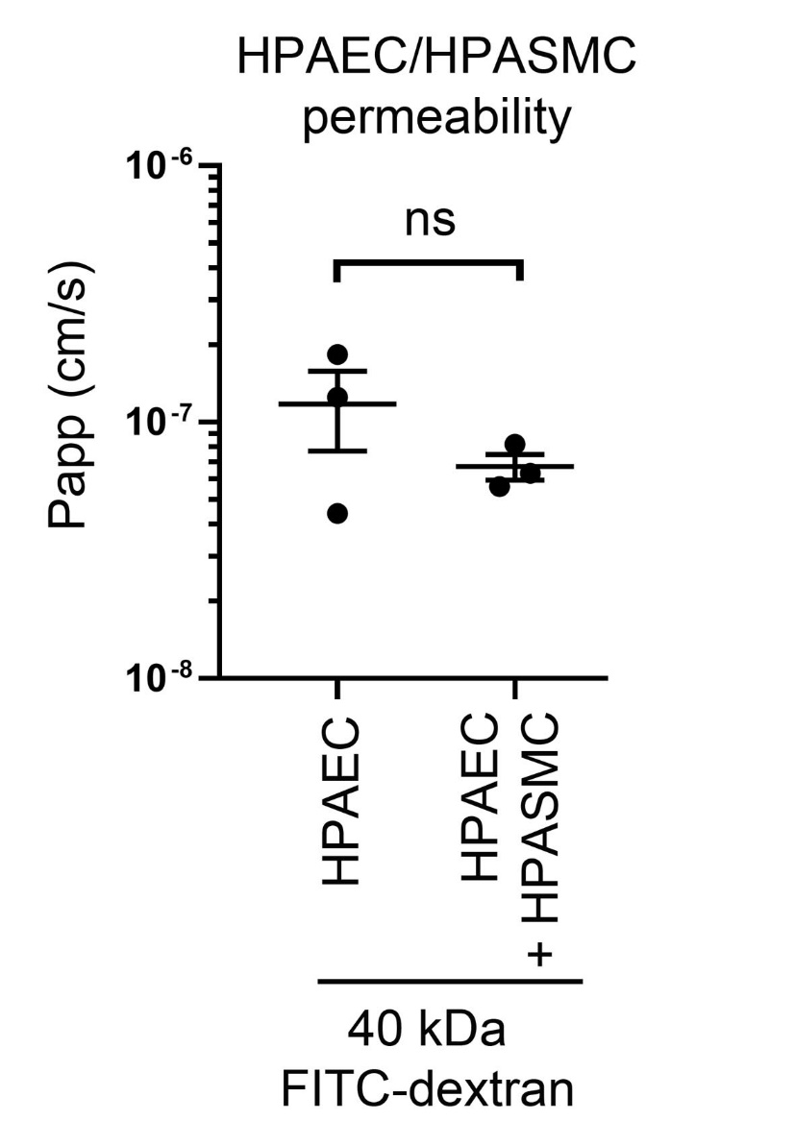

Figure S4. Contributions of HPASMCs to changes in endothelial barrier function in PA-on-a-chip. Passage of 40 kDa (1mg/ml; 1h) across a monolayer of HPAECs cultured with, or without HPASMCs, was used as a measure of barrier function in PA-on-a-chip. (n=3). Error bars indicate mean ±SEM of a one-way ANOVA with a Tukey’s post-hoc correction test.

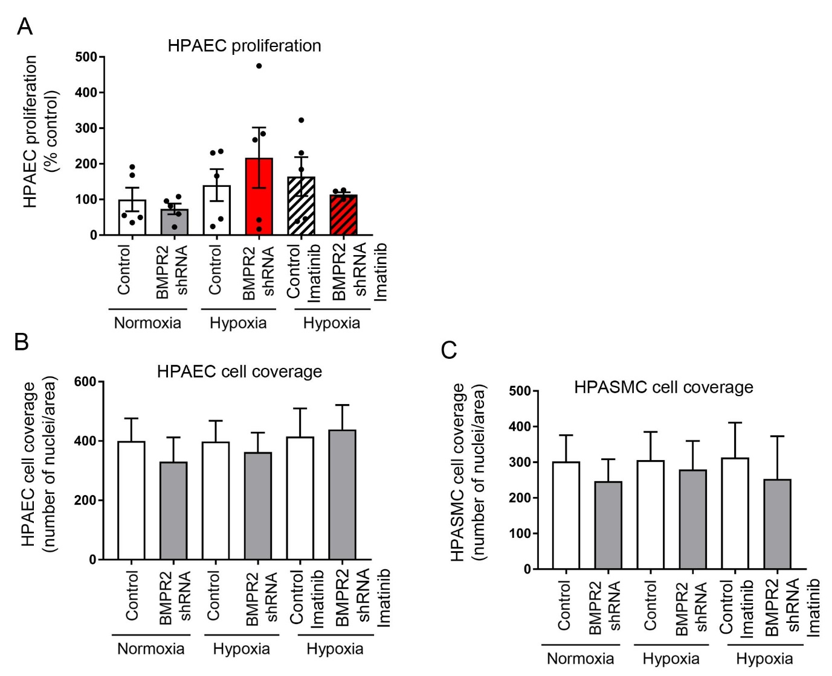

Figure S5. Endothelial proliferation and cell coverage. (A) Effect of hypoxia and endothelial BMPR2 knockdown on HPAEC proliferation. Cells were untreated or were treated with 10µM imatinib mesylate for 24h and cell proliferation was measured in EdU assay. (B) HPAEC coverage per area (0.5 mm²). Cell coverage was defined as a number of cell nuclei/ area. (C) HPASMC coverage per area. n=4-5 individual chips

Figure S6. Differentially expressed genes in WT HPASMCs co-cultured with BMPR2-deficient HPAECs. Volcano plot shows differentially expressed genes, with red dots marking upregulated genes and blue dots marking downregulated genes, as indicated. n=5 different biological donors/treatment group.

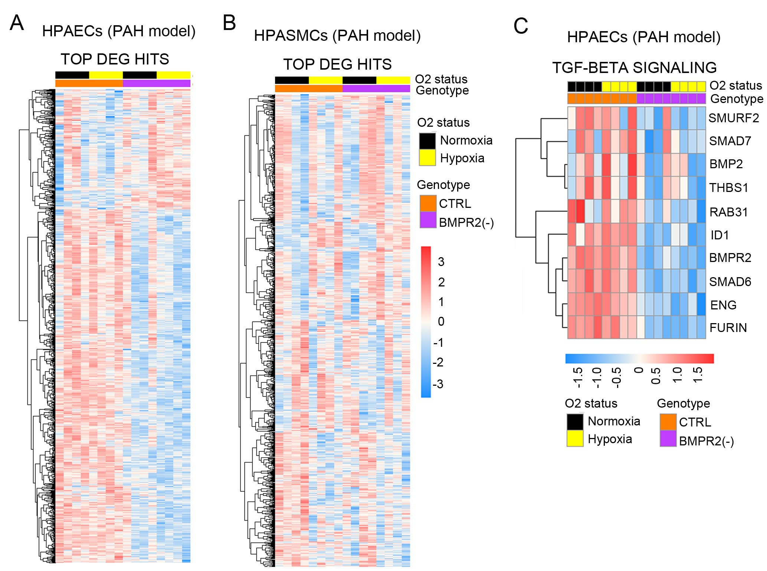

Figure S7. Disease gene signatures in the “double hit” microfluidic model of PAH. (A, B) Heatmaps with hierarchical DEG clustering in (A) HPAECs and in (B) HPASMCs from the “double hit” microfluidic PAH model. (C) Heatmap of genes involved in the TGF-β signalling pathway in HPAECs. The genotype status (control and BMPR2 knockdown) and oxygen status (normoxia or hypoxia) shown at the top of the heatmap are colour-coded, as indicated. Changes in gene expression are also colour coded, with blue denoting a lower relative gene expression and red denoting a higher relative gene expression. Each column represents 1 experimental repeat (n=4/treatment group).

Figure S8. Gene enrichment scores in GSEA pathway analysis in the “double hit” microfluidic model of PAH. (A) Dot plot matrix of GSEA pathway analysis in HPAECs; (B) Dot plot matrix of GSEA pathway analysis in HPASMCs.

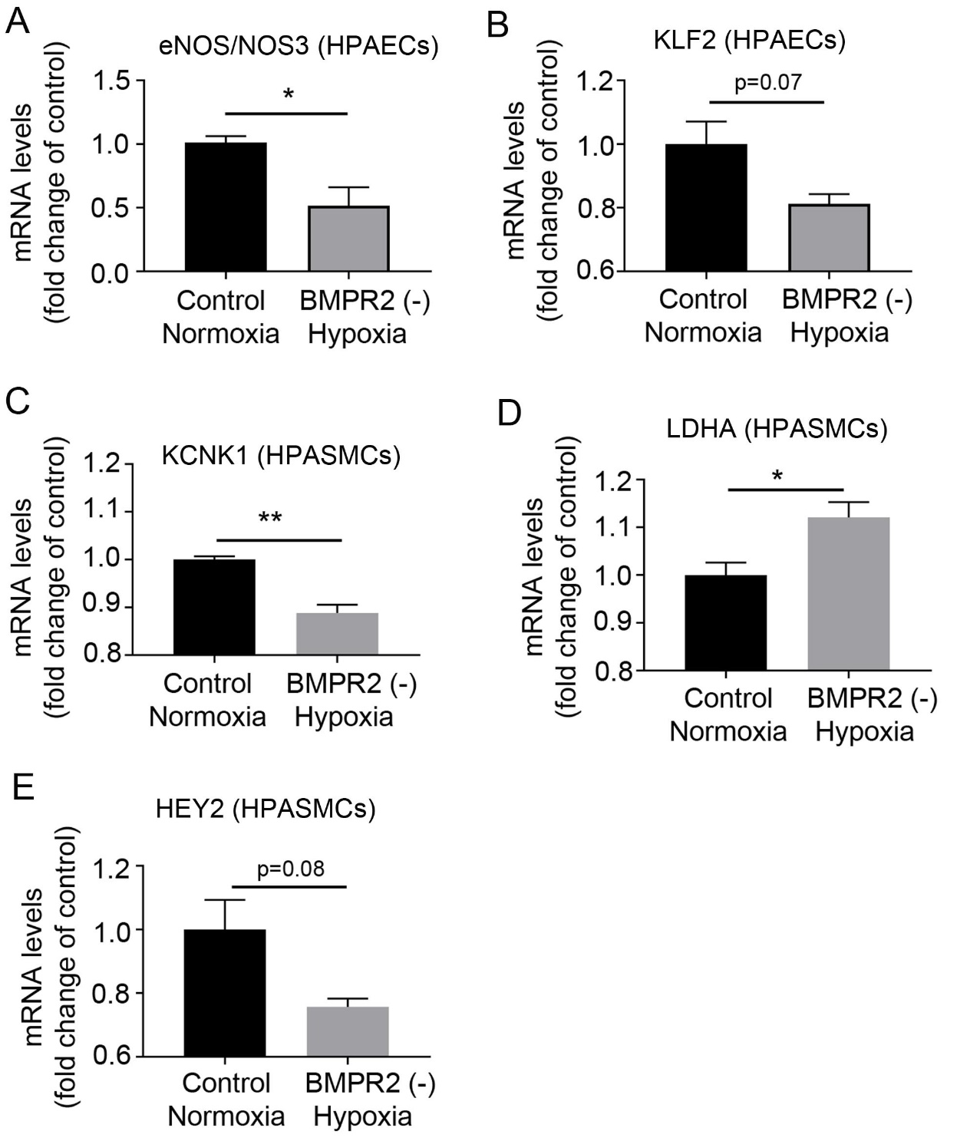

Figure S9. qPCR validation of selected DE genes identified in HPAECs and HPASMCs in the “double hit” microfluidic PAH model. mRNA expression of selected endothelial (A, B) and smooth muscle (C, D, E) differentially expressed genes assessed by qPCR. **P<0.01; *P<0.05; Unpaired t test. n=3.

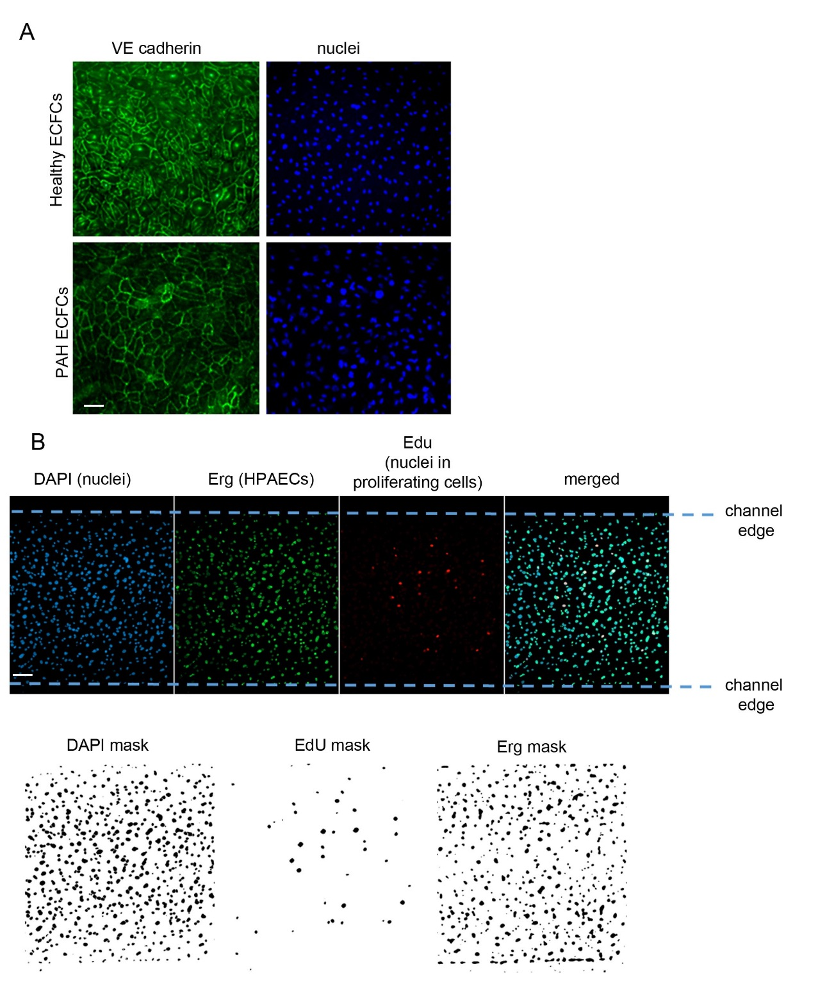
Figure S10. ECFC characteristics and cell counting method. (A) VE Cadherin immunostaining in ECFCs from healthy and PAH individuals. VE-cadherin is green and cell nuclei are blue, as indicated. Bar=50µm. (B) Representative images of images used for cell counting. Endothelial cell nuclei are green (Erg-positive) and all cell nuclei are blue (DAPI). Colour channels were converted to binary masks and overlaid onto a DAPI mask for semi-automated counting. Bar=100µm.

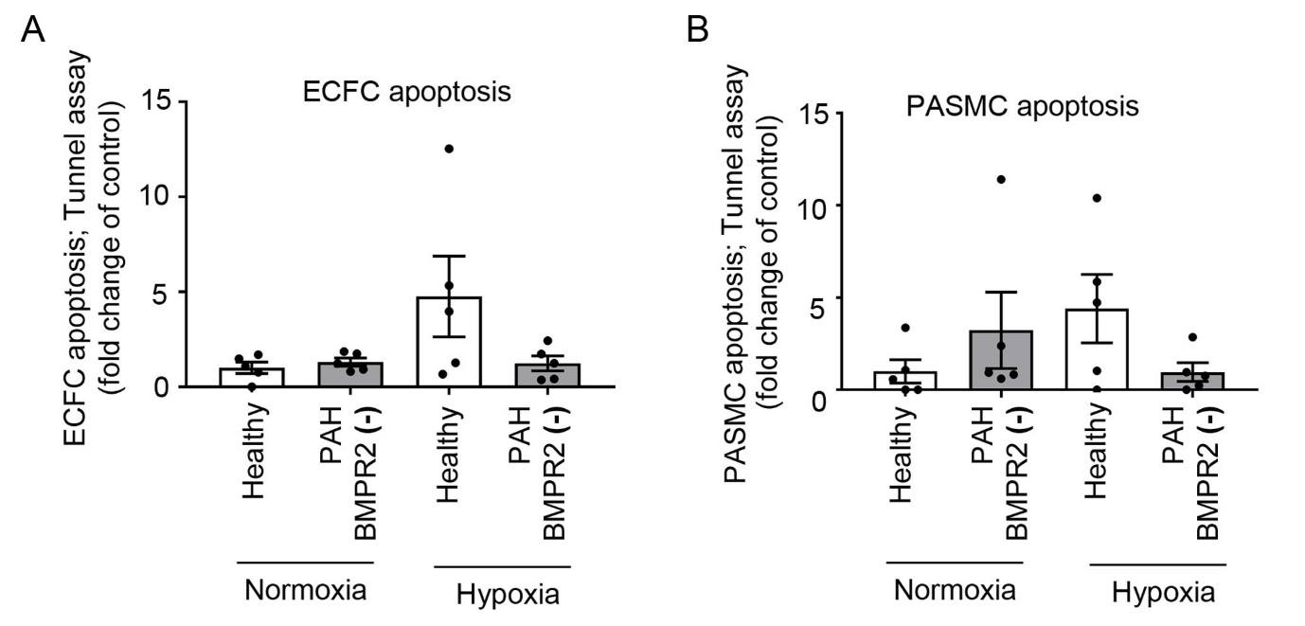

Figure S11. Cell apoptosis in the ECFC PAH model. (A) Apoptosis of healthy and PAH ECFCs in PA-on-a-chip under normoxic or hypoxic conditions (2% O₂, 24hrs), as indicated. (B) Apoptosis of HPASMCs co-cultured with control or patient ECFCs under normoxic or hypoxic conditions. n=4-5 biological donors, each assayed in a separate chip. Bars are means ±SEM; one-way ANOVA with a Tukey post-test.

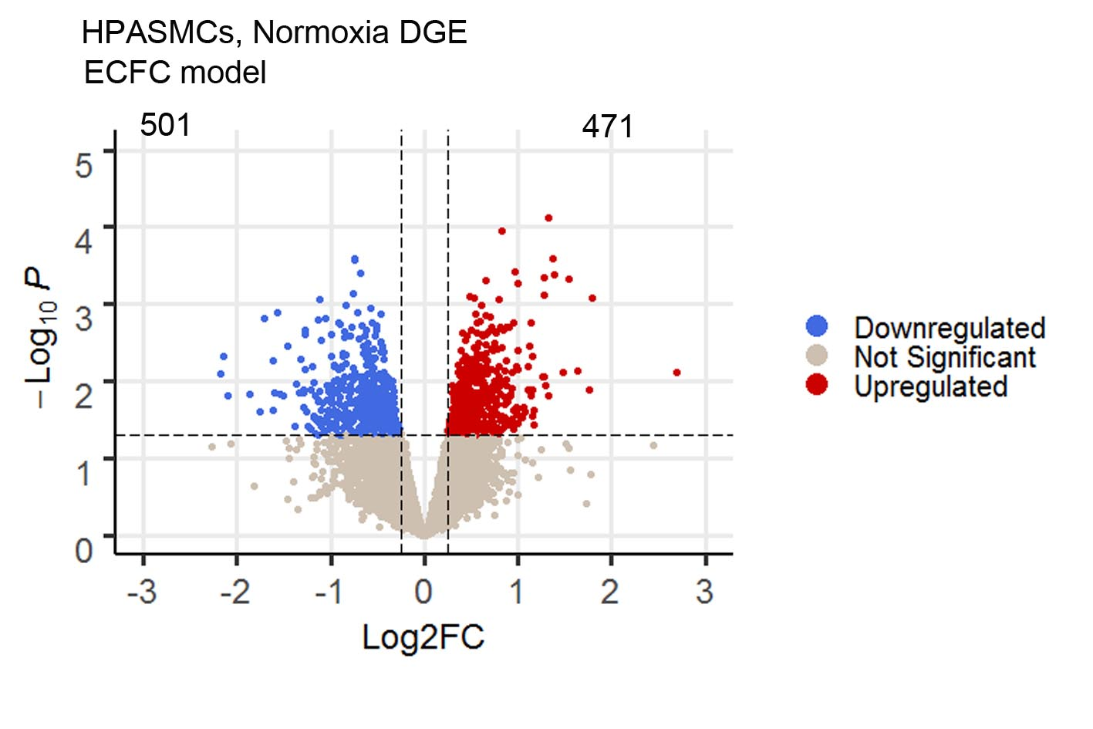
Figure S12. Differentially expressed genes in WT HPASMCs co-cultured with PAH ECFCs. Volcano plot showing differentially expressed genes. n=5 different biological donors/treatment group.

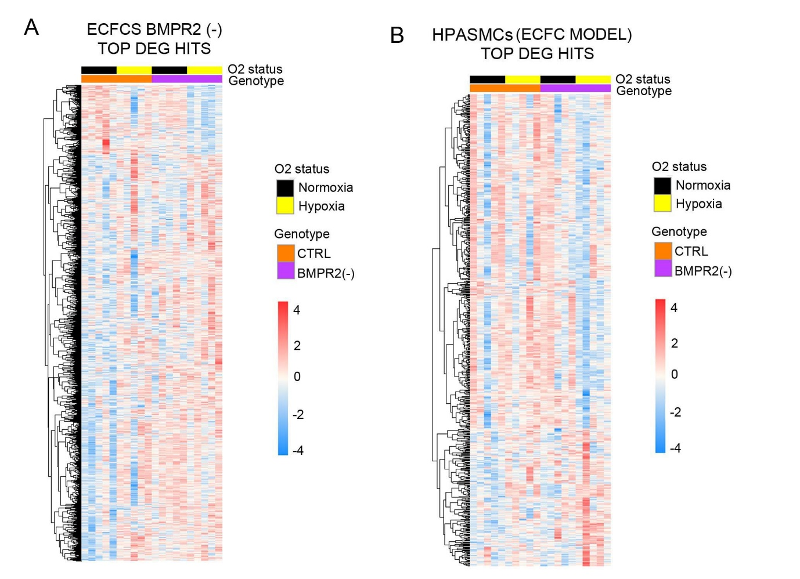

Figure S13. Disease gene signatures in the ECFC microfluidic model of PAH. Heatmaps with hierarchical gene clustering in (A) healthy and PAH ECFCs (B) HPASMC co-cultured with these cells. The genotype status (control and BMPR2 knockdown) and oxygen status (normoxia or hypoxia) are shown at the top of each heatmap in different colours, as indicated. Changes in gene expression are also colour coded, with blue denoting a lower relative gene expression and red denoting a higher relative gene expression. Each column represents 1 donor; n=5 different biological donors/treatment group.

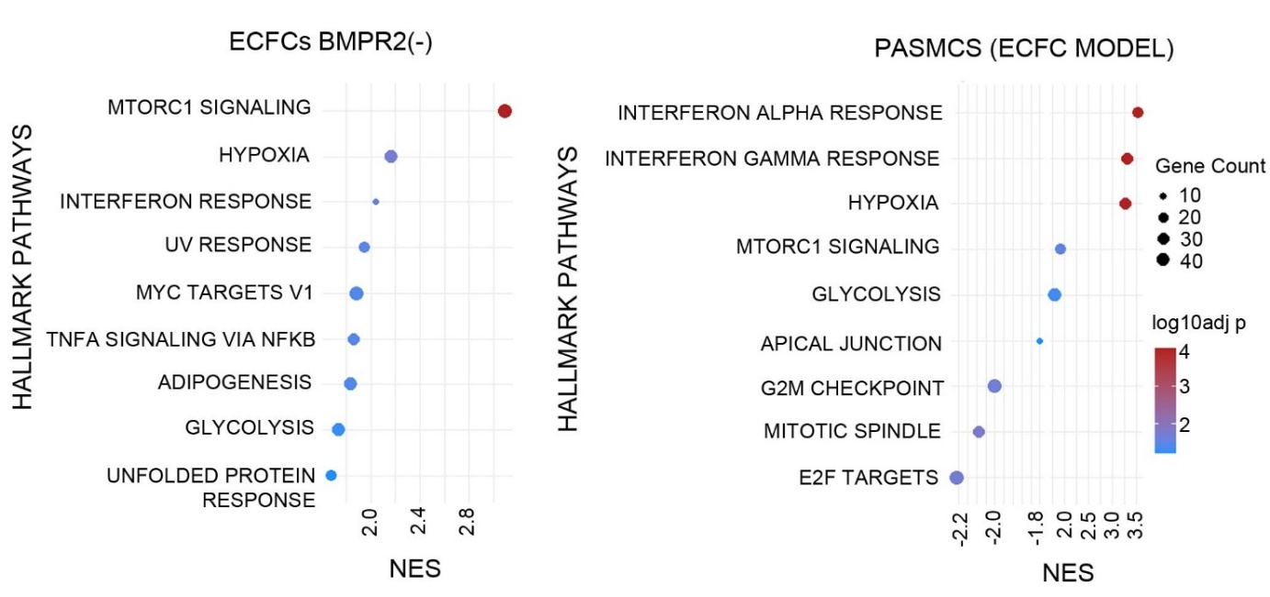

Figure S14. Dot plot matrix of GSEA pathway analysis. (A) Dot plot matrix of GSEA pathway analysis generated from healthy or PAH ECFCs cultured under normoxic or hypoxic conditions. (B) Dot plot matrix of GSEA pathway analysis generated from HPASMCs co-cultured with healthy or PAH ECFCs.

SUPPLEMENTARY REFERENCES
1. Material Properties Database. http://matweb.com/
2. Polymer Properties Database https://polymerdatabase.com/polymer%20classes/Intro.html
3. Material Properties Database https://designerdata.nl/
4. Plastics and Elastomers Properties Database https://omnexus.specialchem.com/
5. Polymer Mechanical Properties Database http://www.goodfellow.com/catalogue/GFCat2C.php?ewd_token=oGMPLDtnz3n13gndyuSlwIkTl0W9Ui&n=yxx30n0WFpfmeOxK6s9CprjvNbsCsC&ewd_urlNo=GFCat26&type=30&prop=3

