Histology Imaging of the Brain

Groups | No | Image
Control | 1 | 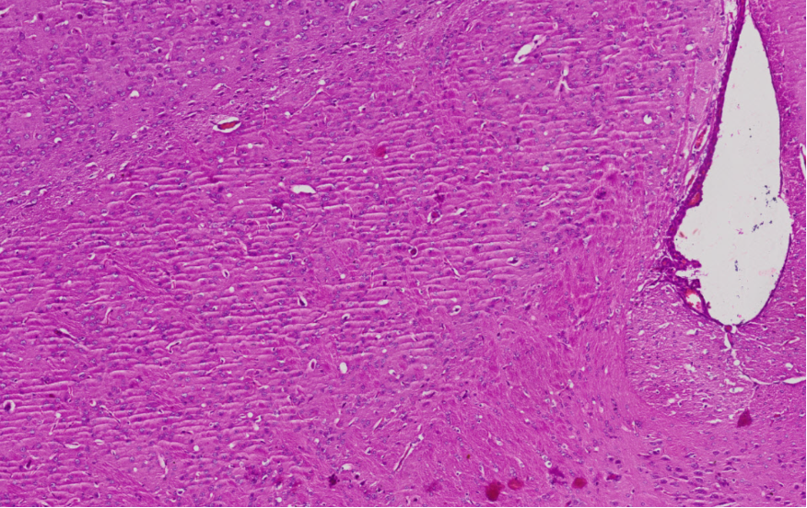
 | 2 | 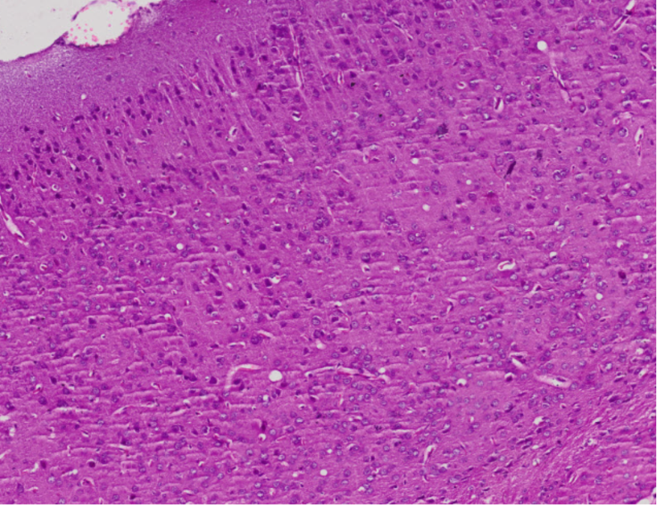
 | 3 | 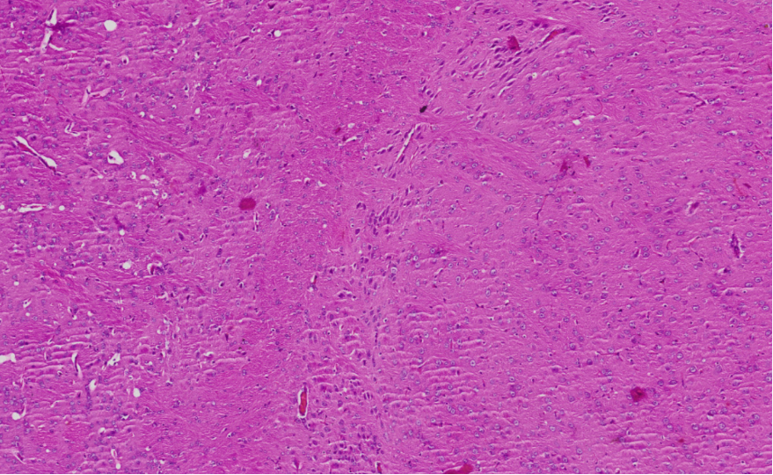
 | 4 | 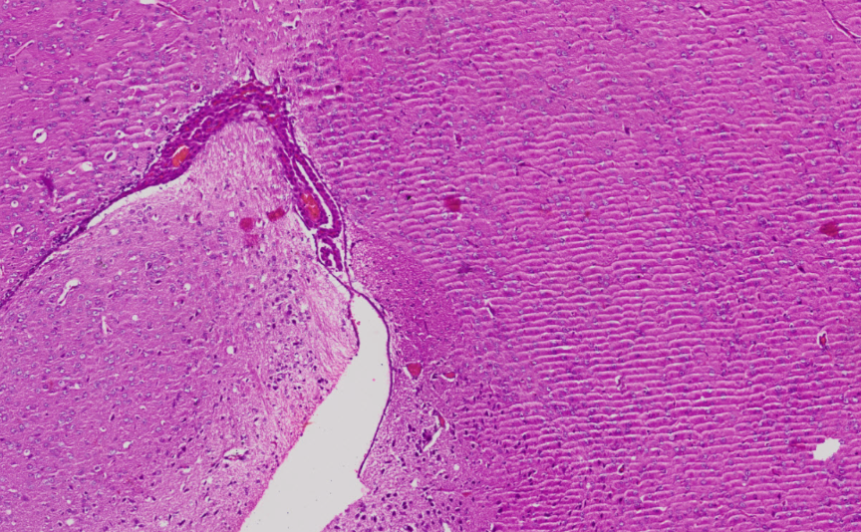
 | 5 | 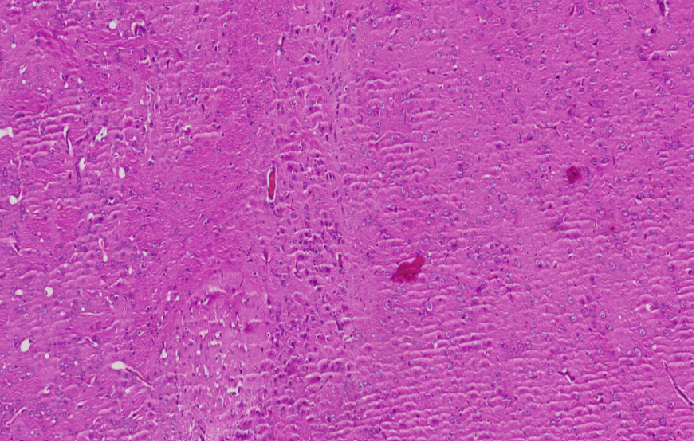
Dose 1:1 | 1 | 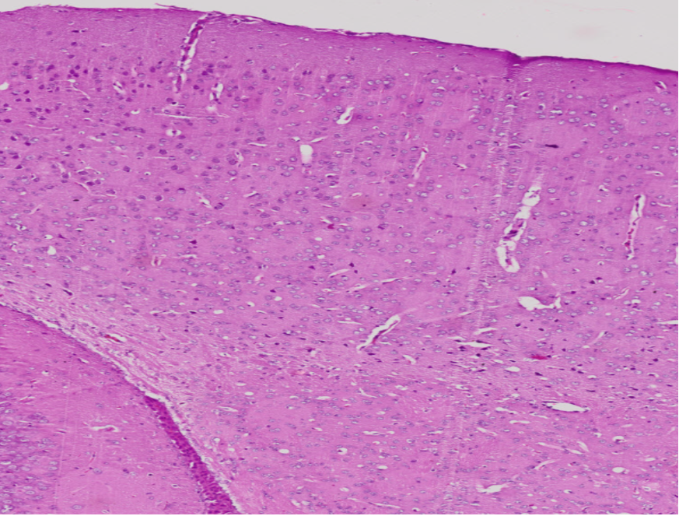
 | 2 | 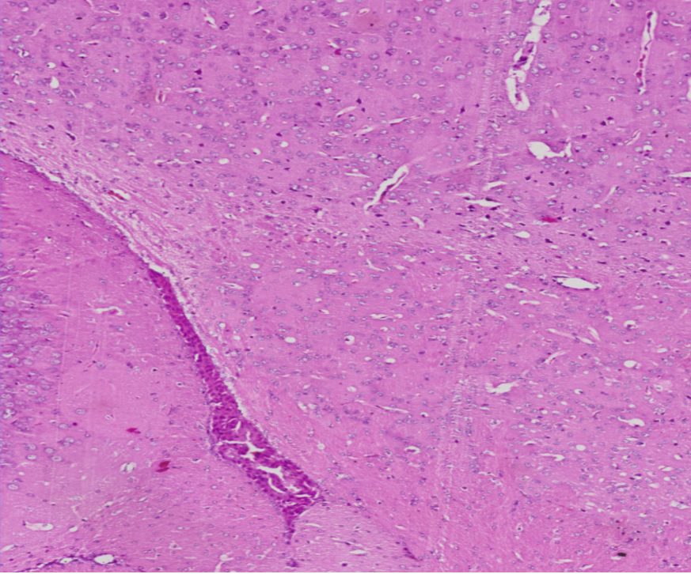
 | 3 | 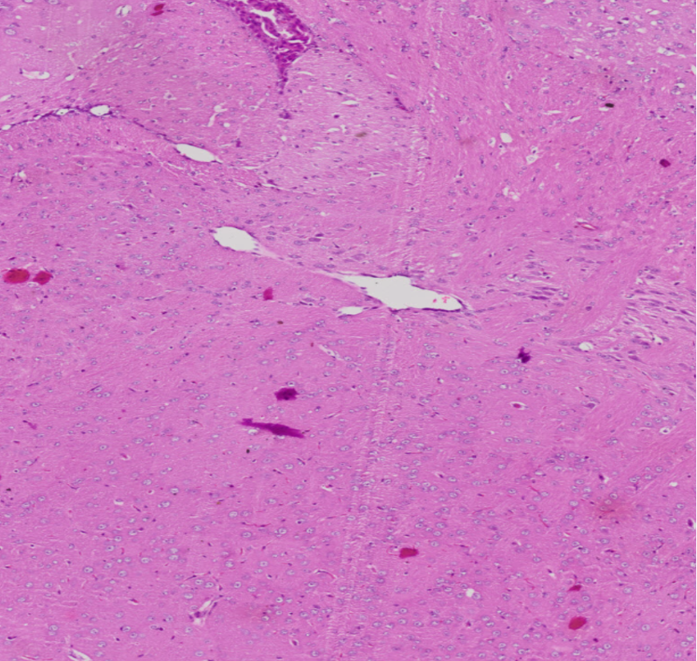
 | 4 | 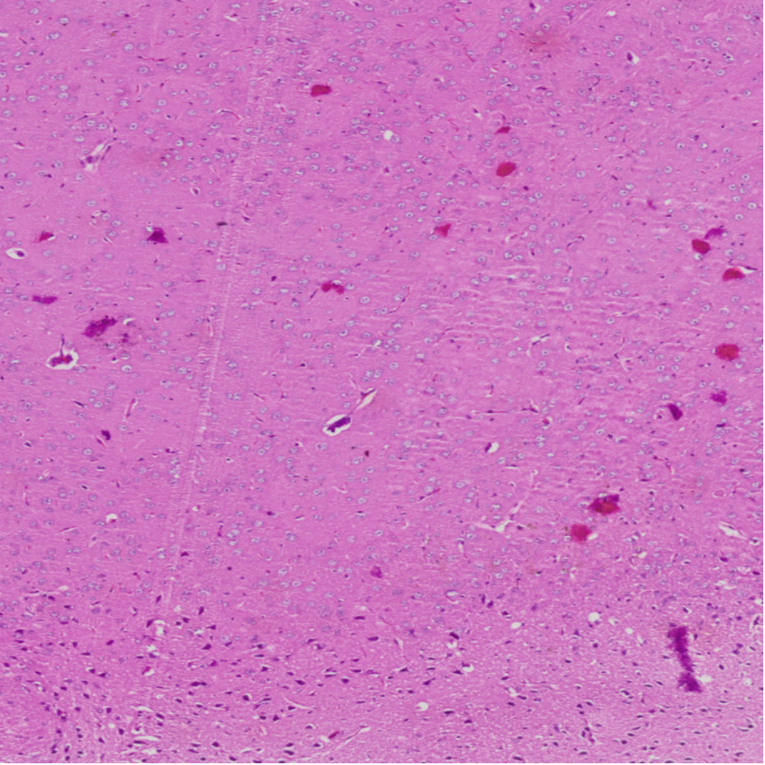
 | 5 | 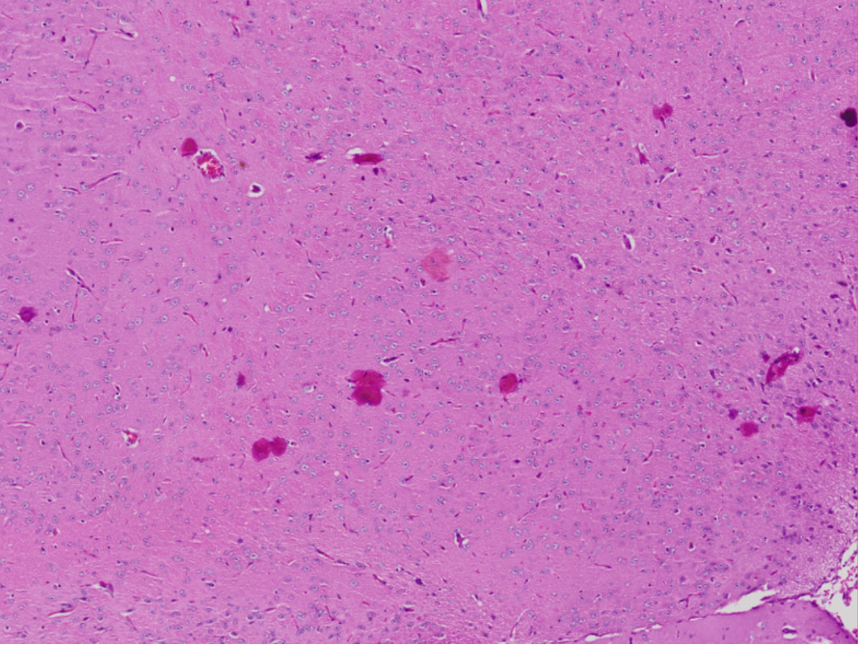
Dose 1:100 | 1 | 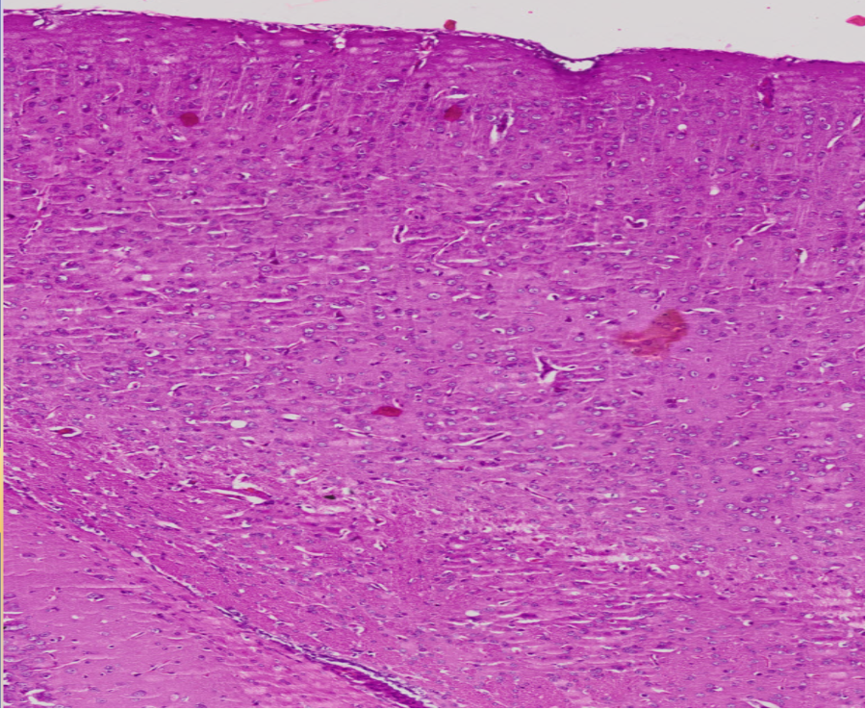
 | 2 | 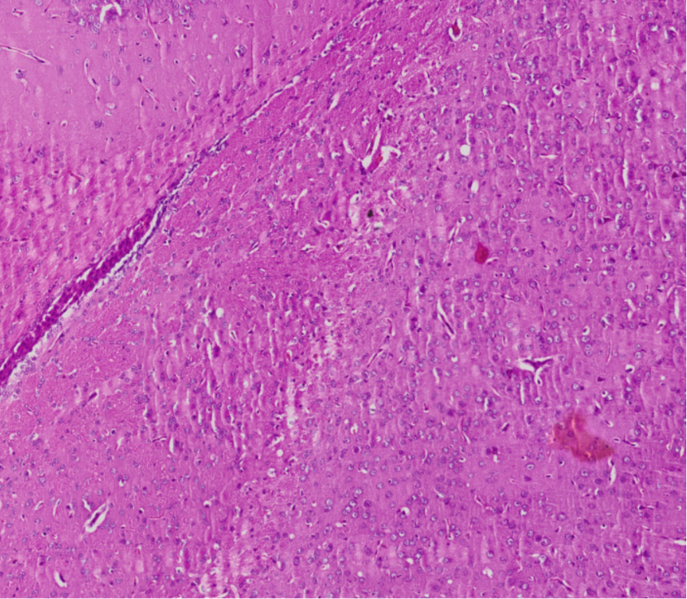
 | 3 | 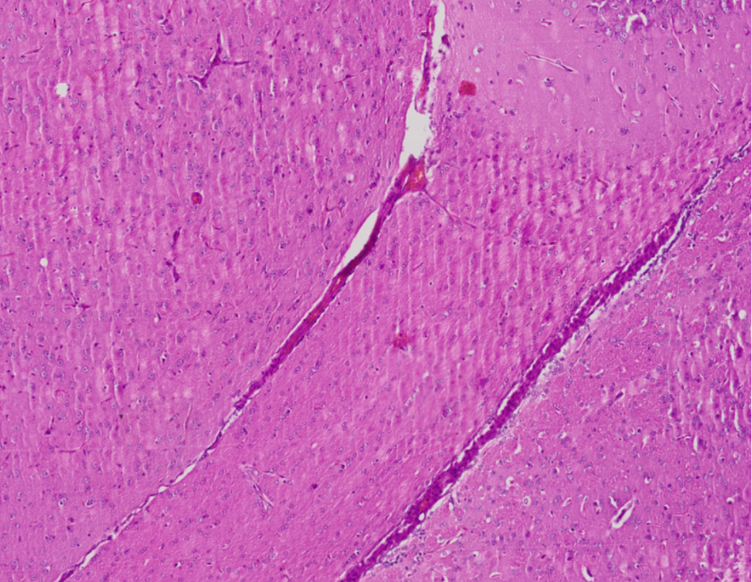
 | 4 | 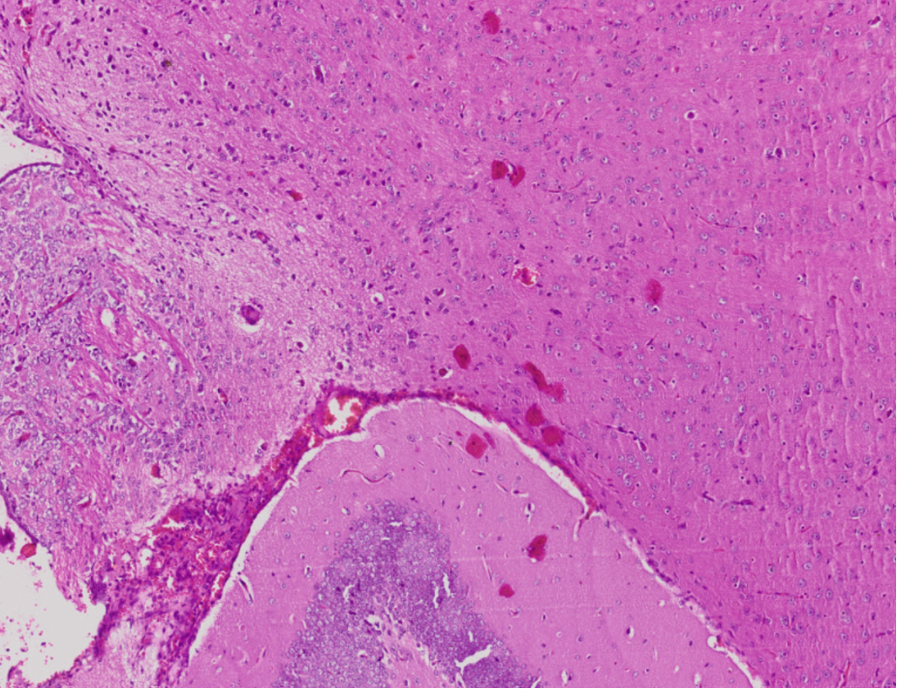
 | 5 | 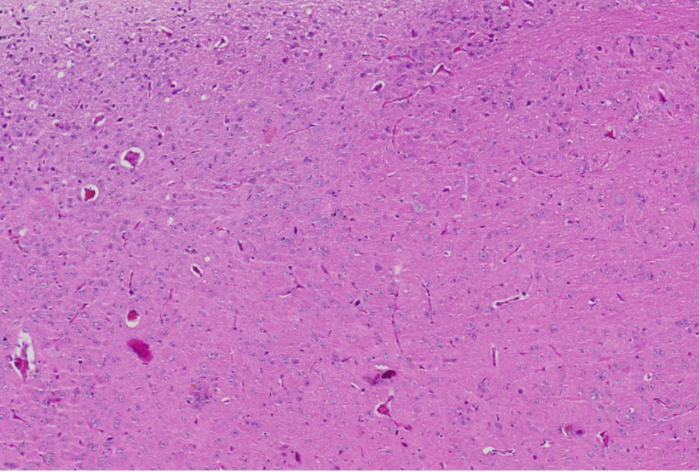
Dose 100:1 | 1 | 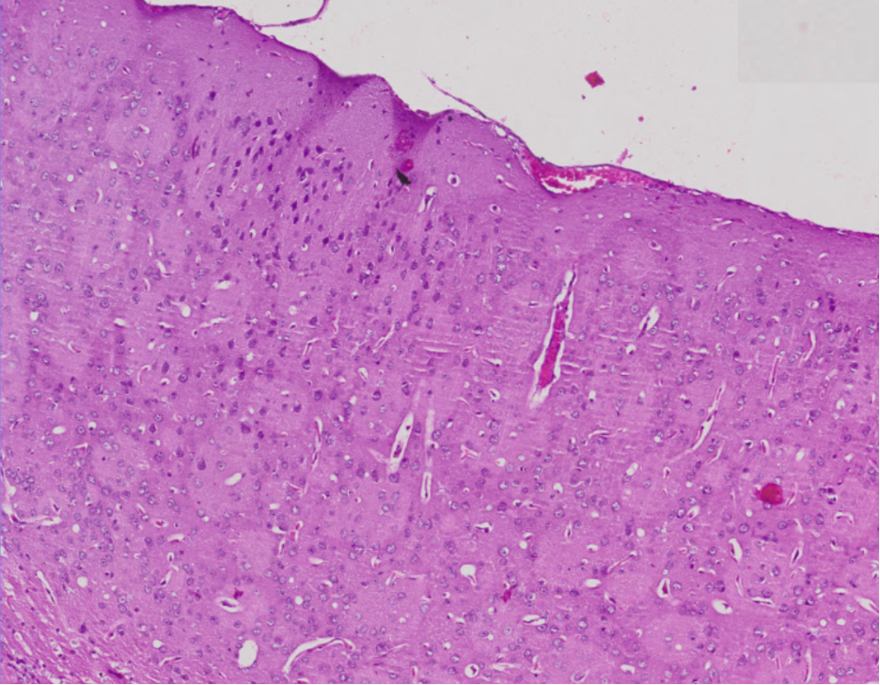
 | 2 | 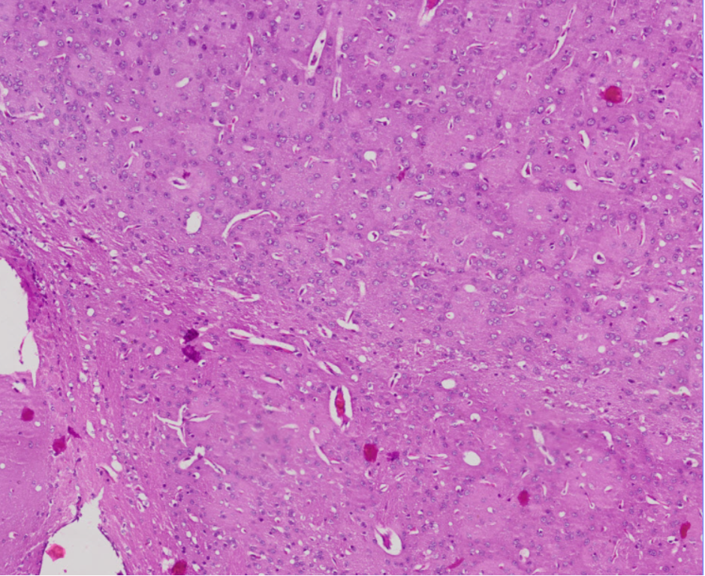
 | 3 | 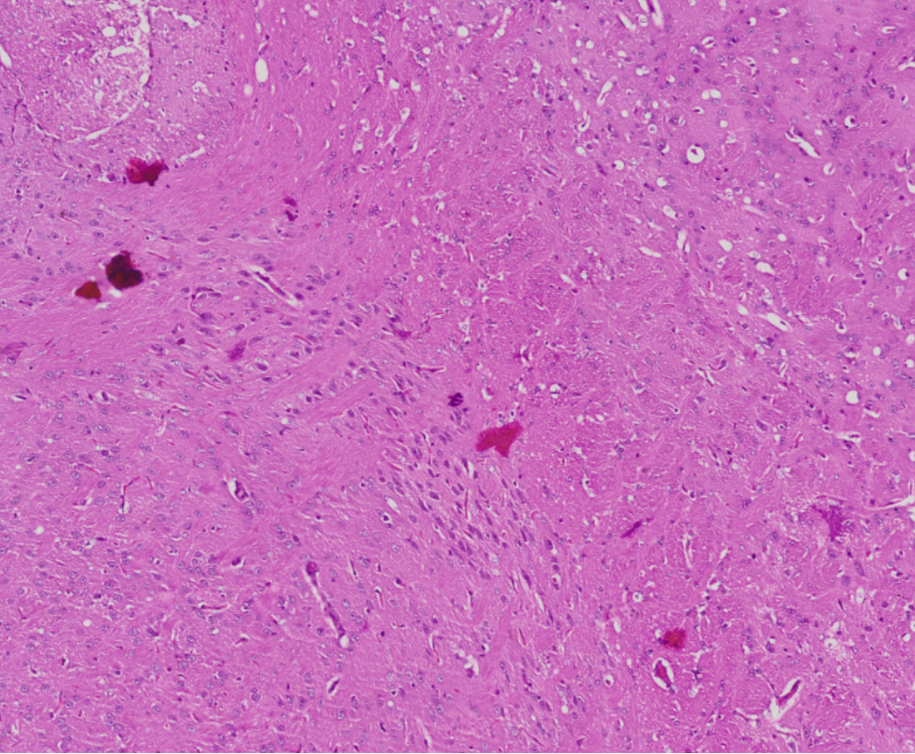
 | 4 | 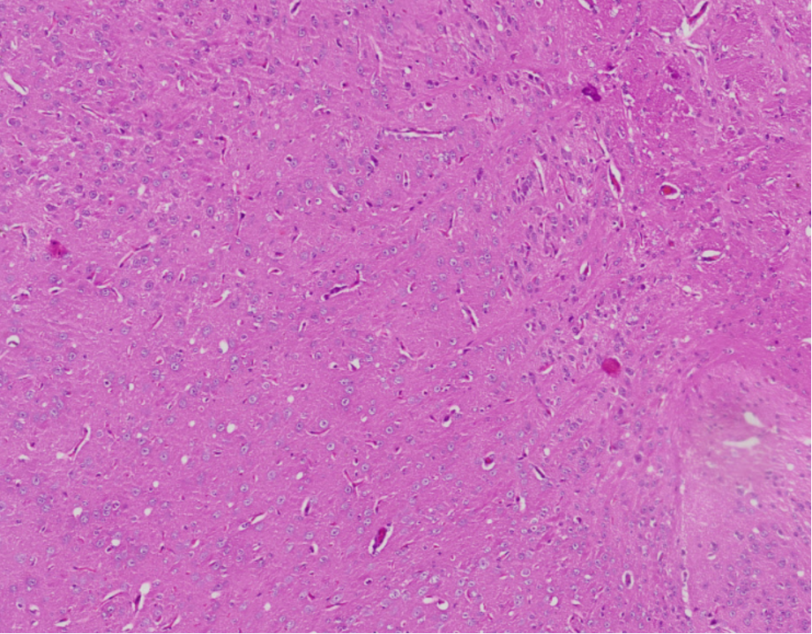
 | 5 | 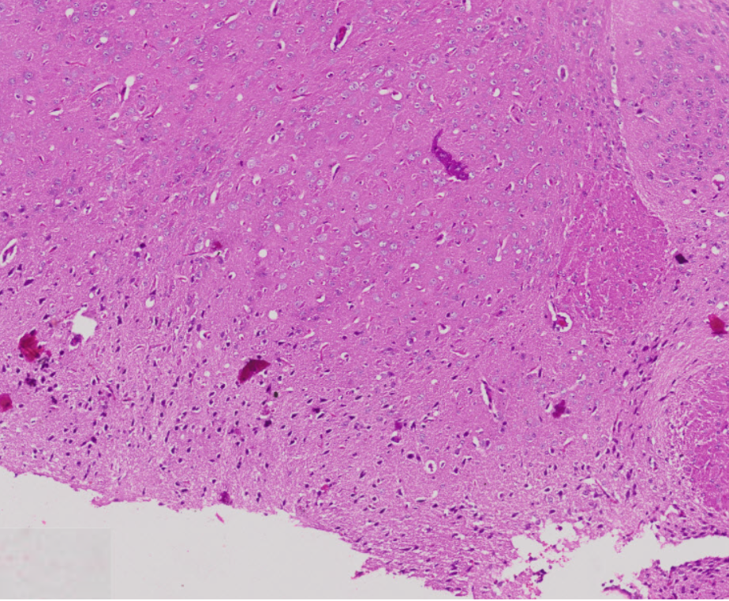

Pre test post test

Perlakuan |  | U1 |  | U2 |  | U3 |  | U4 |  | U5
Kontrol | Pre-Test | 8.44 | 6.15 |  | 6.58 |  | 7.15 |  | 7.37
Kontrol | Post-Test | 7.56 | 8.53 |  | 7.49 |  | 6.19 |  | 6.37
Dosis 1:1 | Pre-Test | 10.56 | 8.34 |  | 8.59 |  | 7.1 |  | 7.29
Dosis 1:1 | Post-Test | 8.34 | 7.23 |  | 6.49 |  | 6.32 |  | 5.29
Dosis 1:100 | Pre-Test | 7.51 | 8.34 |  | 7.39 |  | 7.45 |  | 6.47
Dosis 1:100 | Post Test | 6.58 | 7.34 |  | 6.59 |  | 6.9 |  | 5.92
Dosis 100:1 | Pre-Test | 7.56 | 7.34 |  | 7.79 |  | 7.54 |  | 7.29
Dosis 100:1 | Post-Test | 8.56 | 7.34 |  | 6.39 |  | 6.53 |  | 5.42

Sel |  | Kontrol |  | P1 |  | P2 |  | P3
Sel Normal | Pre-Test | 55 | 6.15 |  | 6.58 |  | 7.15
Sel Normal | Post-Test | 62 | 8.53 |  | 7.49 |  | 6.19
Dosis 1:1 | Pre-Test | 71 | 8.34 |  | 8.59 |  | 7.1
Dosis 1:1 | Post-Test | 62,67 | 7.23 |  | 7.49 |  | 6.32
Dosis 1:100 | Pre-Test | 7.51 | 8.34 |  | 7.39 |  | 7.45
Dosis 1:100 | Post Test | 6.58 | 7.34 |  | 7.59 |  | 7.9
Dosis 100:1 | Pre-Test | 7.56 | 7.34 |  | 7.79 |  | 7.54
Dosis 100:1 | Post-Test | 8.56 | 7.34 |  | 6.39 |  | 6.53

- No. Catalogue tiap bahan
  - 554655: BD Cytofix™ Fixation Buffer (BD Biosciences; BD Cytofix™ Fixation BufferBD Bioscienceshttps://www.bdbiosciences.com › en-us › research-reagents)
  - SAB4502982: Anti TNF-a Ab (Sigma Aldrich; https://www.sigmaaldrich.com/ID/en/search/mfcd00162116?focus=products&page=1&perpage=30&sort=relevance&term=mfcd00162116&type=mdl_number)
  - P4474: PBS 7.4 (Sigma Aldrich; https://www.sigmaaldrich.com/ID/en/product/sigma/p4474)
  - BK-802N DLS nano particle size analyser biobase
- PEG400 Polyethylene glycol 400
Synonym(s):
Poly(ethylene glycol), PEG
Linear Formula:
H(OCH₂CH₂)_{n}OH
CAS Number:
25322-68-3

1. Therapeutic Potential of Centella asiatica Nanoparticles in Mitigating Cognitive Decline and TNF-α Mediated Inflammation: An In Vivo Study in Mice
2. Centella asiatica in Nanoparticles as a Potential Neuroprotective Agent Against Cognitive Decline and TNF-α Inflammation: An In Vivo Investigation in Mice
3. Exploring the Neuroprotective Potential of Centella asiatica Nanoparticles: Effects on Cognitive Function and TNF-α Mediated Inflammation in a Mice Model

