Table S1. Clinical and histological characteristics of patients with DLBCL in this study.
Clinical-Features | GSE10846 | GSE10846-Test | GSE10846-Train | P-value | GSE11318
Age
<=65 | 173 | 48 | 125 | 0.53 | 58
>65 | 139 | 44 | 95 | 0.53 | 42
unkown | - | - | - | - | 37
Stage
1-2 | 140 | 39 | 101 | 0.656 | 48
3-4 | 172 | 53 | 119 | 0.656 | 89
Gender
Female | 131 | 35 | 96 | 0.617 | 58
Male | 163 | 52 | 111 | 0.617 | 79
Unknown | 18 | 5 | 13 | 0.617 | -
OS
0 | 202 | 67 | 135 | 0.0715 | 77
1 | 110 | 25 | 85 | 0.0715 | 60

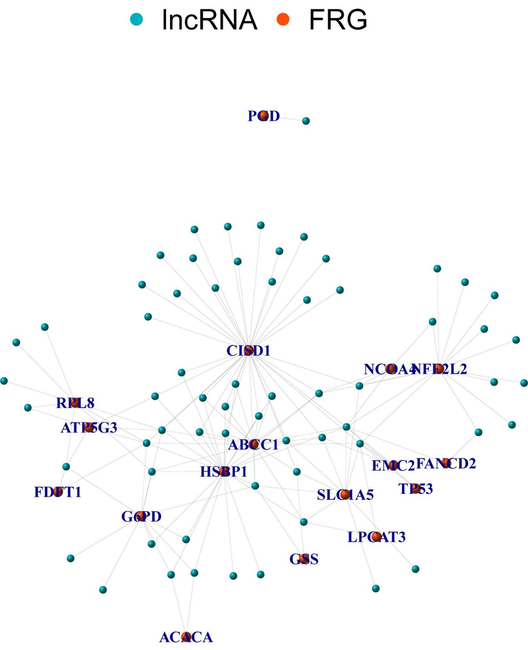
Figure S1. Ferroptosis-related lncRNA identification in patients with DLBCL.

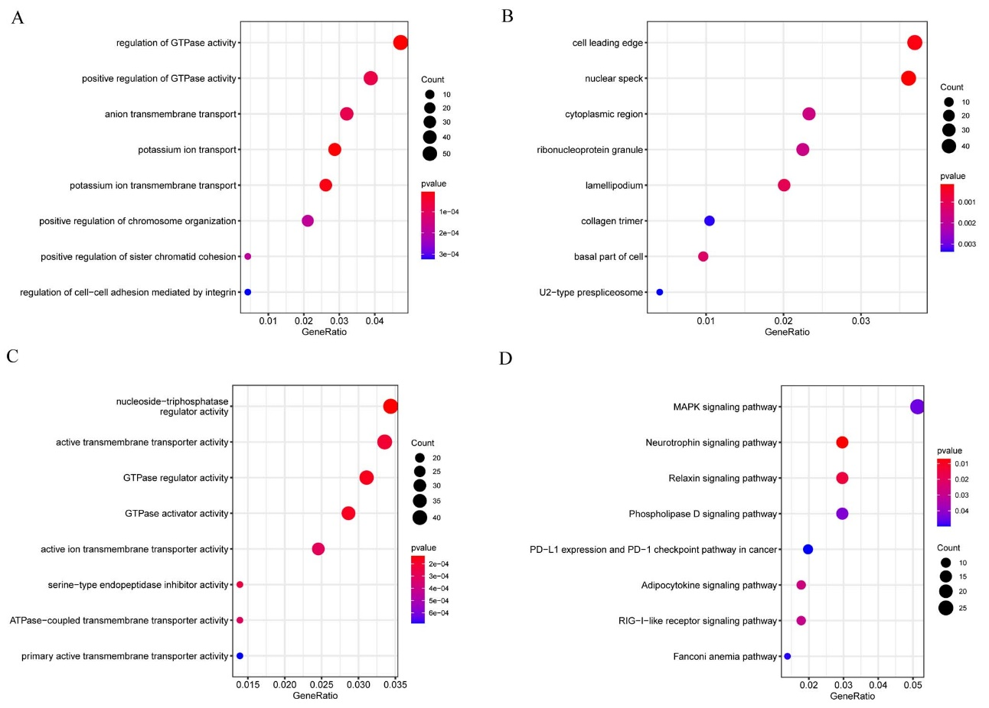
Figure S2. GO and KEGG analyses of DEGs. (A) GO biological process (GO-BP), (B) GO cellular component (GO-CC), and (C) GO molecular function (GO-MF) DEG enrichment analyses, and (D) functional gene annotation with different expression patterns between clusters 1 and 2 by using KEGG pathway terms.

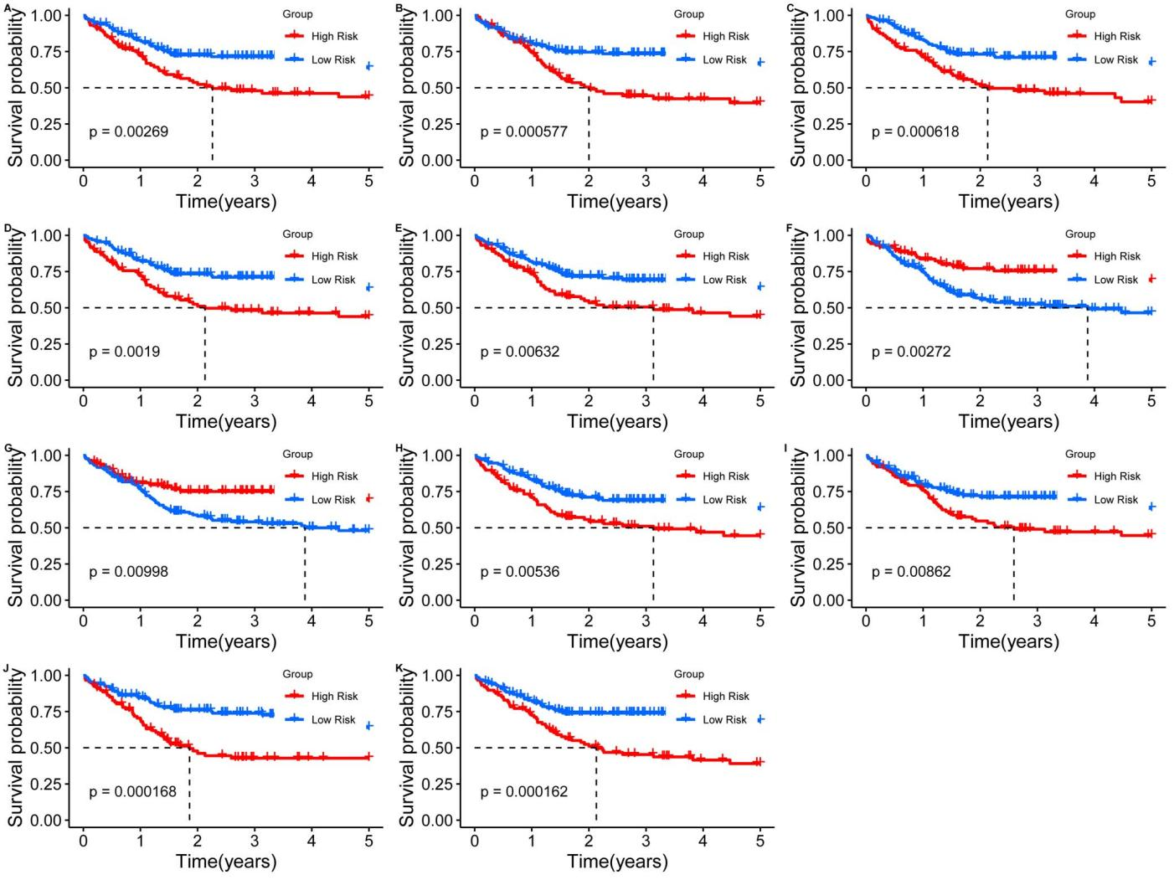
Figure S3. Identification of ferroptosis-related lncRNAs and prognostic analysis.
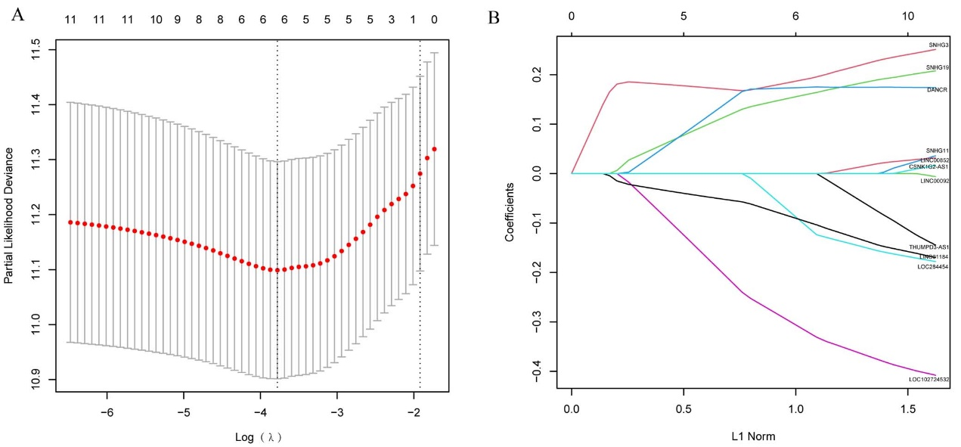
Figure S4. Identification of the risk signature by using LASSO analysis. (A) The change trajectory of an independent variable, with the horizontal axis representing the independent variable lambda log value and the vertical axis representing the independent variable coefficient. (B) The confidence interval under each lambda value.
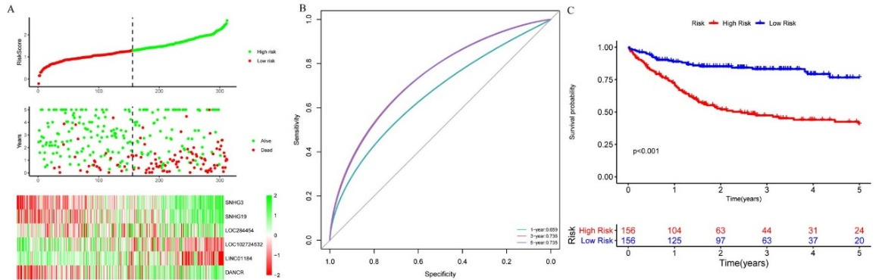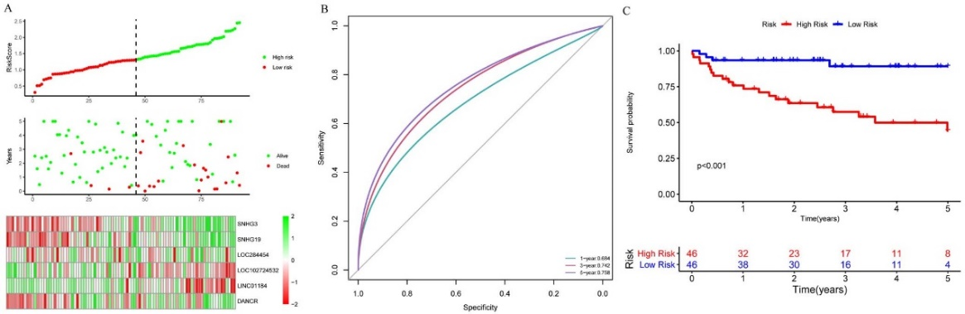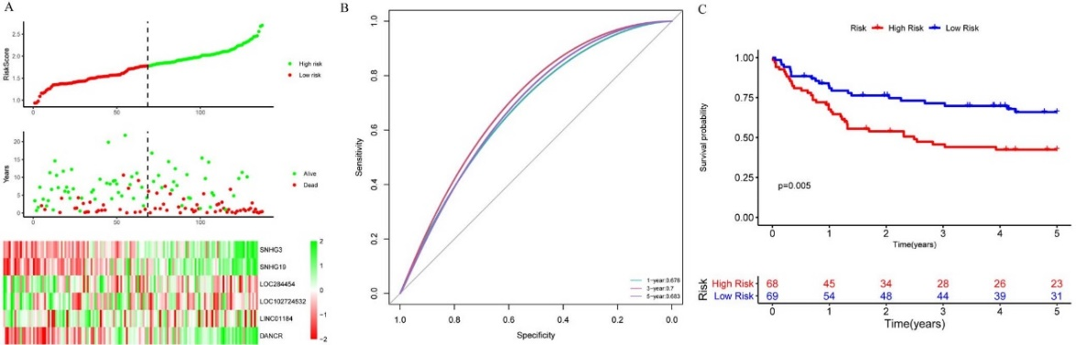
Figure S5. Prognostic performances of risk prediction models based on validation sets. (A) Risk scores and survival status distribution of DLBCL patients in the validation cohort. (B) ROC curves of the 6-gene signature model for the prediction of 1-, 3-, and 5-year survival in the validation cohort. (C) Kaplan–Meier analysis exhibited the association of expression characteristics of high-risk lncRNAs with poor survival.
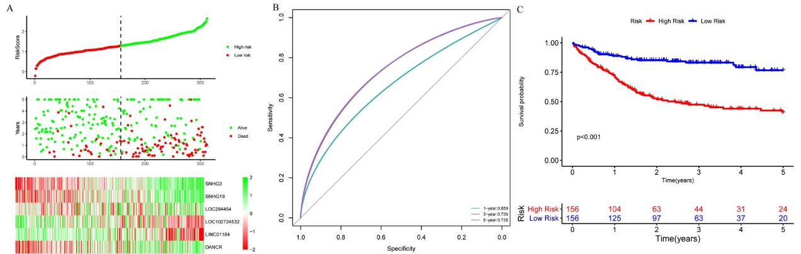
Figure S6. Prognostic performances of risk prediction models in the full datasets. (A) Expression levels, survival status, and risk scores of 6 lncRNAs in the full dataset. (B) ROC curves of the 6-gene signature model for 1-, 3-, and 5- survival prediction in the full dataset. (C) According to the Kaplan–Meier curve, the outcomes of the high-risk patients were poorer than those of the low-risk patients in the full dataset.
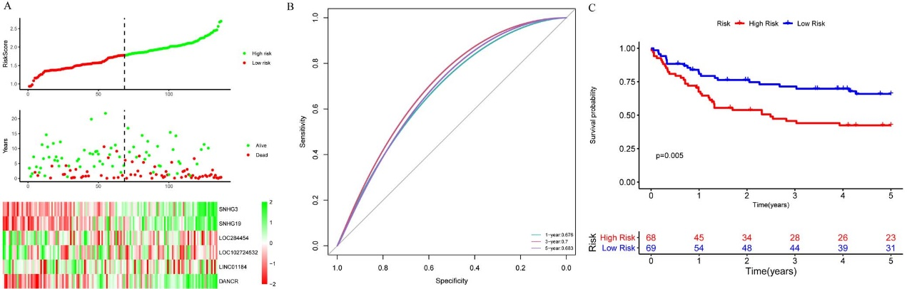
Figure S7. Prognostic performance of risk prediction models is constructed on the external validation dataset. (A) Expression levels, survival status, and risk scores of 6 lncRNAs in the dataset for external validation. (B) ROC curves of the 6-gene signature model for predicting 1-, 3-, and 5-year survival in the dataset for external validation. (C) As shown in the Kaplan–Meier curve, the high-risk group showed poorer outcomes than the low-risk group in the external validation dataset.

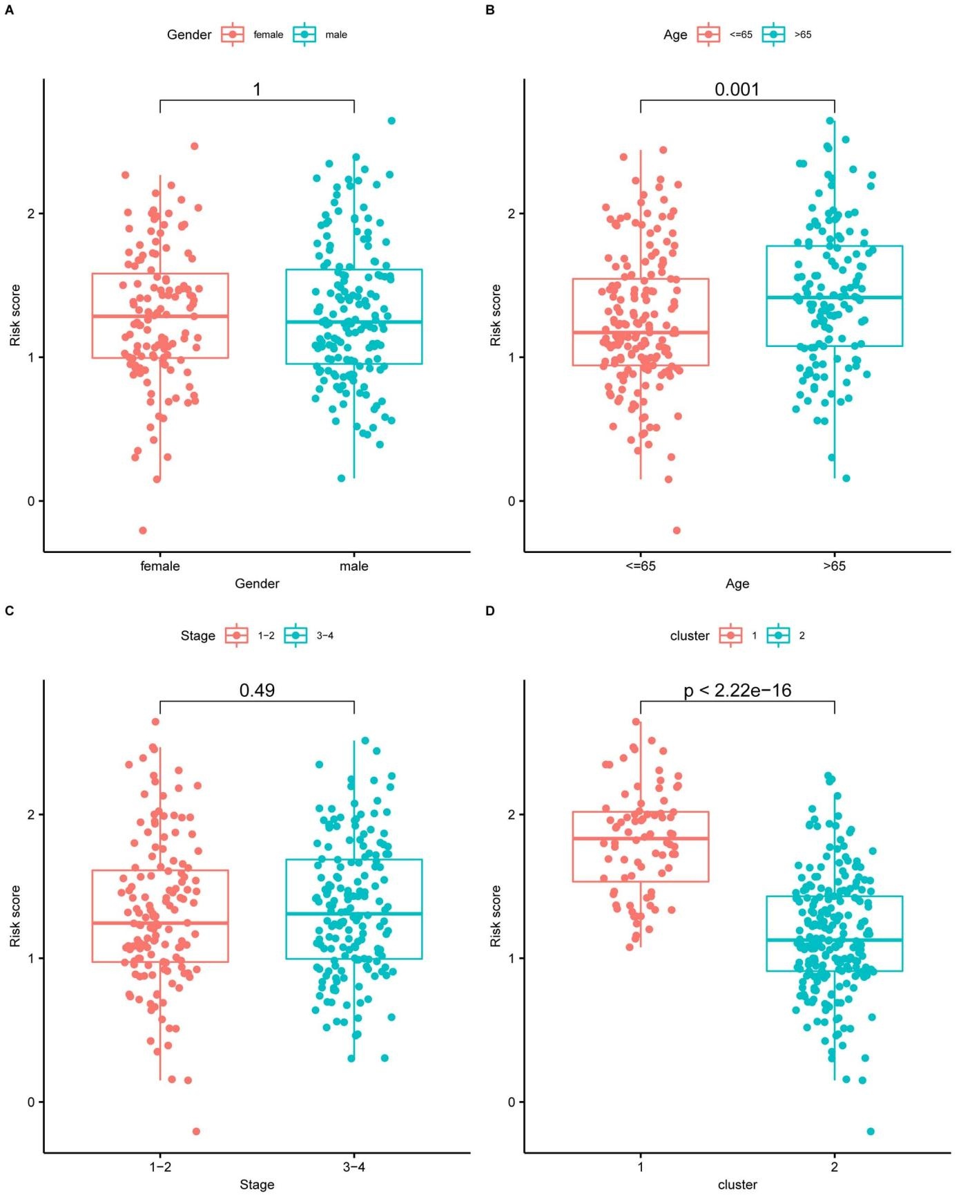
Figure S8. Differences in risk scores among patients with different clinical characteristics. (A) Risk score comparison between different sex groups. (B) Risk score comparison between different age groups. (C) Risk score comparison between varied stage groups. (D) Risk score comparison between clusters.
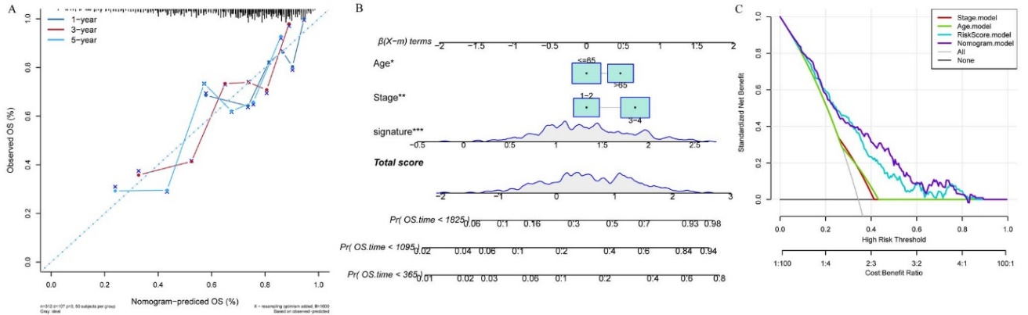
Figure S9. Predictive histogram construction. Predictive ability of the calibration plot of the nomogram for the probability of 1-, 3-, and 5-year OS. (B) Predictive ability of the nomogram for the probability of 1-, 3-, and 5-year OS. (C) DCA curve of the stage, risk score, and age combination.

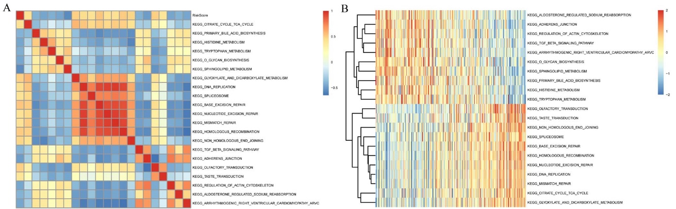
Figure S10. (A) Correlation coefficients for KEGG pathways and the risk score were clustered into heat maps. (B) The KEGG pathway is altered with increases in the risk score in ssGSEA for each sample.

