Supplementary Information

Reconstructing the invasion pathways of the bark beetles Orthotomicus erosus and Cyrtogenius luteus (Coleoptera, Curculionidae, Scolytinae) in South America

Authors: Leonel Stazione, Carolina Soliani, Anthony Cognato, Demian F. Gomez, Dimitrios Avtzis, Edgar Eskiviski, Gonzalo Martinez Crosa, Wei Lin, You Li, Juan Corley, Victoria Lantschner

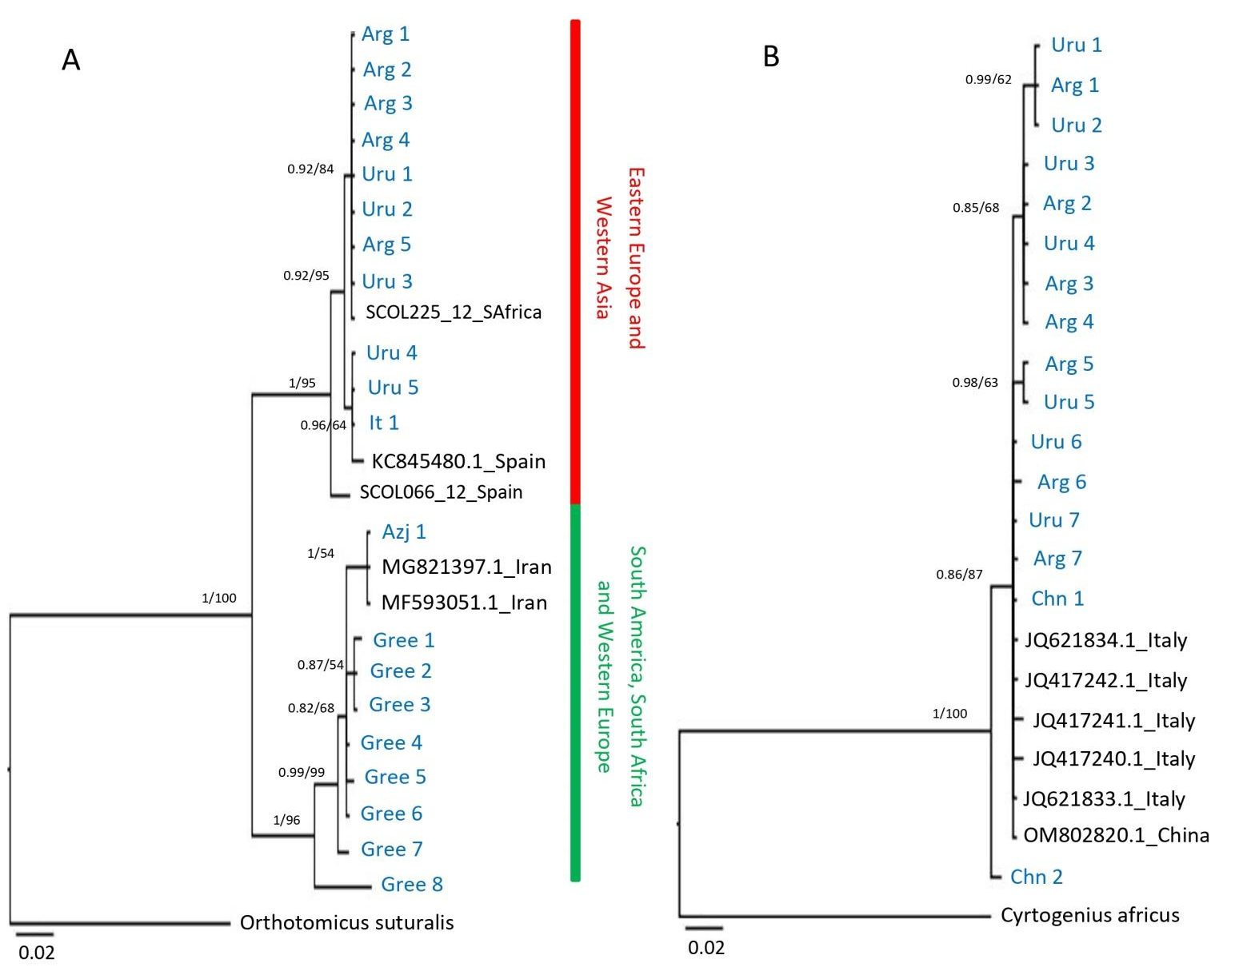

Fig. S1 Bayesian inference method and Maximum likelihood analysis of COI sequences. (a) For O. erosus a total of 433 bp were used in constructing the tree. Samples included were from Arg: Argentina, Uru; Uruguay, It: Italy, Ir: Iran, Azj: Azerbaijan and Gree: Greece. COI sequences of O. suturalis were included as outgroups (GenBank accessions: KJ964978). (b) C. luteus a total of 413 bp were used in constructing the tree. Samples included were from Arg: Argentina, Uru; Uruguay and Chn: China. COI sequences of C. africus were included as outgroups (GenBank accessions: JX263811). In blue are indicated the individuals sequencing in this study. Values at nodes indicate Bayesian posterior probabilities and bootstrap values for the BI and ML trees, respectively.

