SUPPLEMENTARY MATERIALS

- NEAR-FIELDS
The following Figures illustrate the near-fields for the rest of the simulated nano-rods.
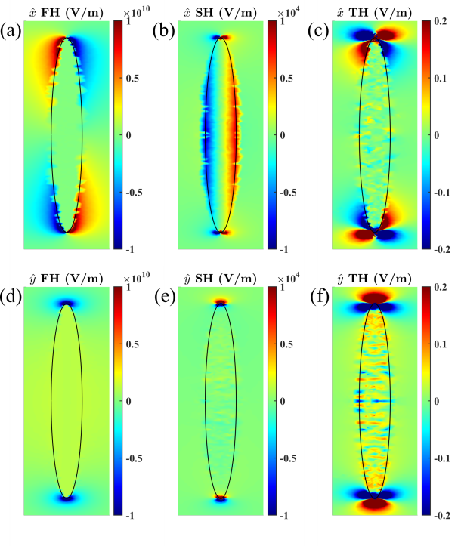
FIGURE A1: Near-fields of a nano-ellipsoid.
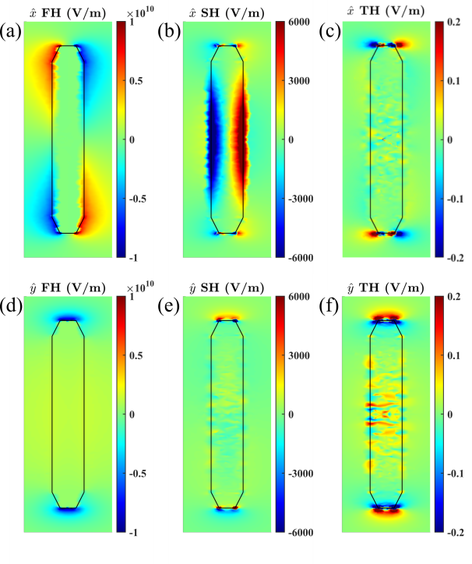
FIGURE A2: Near-fields of a blunted nano-cylinder.
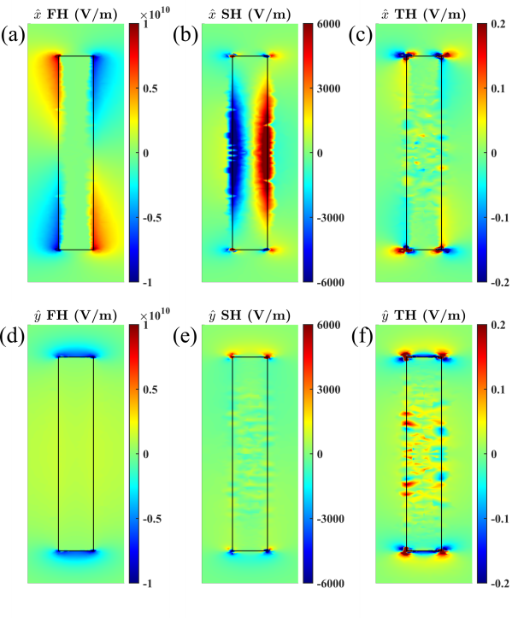
FIGURE A3: Near-fields of a nano-cylinder.
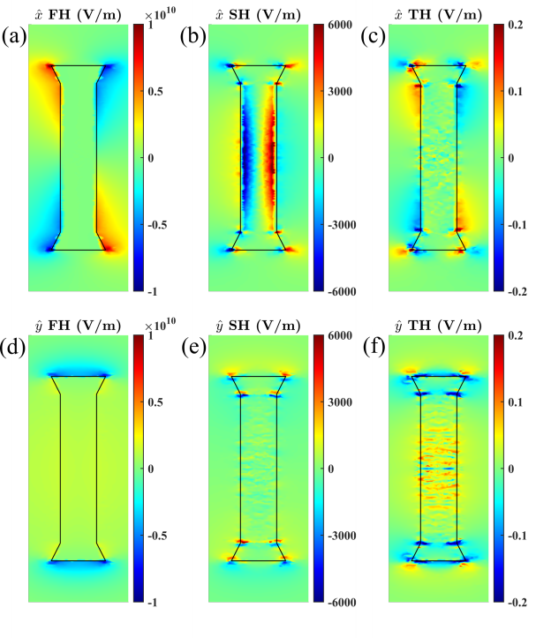
FIGURE A4: Near-fields of a flanged nano-cylinder.

- FARFIELDS
Figure B1 illustrate the radiated first and second-order modes for the nano ellipsoid and cylinders, respectively. Third-order fields are not included due to noise caused by low amplitudes.
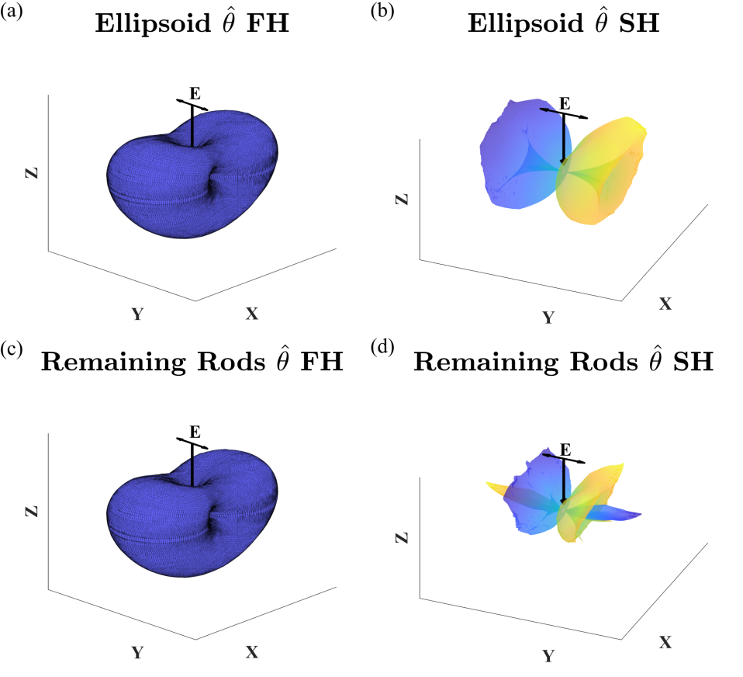
FIGURE B1: Scattered first and second-order modes.
- DIMENSIONS

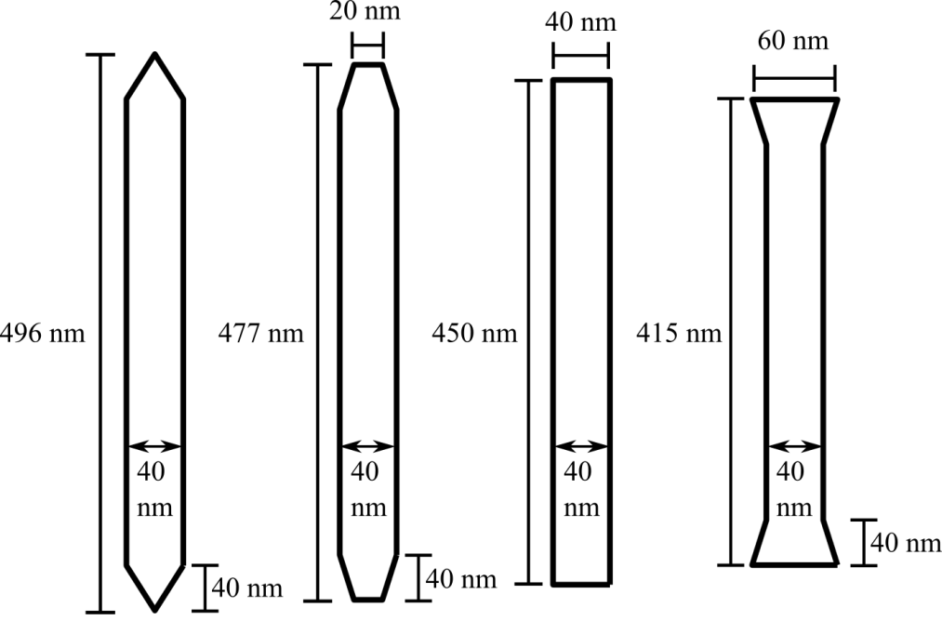
FIGURE C1: Dimensions of the nano-cylinders. The lengths are optimized to absorb 1560 nm wavelengths.

- SPECTRA

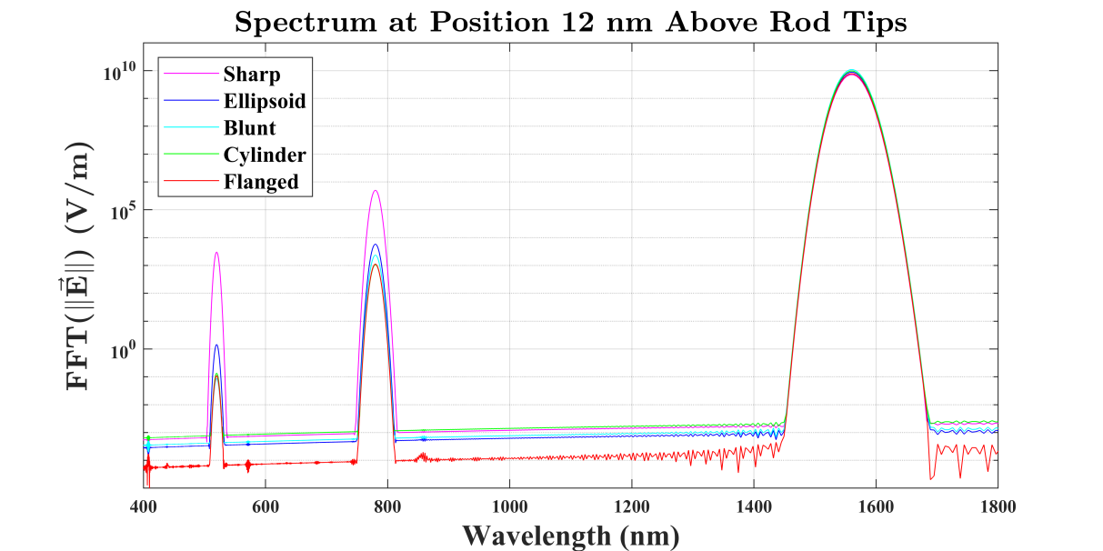
FIGURE D1: Spectra of the nanorods probed at a distance 12 nm above (along the y-axis). Rods have different lengths and the probe position is adjusted to maintain the gap of 12 nm.

- DIELECTRIC MAP

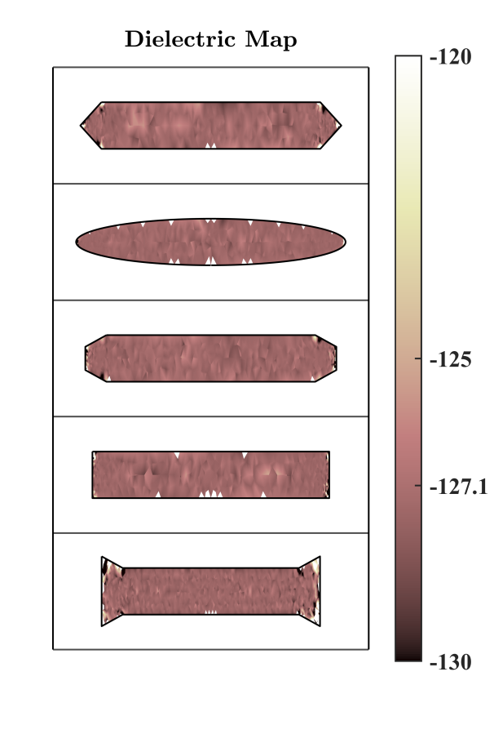

FIGURE E1: The dielectric maps of all nano-rods. The theoretically expected (Drude model) value at 1560 nm wavelength is -127.1.

- POLARIZATION DEPENDENCY

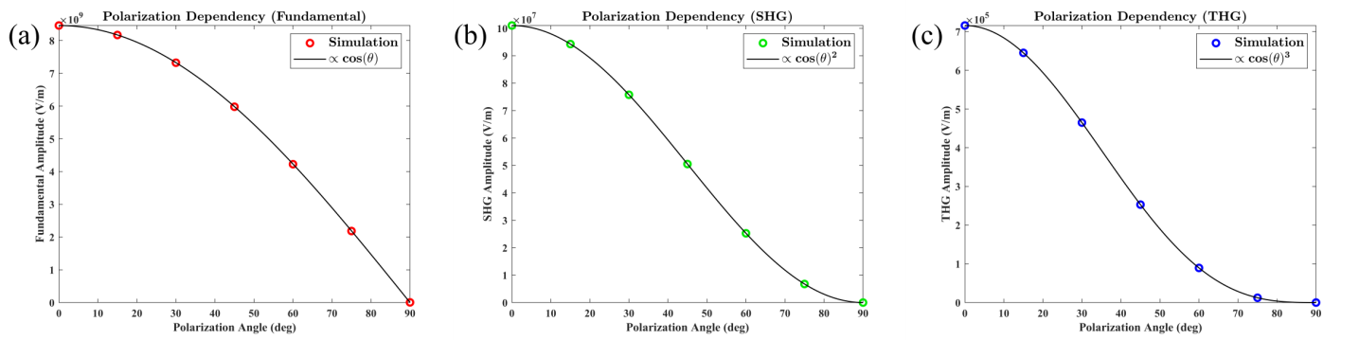

FIGURE F1: Polarization and intensity dependence of the sharp tipped nano-cylinder. Figures F1(a), F1(b) and F1(c) are linearly, quadratically and cubically dependent on cosine, respectively. The dotted data are the simulated values and the solid black line is the fitted function curve.

