Table 1: Demographic and Financial Data of Study Participants
%
Variable
Category
N.

Age 17-25 years 170 18.0
26-35 years 341 36.1
36-45 years 237 25.1
46-55 years 121 12.8
56-65 years 64 6.8
> 65 years 20 2.2
Gender Male 704 74.5
Female 235 24.9
Diverse 6 0.6
Marital Status Single 329 34.8
Partnered 237 25.1
Married 353 37.3
Divorced 26 2.8
Children No children 592 62.6
1 child 135 14.3
2 children 155 16.4
3 children 63 7.3
Education No school degree 5 0.5
Lower Secondary school diploma 34 3.6
Intermediate secondary school diploma 135 14.3
Technical diploma 146 15.5
High school diploma 625 66.1
Highest Degree No degree 96 10.2
Vocational degree 262 27.7
University degree 454 48.0
Doctorate 117 12.4
Postdoctoral qualification 16 1.7
Net Income in € < 1,500 126 13.3
1,500-3,000 273 28.9
3,000-4,000 196 20.7
4,000-6,000 202 21.4
6,000-8,000 78 8.3
> 8,000 68 7.2
NA 2 0.2
Assets in € < 20,000 116 12.3
20,000-50,000 173 18.3
50,000-100,000 151 16.0
100,000-200,000 140 14.8
200,000-500,000 171 18.1
> 500,000 192 20.3
NA 2 0.2
Investment Type* Savings 89 9.4
Bonds 11 1.2
Real Estate 94 9.9
ETFs 478 50.6
Stocks 250 26.5
Crypto 23 2.4
Expected Returns 0-5% 165 17.5
5-10% 609 64.4
10-15% 118 12.5
15-20% 36 3.8
> 20% 17 1.8
Last Year Returns < -20% 25 2.6
-20% to -10% 15 1.6
-10% to 0 43 4.5
0-10% 476 50.4
10-20% 283 30.0
> 20% 103 10.9
Portfolio tracking Once a month 181 19.1
Once a week 92 9.7
2-3 times/week 162 17.1
Daily 226 23.9
Multiple times/day 284 30.1
Trading Frequency < 3/month 466 49.4
3-5/month 236 24.9
5-10/month 138 14.6 10-20/month 55 5.8
> 20/month 50 5.3
Note: NA: no answer, *multiple choice possible
Table 2: Multilinear Regression Model predicting the ADHS-SB score
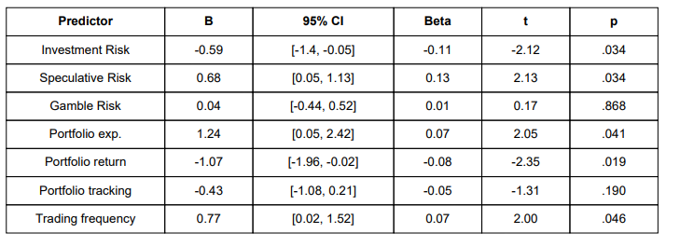
Note: B = unstandardized regression coefficient; CI = confidence interval; β = standardized regression coefficient; t = t-test statistic; p = probability value. The model had an overall fit of R = .161, R² = .026. Confidence intervals are reported in brackets.

