For Table of Contents Only

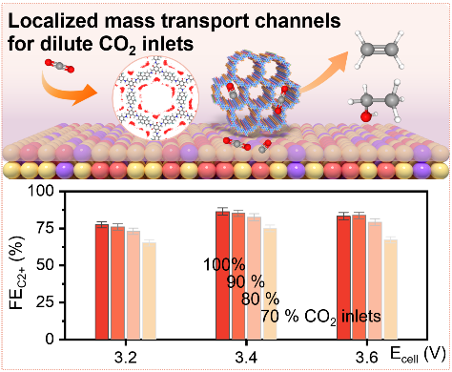
To continuously perform electrolysis of dilute CO₂ for industrial applications, we regulate both catalytic sites by single atomic alloy and the local environment by mass transport channels of a functionalized covalent organic framework. Such scalable architecture couples CO₂ concentrating and converting process to synthesize highly selective and stable C₂₊ products with dilute CO₂ inlet.

