Supplementary Information

Localized mass transport channels for electro-upgrade of dilute CO₂ toward high-yield C₂₊ products

Bohua Ren, et al.

This file includes:
1. Experimental Methods
2. Simulation Methods
3. Supplementary Figures
4. Supplementary Tables
5. Reference

Experimental Methods

Chemicals
Copper(II) chloride dihydrate (CuCl₂·2H₂O, metal basis > 99.99%), indium nitrate hydrate (In(NO₃)₃·5H₂O, metal basis > 99.99%), ethanol ( > 99.7%), propylene oxide ( > 99.5%), and isopropanol ( > 99.7%) were purchased from Aladdin. Nafion solution (5 wt. %) was purchased from Macklin. Nafion 211 cation-exchange membranes were obtained from Dupont. All of the chemicals were used without further purification. The ultrapure water was obtained from the milli-Q system.

Synthetic procedures
Preparation of TfCOF: 1 mmol 1,3,5-triformyl phloroglucinol (Tp, 210 mg) and 1 mmol 2,2'-Bis(trifluoromethyl)benzidine (BTBD, 324 mg) were added to a Pyrex tube containing 10 mL mixed solvent (dioxane/mesitylene =1:1, volume ratio) with 1 mL acetic acid (6 M), which was then sonicated for 20 min. The mixture was flash-frozen under liquid nitrogen. After that, the mixture was sealed to the oven and dried at 120 ºC for 3 days. The resultant precipitate was collected by filtration and washed with acetone, dichloromethane, and tetrahydrofuran, respectively. The precipitates were then heated at 120 ºC for 24 h in a vacuum oven to get the material which was named TfCOF.
Preparation of In-Cu gel: The CuCl₂·2H₂O (3.0 mmol) and In(NO₃)₃·5H₂O (0.2 mmol) were dissolved in 2 ml isopropanol. Under consistent bath sonication, 2 ml propylene oxide was added to the resulting solution and mixed for 20 s. Then, 0.2 ml H₂O was added and sonicated continuously until a homogeneous grey-green gel was formed. The above grey-green gel was aged for 24 h and eventually dried at 60 °C lasting 24 h in a vacuum oven.
Preparation of TfCOF-In₁@Cu₂O electrode: First, the above In-Cu gel was formulated into ink solution in the usual way. In a typically prepared procedure of the working electrode, 5mg of the dried In-Cu gel was mixed with TfCOF (In-Cu gel: TfCOF = 5:1, weight ratio), 1 ml water-isopropanol solution with a volume ratio of 7:3 and 80 μl Nafion solution (5 wt%) to prepare an ink solution. Then, the pristine electrode was obtained by loading the ink solution onto Sigracet 29 BC carbon paper of 1.0 × 1.0 cm and dried in an infrared drying oven. Finally, under CO₂RR conditions, the TfCOF-In₁@Cu₂O electrode was in-situ electrochemically activated in a CO₂-saturated 0.5 M KHCO₃ electrolyte at a constant potential of -3.14 V vs. RHE for 30 mins. TfCOF-In₁@Cu₂O(0.1) and TfCOF-In₁@Cu₂O(0.3) electrodes were synthesized as described above but with different additions of TfCOF (weight ratios of In-Cu gel: TfCOF = 1:0.124, In-Cu gel: TfCOF = 1:0.372, respectively).
Preparation of In₁Cu₂O/Cu electrode and Cu nanoparticles (Cu NPs): In₁Cu₂O/Cu electrode and Cu nanoparticles were synthesized in a similar way to that used for the TfCOF-In₁@Cu₂O catalyst, except that TfCOF powder and In(NO₃)₃·5H₂O were not added.

Electrochemical measurement
Electrochemical CO₂ reduction was conducted in a customized flow cell with a Nafion 211 membrane to separate the two compartments, preventing the reoxidation of CO₂RR products at the anode. ^{1,2} Different inlets of pure and impure CO₂ were continuously bubbled into the catholyte botter to saturate 0.5 M KHCO₃ solution. N₂ is used to balance and simulate the impure CO₂ from fuel gas.^{3,4} The flow rate of gas was controlled at 60 ml/min by a mass flow meter. The anolyte was also 0.5 M KHCO₃ solution. All electrochemical experiments were tested using a Biologic VMP-300 Potentiostat with a current booster. The cell voltage of E_{cell} is reported without iR correction. The current densities were normalized to the geometric surface area in this work. The partial current densities were equal to the total current densities multiplied by the Faraday efficiency. Three independent measurements were performed under ambient pressure and room temperature.
The electrolyzer stack was assembled by four module units with the electrode area of 10×10 cm². Two 1 L electrolyte bottles were employed for 0.5 M KHCO₃ solutions as the anolyte and catholyte. The inlet was separated into four modules in parellar, and the outlets were collected in the bottom flow channels.

Products analysis
The gaseous products were quantified by the online gas chromatograph (GC, GC-2014 Shimadzu) with a packed molecular sieve column. The online GC is equipped with a flame ionization detector (FID 1) for CO and CH₄, a flame ionization detector (FID 2) for C₂H₄, C₂H₆, and C₂H₂, as well as a thermal conductivity detector (TCD) for H₂. Liquid products in the catholyte were analyzed on a nuclear magnetic resonance spectroscopy (400 MHz ¹H liquid NMR spectrometer, Bruker Avance NEO) with the water suppression method. 1 ml of product-containing electrolyte was collected from the cathodic compartment after electrolysis. It was mixed with an internal standard of dimethyl formamide (DMF, Sigma-Aldrich, >99.9%) and D₂O (Sigma-Aldrich, 99.9%), and then sealed for NMR measurements.

Materials Characterizations
The X-ray diffraction (XRD) was performed to disclose the crystal structure of the as-prepared materials by Bruker/D8 ADVANCE X-ray diffractometer. Scanning electron microscope (SEM, ZEISS Sigma 500) and transmission electron microscopy (TEM, FEI Talos F200x) were applied to observe the morphologies and microstructures of materials and electrodes. The FEI Talos F200X TEM combines outstanding high-resolution S/TEM and TEM imaging with energy-dispersive X-ray spectroscopy (EDS) signal detection and 3D chemical characterization with compositional mapping. High-angle annular dark-field scanning transmission electron microscopy (HAADF-STEM) characterization was carried out on a Titan Cubed Themis G2 300 thermal field emission microscope with a high-tension voltage range of 60-300kV.
XANES and EXAFS spectra of Cu K-edge and In K-edge were acquired on HXMA and BioXAS beamlines at Canadian Light Source (CLS), respectively. The results were analyzed via Athena and Artemis software. Solid-state ¹³C NMR experiments were recorded on an AVANCE NEO 600MHz spectrometer (Bruker BioSpin Corp.) at the resonance frequency of 150.72 MHz for 13C using the cross-polarization (CP), magic-angle spinning (MAS), and a high-power ¹H decoupling. The powder samples were placed in a pencil-type zirconia rotor of 4.0 mm o.d. The spectra were obtained at a spinning speed of 10 kHz (4.2 μs 90° pulses), a 2 ms CP pulse, and a recycle delay of 3 s. The C signal of tetramethylsilane (TMS) at 0 ppm was used as the reference of 13C chemical shift.
Time-of-flight secondary ion mass spectroscopy (TOF-SIMS) was employed to study the elemental composition of various catalysts. All depth profiles were acquired in non-interlaced mode, namely sequential sputtering. A 50 × 80 µm² area centred on the analysis area was sputtered using a Cs+ ion beam (1 KeV ion energy, ~40 nA measured sample current).

Details of the operando, in-situ and quasi in-situ measurements
The operando synchrotron two-dimensional wide-angle X-ray scattering (2D-WAXS) images were performed on the High Energy Wiggler Beamline in the Brockhouse Diffraction Sector (BXDS-WHE) at CLS, Canada.
Thermo Fisher Nicolet IS50 spectrometer was employed for in-situ electrochemical attenuated total reflection Fourier-transform infrared (ATR-FTIR) experiments. The Si prism with an incidence of a 60° angle was assembled into the bottom of the three-electrode in-situ electrochemical cell.
Quasi in-situ characterizations were conducted to explore the information on elemental composition and oxidation states, which were collected by a near-ambient pressure X-ray photoelectron spectroscopy (NAP-XPS) located at the Vacuum Interconnected Nanotech Workstation (Nano-X), Suzhou Institute of Nano-Tech, and Nano-Bionics, Chinese Academy of Sciences (CAS).

Computational Methods

DFT calculations
We used the Vienna Ab-initio Simulation Package (VASP)⁵ with the projector augmented wave (PAW) method⁶ for all density functional theory (DFT) calculations. The Perdew-Burke-Ernzerhof (PBE) functional⁷ combined with DFT-D3 correction⁸ was employed to treat the exchange-functional for describing the weak interactions between atoms. During the calculations, the plane-wave basis had a cut-off energy of 420 eV. The Brillouin zone integration was conducted with a 2×2×1 Monkhorst-Pack k-points for optimizing the geometry and lattice size. We performed structural relaxation until the electronic structure self-consistency loop reached 1×10⁻⁴ eV. Partial occupancies were permitted for the Kohn-Sham orbitals by using the Gaussian smearing method and a width of 0.1 eV. The energy change in a geometry optimization was considered convergent when it was less than 0.01 eV Å⁻¹. The implicit dipole and solvent corrections^{9,10} were also taken into account in this work. For each elementary step, Gibbs reaction free energy ΔG is the difference of free energies between the initial and final states and is defined as follows:
where the reaction energies of reactants calculated by DFT correspond to ΔE, ΔZPE and ΔS are the zero-point energy and entropy changes due to the reaction. The definitions of adsorption energy (E_{ads}) for the adsorbate are depicted in the reported literature ^{9,11,12}.

Molecular Dynamics Simulation
The all-atom MD simulations were performed using the Gromacs-4.6.7 software package¹³, with a general AMBER force field¹⁴ featuring RESP charges¹⁵. The system was in a relaxed liquid configuration at 298K, and the equilibrium MD simulation ran for a total of 10ns NPT. We used the relaxed system as a starting configuration and performed energy minimization with a composite protocol of steepest descent, using 100 kJ/mol∙nm termination gradients, prior to system relaxation MD. To maintain the equilibrium temperature at 298 K, the Nose´-Hoover thermostat¹⁶ was employed, while periodic boundary conditions were enforced on all three dimensions. The Particle Mesh-Ewald method^{17,18} was utilized to calculate long-range electrostatics with a relative tolerance of 1x10⁻⁶, and a 1nm cut-off distance was applied to real-space Ewald interactions and van der Waals interactions. The bond lengths of hydrogen atoms were constrained using the LINCS algorithm¹⁹, and we used a leap-frog algorithm²⁰ with a time step of 1 fs.

Supplementary Figures

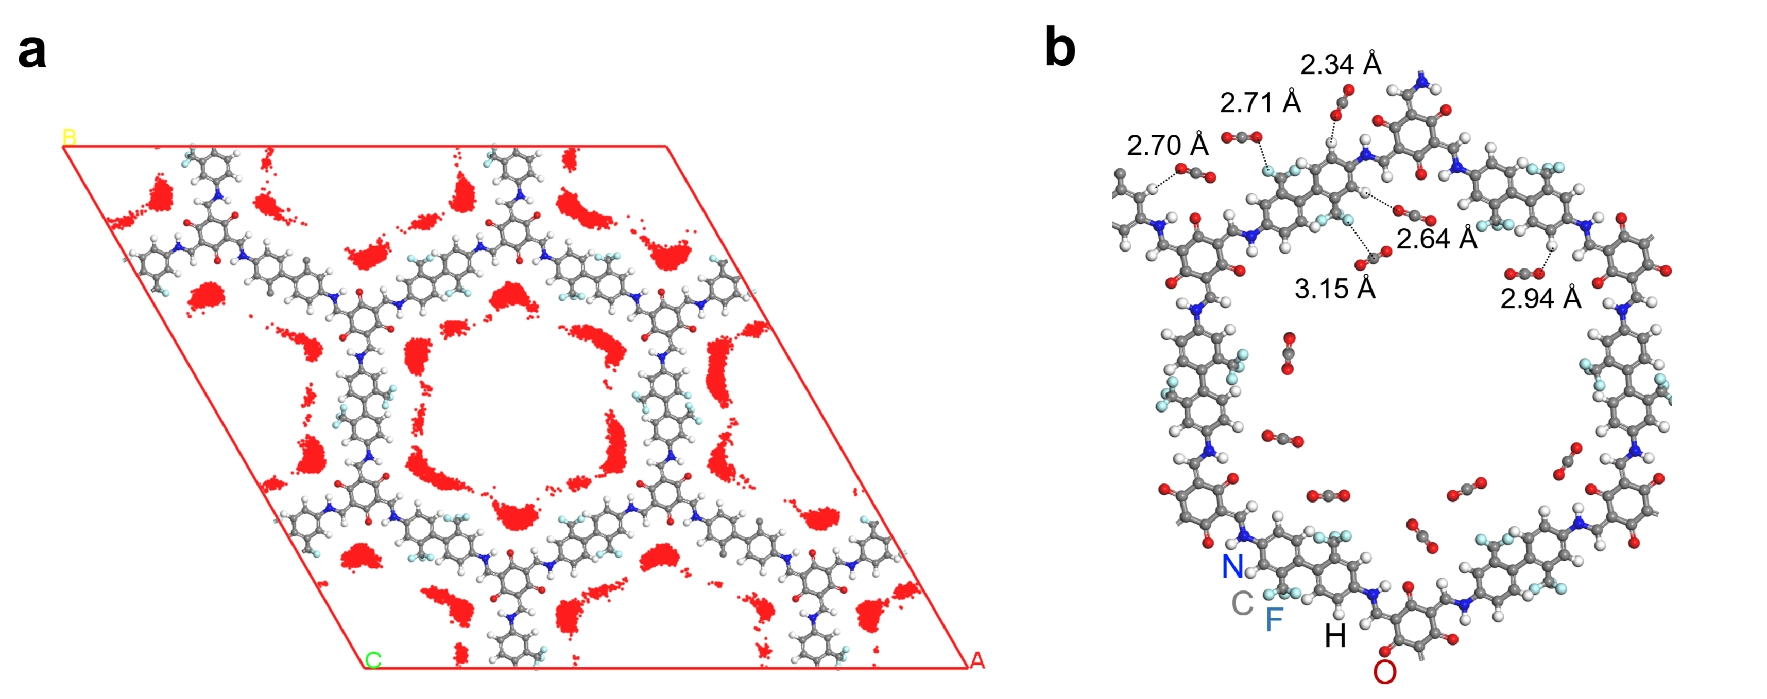

Supplementary Figure 1. (a) Results of Molecular Dynamics simulations of adsorbed CO₂ molecule distribution probability at ambient temperature and pressure. (b) (c) Representative CO2 adsorption sites and distances on TfCOF calculated by Molecular Dynamics simulations.

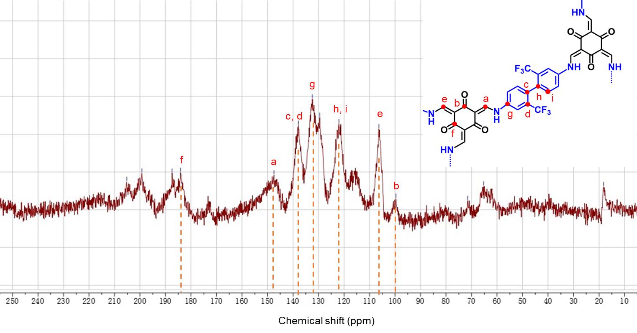Supplementary Figure 2. Solid-state ¹³C NMR spectra of TfCOF.
The chemical structure of TfCOF is further confirmed by solid-state ¹³C NMR. The peak at ~ 100 ppm indicated that the exocyclic C=C carbon was adjacent to the C=O carbon. The carbon signal of C=C at around 150 ppm signified C=C carbon attaching to the N. The chemical shifts corresponding to the other chemical bonds of TfCOF are shown in the figure above.
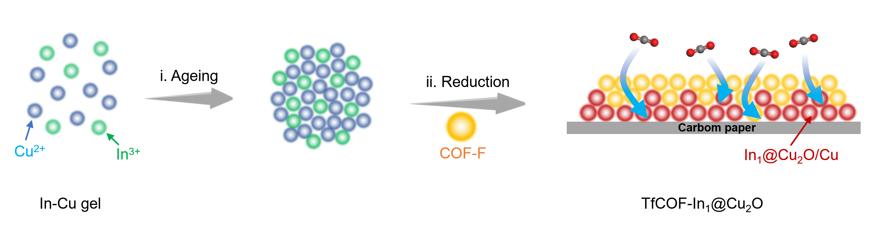

Supplementary Figure 3. (a) SEM images of In-Cu gel mixed with TfCOF at a weight ratio of 1:0.2. (b) is the material drop-casted on carbon paper. (d-e) Corresponding EDS elemental mapping.

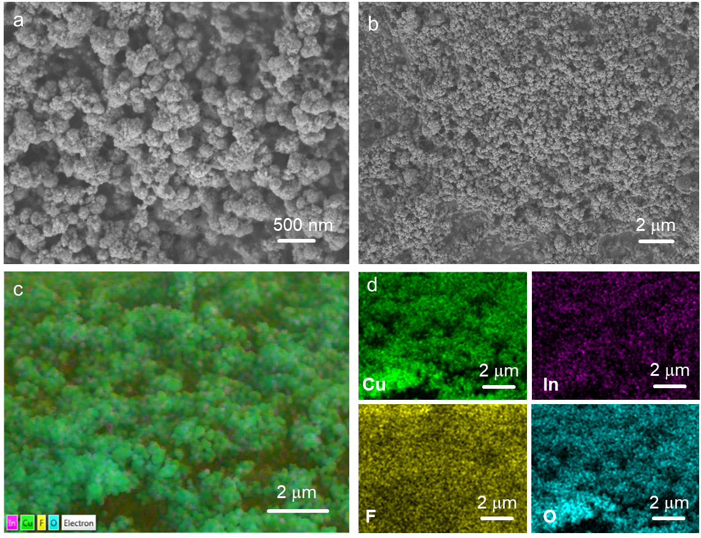

Supplementary Figure 4. (a) SEM images of In-Cu gel mixed with TfCOF at a weight ratio of 1:0.2. (b) is the material drop-casted on carbon paper. (d-e) Corresponding EDS elemental mapping.
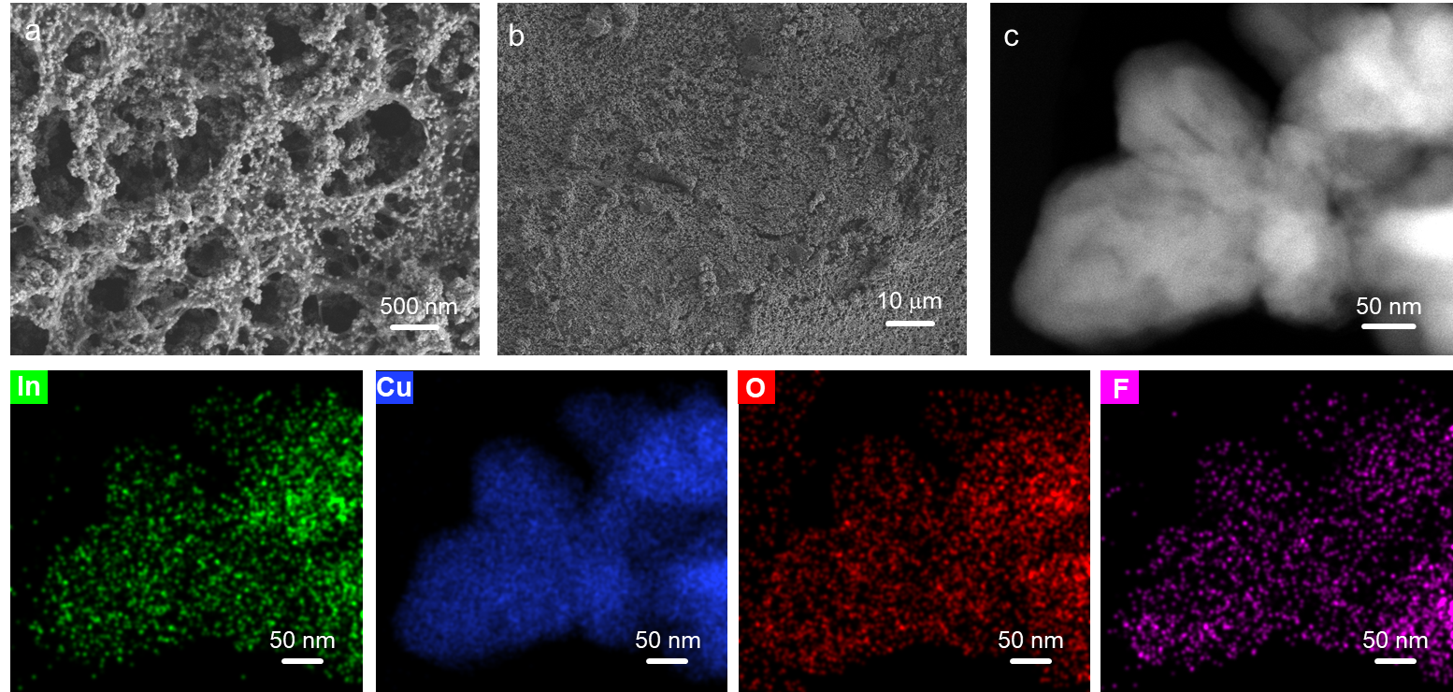

Supplementary Figure 5. (a) SEM images of TfCOF-In₁@Cu₂O. (b) is the material distributed on carbon paper. (c) HAADF-STEM images and corresponding EDS elemental mapping of TfCOF-In₁Cu₂O.
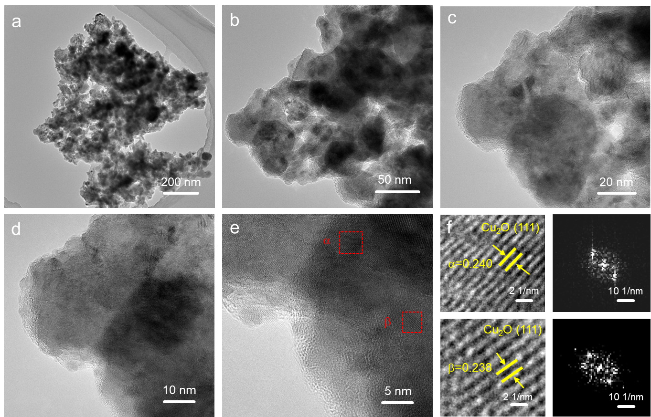

Supplementary Figure 6. (a-f) HRTEM images of TfCOF-In₁@Cu₂O material. The selected interplanar distance was around 0.24 nm, corresponding to the Cu₂O (111) facet.

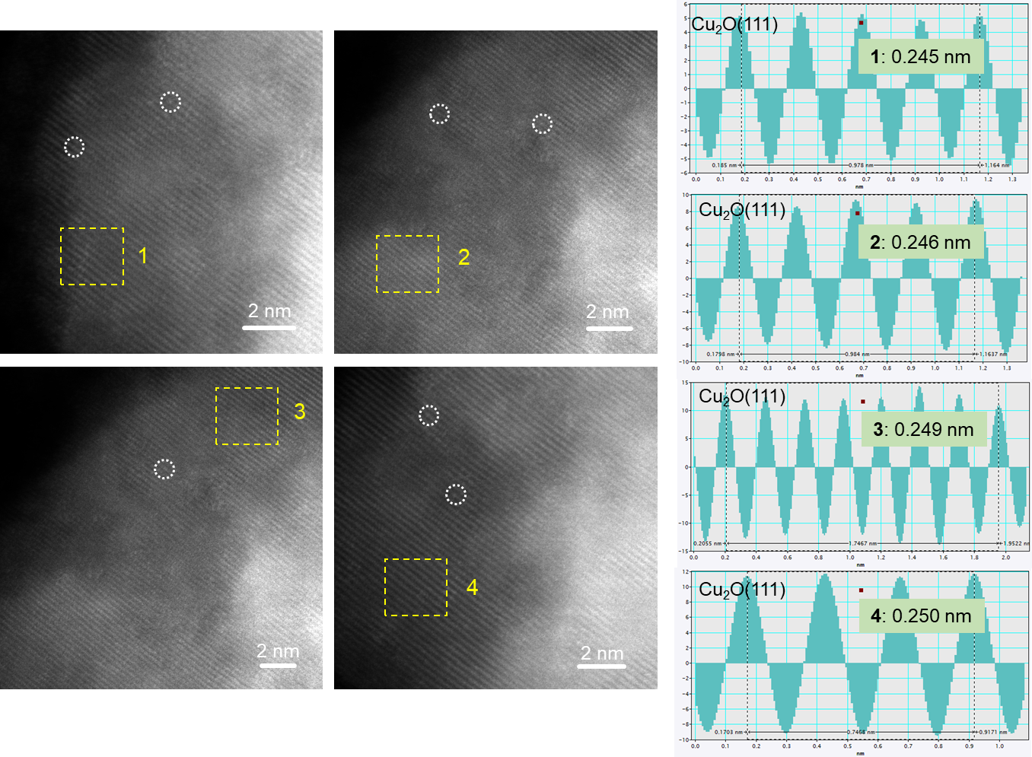

Supplementary Figure 7. HAADF-STEM images of TfCOF-In₁Cu₂O material and the selected interplanar distance measurements. The results indicate that In single atoms were mono-dispersed among Cu₂O matrix.
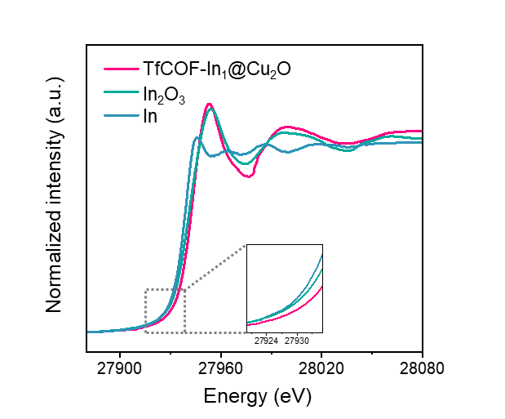

Supplementary Figure 8. In K-edge XANES spectra of as-prepared TfCOF-In₁@Cu₂O catalyst. In foil and In₂O₃ were used as references for In⁰, In³⁺, respectively. The near edge positions of the catalysts were higher than the In₂O₃ standard sample, confirming that the oxidation state of In species in the as-synthesized TfCOF-In₁@Cu₂O samples was higher than In³⁺.
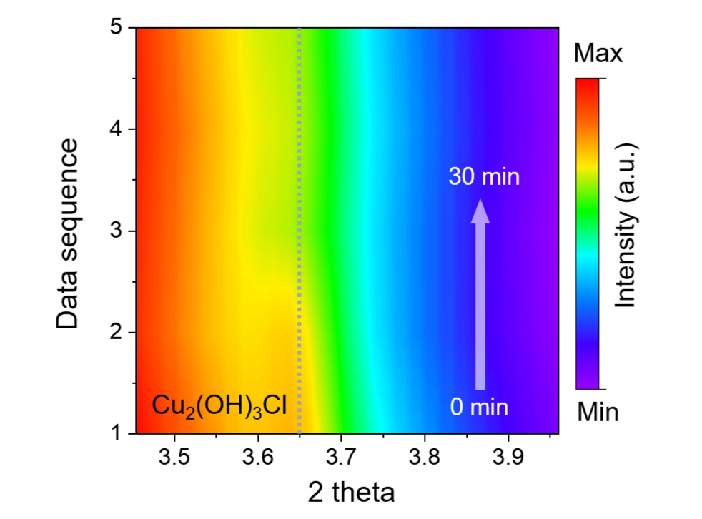

Supplementary Figure 9. In-situ XRD spectra of Cu₂(OH)₃Cl evolution in TfCOF-In₁@Cu₂O catalyst during the activation step. The peak of Cu₂(OH)₃Cl (2θ = 3.65°) progressively disappeared. The Cu₂(OH)₃Cl would be gradually reduced to Cu₂O species.
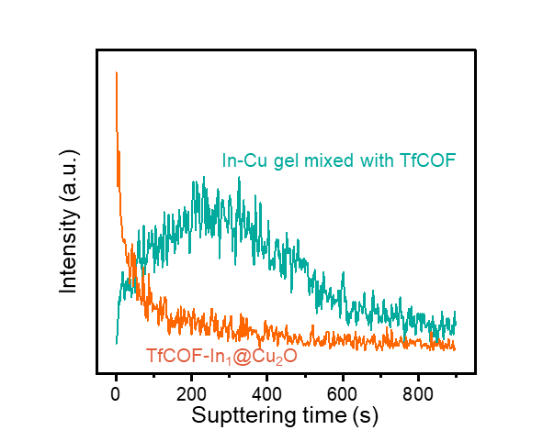

Supplementary Figure 10. TOF-SIMS depth profiles of In element for TfCOF-In₁@Cu₂O before and after the activation step. The sample before the activation is noted as In-Cu gel mixed with TfCOF in the figure.

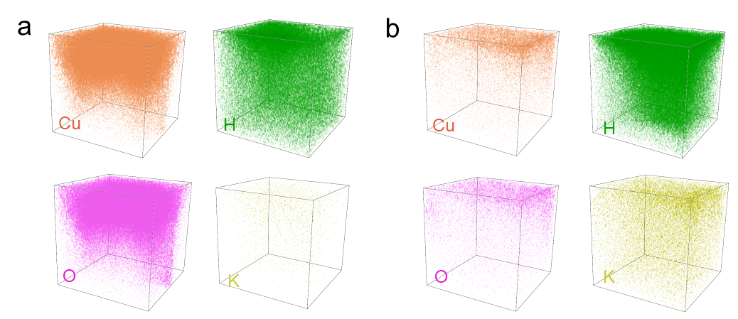

Supplementary Figure 11. 3D images of TOF-SIMS elemental depth distribution of (a) In-Cu gel mixed with TfCOF and (b) TfCOF-In₁@Cu₂O, including Cu, H, O and K element.
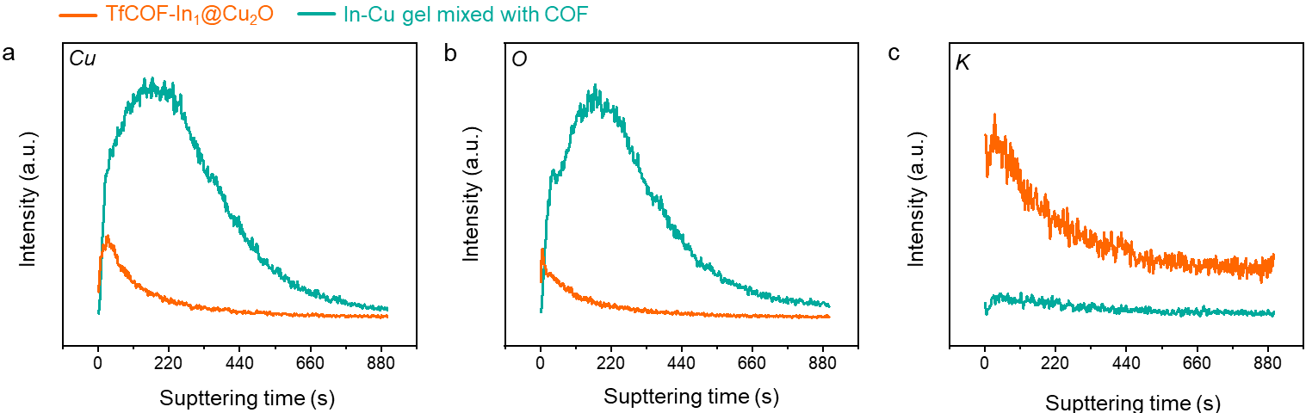

Supplementary Figure 12. TOF-SIMS depth profiles of In-Cu gel mixed with TfCOF and TfCOF-In₁@Cu₂O, respectively. (a-b) The trend is the same for the elements Cu and O before and after the electroreduction. (c) The distribution of element K increased over the whole TfCOF-In₁@Cu₂O material after the electroreduction. This proves the outstanding ability of conducting K ions.

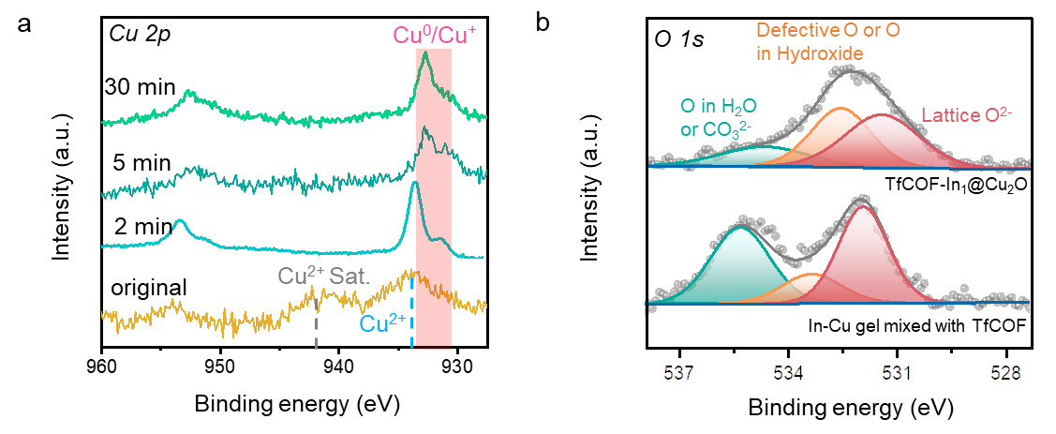

Supplementary Figure 13. (a) Quasi in-situ NAP-XPS spectra of Cu 2p of TfCOF-In₁@Cu₂O catalyst during the ER process. (b) In 3d XPS spectra of In-Cu gel mixed with TfCOF and TfCOF-In₁@Cu₂O.

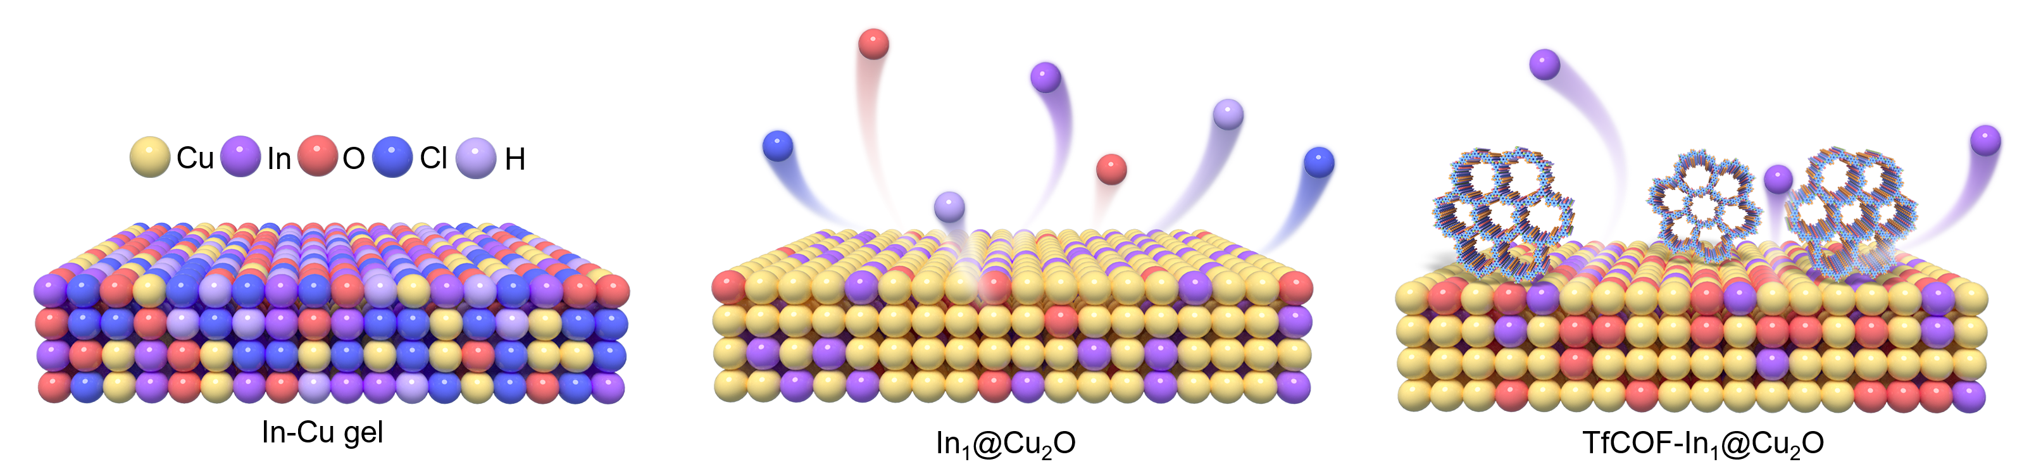

Supplementary Figure 14. Schematic of the atomic structure of In-Cu gel, In₁@Cu₂O and TfCOF-In₁@Cu₂O materials.

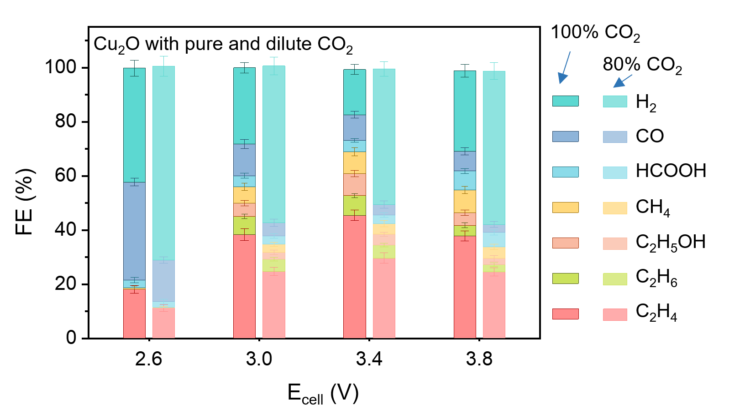

Supplementary Figure 15. FEs of different products for Cu₂O with pure and dilute CO₂ inlets.
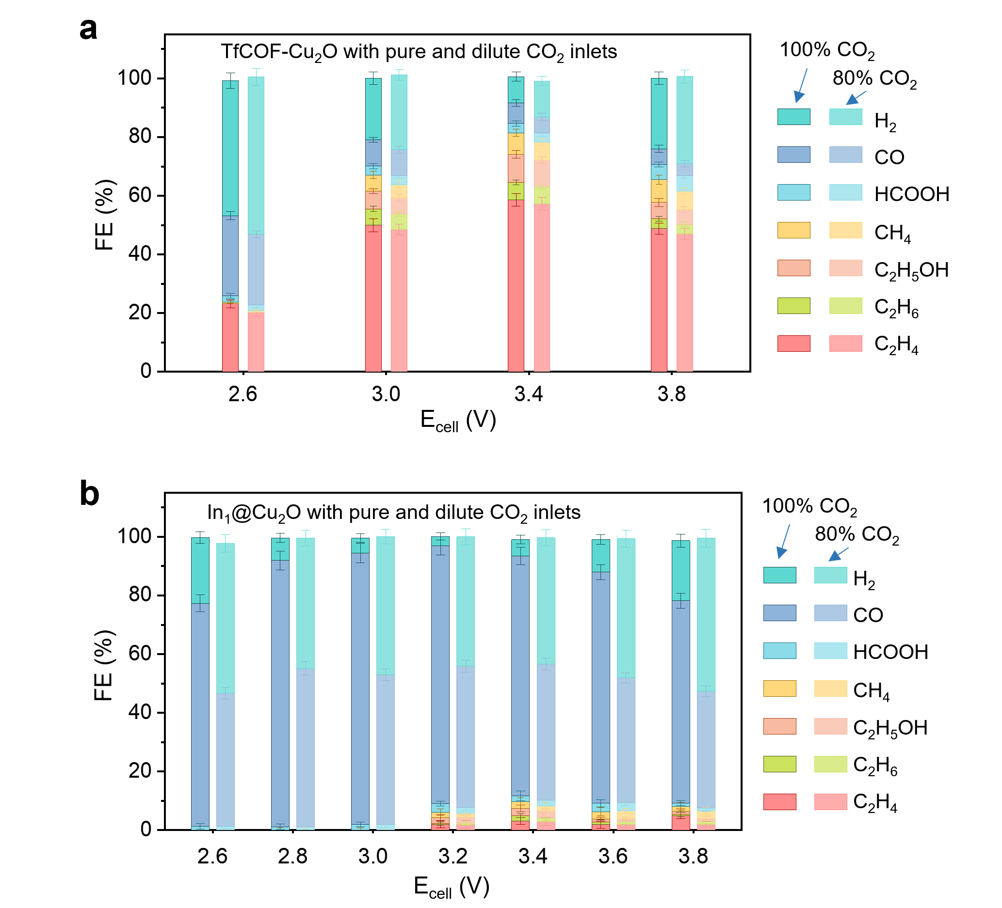

Supplementary Figure 16. FEs of different products for (a) TfCOF-Cu₂O and (b) In₁@Cu₂O control groups with pure and dilute CO₂ inlets. The error bars represent the standard deviation from the measurement of three independent electrodes.

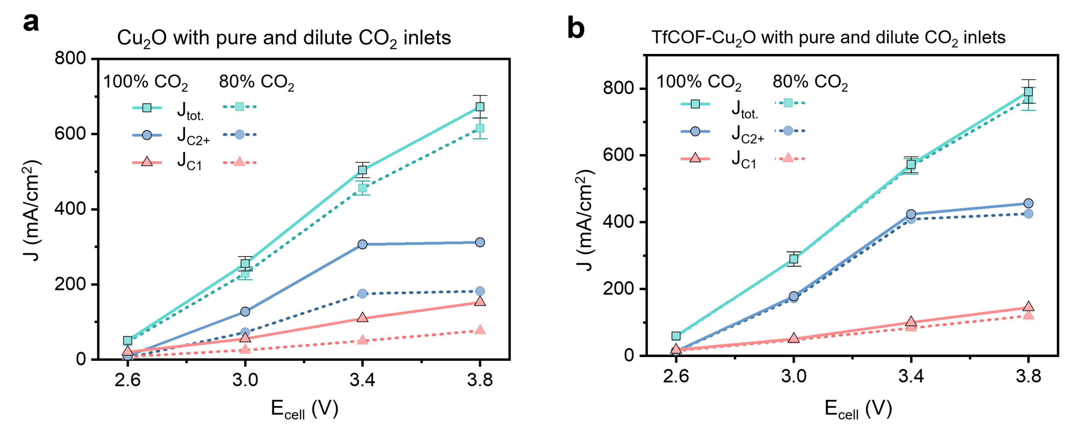

Supplementary Figure 17. Total current density and partial current density for C₂₊ and C₁ products for (a) Cu₂O and (b) TfCOF- Cu₂O control groups.

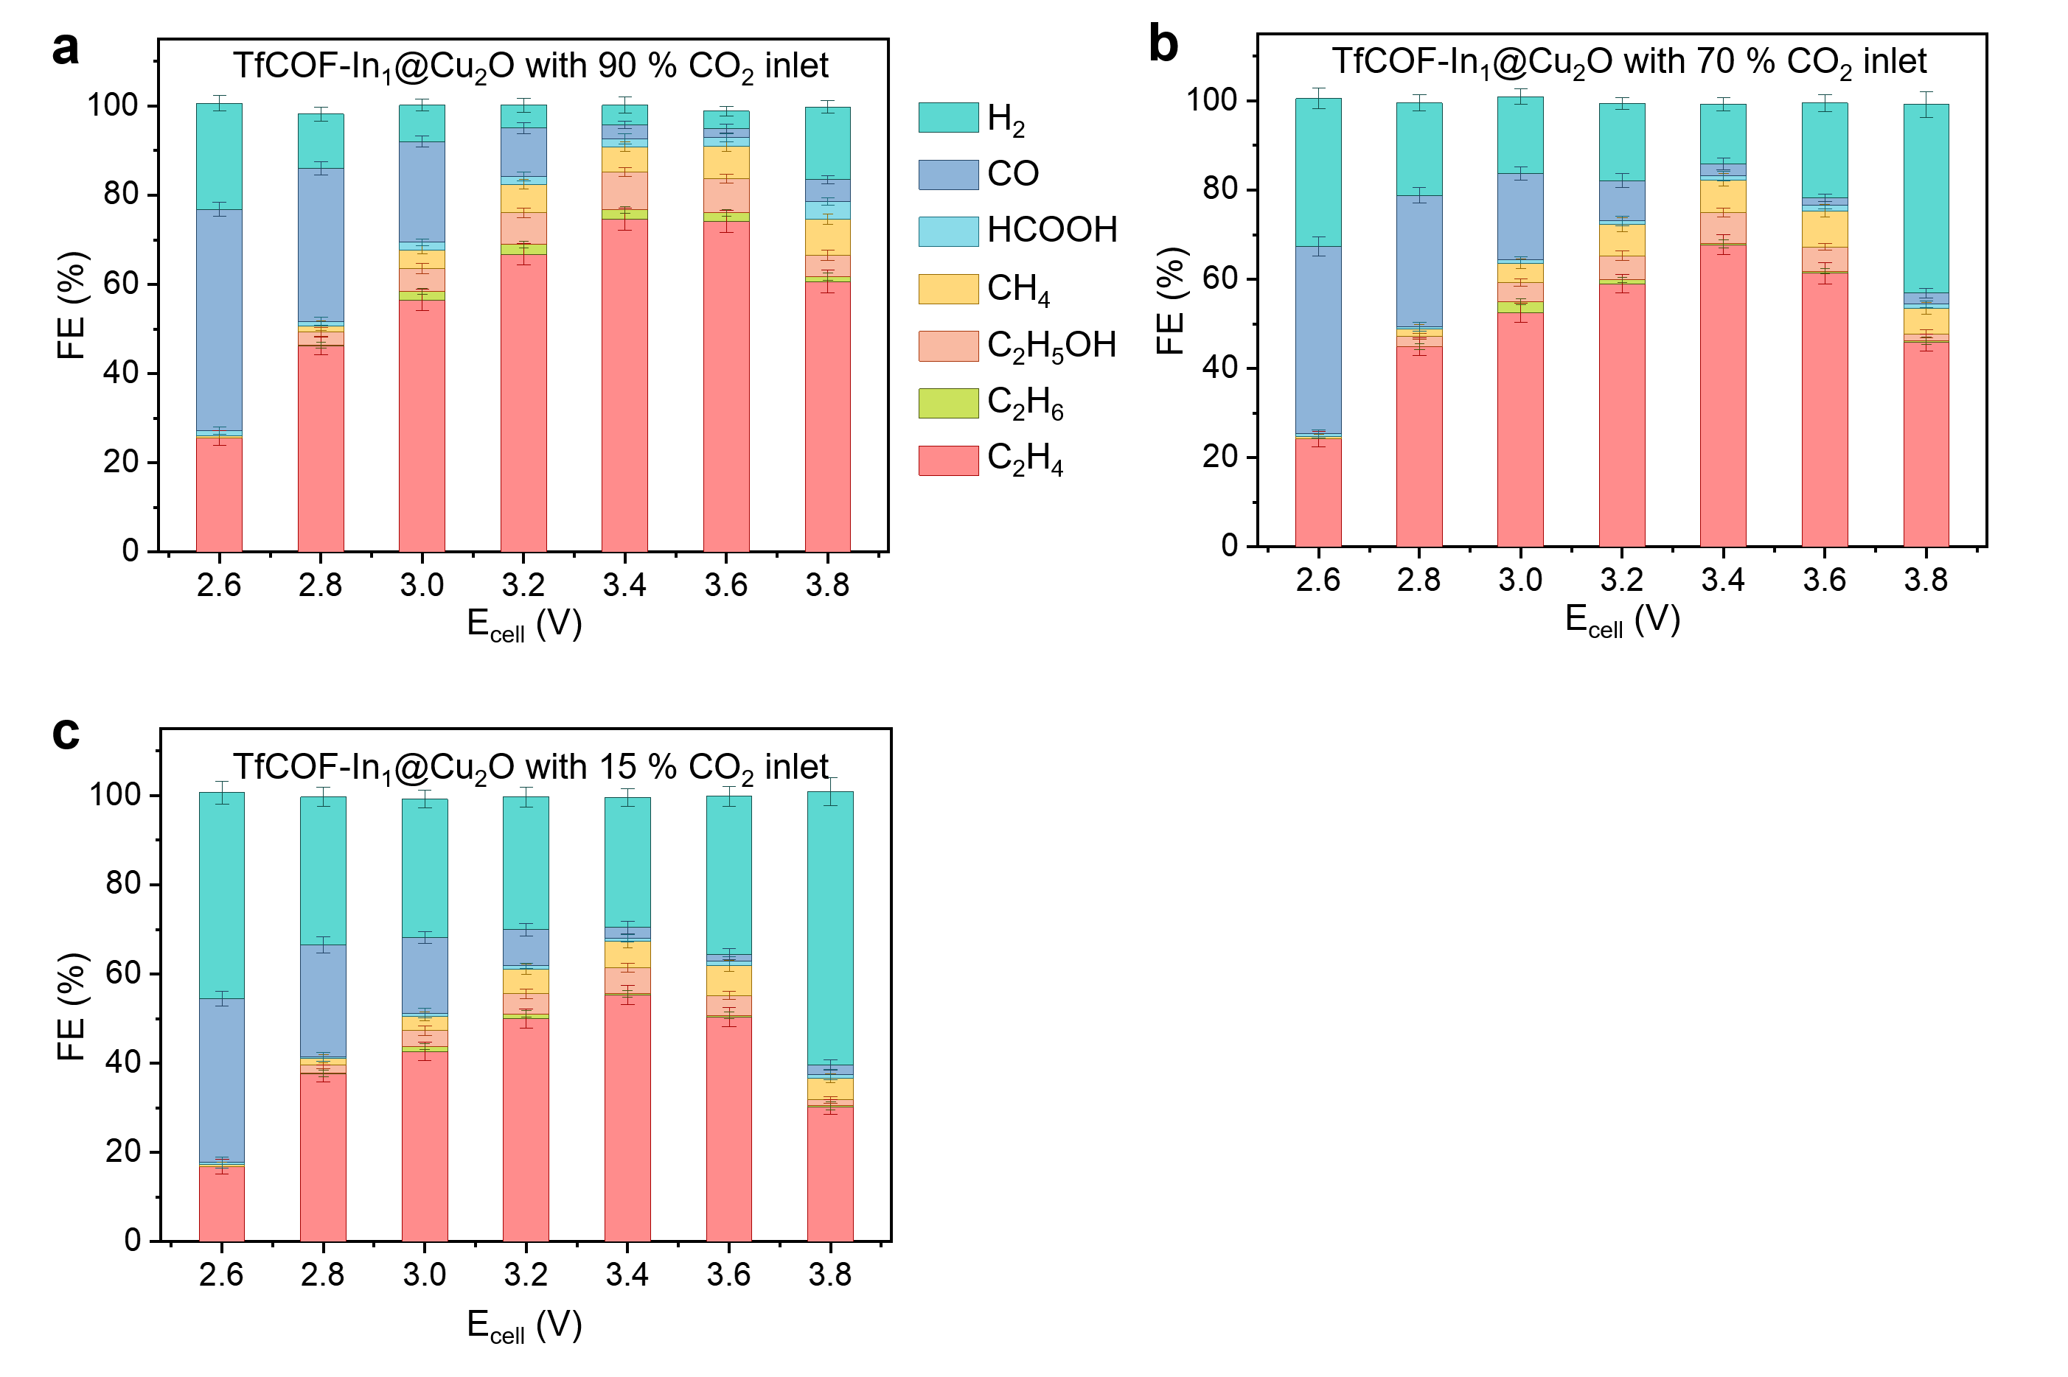

Supplementary Figure 18. FEs of different products for TfCOF-In₁@Cu₂O with dilute (a) 90 %, (b) 70% CO₂ and (c) 15% CO₂ (simulated flue gas) inlets. The error bars represent the standard deviation from the measurement of three independent electrodes.

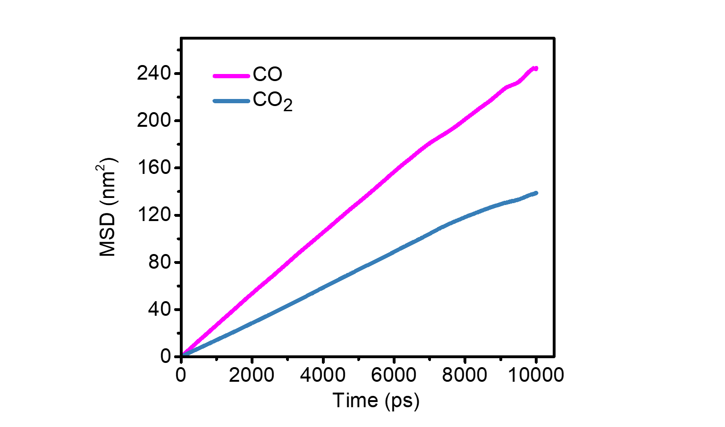

Supplementary Figure 19. Mean square displacement (MSD) of CO and CO₂ over time with the existence of TfCOF, which are simulated by the MD simulations. Then the diffusion coefficients of CO and CO₂ are 4.13 × 10⁻⁹ m²/s and 2.48 × 10⁻⁹ m²/s, which is calculated by the slope of MSD.

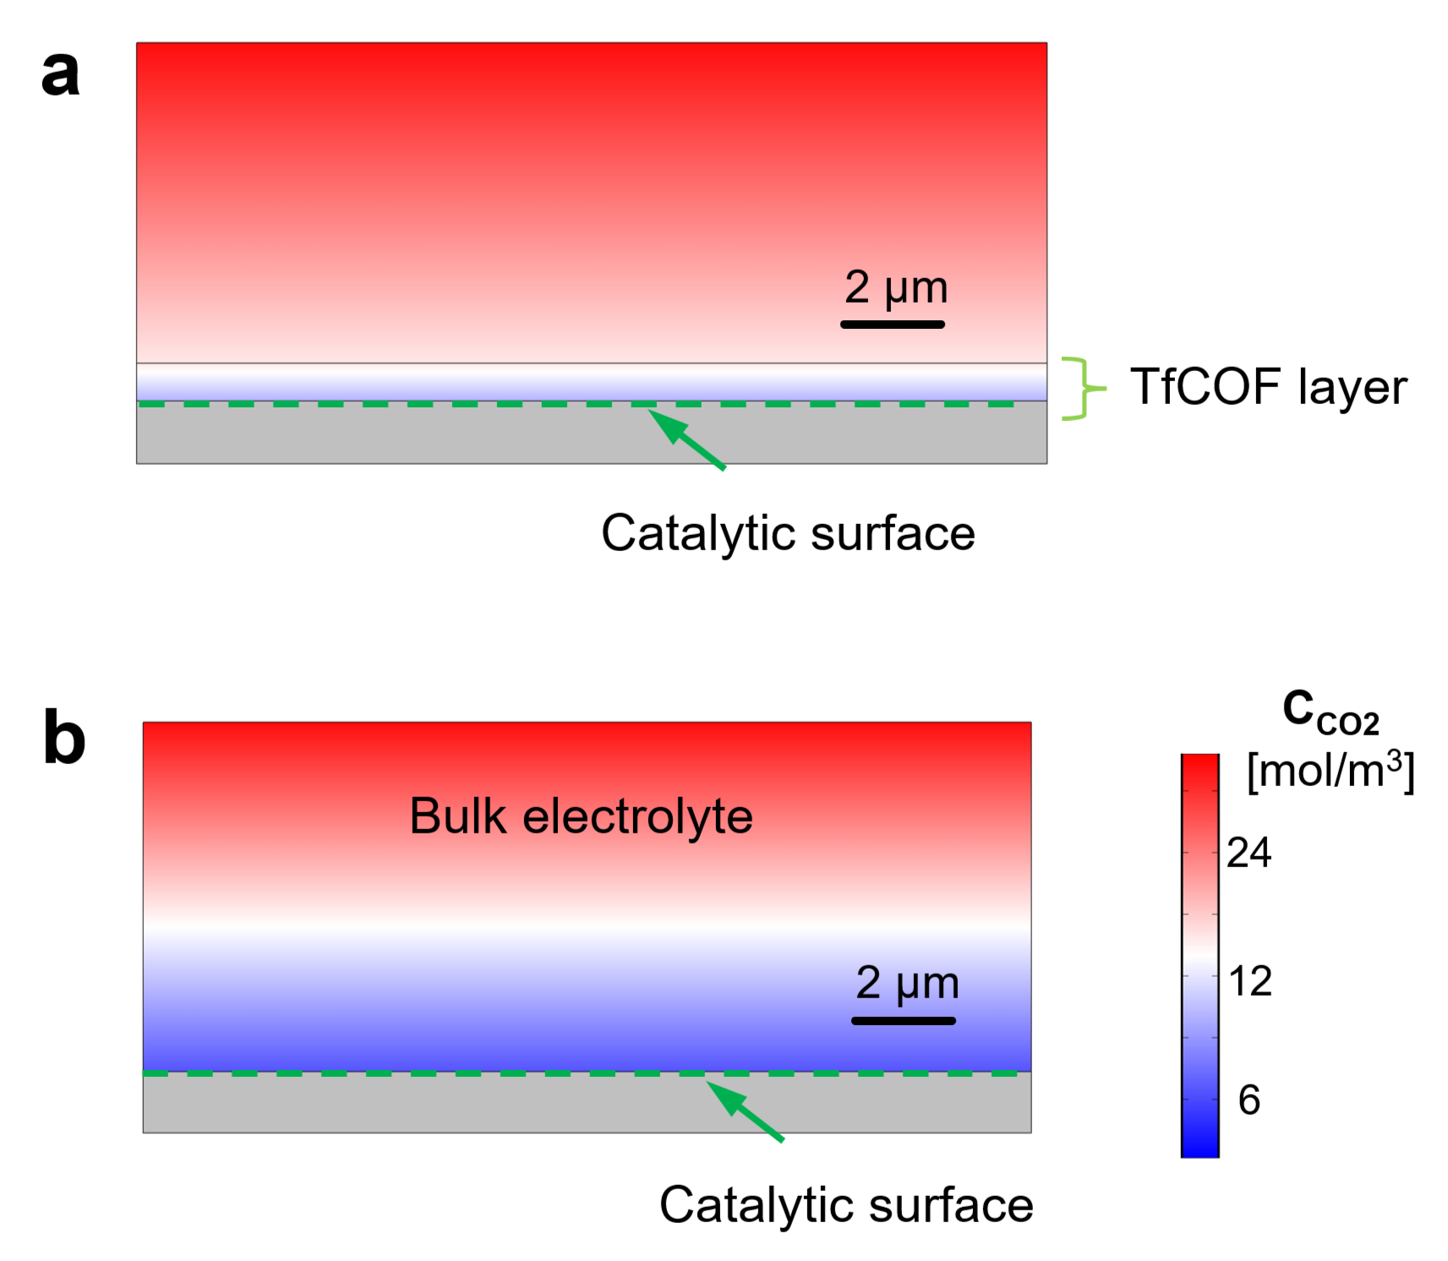

Supplementary Figure 20. Calculated 2D distributions of CO₂ concentration around electrodes (a) with and (b) without TfCOF layer.

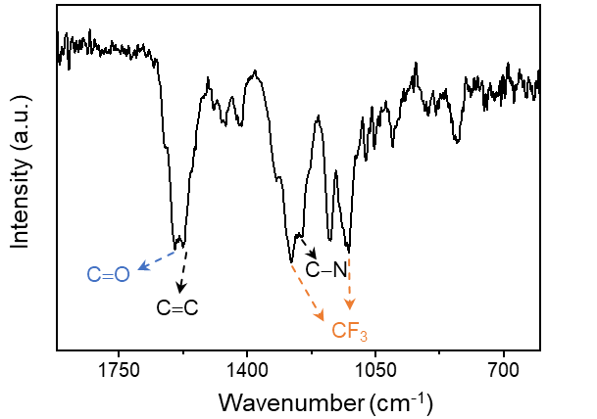

Supplementary Figure 21. FTIR spectra of TfCOF. The typical peaks at 1577 and 1600 cm⁻¹ can be attributed to C=C and C=O stretching, respectively²¹. The bands around 1124 and 1280 cm⁻¹ are assigned to symmetric and asymmetric −CF₃ stretching vibration. The peak of 1248 cm⁻¹ corresponds to the C−N stretching vibration.

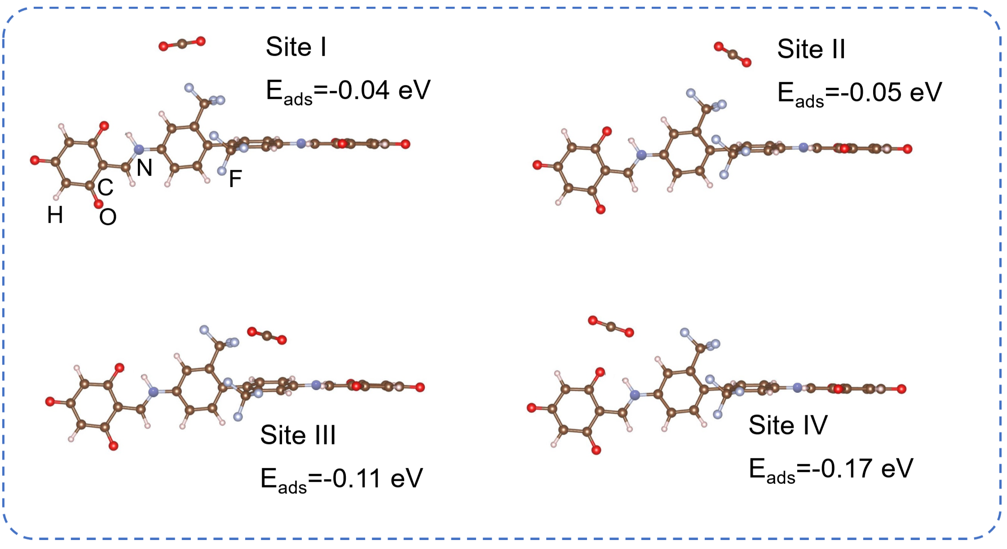

Supplementary Figure 22. Different adsorption energies of CO₂ molecules on TfCOF fragments calculated by the DFT simulations.

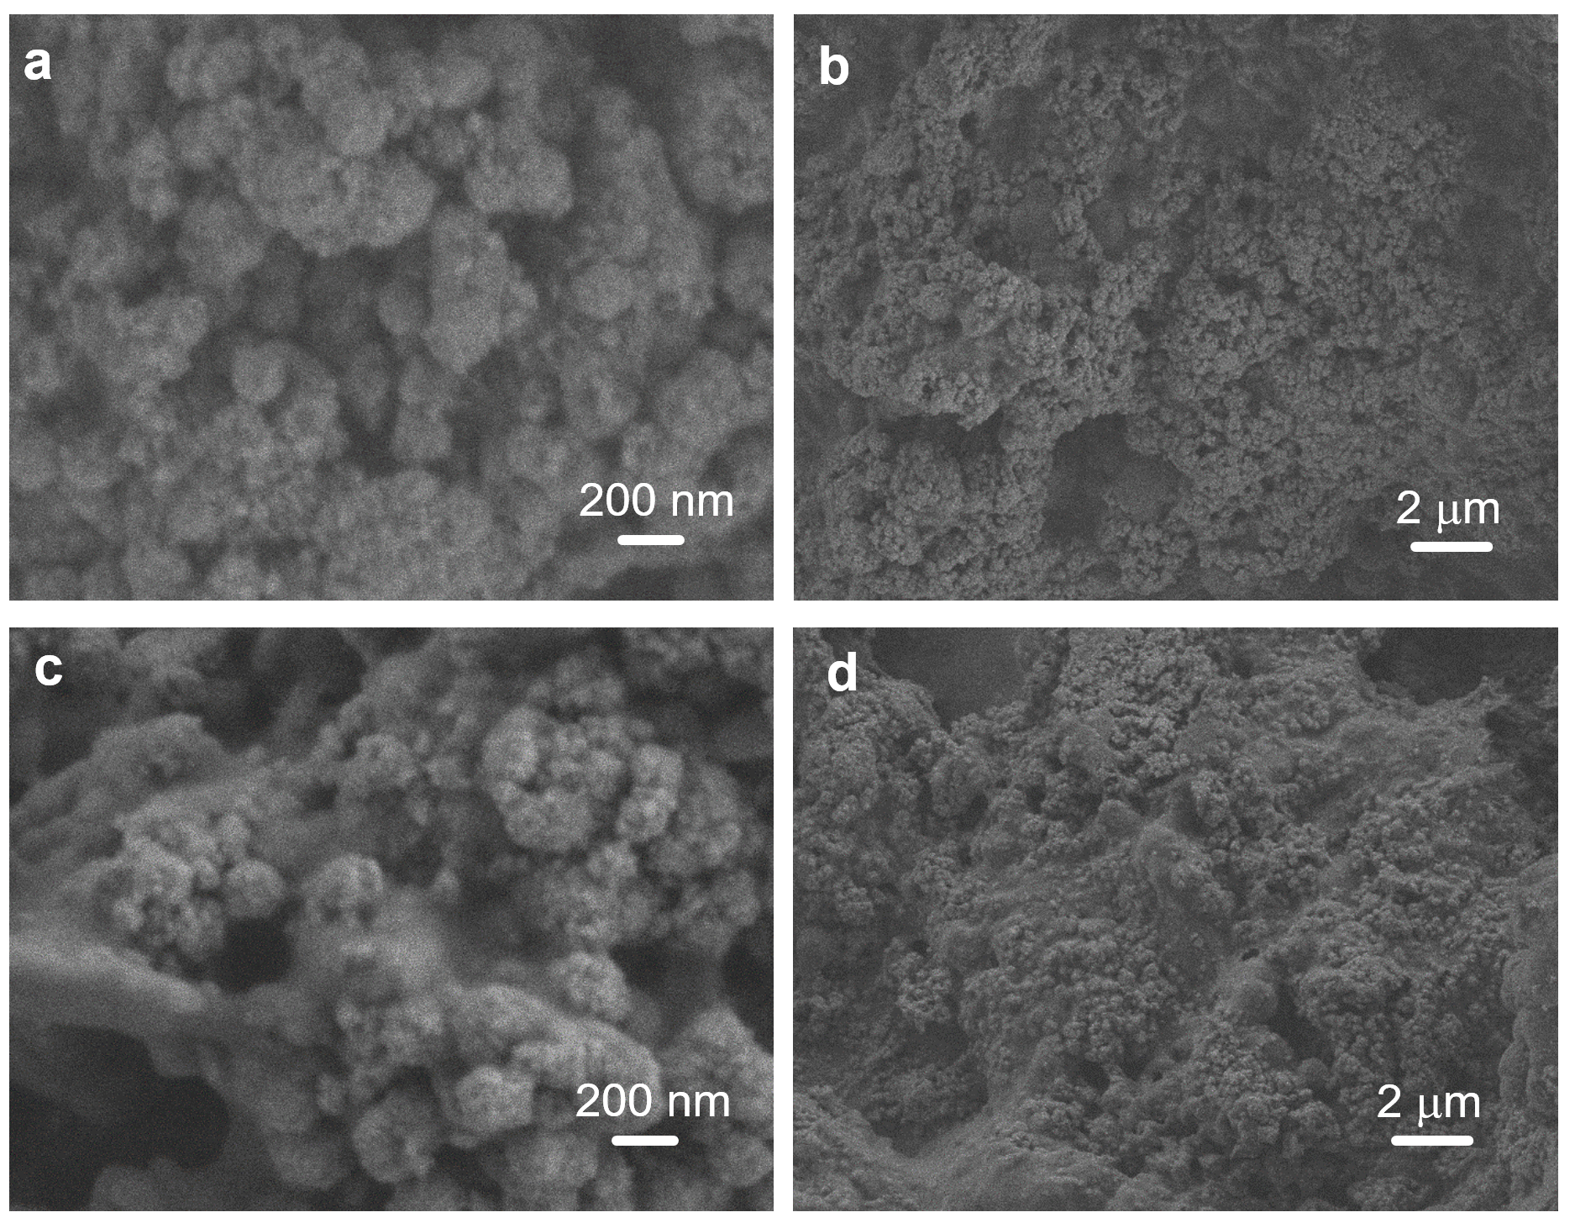

Supplementary Figure 23. SEM images for electrodes with different amounts of TfCOF additives: (a,b) TfCOF(0.1) and (c,d) TfCOF(0.3). The ratios of 0.1 and 0.3 are the weight ratios of the In-Cu gel and TfCOF, and the precise ratios are 0.124 and 0.372, respectively.
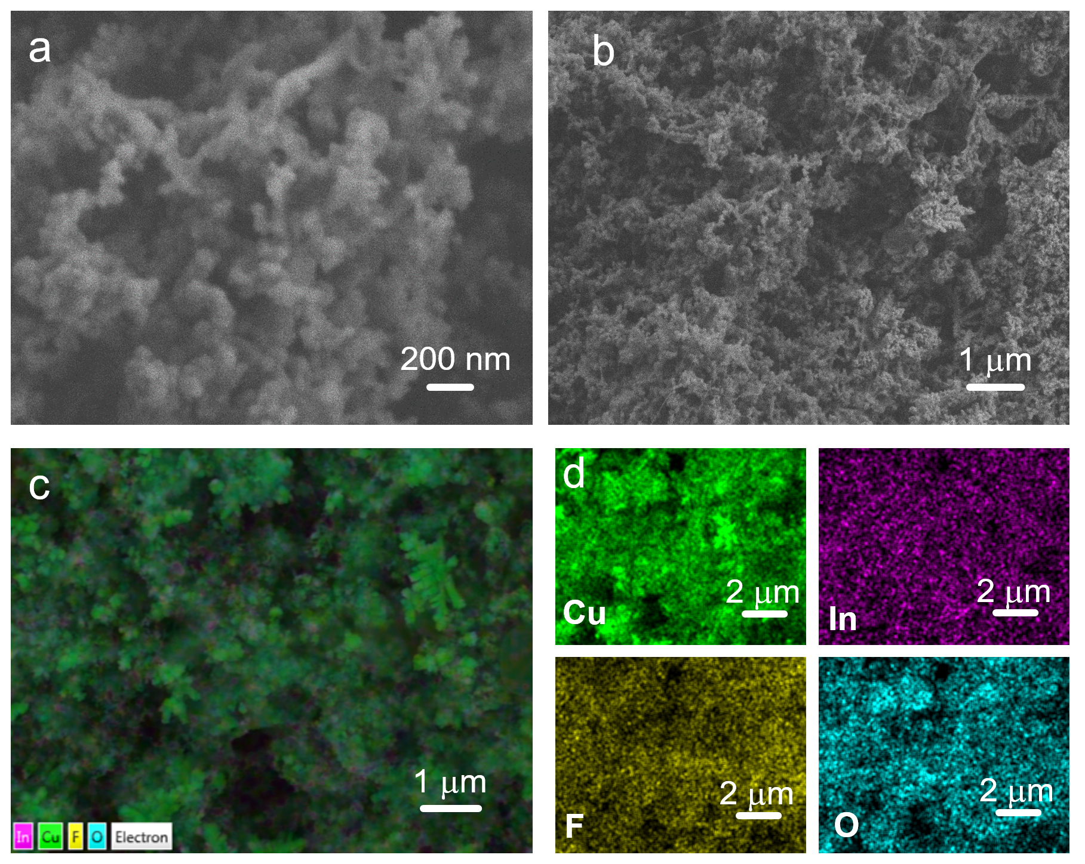

Supplementary Figure 24. (a) SEM images of In-Cu gel mixed with TfCOF at a weight ratio of 1:0.1. (b) is the material drop-casted on carbon paper. (d-e) Corresponding EDS elemental mapping.
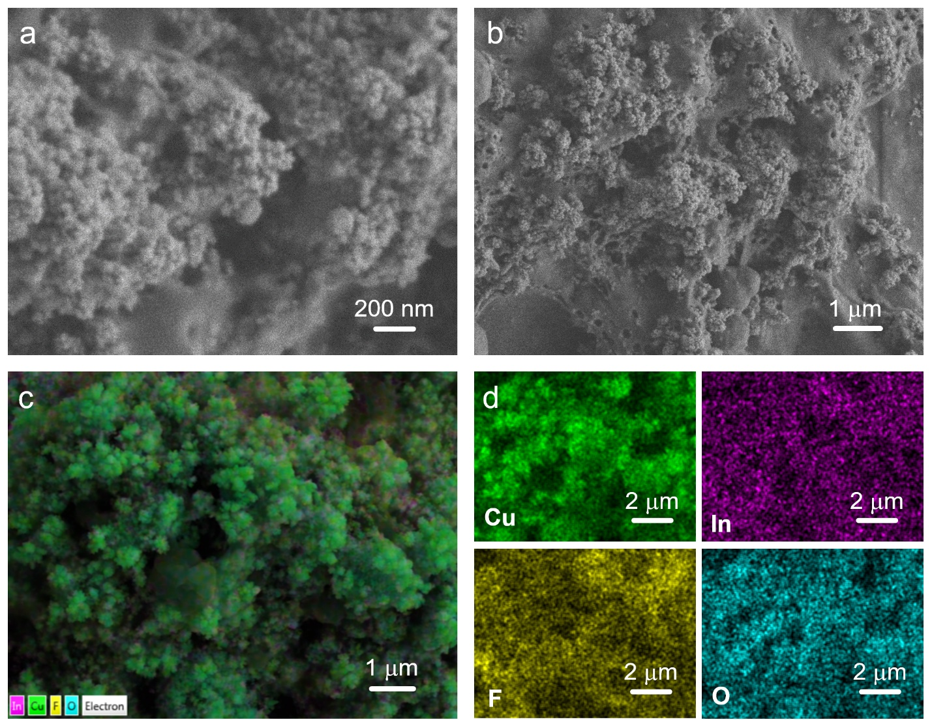

Supplementary Figure 25. (a) SEM images of In-Cu gel mixed with TfCOF at a weight ratio of 1:0.3. (b) is the material drop-casted on carbon paper. (d-e) Corresponding EDS elemental mapping.

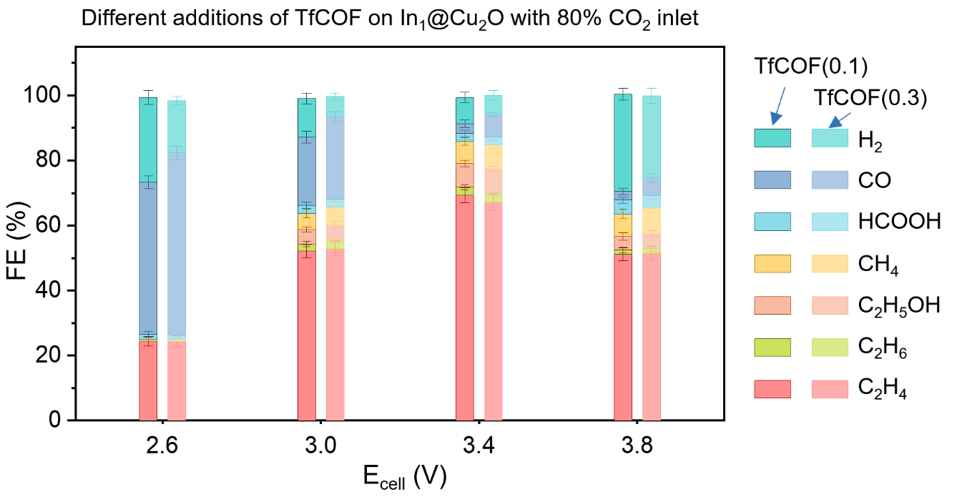

Supplementary Figure 26. FEs of different products for electrodes with different amounts of TfCOF additives: TfCOF(0.1) and TfCOF(0.3). The error bars represent the standard deviation from the measurement of three independent electrodes.

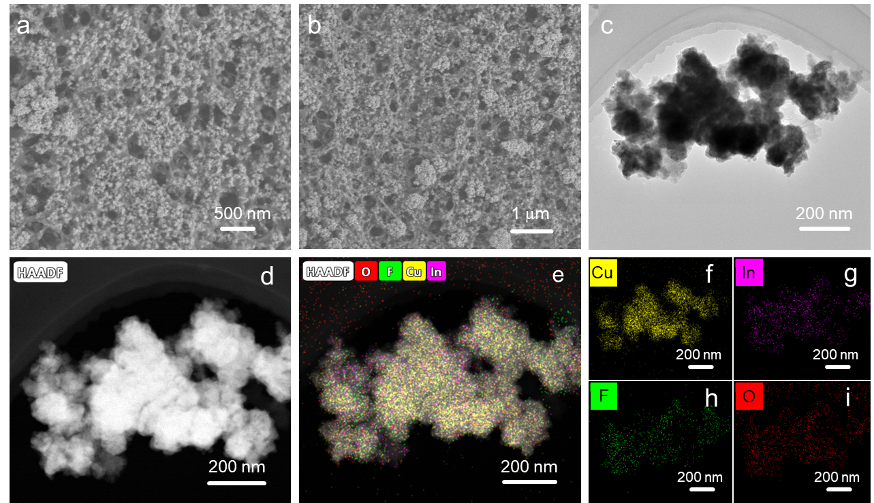Supplementary Figure 27. (a-b) SEM images of TfCOF-In₁@Cu₂O after stability testing. (c) TEM image of TfCOF-In₁@Cu₂O after stability testing. (d-i) HAADF-STEM image and corresponding EDS elemental mapping of TfCOF-In₁@Cu₂O after stability testing.

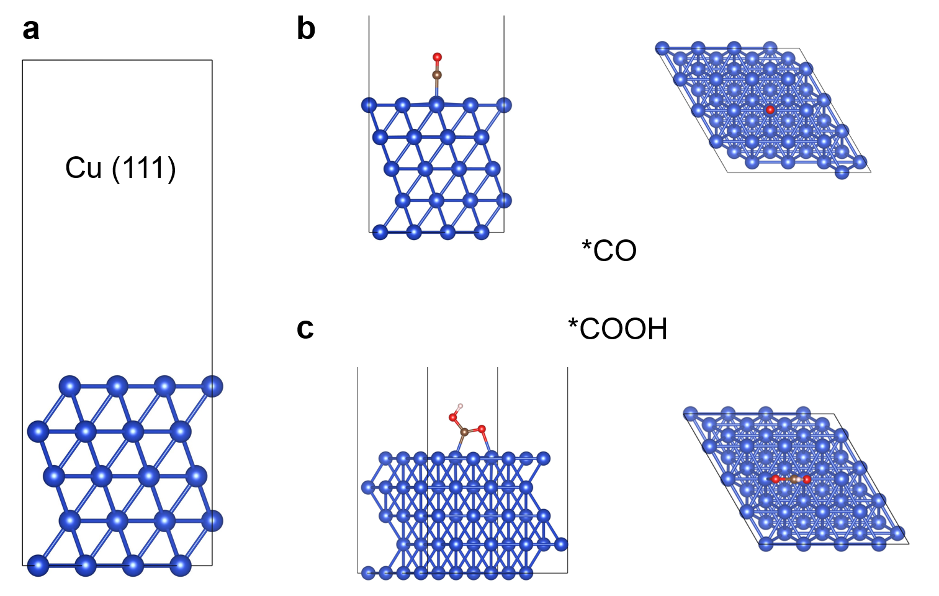

Supplementary Figure 28. (a) Cu (111) surface model used in DFT computations. (b) Optimized configurations of (b) *CO (c) *COOH on Cu (111).
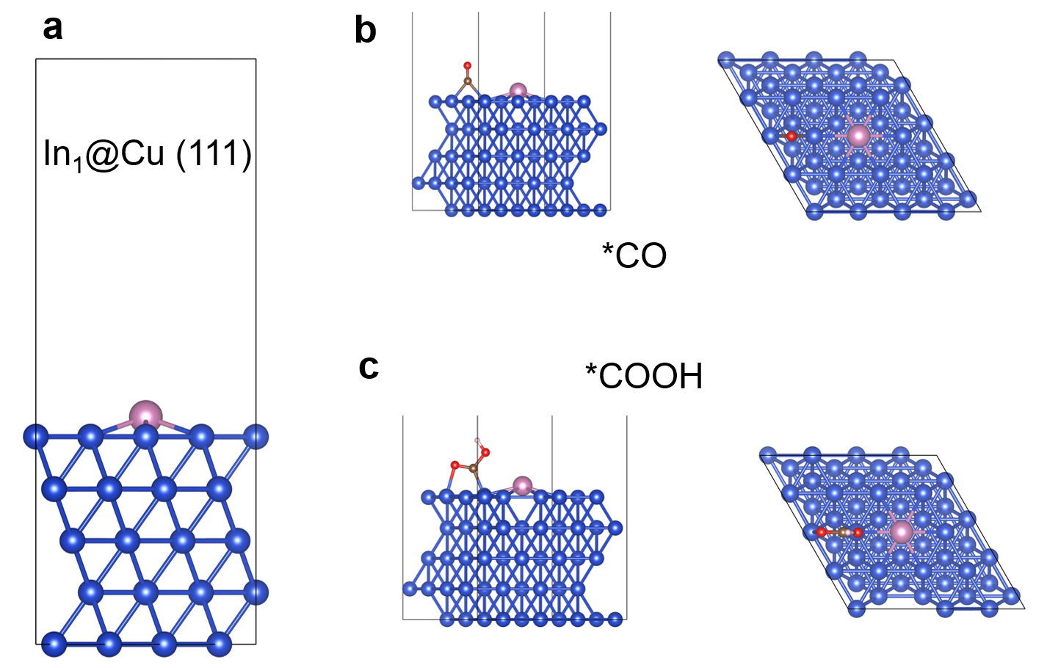

Supplementary Figure 29. (a) In₁@Cu (111) surface model used in DFT computations. (b) Optimized configurations of (b) *CO (c) *COOH on In₁@Cu (111).

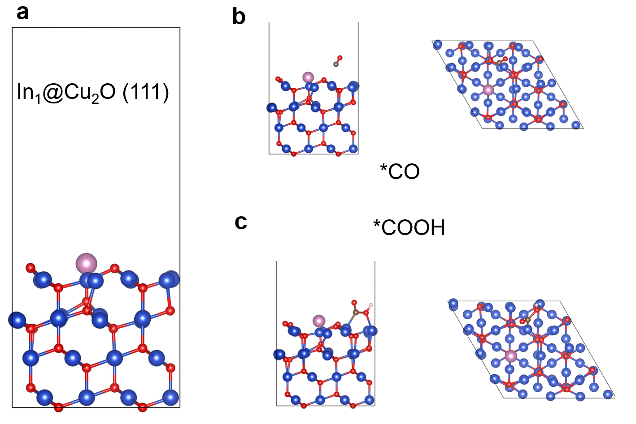

Supplementary Figure 30. (a) In₁@Cu₂O (111) surface model used in DFT computations. (b) Optimized configurations of (b) *CO (c) *COOH on In₁@Cu₂O (111).

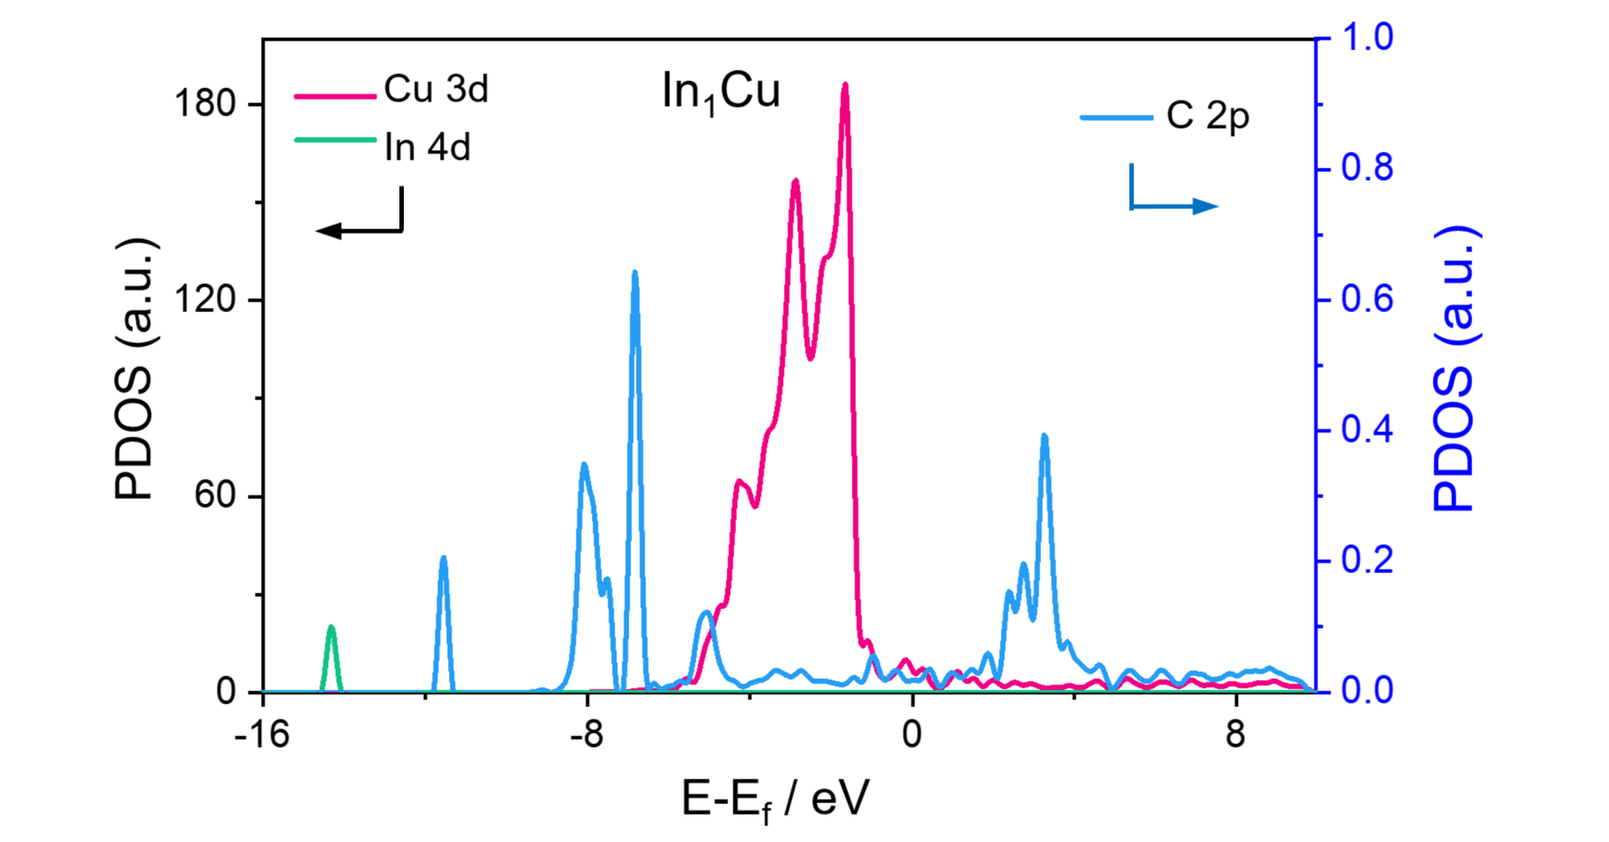

Supplementary Figure 31. Projected density of states (PDOS) of Cu-3d, In-4d, and C-2p orbitals with adsorbed COOH* on In₁Cu surface.
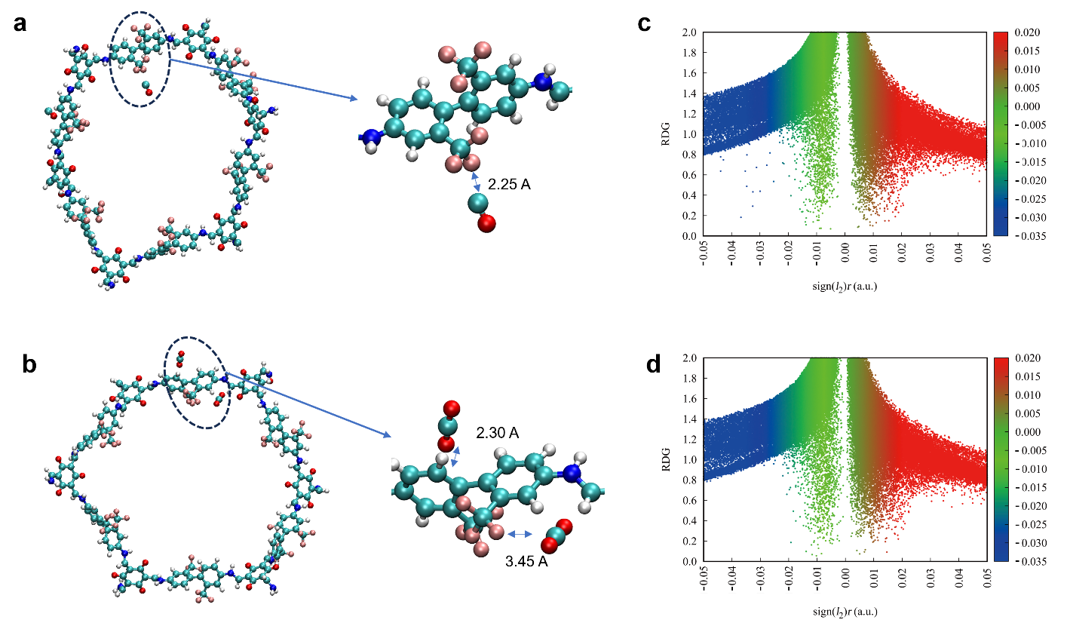

Supplementary Figure 32. Representative snapshots showing close interactions of (a) TfCOF-CO₂ and (b) TfCOF-CO. PF₆-CO₂. Reduced density gradient (RDG) scatter of (c) CO - TfCOF and (b) CO₂ - TfCOF.

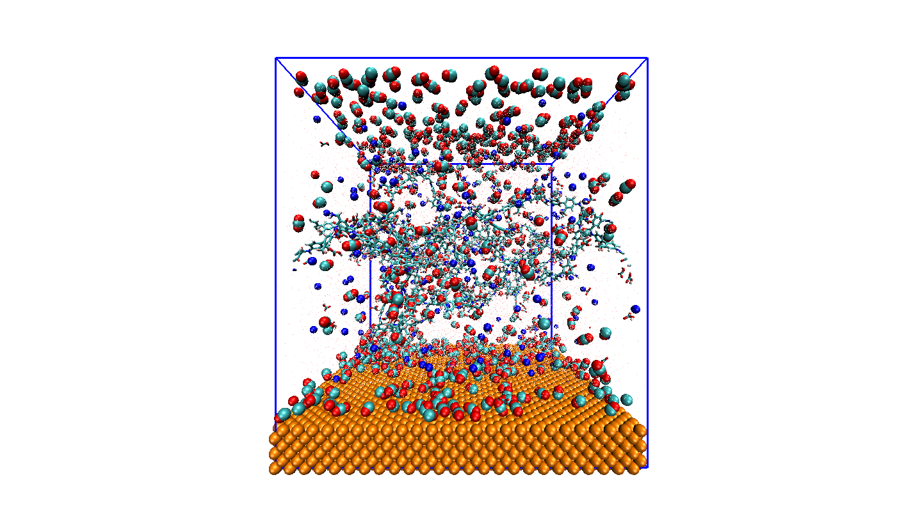

Supplementary Figure 33. CO and CO₂ distributions in the lattice implemented in the MD simulation considering Cu surface (yellow), K⁺ (blue balls), H₂O (red dots), HCO₃⁻ (short-stick structures, red, white, cyan: O, H, C) and TfCOF (long-stick structures, blue, white, and pink sticks: N, H, and F).
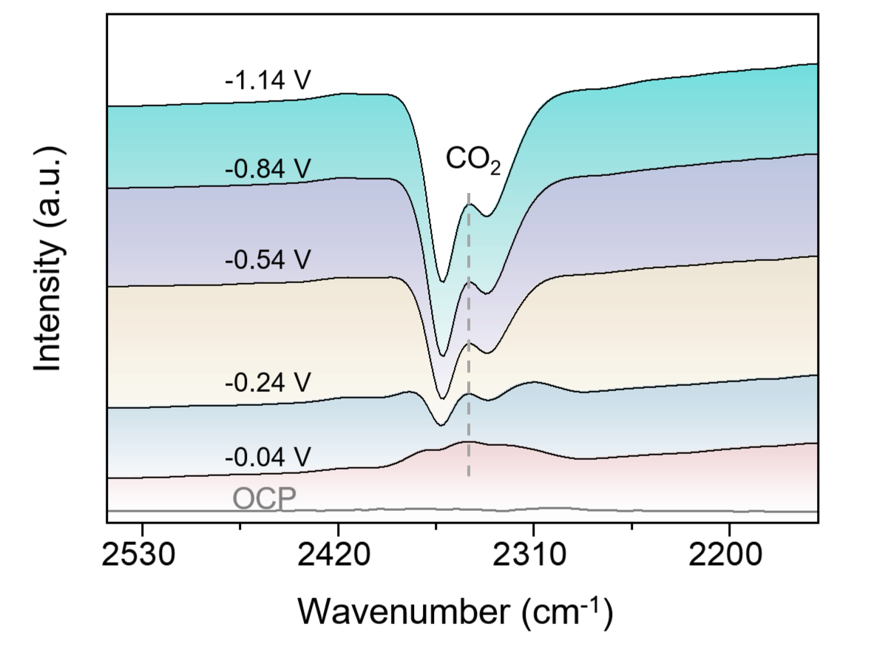

Supplementary Figure 34. In-situ FTIR spectrum of TfCOF-In₁@Cu₂O for CO₂RR in wavenumber region between 2550 and 2150 cm⁻¹.

Supplementary Tables

Supplementary Table 1. CO₂ adsorption configurations on TfCOF.
Adsorption diagram | Adsorption sites and distances (Å)
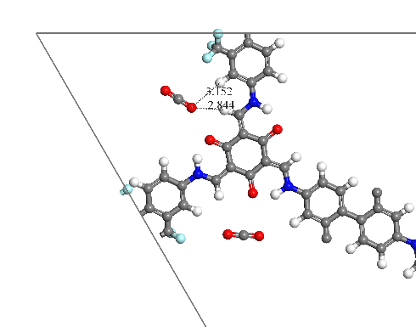 | O (CO₂)...H (HC): 2.844  O (CO₂)...H (HC on benzene): 3.152
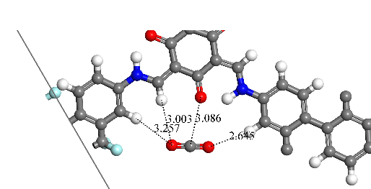 | O (CO₂)...H (HC): 3.003  O (CO₂)...H (HC on benzene): 3.257  C (CO₂)...O (O=C on the hexatomic ring): 3.086  O (CO₂)...H (HC on benzene): 2.645
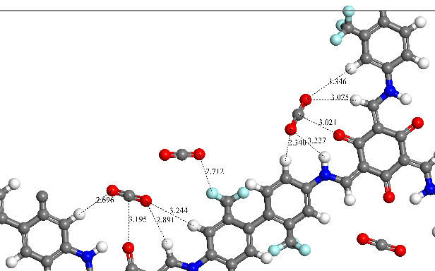 | Left, O (CO₂)...H (HC on benzene): 2.696  C (CO₂)...O (O=C on the hexatomic ring): 3.195  O (CO₂)...H (HC on benzene): 3.244  O (CO₂)...H (HC): 2.891  Middle, O (CO₂)...F (F3C): 2.712  Right, O (CO₂)...H (HC on benzene): 2.340  O (CO₂)...H (HN): 3.227  C (CO₂)...O (O=C on the hexatomic ring): 3.021  O (CO₂)...H (HC): 3.075  O (CO₂)...H (HC on benzene): 3.346
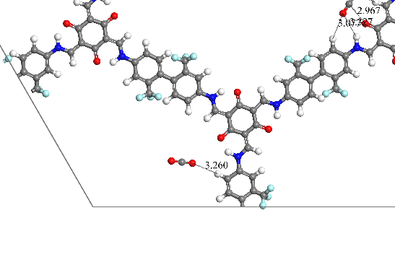 | O (CO₂)...H (HC on benzene): 3.260
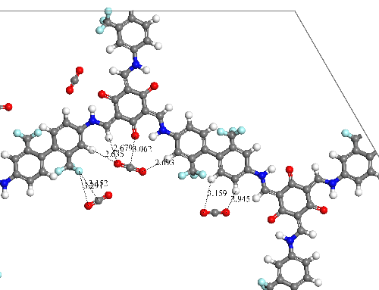 | Left, O (CO₂)...F (F3C): 3.291  C (CO₂)...F (F3C): 3.152  Middle, O (CO₂)...H (HC on benzene): 2.635  O (CO₂)...H (HC): 2.679  C (CO₂)...O (O=C on the hexatomic ring): 3.062  O (CO₂)...H (HC on benzene): 2.693  Right, O (CO₂)...H (HC on benzene): 3.159  O (CO₂)...H (HC on benzene): 2.945
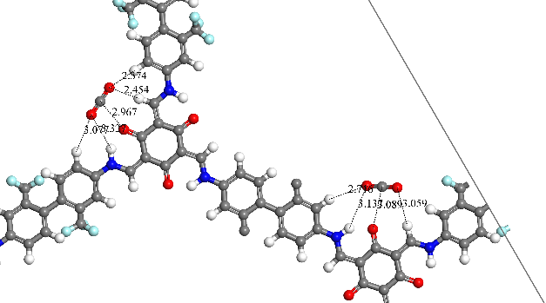 | Left, O (CO₂)...H (HN): 3.327  O (CO₂)...H (HC on benzene): 3.077  C (CO₂)...O (O=C on the hexatomic ring): 2.967  O (CO₂)...H (HC on benzene): 2.374  O (CO₂)...H (HC): 2.454  Right, O (CO₂)...H (HN): 3.137  O (CO₂)...H (HC on benzene): 2.716  C (CO₂)...O (O=C on the hexatomic ring): 3.089  O (CO₂)...H (HC): 3.059

Supplementary Table 2. Performance comparisons of electrocatalysts for CO₂RR to C_{8e-} products.
Cathode Catalyst | Cell type | Electrolyte | Selectivity  FE_{C2+} (%) | Overpotential  (V_{RHE}) | Total Activity  J (mA⋅cm⁻²) | Stability  (h) | Ref.
TfCOF-In₁Cu₂O | Flow cell | 80% CO₂ inlet  0.5 M KHCO₃ | 83.5 | -1.6 ª | -920 | 96 | This work
Carbon/Cu/PTFE | Flow cell | 0.5 M KHCO₃/0.5 M KCl | 70 | -0.89 | -381 | 50 | ²²
Cu/Ni-NAC | Flow cell | 10 M KOH | 66 | -0.5 | -100 | 10 | ²³
CuAl₂O₄/CuO | Flow cell | 1 M KOH | 70 | -1.0 | -200 | 150 | ²⁴
F-Cu | Flow cell | 0.75 M KOH | 80 | -0.89 | -1600 | 40 | ²⁵
CuGa-II | Flow cell | 1.0 M KOH | 81.5 | -1.07 | -900 | 12 | ²⁶
Cu₂O nanoparticle | Flow cell | 0.1 M KHCO₃ | 68.4 | -0.99 | -500 | 10 | ²⁷
PTFE-Cu | Flow cell | 1 M phosphoric  acid | 75 | -1.34 | -200 | 30 | ²⁸
Cu@AIL | Flow cell | 1.0 M KOH | 81.4 | -0.76 | -900 | 15 | ²⁹
B-doped Cu | H-cell | 0.1 M KCl | 79 | -1.1 | -70 | 39 | ³⁰
EP-Cu | H-cell | 0.05 M KHCO₃ | 71 | -1.71 | -30 | 2.5 | ³¹
TWN-Cu_{13.35}-600-SACs | H-cell | 0.5 M  CsHCO₃ | 81.9 | -1.1 | -35.6 | 25 | ³²
BmimNO₃@Cu₃(BTC)₂ | H-cell | 0.1 M KHCO₃ | 77.3 | -1.49 | -34.2 | 3 | ³³
Branched CuO | H-cell | 0.1 M KHCO₃ | 70 | -1.0 | -22 | 12 | ³⁴
CuNW | H-cell | 0.1 M KHCO₃ | 77.4 | -1.0 | -17.3 | 200 | ³⁵
ª Ecell = 3.4 V (without iR correction)

Reference
1 Wen, G. et al. Continuous CO₂ electrolysis using a CO₂ exsolution-induced flow cell. Nat Energy 7, 978-988 (2022).
2 Ren, B. et al. Nano-crumples induced Sn-Bi bimetallic interface pattern with moderate electron bank for highly efficient CO₂ electroreduction. Nat. Commun. 13, 2486 (2022).
3 Shi, Z. et al. Robust Metal-Triazolate Frameworks for CO₂ Capture from Flue Gas. J. Am. Chem. Soc. 142, 2750-2754 (2020).
4 Zhang, Z. et al. Porous metal electrodes enable efficient electrolysis of carbon capture solutions. Energy Environ. Sci. 15, 705-713 (2022).
5 Hafner, J. Ab-initio simulations of materials using VASP: Density-functional theory and beyond. Journal of Computational Chemistry 29, 2044-2078 (2008).
6 Blöchl, P. E. Projector augmented-wave method. Physical Review B 50, 17953-17979 (1994).
7 Perdew, J. P., Burke, K. & Ernzerhof, M. Generalized Gradient Approximation Made Simple. Phys. Rev. Lett. 77, 3865-3868 (1996).
8 Grimme, S. Semiempirical GGA-type density functional constructed with a long-range dispersion correction. Journal of Computational Chemistry 27, 1787-1799 (2006).
9 Ren, B. et al. First-Principles Based Microkinetic Modeling of CO₂ Reduction at the Ni/SDC Cathode of a Solid Oxide Electrolysis Cell. J. Phys. Chem. C 122, 21151-21161 (2018).
10 Han, N. et al. Ultrathin bismuth nanosheets from in situ topotactic transformation for selective electrocatalytic CO₂ reduction to formate. Nat. Commun. 9, 1-8 (2018).
11 Ren, B. et al. A density functional theory study on the carbon chain growth of ethanol formation on Cu-Co (111) and (211) surfaces. Appl. Surf. Sci. 412, 374-384 (2017).
12 Ren, B. et al. New mechanistic insights into CO₂ reduction in solid oxide electrolysis cell through a multi-scale modelling approach. J. Power Sources 490, 229488 (2021).
13 Hess, B. et al. GROMACS 4: Algorithms for Highly Efficient, Load-Balanced, and Scalable Molecular Simulation. J Chem Theory Comput 4, 435-447 (2008).
14 Wang, J. et al. Development and Testing of a General Amber Force Field. J Comput Chem 25, 1157-1174 (2004).
15 Bayly, C. I. et al. A Well-Behaved Electrostatic Potential Based Method Using Charge Restraints for Deriving Atomic Charges: The RESP Model. J Phys Chem 97, 10269-10280 (1993).
16 Berendsen, H. J. C. et al. Molecular dynamics with coupling to an external bath. The Journal of Chemical Physics 81, 3684-3690 (1984).
17 Essmann, U. et al. A smooth particle mesh Ewald method. The Journal of Chemical Physics 103, 8577-8593 (1995).
18 Astrakas, L. G., Gousias, C. & Tzaphlidou, M. Structural destabilization of chignolin under the influence of oscillating electric fields. J. Appl. Phys. 111 (2012).
19 Hess, B. et al. LINCS: A Linear Constraint Solver for Molecular Simulations. J Comput Chem. 18, 1463-1472 (1997).
20 Van Gunsteren, W. F. & Berendsen, H. J. C. A Leap-frog Algorithm for Stochastic Dynamics. Mol. Simul. 1, 173-185 (2007).
21 Yang, L. et al. COF membranes with uniform and exchangeable facilitated transport carriers for efficient carbon capture. Journal of Materials Chemistry A 9, 12636-12643 (2021).
22 Wang, Z. et al. Localized Alkaline Environment via In Situ Electrostatic Confinement for Enhanced CO2-to-Ethylene Conversion in Neutral Medium. J Am Chem Soc 145, 6339-6348 (2023).
23 Yin, Z. et al. Hybrid Catalyst Coupling Single-Atom Ni and Nanoscale Cu for Efficient CO2 Electroreduction to Ethylene. J Am Chem Soc 144, 20931-20938 (2022).
24 Li, H. et al. High‐Rate CO2 Electroreduction to C2+ Products over a Copper‐Copper Iodide Catalyst. Angew. Chem. Int. Ed. 60, 14329-14333 (2021).
25 Ma, W. et al. Electrocatalytic reduction of CO₂ to ethylene and ethanol through hydrogen-assisted C–C coupling over fluorine-modified copper. Nat. Catal. 3, 478-487 (2020).
26 Li, P. et al. p–d Orbital Hybridization Induced by p-Block Metal-Doped Cu Promotes the Formation of C2+ Products in Ampere-Level CO2 Electroreduction. Journal of the American Chemical Society 145, 4675-4682 (2023).
27 Tan, Y. C. et al. Modulating Local CO2 Concentration as a General Strategy for Enhancing C−C Coupling in CO2 Electroreduction. Joule 4, 1104-1120 (2020).
28 Zhao, Y. et al. Conversion of CO2 to multicarbon products in strong acid by controlling the catalyst microenvironment. Nature Synthesis (2023).
29 Tan, Z. et al. Alkaline Ionic Liquid Microphase Promotes Deep Reduction of CO(2) on Copper. J Am Chem Soc 145, 21983-21990 (2023).
30 Zhou, Y. et al. Dopant-induced electron localization drives CO(2) reduction to C(2) hydrocarbons. Nat Chem 10, 974-980 (2018).
31 Bai, H. et al. Controllable CO adsorption determines ethylene and methane productions from CO(2) electroreduction. Sci Bull (Beijing) 66, 62-68 (2021).
32 Xia, W. et al. Adjacent Copper Single Atoms Promote C-C Coupling in Electrochemical CO(2) Reduction for the Efficient Conversion of Ethanol. J. Am. Chem. Soc. 145, 17253-17264 (2023).
33 Sha, Y. et al. Anchoring Ionic Liquid in Copper Electrocatalyst for Improving CO2 Conversion to Ethylene. Angew Chem Int Ed Engl 61, e202200039 (2022).
34 Kim, J. et al. Branched Copper Oxide Nanoparticles Induce Highly Selective Ethylene Production by Electrochemical Carbon Dioxide Reduction. J. Am. Chem. Soc. 141, 6986-6994 (2019).
35 Choi, C. et al. Highly active and stable stepped Cu surface for enhanced electrochemical CO2 reduction to C2H4. Nat. Catal. 3, 804-812 (2020).

