Appendix
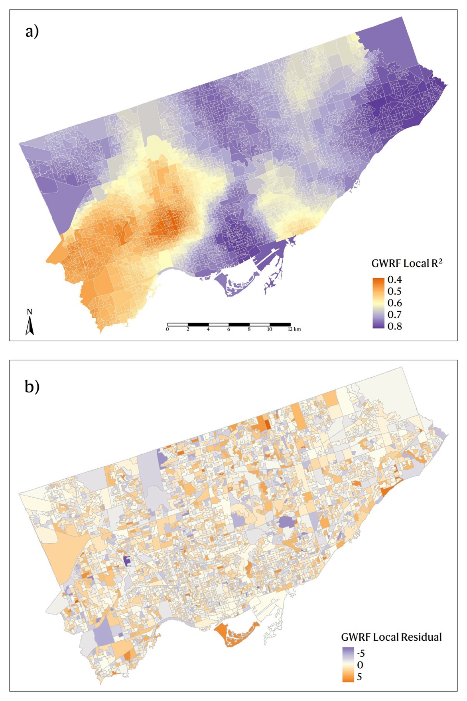
Figure A1. Local a) R² and b) residual for the GWRF model
Table A1. Summary statistics for Permutation Feature Importance in the GWRF model ranked in descending order

Variable | Minimum | Maximum | Mean | Median | Standard Deviation
Regular Health Care Provider | 0.3098 | 19.9401 | 4.8728 | 3.0992 | 4.2182
Age | 0.3094 | 7.7573 | 2.2658 | 2.1236 | 1.3230
Obesity Prevalence | 0.0453 | 8.3091 | 1.8776 | 0.9395 | 2.0244
Smoking Rate | 0.1509 | 5.0895 | 1.4223 | 1.0395 | 1.0038
Drinking Rate | 0.0379 | 6.1354 | 0.9436 | 0.6076 | 0.9423
Life Dissatisfaction | 0.0649 | 3.6580 | 0.9085 | 0.5524 | 0.8317
Poor Mental Health | 0.0054 | 3.9546 | 0.7829 | 0.5775 | 0.6297
Anxiety Disorder Rate | 0.0296 | 2.6372 | 0.7208 | 0.6018 | 0.4523
Median Income | 0.0340 | 4.3817 | 0.6423 | 0.4181 | 0.6579
Non- Citizens | 0.0036 | 4.4265 | 0.5899 | 0.3083 | 0.6649
Beauty and Safety Perception | -0.0386 | 4.3262 | 0.5690 | 0.3657 | 0.6416
Weekly Physical Activity Minute | -0.0848 | 3.9135 | 0.4985 | 0.2745 | 0.6101
Married or Common Law | 0.0326 | 2.0867 | 0.4917 | 0.3933 | 0.3106
NDVI | -0.0237 | 2.1420 | 0.3897 | 0.2691 | 0.3401
Immigrant Population | -0.0114 | 3.4557 | 0.3729 | 0.1556 | 0.5192
Commute Duration | 0.0007 | 1.8438 | 0.3423 | 0.2811 | 0.2357
Fence Density | -0.0269 | 1.8457 | 0.1868 | 0.1165 | 0.2219
Commute by Transit | -0.0868 | 0.8894 | 0.1469 | 0.1086 | 0.1276
Pole Density | -0.0974 | 0.9634 | 0.1159 | 0.0796 | 0.1326
Without Certificate or Diploma | -0.0788 | 0.7283 | 0.1146 | 0.0807 | 0.1176
Road Density | -0.0913 | 0.7261 | 0.1132 | 0.0722 | 0.1183
Traffic Light Density | -0.0689 | 0.6142 | 0.0990 | 0.0787 | 0.0930
Wall Density | -0.0379 | 0.5167 | 0.0695 | 0.0563 | 0.0628
Unemployment Rate | -0.0432 | 0.3101 | 0.0668 | 0.0607 | 0.0439
Cycling Network Density | -0.0711 | 0.3769 | 0.0616 | 0.0452 | 0.0612
Water Body Density | -0.1704 | 0.3320 | 0.0491 | 0.0264 | 0.0617
Commute by Walk or Cycle | -0.0426 | 0.2614 | 0.0266 | 0.0192 | 0.0335

Table A2. 10-fold spatial cross-validation result for GWRF

Fold | R² | RMSE | MAE
1 | 0.6785 | 2.3279 | 1.8078
2 | 0.7214 | 2.1673 | 1.6677
3 | 0.6516 | 2.2992 | 1.8188
4 | 0.7079 | 2.2521 | 1.7171
5 | 0.7128 | 2.1247 | 1.6644
6 | 0.7776 | 2.1805 | 1.7161
7 | 0.8183 | 2.2417 | 1.7575
8 | 0.7898 | 2.2276 | 1.7424
9 | 0.6786 | 2.2236 | 1.6794
10 | 0.6875 | 2.7253 | 2.0671

