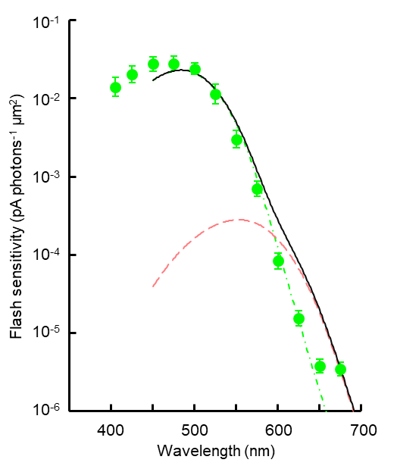
Supplementary Information

Supplemental Figure S1 Spectral sensitivity plots of green-sensitive cones fitted with red and green mixed spectral template. Green (λ_{max} 484 nm) and red (553 nm) spectral templates were mixed with scaling factors of 2.29 × 10⁻² and 2.80 × 10⁻⁴, respectively. However, the curve did not fit well to the plots.

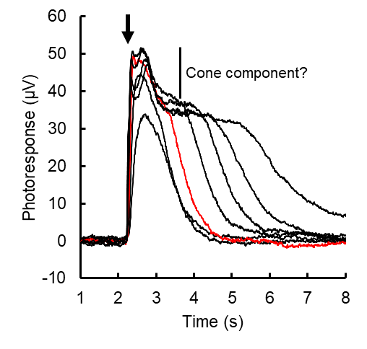
Supplemental Figure S2 Waveform of rod-cone mixed responses after subtracting isolated cone component (Fig. 6c). Flash intensity: 32 to 32000 photons µm⁻², Red: 320 photons µm⁻². Timing of the test flash is shown by an arrow. Cone response-like bumps are still observed on the rod response plateau indicating incomplete rod-cone response separation.

