Appendix 1: Supplemental Methods
Deer Field Methods
Deer were captured between January – March from 2019 to 2023 beginning after the end of deer hunting season and continuing until green up in each location. Deer were captured using Clover traps, darting, and drop nets (Vercauteren et al. 1999). Captured deer were immobilized with an intramuscular injection of Buturphanol-azaperone medetomidine (BAM) (ZooPharm, Butler et al. 2017). Dosages of BAM were determined based on the capture method, sex, and size of deer (McDermott et al. 2020). For deer capture using clover traps or drop nets, dosages ranged from 0.5 for fawns to 3.0 cc for large males. Darting was primarily used to target adult males, so all darts were filled with 2.0 – 3.0 cc of BAM (McDermott et al. 2020). Clover traps were placed in areas deer are likely to use frequently, baited with corn, and checked once to twice per day for deer. For males and large adult females, traps were always collapsed, and deer were injected with BAM. Yearlings and smaller deer were processed by manual restraint if deemed safe. Deer were darted from blinds placed roughly 30 meters from a corn pile. Upon darting a deer, darters waited roughly 5 minutes to allow the deer to run away safely and drugs to take effect without further chase. Deer were located using VHF equipment as quickly as possible and additional BAM administered if needed. Drop nets were placed in open areas where groups of deer congregate and baited with multiple corn piles. A crew of up to four people waited in a blind or vehicle for deer to move under the center of the net and waited to drop the net until all deer had their head down. Deer were first manually restrained and then chemically immobilized in order of placement from closest to the edge to nearest to the center of the net. Fix interval for collars varied between years resulting in deer trajectories sampled at different frequencies that ranged from two hours to thirty minutes.
Predator Field Methods
Bobcats and coyotes in both study sites were captured using cage traps (Tomahawk Live Trap, Hazelhurst, Wisconsin, Model 209.5, and homemade cage traps with similar dimensions, Beltrán and Tewes 1995) and rubber-padded foothold traps (Minnesota Trapline Products, Pennock, Minnesota, MB-650-RJ, Skinner and Todd 1990) during four winter capture seasons from January through March 2018 and 2019, and from mid-November through March 2019-2020 and 2020-2021. Bobcats were chemically immobilized with ketamine hydrochloride and xylazine hydrochloride and recovered inside a cage trap before release (ZooPharm, Beltrán and Tewes 1995). Coyotes were chemically immobilized with BAM and were reversed post-handling with naltrexone hydrochloride and atipamezole hydrochloride before release.
Captured coyotes and bobcats were fitted with LiteTrack Iridium 250 GPS collars (Lotek Wireless, Newmarket, Ontario, Canada) equipped with a release mechanism to drop off. Most collars recorded GPS locations once every 1.5 hours, but 14 collars had a different schedule (1, 2, 3, or 4 hours). Each animal was also weighed, measured, sexed, aged (juvenile or adult), scored for body condition, fitted with an ear tag, and had a biopsy sample taken from the ear. Fifteen bobcat-years (female n=7, male n=8) and 31 coyote-years (female n=12, male n=19) of location data were collected from 13 individual bobcats and 31 individual coyotes over the four trapping seasons. An average of 1,397 GPS locations were obtained from each bobcat (range 293-2,695) and an average of 1,736 locations were obtained from each coyote (range 213-3,596).
Predator RSFs
To determine individual-level habitat selection, we used a logistic regression to estimate
resource selection functions (RSFs) for each individual within the annual home ranges (Manly et
al. 2002, Bastille-Rousseau and Wittemyer 2019). To estimate the annual home ranges of bobcats and coyotes, we used autocorrelated kernel density estimation (AKDE), as developed by Fleming et al. (2015). We used the package ‘ctmm’ in Program R (Calabrese et al. 2016) to estimate home ranges. Home range sizes were calculated using the Ornstein-Uhlenbeck with foraging (OUF) model using a 0.95 quantile. Twelve thousand random locations were generated within
each of these home ranges. Each random location was also assigned a random date and time
(Bastille-Rousseau et al. 2015). Bobcat and coyote RSFs were estimated using the package ‘IndRSA’ in Program R (Bastille-Rousseau and Wittemyer 2019). ‘IndRSA’ estimates an individual-level RSF for each individual and a population average in a second step (Murtaugh 2007). K-fold cross-validations were performed for each output. We used yearly predator RSFs, because predictions from seasonal RSFs did not greatly differ (Gorman et al. 2024). Land cover categories, human modification, distance to water, and distance to road covariates were extracted for each used and random point. Land cover categories included the dummy variables of forested (reference category), agricultural, exurban and other. The continuous variables of human modification, distance to water, and distance to road covariates were scaled so they could be compared to ease interpretation (Schielzeth 2010).

References
Beltrán, J.F., & Tewes, M.E. (1995). Immobilization of ocelots and bobcats with ketamine hydrochloride and xylazine hydrochloride. Journal of Wildlife Diseases, 31(1), 43–48. https://doi.org/10.7589/0090-3558-31.1.43
Butler, Z., Gamba, D., Morris, S., Zahratka, J., & Lehmer, E.M. (2017). Novel use of a rapidly reversible field anesthetic in small game mammals using yellow-bellied marmots (Marmota flaviventris) as a model organism. BIOS, 88(4), 135–143. https://doi.org/10.1893/BIOS-D-16-00004.1
Gorman, N. T., Eichholz, M. W., Skinner, D. J., Schlichting, P. E., & Bastille-Rousseau, G. (2024). Carnivore space use behaviors reveal variation in responses to human land modification. Movement Ecology, 12(1), 51.
McDermott, J.R., Leuenberger, W., Haymes, C.A., Clevinger, G.B., Trudeau, J.K., Carter, T.C., Hast, J.T., Jenkins, G.S. W., Bowling, W.E., & Cox, J.J. (2020). Safe Use of Butorphanol–Azaperone–Medetomidine to Immobilize Free‐Ranging White‐tailed Deer. Wildlife Society Bulletin, 44(2), 281–291. https://doi.org/10.1002/wsb.1096
Rockhill, A.P., Chinnadurai, S.K., Powell, R.A., & DePerno, C. S. (2011). A Comparison of Two Field Chemical Immobilization Techniques for Bobcats (Lynx rufus). Journal of Zoo and Wildlife Medicine, 42(4), 580–585. https://doi.org/10.1638/2010-0152.1
VerCauteren, K.C., Beringer, J., & Hygnstrom, S.E. (1999). Use of Netted Cage Traps for Capturing White-Tailed Deer.

Appendix 2: Supplemental Tables
AICc Model Ranking from step selection function (SSF) and hidden Markov models (HMM).

Model | AICc
coyote+roaddist+int | 101645.2
bobcat+roaddist+int | 101951.7
coyote+hummod | 102111.3
coyote+hummod+int | 102115.7
coyote+hunt+int | 102402.4
bobcat+roaddist | 102417
hummod | 102417
coyote+roaddist | 102418.7
bobcat+hummod | 102426.9
bobcat+hummod+int | 102449.4
coyote+hunt | 102477.3
coyote | 102486
coyote+bobcat+int | 102491.2
coyote+bobcat | 102516.1
roaddist | 102524.2
bobcat+hunt+int | 102743.2
bobcat+hunt | 102763.9
bobcat | 102773.4
hunt | 102865.6
null | 102869.6

Table 1: AICc scores for SSFs for bucks during the hunting period in the encamped state.

Model | AICc
coyote+hummod | 152775.4
coyote+hummod+int | 152870.1
bobcat+hummod | 152905.8
hummod | 152911.3
bobcat+hummod+int | 153009.9
coyote+roaddist+int | 153182.7
bobcat+roaddist+int | 153311.2
coyote+bobcat+int | 153495.6
bobcat+roaddist | 153679.6
coyote+roaddist | 153703.6
roaddist | 153878.9
coyote+hunt | 154129.3
coyote+hunt+int | 154152.2
coyote+bobcat | 154213.4
bobcat+hunt | 154229.2
coyote | 154232.1
bobcat+hunt+int | 154255.5
hunt | 154287.9
bobcat | 154320
null | 154373.8

Table 2: AICc scores for SSFs during the hunting period in the active state.

Model | AICc
coyote+hummod | 227906.8
coyote+hummod+int | 227963.9
hummod | 228191.1
bobcat+hummod+int | 228284.1
roaddist | 228467.9
coyote+roaddist | 228492.7
bobcat+roaddist | 228493.3
coyote+bobcat+int | 229063.5
coyote+hunt+int | 229128
bobcat+hunt | 229179
bobcat+hunt+int | 229191
coyote+bobcat | 229327.3
coyote | 229367.4
bobcat | 229427.6
null | 229701.8
coyote+hunt | 229828.9
hunt | 229955.9
bobcat+hummod | 230083
coyote+roaddist+int | 230210.1
bobcat+roaddist+int | 230337.1

Table 3: AICc scores for SSFs for bucks during the hunting period in the directed state.

Model | AICc
coyote+roaddist+int | 112258
bobcat+roaddist+int | 112370.9
roaddist | 112754.9
bobcat+roaddist | 112791.8
coyote+roaddist | 112801.6
coyote+hummod | 112849.6
bobcat+hummod | 112876.9
coyote+hummod+int | 112878.7
hummod | 112885.7
bobcat+hummod+int | 112897.9
coyote+hunt | 112900.2
coyote+bobcat | 112901.3
bobcat+hunt | 112912.8
coyote+hunt+int | 112920.4
bobcat+hunt+int | 112934.4
coyote | 112938.7
coyote+bobcat+int | 112945.4
bobcat | 112950.6
hunt | 112964.5
null | 112998.2

Table 4: AICc scores for SSFs for bucks during the fawning period in the encamped state.

Model | AICc
coyote+hummod | 197392.7
coyote+hummod+int | 197417.9
hummod | 197430.3
bobcat+hummod | 197511.5
bobcat+hummod+int | 197561.8
coyote+roaddist+int | 197673.4
bobcat+roaddist+int | 197830.7
bobcat+roaddist | 197955.2
coyote+bobcat+int | 197981.7
coyote+roaddist | 198019.7
roaddist | 198180.4
coyote | 198330.7
coyote+hunt | 198339.1
coyote+hunt+int | 198348.7
bobcat | 198407.7
bobcat+hunt | 198414.5
bobcat+hunt+int | 198432.1
null | 198457.4
hunt | 198470.4
coyote+bobcat | 198619.8

Table 5: AICc scores for SSFs for bucks during the fawning period in the active state.

Model | AICc
coyote+hummod+int | 324873.4
coyote+hummod | 324902.3
bobcat+hummod | 324937.6
bobcat+hummod+int | 324948.8
hummod | 325144.2
bobcat+roaddist+int | 325572.7
coyote+roaddist+int | 325576.8
bobcat+roaddist | 325728.6
coyote+roaddist | 325787.2
roaddist | 325899.5
coyote+bobcat+int | 326245.9
coyote+hunt+int | 326421.3
coyote+hunt | 326433.9
bobcat+hunt+int | 326506.1
coyote+bobcat | 326539.1
coyote | 326557.7
bobcat | 326614.7
hunt | 326724.8
null | 326836.1
bobcat+hunt | 327114.3

Table 6: AICc scores for SSFs for bucks during the fawning period in the directed state.

Model | AICc
hummod | 112819.4
null | 112850.2
hunt | 112866.8
bobcat+hummod | 112891.6
bobcat+hummod+int | 112920.7
coyote+hunt | 112942.9
bobcat+hunt | 112967.3
coyote+hunt+int | 112991.7
bobcat+hunt+int | 113016.1
coyote | 113040.5
bobcat | 113064.9
roaddist | 113089.3
coyote+bobcat | 113113.7
coyote+bobcat+int | 113138.1
coyote+hummod | 113162.5
coyote+hummod+int | 113186.9
coyote+roaddist | 113211.3
coyote+roaddist+int | 113235.7
bobcat+roaddist | 113260.1
bobcat+roaddist+int | 113284.5

Table 7: AICc scores for SSFs for bucks during the baseline period in the encamped state.

Model | AICc
hummod | 281413.1
coyote+hummod | 281444.8
bobcat+hummod | 281483.7
coyote+hummod+int | 281486.9
bobcat+hummod+int | 281523.7
bobcat+roaddist | 281527.6
roaddist | 281551.2
coyote+roaddist+int | 281564.9
coyote+hunt+int | 281611
coyote+hunt | 281623.6
null | 281707.8
bobcat+hunt | 281719
bobcat | 281740.7
bobcat+hunt+int | 281755.8
coyote | 281782.5
hunt | 281809.2
coyote+bobcat | 281835.8
coyote+bobcat+int | 281862.5
coyote+roaddist | 281889.2
bobcat+roaddist+int | 281915.9

Table 8: AICc scores for SSFs for bucks during the baseline period in the active state.

Model | AICc
hummod | 390171.2
coyote+hummod | 390196.8
coyote+roaddist+int | 390217.5
bobcat+hummod+int | 390218.7
bobcat+roaddist+int | 390226.7
bobcat+roaddist | 390259.2
hunt | 390349.4
bobcat+hunt | 390381.3
bobcat+hunt+int | 390401.9
coyote+bobcat+int | 390414.7
null | 390546.7
bobcat | 390590.3
coyote+hunt | 390572.3
coyote+hunt+int | 390609.4
coyote | 390646.5
roaddist | 390683.6
coyote+bobcat | 390720.7
coyote+hummod+int | 390757.8
bobcat+hummod | 390794.9
coyote+roaddist | 390832

Table 9: AICc scores for SSFs for bucks for the baseline period in the directed state.

Model | AICc
coyote+hummod+int | 776248.8
bobcat+hummod+int | 776346.7
coyote+hummod | 776377.7
bobcat+hummod | 776468.2
hummod | 776579.9
coyote+bobcat+int | 777312.2
coyote+bobcat | 777694.6
coyote+hunt+int | 777789.6
coyote+hunt | 777930.8
bobcat+hunt+int | 778000.9
bobcat+hunt | 778041.8
coyote | 778055.2
bobcat | 778147.2
hunt | 778152.9
null | 778268.9
roaddist | 778746.9

Table 10: AICc scores for SSFs for does for the hunting period in the encamped state.

coyote+hummod+int | 1086671
bobcat+hummod+int | 1086904
bobcat+hummod | 1086904
hummod | 1087001
coyote+bobcat+int | 1087031
coyote+bobcat | 1087474
roaddist | 1087613
coyote+hunt+int | 1087640
coyote+hunt | 1087647
coyote | 1087747
bobcat+hunt | 1087862
bobcat+hunt+int | 1087876
bobcat | 1087938
hunt | 1087991
null | 1088068
coyote+hummod | 1088292

Table 11: AICc scores for SSFs for does for the hunting period in the active state.

Model | AICc
hummod | 631105.7
coyote+hummod+int | 631114.2
coyote+hummod | 631185.6
bobcat+hummod | 631189.8
roaddist | 631440.4
bobcat+hummod+int | 631488.3
coyote+bobcat+int | 631608.1
coyote+bobcat | 631655.5
coyote+hunt+int | 631703.1
coyote+hunt | 631740
hunt | 631755.9
null | 631764.3
bobcat+hunt | 631775
bobcat+hunt+int | 631793.3
bobcat | 631799.3
coyote | 631990.4
Table 12: AICc scores for SSFs for does during the hunting period in the directed state.

Model | AICc
coyote+hummod+int | 915912.1
bobcat+hummod | 915942.1
hummod | 915995.5
coyote+hummod | 916004.7
roaddist | 916989.9
coyote+bobcat+int | 917258.1
coyote+bobcat | 917508.5
bobcat+hunt+int | 917615.7
coyote+hunt+int | 917619.1
coyote+hunt | 917630.9
bobcat+hunt | 917662.8
hunt | 917703.8
coyote | 917768.7
bobcat | 917794.1
null | 917848.8
bobcat+hummod+int | 918384.8

Table 13: AICc scores for SSFs for does during the fawning period in the encamped state.

Model | AICc
bobcat+hummod+int | 1469416
coyote+hummod+int | 1469450
bobcat+hummod | 1469473
coyote+hummod | 1469568
hummod | 1469683
roaddist | 1470027
coyote+bobcat+int | 1470119
coyote+bobcat | 1470325
coyote+hunt+int | 1470332
bobcat+hunt | 1470332
bobcat+hunt+int | 1470339
coyote+hunt | 1470360
bobcat | 1470496
coyote | 1470545
hunt | 1470550
null | 1470725

Table 14: AICc scores for SSFs for does during the fawning period in the active state.

3 fawn doe
Model | AICc
coyote+hummod+int | 759367.2
roaddist | 759736.5
bobcat+hummod+int | 759840.2
coyote+hummod | 759849.3
hummod | 759863.6
bobcat+hummod | 759906.4
coyote+bobcat+int | 760001.7
coyote+hunt+int | 760046.6
coyote+hunt | 760088.2
coyote+bobcat | 760104
bobcat+hunt | 760148.6
hunt | 760152.2
bobcat+hunt+int | 760158.7
coyote | 760255.6
null | 760303.4
bobcat | 760306.9

Table 15: AICc scores for SSFs for does during the fawning period in the directed state.

Model | AICc
coyote+hummod+int | 1088419
coyote+hummod | 1088559
bobcat+hummod+int | 1088600
bobcat+hummod | 1088639
hummod | 1088700
coyote+bobcat+int | 1089155
roaddist | 1089566
coyote+hunt+int | 1089615
coyote+bobcat | 1089650
coyote+hunt | 1089747
bobcat+hunt+int | 1089860
bobcat+hunt | 1089865
hunt | 1090000
coyote | 1090031
bobcat | 1090143
null | 1090325

Table 16: AICc scores for SSFs for does during the baseline period in the encamped state.

Model | AICc
coyote+hummod+int | 1598453
coyote+hummod | 1598578
bobcat+hummod | 1598617
hummod | 1598860
coyote+hunt+int | 1598993
coyote+bobcat | 1599082
coyote+hunt | 1599110
bobcat+hunt+int | 1599184
roaddist | 1599223
bobcat | 1599330
hunt | 1599463
null | 1599627
bobcat+hunt | 1599686
coyote | 1599785
coyote+bobcat+int | 1599884

Table 17: AICc scores for SSFs for does during the baseline period in the active state.

Model | AICc
coyote+hummod+int | 767768.8
coyote+hummod | 767829.6
bobcat+hummod+int | 767849
bobcat+hummod | 767875.5
hummod | 767879.5
coyote+bobcat+int | 767986.6
roaddist | 768013.6
coyote+hunt+int | 768095.6
coyote+bobcat | 768099.5
coyote+hunt | 768127.5
bobcat+hunt+int | 768128.7
bobcat+hunt | 768136.9
hunt | 768139.4
coyote | 768164
bobcat | 768172.8
null | 768174.2

Table 18: AICc scores for SSFs for does during the baseline period in the directed state.

AICc | Model
144975.5 | forest + coyote_pred + bobcat_pred + coyote_pred * bobcat_pred
145042.7 | forest +coyote_pred + as.factor(hunt) + coyote_pred * as.factor(hunt)
145053.5 | forest + bobcat_pred + hummod
145071.9 | forest + bobcat_pred + dist_road + bobcat_pred * dist_road
145125.8 | forest + coyote_pred + hummod + coyote_pred * hummod
145191 | forest +bobcat_pred + as.factor(hunt) + bobcat_pred * as.factor(hunt)
145238.3 | forest + coyote_pred + hummod
145242 | forest + dist_road
145247.7 | forest + coyote_pred + as.factor(hunt)
145274.8 | forest + coyote_pred + dist_road
145277.6 | forest + bobcat_pred + hummod + bobcat_pred * hummod
145280 | forest + coyote_pred
145285.8 | forest + bobcat_pred + as.factor(hunt)
145314 | forest + as.factor(hunt)
145322.8 | forest + bobcat_pred
145326.4 | forest + hummod
145358.7 | forest

Table 19: AICc scores for HMMs for bucks during the fawning period.

AICc | Model
147520 | forest + coyote_pred + as.factor(hunt) + coyote_pred * as.factor(hunt)
147560.9 | forest + coyote_pred + bobcat_pred + coyote_pred * bobcat_pred
147661.3 | forest + coyote_pred + dist_road
147665 | forest + coyote_pred + dist_road + coyote_pred * dist_road
147670 | forest + coyote_pred + hummod
147682.5 | forest + bobcat_pred + dist_road + bobcat_pred * dist_road
147713.9 | forest + bobcat_pred + as.factor(hunt)
147718.8 | forest + bobcat_pred + as.factor(hunt) + bobcat_pred * as.factor(hunt)
147735.2 | forest + dist_road
147756.4 | forest + coyote_pred + as.factor(hunt)
147764.2 | forest + bobcat_pred + hummod + bobcat_pred * hummod
147772.6 | forest + as.factor(hunt)
147813.3 | forest + bobcat_pred + hummod
147817.9 | forest + coyote_pred + hummod + coyote_pred * hummod
147821.9 | forest + bobcat_pred
147840.6 | forest + hummod

Table 20: AICc scores for HMMs for bucks for the baseline period.

AICc | Model
104413.5 | forest + bobcat_pred + hummod + bobcat_pred * hummod
104444.9 | forest + coyote_pred + hummod
104445.3 | forest + coy ote_pred + bobcat_pred + coyote_pred * bobcat_pred
104445.6 | forest + bobcat_pred + dist_road
104459.3 | forest + bobcat_pred + hummod
104490 | forest + coyote_pred
104509.6 | forest +bobcat_pred + dist_road + bobcat_pred * dist_road
104515 | forest + coyote_pred + dist_road
104521.5 | forest + dist_road
104523.1 | forest +coyote_pred + dist_road + coyote_pred * dist_road
104533.3 | forest + bobcat_pred + as.factor(hunt)
104533.9 | forest + hummod
104564.2 | forest + coyote_pred
104569.3 | forest + bobcat_pred
104592.5 | forest

Table 21: AICc scores for the HMMs for bucks for the hunting period.

AICc | Model
809625.6 | forest + coyote_pred + bobcat_pred + coyote_pred * bobcat_pred
810069.4 | forest + coyote_pred + dist_road + coyote_pred * dist_road
810117.7 | forest +coyote_pred + as.factor(hunt) + coyote_pred * as.factor(hunt)
810133.5 | forest + coyote_pred + hummod + coyote_pred * hummod
810207.4 | forest + coyote_pred + dist_road
810207.7 | forest + coyote_pred + as.factor(hunt)
810218.1 | forest + coyote_pred + hummod
810218.4 | forest + coyote_pred
810273.3 | forest + bobcat_pred + hummod + bobcat_pred * hummod
810314.9 | forest + bobcat_pred + dist_road + bobcat_pred * dist_road
810347.6 | forest +bobcat_pred + as.factor(hunt) + bobcat_pred * as.factor(hunt)
810410.7 | forest + bobcat_pred + dist_road
810413.2 | forest + bobcat_pred + as.factor(hunt)
810419.7 | forest + bobcat_pred + hummod
810429.5 | forest + bobcat_pred
810468 | forest + dist_road
810491.7 | forest + as.factor(hunt)
810494.6 | forest + hummod
810502.3 | forest

Table 22: AICc scores for HMMs for does for the baseline period.

AICc | Model
878629.8 | forest + coyote_pred + hummod + coyote_pred * hummod
879147.9 | forest + coyote_pred + bobcat_pred + coyote_pred * bobcat_pred
879149.8 | forest + bobcat_pred + hummod + bobcat_pred * hummod
879188.5 | forest +bobcat_pred + as.factor(hunt) + bobcat_pred * as.factor(hunt)
879210 | forest +coyote_pred + as.factor(hunt) + coyote_pred * as.factor(hunt)
879246.4 | forest + coyote_pred + as.factor(hunt)
879258.9 | forest + bobcat_pred + as.factor(hunt)
879262.1 | forest + coyote_pred + dist_road + coyote_pred * dist_road
879263.2 | forest + bobcat_pred + hummod
879263.3 | forest + coyote_pred + hummod
879283.4 | forest + coyote_pred + dist_road
879287.8 | forest + bobcat_pred + dist_road + bobcat_pred * dist_road
879288.9 | forest + as.factor(hunt)
879290.9 | forest + bobcat_pred + dist_road
879292.4 | forest + hummod
879309.5 | forest + coyote_pred
879311.9 | forest + bobcat_pred
879330 | forest + dist_road
879343.3 | forest

Table 23: AICc scores for HMMs for does for the fawning period.

AICc | Model
537880.5 | forest + coyote_pred + bobcat_pred + coyote_pred * bobcat_pred
537937.1 | forest + coyote_pred + hummod + coyote_pred * hummod
537949.1 | forest + coyote_pred + hummod
537952 | forest +coyote_pred + as.factor(hunt) + coyote_pred * as.factor(hunt)
537964.8 | forest + coyote_pred + as.factor(hunt)
537965.8 | forest + coyote_pred + dist_road + coyote_pred * dist_road
537971.7 | forest +bobcat_pred + as.factor(hunt) + bobcat_pred * as.factor(hunt)
537976.1 | forest + coyote_pred + dist_road
537983.9 | forest + coyote_pred
538025.4 | forest + bobcat_pred + hummod + bobcat_pred * hummod
538049.2 | forest + bobcat_pred + hummod
538050.5 | forest + bobcat_pred + as.factor(hunt)
538060.2 | forest + bobcat_pred + dist_road
538062.1 | forest + bobcat_pred + dist_road + bobcat_pred * dist_road
538064.1 | forest + bobcat_pred
538152.6 | forest + as.factor(hunt)
538153.5 | forest + hummod
538165.6 | forest + dist_road
538178.8 | forest

Table 24: AICc scores for HMMs for does for the hunting period.

Appendix 3: Supplemental Figures

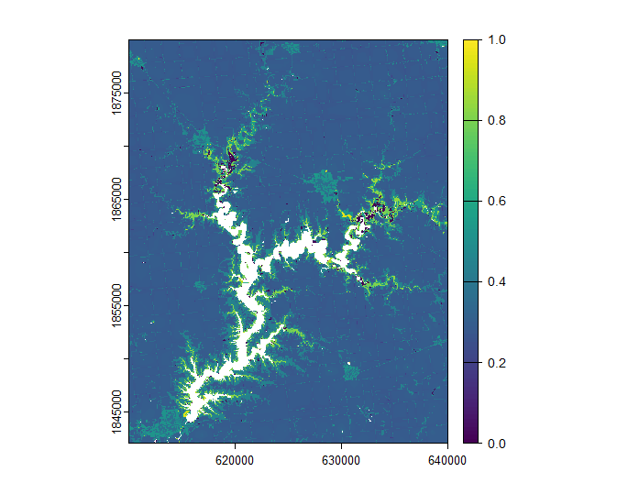
Supplemental Figure 1: Coyote risk layer for the Shelbyville site.

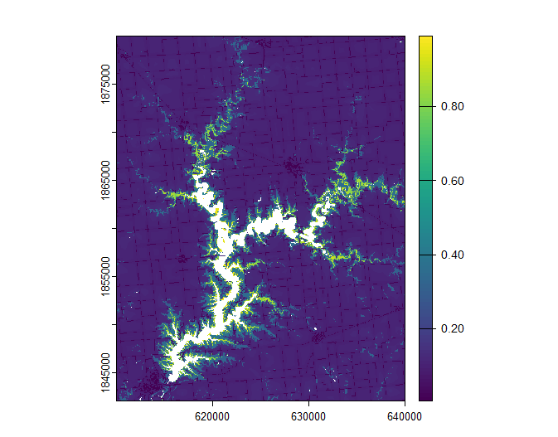
Supplemental Figure 2: Bobcat risk layer for the Touch of Nature site.

Supplemental Figure 1: Coyote risk layer for the Shelbyville site.

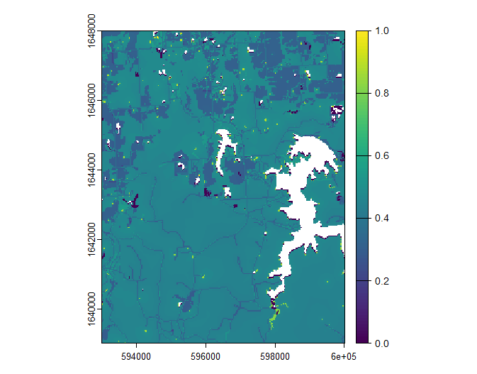
Supplemental Figure 3: Coyote risk layer for the Touch of Nature site.
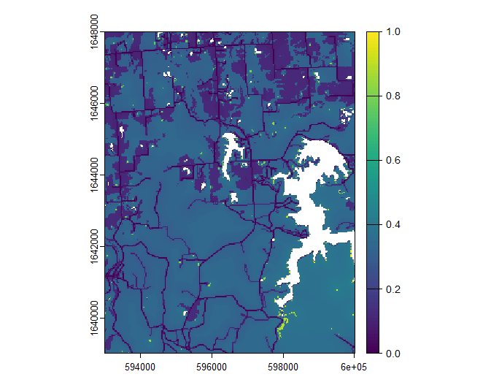
Supplemental Figure 4: Bobcat risk layer for the Touch of Nature site.

