Supplementary Table 1. Mean AUCs of logistic regression for 10-fold CV results.
Fold | Training mean | Test mean | Normal-like | Luminal A | Luminal B | Basal-like | HER2-enriched
1 | 0.850 | 0.830 | 0.902 | 0.739 | 0.643 | 0.999 | 0.867
2 | 0.854 | 0.807 | 0.547 | 0.763 | 0.808 | 0.994 | 0.924
3 | 0.853 | 0.866 | 0.968 | 0.805 | 0.755 | 0.936 | 0.867
4 | 0.855 | 0.821 | 0.816 | 0.827 | 0.743 | 0.993 | 0.724
5 | 0.853 | 0.825 | 0.892 | 0.762 | 0.716 | 0.988 | 0.766
6 | 0.854 | 0.881 | 0.962 | 0.885 | 0.811 | 0.979 | 0.768
7 | 0.844 | 0.885 | 0.981 | 0.816 | 0.777 | 0.997 | 0.855
8 | 0.855 | 0.851 | 0.943 | 0.808 | 0.675 | 0.991 | 0.840
9 | 0.842 | 0.903 | 0.949 | 0.829 | 0.777 | 0.985 | 0.973
10 | 0.853 | 0.860 | 0.873 | 0.814 | 0.756 | 0.991 | 0.867
Mean | 0.851 | 0.853 | 0.883 | 0.805 | 0.746 | 0.985 | 0.845
Std. | 0.005 | 0.032 | 0.129 | 0.042 | 0.054 | 0.018 | 0.075

Supplementary Table 2. Mean AUCs of SNNs for 10-fold CV results.
Fold | Training mean | Test mean | Normal-like | Luminal A | Luminal B | Basal-like | HER2-enriched
1 | 0.767 | 0.735 | 0.543 | 0.719 | 0.575 | 0.994 | 0.842
2 | 0.798 | 0.679 | 0.338 | 0.741 | 0.729 | 0.995 | 0.589
3 | 0.768 | 0.775 | 0.766 | 0.712 | 0.693 | 0.914 | 0.791
4 | 0.770 | 0.752 | 0.861 | 0.713 | 0.621 | 0.987 | 0.578
5 | 0.767 | 0.706 | 0.551 | 0.766 | 0.631 | 0.988 | 0.595
6 | 0.762 | 0.786 | 0.785 | 0.774 | 0.510 | 0.964 | 0.898
7 | 0.771 | 0.710 | 0.785 | 0.709 | 0.445 | 0.990 | 0.624
8 | 0.781 | 0.795 | 0.709 | 0.801 | 0.677 | 0.960 | 0.826
9 | 0.775 | 0.728 | 0.335 | 0.807 | 0.645 | 0.945 | 0.907
10 | 0.760 | 0.783 | 0.766 | 0.779 | 0.623 | 0.980 | 0.770
Mean | 0.772 | 0.745 | 0.644 | 0.752 | 0.615 | 0.972 | 0.742
Std. | 0.011 | 0.040 | 0.191 | 0.038 | 0.085 | 0.026 | 0.133

Supplementary Table 3. Mean AUCs of point-wise linear for 10-fold CV results

Fold | Training mean | Test mean | Normal-like | Luminal A | Luminal B | Basal-like | HER2-enriched
1 | 0.879 | 0.848 | 0.825 | 0.792 | 0.728 | 0.999 | 0.898
2 | 0.860 | 0.806 | 0.564 | 0.773 | 0.823 | 0.992 | 0.880
3 | 0.855 | 0.883 | 0.987 | 0.824 | 0.812 | 0.939 | 0.853
4 | 0.864 | 0.811 | 0.778 | 0.834 | 0.757 | 0.990 | 0.696
5 | 0.860 | 0.795 | 0.816 | 0.743 | 0.688 | 0.994 | 0.734
6 | 0.849 | 0.932 | 1.000 | 0.909 | 0.869 | 0.980 | 0.900
7 | 0.854 | 0.883 | 0.981 | 0.818 | 0.777 | 0.998 | 0.842
8 | 0.857 | 0.870 | 0.994 | 0.790 | 0.712 | 0.991 | 0.865
9 | 0.851 | 0.906 | 0.943 | 0.844 | 0.800 | 0.982 | 0.963
10 | 0.861 | 0.882 | 0.899 | 0.838 | 0.823 | 0.995 | 0.853
Mean | 0.859 | 0.862 | 0.879 | 0.817 | 0.779 | 0.986 | 0.848
Std. | 0.008 | 0.045 | 0.138 | 0.046 | 0.057 | 0.018 | 0.079

Supplementary Table 4. Hyper parameter search range of logistic regression.

Parameter name | Distribution and search range | Distribution and search range
params_alpha | Regularization coefficient | Log-uniform [1.0e−10, 0]
params_l1_ratio | Ratio of the L1 and L2 norms | Uniform [0.0, 1.0]

Supplementary Table 5. Hyper parameter search range of SNNs.

Parameter name | Distribution and search range | Distribution and search range
params_dropout_rates_h | Dropout rate of inner layer | Uniform [0.0, 0.5]
params_dropout_rates_x | Dropout rate of input layer | Uniform [0.0, 0.5]
params_label_smoothing | Label smoothing | Uniform [0.0, 0.3]
params_layer_size | Number of neurons | Discrete uniform [100, 250]
params_learning_rate | Learning rate | Log-uniform [1.0e−10, 1.0e-3]
params_momentum | Momentum | Uniform [0.9, 0.999]
params_num_epochs | Number of epochs | Discrete uniform [50, 250]
params_num_layers | Number of inner layers | Discrete uniform [10, 25]
params_optimization | Optimization method | SGD or Adam
- | Batch size | 100
- | Activation function | SELU

Supplementary Table 6. Hyper parameter search range of point-wise linear.

Parameter name | Distribution and search range | Distribution and search range
params_dropout_rates_h | Dropout rate of inner layer | Uniform [0.0, 0.5]
params_dropout_rates_x | Dropout rate of input layer | Uniform [0.0, 0.5]
params_label_smoothing | Label smoothing | Uniform [0.0, 0.3]
params_layer_size | Number of neurons | Discrete uniform [100, 250]
params_learning_rate | Learning rate | Log-uniform [1.0e−10, 1.0e-3]
params_momentum | Momentum | Uniform [0.9, 0.999]
params_num_epochs | Number of epochs | Discrete uniform [50, 250]
params_num_layers | Number of inner layers | Discrete uniform [10, 25]
params_optimization | Optimization method | SGD or Adam
params_reg_coeff | Regularization coefficient | Log-uniform [1.0e−20, 1.0e-3]
params_reg_ratio | Ratio of the L1 and L2 norms | Uniform [0.0, 1.0]
- | Batch size | 100
- | Activation function | sigmoid

Supplementary Table 7. Optimized hyper parameters of logistic regression.

Fold | AUC | Loss: 1 - AUC | params_alpha | params_l1_ratio
1 | 0.850 | 0.150 | 6.216 | 0.004
2 | 0.854 | 0.146 | 7.822 | 0.108
3 | 0.853 | 0.147 | 3.145 | 0.375
4 | 0.855 | 0.145 | 6.094 | 0.164
5 | 0.853 | 0.147 | 4.154 | 0.538
6 | 0.854 | 0.146 | 0.921 | 0.499
7 | 0.844 | 0.156 | 4.352 | 0.476
8 | 0.855 | 0.145 | 2.508 | 0.169
9 | 0.842 | 0.158 | 3.684 | 0.005
10 | 0.853 | 0.147 | 2.170 | 0.188

Supplementary Table 12. The intersections of the top 500 gene sets.
 |  | Normal-like | Luminal A | Luminal B | Basal-like | HER2-enriched
# of specific feature genes | Point-wise linear | 438 | 476 | 429 | 448 | 442
# of specific feature genes | Logistic regression | 455 | 360 | 388 | 390 | 441
% in top 500 | Point-wise linear | 87.6% | 95.2% | 85.8% | 89.6% | 88.4%
% in top 500 | Logistic regression | 91.0% | 72.0% | 77.6% | 78.0% | 88.2%

Supplementary Figure 1. Ideogram of chromosome 17, Cytogenetic: GRCh37.p12 (GCF_000001405.24)

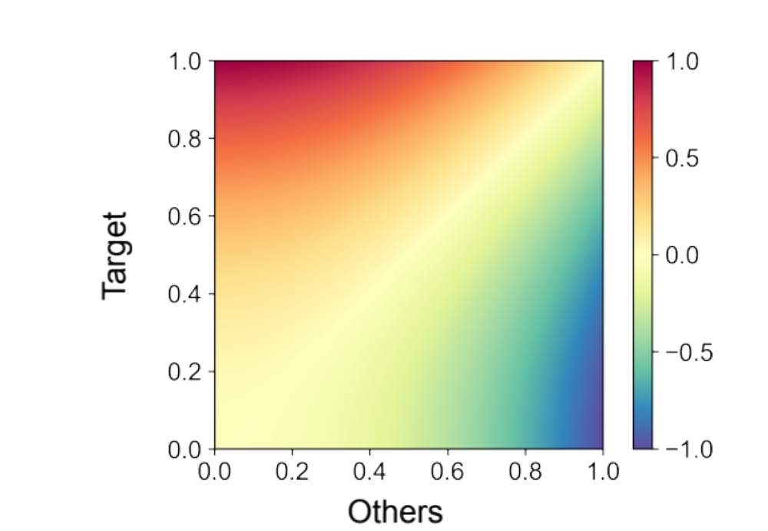
Supplementary Figure 2. The heat map visualization of the distribution of the relative score v_{rel}. The vertical and horizontal axes represent v_{target} and v_{others}, the group-wise importance scores for the target subtype samples group and the other samples group, respectively.

