Supplementary information
Granular flow experiment using artificial gravity generator on International Space Station

Authors
S. Ozaki^{1*}, G. Ishigami^{2*}, M. Otsuki^{3*}, H. Miyamoto⁵, K. Wada⁶, Y. Watanabe¹, T. Nishino¹, H. Kojima², K. Soda², Y. Nakao², M. Sutoh³, T. Maeda³, and T. Kobayashi⁴
¹Yokohama National University, ²Keio University, ³Japan Aerospace Exploration Agency, ⁴Ritsumeikan University, ⁵The University of Tokyo, ⁶Chiba Institute of Technology, *equally contributed.

^{1*} 79-5 Tokiwadai, Hodogaya-ku, Yokohama 240-8501, Japan. Email: s-ozaki@ynu.ac.jp
^{2*} 3-14-1 Hiyoshi, Yokohama 223-8522, Japan. Email: ishigami@mech.keio.ac.jp.
^{3*} 3-1-1 Yoshinodai Chuo-ku, Sagamihara-shi, Kanagawa 252-5210, Japan. Email: otsuki.masatsugu@jaxa.jp
.

Movies S1 and S2
The DEM analysis results of alumina beads and silica sand No. 5 under 0.1 G are shown here. In the NG environment, the prescribed uniform gravity field was set, and only flips were imposed on the hourglass. Meanwhile, in the AG environment, both the revolution corresponding to the rotary table and the flips were imposed on the hourglass under the boundary condition of a zero-gravity field. Here, the centre and radius of revolution and respective angular velocities were the same as those of the experiment. Note that the video is played at 0.5x speed.

Supplementary text
This supplementary text contains five sections: In Section 1, we introduce detailed information of the granular media used in the experiment. In Section 2, we outline the layout of the experimental apparatus, including the geometric information of the hourglass and centrifuge. In Section 3, we describe the specifications of the experimental components along with those of the sensor and camera. Section 4 describes the acceleration histories at each AG condition. Finally, Section 5 provides the method for measuring particle velocity based on DEM analysis.

1. Information of tested materials
In this experiment, the eight types of granular media shown in Table 1 were used. The alumina beads were adopted as a comparative material which has a nearly spherical shape and quite narrow particle size distribution. In addition, silica sand (Tohoku sand) No. 5 and No. 8 and Toyoura sand were adopted as typical sandy soils for which many soil tests results have been reported^{S1-S3}. In particular, the latter is often used as standard sand in soil mechanics^{S1}. Furthermore, considering the use for future space exploration, four types of regolith simulants—specifically, Lunar regolith simulant (FJS-1)^{S4}, Phobos regolith simulant^{S5}, and Martian regolith simulant (JSC MARS-1A)—were adopted.
The details of the soil test results, such as particle size distribution, particle density and bulk density tests, direct shear test, and static friction test, are summarised below.
Figure S1-1 shows the particle size distribution of each granular media, which was measured by the laser diffraction particle size analyser (SALD-2300, SHIMADZU Co.). Table S1-1 shows the particle densities measured according to JIS A 1202: 2009 (ISO 17892-3:2015) and the maximum and minimum bulk densities measured according to JIS 1224: 2009.
All granular media were prepared via the following process: first, the granular media were dried for 24 hours at 120 °C, and then sieved at 850 μm (425 μm only for #04 FSJ-1). Subsequently, the granular media were packed into the hourglass and vacuumed. We confirmed that the hourglass maintains the vacuum level in the range of 15–20 Pa after 2 hours and then sealed the hourglass.
Strength parameters were obtained from constant-pressure direct shear tests (JGS 0561-2009). The internal friction angle $ϕ_{d}$ and cohesion $c_{d}$ were evaluated under three levels of relative density conditions, i.e. 50, 70, and 90 %. The raw data are available via the Open Science Framework at https:/osf.io/3zcm2/.
The frictional property between particles and the diagonal wall of the hourglass is one of the most important information for analysing granular flow characteristics. The static friction coefficient measured by the static friction test apparatus (TRIBOGEAR TYPE:10, SHINTO Scientific Co.) and shown in Table S1-2 is used as both static and dynamic friction coefficients in DEM analysis.

Figure S1-1: Particle size distribution of eight types of granular media. The raw data are available via the Open Science Framework at https:/osf.io/3zcm2/.

Table S1-1: Particle and bulk densities data. Each particle density is the average of three samples, while each bulk density is the average of five samples.
# | Name | Particle density (g/cm³) | Bulk density (g/cm³)
# | Name | Particle density (g/cm³) | Maximum | Minimum
1 | Alumina beads | 3.819 | 2.349 | 2.116
2 | Silica sand No. 5 | 2.661 | 1.631 | 1.378
3 | Toyoura sand | 2.701 | 1.699 | 1.467
4 | Lunar regolith simulant  (FJS-1, sieved) | 2.890 | 1.979 | 1.551
5 | Phobos regolith simulant | 2.907 | 1.352 | 1.056
6 | Martian regolith simulant | 2.636 | 0.940 | 0.742
7 | Silica sand No. 8 | 2.899 | 1.908 | 1.497
8 | Lunar regolith simulant  (FJS-1, original) | 2.634 | 1.511 | 1.169

Table S1-2: Static friction coefficients between particles and diagonal wall of the hourglass. These values are each the average value obtained from respective five samples.
# | Name | Static friction coefficient
1 | Alumina beads | 0.33
2 | Silica sand No. 5 | 0.22
3 | Toyoura sand | 0.18
4 | Lunar regolith simulant  (FJS-1, sieved) | 0.25
5 | Phobos regolith simulant | 0.30
6 | Martian regolith simulant | 0.25
7 | Silica sand No. 8 | 0.27
8 | Lunar regolith simulant  (FJS-1, original) | 0.30

2. Experimental layout
The centrifuge on the ISS mounts four sets of the experimental apparatus on its turntable (Fig. S2-1). The centrifuge can produce artificial gravity in the range of 0.063–2.0 G by controlling the angular velocity of the turntable $ω_{c}$that can geometrically be determined by the following equation:
$$\begin{aligned}ω_{c}= \sqrt{\frac{{\hat{g}}_{AG}}{r_{o}}}\#\left(S2-1\right)\end{aligned}$$
where ${\hat{g}}_{AG}$ is the reference AG and $r_{o}$ is the radius measured from the rotation centre of the turntable to the reference point of the experimental apparatus (P in Fig. S2-1). Table S2-1 lists the relationship between the reference AGs in our experiment and centrifuge angular velocity. Owing to the centrifuge principle, the AG at the position $r_{xyz}$ inside the hourglass with respect to the reference P varies according to the following equation:
$$\begin{aligned}g_{xyz}= \frac{r_{xyz}}{r_{o}}{\hat{g}}_{AG}\#\left(S2-2\right)\end{aligned}$$
The hourglass is mounted on the apparatus with an offset tile angle of 12.6° to make the hourglass central axis coincide with the AG direction (Fig. S2-1).
Figure S2-1: Geometric information of the experimental apparatus on the centrifuge. $r_{o}$ is 139.33 mm.

Figure S2-1: Geometric information of the experimental apparatus on the centrifuge. $r_{o}$ is 139.33 mm.

Table S2-1: Relationship between the reference AG and the rotational angular velocity of the centrifuge.

${\hat{g}}_{AG}$ [G] | $ω_{c}$ [rpm]
0.063 | 20.1
0.10 | 25.3
0.17 | 33.0
0.38 | 49.4
0.50 | 56.7
0.75 | 69.4
1.00 | 80.1
2.00 | 113.1

3. Specifications of the components on the apparatus
The components used in the experimental apparatus include a CPU board with a camera module, accelerometer, servo motor, and battery packs.
The CPU board with a camera module, or main control unit (MCU), is Armadillo 810 (Atmark Techno Inc.) running a Linux OS dedicated to the MCU. Figure S3-1 shows the diagram of the MCU and peripheral devices. The camera is mounted in a position where the entire hourglass can be captured. It has a rolling shutter image sensor with a resolution of 1280 x 960 and a frame rate of 25 fps. The optical axis of the camera is perpendicular to the vertical axis of the hourglass. The field of view of the camera is 119 × 99°, which leads to significant image distortion and is calibrated using the Computer Vision Toolbox of MATLAB®. The SD card mounted on the extension board stores all the MP4 files captured by the camera and acceleration data in the experiment. After the experiments were completed, the astronaut on the ISS supporting our experiment ejected the SD cards from each apparatus. Some MP4 files were directly downlinked from the ISS to a ground station for quick-look purposes, while others were sent back to Earth.
The MEMS accelerometer (Analog Devices ADXL355) measures the three-axis acceleration at 50 Hz. The acceleration measured by the sensor and the AG at the reference point (P in Figure S2-1) differ because of the geometric offset. Therefore, the measured data must be converted to that of the acceleration on the hourglass:
$$\begin{aligned}g_{AG}=\left(a_{y}\cos{θ-a_{z}\sin{θ}}\right) r_{0}/r_{acc}\#\left(S3-1\right)\end{aligned}$$
where $g_{AG}$ is the AG at the reference point of the hourglass (Fig. S2-2), $a_{y}$ and $a_{z}$ are the accelerations measured at the sensor coordinates, $θ$ is the offset angle of the x-y plane relative to the AG direction, and $r_{acc}$ is the distance between the sensor and the centre of the centrifuge.

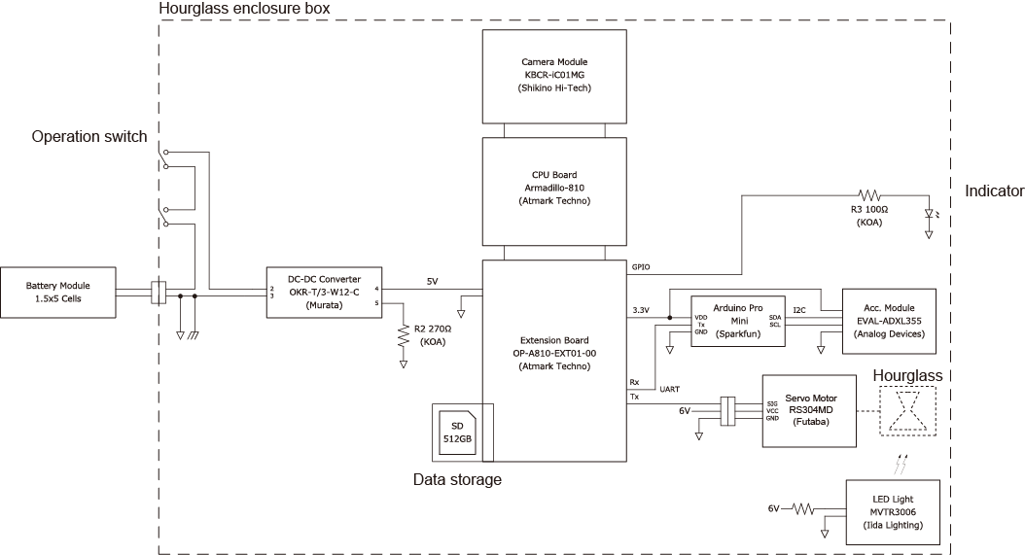
Figure S3-1: System diagram of the main control unit and peripheral devices.
(The figures are currently compressed, they will be replaced with higher-resolution versions for the submission.)

4．Ａcceleration histories
The comparison of the statistical data of AG with the reference gravity level is summarised in Table S4-1. The centrifuge accurately produces the AG within a difference of 0.02 G. The standard deviation of the AG is also negligible. Therefore, the experimental campaign was completed under high-quality AG conditions.
The AG profile for each reference gravity level is summarised in Fig. S4-1. The periodic vibration of the raw acceleration data (blue-coloured lines) is due to the mechanical misalignment of the centrifuge as well as the resolution of the motor controller for the centrifuge. Further, the spike noise observed every 60 s is due to the flip motion of the hourglass.

Table S4-1: Statistics of AG in the experiment.
Reference ${\hat{g}}_{AG}$ (G) | Generated $g_{AG}$ (Ave.) (G) | Generated $g_{AG}$ (Std.) (G)
0.063 | 0.067 | 0.009
0.100 | 0.103 | 0.013
0.170 | 0.180 | 0.021
0.380 | 0.393 | 0.029
0.500 | 0.519 | 0.008
0.750 | 0.758 | 0.008
1.00 | 1.01 | 0.006
2.00 | 1.98 | 0.006

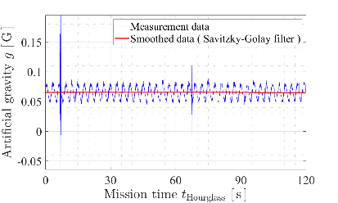 | 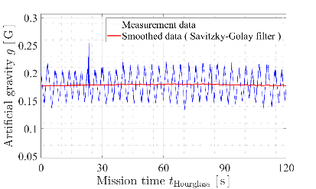
(a) 0.063 G | (b) 0.10 G
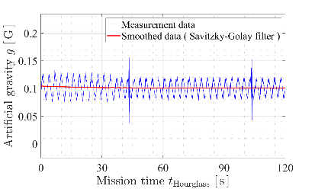 | 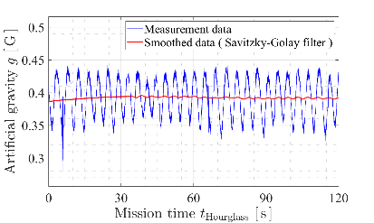
(c) 0.17 G | (d) 0.38 G
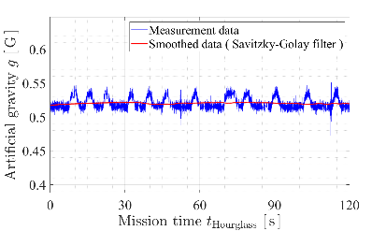 | 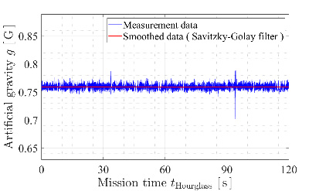
(e) 0.50 G | (f) 0.75 G
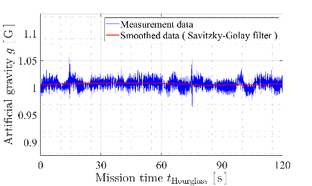 | 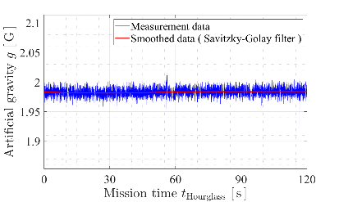
(g) 1.0 G | (h) 2.0 G

Figure S4-1: AG profiles generated by the centrifuge.

5．Particle velocity data obtained by DEM
As shown in Fig. S5-1, for both the NG and AG conditions, the particle velocity was measured in a cuboid region at the centre position immediately below the orifice. The size of the cuboid region is 5 mm ×15 mm in the x-y plane and it has a length of 1 mm in the z direction (longitudinal direction). The particle velocity was evaluated as the average value of all the passed particles for the cuboid region. The detailed data for the three granular media are available via the Open Science Framework at https:/osf.io/3zcm2/.

Figure S5-1: Measurement position of particle velocity. The size of the cuboid region is 5 mm × 15 mm in the x-y plane and it has a length of 1 mm in the z direction.

References
- Iwasaki, T., Tatusoka, F. & Takagi, T. Shear moduli of sands under cyclic torsional shear loading. Soils and Foundations 18, 39–56 (1978).
- Oztoprak, S. & Bolton, M.D. Stiffness of sands through a laboratory test database. Geotechnique 63, 54–70 (2013).
- Arshad, M.I., Tehrani, F.S., Prezzi, M. & Salgado, R. Experimental study of cone penetration in silica sand using digital image correlation. Geotechnique 64, 551–569 (2014).
- Kobayashi, T., Fujiwara, Y., Yamakawa, J. & Yasufuku, N. Mobility performance of a rigid wheel in low gravity environments. J. Terramech. 47, 261–274 (2010).
- Miyamoto et al. Surface Environment of Phobos and Phobos Simulant UTPS, Earth Planet. Sci. (in press).

