Supplementary Information for Agent-Based Simulation with Data-Driven Parameterization for Evaluation of Social Acceptance of a Geothermal Development

Shuntaro Masuda¹, Kyle Bahr¹, Noriyoshi Tsuchiya¹*, Tatsuya Takemori¹

1 Graduate School of Environment, Tohoku University, Sendai, Japan
*Corresponding Author

Supplementary Table 1 Questions about perception of the geothermal industry and development.
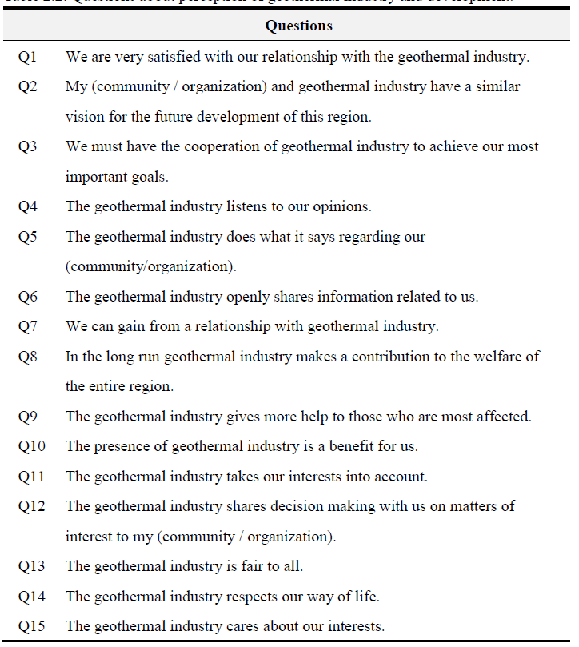
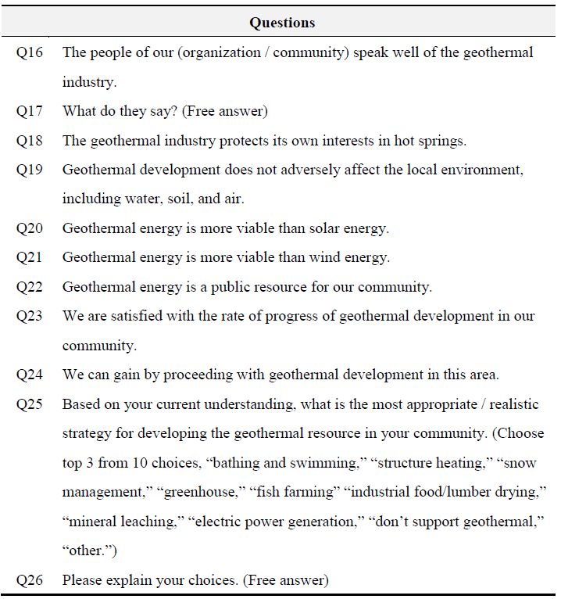
Interview was conducted according to Tohoku University Privacy Policy (https://www.tohoku.ac.jp/japanese/site/siteinfo/01/siteinfo0103/, in Japanese).

Supplementary Table 2 Dataset for construction of a Bayesian network.
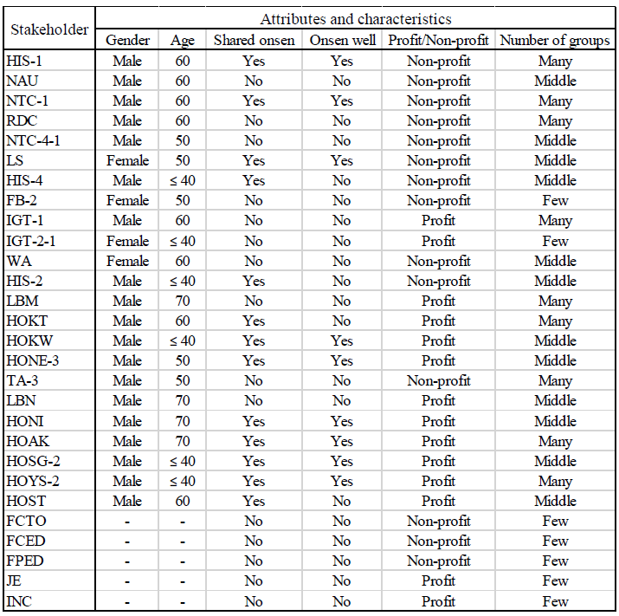
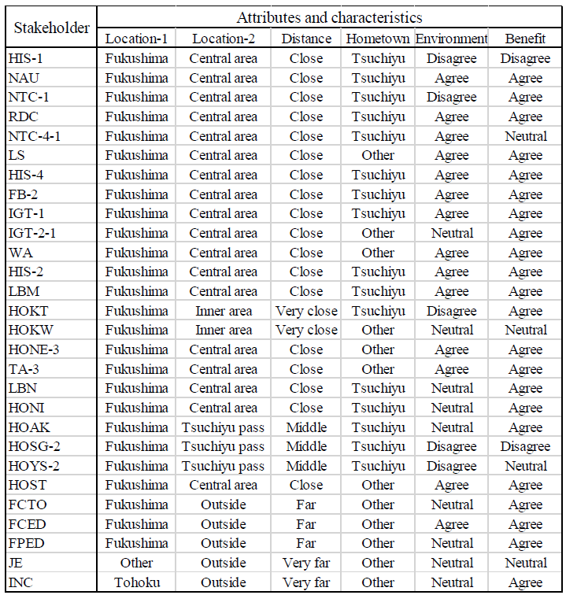
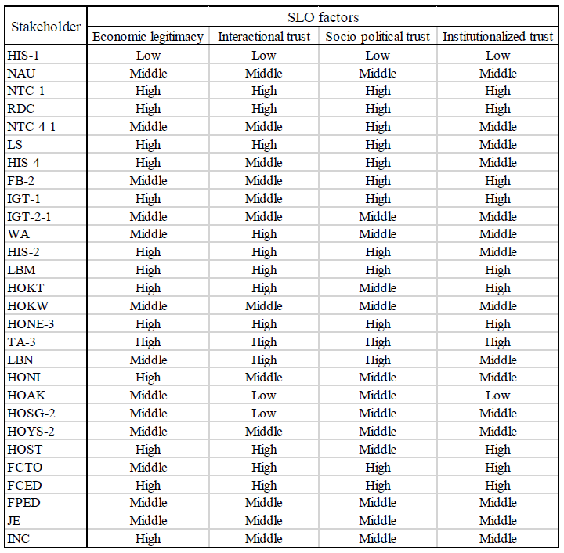

Supplementary Table 3 Explanation of variables in the dataset.
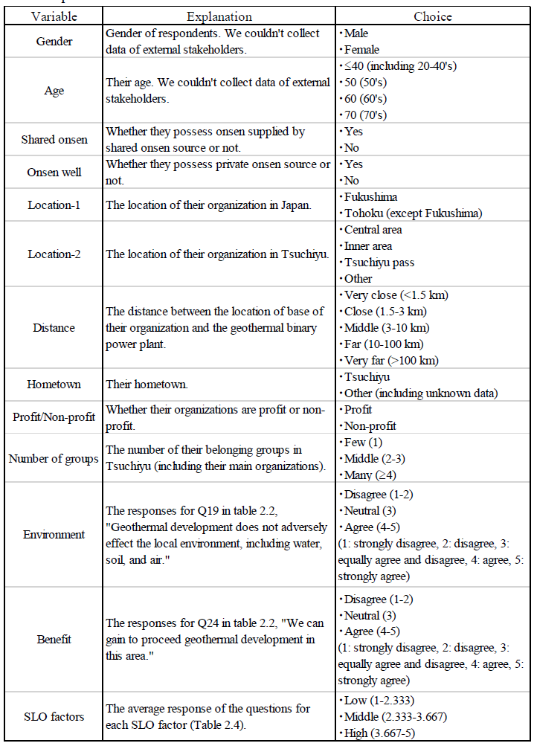

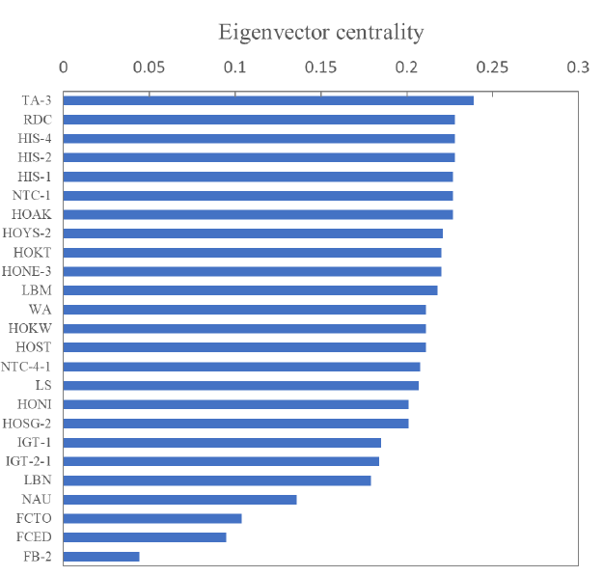
Supplementary Figure 1 Eigenvector centrality of responses from stakeholders in Tsuchiyu.

