Extended Data: Microbiome manipulation and enhanced weathering stimulate CO₂ removal in reforestation

Table S1. Model coefficients (and their associated t statistics and P values) for four mixed linear models (A-D) and one spatial simultaneous autoregressive lag model (E) of tree growth at Glandwr Forest. All models include the same fixed effects: forest type (native woodland restoration vs. commercial forestry); microbiome enrichment treatment (control or forest soil inoculum); and ERW treatment (control or addition of crushed basalt). Models A-D also include random effects for block identity and year, but differ in the way interactions between fixed and random effects are represented. In the main text, we present and discuss results from Model D, which fit the data best. However, coefficient estimates are similar across all the models.

Model Term | Model Formulation
Model Term | A |  |  | B |  |  | C |  |  | D |  |  | E
Model Term | Coef | t | p | Coef | t | p | Coef | t | p | Coef | t | p | Coef | z | p
Intercept | 544 | 2.79 | 0.065 | 458 | 2.06 | 0.101 | 458 | 2.06 | 0.101 | 455 | 2.17 | 0.085 | 1017 | 35.05 | 0.001
Forest type (F) – spruce | -289 | -20.5 | 0.001 |  |  |  |  |  |  |  |  |  | -594 | -15.84 | 0.001
+ ERW (E) | 109 | 7.64 | 0.001 | 32.7 | 3.52 | 0.001 | 32.7 | 3.52 | 0.001 | 38.6 | 1.83 | 0.112 | 232 | 6.21 | 0.001
+ soil inoculum (I) | 65.2 | 4.56 | 0.001 | 30.4 | 2.38 | 0.038 | 30.4 | 2.38 | 0.038 | 30.1 | 2.43 | 0.032 | 126 | 3.37 | 0.001
F x E | -104 | -5.22 | 0.001 |  |  |  |  |  |  |  |  |  | -224 | -4.29 | 0.001
F x I | -48.7 | -2.45 | 0.015 |  |  |  |  |  |  |  |  |  | -104 | -2.00 | 0.046
E x I | -108 | -5.34 | 0.001 | -47.1 | -3.59 | 0.001 | -47.1 | -3.59 | 0.001 | -46.8 | -3.57 | 0.001 | -218 | -4.11 | 0.001
F x E x I | 86.4 | 3.06 | 0.002 |  |  |  |  |  |  |  |  |  | 181 | 2.45 | 0.014
Model A (AIC: 249488) | Biomass ~ ForestType × ERW × Inoculum + (1|block) + (1|year)
Model B (AIC: 247156) | Biomass ~ ERW × Inoculum + (1|block) + (1|year) + (Inoculum|species)
Model C (AIC: 247160) | Biomass ~ ERW × Inoculum + (1|block) + (Inoculum|year) + (Inoculum|species)
Model D (AIC: 247141) | Biomass ~ ERW× Inoculum + (1|block) + (Inoculum + ERW|year) + (Inoculum + ERW|species)
Model E (AIC: NA) | Biomass ~ ForestType × ERW × Inoculum (spatial simultaneous autoregressive lag model)

Table S2. Results of a Cox proportional hazards model examining the effects of species identity on tree mortality (N = 6,400 trees) from 2021-2023.

Species | Hazard ratio* | z | p-value
Alder | 0.218 | -4.709 | <0.001
Aspen | 1.004 | 0.011 | 0.991
Birch | 1.381 | 2.597 | 0.009
Cherry | 0.606 | -2.321 | 0.020
Oak | 0.470 | -2.637 | 0.008
Rowan | 2.466 | 4.334 | <0.001
*Sitka spruce is considered the baseline (reference) group for this analysis

Table S3. Results of a Cox proportional hazards model examining the effects of field treatments (microbiome enrichment with soil inoculum, and ERW) on tree mortality from 2021-2023. The regression model was stratified by tree species identity.

Treatment | Hazard ratio | z | p-value
Soil inoculum | 0.943 | -0.574 | 0.566
ERW | 1.082 | 0.764 | 0.445

Table S4. Results of a Cox proportional hazards model examining the effects of tree biomass on mortality from 2021-2023. Treatment levels are quartiles of the sapling biomass distribution, as measured at the 2021 census. The regression model was stratified by tree species identity.

Biomass quartile | Hazard ratio* | z | p-value
Second | 0.394 | -5.580 | < 0.001
Third | 0.130 | -8.397 | < 0.001
Fourth | 0.123 | -8.372 | < 0.001
*Trees in the first (smallest) quartile of the size distribution constitute the baseline (reference) group for this analysis

Table S5. Results of a PERMANOVA examining treatment effects on fungal community composition (N = 224 soil samples)
 | df | R² | F statistic | p
Soil inoculum (I) | 1 | 0.017 | 4.028 | 0.001
EWR (E) | 1 | 0.007 | 1.546 | 0.027
Tree species identity (T) | 7 | 0.038 | 1.280 | 0.004
I × E | 1 | 0.008 | 1.767 | 0.008
I × T | 6 | 0.020 | 0.777 | 0.999
E × T | 1 | 0.018 | 0.715 | 1.000
I × E × T | 6 | 0.019 | 0.734 | 0.999
Residuals | 205 | 0.874

Table S6. Analysis of variance on the proportion of ectomycorrhizal fungal sequence variants in samples obtained from different tree species and microbiome enrichment treatments.,
Model term | Mean squares | F statistic | p value
Tree species (T) | 0.011 | 6.12 | < 0.001
Soil inoculum (I) | 0.003 | 1.86 | 0.158
T x I | 0.001 | 0.59 | 0.737

Table S7. Analysis of variance on plot-level stocks (kg ha⁻¹) of thirteen elements in plant tissue. F statistics are shown with p values in parentheses. N = 64 plots; residual degrees of freedom = 27.
Element | EWR (E)  df = 1 | Forest type (F)  df = 1 | E x F  df = 1
N | 3.82 (0.061) | 122.11 (<0.001) | 2.67 (0.114)
P | 4.04 (0.055) | 152.10 (<0.001) | 3.40 (0.076)
K | 1.10 (0.303) | 57.12 (<0.001) | 0.99 (0.328)
Ca | 7.78 (0.010) | 223.39 (<0.001) | 5.17 (0.031)
Mg | 1.78 (0.194) | 263.11 (<0.001) | 0.74 (0.398)
Al | 0.16 (0.668) | 18.84 (<0.001) | 0.07 (0.788)
Fe | 1.02 (0.322) | 21.60 (<0.001) | 0.73 (0.401)
Mn | 8.99 (0.006) | 73.26 (<0.001) | 5.41 (0.028)
Cd | 8.87 (0.006) | 102.45 (<0.001) | 6.17 (0.019)
Cr | 0.08 (0.776) | 26.32 (<0.001) | 0.25 (0.619)
Cu | 6.24 (0.019) | 111.53 (<0.001) | 5.17 (0.031)
Ni | 0.16 (0.695) | 57.23 (<0.001) | 0.00 (0.993)
Zn | 0.43 (0.519) | 169.34 (<0.001) | 0.56 (0.461)

Table S8. Analysis of variance on foliar concentrations of thirteen elements in plots with and without ERW treatment (rock dust amendment). F statistics are shown with p values in parentheses. Residual degrees of freedom = 92.
Element | ERW (E)  df = 1 | Tree species (T)  df = 6 | E x T  df = 6
N | 0.61 (0.438) | 5.47 (<0.001) | 0.31 (0.931)
P | 0.01 (0.934) | 40.03 (<0.001) | 0.36 (0.903)
K | 0.96 (0.329) | 20.29 (<0.001) | 0.44 (0.851)
Ca | 3.90 (0.051) | 159.15 (<0.001) | 0.17 (0.983)
Mg | 1.37 (0.245) | 69.27 (<0.001) | 0.55 (0.771)
Al | 0.03 (0.862) | 4.53 (<0.001) | 0.52 (0.789)
Fe | 0.02 (0.889) | 4.28 (<0.001) | 0.97 (0.450)
Mn | 84.00 (<0.001) | 33.54 (<0.001) | 9.04 (<0.001)
Cd | 3.28 (0.074) | 87.09 (<0.001) | 1.61 (0.153)
Cr | 0.32 (0.573) | 9.32 (<0.001) | 0.21 (0.974)
Cu | 0.01 (0.930) | 257.08 (<0.001) | 1.08 (0.381)
Ni | 13.13 (<0.001) | 31.31 (<0.001) | 1.28 (0.273)
Zn | 20.11 (< 0.001) | 219.75 (<0.001) | 5.72 (<0.001)

Figure S1. The partial feature contributions of the 100 most important taxa in classifying inoculated vs. non-inoculated soil communities. Taxa are arranged in order from most important (top) to least important (bottom). Positive feature contribution scores mean that the identified taxa is a positive indicator of inoculation and vice versa. Bars are colored according to fungal guild: orange for saprotrophs, yellow for ectomycorrhizal fungi, black for unknown, and grey for other functional guilds (e.g., parasites, pathogens, and other endophytes).
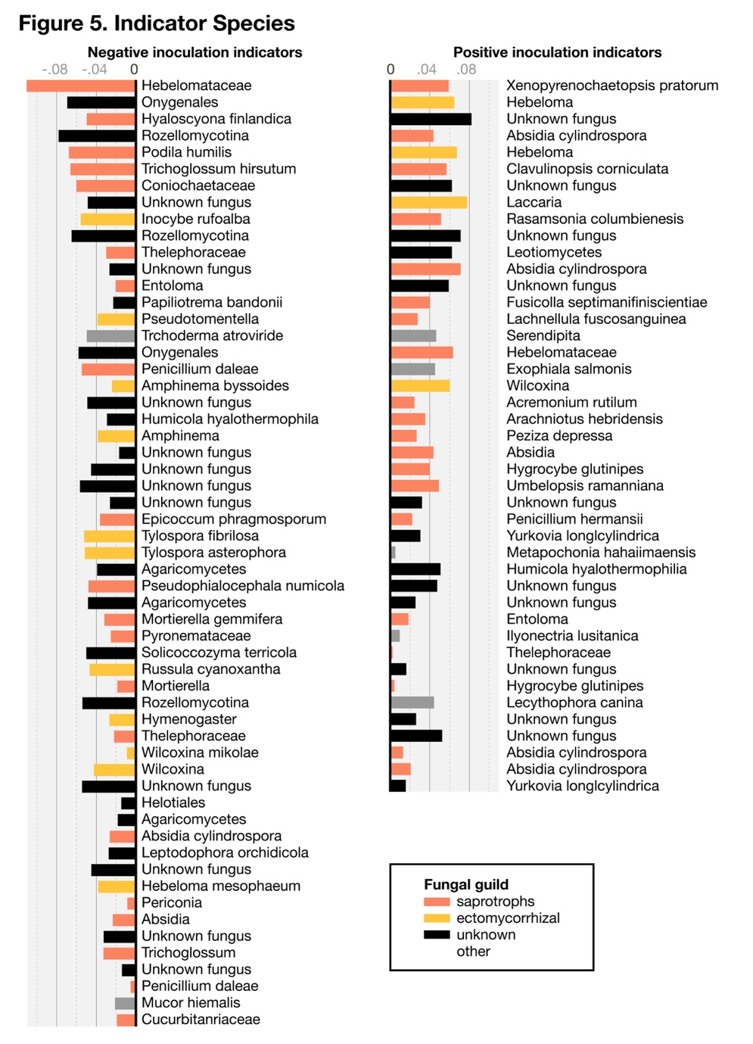

Fig S2. Proportion of sequence variants in each treatment group belonging to the ectomycorrhizal fungal guild.

