Supplementary Information

Highly Hydrated Paramagnetic Amorphous Calcium Carbonate Nanoclusters as a Superior MRI Contrast Agent

Dong et al.

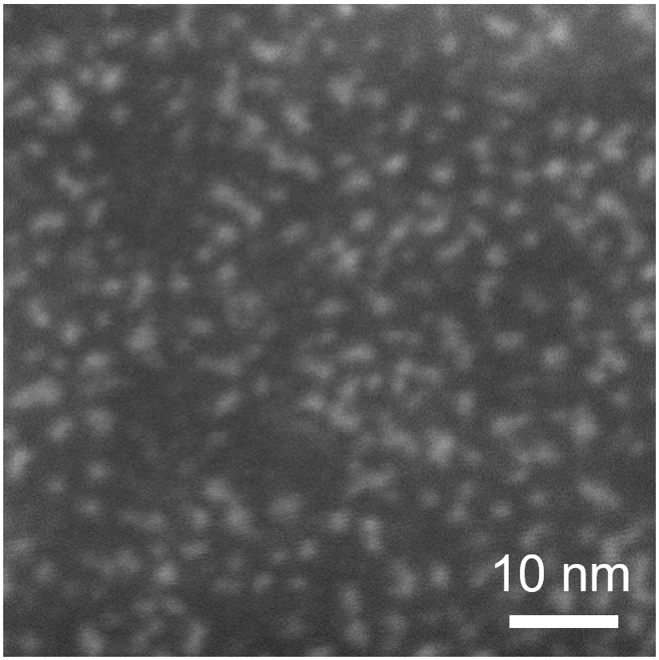
Supplementary Figure 1 STEM image of ACNC dispersed in normal saline solution.

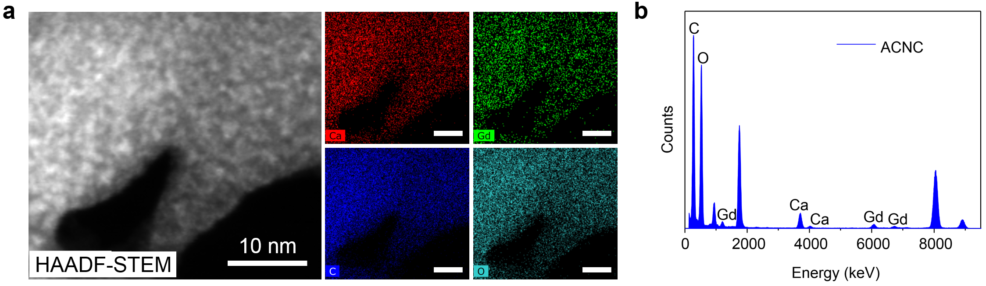
Supplementary Figure 2 a EDS mapping and b EDS result of ACNC collected by ethanol precipitation.

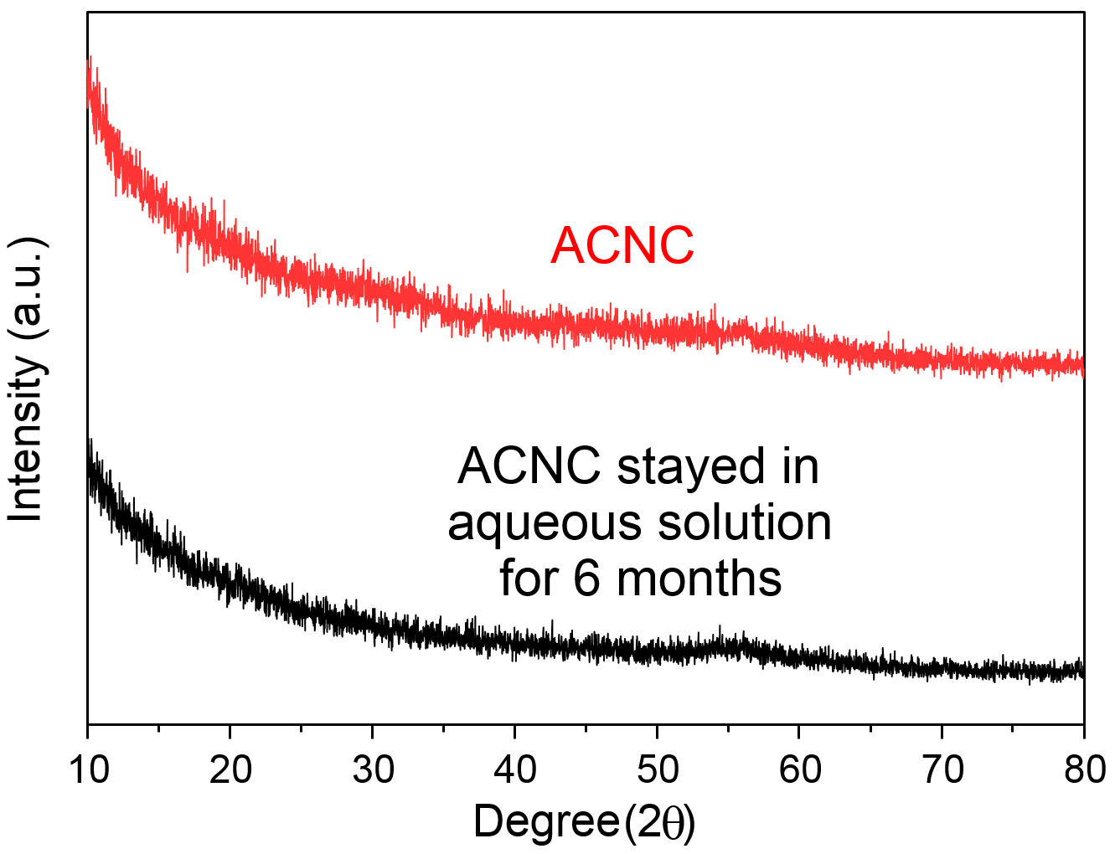
Supplementary Figure 3 XRD patterns of ACNC and ACNC stayed in aqueous solution for 6 months.

Supplementary Figure 4 DLS size distribution of ACNC dispersed in normal saline solution. The particle size of ACNC was measured to be approximately 7.46 ± 1.30 nm.

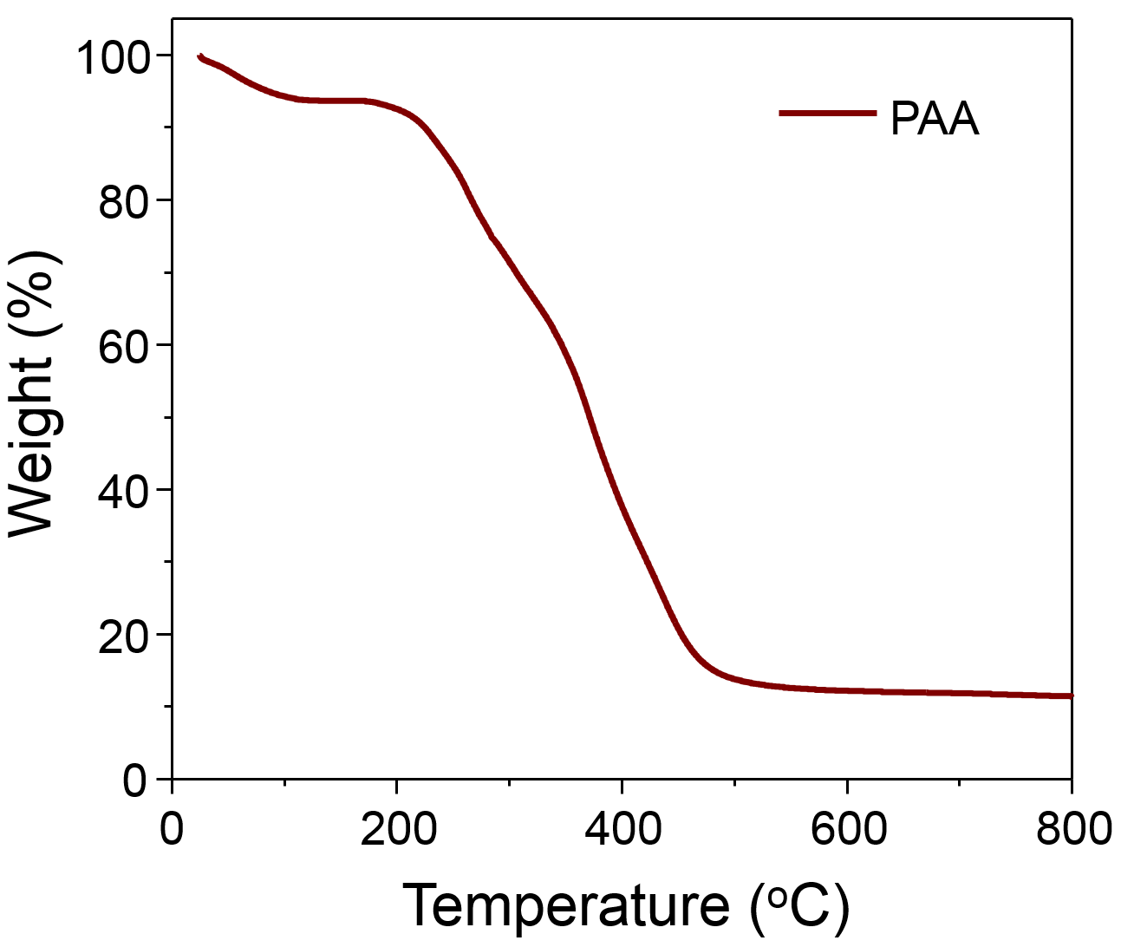
Supplementary Figure 5 Thermogravimetric curve of PAA powder under an N₂ atmosphere with a heating rate of 10 °C min⁻¹

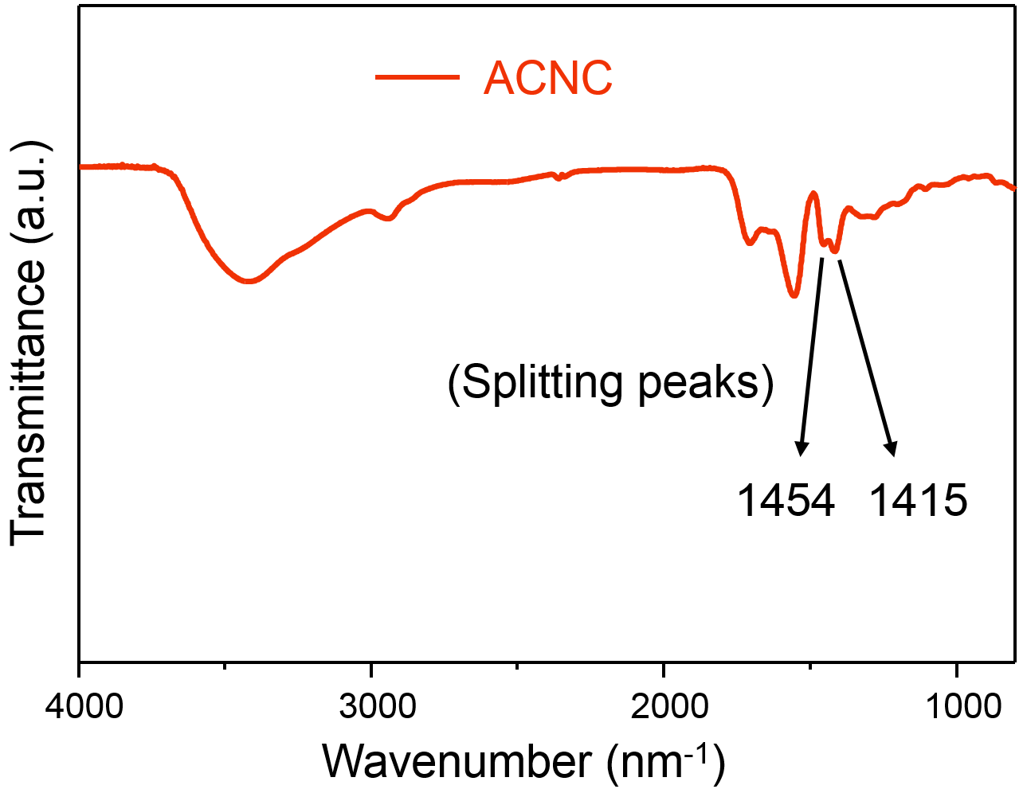
Supplementary Figure 6 FT-IR spectrum of ACNC. The split band at 1415 and 1454 cm⁻¹ in the FTIR spectrum can be assigned to the asymmetric stretch vibration of the carbonate ions in typical ACC environments.

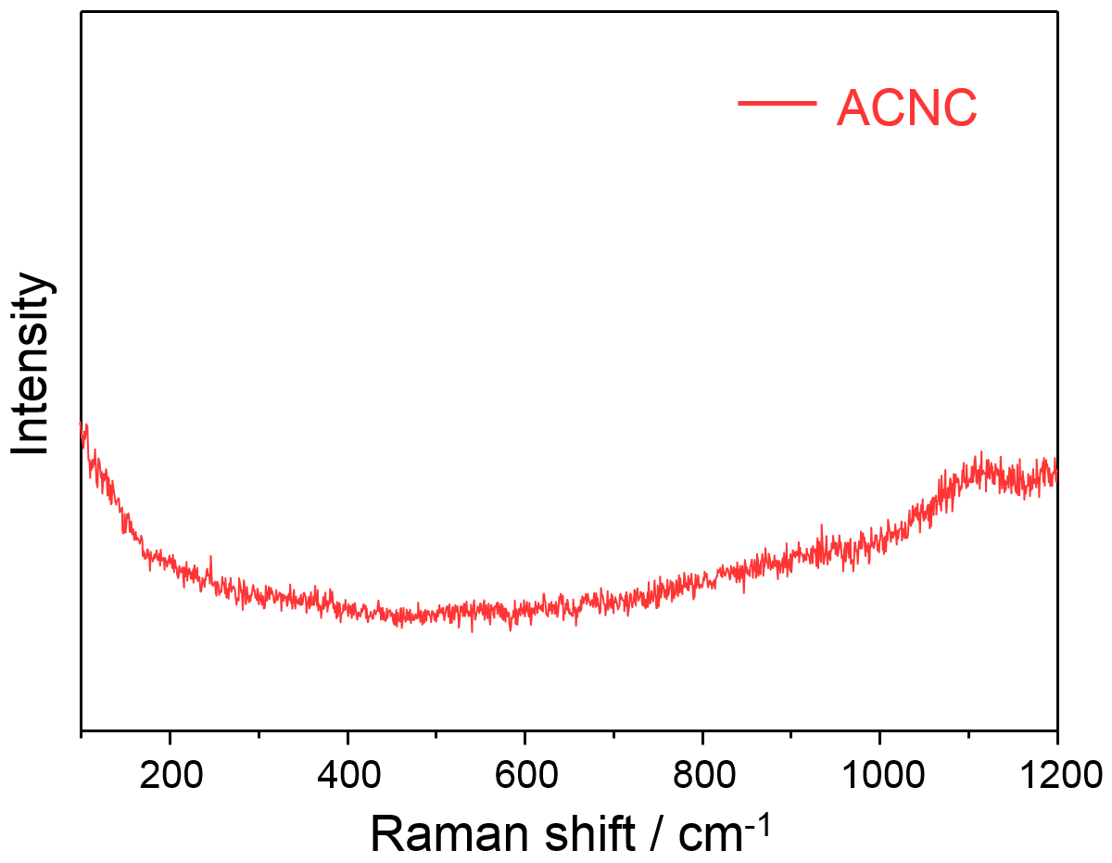
Supplementary Figure 7 Raman spectrum of ACNC. A broad peak centered at 1086 cm⁻¹ was attributed to the internal CO₃²⁻ symmetric stretch.

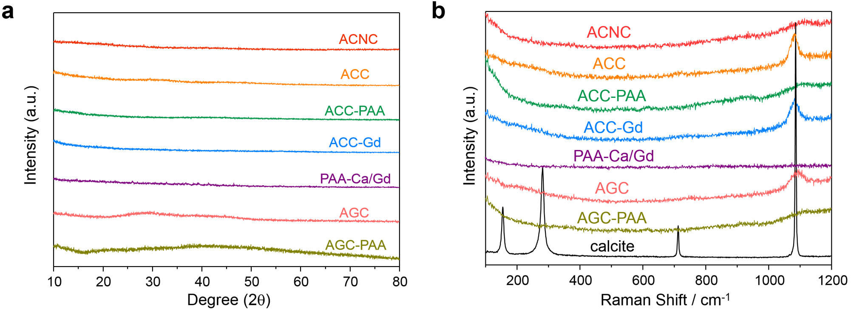
Supplementary Figure 8 a XRD patterns of ACNC and a series of control samples. b Raman spetra of ACNC and a series of control samples compared with calcite.

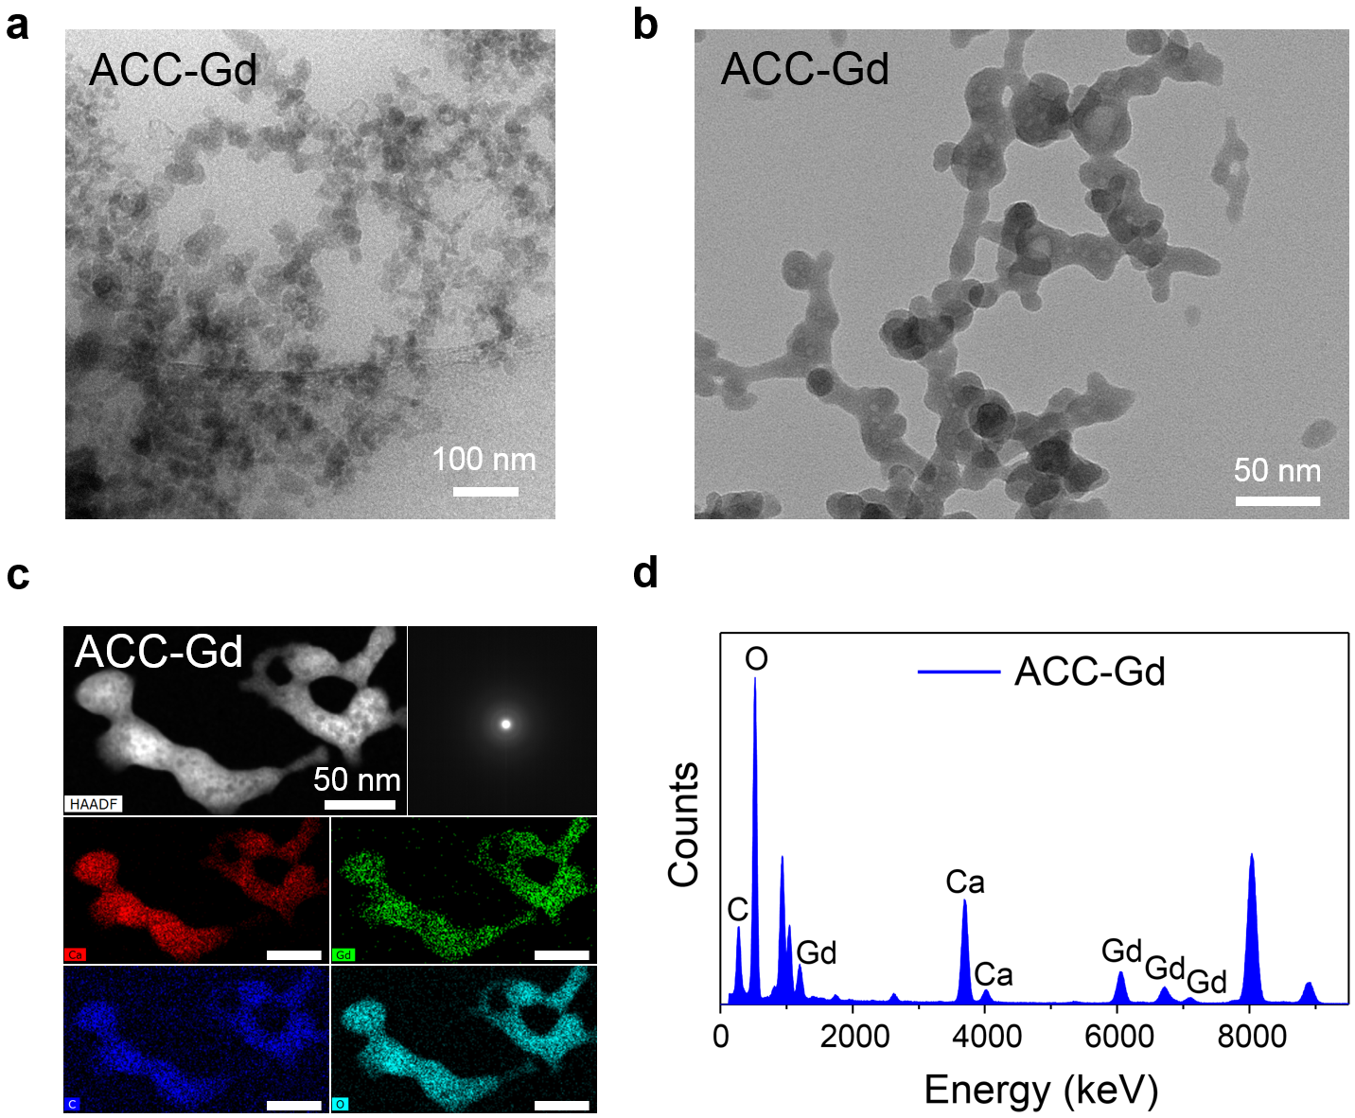
Supplementary Figure 9 a cryo-TEM and b TEM image of ACC-Gd. c HAADF-STEM image and SAED of ACC-Gd, and EDS mapping indicated the distribution of calcium (red), gadolinium (green), carbon (blue) and oxygen (cyan). d EDS result of ACC-Gd.

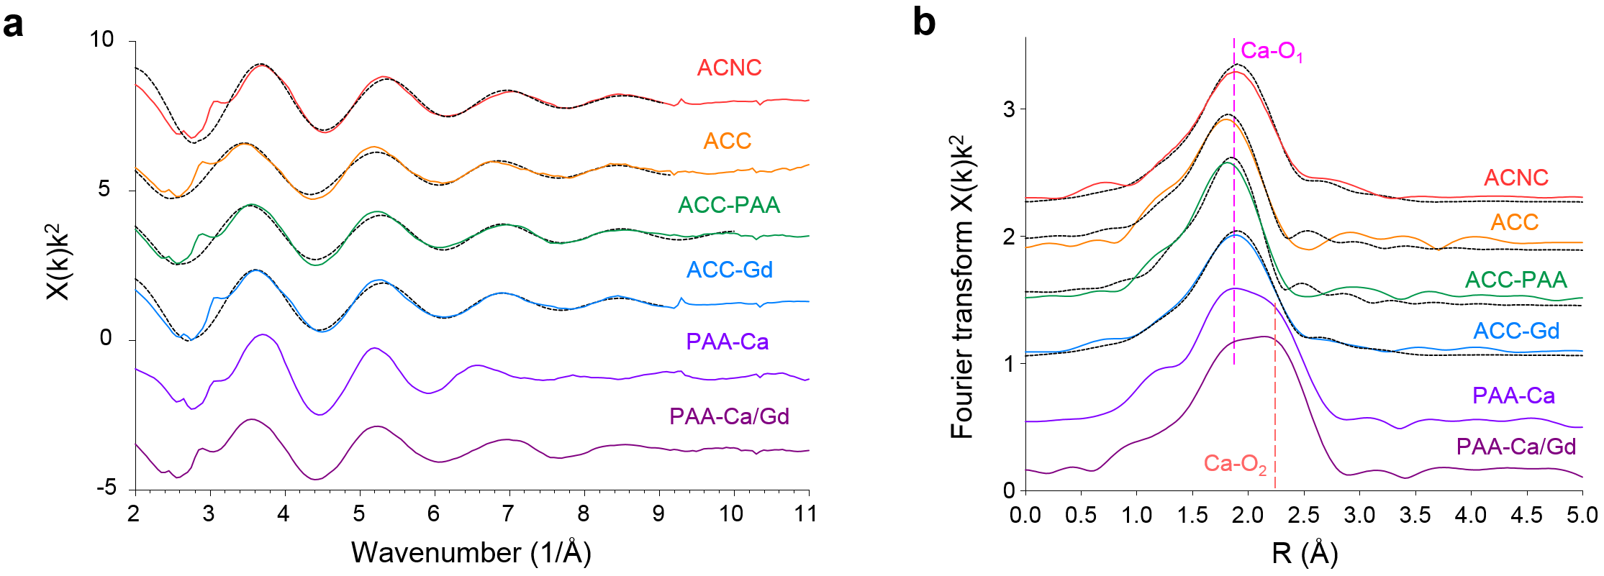
Supplementary Figure 10 a k²-weighted EXAFS and b k²-weighted Fourier transform of the EXAFS for the ACNC, ACC standard, ACC-PAA, ACC-Gd, PAA-Ca and PAA-Ca/Gd. Dotted black lines are their best fit.

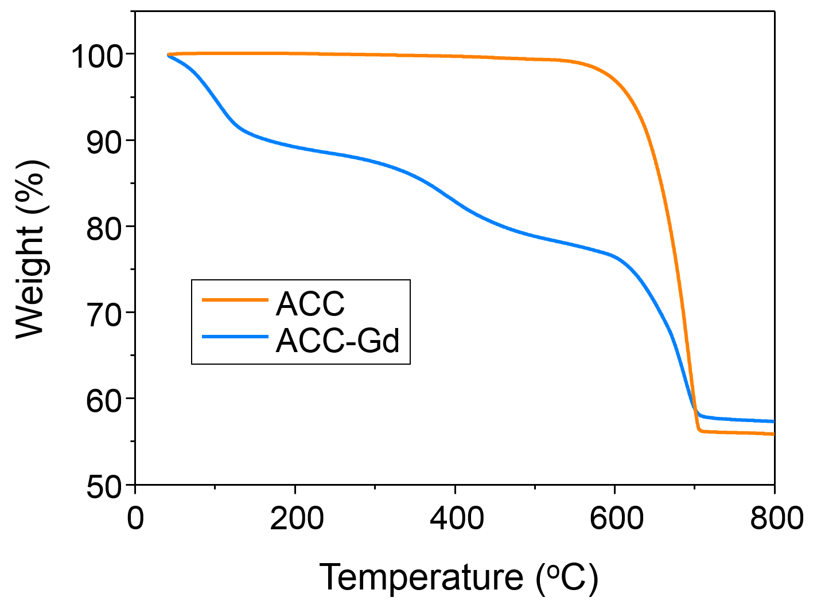
Supplementary Figure 11 Thermogravimetric curve of ACC and ACC-Gd powder lyophilized powder isolated by deionized water and exposed to the air for over 6 months. The weight loss before 300 ºC could be attributed to the loss of water. Note that ACC, which is precipitated in a hydrated form has completely lost its hydration water under these conditions.

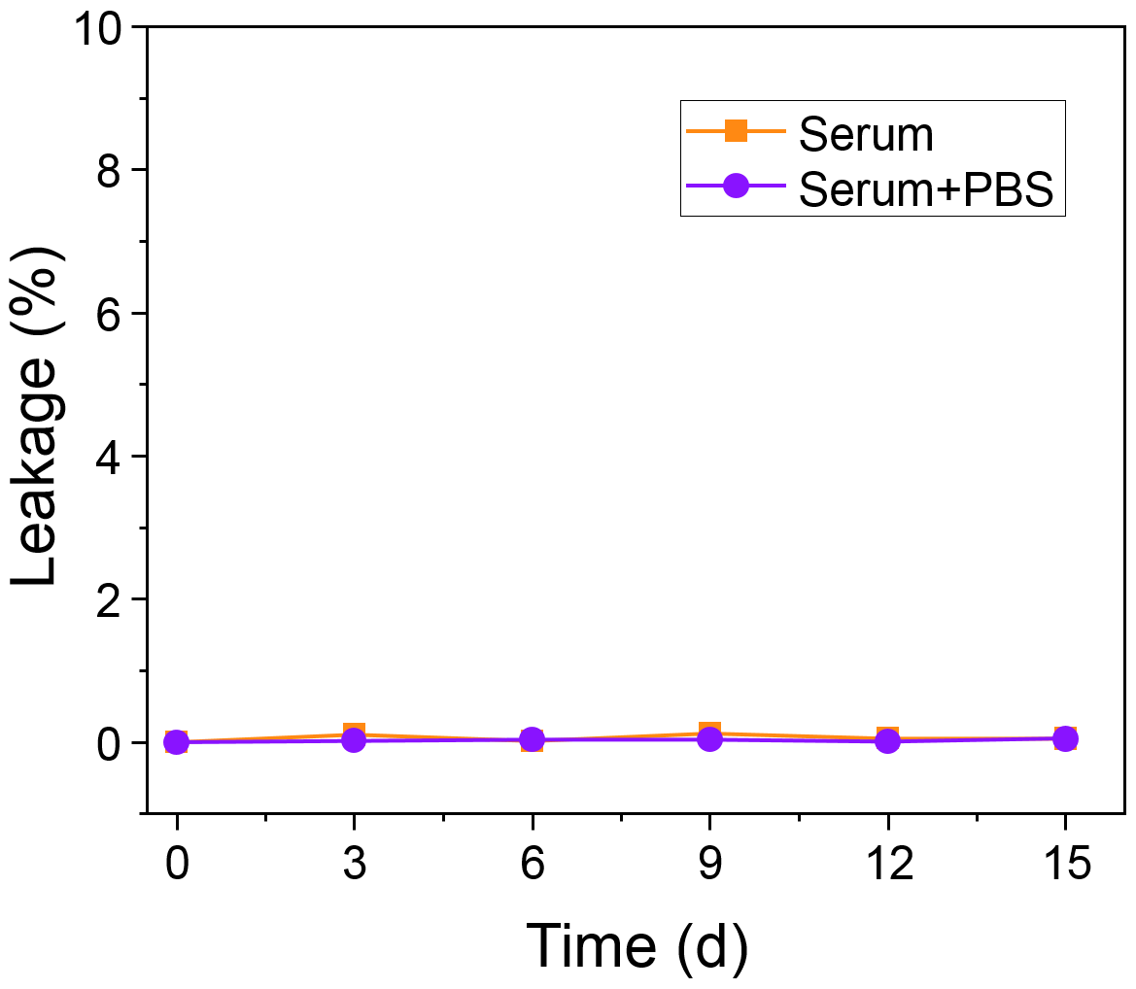
Supplementary Figure 12 Analysis of the leakage of free gadolinium ion from ACNC dispersed in human serum and human serum with supplemented additional phosphate by means of ICP-MS.

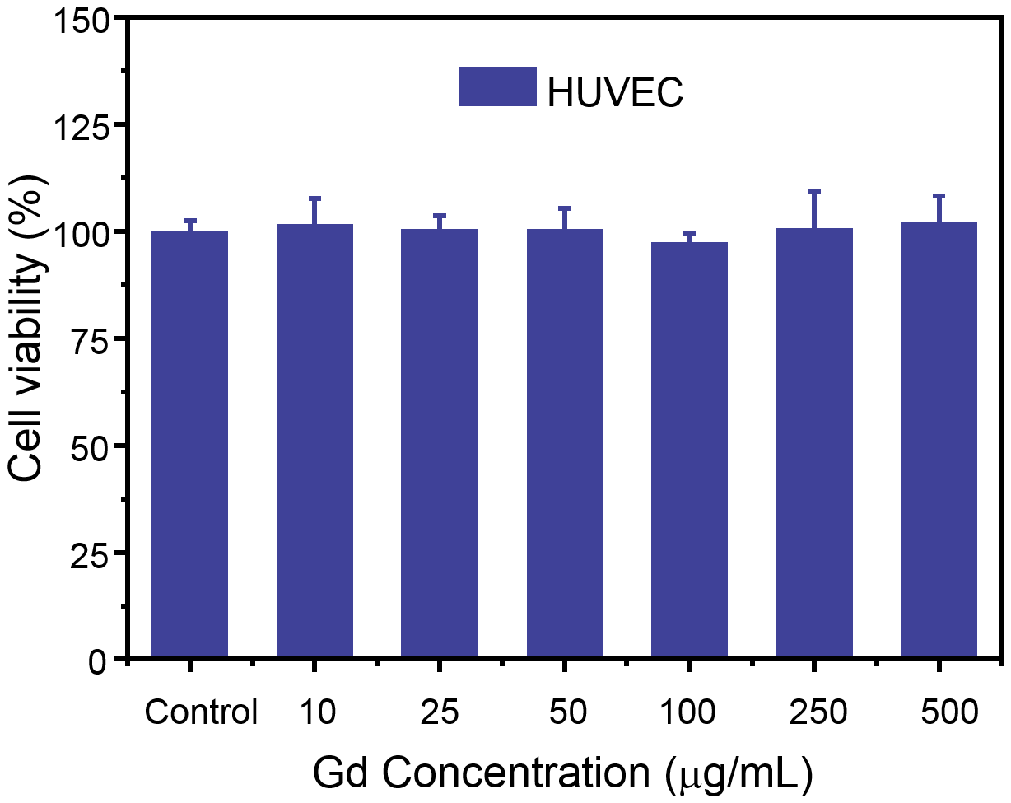
Supplementary Figure 13 MTT results of ACNC evaluated on HUVEC cells.

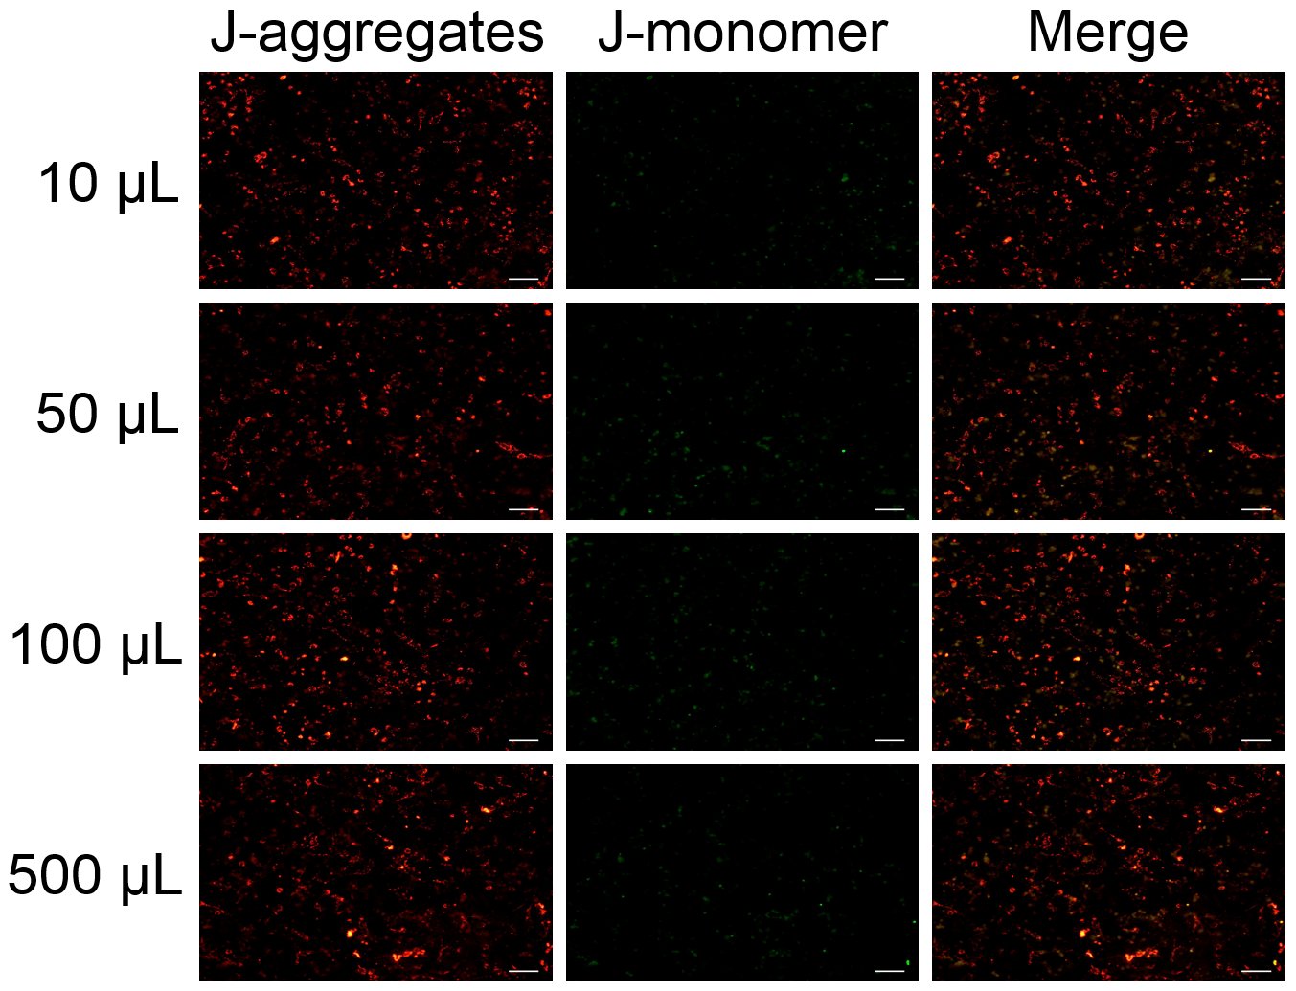
Supplementary Figure 14 CLSM images of HK-2 cells stained with JC-1 after treatment with ACNC for 12 h, scale bar = 50 μm.

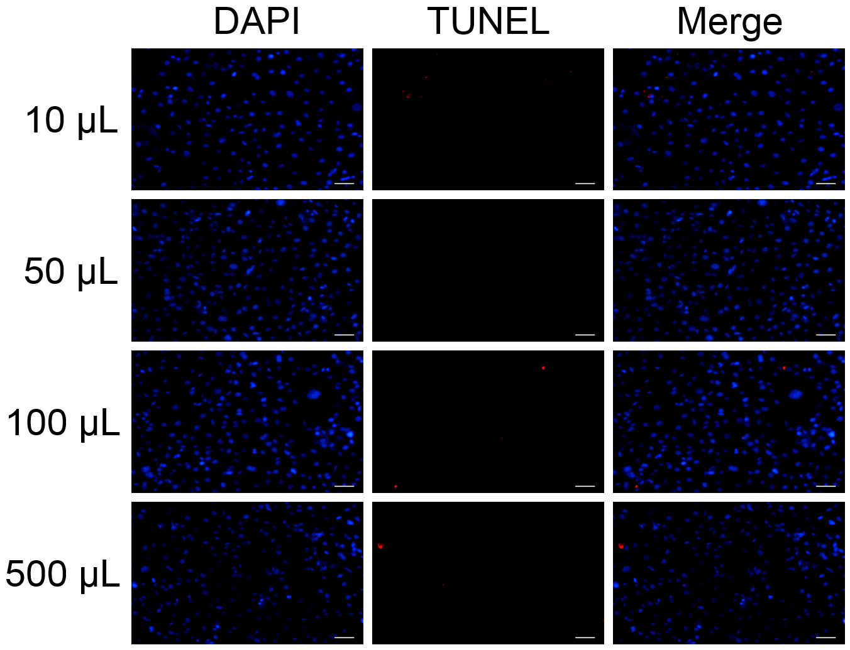
Supplementary Figure 15 Representative TUNEL immunofluorescent images of HK-2 cells separately treated with ACNC for 24 h, scale bar = 50 μm.

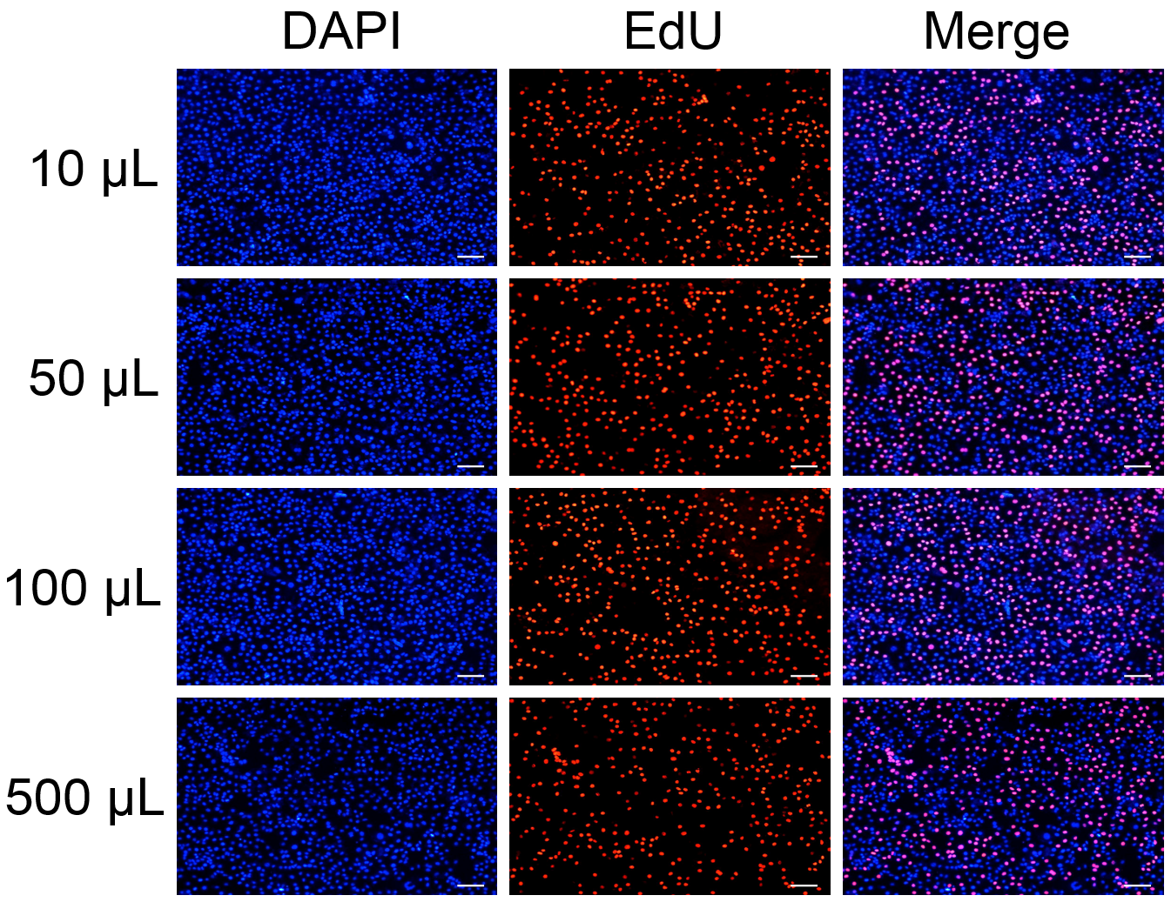
Supplementary Figure 16 Cell proliferation in HK-2 cells by EdU cell proliferation assay, scale bar = 50 μm.

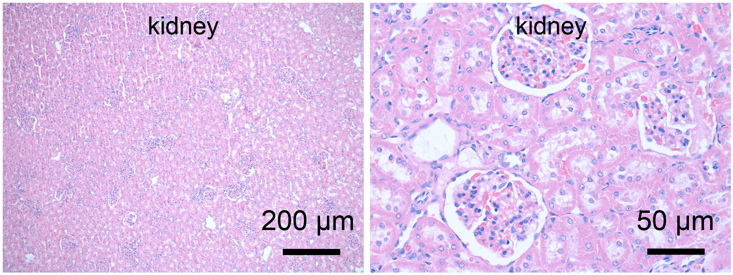
Supplementary Figure 17 Histological analyses of kidney tissue of rabbit, 30 minutes after the intravenous injection of ACNC.

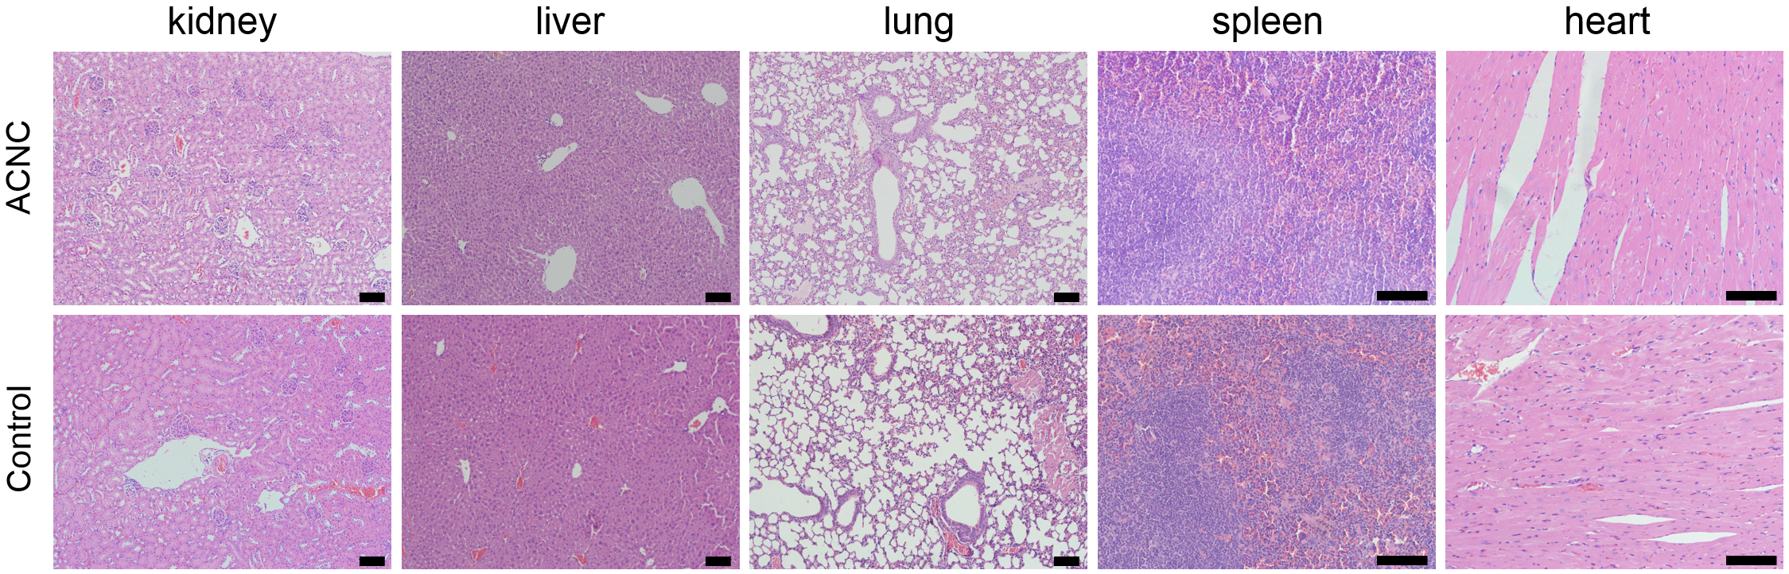
Supplementary Figure 18 Histological analyses of tissues of mice including kidney, liver, lung, spleen and heart 2 weeks after the intravenous injection of ACNC. The scale bar is 100 μm.

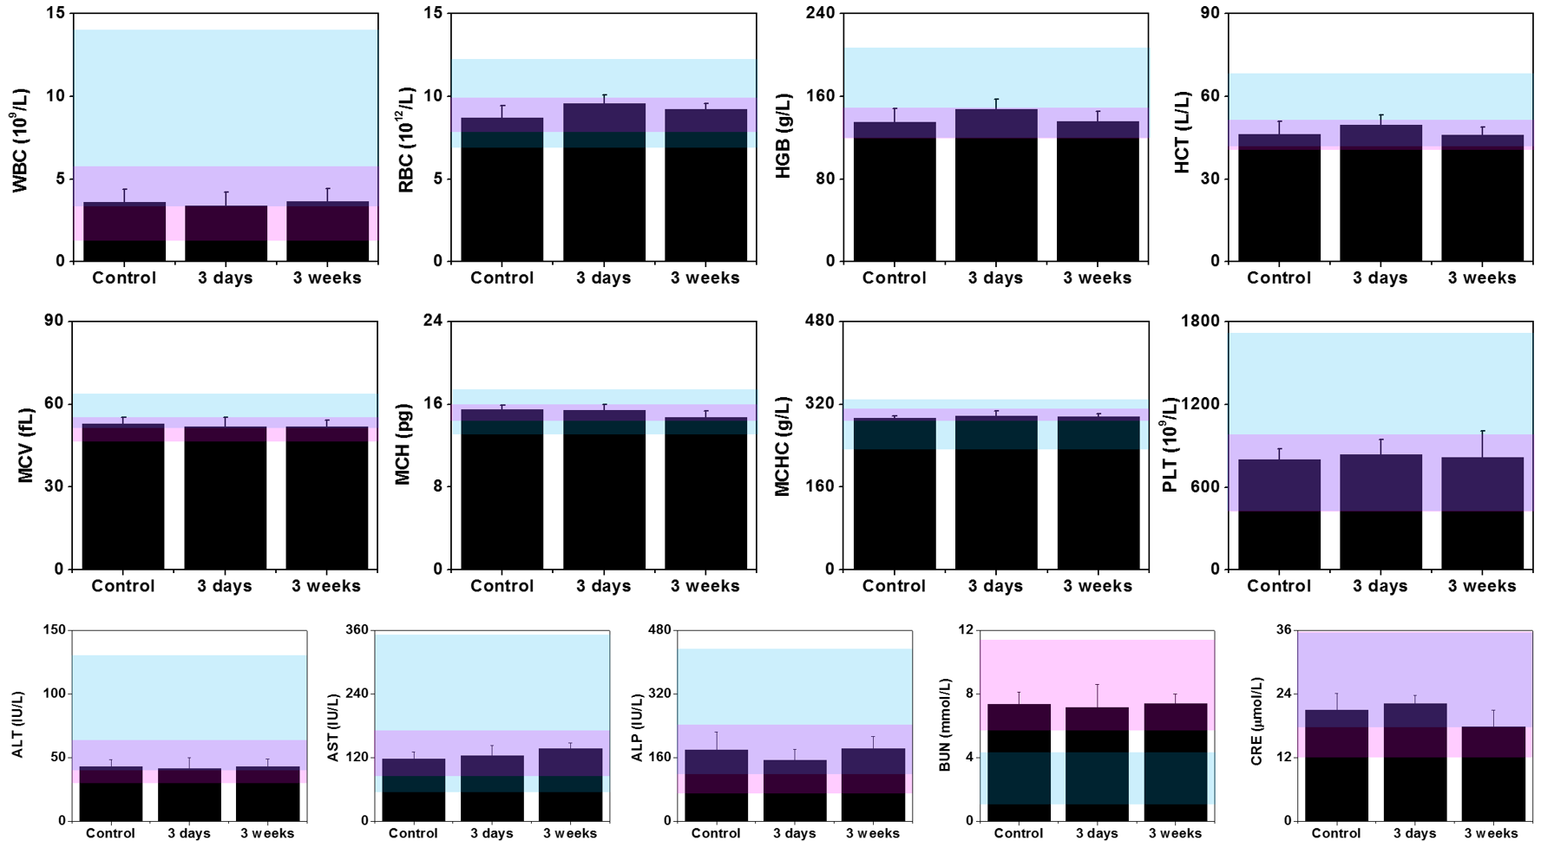
Supplementary Figure 19 Blood biochemical examination and blood routine examination in mouse. Major hematologic and biochemical indices of liver and kidney were examined 3 days and 3 weeks after the intravenous injection of ACNC in BALB/c mice (n = 5), and the intravenous injection of normal saline was set as control. Major indices were listed, including white blood cells (WBC), red blood cells (RBC), hemoglobin (HGB), hematocrit (HCT), mean corpuscular volume (MCV), mean corpuscular hemoglobin (MCH), mean corpuscular hemoglobin concentration (MCHC), and platelets (PLT), alanine transaminase (ALT), aspartate transaminase (AST), alkaline phosphatase (ALP), blood urea nitrogen (BUN), and creatinine (CRE). Reference ranges of hematologic and biochemical indices of healthy Balb/c mice (the blue labelled region) were obtained from Charles River Laboratories (http://www.criver.com/). Meanwhile, the reference normal range from 30 healthy Balb/c mice in our group was marked by pink.

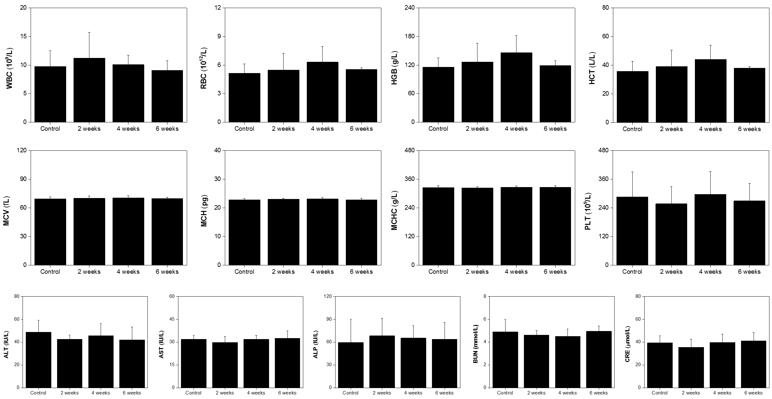
Supplementary Figure 20 Blood biochemical examination and blood routine examination in beagle dog at a high dose (9 mg/kg bw). Major hematologic and biochemical indices of liver and kidney were examined every 2 weeks after the intravenous injection of ACNC in beagle dogs (n = 5), and the intravenous injection of normal saline was set as control. Major indices were listed, including white blood cells (WBC), red blood cells (RBC), hemoglobin (HGB), hematocrit (HCT), mean corpuscular volume (MCV), mean corpuscular hemoglobin (MCH), mean corpuscular hemoglobin concentration (MCHC), and platelets (PLT), alanine transaminase (ALT), aspartate transaminase (AST), alkaline phosphatase (ALP), blood urea nitrogen (BUN), and creatinine (CRE).

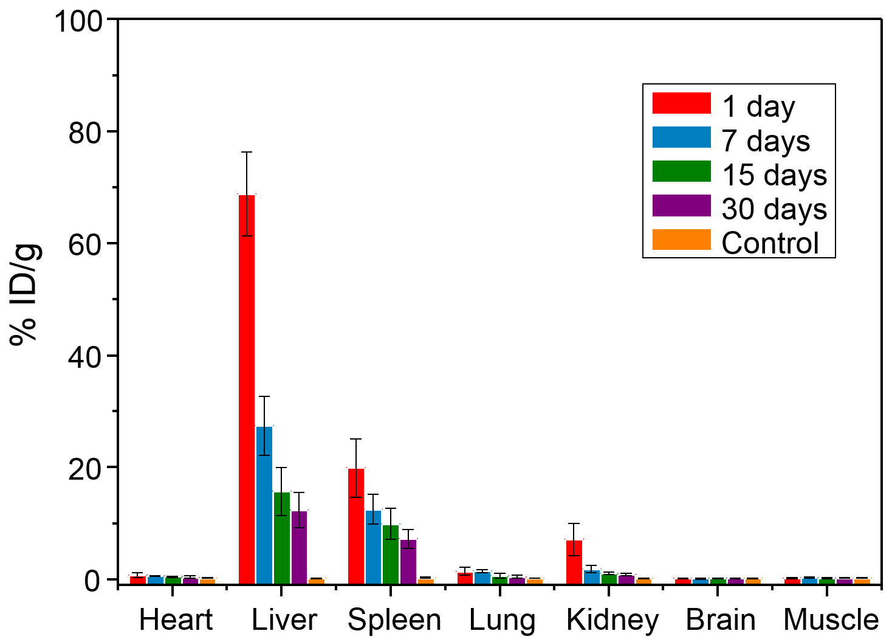
Supplementary Figure 21 The time dependent distribution of ACNC in organs of mice after rapid manual injection of ACNC.

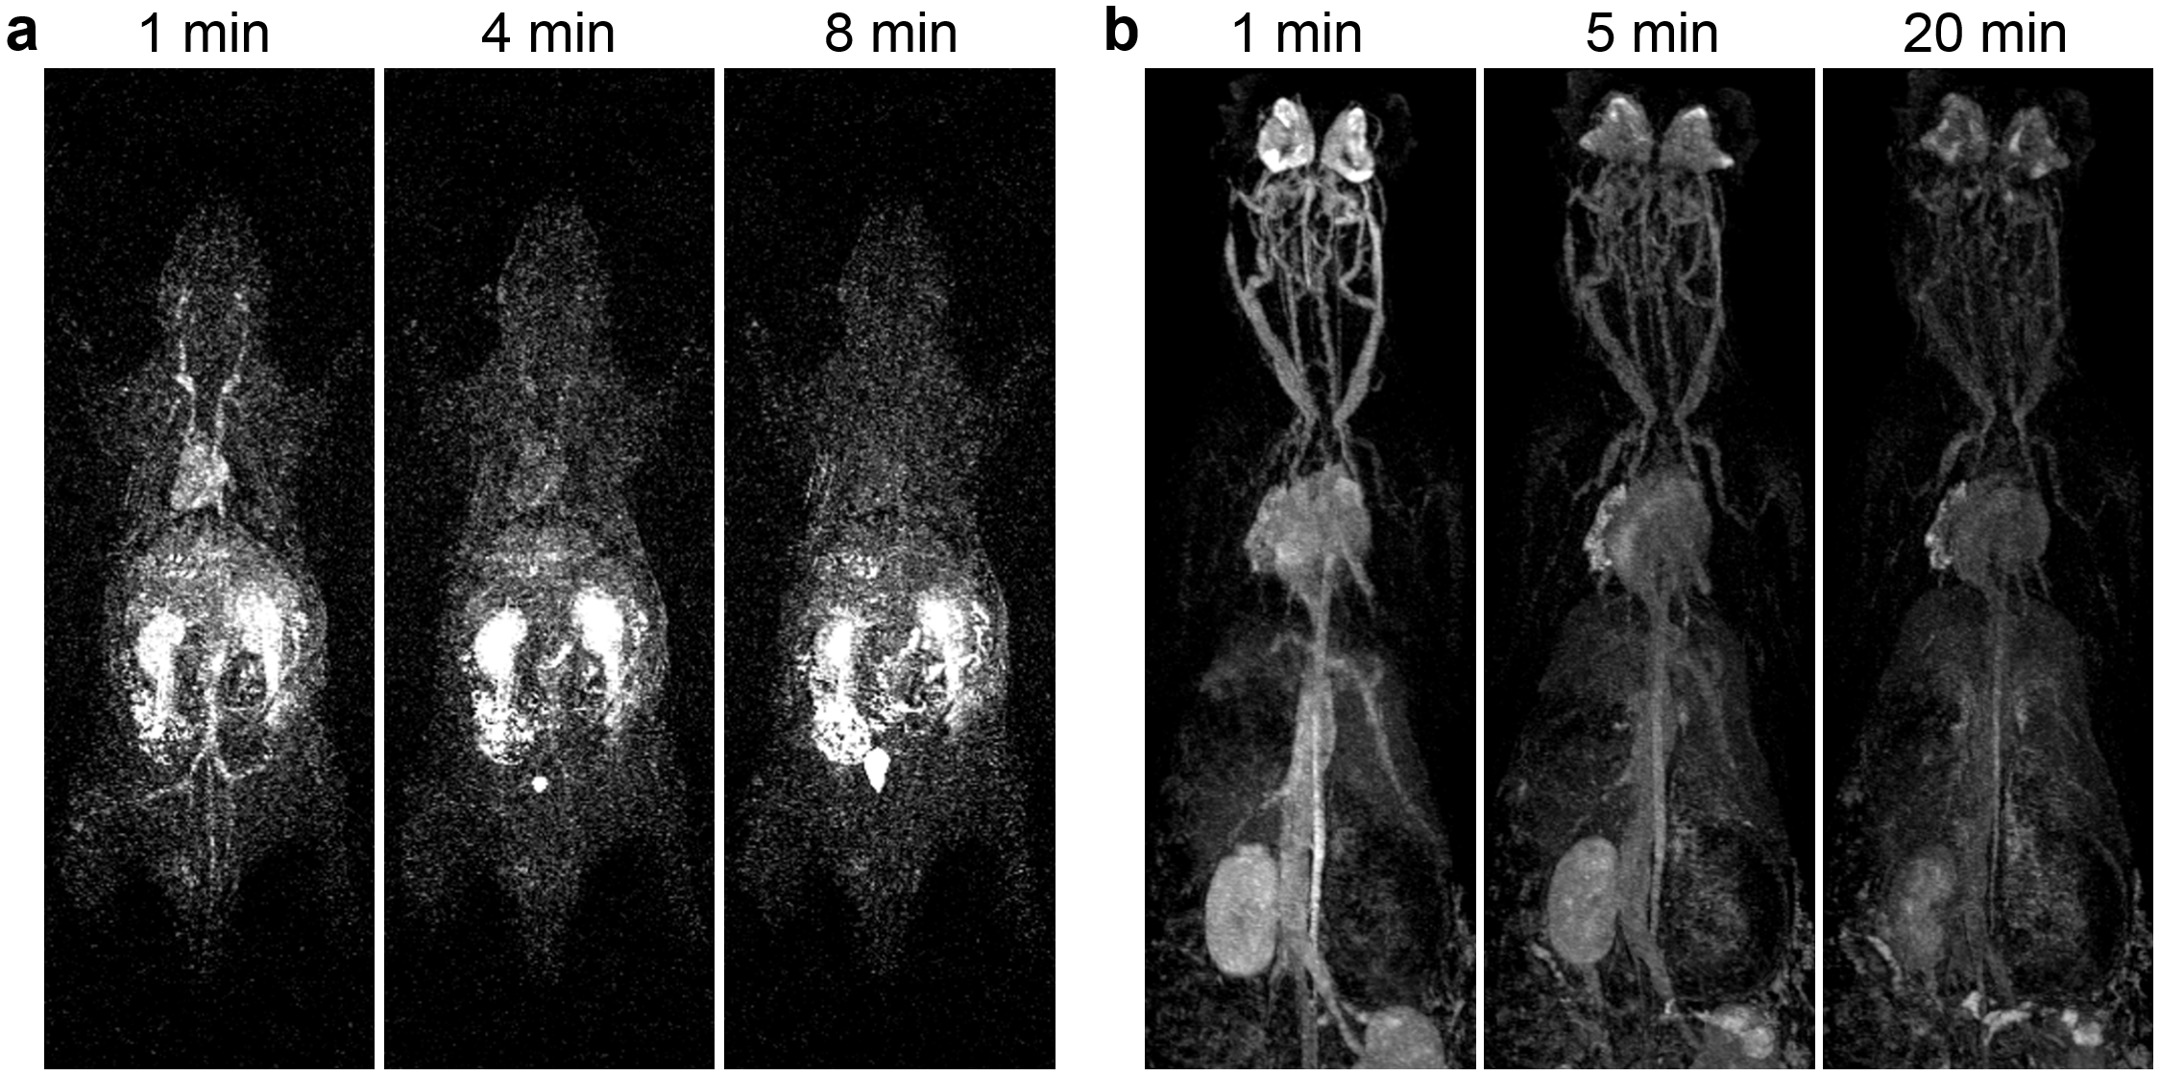
Supplementary Figure 22 MR angiography on a rat b rabbit at different time points after the intravenous injection of ACNC to analyse its dynamic distribution.

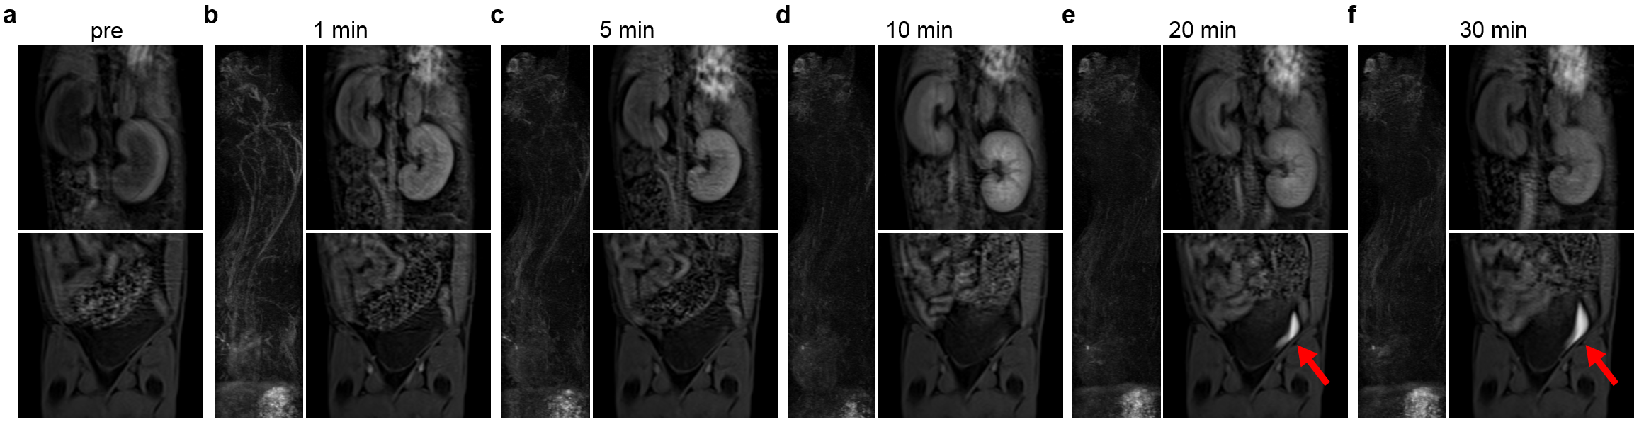
Supplementary Figure 23 MR angiography and rapid renal clearance of ACNC. MR angiography on (a to f) beagle dog at different time points after the intravenous injection of ACNC to analyse its dynamic distribution. The kidney continues to brighten within 10 minutes and the bladder (the red arrow) brightened obviously after 10 minutes.

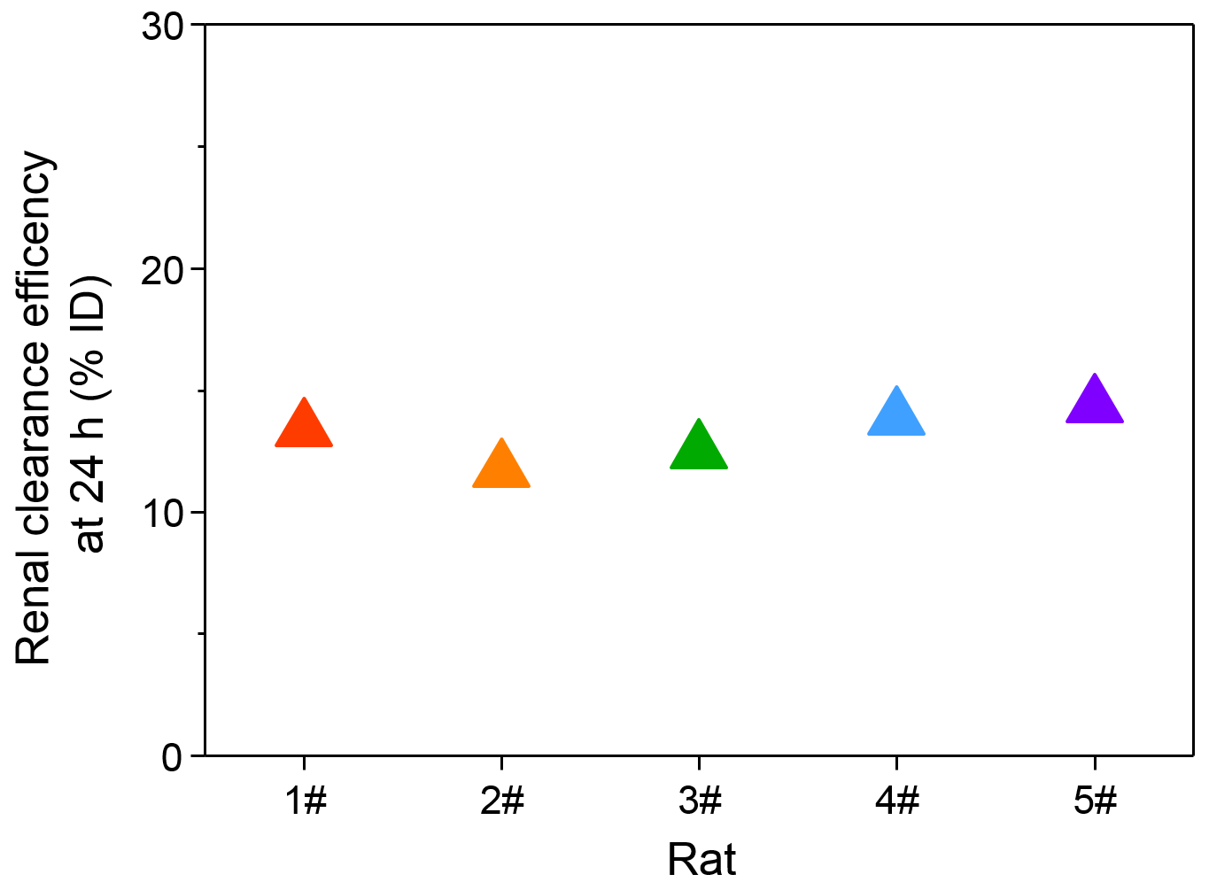
Supplementary Figure 24 Renal clearance efficiencies of ACNC in five rats at 24h.

Supplementary Table 1 EXAFS fit values for ACC standard, ACC-PAA, ACC-Gd and ACNC samples.
Sample | N  (Coordination number) | R (Å) | Debye-Waller (10² Å²)
ACC | 5.2 ± 0.8 | 2.41 ± 0.03 | 0.8 ± 0.1
ACC-PAA | 5.9 ± 0.9 | 2.40 ± 0.03 | 0.7 ± 0.1
ACC-Gd | 5.7 ± 0.9 | 2.42 ± 0.03 | 1.0 ± 0.1
ACNC | 6.0 ± 0.9 | 2.41 ± 0.03 | 0.9 ± 0.1

Supplementary Table 2 Linear combination results between standards ACC-PAA and PAA-Ca and samples PAA-Ca/Gd, ACC-Gd and ACNC.
Standard | ACC-PAA | PAA-Ca
Samples | R² | R²
PAA-Ca/Gd | 0.00% | 100.00%
ACC-Gd | 93.80% | 6.20%
ACNC | 95.70% | 4.30%

Supplementary Table 3 Details of final product ACNC and a series of control samples. ‘N/A’ represents the absence of a component, while ‘+’ represents the presence.
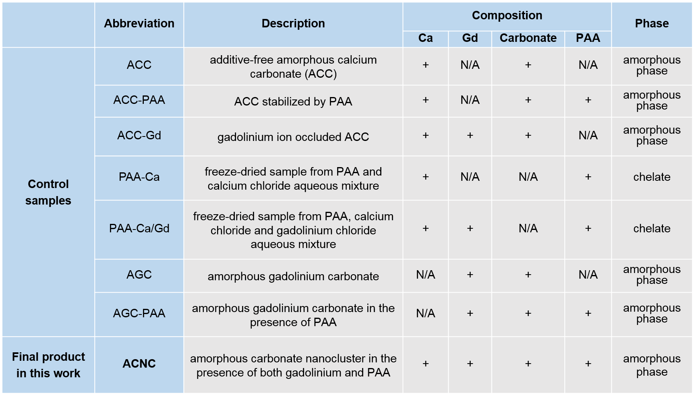

Supplementary Table 4 Results of AUC experiments. Results of AUC experiments using 2-dimensional spectrum analysis (2-DSA) for the determination of the cluster hydration calculated for spherical clusters via the Perrin coefficient¹. Absorption optics was used for ACNC detection via PAA (230 nm). s = sedimentation coefficient, D = diffusion coefficient, ρ= density of the cluster (n=3) and δ = hydration.
Sample | s  (10⁻¹³s) | D  10⁻¹⁰ (m²/s) | d_{H} (nm) | M  (g/mol) | ρ (g/cm³) | $\overline{v}$ (cm³/g) | f/f₀ | δ (g_{H2O}/g_{Solute})
ACNC1 | 1.19 | 2.86 | 1.5 | 2030 | 2.0171 | 0.4958 | 1.90 | 2.90
ACNC2 | 1.20 | 2.80 | 1.5 | 2200 | 2.0045 | 0.4989 | 2.00 | 3.49
ACNC3 | 1.17 | 2.60 | 1.6 | 2460 | 1.8157 | 0.5508 | 1.90 | 3.22
Average | 1.19 | 2.75 | 1.5 | 2230 | 1.9458 | 0.5152 | 1.93 | 3.20

Supplementary Table 5 Water content of ACNC in solution measured by AUC (n=3).
Sample | Molar ratio of water molecules per mole of CaCO₃ | Molar ratio of water molecules per mole of Gd
ACNC1 | 7.6 | 19.8
ACNC2 | 10 | 26.0
ACNC3 | 8.9 | 23.2
Average | 8.8 | 23.0

Supplementary References
1. Schuck, P., Rossmanith, P. Determination of the sedimentation coefficient distribution by least-squares boundary modeling. Biopolymers 54, 328-341 (2000).

