Figure 1 Trends in Median Household Drug Expenditure Over Time with Intervention Points
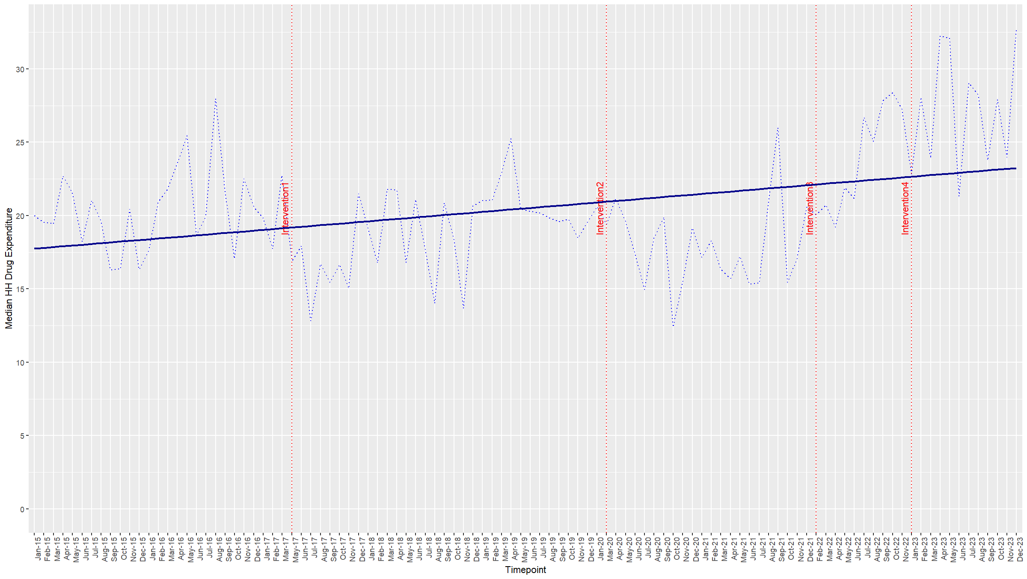

Figure 2 Visual inspection of seasonality in inflation adjusted median monthly drug expenditure (decomposition with 4-month frequency)
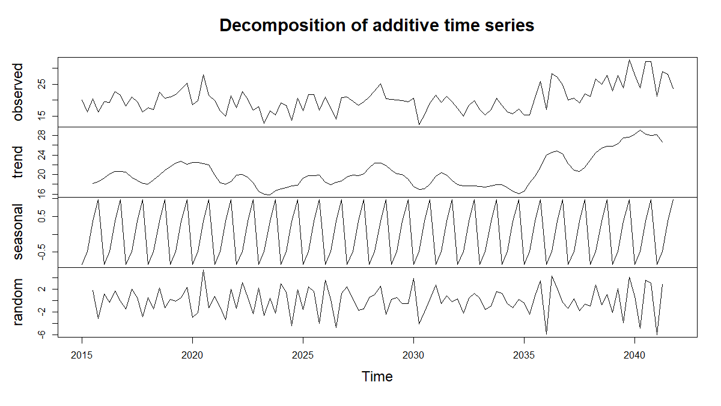

Figure 3 Autocorrelation Function (ACF) Plot of Residuals
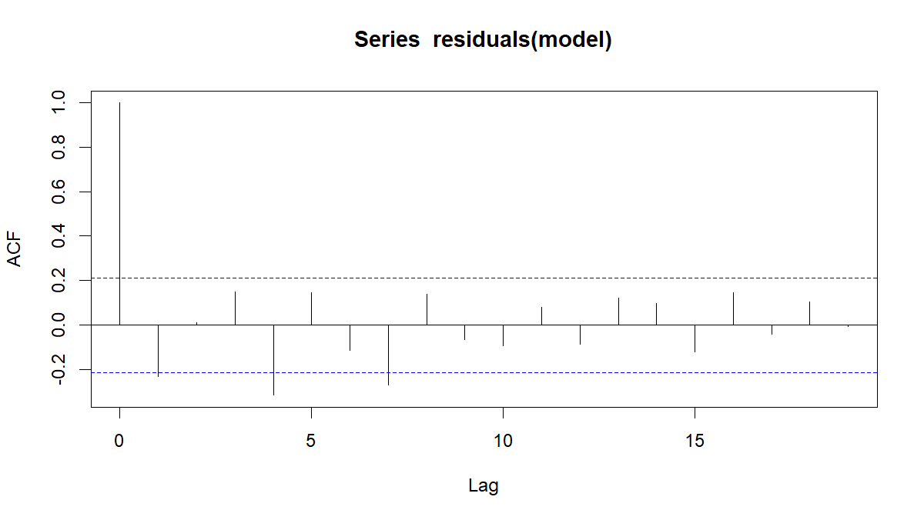
Durbin Watson static = 2.442 (p- value = 0.89)

Figure 4 Residuals vs. Fitted Values Plot for Model Diagnostics
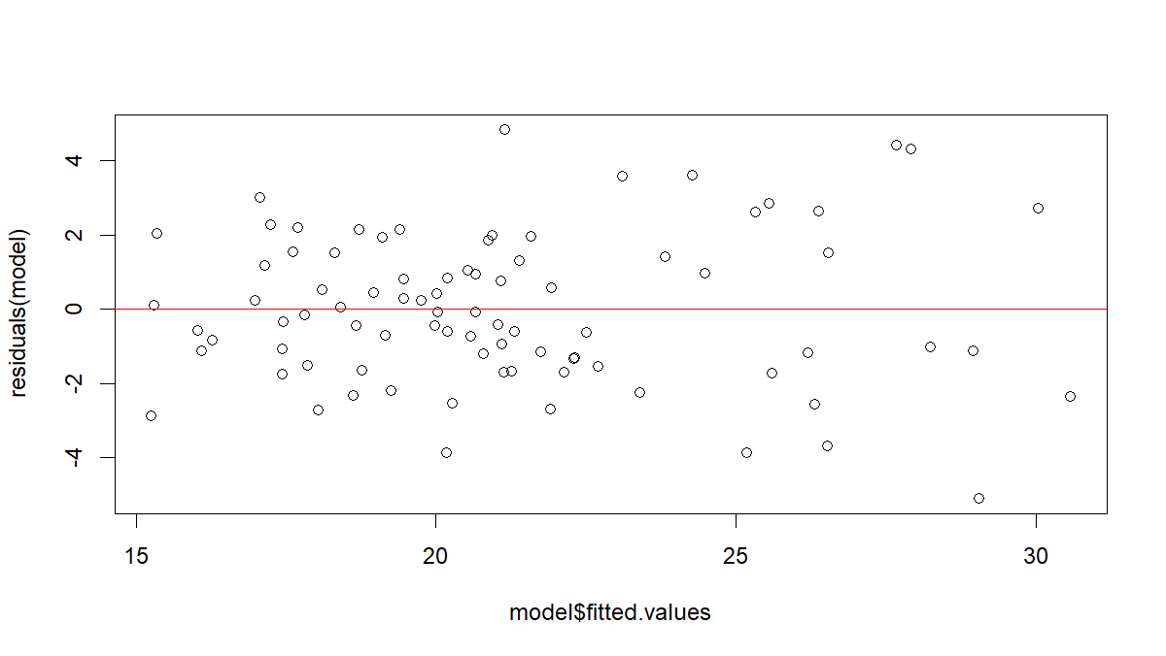
Table 1 Model fit statistics
Metric | Value
R-squared | 0.762
AIC | 408.89
BIC | 467.52

