Questionnaire used in the study
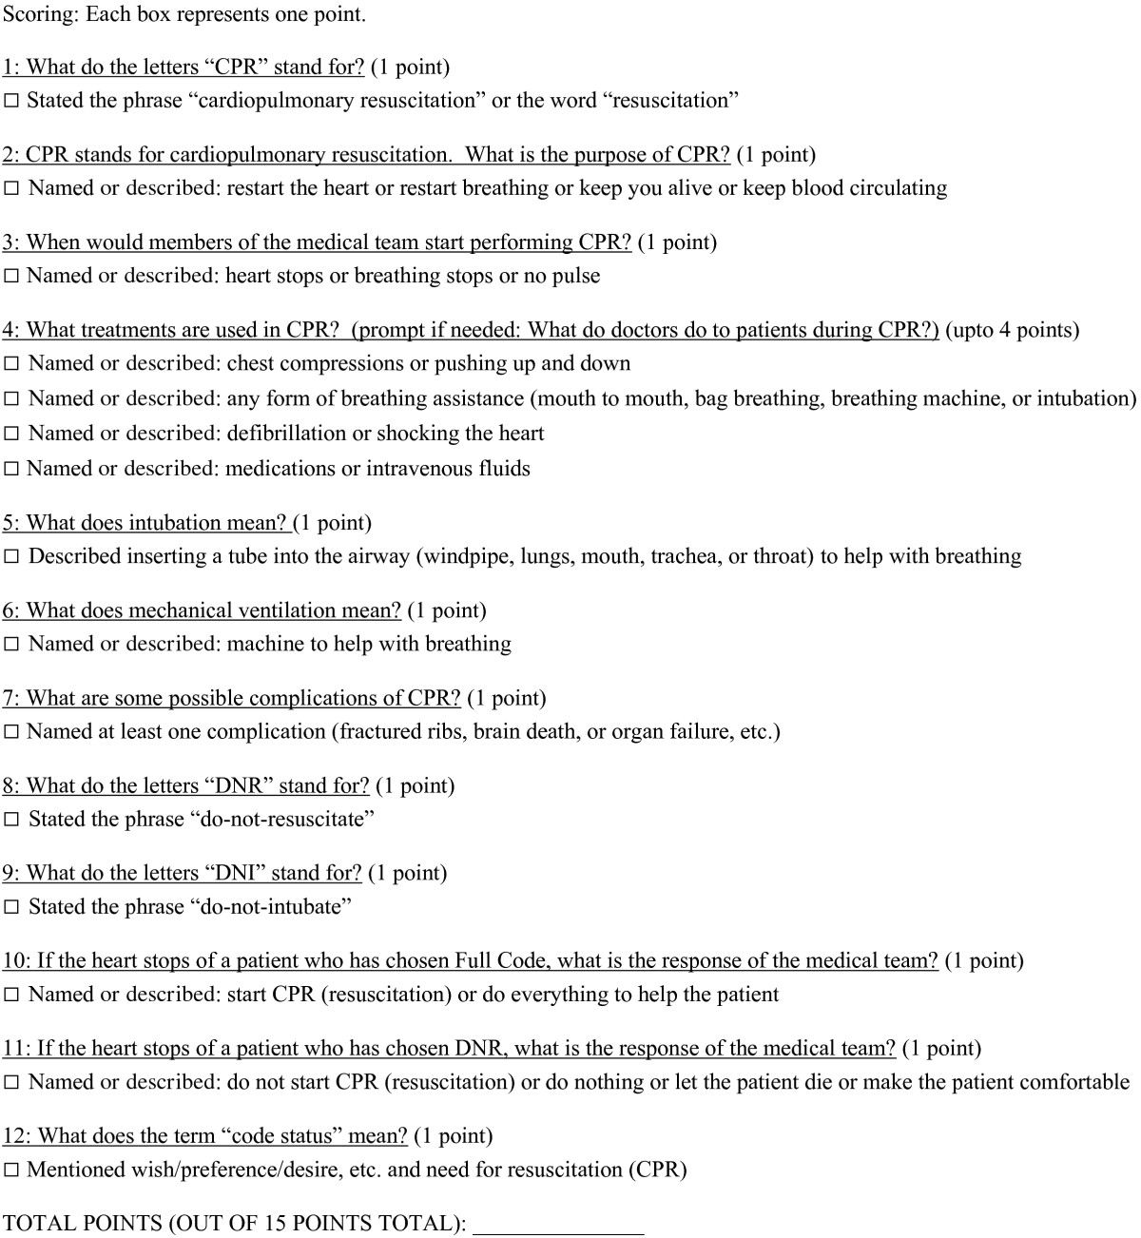

From:Wilson, M.E., Akhoundi, A., Krupa, A.K. et al. Development, validation, and results of a survey to measure understanding of cardiopulmonary resuscitation choices among ICU patients and their surrogate decision makers. BMC Anesthesiol 14, 15 (2014) doi:10.1186/1471-2253-14-15 https://bmcanesthesiol.biomedcentral.com/articles/10.1186/1471-2253-14-15

