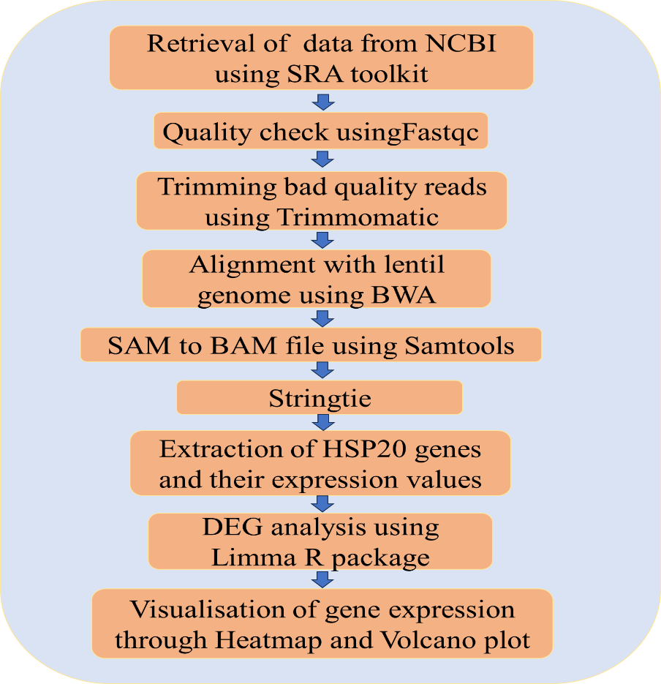
Figure 1: Flowchart of differential expression analysis of WRKY gene under Abiotic stress (drought and salt) condition

