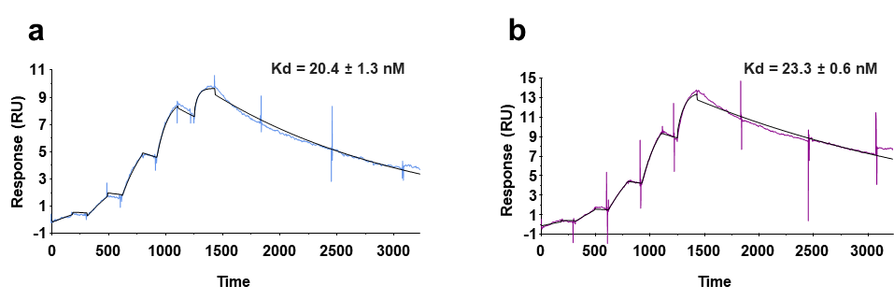
Extended Data Fig. 1 SPR analysis of the binding affinity between S-880008 and two SARS-CoV-2 spike proteins. The binding affinities between S-880008 and the SARS-CoV-2 spike proteins derived from the WT (a) and BA.2 (b) strains were as measured by SPR. Kd, dissociation constant. Data are expressed as the mean ± standard deviation of three independent experiments.

Extended Data Fig. 2 Details of S-880008 binding mode and binding site and the Cryo-EM structure of SARS-CoV-2 spike in complex with S-880008 derivatives.
a. Superposition of the S-880008 structure in complex with the spike protein onto the structure of the SARS-CoV-2 spike when the RBD assumes the 3-down configuration (PDB: 6VXX). S-880008 shown in stick representation (orange), while the spike RBD 3-down structure shown in cartoon representation (gray). b. The amino acid sequence and secondary structure of NTD/RBD/SD1 (residues 1–591) in SARS-CoV-2 WT spike. The mutation sites present in the SARS-CoV-2 variants against which S-880008 exhibited antiviral activity (Table 1) are highlighted in red. Black triangles indicate residues that are located within 4.5 Å of S-880008 in the complex. c. The cis-conformation of 7-MeA in S-880008. d. The cryo-EM maps and structures of compound 10, and an enlarged view of its interaction with the spike protein. e. The conformation of the spike protein in the presence of compound 12. An enlarged view of the binding pocket containing compounds 12, with the RBD assuming the up (top) or down (bottom) conformations. 7-MeA, N-methyl-L-alanine; NTD, N-terminal domain; OEG, 8-amino-3,6-dioxaoctanoic acid; RBD, receptor-binding domain; SD1, subdomain 1.

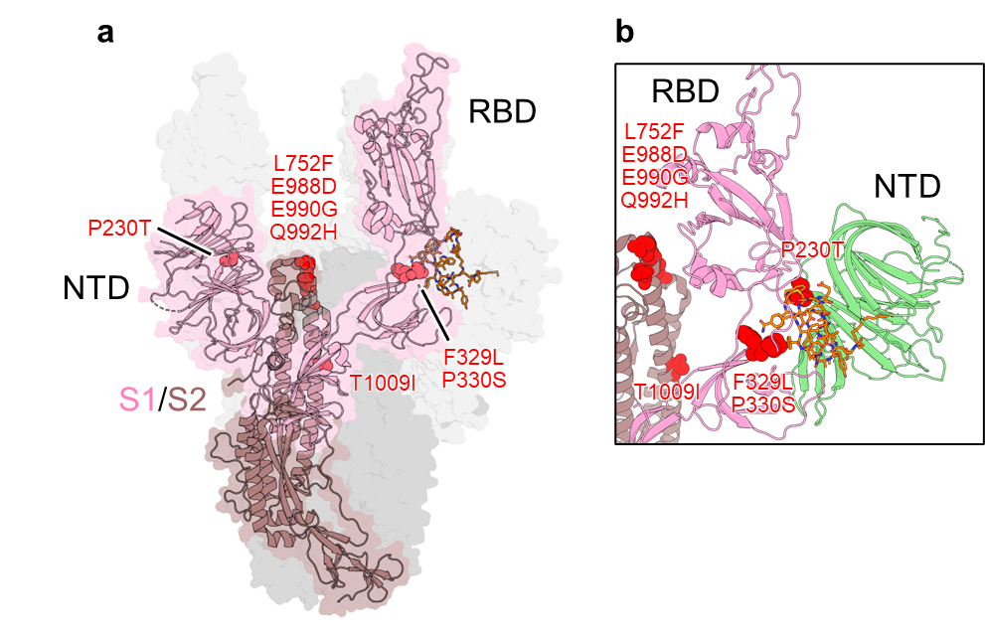
Extended Data Fig. 3 Structural mapping of the amino acid substitutions induced in the SARS-CoV-2 spike protein by S-880008 treatment.
a. The amino acid substitutions (Extended Data Table 2) affecting the spike trimer binding to S-880008 are shown as red spheres. The surface of the spike trimer is shown, with one protomer highlighted in cartoon representation. The S1 domain is colored gray or pink, while the S2 domain is colored dark gray or dark pink. b. Close-up view of the amino acid substitutions. The NTD domain is colored light green. NTD, N-terminal domain; RBD, receptor-binding domain.

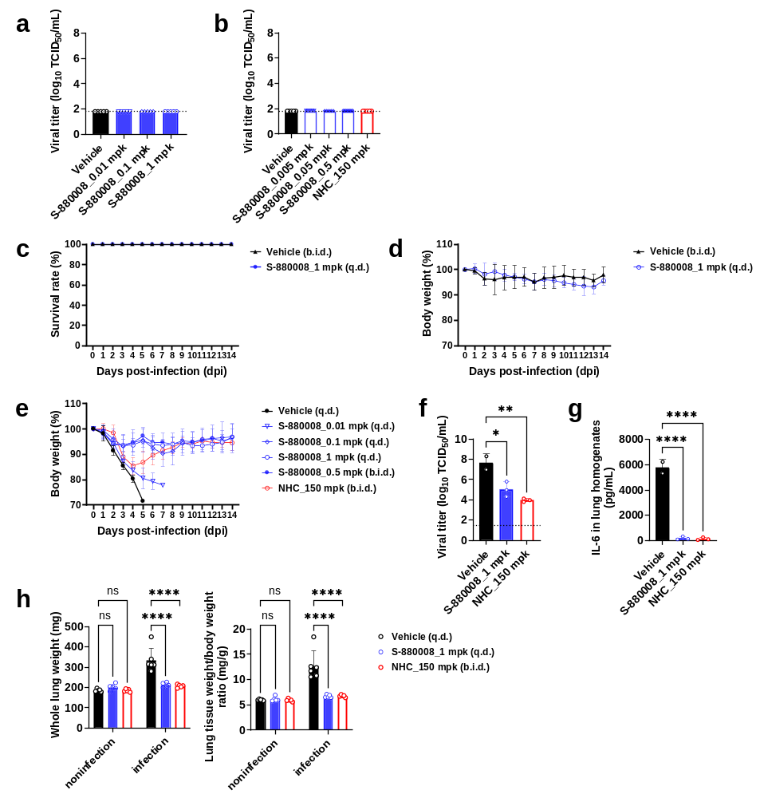
Extended Data Fig. 4 Evaluation of the in vivo antiviral efficacy of S-880008 in a mouse model of SARS-CoV-2 infection.
a, b. The viral titer in the lung homogenates of mice (n = 5/group) at 9 dpi after treatment with vehicle, S-880008, or NHC. The survival times (c) and body weights (d) of uninfected adult mice were monitored over a 14-day period after treatment with vehicle or S-880008 (n = 5/group). e. The body weights of SARS-CoV-2-infected adult mice were monitored over a 14-day period after treatment with vehicle, S-880008, or NHC (n = 10/group). The survival times are shown in Fig. 5i. f, g. The viral titer and interleukin (IL)-6 concentration in the lung homogenates of SARS-CoV-2-infected adult mouse at 4 dpi after treatment with vehicle (n = 2), S-880008 (n = 3), or NHC (n = 3). h. The whole lung tissue weight and the whole lung tissue weight as a proportion of body weight of each adult SARS-CoV-2-infected mouse was measured at 4 dpi after treatment with vehicle (n = 5–6), S-880008 (n = 5), or NHC (n = 5). Vehicle and S-880008 were administered intranasally q.d. (a, c-h) or b.i.d. (b, e) at 1 dpi. The total daily dose of S-880008 administered to the 1 mg/kg (q.d.) and 0.5 mg/kg (b.i.d.) groups was the same. NHC was administered orally b.i.d. at 1–5 dpi (a, b, e) or at 1–3 dpi (f–h). b.i.d., bis in die (twice a day); NHC, beta-D-N4-hydroxycytidine; q.d., quaque die (once a day); TCID₅₀, 50% tissue culture infective dose. Data are expressed as the mean ± standard deviation. f, g, h. Data were analyzed in comparison with the vehicle group using a one-way ANOVA, followed by Dunnett’s post-hoc test; ns, not significant; *, p<0.05; **, p<0.01; ****, p<0.0001.

Extended Data Table 1. RT-PCR evaluation of the antiviral activities (EC₉₀) of S-880008 and remdesivir against WT, BA.1, and BA.2 SARS-CoV-2 strains
SARS-CoV-2 variant |  | EC₉₀ (nM)
 |  | S-880008 |  |  | Remdesivir
hCoV-19/Japan/TY/WK-521/2020 | WT | 7.46 | ± | 1.18 | 2099 | ± | 1365
hCoV-19/Japan/TY38-873/2021 | BA.1 | 5.46 | ± | 2.68 | 1036 | ± | 649
hCoV-19/Japan/TY40-385/2022 | BA.2 | 52.2 | ± | 17.3 | 3055 | ± | 567
Data are expressed as the mean ± standard deviation of three independent experiments.

Extended Data Table 2. Amino acid substitutions induced by S-880008 treatment in the spike region of several SARS-CoV-2 variants
SARS-CoV-2  variant |  | S-880008 (nM) |  |  |  |  |  | virus control
 |  | 5000 | 1000 | 200 | 40 | 8 | 1.6 | virus control
WT | No. 1 | S735L, A771V,  I834T, N955D,  T1009I (36) | S810P, I834V,  N955D | L984F (100) | E988D (100) | N544S,  Q992H (70) | N360D,  E988D (13) | H655Y
WT | No. 2 | N803L, 952A,  N955D | L752F (10),  I834V, N955D | W64R, L984F (35),  E988D (65) | T51A,  E988D (99) | N544S | D571G (93) | H655Y
α | No. 1 | E988D (82),  E990G (10) | Q755R, R983L | P330S (17), I742V,  A942S, Q992H (100) | P330S (96), Y365F | F329L (CTT, 68),  P330S (24) | A766D, N969T | －
α | No. 2 | L984F (87),  E988D (10) | Q755R, R983L | N856Y, A942S,  Q992H (100),  D1041G | P330S (95), Y365F | F329L (CTT, 59),  Q564H,  Q992H (34) | A520E | －
δ | No. 1 | S494L,  L752F (99) | F562C (96) | P330S (100), T573I,  T1009I (91) | T299I,  F329L (TTG, 80),  P330S (20) | S172C,  P230T (51),  P521Q | T1009I (31) | －
δ | No. 2 | L752F (100) | F562C (91),  G769E | P330S (100),  T1009I (100) | L24I,  F329L (TTG, 39),  P330S (49) | P521Q, S968Y,  T998A | － | －
ο  (BA.2) | No. 1 | － | D405N,  L752F (33),  E990G (25),  Q992H (79) | D405N,  F562Y (100) | L5F, P230A (75),  R357T, Q992H (100) | L176F, D405N,  D571G (90) | T732I,  Q992H (97) | Y369H, 405N,  T573I, R682W, T791I
ο  (BA.2) | No. 2 | － | L752F (89),  Q992H (99) | L176F, P230S (39),  F329L (CTT, 34),  D405N, F562Y (32), E990G (35) | P330S (68), S982A,  Q992H (100) | Q992H (95) | Q992H (88) | Y369H, 405N,  T573I, R682W, T791I
Data represent the results of two independent experiments (No.1 and No.2).
Silent mutations, amino acid substitutions with a frequency < 10%, and SARS-CoV-2-variant-specific mutations were excluded.
The amino acid substitutions that met the selection criteria for the preparation of S-880008-resistant viruses by reverse genetics are highlighted in red.
The numbers in parentheses indicate amino acid substitution frequency (%).
If several base codons encoded the same amino acid, the base codons found in multiple samples at a frequency > 50% were selected.

Extended Data Table 3. Antiviral activities (EC₅₀) of several compounds against S-880008-resistant viruses
S-880008-resistant virus | EC₅₀ª |  |  |  |  |  |  |  |  | Comparison with WT (fold-change)
S-880008-resistant virus | S-880008 |  |  | Remdesivir |  |  | CAS + IMD^{b} |  |  | S-880008 | Remdesivir | CAS + IMD^{b}
rgSARS-CoV-2/Hu/DP/Kng/19-020  (WT) | 2.31 | ± | 1.00 | 2012 | ± | 479 | 43.4 | ± | 8.53 | - | - | -
rgSARS-CoV-2 with spike/P230A | 17.3 | ± | 9.34 | 1381 | ± | 543 | 23.3 | ± | 6.25 | 7.47 | 0.69 | 0.54
rgSARS-CoV-2 with spike/F329L | 29.3 | ± | 12.5 | 1221 | ± | 504 | 17.8 | ± | 8.57 | 12.7 | 0.61 | 0.41
rgSARS-CoV-2 with spike/P330S | 12.1 | ± | 6.35 | 969 | ± | 226 | 11.0 | ± | 2.06 | 5.24 | 0.48 | 0.25
rgSARS-CoV-2 with spike/D571G | 9.79 | ± | 4.60 | 2256 | ± | 525 | 97.2 | ± | 13.7 | 4.23 | 1.12 | 2.24
rgSARS-CoV-2 with spike/L752F | 749 | ± | 178 | 564 | ± | 154 | 6.47 | ± | 2.20 | 324 | 0.28 | 0.15
rgSARS-CoV-2 with spike/E988D | >5000 |  |  | 889 | ± | 192 | 9.35 | ± | 1.59 | >2165 | 0.44 | 0.22
rgSARS-CoV-2 with spike/Q992H | 63.7 | ± | 36.6 | 1295 | ± | 520 | 26.8 | ± | 4.02 | 27.5 | 0.64 | 0.62
rgSARS-CoV-2 with spike/T1009I | 3.20 | ± | 1.67 | 1472 | ± | 468 | 30.8 | ± | 4.09 | 1.38 | 0.73 | 0.71
a: S-880008 and remdesivir: nM, CAS + IMD: ng/mL
b: CAS + IMD = antibody cocktail (casirivimab and imdevimab)
Data are expressed as the mean ± standard deviation of three independent experiments.

Extended Data Table 4. Effect of human or mouse sera on the antiviral activities (EC₉₀) of S-880008 and CAS + IMD
Serum (%) | EC₉₀ª
Serum (%) | Human serum |  |  |  |  |  | Mouse serum
Serum (%) | S-880008 |  |  | CAS + IMD^{b} |  |  | S-880008 |  |  | CAS + IMD^{b}
0 | 7.46^{c} | ± | 1.18 | 29.3 | ± | 0.00 | 7.01 | ± | 1.61 | 29.4 | ± | 0.01
3.125 | 12.1 | ± | 3.34 | 23.0 | ± | 0.00 | 13.3 | ± | 2.32 | 29.0 | ± | 0.01
6.25 | 14.1 | ± | 6.58 | 21.9 | ± | 0.00 | 19.6 | ± | 5.06 | 25.4 | ± | 0.01
12.5 | 27.2 | ± | 3.34 | 21.9 | ± | 0.00 | 33.7 | ± | 5.82 | 27.1 | ± | 0.01
25 | 31.9 | ± | 5.36 | 20.1 | ± | 0.00 | 47.0 | ± | 7.73 | 29.2 | ± | 0.01
a: S-880008: nM, CAS + IMD: ng/mL
b: CAS + IMD = antibody cocktail (casirivimab and imdevimab)
c: The EC₉₀ (mean ± standard deviation) of S-880008 in the absence of human serum (0%) was the same as that shown in Extended Data Table 1.
Data are expressed as the mean ± standard deviation of three independent experiments.

Extended Data Table 5. Potency shift (PS) of S-880008 in the presence of human or mouse sera
 | PA-EC₉₀ª (nM) |  |  | PS^{b}
Human serum | 110 | ± | 16.1 | 15.2 | ± | 4.89
Mouse serum | 170 | ± | 28.3 | 25.6 | ± | 8.79
a: PA-EC₉₀ was the extrapolated value in the presence of 100% serum; PA-EC₉₀ = protein binding-adjusted 90% effective concentration.
b: PS = PA-EC₉₀/EC₉₀ (0% serum)
Data are expressed as the mean ± standard deviation of three independent experiments.

Extended Data Table 6. Summary statistics relating to Cryo-EM data collection, refinement, and validation
 | SARS-CoV-2 Spike
 | S-880008 | compound 8 | compound 9 | compound 10 | compound 11 | compound 12
Data collection and processing | global / local | global / local | global / local | global / local | 3-up / 2-up / 1-up | 1-up / 3-down
EMDB ID | 37073 / 37074 | 37075 / 37076 | 37077 / 37078 | 37079 / 37080 | 37081 / 37082 / 37083 | 37084 / 37085
PDB ID | 8KBN / 8KBO | 8KBP / 8KBQ | 8KBR / 8KBS | 8KBT / 8KBU | - | -
Microscope | Krios G4 | Krios G4 | Krios G4 | Krios G4 | Krios G4 | Krios G4
Camera  energy filter | Gatan K3  Gatan Biocontinuum | Gatan K3  Gatan Biocontinuum | Gatan K3  Gatan Biocontinuum | Gatan K3  Gatan Biocontinuum | Gatan K3  Gatan  Biocontinuum | Gatan K3  Gatan Biocontinuum
slit width | 20 | 20 | 20 | 20 | 20 | 20
Magnification | 130,000 | 130,000 | 130,000 | 130,000 | 130,000 | 130,000
Recording mode | counting | counting | counting | counting | counting | counting
Voltage (kV) | 300 | 300 | 300 | 300 | 300 | 300
Dose rate (e–/pixel/s) | 16.1 | 17.2 | 17.2 | 17.2 | 17.2 | 17.2
Electron exposure (e–/Å²) | 53.5 | 57.5 | 57.5 | 57.5 | 57.5 | 57.5
Exposure time (s) | 1.5 | 1.5 | 1.5 | 1.5 | 1.5 | 1.5
Number of raw frames | 50 | 50 | 50 | 50 | 50 | 50
Defocus range (μm) | -1.0 to -2.5 | -0.8 to -1.8 | -0.8 to -1.8 | -0.8 to -1.8 | -0.8 to -1.8 | -0.8 to -1.8
Pixel size (Å) | 0.67 | 0.67 | 0.67 | 0.67 | 0.67 | 0.67
Initial particle  images (no.) | 849,174 | 973,982 | 840,459 | 747,408 | 791,978 | 778,736
Final particle  images (no.) | 81,884 / 127,718 | 134,920 / 166,270 | 97,701 / 123,394 | 73,580 / 162,004 | 34,222 / 29,340 / 52,091 | 88,634 / 26,181
Symmetry imposed | C3 / C1 | C3 / C1 | C3 / C1 | C3 / C1 | C3 / C1 / C1 | C1 / C3
Map resolution (Å)  FSC 0.143 | 3.02 / 3.6 | 2.92 / 3.34 | 2.99 / 3.21 | 2.95 / 3.13 | 3.52 / 3.95 / 3.57 | 3.57 / 3.57
Refinement
Initial model used | PDB : 7K4N | PDB : 7K4N | PDB : 7K4N | PDB : 7K4N | - | -
Model composition  Protein residues | 1047 / 521 | 1026 / 496 | 1053 / 526 | 1048 / 520 | - | -
Map CC | 0.81 / 0.85 | 0.80 / 0.82 | 0.80 / 0.84 | 0.79 / 0.85 | - | -
R.m.s. deviations  Bond lengths (Å)  Bond angles (°) | 0.004 / 0.003  0.648 / 0.664 | 0.002 / 0.003  0.550 / 0.614 | 0.003 / 0.004  0.591 /0.630 | 0.003 / 0.003  0.581 / 0.601 | - | -
Validation  MolProbity score  Clashscore  Rotamer outliers (%) | 1.77 / 2.10  9.21 / 13.81  0.11 / 0.22 | 1.59 / 1.88  7.21 / 9.80  0.22 / 0.46 | 1.58 / 1.81  6.55 / 8.43  0.33 / 0.43 | 1.56 / 1.76  6.27 / 7.78  0.44 / 0.87 | - | -
Ramachandran plot  Favored (%)  Allowed (%)  Outliers (%) | 95.89 / 93.00  4.11 / 7.00  0.00 / 0.00 | 96.80 / 94.71  3.20 / 5.29  0.00 / 0.00 | 96.59 / 94.83  3.41 / 5.17  0.00 / 0.00 | 96.67 / 95.17  3.33 / 4.83  0.00 / 0.00 | - | -

